All the source code can be found at my **github**(username:Luping).

I have 3 versions here:

1.Complete the following functions without framework

2.Complete the following functions with CI.

3.Complete the following functions with phalcon.

Function :login

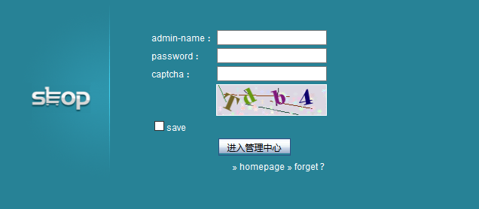

If the captcha is wrong:

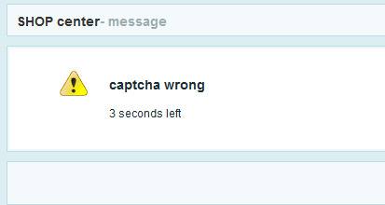

If the username and password doesn’t match the Table(cz_admin)

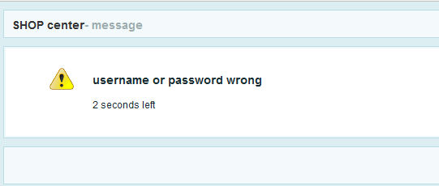

Once login, you go into this page: -this page will list all the admin users from DB

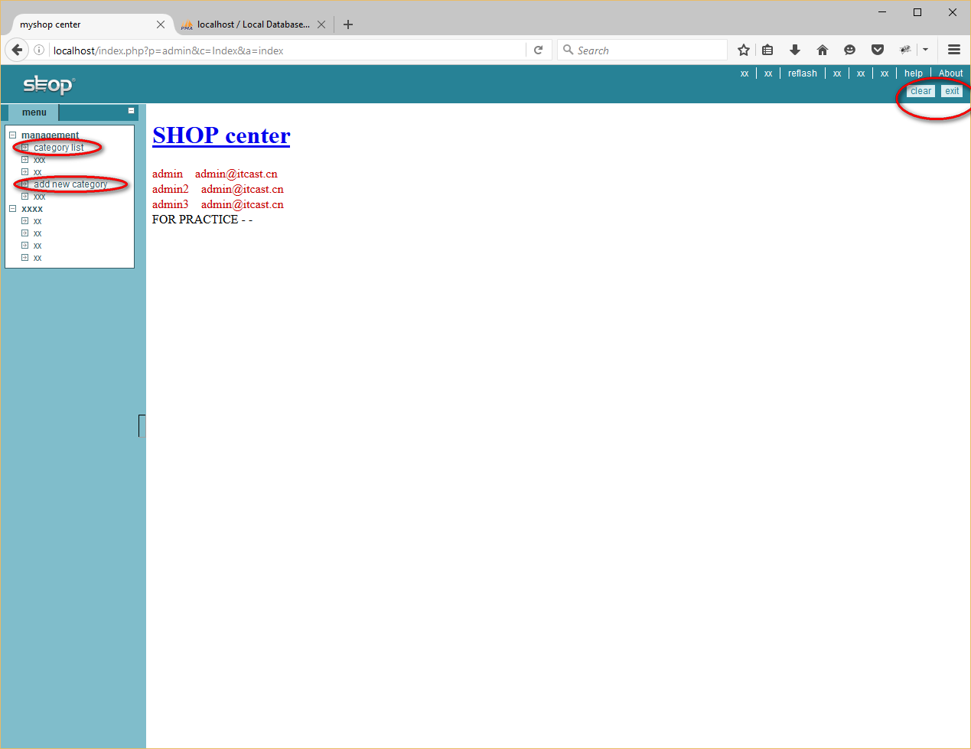

(Red circles are the functions completed)

If you press the Category List button, then you can go into this page:

All the categories are sorted and then list on the page.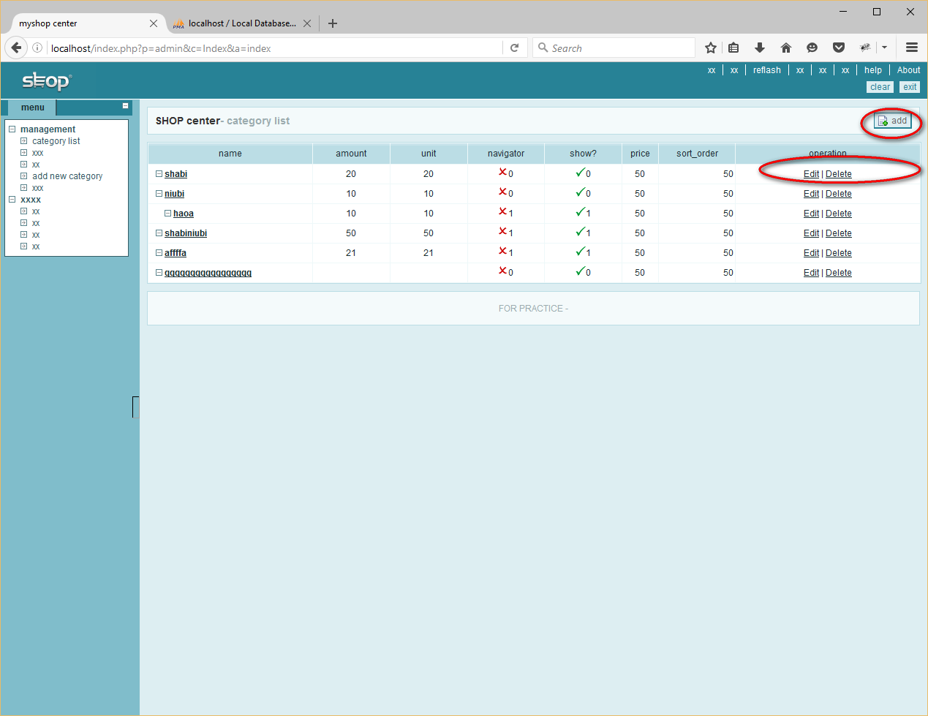

If you press add button:

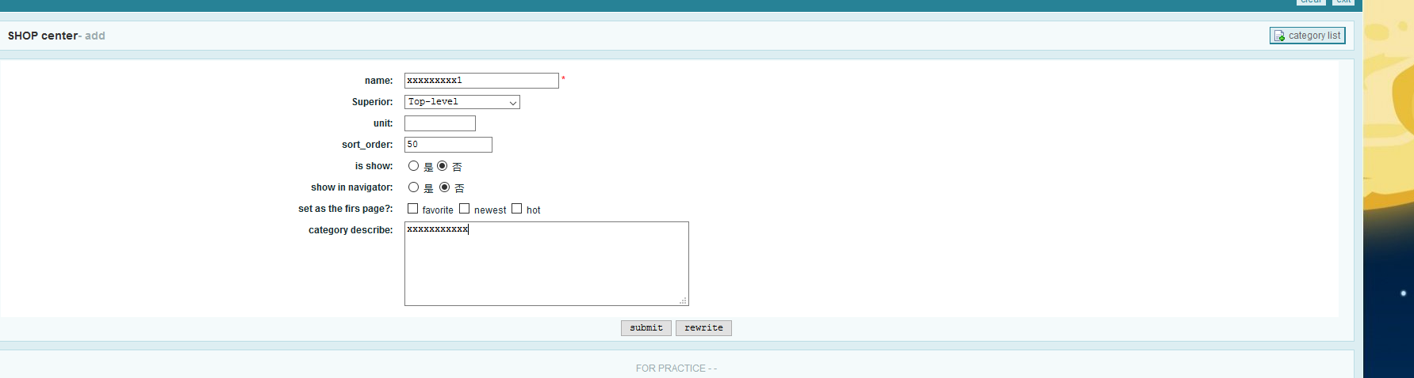

If failed:

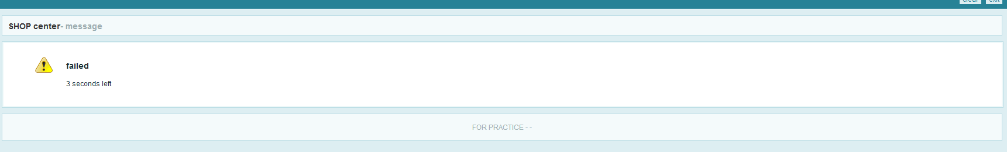

If add successfully:

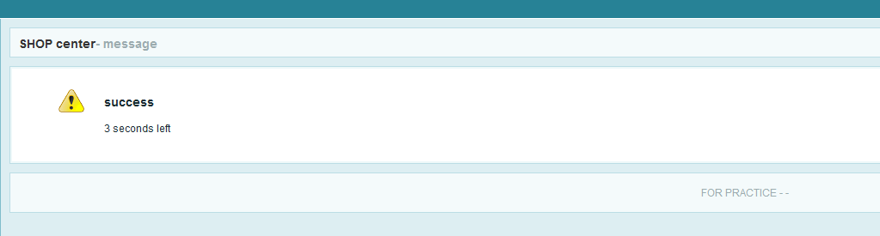

You can choose which level you want to put this category in:

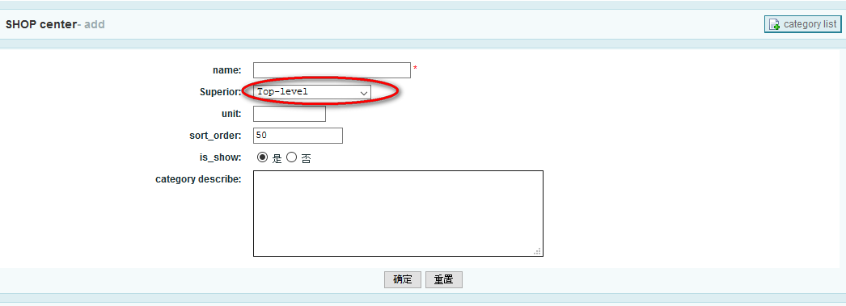

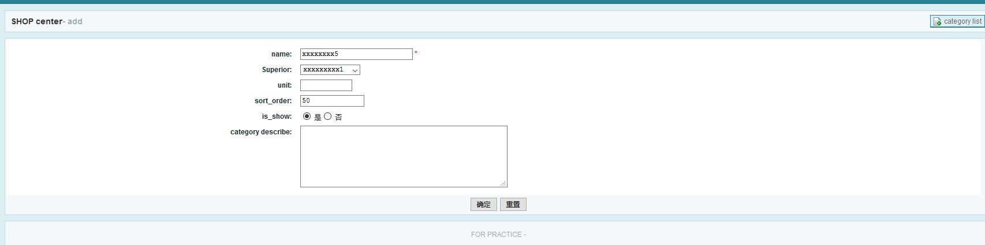

Or you can press the delete button:

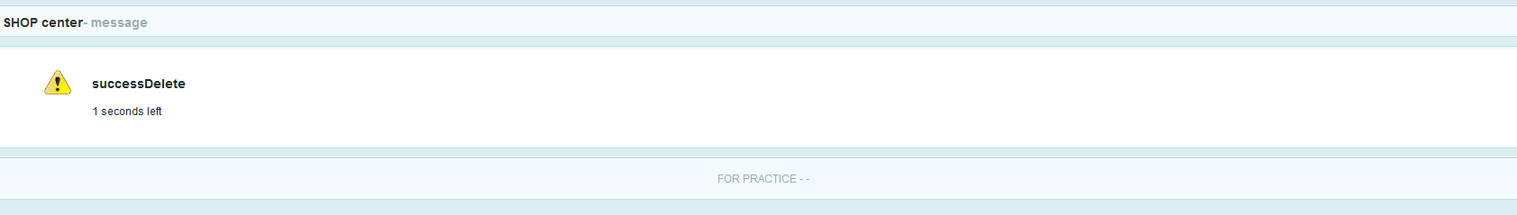

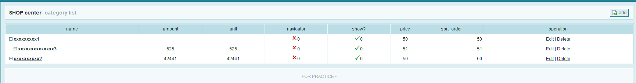

I use Session to login, so if you press Exit or Clear, the session data will be destroyed and you cannot do other operations.

