EBU6304 Software Engineering Group Project

2025-26
Group number | 100
member 1 | QM no: | Name:
member 2 | QM no: | Name:
member 3 | QM no: | Name:
member 4 | QM no: | Name:
member 5 | QM no: | Name:
member 6 | QM no: | Name:

Final short report

Design
Explain the design strategy and provide detailed design descriptions at different levels, such as architecture, components, and the design principles and patterns applied. You may use diagrams where appropriate to illustrate and support your design ideas.

Design response
Our system, TA&MO, is a full-stack teaching-assistant recruitment and management platform for three stakeholder groups: applicants/TAs, module organisers, and administrators. The design strategy was driven by software engineering concerns rather than by screens alone: we first identified externally visible requirements and role-specific workflows, then mapped them into a modular architecture with clear responsibility boundaries. This follows the spirit of IEEE-style requirements practice: each major feature is observable, testable, and linked to a user goal, such as “an applicant can apply once to a job”, “an organiser can move candidates through a pipeline”, and “an administrator can maintain system-wide data safely”.
At architecture level, the system uses a pragmatic Model–View–Controller style suitable for a Java Servlet/JSP project. JSP pages and vanilla JavaScript form the view layer; role-specific servlets act as controllers exposing REST-like endpoints; service classes contain business rules; model classes represent persistent domain entities; and `JsonDataService` provides a single persistence gateway to `data.json`. This separation of concerns improved maintainability because UI changes, workflow rules, and storage access could usually be changed independently.
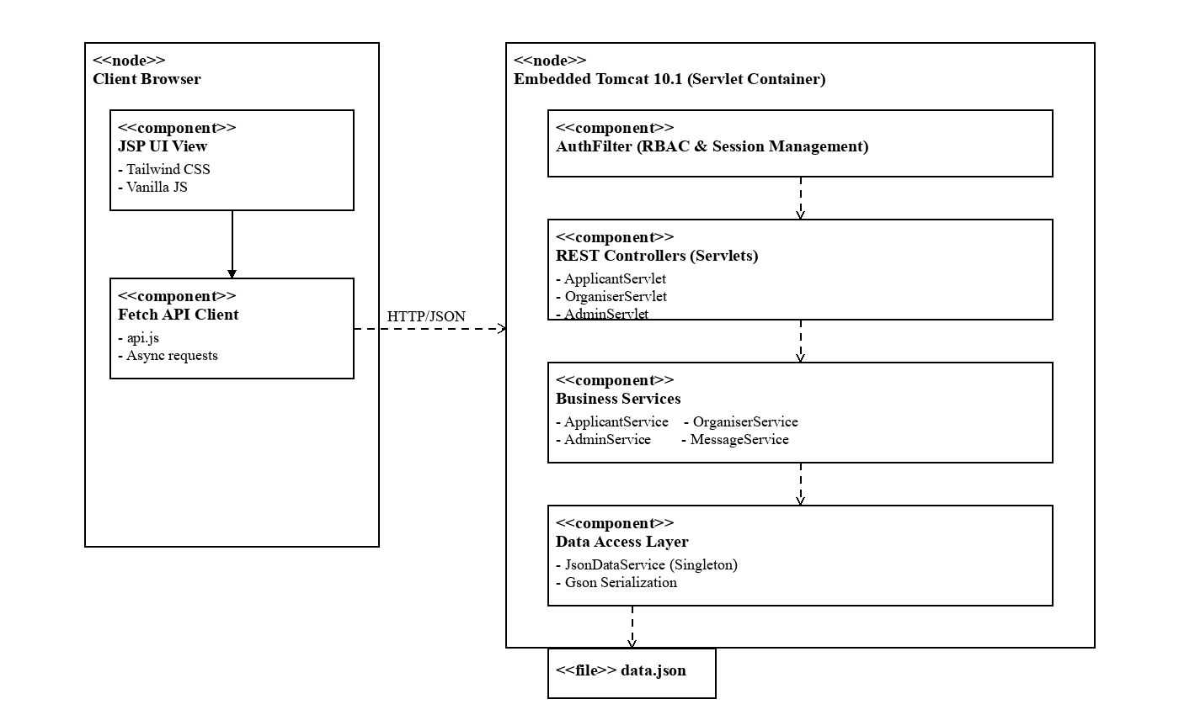
Figure 1. System architecture showing layered responsibilities (UML Component Diagram).
The component design deliberately uses high cohesion and low coupling. `ApplicantService` owns applicant concerns such as job browsing, profile editing, document management and application submission. `OrganiserService` owns job posting, recruitment pipeline, interview scheduling and applicant review. `AdminService` owns global management, data editing, workload monitoring and audit-style operations. `MessageService` encapsulates conversation logic, including unique contact lists and user detail cards. This structure avoids a “god servlet” and makes each component easier to reason about, test and extend.
The data model captures the recruitment lifecycle as a set of related entities. A `Job` belongs to a module and organiser and includes explicit `workDates`; an `Application` links an applicant to a job and progresses through applied, review, shortlisted, interview, offer and rejected states; a `Profile` stores academic details, skills, coursework, experience and reusable documents; `Interview` and `Notification` provide scheduling and status feedback; and `Message` supports communication between applicants and organisers. The model therefore represents both static information and process state.
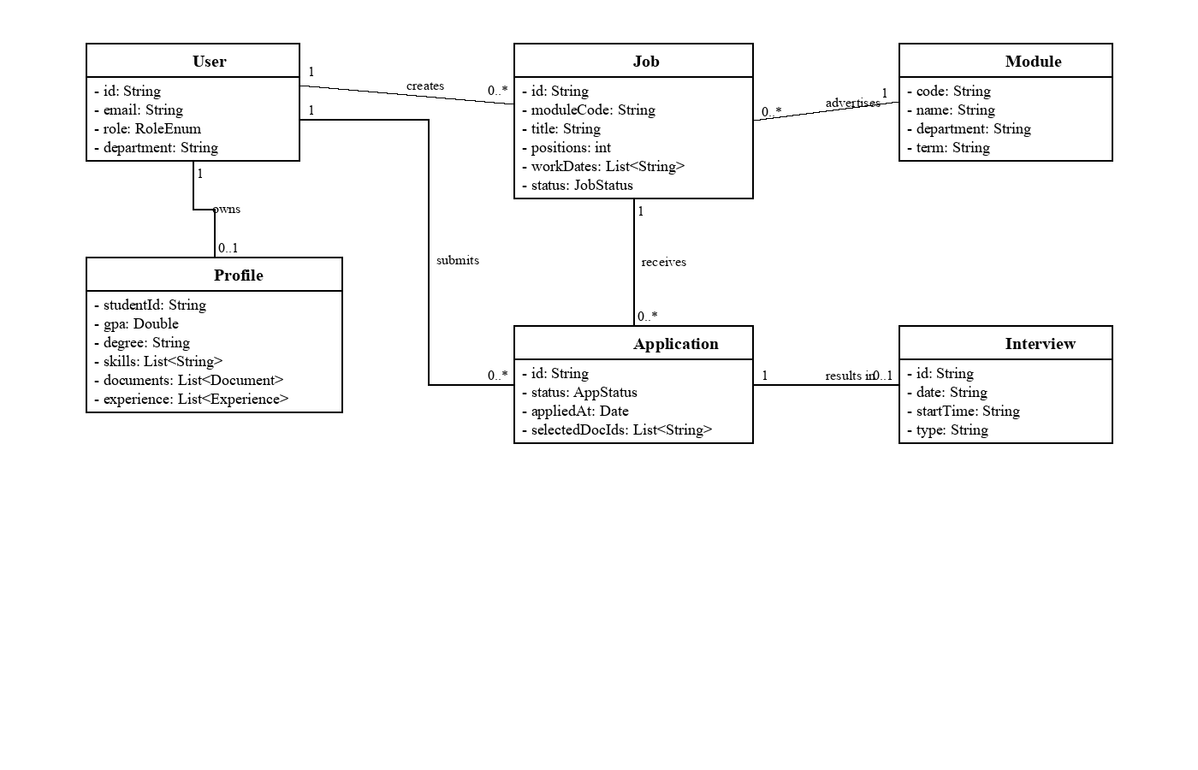
Figure 2. Core domain model supporting the TA recruitment lifecycle (UML Class Diagram).
Several design principles were applied. Role-Based Access Control (RBAC) is enforced through `AuthFilter`, which protects `/api/applicant/*`, `/api/organiser/*` and `/api/admin/*` according to session role. Defensive validation is placed server-side for permissions, duplicate applications, invalid status transitions and ownership checks, while the front end adds immediate usability feedback. Information hiding is used in profile retrieval and messaging: sensitive fields such as passwords are not exposed to the UI. Single source of truth is maintained by routing all persistence through `JsonDataService`, reducing inconsistent file access.
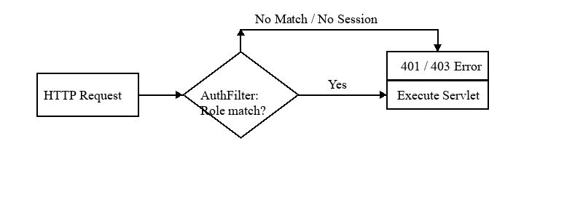
Figure 3. Role-Based Access Control logic enforcing permission boundaries (Flowchart).
The UI design supports user workflows instead of isolated pages. Applicants can browse jobs, view work schedules, apply with pre-filled profile data, manage CV documents, track applications and receive offers. Organisers can create jobs with generated work dates, preview submitted documents, inspect full applicant profiles, manage a Kanban-style pipeline and schedule interviews. Administrators can maintain users, modules, departments, terms, workload and raw data. These workflows demonstrate usability and traceability from stakeholder needs to implemented features.
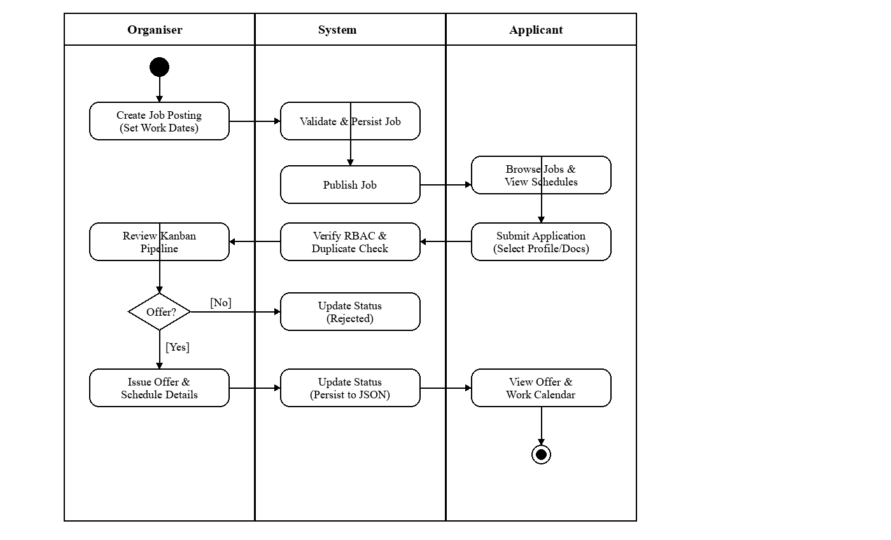
Figure 4. End-to-end recruitment workflow mapping user actions to system boundaries (UML Activity Diagram).
Quality attributes were considered using ISO/IEC 25010-style thinking. Functional suitability is addressed by covering the full recruitment workflow. Security is addressed by session authentication, RBAC and ownership checks. Maintainability is supported by layered services and consistent API patterns. Usability is supported by role-aware navigation, inline validation, modals, progress indicators and meaningful error messages. Reliability is improved through duplicate prevention, cascade warnings in admin deletion, and consistent JSON persistence.

Implementation
Outline the implementation strategy and project build plan. Discuss how version control is used to support development and collaboration.

Implementation response
The implementation strategy followed an incremental and iterative approach. We first delivered a working vertical slice: login, role-aware routing, basic dashboards and JSON persistence. We then expanded the system by role: applicant profile and applications, organiser job management and recruitment pipeline, administrator data management and workload monitoring, and finally cross-cutting features such as notifications, messaging, document upload/preview and work schedules. This reduced integration risk because every iteration produced executable software rather than a large untested final merge.
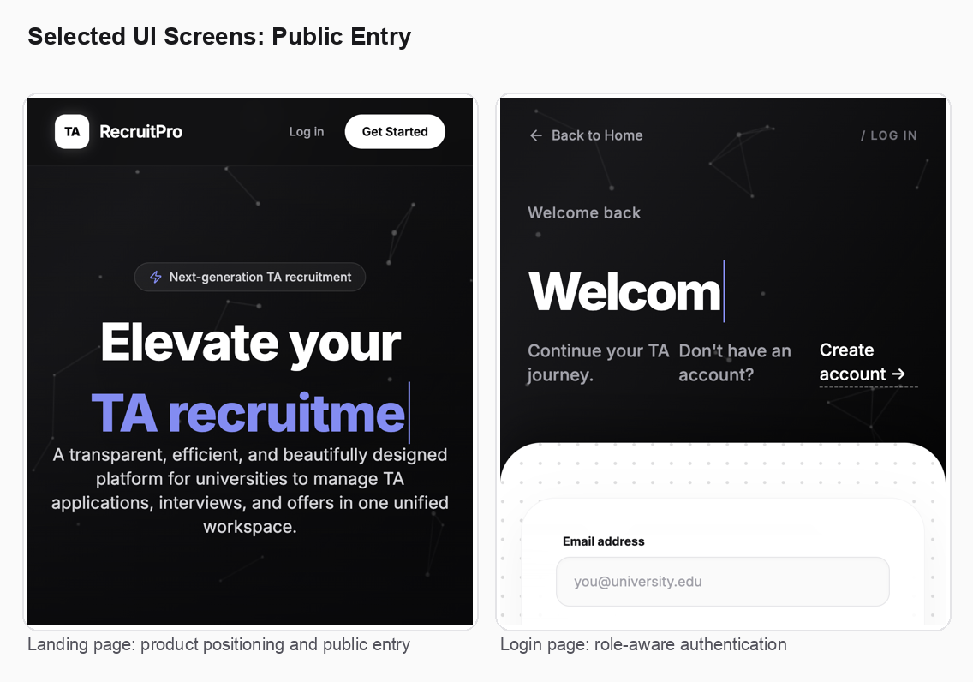
Figure 5. Public entry and login screens demonstrating polished UI and role-aware authentication.
The project is built with Java 17, Maven, Embedded Tomcat 10.1, Jakarta Servlet/JSP, Gson, Tailwind CSS, Lucide icons and vanilla JavaScript. We chose this stack because it matches the course requirement for web software engineering while remaining transparent enough to show architecture, request handling and persistence clearly. Maven provides a repeatable build process (`mvn compile exec:java`), while embedded Tomcat simplifies deployment by running the application locally under `/tamo`.
Implementation was organised around role-specific APIs. Applicant endpoints support dashboard statistics, job search/filtering, job details, application submission, application history, profile update and document management. Organiser endpoints support managed jobs, pipeline status movement, application details, interview scheduling and notification handling. Admin endpoints support global analytics, user/module/term/department management, workload reassignment, logs and a data editor. This API organisation makes the system easier to understand because endpoint location mirrors stakeholder responsibility.
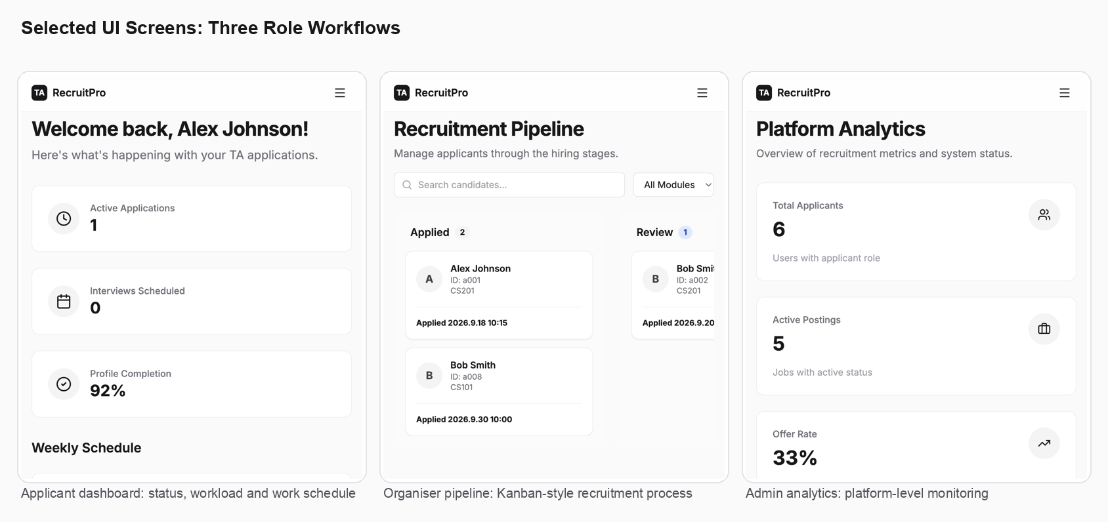
Figure 6. Representative role-specific interfaces for applicant, organiser and administrator workflows.
Important implementation details include: session-based authentication in `AuthFilter`; safe JSON serialization with Gson; server-side permission checks before document deletion and application review; dynamic front-end calls through `static/js/api.js`; reusable JSP layout fragments; and browser-side enhancement for document preview. For example, document preview uses native PDF/image preview and `mammoth.js` for `.docx` conversion, while `.doc` files fall back to a clear download recommendation because legacy binary Word format cannot be reliably rendered in the browser.
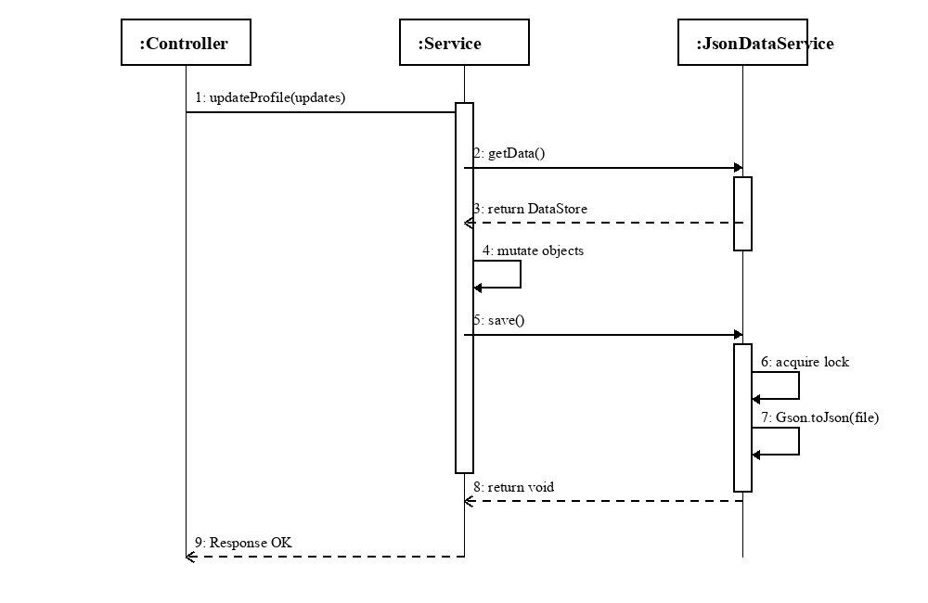
Figure 7. Data persistence mechanism ensuring single source of truth via JsonDataService (UML Sequence Diagram).
The work schedule feature illustrates implementation from requirement to data model. The organiser UI allows quick generation of dates such as “12 weeks every Wednesday”; generated dates are stored in `Job.workDates`; applicants see the schedule in job details; and accepted applicants see work dates on the dashboard. A timezone defect was found and fixed by replacing `toISOString()` formatting with local date construction, demonstrating the importance of real-world edge cases even in simple-looking date logic.
Version control was central to collaboration. The team used Git branches such as `dev` and feature branches, with commits grouped around functional changes or bug fixes. We used pull/fetch regularly to keep local work aligned with the shared branch, and we resolved integration issues by selective merging when a feature branch contained unrelated files. Runtime data files and uploaded documents were treated carefully so that demo data and local test artifacts did not overwrite code changes unintentionally. Commit history also provides traceability from defect reports to fixes, such as profile editing, notification 403 errors, document preview and schedule generation.
The project build plan can be summarised as: establish base architecture and authentication; implement role dashboards; implement core recruitment flows; add admin management and audit support; add communication, document and notification features; then stabilise with bug fixing and demo data. This plan reflects agile values: frequent integration, feedback-driven change, and continuous refinement of user-facing workflows.

Testing
Describe the testing strategy, techniques, test case design, and the test results. Give specific examples.

Testing response
Our testing strategy combined requirements-based testing, role-based end-to-end testing, integration testing through API calls, UI interaction testing and regression testing after bug fixes. We used a V-model style mindset: each user requirement had a corresponding validation activity. For example, the requirement “an applicant cannot apply twice to the same job” was tested by submitting once successfully and submitting again to confirm the server rejects the duplicate. The requirement “organisers can only manage their own jobs” was tested by verifying organiser API access and ownership checks.
Test case design used both positive and negative paths. Positive tests confirmed normal workflows: applicant login, profile update, CV upload, job application, organiser job creation, pipeline movement, interview scheduling, admin user/module management and messaging. Negative tests covered invalid login, missing required job fields, duplicate application, unauthorised role access, invalid document deletion, backward movement in the pipeline, unsupported document preview and invalid data editor operations. This gives stronger evidence than only demonstrating happy paths.
Specific example 1: RBAC and notification bug. A 403 error occurred because a shared layout called `applicantApi.getNotifications()` even when an organiser was logged in. The fix was to select the notification API dynamically according to the session role. The regression test was to log in as applicant and organiser separately, load pages using the shared header, and confirm each role calls its own notification endpoint without a 403.
Specific example 2: document ownership bug. Applicants could not delete their uploaded CV because document IDs were not globally unique enough for the original search logic. The corrected implementation first locates the current user’s profile and then searches documents inside that profile. The test was to upload a document, delete it as the same applicant and confirm success, while ensuring another applicant cannot delete it.
Specific example 3: work schedule date generation. When an organiser selected Wednesday, generated dates appeared as Tuesday because `toISOString()` converted local midnight into UTC. The fix used local date parsing and manual `YYYY-MM-DD` formatting. The test cases included generating 12 weeks from a known Tuesday, Wednesday and Sunday start date and checking that the label and date remain consistent across the browser timezone.
Specific example 4: application detail completeness. Organisers originally saw limited applicant data. We extended `getApplicationDetails` to return email, phone, department, student ID, year, max GPA, skills and experience, then tested that the applicant profile card renders those fields and still hides sensitive fields such as password. This validates both functional completeness and information security.
Testing results show that the major workflows are operational in the demo environment. The final demo data supports applicants, organisers and admin accounts; role dashboards load correctly; job search/filtering works; profile editing persists; applications move through the pipeline; interviews can be scheduled; notifications load according to role; and the admin data editor exposes new fields such as `workDates`, profile documents and experience. Remaining risks are mainly those expected in a course prototype: the JSON-file store is not as robust as a database under high concurrency, browser rendering of legacy `.doc` files is limited, and future work should add automated unit tests and CI checks for services such as status transitions and data validation.

The use of Generative AI (GenAI)
Describe the GenAI tool(s) used at different stages of the software development process. Critically evaluate their effectiveness in supporting development activities and discuss their limitations and challenges.

GenAI response
We used Generative AI as an engineering assistant, not as an unchecked replacement for design judgement. It supported several stages of the software development process: requirement clarification, UI copy refinement, code generation for repetitive JSP/JavaScript structures, debugging, test idea generation, commit-message drafting and report writing. This aligns with a modern software engineering workflow where AI can accelerate iteration while developers remain responsible for correctness, maintainability and ethical use.
During requirements analysis, GenAI helped translate informal stakeholder needs into concrete user stories and acceptance criteria. For example, the vague requirement “MO should know who they are chatting with” became a feature in which clicking a chat avatar opens a role-aware user information card. The requirement “TA should see what information is sent when applying” became a pre-filled application form showing profile details and selected documents before submission. This helped improve requirement testability, a key software engineering quality.
During design and implementation, GenAI was useful for proposing code-level changes across related files. For example, adding work schedules required coordinated updates to the `Job` model, organiser service, job creation UI, applicant job detail page and dashboard display. AI assistance reduced the mechanical cost of tracing these dependencies. It also helped identify common web pitfalls, such as using local date formatting instead of UTC `toISOString()` for schedule generation.
During debugging, GenAI was most effective when combined with runtime evidence. Error messages such as JSP compilation failures, HTTP 403 responses and Tomcat logs were used as evidence, and fixes were applied only after checking the relevant source files. This prevented blind changes. Examples include fixing `layout-bottom.jsp` after discovering that JSP include scope did not expose `userRole`, and fixing organiser/applicant notification calls based on the actual endpoint and RBAC behaviour.
The limitations were also clear. GenAI can hallucinate APIs, assume unavailable libraries, or suggest a fix that works in theory but not in the local environment. For instance, Office Online Viewer was not suitable for previewing local `localhost` documents, so the design was revised to use browser-side `.docx` conversion with `mammoth.js` and a clear fallback for `.doc`. AI outputs also required careful review to avoid over-engineering, preserve existing project style and prevent unrelated changes from entering commits.
Our critical evaluation is that GenAI was valuable for speed, breadth and explanation, but its effectiveness depended on disciplined software engineering practices: reading the existing code, making small changes, compiling, testing manually, checking Git status, and preserving separation of concerns. Used in this way, GenAI improved productivity and helped us articulate design rationale, but final accountability remained with the team.
To here - No more than 10 pages including tables, charts, figures and diagrams you may have.

Individual contribution and reflection
Each group member should provide one paragraph outlining their key contribution to the project (this must be agreed by the group) and another paragraph reflecting on their learning experience (this should include thoughts on the overall process, challenges encountered, and skills developed). Maximum 300 words for each member. Copy the template below.
QM no:
Name:

Draft individual contribution and reflection text
Note: exact QM numbers and legal names should be filled in by the group before submission. The following paragraphs are drafted from the project evidence and Git history, and can be assigned to the relevant members.
Member 1 – Backend architecture and persistence
QM no: [to be filled]
Name: [to be filled]
Main contribution: I contributed mainly to the backend architecture, data model and persistence layer. I helped design the role-based API structure for applicants, organisers and administrators, implemented service-layer logic for profiles, job applications, recruitment pipeline operations and JSON persistence, and fixed defects related to document ownership, notification permissions and work schedule date generation. I also supported Git integration by keeping the `dev` branch updated and resolving conflicts safely.
Reflective statement: This project helped me understand that software engineering is not only about writing features, but about designing changeable systems. The biggest challenge was coordinating many related components when one requirement changed, such as adding work schedules across the model, service and UI. I improved my skills in debugging with logs, tracing data flow, managing Git branches, and thinking about maintainability, security and testability before coding.
Member 2 – Applicant experience and profile workflow
QM no: [to be filled]
Name: [to be filled]
Main contribution: I focused on the applicant-facing workflow, including job browsing, application submission, profile editing, CV/document management, application status tracking and dashboard presentation. I helped ensure applicants can see the information submitted to organisers, update academic details, skills and experience, and view work schedules clearly before and after receiving offers.
Reflective statement: I learned the importance of user-centred design in software engineering. A feature is not complete just because the API works; users need clear feedback, editable forms and predictable error handling. I developed stronger front-end integration skills and became more aware of edge cases, such as duplicate applications, missing profile data and unsupported document formats.
Member 3 – Organiser workflow and recruitment pipeline
QM no: [to be filled]
Name: [to be filled]
Main contribution: I contributed to organiser features, especially job posting, module-based job ownership, application review, candidate detail pages, document preview and interview scheduling. I helped build a workflow where organisers can manage applications through a pipeline, inspect full applicant information, set work dates and make recruitment decisions with better visibility.
Reflective statement: This project taught me how business rules shape implementation. The organiser pipeline required careful control of valid status transitions, ownership checks and UI feedback. I learned to connect domain requirements with system states and to design interfaces that reduce administrative workload while preserving process integrity.
Member 4 – Admin management, data editor and workload monitoring
QM no: [to be filled]
Name: [to be filled]
Main contribution: I worked on administration features such as global user/module management, data editor schemas, workload monitoring, logs, terms and department configuration. I also helped improve the data editor so newly added fields such as `workDates`, profile documents and experience remain visible and editable for admin users.
Reflective statement: I gained a deeper appreciation of maintainability and operational support. Admin tools are easy to overlook, but they are essential for diagnosing issues and maintaining data quality. I learned how cascade impacts, audit logs and validation rules help protect a system after deployment, not only during development.
Member 5 – Messaging, notifications and UI integration
QM no: [to be filled]
Name: [to be filled]
Main contribution: I contributed to cross-cutting communication features, including the messaging interface, unique contact list behaviour, avatar-based user detail cards and role-aware notifications. I helped integrate shared layout components so applicants and organisers receive relevant feedback without duplicating code across pages.
Reflective statement: I learned that shared components create both benefits and risks. Reusing a header or message component saves effort, but role-specific behaviour must be handled carefully, as seen in the notification API bug. The project improved my understanding of modular UI design, regression testing and the need to test shared code under every user role.
Member 6 – Testing, demo preparation and quality assurance
QM no: [to be filled]
Name: [to be filled]
Main contribution: I supported testing, demo preparation and quality assurance. I helped prepare realistic demo data, validate end-to-end scenarios for the three roles, document expected behaviours, and check that fixes did not break existing workflows. I also contributed to improving error messages and presentation quality for the final demonstration.
Reflective statement: This project showed me the value of systematic testing and communication within a team. Many defects only appeared when running full user journeys, not when inspecting one file. I developed better skills in designing test cases, reproducing bugs, recording evidence and explaining technical decisions clearly to both developers and users.
Main contribution:
Reflective statement:

