Interrupts Tutorial Exercise

It is advised that when you attempt this exercise either during in-class or in tutorial, please work in groups.

Question 1
The table below shows the Initial State of registers:

Register | Value |  | Register |  | Value | Register/State | Value
R0 | 10 |  | R8 |  | 18 | xPSR | 0x0100_0000
R1 | 11 |  | R9 |  | 19 | MSP | 0x2000_0FF4
R2 | 12 |  | R10 |  | 20 | PSP | n/a
R3 | 13 |  | R11 |  | 21 | PRIMASK | 0x0000_0000
R4 | 14 |  | R12 |  | 22
R5 | 15 |  | R13 (SP) |  | 0x2000_0FF4 | Mode | Thread
R6 | 16 |  | R14 (LR) |  | 0x1000_0000 | Privilege | Privileged
R7 | 17 |  | R15 (PC) |  | 0x0000_0220 | Stack | Main
Exception No. |  | Value
12 |  | 0x0000_1441
13 |  | 0x0000_1211
14 |  | 0x0000_1335
15 |  | 0x0000_1669
16 |  | 0x0000_120D
17 |  | 0x0000_1129
18 |  | 0x0000_1351
19 |  | 0x0000_1539
20 |  | 0x0000_1285
21 |  | 0x0000_183D
22 |  | 0x0000_1849
23 |  | 0x0000_1661

The CPU then responds to an IRQ2 exception request.

Write down the values for the registers, after responding to exception request and before executing the first instruction exception handler:

Register | Value | Register | Value | Register/State | Value
R0 |  | R8 |  | xPSR
R1 |  | R9 |  | MSP
R2 |  | R10 |  | PSP
R3 |  | R11 |  | PRIMASK
R4 |  | R12
R5 |  | R13 (SP) |  | Mode
R6 |  | R14 (LR) |  | Privilege
R7 |  | R15 (PC) |  | Stack

Also write down the addresses and contents of the stack area.

Address | Value | Description

Question 2

What is the return address will an exception handler return to, given the following register and memory contents? Write and explain your logic behind your deduction.
Assume the instruction for exiting the exception handler is POP {R4,PC}.

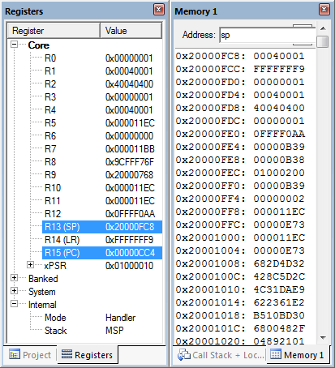

Question 3

Consider a system built on a 48 MHz processor with a main loop and an interrupt which occurs at a 10 kHz frequency. Assume the ISR take 14.9 us to execute and there is a total of 1 us of response and return time overhead.

(a) What percentage of the processor’s time is spent in the ISR and the overhead?

(b) What percentage of the processor’s time is left for the main loop to execute?

(c) If the main loop requires 37 ms of computation to execute one iteration, what is the maximum main loop update rate (in Hz)?

Consider the system above again, but now with the interrupt running at 25 kHz and the ISR taking 34 us to execute.

(d) What percentage of the processor’s time is spent in the ISR and the overhead?

(e) What percentage of the processor’s time is left for the main loop to execute?

(f) If the main loop requires 37 ms of computation to execute one iteration, what is the maximum main loop update rate (in Hz)?

- End of Tutorial Exercise

