ReinGuide
Designing A Haptic Communication Channel Through Digital Reins for A Non-Verbal Rider in Equine Therapy, An Exploratory Case Study

――――――――――――――――――――

Lupita Vásquez-Fabela
MFA Design & Technology
Parsons School of Design

Thesis Document
2026

Abstract
ReinGuide is a haptic communication system designed to bridge the gap between spoken instruction and tactile experience in therapeutic horseback riding. Composed of sensor-embedded rein grips and a wireless controller, ReinGuide enables lesson assistants to deliver precise directional vibrotactile cues directly into a non-verbal autistic rider's hands during equine therapy sessions. Rather than introducing a new communication modality from outside the riding context, ReinGuide digitally augments a channel that already exists in horsemanship: the proprioceptive feedback loop of the reins.
This thesis documents the full design and prototyping process for ReinGuide, situating the project within the disciplines of haptic assistive technology, equine therapy, autism spectrum research, and participatory design. The work centers on a single-participant naturalistic case study: Mariana (a pseudonym), a seven-year-old non-verbal autistic rider at GallopNYC whose therapeutic sessions were frequently interrupted when her horse stopped moving and she lost the rhythmic sensory input she depended on. The design process included direct ethnographic field observation, informal testing of sensory interventions, expert consultation with Mariana's mother and GallopNYC instructors, iterative hardware prototyping, and the development of a companion web-based training application and Unity riding game.
The thesis argues that designing for a single, specific, extreme user—in obsessive, case-study-level detail—does not limit the generalizability of the design outcome; it deepens it. ReinGuide's haptic vocabulary, hardware form, and pedagogical software have potential applications for ADHD riders, beginners, and other neurodivergent populations. The project represents the founding product of BIG FROOTS, a design studio focused on assistive and therapeutic technology, and lays groundwork for future clinical validation partnerships with occupational therapists and PATH-certified equine therapy centers.

Table of Contents
Chapter I — Introduction
1.1 Concept Statement
1.2 Impetus
1.3 Significance: Why It Matters

Chapter II — Context
2.1 Situating the Thesis: Discipline Areas
2.1.1 Horse Riding, Proprioception, and Touch
2.1.2 English Riding and Rein Use
2.1.3 Therapeutic Horseback Riding at GallopNYC
2.1.4 Non-Verbal Autism and Sensory Processing
2.1.5 Haptic Feedback and Assistive Technology
2.2 Precedent Projects

Chapter III — Methodology
3.1 Scope of the Thesis Project
3.2 Form: Approach to Experience Design
3.3 Form: Making — Hardware Design
3.4 Form: Making — Software Design
3.5 Form: Iterative Prototyping Decision Points
3.6 Form: Testing — Impact on Design

Chapter IV — Evaluation
4.1 The Case Study: Mariana
4.2 Reflection on the Status of the Project
4.3 Reflection on Learning
4.4 Future Prospects

References
Appendices

CHAPTER I
Introduction

1.1 Concept Statement
In a therapeutic horseback riding arena, communication between instructor and rider is almost entirely spoken. The instructor calls out “forward,” “left,” “right,” “whoa”—and the rider responds, body adjusting, reins shifting, weight redistributing across the saddle. For most riders, this verbal-to-physical translation happens quickly, almost automatically. For a non-verbal autistic child, it may not happen at the same speed, or it might not happen at all.
ReinGuide is a haptic communication system—consisting of sensor-embedded rein grips and a wireless controller—that allows lesson assistants to deliver tactile directional cues directly into a non-verbal autistic rider's hands during therapeutic horseback riding sessions. By digitally augmenting the reins’ existing proprioceptive communication channel, ReinGuide enables a child who cannot rely on verbal instruction to participate fully in equine therapy: staying in the saddle, following cues, and progressing therapeutically session after session.
The system is not an interruption of the existing lesson structure—it is an amplification of it. The reins are already the primary physical communication channel between rider and horse. ReinGuide makes that channel legible to a rider whose nervous system learns best through structured, predictable tactile input. The result is not a workaround or an accommodation: it is a redesign of the communication interface itself.
The five haptic commands—Forward, Left, Right, Stop/Whoa Back, and Heartbeat Mode—were derived directly from existing verbal cues and English riding conventions. They are a translation, not an invention. And like any language, they require learning: by the rider, by the assistant, by the instructor, and potentially by the horse. ReinGuide includes two software environments—a web-based Equestrian Arena Trainer and a Unity riding game set in Central Park—specifically designed to teach that language before anyone enters the arena.
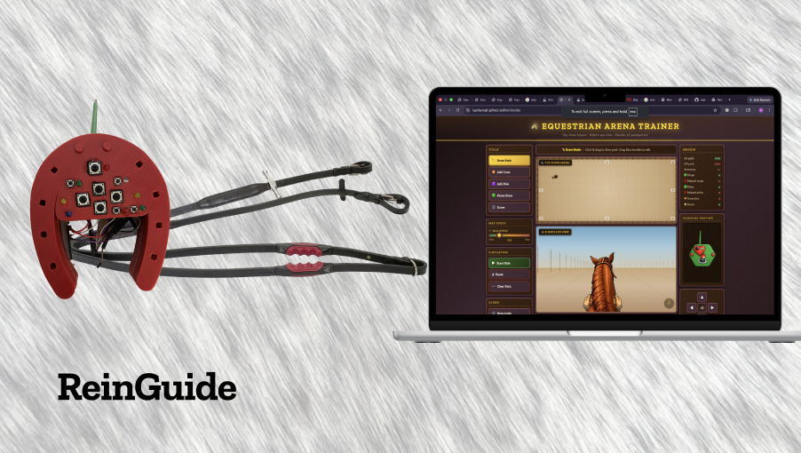

1.2 Impetus
The design origin of ReinGuide is not an abstract design brief or a studio prompt. It is a specific afternoon at GallopNYC, a PATH-certified therapeutic horseback riding center in New York City, where the author was volunteering as a side-walker, or lesson assistant.
Mariana—a seven-year-old non-verbal autistic girl whose name has been changed to protect her privacy—was having a riding lesson. The lesson was going well: she was seated correctly, her body responding to the horse's rhythm, her face calm. Then the horse stopped. And Mariana, who had been grounded and present just seconds before, began to destabilize—shifting her weight, reaching for her side-walkers, beginning the behavioral escalation that her instructors recognized as the precursor to a dismount attempt. The session ended early.
This happened again. And again. The pattern was clear: the horse's rhythmic, multidimensional movement was itself a regulatory input for Mariana. When it stopped, the sensory signal she had been relying on vanished, and the resulting disorientation—not the horse's behavior, not any external danger—was what ended her sessions.
A first informal experiment: clay foam. A small piece was placed in Mariana's hand during a stop. It worked—she stayed in the saddle. But it worked “too well”. Absorbed in squeezing the foam, she stopped tracking the lesson. Regulation had been achieved; engagement had been sacrificed. The intervention was a distraction, not the most effective tool.
The crucial conversation came with Mariana's mother, after a session. She described Mariana's morning sensory routine: a specific sequence of brushing motions, with a specific type of brush, at a specific intensity, before every school day. The brushing did not distract Mariana from the day ahead. It prepared her for it. The tactile input was organizational, not distracting—because it was structured, predictable, and integrated into a purposeful sequence.
That conversation reframed everything. The design question was not: how do we give Mariana something to hold during stops? It was: how do we give her hands a purposeful, predictable, task-integrated tactile signal that keeps her oriented within the lesson rather than withdrawing from it?
The answer was already in her hands. The reins.

1.3 Significance: Why It Matters
ReinGuide addresses a specific gap in assistive technology for a specific population in a specific therapeutic context. But the specificity of its origins does not limit the significance of its implications.

For Riders Like Mariana
Equine therapy delivers documented therapeutic benefits—improved balance, motor coordination, emotional regulation, and social engagement—but only when the rider can remain engaged in a session. Current therapeutic riding instruction relies almost entirely on spoken language to communicate with riders. For non-verbal riders, this means the primary channel of instruction is simply unavailable. The lesson continues around them, but not with them.
ReinGuide proposes that this is not a limitation of the rider—it is a limitation of the communication design. By creating a haptic interface that operates within the rider's existing sensory strengths rather than around her deficits, ReinGuide enables genuine participation rather than supervised proximity.

For the Field of Equine Therapy
Approximately 900 PATH-certified equine therapy centers in the United States serve over 66,000 individuals annually. The population includes children and adults with autism spectrum disorder, cerebral palsy, Down syndrome, traumatic brain injury, ADHD, PTSD, and a range of other conditions affecting communication and sensory processing. Of these, a significant proportion are non-verbal or minimally verbal.
Despite the size and growth of this field, haptic-first communication systems designed specifically for the equine therapy context do not currently exist. ReinGuide fills that gap.

For Families and the Economics of Therapy
Therapeutic horseback riding sessions typically cost between $100 and $200 each. Insurance coverage is inconsistent and often incomplete. For a family investing in equine therapy for a non-verbal autistic child, a session that ends after eight minutes represents not just a therapeutic setback but a significant financial loss—and a source of emotional difficulty for the child, the family, and the therapeutic team.
A system that extends session duration and enables greater therapeutic progress per session has direct economic as well as clinical value. The design case for ReinGuide is not only humanitarian; it is practical.

For Design Practice
This project demonstrates a methodology: designing obsessively for one user—in extreme, specific, contextually embedded detail—as a strategy for generating tools with broader generalizability. Mariana is the extreme user. Her needs are sharp, specific, and non-negotiable. A system that works for her will, by the discipline required in its creation, work for a wider range of riders: beginners who cannot yet process verbal cues in motion, ADHD riders who need a consistent sensory anchor, older adults relearning riding coordination after neurological injury.
The thesis frames this as a naturalistic, single-participant case study following the methodological traditions established by Stake (1995) and elaborated by Greenhalgh (2025). The goal is not statistical generalization but what Stake calls “naturalistic generalization”—the kind of rich, contextual design knowledge that practitioners can recognize, adapt, and apply to new situations.

CHAPTER II
Context

2.1 Situating the Thesis: Discipline Areas
ReinGuide sits at the intersection of five distinct disciplinary areas, each of which contributed essential knowledge to the design. This section maps those areas—not as a literature review in the traditional academic sense, but as an account of the intellectual terrain that shaped every design decision in the project.

2.1.1 Horse Riding, Proprioception, and Touch
Proprioception is often described as the “sixth sense”: the continuous, largely unconscious awareness of one's own body position, movement, and orientation in space. Unlike the five classical senses, proprioception does not depend on external stimuli—it arises from receptors within muscles, tendons, and joints that communicate the body's state to the nervous system in real time.
In horseback riding, proprioception is not a background condition—it is the primary medium of communication. The reins function as a proprioceptive channel between rider and horse: a loop of tactile feedback through which the rider conveys intention (forward, stop, left, right) and through which the horse's responses return as physical sensation. This is why experienced riders are sometimes described as having “soft hands”—not because they grip lightly, but because they maintain a continuous, nuanced conversation through contact rather than force (Jones, 2020).
The astonishing corollary of this, described by Jones in Horse Brain, Human Brain, is that a sufficiently skilled rider can steer a horse without reins at all. The horse reads the rider's body language—weight distribution, hip orientation, leg pressure—as a proprioceptive signal. Verbal commands, in this context, are supplementary. The body is the primary text.
This is significant for the design of ReinGuide in two ways. First, it confirms that the reins are already a haptic communication channel—one with thousands of years of refinement. ReinGuide does not introduce haptic communication to equine therapy; it makes an existing haptic channel legible to a rider who learns best through structured touch. Second, it establishes that proprioception is not a specialized accommodation for riders with disabilities—it is the fundamental medium of riding. Designing for proprioceptive clarity is designing for the essence of horsemanship itself.
Touch is also central to equine neuroscience. Horses are prey animals, and their nervous systems are calibrated for exquisite sensitivity to tactile input—a sensitivity that serves both their survival instincts and their capacity to bond with and respond to human partners. A horse can detect the landing of a fly on its skin. This is both a strength (the horse is highly responsive to subtle rider cues) and a safety consideration (the horse's response to unexpected tactile stimuli must be carefully managed during the introduction of any new haptic device into the riding environment).

2.1.2 English Riding and Rein Use
ReinGuide was designed specifically for the English riding tradition, the discipline practiced at GallopNYC and at the majority of therapeutic riding centers in the northeastern United States. English riding has its own conventions for rein use, hand position, and the application of aids—the term used in horsemanship for the signals a rider gives to the horse.
In English riding, the reins are held with a relatively upright hand position, thumbs on top, and the rein runs from the horse's bit, through the rider's hand, to a contact point maintained by the rider's fingers. The communication is through degrees of pressure and release: a closing of the fingers creates contact; a softening creates release. Lateral rein pressure (drawing one rein slightly toward the hip) indicates direction. Both reins drawn simultaneously with a cessation of forward driving aids signals the halt.
This is distinct from Western riding, in which the reins are typically held in one hand, looser, and direction is communicated through neck reining—the rein contacting the side of the horse's neck rather than applying lateral pressure to the bit. The rein conventions of Western riding would produce a different haptic vocabulary and would require a different hardware design.
The design implication is clear: rein language is not universal. It is culturally and discipline-specific, acquired through training and practice. This means that the haptic vocabulary of ReinGuide—which translates English riding cues into vibrotactile patterns—must also be learned. It is not intuitive in the sense of being immediately obvious; it is intuitive in the sense of being consistent, learnable, and grounded in a logic the rider's body can internalize. This is precisely why the simulator software was not an afterthought in the ReinGuide system—it is the onboarding environment in which the haptic language is taught.

2.1.3 Therapeutic Horseback Riding at GallopNYC
Therapeutic horseback riding (THR) is skill-based riding instruction adapted for individuals with physical, cognitive, or emotional disabilities. The goal is to teach riding as a functional skill, with therapeutic benefits emerging as a consequence of the riding itself—balance, coordination, emotional regulation, and social engagement with the horse and the therapeutic team. Riders are learning to ride; they are active participants in the lesson, not passive recipients of the horse's movement.
GallopNYC is a PATH International–certified therapeutic riding center in New York City. Its sessions follow a structured format: the rider mounts with assistance, is guided through a warm-up, and then practices riding skills—walking, steering, stopping, navigating poles and cones—under the instruction of a certified riding instructor, with lesson assistants and side-walkers providing support on the ground. The instructor communicates primarily through verbal cues. The problem that ReinGuide addresses—the inaccessibility of verbal instruction to non-verbal riders—is embedded in the fundamental structure of therapeutic horse riding as a practice.
It is worth noting that the horse's movement itself carries regulatory value: the rhythmic stimulation of the vestibular and proprioceptive systems during riding engages neural pathways involved in balance, spatial orientation, and sensory integration. When the horse stops moving, these inputs cease. For a rider whose nervous system is calibrated to find that movement organizing, the cessation is not a neutral event—it is a sensory loss. This observation is the foundational premise of ReinGuide's Heartbeat Mode.

2.1.4 Non-Verbal Autism and Sensory Processing
Autism spectrum disorder (ASD) is a neurodevelopmental condition characterized by variation in social communication, sensory processing, and behavioral patterns. “Non-verbal autism” refers to the subset of the autism spectrum in which an individual has not developed functional speech as a primary communication modality—a category that encompasses a wide range of communicative capacities and profiles.
In a therapeutic riding context, non-verbal autism presents several design challenges. First, the primary channel of instruction—spoken language—is unavailable or unreliable. The rider may understand some verbal cues, particularly familiar phrases delivered in a familiar voice and context, but may not be able to process spoken instruction in real time during a high-stimulation activity. Second, sensory sensitivities—which are prevalent but highly variable among autistic individuals—may make certain aspects of the riding environment particularly activating: the sounds of the barn, the smells, the unpredictable movement of the horse, the presence of multiple adults speaking simultaneously.
Mariana's profile, as understood through observation and her mother's account, includes both sensory-seeking and sensory-sensitive characteristics. She appears to find the horse's rhythmic movement deeply regulating—a sensory-seeking response to proprioceptive input. She responds with distress when that input is abruptly removed, as when the horse stops. And she responds positively to structured, predictable tactile input—as evidenced by the efficacy of her mother's morning sensory brush routine.
The occupational therapy literature on sensory processing disorder (SPD) and autism documents this pattern well. Structured, predictable deep pressure and haptic input—the type delivered through brushing protocols, weighted blankets, and compression garments—is consistently associated with calming, organizing effects on the nervous systems of many autistic children (Ayres, 1972; Miller et al., 2007). The key word is “structured”: unpredictable or overwhelming sensory input tends to dysregulate; predictable, moderate sensory input tends to organize.
This is the theoretical foundation for ReinGuide's Heartbeat Mode—the haptic pattern that activates during horse stops. Rather than offering Mariana silence (sensory void) or a distraction (clay foam), ReinGuide offers a steady, predictable rhythm: a pulse that her nervous system can anchor to while waiting for the lesson to resume. The heartbeat metaphor is not decorative—it is chosen because it evokes the most universal, steady, involuntary rhythm the human body knows.

2.1.5 Haptic Feedback and Assistive Technology
Haptic feedback—the use of tactile and force sensations to communicate information—has been an area of growing interest in both human-computer interaction (HCI) research and assistive technology design over the past two decades. The range of applications includes vibrotactile vests that convert audio input to skin sensation for deaf users, haptic navigation devices that guide visually impaired users through spatial environments, and tactile augmentative and alternative communication (AAC) tools for individuals with complex communication needs.
Within the AAC category, several relevant precedents exist. BrailleTouch and related projects have explored how tactile systems can encode linguistic information for users with visual and communication disabilities. Vibrotactile language learning systems have been developed for sign language interpretation and for communicating phonemic information to deaf users. Research into haptic feedback in educational gaming has demonstrated that tactile cues can enhance learning and engagement for children with ADHD and autism.
What distinguishes ReinGuide from existing haptic assistive devices is the specificity of its context and the integration of its delivery mechanism. Most haptic devices are worn on the body—as gloves, vests, wristbands, or earpads—and require the user to translate haptic signals into some other form of action. ReinGuide delivers haptic cues through an object—the rein grip—that the rider is already holding and already using functionally. The haptic channel is not added on top of the riding context; it is embedded within it.
This design distinction matters practically: a child who is already overwhelmed by the sensory complexity of a riding session does not need an additional wearable device to attend to. She needs her existing sensory environment to be more legible—for the thing already in her hands to speak to her more clearly. That is what ReinGuide proposes.

2.2 Precedent Projects
The design precedent landscape for ReinGuide spans three domains: augmentative and alternative communication (AAC), wearable haptic assistive devices, and gamified therapeutic training tools. Understanding where ReinGuide departs from each of these domains is as important as understanding where it draws from them.
In the AAC domain, the dominant paradigm is symbol-based communication: speech-generating devices, picture exchange communication systems (PECS), and tablet-based applications like Proloquo2Go allow non-verbal users to express themselves by selecting symbols or generating synthesized speech. These tools are powerful, but they are designed for expressive communication—for the user to speak. ReinGuide is designed for receptive communication: for the user to receive and act on instruction. It is not an AAC device in the traditional sense, though it shares AAC's commitment to accessibility and multimodal communication.
In the wearable haptic domain, devices like HapticWorks (a haptic bracelet for blind people to navigate digital maps), the Neosensory Buzz (a wrist-worn vibrotactile device for translating audio to touch for deaf users), and research prototypes exploring haptic navigation for visually impaired users demonstrate the breadth of vibrotactile technology. None of these devices, however, is designed for the equine therapy context, and none integrates the haptic delivery mechanism with the primary functional object of the activity.
The gamified therapeutic training space offers perhaps the closest formal precedents. Therapeutic VR applications for autism—such as JeStER (Joint Engagement in Social Training using Extended Reality) (https://pmc.ncbi.nlm.nih.gov/articles/PMC11306495/) and various proprioceptive training games used in occupational therapy settings—demonstrate that game mechanics can motivate and scaffold learning in neurodivergent users. ReinGuide's Unity riding game draws on this tradition, using game mechanics not for entertainment alone but as a deliberate pedagogical environment for learning the haptic vocabulary that the physical system delivers.
What ReinGuide is: a functional communication system, not a sensory toy. Not a replacement for verbal instruction, but a parallel channel that operates independently of the user's ability to process spoken language. Not an add-on to the existing riding environment, but an augmentation of the rein itself—the channel that was already there.

CHAPTER III
Methodology

3.1 Scope of the Thesis Project
ReinGuide is a two-component assistive system—hardware and software—designed to augment the rein as a communication channel during therapeutic horseback riding. The thesis project encompasses both components in their current state of development: functional prototypes that demonstrate the system's viability and architecture, and that establish the foundation for future clinical validation and iterative refinement.
The hardware component consists of two elements: a wireless joystick controller designed to be operated one-handed by the lesson assistant standing at the edge of the arena, and a pair of rein grips that clip onto any standard English rein without modification. The grips contain vibrating motors that deliver vibrotactile patterns to the rider's hands according to commands transmitted from the controller via ESP-NOW wireless protocol.
The software component consists of two elements: the Equestrian Arena Trainer, a web-based application that allows riders, instructors, and lesson assistants to learn the ReinGuide haptic command vocabulary before entering the arena; and a Unity-based riding game set in a Central Park environment that provides a more immersive, gamified context for haptic vocabulary learning.
Together, the hardware and software components constitute a system—not a collection of separate tools. The controller that sends haptic commands to the rein grips during a live session is the same controller that connects to the Arena Trainer during simulator-based onboarding. The haptic patterns that vibrate in the rider's hands during a lesson are the same patterns she practiced in the Unity game. The learning is continuous; the transitions between simulation and reality are deliberately smooth.
The thesis project also includes a deployment protocol: a step-by-step procedure for introducing ReinGuide into a real therapeutic session. This protocol encompasses horse acclimation (the process by which an experienced rider introduces the vibrating grips to the horse before any child uses them), simulator-based onboarding (in which the rider, assistant, and instructor practice together using the Arena Trainer), and live session use (in which the assistant operates the controller in real time while the rider rides with the haptic grips).

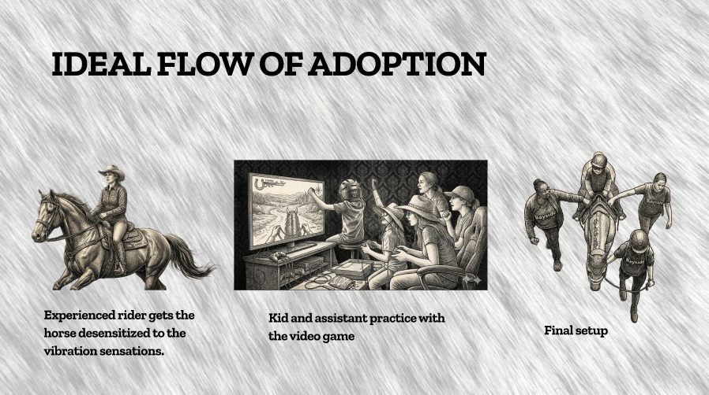
What the thesis project does not include, at the time of writing, is a completed live deployment with Mariana in a real session, formal usability studies, or clinical validation of therapeutic outcomes. These are clearly identified as next-phase work, and the thesis is honest about the gap between design intent and tested outcome—a gap that is not a failure of the project but a characteristic of responsible thesis-stage design research.

3.2 Form: Approach to Experience Design
The design philosophy of ReinGuide rests on four principles that together constitute an approach to experience design for neurodiverse users in therapeutic contexts.
The first principle is respect for the user's sensory profile. Mariana's nervous system is not deficient—it is calibrated differently. Designing for her means designing with her sensory profile, not against it. The haptic patterns of ReinGuide are calibrated to be detectable without being overwhelming; the sensory materials of the rein grips are chosen to be engaging without being absorbing; the Heartbeat Mode exploits her existing comfort with rhythmic input rather than introducing a novel sensory demand.
The second principle is ecology preservation. ReinGuide works within the existing structure of a therapeutic riding session rather than disrupting it. The lesson assistant already walks alongside the horse; ReinGuide gives her a controller. The rider already holds the reins; ReinGuide gives those reins a voice. The instructor already calls out cues; ReinGuide translates those cues into a channel the rider can receive. Nothing is replaced. Everything is augmented.
The third principle is the extreme-user hypothesis. This project was designed for Mariana specifically—not for a general population of non-verbal autistic riders, not for a theoretical average user. The bet underlying this decision is that designing for the most specific, most demanding, most constrained version of the user will produce a more robust and more generalizable system than designing for a blurred composite. Mariana's specificity is not a constraint; it is a creative resource.
The fourth principle is haptic vocabulary as learned language. The five command patterns of ReinGuide—Forward, Left, Right, Stop/Whoa Back, and Heartbeat Mode—are not self-explanatory. They must be learned. This is true of all riding aids, all sign languages, all musical notations. The design implication is that the system is incomplete without its pedagogical infrastructure: the simulator software is not a nice-to-have but an architectural component of the communication system. A haptic vocabulary without an onboarding environment is a language without a grammar course.
The haptic command vocabulary was derived by working backward from existing spoken cues and English riding conventions. “Forward” or “Up” (or “tap tap”) becomes a two-pulse pattern delivered to both grips simultaneously—the rhythm of two quick taps suggesting acceleration. “Left” becomes a continuous pulse delivered to the left grip for as long as we keep the left button pressed; “Right” does the same, but for the right rein. “Halt” or “Down” (or “whoa back”) becomes two sustained pulses to both grips, a long pulse followed by a shorter pulse—firm, clear, final. And Heartbeat Mode repeats the “halt” or “whoa back” pattern every two seconds, to provide rhythmic stimulation while both the kid and the horse remember they should be still.

3.3 Form: Making — Hardware Design

3.3.1 The Rein Grips
The rein grips are the rider-facing component of ReinGuide—the element that makes contact with the user's body and delivers the haptic commands. Their design reflects both functional and sensory requirements: they must communicate clearly, they must not distract, they must not require any modification to the existing rein or saddle, and they must be comfortable to hold for the duration of a thirty-to-sixty-minute riding session.
The grips clip onto any standard English rein using an adjustable mounting mechanism that does not damage or alter the rein. This was a non-negotiable design constraint: GallopNYC's horses and equipment are shared across multiple riders and sessions, and any system that required permanent modification would be impractical for the center's operations.
The grip surface is made of a soft, gummy material—chosen through the iterative observation process described in section 3.5. The material engages the tactile sensitivity of the rider's palm without absorbing her attention the way that foam clay did. It is pleasant without being distracting; its purpose is to keep the rider's hands in contact with the grips reliably, ensuring that the vibrotactile patterns are always delivered to the same location.
Each grip contains a linear resonant actuator (LRA), a specific subset of vibrating motors, positioned to deliver vibration through the grip surface to the center of the rider's palm. LRAs were chosen over eccentric rotating mass (ERM) motors for their greater precision in frequency and amplitude control, their faster response time, and their ability to produce clearly distinguishable patterns. The actuator placement was validated through informal testing on the design team before any hardware was assembled.
The electronics within each pair of grips include a microcontroller (ESP32), the LRA driver circuit, and a small rechargeable battery sufficient for multiple sessions between charges. The grip communicates wirelessly with the controller via ESP-NOW protocol over the 2.4 GHz band—a protocol chosen for its low latency and freedom from WiFi infrastructure dependency (see section 3.5 for the iterative decision history).
A movable grip element helps the rider maintain correct hand position—a functional benefit that emerged as a secondary feature of the form factor. Correct hand position is a goal of English riding instruction for all riders; a grip that guides the hand toward correct positioning has value beyond the haptic communication function.
A planned future iteration includes a hand warming element—a gentle, low-level heat source that activates during horse stops alongside the Heartbeat Mode vibration. The warmth is intended to provide an additional sensory anchor during pauses, drawing on the calming associations of warmth as a regulatory input. This feature was not included in the current prototype due to component availability and development timeline constraints.

3.3.2 The Controller
The controller is the lesson-assistant-facing component of ReinGuide: the device through which the assistant translates the instructor's verbal cues into haptic signals delivered to the rider's hands. Its design requirements were shaped by the physical and operational context of a therapeutic riding session: the assistant is walking alongside a moving horse, her attention divided between the rider, the horse, the instructor, and the environment. The controller must be operable with one hand, without looking at it, without breaking stride.
The form factor is a wireless controller—a compact, palm-sized device with a set of primary directional buttons (arrow-keys), and a small number of additional buttons and LEDs for data gathering and management of other functionalities, like the Heartbeat Mode or LED indicators on each side to signal when each rein has been activated. The arrow-keys map directly to the four directional commands (Forward, Left, Right, Halt), and a dedicated button activates Heartbeat Mode. The mapping is designed to be intuitive for the assistant after a brief training session.
LED indicators on the controller provide confirmation feedback: when a command is transmitted, the corresponding LED lights briefly, confirming that the signal has been sent and acknowledged by the grips. This is critical for the assistant's situational awareness—she needs to know that her command is reaching the rider without turning around to check.
The controller communicates with the grips via ESP-NOW, the same wireless protocol used within the grips. The range of ESP-NOW (approximately 200 meters in open air conditions) is more than sufficient for a standard therapeutic riding arena. The protocol requires no WiFi network, no Bluetooth pairing process, and no phone or tablet as an intermediary—an important practical advantage in outdoor arenas where network connectivity cannot be assumed.
The controller is powered by a rechargeable battery with sufficient capacity for multiple sessions. The enclosure was designed for durability in an outdoor barn environment: dust-resistant, lightly splash-resistant, and sturdy enough to survive the inevitable dropped-on-dirt incidents of an active therapeutic program.

3.3.3 System Diagram and Signal Pattern Specifications
The ReinGuide system architecture follows a clear signal path: Controller → ESP-NOW wireless transmission → Rein grips → LRA vibration motors → Rider's hands. The controller also interfaces with the Equestrian Arena Trainer via USB or Bluetooth, allowing the same joystick hardware to be used in simulator-based training sessions before live arena deployment.
The five haptic signal patterns are specified as follows:
- Left: Left-grip LRA only. Continuous pulse.
- Right: Right-grip LRA only. Continuous pulse
- Down/Halt/Whoa Back: Both grips simultaneously. One sustained pulse followed by a short pulse.
- Up/Forward: Both grips simultaneously. Two pulses, one followed by the other.
- Heartbeat Mode: Both grips simultaneously. Double-pulse halt or whoa back pattern every two seconds.
The 150 Hz frequency for directional commands was selected as a strong, clearly perceptible vibration frequency that remains distinguishable from ambient tactile noise (the horse's footfalls, the gait vibration transmitted through the reins). Heartbeat Mode produces a repetitive signal to continue staying still.
HapticWorks claims it is 250 Hz.

YES/NO Observation Buttons
The controller includes two dedicated observation buttons: YES (paired with a green LED) and NO (paired with a red LED). These are not command inputs—they are data capture inputs. After every directional command is issued, both LEDs illuminate simultaneously, prompting the lesson assistant to register, in real time, whether Mariana followed the command. Pressing YES or NO logs the response and resets the system for the next command.
Every event—session start, directional command, and YES/NO response—is timestamped and written automatically to a Google Sheet. The result is a structured, session-by-session behavioral record with the granularity of individual command-response pairs.
A representative session log entry reads: NEW SESSION → UP / NO → DOWN / YES → DOWN / YES → UP / YES → RIGHT / YES → LEFT / YES → DOWN / YES. Each row captures a single event; the YES/NO rows immediately follow the command they evaluate, making the compliance pattern legible at a glance.
This data capture mechanism transforms the controller from a one-way haptic delivery device into a two-way observational instrument. The lesson assistant is not just giving commands—they are continuously documenting the rider's response to each one, without breaking the flow of the session.
(IMAGE OF A CLOSEUP OF THE CONTROLLER)
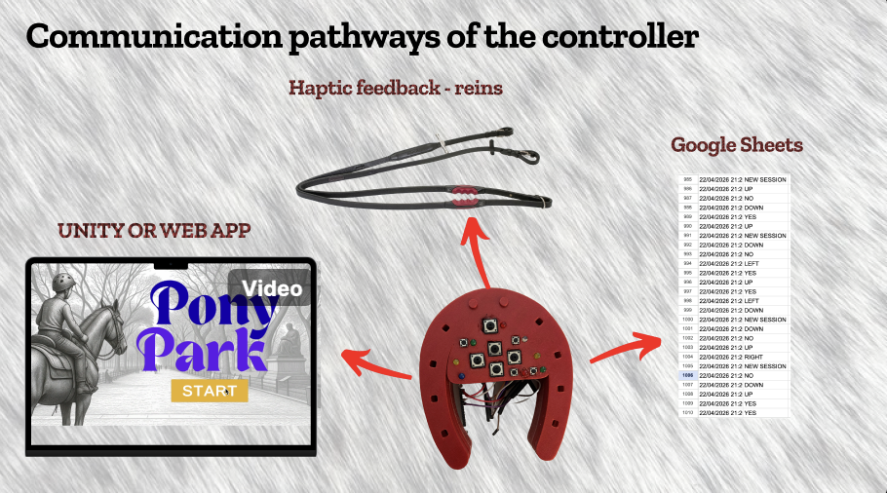

3.4 Form: Making — Software Design

3.4.1 Equestrian Arena Trainer (Web Application)
The Equestrian Arena Trainer is a browser-based application designed to serve as the onboarding environment for the ReinGuide haptic vocabulary. Its purpose is to allow riders, lesson assistants, and instructors to practice the command language—both giving and receiving—in a simulation context before they encounter it in a real session with a real horse.
The application is web-based by design. No installation is required, and it can be accessed from any device at the therapy center or at home. This accessibility is deliberate: riders who practice with the simulator at home between sessions will internalize the haptic vocabulary more rapidly, and families who understand the system can reinforce learning in non-therapeutic contexts.
The Arena Builder feature allows the instructor to design the layout of the planned lesson before the session. She can draw paths, place cones, add poles, mark pause zones, and configure the sequence of exercises. This layout then drives the Rider's Eye View and Session Tracker features—making the simulation a direct preparation for the specific lesson the rider will have, not a generic training environment.
The Rider's Eye View was the most significant design discovery of the software development process. Initially, the team assumed a top-down two-dimensional map view would be sufficient for navigating the simulated arena—clear, legible, and simple to implement. During development, it became clear that the team itself could not navigate the arena reliably from a bird's-eye view alone. Steering a horse through a planned path requires a body-centered reference point: the sensation of moving through space, not watching movement from above.
This insight—which the team experienced as a design problem before recognizing it as a research finding—led to the development of a pseudo-3D first-person perspective that runs alongside the top-down map. The rider sees the arena from her own point of view: the horse's neck ahead of her, the cones and poles approaching, the path curving left or right. This perspective makes the proprioceptive demands of riding legible within the game environment, and it became a pedagogical feature in its own right—the simulator teaches riders not just the haptic vocabulary but the spatial experience of navigating an arena.
The Session Tracker records quantitative data on the rider's performance in the simulator: time on path, time off path, number of stops, missed poles, cone hits, and an overall accuracy score. This data is available to therapists and instructors as an indicator of the rider's proprioceptive progress over time—a secondary benefit of the simulator that connects it to the therapeutic program's assessment framework.
The Command Preview feature displays the controller's current state in real time on the instructor's screen: which joystick position is active, which haptic pattern is being transmitted, and whether the signal has been acknowledged by the grips. This allows the instructor to monitor the assistant's cue-giving during training, ensuring that the haptic language is being applied correctly before the rider enters the arena.
The UI was developed iteratively using Figma Make and Claude, building from backend systems outward toward the interface. Early iterations prioritized functionality; later iterations refined the visual design, the information hierarchy, and the accessibility of controls for users with varying levels of digital fluency. The instructor and assistant, in particular, needed an interface they could operate confidently without technical expertise.

3.4.2 Unity Riding Game (Central Park)
The Unity riding game is a more immersive complement to the Equestrian Arena Trainer—a gamified environment in which the rider can practice the haptic vocabulary in a context that is motivating, emotionally resonant, and visually engaging. Where the Arena Trainer is functional (it simulates a real lesson in a real arena), the Unity game is experiential: it gives the rider the feeling of riding through a familiar, beautiful place under the guidance of haptic cues.
The setting—Central Park—was chosen because it is familiar to New York City children, including the riders at GallopNYC, and because it carries emotional associations with outdoor freedom and movement that align with the therapeutic goals of equine therapy. The environment is recognizable without requiring the rider to build a mental model of an unfamiliar virtual space; she arrives already knowing what Central Park looks like and what it feels like to move through it.
The controller sends commands to the Unity game using the same radio and API architecture as the web application—the same joystick, the same haptic patterns, the same command vocabulary. The transition from the game to the real rein grips is designed to be smooth: the rider has already associated the Left two-pulse pattern with turning left, the three-pulse pattern with moving forward. When she feels those patterns in her hands on a real horse, she has already internalized what to do.
Game design decisions for the Unity environment were made with Mariana's sensory and cognitive profile in mind. The pacing is calm rather than fast-paced; the visual environment is naturalistic rather than abstract or high-contrast; the feedback for correct responses is positive and measured rather than loud or startling. The difficulty increases gradually as the rider demonstrates proficiency with each haptic command. At no point does the game introduce a new command pattern without first establishing the rider's familiarity with the preceding patterns.

3.4.3 Use Flow Diagram
The participant experience over the complete deployment arc of ReinGuide follows three sequential phases, each building on the previous:
Phase 1 — Simulator Onboarding. The rider, lesson assistant, and instructor meet without the horse. The instructor demonstrates the five haptic commands using the Arena Trainer and the Unity game. The assistant practices operating the controller while the rider experiences the haptic patterns in the rein grips. The instructor observes and provides feedback. This phase continues across multiple sessions until all three participants are comfortable with the full command vocabulary.
Phase 2 — Horse Acclimation. Before any child uses the haptic grips in a live session, an experienced adult rider introduces the vibrating grips to the horse in a controlled setting. The horse is allowed to smell, investigate, and become accustomed to the grips. The experienced rider then uses the grips while riding the horse through normal exercises at all gaits, while the instructor monitors the horse's response. Only when the horse demonstrates comfort with the grips under all normal conditions is the system cleared for use with a child rider.
Phase 3 — Live Session. The rider mounts with the haptic grips attached to the reins. The lesson assistant carries the controller. The instructor directs the session as normal, signaling to the assistant when to send each haptic command. The assistant operates the controller, the rider receives the haptic cues, and the instructor observes the rider's response. Session data is recorded via the Arena Trainer's Session Tracker for review between sessions.

3.4.3.1 Use Flow Diagram - Assistant
Phase 1
Phase 2
Phase 3

3.4.3.1 Use Flow Diagram - Rider
Phase 1
Phase 3

3.5 Form: Iterative Prototyping Decision Points
The development of ReinGuide followed an iterative trajectory in which each prototype stage generated a specific insight that redirected the next stage. Four decision points were particularly formative.

Key Decision Point 1: Clay Foam → Digital Reins
The clay foam experiment was the first design intervention—a deliberate, controlled trial of a sensory object as a regulatory tool during horse stops. The clay foam worked: Mariana stayed in the saddle longer. But it worked by distracting her from the lesson, not by keeping her in it. The critical observation was that regulation and engagement are not the same thing—and that a design intervention that achieves one at the cost of the other is not a therapeutic success.
This insight reframed the design problem: the intervention needed to be task-integrated, not supplementary. The sensory input needed to be part of the riding activity, not an alternative to it. And the object that was already task-integrated—already in Mariana's hands, already part of the communication structure of riding—was the rein. That recognition was the origin of ReinGuide.

Key Decision Point 2: Bluetooth → Radio
The first wireless communication approach for the ReinGuide system was Bluetooth—the most familiar short-range wireless protocol and the simplest to implement with standard development boards. Bluetooth was abandoned for two reasons: the range limitations of standard Bluetooth (typically 10 meters in real-world conditions) were insufficient for outdoor riding arenas, and the pairing process introduced latency and reliability concerns that were unacceptable in a real-time communication system.
The team moved to a dedicated radio module operating in the 433 MHz band, which offered greater range and lower latency. This worked in principle, but created its own obstacle: most 433 MHz radio modules operate on 3.3V logic, while the motors, joystick, and other components in the system operate on 5V logic. Sourcing the appropriate level-shifting components and voltage regulators introduced delays that halted development.

Key Decision Point 3: Radio → ESP-NOW
The solution to the voltage mismatch problem was already built into the development hardware: ESP-NOW, a proprietary wireless communication protocol developed by Espressif Systems and included by default in all ESP32 microcontrollers. ESP-NOW operates over the 2.4 GHz band, uses no WiFi or Bluetooth infrastructure, and provides low-latency peer-to-peer communication between ESP32 devices.
The range of ESP-NOW (approximately 200 meters in open air) is more than sufficient for a therapeutic riding arena. The protocol requires no pairing, no network configuration, and no intermediary devices—it simply works, out of the box, on hardware the project was already using. The transition to ESP-NOW resolved the development bottleneck and accelerated the hardware prototype significantly.

Key Decision Point 4: 2D-Only → Pseudo-3D
The most intellectually significant decision point in the software development process was the transition from a purely top-down two-dimensional arena view to the pseudo-3D first-person perspective that became the Rider's Eye View feature. This decision emerged not from user testing but from the team's own experience: during mid-development testing of the Arena Trainer, it became apparent that none of the team members could navigate a horse through a planned arena path using only the top-down map view.
The difficulty was not a UI problem or a rendering problem—it was a proprioception problem. Navigating through space requires a body-centered reference frame: the sense of moving forward, the horizon ahead, the objects approaching from the edges of the visual field. A bird's-eye view provides spatial information without providing the experiential reference frame that spatial navigation requires.
Recognizing this difficulty as an instance of the research question itself—proprioception as the missing ingredient in spatial communication—transformed the pseudo-3D view from a technical requirement into a pedagogical feature. The simulator now teaches riders not just the haptic vocabulary but the experience of proprioceptive navigation—the felt sense of moving through an arena—in a context where the stakes are low and the feedback is immediate.
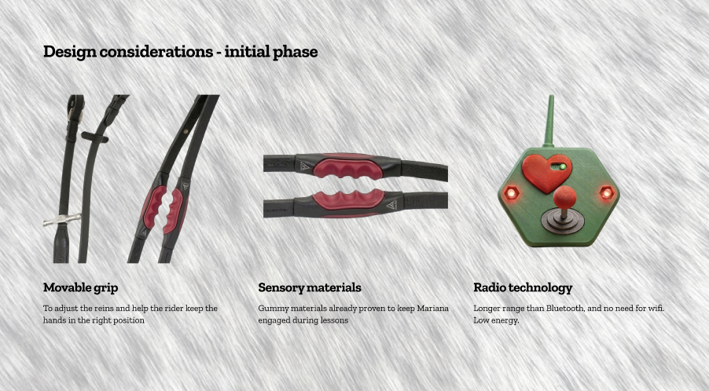
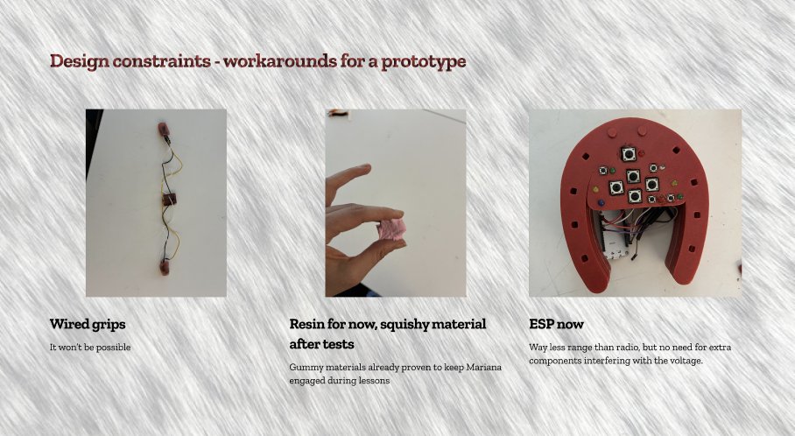

3.6 Form: Testing — Impact on Design
The testing process for ReinGuide was not a formal empirical study with control conditions and statistical measures. It was a naturalistic, participatory, observation-driven process—the kind of testing appropriate to a thesis-stage design project in which the primary goal is to generate design knowledge rather than to validate clinical outcomes.

Informal Field Testing at GallopNYC
Over the course of multiple volunteer sessions at GallopNYC, the author documented Mariana's behavioral patterns across the full arc of a riding session: mounting, warm-up, active riding, horse stops, and dismount. The documentation was observational rather than instrumental—field notes rather than sensor data—and was focused on identifying the specific moments of transition that triggered behavioral escalation.
The clay foam trial constituted a controlled informal A/B observation: one session in which no intervention was provided (baseline), and one session in which the clay foam was offered during horse stops. The behavioral difference was observable and consistent with the hypothesis. The clay foam experiment was not a rigorous experimental study; it was a design probe—a deliberate, bounded intervention intended to generate a specific insight.

Expert Consultations
The most informative consultation in the design process was the interview with Mariana's mother. Her account of the morning sensory brush routine provided the conceptual framework that shifted the design from distraction-based to engagement-based: the understanding that structured, predictable tactile input can be regulatory without being distracting, when it is integrated into a purposeful sequence of activity.
Conversations with GallopNYC instructors and lesson assistants provided grounding in the operational realities of a therapeutic session: what the assistant can realistically do while walking alongside a moving horse, what the instructor's attention is focused on, what the horse's behavioral signals mean, and what the institutional constraints of the program are. These conversations shaped the controller's form factor, the deployment protocol, and the decision to preserve rather than disrupt the existing lesson structure.
Future consultations—identified as next-phase work—will include occupational therapists specializing in sensory integration, who will provide clinical grounding for the Heartbeat Mode design and guidance on the appropriateness of the haptic patterns for Mariana's specific sensory profile.

Usability Considerations
Formal usability studies have not yet been conducted. The simulator software—the Equestrian Arena Trainer and the Unity game—will serve as the primary platform for structured onboarding studies in the next phase of the project. These studies will measure how quickly riders, lesson assistants, and instructors learn the five-pattern haptic vocabulary; what error patterns emerge; and how many repetitions are required before the patterns are reliably retained.
The design of the controller included two yes and no buttons that activate every time after the user presses any command. They light up to prompt the assistant to register the observation (did the rider follow the command? Yes/no) to later send that information to a database.
The safety testing protocol for horse acclimation has been designed in consultation with GallopNYC staff. The protocol specifies that an experienced adult rider must ride each participating horse with the active haptic grips through the full range of normal lesson activities—at walk, trot, and canter—before any child uses the grips. The horse's behavioral response to the vibrating grips must be assessed as calm and unaffected before the system is cleared for pediatric use. This is not a bureaucratic requirement; it is a genuine safety measure grounded in equine neuroscience.

CHAPTER IV
Evaluation

4.1 The Case Study: Mariana
The methodological heart of this thesis is a naturalistic case study: an in-depth account of one child, one therapeutic context, and one design process, conducted in the tradition established by Stake (1995) and elaborated by Greenhalgh (2025). Case study methodology is appropriate here not as a second-best alternative to experimental research but as the right tool for the epistemological task: generating contextual, transferable design knowledge from a specific, embedded situation.
Mariana is seven years old. She has been diagnosed with non-verbal autism spectrum disorder. She has been riding at GallopNYC for approximately two years, with varying session lengths depending on her regulation state on a given day. She enjoys the riding sessions—her engagement and positive affect during active riding are observable and consistent. Her instructors describe her as a natural rider who responds well to the horse's movement. The problem is not riding; the problem is stopping.
The pattern is consistent enough to be predictable: when the horse stops—whether because the instructor has asked for a halt, because the horse has paused on its own, or because a cone or obstacle has caused a break in the lesson flow—Mariana's behavioral state begins to shift. Within seconds of the stop, she begins reaching for the side-walkers, shifting her weight toward one side, or producing the vocalizations that her team recognizes as distress signals. If the stop continues for more than thirty to forty-five seconds without resolution, dismount is likely.
The working hypothesis—grounded in the sensory processing literature and in the observations of Mariana's behavior—is that the horse's rhythmic gait provides a proprioceptive and vestibular regulatory input that Mariana relies on to remain grounded and present. When the gait ceases, the regulatory input ceases. The behavioral escalation is not a response to anything the horse does during the stop; it is a response to the absence of the sensory signal that the horse was providing during movement.
The morning sensory brush routine, as described by Mariana's mother, provides the theoretical framework for the design response. The brushing is structured, predictable, and purposeful: it prepares Mariana's nervous system for the demands of the day ahead. It does not distract her from the day; it organizes her for it. ReinGuide's Heartbeat Mode proposes to do the same thing during horse stops: provide a structured, predictable, low-demand sensory input that keeps Mariana's nervous system regulated while the lesson pause resolves.
The directional haptic commands—Forward, Left, Right, Halt—propose something more ambitious: to give Mariana a functional role in the communication loop of her own riding lesson. Not a passive recipient of an instructor's direction, but an active participant who receives cues, interprets them through her body, and responds by directing the horse. This is participation, not accommodation. It is the difference between attending a lesson and being in one.
What the case study can claim: that a specific pattern of session disruption in a specific non-verbal autistic rider can be traced to a specific sensory mechanism, and that a haptic communication system designed to address that mechanism is technically feasible, operationally compatible with the existing lesson structure, and grounded in the best available evidence from sensory integration science. What the case study cannot yet claim: that ReinGuide works—that Mariana's sessions are longer, that her proprioceptive responses to haptic cues are reliable, that her therapeutic outcomes improve. That validation requires a live deployment that has not yet occurred.

4.2 Reflection on the Status of the Project
ReinGuide is, at the time of writing, a functional thesis-stage prototype. The hardware is assembled and tested for basic electronic function. The software is complete and usable. The deployment protocol is written. The design rationale is fully developed. What remains is the most important step: using the system with Mariana in a real therapeutic session.
This gap—between design intent and deployed outcome—is a characteristic of responsible design research at the thesis stage, not a failure. The thesis makes no claim that ReinGuide has been clinically validated or that its therapeutic effectiveness has been demonstrated. It claims that the system is well-designed, grounded in evidence, operationally feasible, and ready for the next phase of development.
The ideal deployment sequence, as described in the thesis, proceeds in three phases: horse acclimation, then simulator-based onboarding with Mariana and her lesson team, then live session deployment with close monitoring. This sequence is designed to minimize risk and maximize the conditions for success. Skipping any phase—deploying the hardware before the horse is acclimated, or sending Mariana into the arena without simulator training—would compromise both the safety and the scientific validity of the deployment.
What is complete at the time of writing: the hardware prototype (controller and rein grips), the Equestrian Arena Trainer web application (fully functional), the Unity riding game (prototype stage), and the deployment protocol. What is in progress: refinement of the Unity game's difficulty curve and haptic feedback integration. What is not yet done: live deployment, formal usability studies, clinical consultation with occupational therapists, and any iteration informed by real-session data.
The gap between design intent and tested outcome is not hidden in this thesis—it is named explicitly. This is a methodological choice, not an admission of failure. Honest acknowledgment of what a prototype can and cannot claim is a mark of rigorous design research. ReinGuide is a proposal, grounded in evidence and developed with care. The next phase will test whether the proposal is right.

4.3 Reflection on Learning
Four categories of learning emerged from the ReinGuide design process, each significant both for the specific project and for the designer's developing practice.

Regulation and Engagement as Distinct Design Goals
The clay foam experiment taught the most important conceptual distinction of the project: the difference between regulation (keeping the rider calm and in the saddle) and engagement (keeping the rider present and participating in the lesson). These are not the same thing, and a design intervention that achieves one at the cost of the other is not a therapeutic success.
This distinction is not obvious before you encounter it. The instinct—natural, compassionate, reasonable—is to do whatever keeps the child from distress. The clay foam did that. But it did so by giving the child something more interesting to do than riding, which is the opposite of therapeutic. The insight is generalizable far beyond equine therapy: in any therapeutic or educational design context, the goal is not to make the user comfortable with being somewhere; it is to make the somewhere worth being in.

Proprioception as a Design Question
The pseudo-3D discovery taught the team something about proprioception from the inside—not as a concept to be read about in neuroscience literature but as an experiential reality to be reckoned with in software design. The team could not navigate the arena from a bird's-eye view because proprioception is not a top-down phenomenon. It is a body-centered phenomenon. It requires a point of view that is located in a body that is moving through space.
This insight—arriving through a design frustration rather than a research seminar—is the most vivid confirmation of the thesis's central argument. Designing for proprioception requires understanding proprioception, and understanding proprioception requires experiencing the gaps it creates when it is absent. The team's inability to navigate the 2D arena was not a failure; it was evidence.

Ethics and Methodology of Designing for a Single User
Designing for Mariana specifically required working through a set of ethical and methodological questions that do not arise when designing for a general population. Pseudonymization is not enough: even with her name changed, a sufficiently specific account of her behavioral patterns, sensory profile, and therapeutic history could identify her to people who know her. The thesis treats these questions seriously: what can be described, what must be abstracted, what requires informed consent and what can be included as observational data under the protection of field notes.
The responsibility that comes with extreme specificity is the obverse of its creative power. Designing for Mariana produces a better system than designing for a theoretical user—but it produces a better system that will be used on a real child. The designer's obligation to that child is not just to design something that works; it is to design something that is safe, that has been validated appropriately, and that serves her therapeutic interests rather than the designer's creative agenda.

Growing Technical Competencies
ReinGuide required the development of technical competencies across multiple domains: embedded systems design, wireless communication protocols, haptic pattern engineering, Unity game development, and web application development. Each of these was approached iteratively, with each failure generating specific knowledge that improved the next attempt.
The embedded systems work—moving from breadboard to enclosure, from Bluetooth to radio to ESP-NOW, from conceptual haptic patterns to tested LRA driver circuits—was the most technically demanding aspect of the project and the area of greatest growth. The experience of hitting a real technical obstacle (the voltage mismatch problem) and resolving it through a creative detour (ESP-NOW) is itself a methodological lesson: prototyping reveals constraints that cannot be anticipated in advance, and the response to those constraints is where the design work actually happens.

4.4 Future Prospects
ReinGuide is the founding product of BIG FROOTS, a design studio focused on assistive and therapeutic technology. The thesis project establishes the conceptual, technical, and methodological foundation for a studio practice that extends well beyond a single MFA project.

Next Phase: Formal Usability Studies
The immediate next step is the conduct of structured usability studies at GallopNYC, using the Equestrian Arena Trainer as the primary platform. These studies will measure the speed and accuracy of haptic vocabulary acquisition for riders, lesson assistants, and instructors; identify error patterns and ambiguities in the current command patterns; and generate quantitative data on onboarding efficiency that can inform the design of future training materials.
Following the usability studies, the full three-phase deployment protocol will be executed with Mariana, pending confirmation that the horse acclimation phase has been completed successfully and that all required consents have been obtained. The live deployment will be documented in detail, and the findings—whether the system works as designed, where it fails, and what it reveals about the design—will be the basis for the first major iteration of the hardware and software.

Clinical Validation and Therapeutic Outcomes
ReinGuide's long-term credibility depends on clinical validation: partnership with licensed occupational therapists and equine therapy specialists who can design and conduct outcome studies that measure the therapeutic benefits of the system. Relevant outcome measures might include session duration (time in the saddle), behavioral dysregulation frequency, instructor-assessed engagement scores, and standardized sensory processing assessments conducted before and after a course of ReinGuide-augmented sessions.
Clinical validation is not a marketing exercise; it is the ethical obligation of a design that proposes to intervene in a child's therapeutic program. ReinGuide must be demonstrated to help before it is deployed broadly. The thesis establishes the design rationale; clinical validation will establish the evidence base.

Hardware Iteration
The next hardware iteration will integrate the hand warming element—the low-level heat source planned for the rein grips but excluded from the current prototype. It will also address the enclosure design for weather resistance (important for outdoor arenas in variable climates), reduce the weight and profile of the grip components (which must be comfortable for a child's hand for extended periods), and explore improvements to battery life and charging convenience.
Longer-term hardware development may explore adaptive haptic patterns—command sequences that can be customized for individual riders based on their sensory profiles—and biometric sensing (heart rate, grip pressure) that provides the instructor with real-time information about the rider's regulatory state.

Expansion to Other Populations
The design of ReinGuide for Mariana does not limit its applicability to non-verbal autistic riders. The system was designed from the extreme case, but its functionality is relevant to any rider who has difficulty processing verbal instruction in real time during an active riding session. This includes riders with ADHD, for whom the competing sensory demands of a riding session may make sustained attention to verbal cues difficult; beginning riders of all ages, who have not yet internalized the physical responses that verbal riding cues imply; and riders with other neurodevelopmental or acquired conditions affecting language processing or sensory integration.
A future study comparing the onboarding curve and session performance of neurotypical beginning riders using ReinGuide versus standard verbal instruction alone would provide valuable data on the system's generalizability—and on the broader potential of haptic communication as a universal design strategy in riding instruction.

Distribution and Institutional Adoption
GallopNYC is the natural first institutional partner for ReinGuide: the system was designed in their context, with their staff, for one of their riders. An institutional adoption pilot at GallopNYC—in which multiple riders use the system across multiple sessions with systematic outcome documentation—would be the most important step toward broader adoption.
Beyond GallopNYC, the approximately 900 PATH-certified therapeutic riding centers in the United States represent the primary distribution target. PATH International's certification and standards framework provides a natural structure for the safety and training requirements that accompany ReinGuide adoption. A training certification program for instructors and lesson assistants—analogous to the certifications PATH already provides for riding instruction—could ensure consistent and safe implementation across diverse institutional contexts.

References
Ayres, A. J. (1972). Sensory integration and learning disorders. Western Psychological Services.
Bundy, A. C., Lane, S. J., & Murray, E. A. (Eds.). (2002). Sensory integration: Theory and practice (2nd ed.). F. A. Davis.
Case-Smith, J., & Arbesman, M. (2008). Evidence-based review of interventions for autism used in or of relevance to occupational therapy. American Journal of Occupational Therapy, 62(4), 416–429.
Cherng, R. J., Liao, H. F., Leung, H. W. C., & Hwang, A. W. (2004). The effectiveness of therapeutic horseback riding in children with spastic cerebral palsy. Adapted Physical Activity Quarterly, 21(2), 103–121.
Greenhalgh, T. (2025). Case studies: A guide for researchers, educators, and implementers. BMJ Medicine.
Jones, J. L. (2020). Horse brain, human brain: The neuroscience of horsemanship. Trafalgar Square Books.
Kaiser, L., Smith, K. A., Heleski, C. R., & Spence, L. J. (2006). Effects of a therapeutic riding program on at-risk and special education children. Journal of the American Veterinary Medical Association, 228(1), 46–52.
Kleim, J. A., & Jones, T. A. (2008). Principles of experience-dependent neural plasticity: Implications for rehabilitation after brain damage. Journal of Speech, Language, and Hearing Research, 51(1), S225–S239.
MacPhail, H. E. A., Edwards, J., Golding, J., Miller, K., Mosier, C., & Zwiers, T. (1998). Trunk postural reactions in children with and without cerebral palsy during therapeutic horseback riding. Pediatric Physical Therapy, 10(4), 143–147.
Miller, L. J., Anzalone, M. E., Lane, S. J., Cermak, S. A., & Osten, E. T. (2007). Concept evolution in sensory integration: A proposed nosology for diagnosis. American Journal of Occupational Therapy, 61(2), 135–140.
PATH International. (2023). Standards for certification and accreditation (10th ed.). PATH International.
Stake, R. E. (1995). The art of case study research. Sage Publications.
Sterba, J. A. (2007). Does horseback riding therapy or therapist-directed hippotherapy rehabilitate children with cerebral palsy? Developmental Medicine & Child Neurology, 49(1), 68–73.
Trevelyan, E., & Robinson, N. (2015). Qualitative research in complementary and alternative medicine. Focus on Alternative and Complementary Therapies, 20(2), 56–61.
Winstein, C. J., & Wolf, S. L. (2009). Task-oriented training to promote upper extremity recovery. In J. Stein, R. L. Harvey, R. F. Macko, C. J. Winstein, & R. D. Zorowitz (Eds.), Stroke recovery and rehabilitation (pp. 267–290). Demos Medical Publishing.

Appendices

Appendix A: Hardware Component List
The following components were used in the ReinGuide prototype at the time of thesis submission. Component availability and specifications may change in subsequent iterations.
- 2× ESP32 development board (Espressif Systems) (one for the reins, one for the controller)
- 2× Vibrating Motors Linear Resonant Actuators (LRAs), 10mm diameter, 3V nominal. 150Hz.
- Buttons
- LED indicators (red, green, blue) — controller feedback
- 220 ohm resistors (one per LED).
- Gummy silicone grip material, custom molded
- Resin enclosures for the grips electronics
- Adjustable rein clip mounts (nylon, custom fabricated)
- PLA 3-D printed case for the controller
- Rigid and flexible cables.

Appendix B: Haptic Pattern Notation
The five ReinGuide command patterns are specified below using actuator activation (L = left grip, R = right grip, B = both) and pulse timing (milliseconds ON / OFF).
Note: The vibration motors produce a constant internal vibration (~150 Hz at full power) whenever activated. Perceived differences between commands are created through temporal patterns, not changes in frequency.
UP / FORWARD
B, [100 ms ON – 120 ms OFF – 100 ms ON]
→ Double pulse (“tap–tap”), both reins
LEFT
L, [ON, continuous while input is active]
→ Continuous vibration, left rein
RIGHT
R, [ON, continuous while input is active]
→ Continuous vibration, right rein
DOWN / HALT / WHOA BACK
B, [600 ms ON – 100 ms OFF – 100 ms ON]
→ Long pulse followed by short pulse, both reins
HEARTBEAT MODE
B, [DOWN pattern] × repeat every 2 s
→ Rhythmic “whoa-back” pattern, both reins

Appendix C: Equestrian Arena Trainer — Feature Summary
The Equestrian Arena Trainer (EAT) is a web-based application accessible at any modern browser without installation. The following features were functional at the time of thesis submission:
- Arena Builder: draw custom arena paths, place cones and poles, mark pause zones, save and load lesson layouts.
- Rider's Eye View: pseudo-3D first-person perspective that updates in real time as the virtual rider navigates the arena.
- Top-Down Map: 2D overhead view of the arena showing the rider's position relative to the planned path.
- Session Tracker: records time on path, time off path, stop count, missed poles, cone contacts, and accuracy score per session.
- Command Preview: real-time display of controller state showing which haptic command is currently active.
- Mute / Audio Toggle: enables or disables verbal audio reinforcement of haptic commands.
- Controller Integration: USB and wireless connection to the ReinGuide controller.

Appendix D: Interview Notes — Mariana's Mother (Anonymized)
The following is a summary of the key themes from the interview conducted with Mariana's mother following a GallopNYC session. Direct quotations have been paraphrased to protect identifiability. The interview was conducted with verbal consent; no audio recording was made.
Morning routine: Mariana's day begins with a structured sensory sequence, including brushing with a specific tactile brush in a specific pattern, before any transitions out of the home. Her mother described this as “priming”—not calming in a sedative sense, but organizing in a preparatory sense.
Sensory preferences: Mariana is drawn to rhythmic, repetitive tactile input. She tolerates—and often seeks—firm pressure, particularly on her palms and forearms. She is more sensitive to unpredictable or sudden tactile input than to sustained input of similar intensity.
Clay foam observation: Mariana's mother had noticed the clay foam trial and reported that Mariana took it home—a clear sign of interest in the sensory toy. While playing with the clay foam, Mariana sits still to wait for her lesson, which her mother appreciated. She was supportive of sensory interventions that kept Mariana in the session but expressed concern about anything that competed with the lesson content for Mariana's attention.

Appendix E: GallopNYC Session Observation Notes (Anonymized)
The following is a summary of behavioral observations across five volunteer sessions. Specific dates and identifying details have been omitted.
Session 1 (Baseline):
Session 2 (Baseline):
Session 3 (Clay Foam Trial):
Session 4 (Clay Foam Trial continued):
Session 5 (No Intervention):

Appendix F: Safety Protocol for Horse Acclimation
The following protocol must be completed for each horse before the horse is used in a live ReinGuide session with a child rider.
- Step 1 — Ground Introduction: Present the inactive rein grips to the horse for olfactory and visual investigation. Allow the horse to smell, touch with lips, and approach and retreat from the grips voluntarily. Duration: minimum 10 minutes, or until the horse shows no reactive behavior.
- Step 2 — Stationary Activation: With an experienced adult holding the horse at halter in a familiar environment, activate one grip at a time (minimum LRA pattern: Heartbeat Mode). Observe horse response. If the horse shows startle, anxiety, or aversion, return to Step 1. Duration: minimum 5 minutes at each intensity level.
- Step 3 — Mounted Walk Test: An experienced adult rider mounts the horse with the active rein grips attached. The rider walks the horse through normal patterns at walk while the instructor monitors the horse's gait, head carriage, and behavioral state. All five haptic commands are transmitted during this phase. Duration: minimum 20 minutes.
- Step 4 — Mounted Trot and Canter Test (if applicable): If the therapeutic program involves trot or canter work, the acclimation ride must include these gaits. Behavioral assessment continues.
- Step 5 — Clearance: The horse is cleared for pediatric use with the ReinGuide system only after the lead instructor has observed and documented a calm, unaffected behavioral response across all steps. Clearance is horse-specific and session-date-specific: a horse cleared on one date must be re-assessed if significant time has passed or if the horse has experienced any notable behavioral events in the interim.

――――――――――――――――――――――――――――――――――――――――
BIG FROOTS Design Studio
Parsons School of Design • MFA Design & Technology • 2025

OVERALL COMMENTS
Lupita: this paper is strong and detailed, documenting ReinGuide on many levels. Your introductory chapter provides a clear orientation to its concept, tells a compelling story of its origins, and argues convincingly about how the project offers distinctive advantages - and fills a void. You position the project within the composite of domains influencing the concept and approach to the form of your thesis. You make a clear statement of the scope of the DT thesis, and provide intimate detail on the making of its components: the controller, including a deployment protocol, and a Unity-based simulation game set in Central Park. As you say in the paper, these are the grounding tools needed to take the project into its next development and testing phase. A trajectory plan for this development is included herein. How the work takes a case study approach to the research, observation of your subject, design thinking and making of the project’s components is a thru-line theme. As mentioned in my comments, the work is at a solid work-in-progress phase. A venue of possible interest to you might be the ACM, TEI Conference (Tangible, Embedded and Embodied Interaction).
I have included some running comments in the paper. Here are some next steps towards finalization of this paper:

Next Steps
- Include more visual representation. You indicate you will be adding more, including close-ups of the controller. I urge you to do so. Although your textual details are vivid, more visual support can concretize them for future readers who will not have prior knowledge of the project - or who may want to learn more about their making.

- Add figure #s and captions to all images. Regardless of where images appear in the paper, you can refer readers to them using the figure #.

- Consider adding more information on your work at GallopNYC. You write knowledgeably about the therapeutic equine environment. As a reader, I would like to know more about your background and experience - volunteering there or possibly other exposure to horses/riding. Your observations of Mariana are so central. This coverage could be in the impetus section or the section later in the paper where you do write more so about GallopNYC.

- Format suggestions:
  - Line spacing rivers. This is a common issue of the forced flush right alignment. This can be fixed in In-Design. I have found some very helpful u-tube sessions offering specifics on settings that can resolve the rivers issue. Rag right is a lot easier.
  - Table of Contents, sub headings.Consider using subheadings in your overall TOC for Chapter 3. You do so for Chapter 2. These provide a specific, immediate schema of the coverage.
  - Subtitle punctuation. Consider stronger punctuation to set off its final phrase: Designing A Haptic Communication Channel Through Digital Reins for A Non-Verbal Rider in Equine Therapy: An Exploratory Case Study
  - Final formatting pdf: follow the template for inclusion of text and elements on the front matter title page and sequence of the front matter pages. Please submit a pre-final PDF by 5/5.

