LAPORAN
BANGUN RUANG TAJ MAHAL 3D

Diajukan untuk Memenuhi Tugas Besar
Mata Kuliah Grafika Komputer

Oleh:
IF-8/S1/VIII
Rudi Budiman 10109322
Lupti Wahyu 10109331
Marni Eka Yulistina 10109357

Dosen:
Hendri Karisma S.Kom



PROGRAM STUDI TEKNIK INFORMATIKA
FAKULTAS TEKNIK DAN ILMU KOMPUTER
UNIVERSITAS KOMPUTER INDONESIA
2013
Daftar Isi

BAB I 2
1.1 Latar Belakang 2
1.2 Daftar Objek 3
1.3 Tools Pembangun 3
1.4 Fungsi Objek Pembangun 3
BAB II 5
2.1 Pembangunan Objek 5
2.2 Pembangunan Objek Oleh Lupti Wahyu 5
2.2.1 Menara 5
2.2.2 Kubah 8
2.2.3 Bangunan Segi Delapan 12
2.3 Pembangunan Objek Oleh Rudi Budiman 15
2.3.1 Awan 15
2.3.2 Pohon 17
2.4 Pembangunan Objek Oleh Marni Eka Yulistina 19
2.4.1 Pintu 19
2.4.2 Lantai 23
2.4.3 Terrain 25

BAB I

Latar Belakang
Bangun Ruang Taj Mahal adalah sebuah monumen yang terletak di Agra, India. Dibangun atas keinginan Kaisar Mughal Shāh Jahān, anak Jahangir, sebagai sebuah musoleum untuk istri Persianya, Arjumand Banu Begum, juga dikenal sebagai Mumtaz-ul-Zamani atau Mumtaz Mahal. Pembangunannya menghabiskan waktu 22 tahun (1630-1653) dan merupakan sebuah adi karya dari arsitektur Mughal.
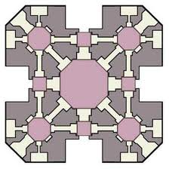
Taj mahal dikenal karena keindahannya, sehingga termasuk pada tujuh keajaiban dunia pada masanya. Bahwasanya struktur bangunan ini nampak sangat simetri.

Walau bangunan ini sudah berusia ratusan tahun, tapi keindahannya masih tetap terpancar. Oleh karena itu kami mencoba menggambarkan bangunan taj mahal ini dalam bentuk 3D dalam Grafika Komputer.
Bangunan Taj Mahal ini akan dibuat dengan tools CodeBlocks dengan menggunakan Library OpenGL. Dalam pembangunannya akan memakai berbagai macam fungsi yang menunjang pembangunan bangun ruang taj mahal 3D ini.

Daftar Objek
- Terrain
- Menara
- Pintu
- Kubah
- Lantai
- Bangunan Segi Delapan
- Pohon
- Awan

Tools Pembangun
- CodeBlocks
- Library OpenGL :
- glut.h
- glu.h
- gl.h
- Library Tambahan :
- imageloader.h
- imageloader.cpp
- vec3f.h
- vec3f.cpp
- color.h
- Bahasa Pemerograman c++

Fungsi Objek Pembangun
- GL
- GL_POLYGON
- GL_LIGHTING
- GL_TEXTURE_2D
- glVertex3f
- glVertex2f
- GLU
- gluCylinder
- gluDisk
- gluSphere
- gluLookAt
- GLUT
- glutSolidCube
- glutSolidSphere
- glutSolidCone
- glutSolidTorus
- glutSolidCube

BAB II

Pembangunan Objek
Proses pembangunan objek-objek dari Tugas besar ini baik fungsi yang digunakan, screenshot hasil, source code dan penjelasannya secara sederhana diuraikan pada sub bab berikut ini .

Pembangunan Objek Oleh Lupti Wahyu

Menara
Function : void menara(), void menarafix(), void kubahkecilfix(), void lantaibulat()
Penjelasan : Fungsi ini bertujuan untuk membuat dan mengatur bagian-bagian dari objek menara. Menggunakan gluCylinder untuk membuat badan menara serta bagian seperti cincin yang menempel di badan menara dan gluDisk untuk menutupi bagian atas dan bawah silinder.
Screenshot :
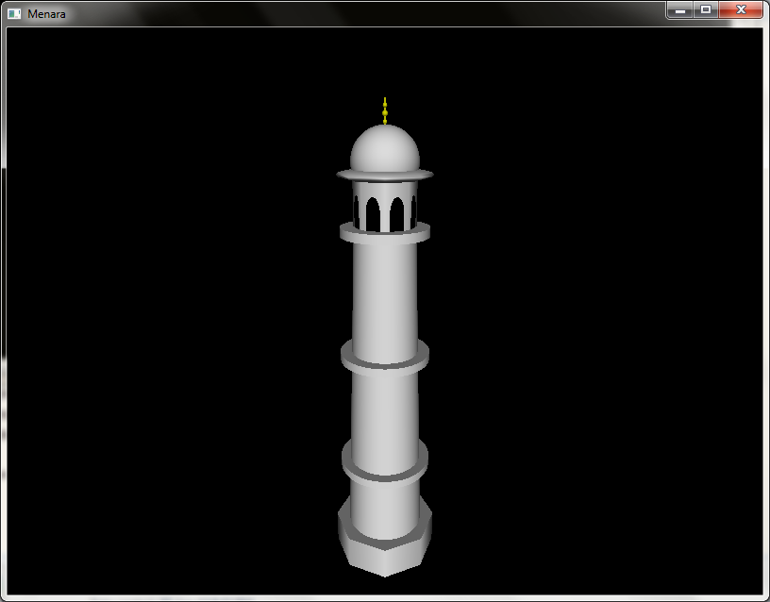
Source Code :
void menara()
{
// menara polos
glPushMatrix();
glColor3f(White);
glTranslated(0.0,-1.0,1.0);
glRotated(90,-1.0,0.0,0.0);
gluCylinder(quad,0.55,0.4,4.5,50,50);
glPopMatrix();

// ring bawah
glPushMatrix();
glColor3f(White);
glTranslated(0.0,0.05,1.0);
glScaled(1.0,0.15,1.0);
glRotated(90,-1.0,0.0,0.0);
gluCylinder(quad,0.65,0.65,0.8,50,50);
glPopMatrix();

glPushMatrix();
glColor3f(White);
glTranslated(0.0,0.17,1.0);
glRotated(90,-1.0,0.0,0.0);
gluDisk(quad,0,0.65,50,1);
glPopMatrix();

glPushMatrix();
glColor3f(White);
glTranslated(0.0,0.05,1.0);
glRotated(270,-1.0,0.0,0.0);
gluDisk(quad,0,0.65,50,1);
glPopMatrix();

// ring tengah
glPushMatrix();
glColor3f(White);
glTranslated(0.0,1.75,1.0);
glScaled(1.0,0.15,1.0);
glRotated(90,-1.0,0.0,0.0);
gluCylinder(quad,0.61,0.61,0.8,50,50);
glPopMatrix();

glPushMatrix();
glColor3f(White);
glTranslated(0.0,1.87,1.0);
glRotated(90,-1.0,0.0,0.0);
gluDisk(quad,0,0.61,50,1);
glPopMatrix();

glPushMatrix();
glColor3f(White);
glTranslated(0.0,1.75,1.0);
glRotated(270,-1.0,0.0,0.0);
gluDisk(quad,0,0.61,50,1);
glPopMatrix();

// ring atas
glPushMatrix();
glColor3f(White);
glTranslated(0.0,3.45,1.0);
glScaled(1.0,0.15,1.0);
glRotated(90,-1.0,0.0,0.0);
gluCylinder(quad,0.57,0.57,0.8,50,50);
glPopMatrix();

glPushMatrix();
glColor3f(White);
glTranslated(0.0,3.57,1.0);
glRotated(90,-1.0,0.0,0.0);
gluDisk(quad,0,0.57,50,1);
glPopMatrix();

glPushMatrix();
glColor3f(White);
glTranslated(0.0,3.45,1.0);
glRotated(270,-1.0,0.0,0.0);
gluDisk(quad,0,0.57,50,1);
glPopMatrix();
}

void menarafix()
{
glPushMatrix();
glTranslated(0.0,-1.0,0.0);
menara();
glTranslated(0.0,4.2,0.0);
kubahkecilfix();
glPopMatrix();

glPushMatrix();
glTranslatef(0.0,-1.45,0.0);
glScalef(1.0,1.1,1.0);
lantaibulat();
glPopMatrix();
}
void lantaibulat()
{
glColor3f(White);
glPushMatrix();
glTranslated(0.0,-1.0,1.0);
glRotated(90,-1.0,0.0,0.0);
gluCylinder(quad,0.8,0.8,0.5,8,1);
glPopMatrix();

glPushMatrix();
glTranslated(0.0,-0.5,1.0);
glRotated(90,-1.0,0.0,0.0);
gluDisk(quad,0.0,0.8,8,1);
glPopMatrix();

glPushMatrix();
glTranslated(0.0,-1.0,1.0);
glRotated(270,-1.0,0.0,0.0);
gluDisk(quad,0.0,0.8,8,1);
glPopMatrix();
}

Kubah
Function : void kubahbesar(), void tiangkubah(), void kerucutatas(), void kubahbesarfix(), void kubahkecilfix(), void square(), void circle()
Penjelasan : Fungsi ini bertujuan untuk membuat dan mengatur bagian-bagian dari object kubah. Menggunakan gluCylinder untuk bagian badan kubah, glutSolidSphere dan glutSolidCone untuk bagian kubah, dan tiang kubah yang terdiri dari gluCylinder, glutSolidSphere, glutSolidCone. Serta void square() dan void circle() untuk membuat jendela-jendela pada badan kubah.
Screenshot :
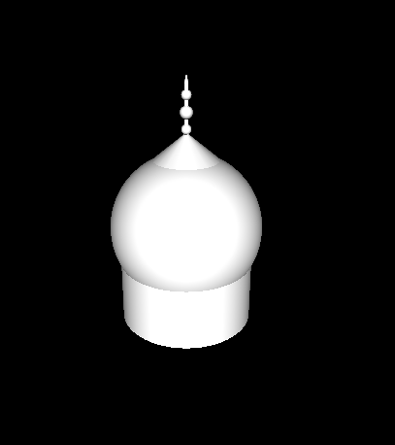
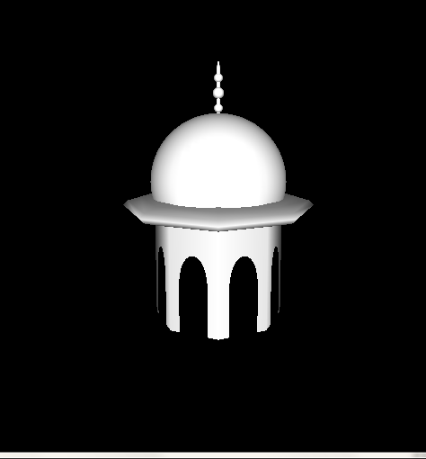

Source Code :
// bulatan bawah di tiang
glPushMatrix();
//glColor3f(225.0f/255,225.0f/255,0);
glTranslated(0.0,0.74,1.0);
glRotated(90,-1.0,0.0,0.0);
glutSolidSphere(0.0275,50,50);
glPopMatrix();

// ujung tiang
glPushMatrix();
//glColor3f(225.0f/255,225.0f/255,0);
glTranslated(0.0,0.98,1.0);
glRotated(90,-1.0,0.0,0.0);
glutSolidCone(0.012,0.05,50,50);
glPopMatrix();
}

void kerucutatas()
{
glPushMatrix();
glColor3f(White);
glTranslated(0.0,0.575,1.0);
glRotated(90,-1.0,0.0,0.0);
glutSolidCone(0.18,0.15,20,20);
glPopMatrix();
}

// kubah besar fix
void kubahbesarfix()
{
glPushMatrix();
glColor3f(Black);
glTranslated(0.0,1.2,-1.0);
glScaled(3.5,3.2,3.5);
tiangkubah();
kerucutatas();
kubahbesar();
glPopMatrix();
}
/* kubah besar */
void kubahbesar()
{
// menara atas
glPushMatrix();
glColor3f(White);
glTranslated(0.0,0.0,1.0);
glRotated(90,1.0,0.0,0.0);
gluCylinder(quad,0.37,0.37,0.35,50,50);
glPopMatrix();

// kubah
glPushMatrix();
glColor3f(White);
glTranslated(0.0,0.19,1.0);
glRotated(90,-1.0,0.0,0.0);
glutSolidSphere(0.42,50,50);
glPopMatrix();
}

void tiangkubah()
{
// tiang silinder
glColor3f(GoldPole);
glPushMatrix();
glTranslated(0.0,0.98,1.0);
glScaled(1.0,8.0,1.0);
glRotated(90,1.0,0.0,0.0);
gluCylinder(quad,0.012,0.012,0.035,50,50);
glPopMatrix();

// bulatan atas di tiang
glPushMatrix();
//glColor3f(225.0f/255,225.0f/255,0);
glTranslated(0.0,0.92,1.0);
glRotated(90,-1.0,0.0,0.0);
glutSolidSphere(0.0275,50,50);
glPopMatrix();

// bulatan tengah di tiang
glPushMatrix();
//glColor3f(225.0f/255,225.0f/255,0);
glTranslated(0.0,0.83,1.0);
glRotated(90,-1.0,0.0,0.0);
glutSolidSphere(0.035,50,50);
glPopMatrix();

// jendela 3
glPushMatrix();
glRotated(-22,0.0,-1.2,0.0);
glTranslated(-0.67,-0.74,1.3);
glScaled(0.15,0.25,0.0);
glPushMatrix();
glTranslated(-0.85,-2.3,1.0);
glScaled(5.7,6.2,1.0);
circle();
glPopMatrix();

glPushMatrix();
glTranslated(2.0,-0.3,1.0);
glScaled(3.0,2.2,1.0);
square();
glPopMatrix();
glPopMatrix();

// jendela 4
glPushMatrix();
glRotated(22,0.0,-1.2,0.0);
glTranslated(0.07,-0.74,0.55);
glScaled(0.15,0.25,0.0);
glPushMatrix();
glTranslated(-0.85,-2.3,1.0);
glScaled(5.7,6.2,1.0);
circle();
glPopMatrix();

glPushMatrix();
glTranslated(2.0,-0.3,1.0);
glScaled(3.0,2.2,1.0);
square();
glPopMatrix();
glPopMatrix();

// jendela 5
glPushMatrix();
glRotated(68,0.0,1.0,0.0);
glTranslated(-1.23,-0.74,0.75);
glScaled(0.15,0.25,0.0);
glPushMatrix();
glTranslated(-0.85,-2.3,1.0);
glScaled(5.7,6.2,1.0);
circle();
glPopMatrix();
/* kubah kecil */
void kubahkecilfix()
{
// menara atas
glPushMatrix();
glColor3f(White);
glTranslated(0.0,0.0,1.0);
glRotated(90,1.0,0.0,0.0);
gluCylinder(quad,0.4,0.4,0.7,8,10);
glPopMatrix();

// jendela 1
glPushMatrix();
glRotated(-22,0.0,1.0,0.0);
glTranslated(0.07,-0.74,1.3);
glScaled(0.15,0.25,0.0);
glPushMatrix();
glTranslated(-0.85,-2.3,1.0);
glScaled(5.7,6.2,1.0);
circle();
glPopMatrix();

glPushMatrix();
//glColor3f(White);
glTranslated(2.0,-0.3,1.0);
glScaled(3.0,2.2,1.0);
square();
glPopMatrix();
glPopMatrix();

// jendela 2
glPushMatrix();
glRotated(22,0.0,1.0,0.0);
glTranslated(-0.68,-0.74,0.55);
glScaled(0.15,0.25,0.0);
glPushMatrix();
glTranslated(-0.85,-2.3,1.0);
glScaled(5.7,6.2,1.0);
circle();
glPopMatrix();

glPushMatrix();
glTranslated(2.0,-0.3,1.0);
glScaled(3.0,2.2,1.0);
square();
glPopMatrix();
glPopMatrix();

// jendela 8
glPushMatrix();
glRotated(112,0.0,1.0,0.0);
glTranslated(-1.22,-0.74,0.002);
glScaled(0.15,0.25,0.0);
glPushMatrix();
glTranslated(-0.85,-2.3,1.0);
glScaled(5.7,6.2,1.0);
circle();
glPopMatrix();

glPushMatrix();
glTranslated(2.0,-0.3,1.0);
glScaled(3.0,2.2,1.0);
square();
glPopMatrix();
glPopMatrix();

// kubah
glPushMatrix();
glColor3f(White);
glTranslated(0.0,0.15,1.0);
glRotated(90,-1.0,0.0,0.0);
glutSolidSphere(0.42,50,50);
glPopMatrix();

// ring
glPushMatrix();
glColor3f(White);
glTranslated(0.0,0.0,1.0);
glScaled(1.0,0.15,1.0);
glRotated(90,1.0,0.0,0.0);
glutSolidSphere(0.6,8,10);
glPopMatrix();

// tiang
glPushMatrix();
glTranslatef(0.0,-0.14,0.0);
tiangkubah();
glPopMatrix();
}
glPushMatrix();
glTranslated(2.0,-0.3,1.0);
glScaled(3.0,2.2,1.0);
square();
glPopMatrix();
glPopMatrix();

// jendela 6
glPushMatrix();
glRotated(-68,0.0,1.0,0.0);
glTranslated(0.63,-0.74,0.75);
glScaled(0.15,0.25,0.0);
glPushMatrix();
glTranslated(-0.85,-2.3,1.0);
glScaled(5.7,6.2,1.0);
circle();
glPopMatrix();

glPushMatrix();
glTranslated(2.0,-0.3,1.0);
glScaled(3.0,2.2,1.0);
square();
glPopMatrix();
glPopMatrix();

// jendela 7
glPushMatrix();
glRotated(-112,0.0,1.0,0.0);
glTranslated(0.63,-0.74,0.002);
glScaled(0.15,0.25,0.0);
glPushMatrix();
glTranslated(-0.85,-2.3,1.0);
glScaled(5.7,6.2,1.0);
circle();
glPopMatrix();

glPushMatrix();
glTranslated(2.0,-0.3,1.0);
glScaled(3.0,2.2,1.0);
square();
glPopMatrix();
glPopMatrix();

Bangunan Segi Delapan
Function : void kubusbesarinti(),void kubuskecilinti(),void bagianinti(),void sudutbagianinti(),void sudutbagianintifix(),void bangunandasarintifix()
Penjelasan : Fungsi ini bertujuan untuk membuat objek bangunan segi delapan yang terdiri dari glutSolidCube, dan gluCylinder.
Screenshot :
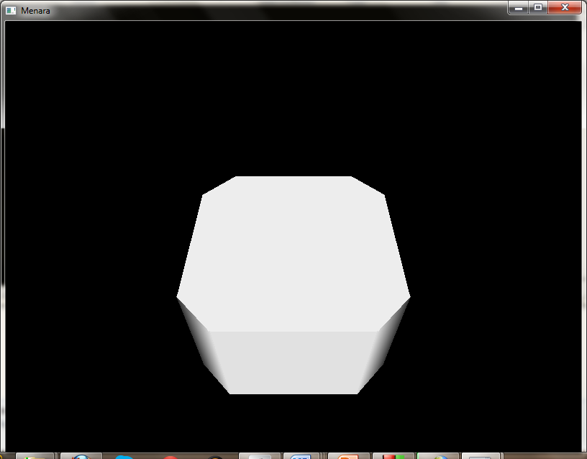

Source code :
glPushMatrix();
glColor3f(White);
glTranslatef(1.88,2.5,2.49);
glRotated(270,1.0,0.0,0.0);
glRotated(45,0.0,0.0,1.0);
gluDisk(quad,0,0.25,3,1);
glPopMatrix();

glPushMatrix();
glColor3f(White);
glTranslatef(1.88,0.5,2.49);
glRotated(90,1.0,0.0,0.0);
glRotated(255,0.0,0.0,1.0);
gluDisk(quad,0,0.25,3,1);
glPopMatrix();
}

void sudutbangunanintifix()
{
glPushMatrix();
glTranslatef(-0.805,0.0,-0.43);
glScalef(1.0,1.0,1.0);
sudutbangunaninti();
glPopMatrix();

glPushMatrix();
glTranslatef(-1.42,0.0,1.81);
glScalef(1.0,1.0,1.0);
glRotatef(90,0.0,1.0,0.0);
sudutbangunaninti();
glPopMatrix();

glPushMatrix();
glTranslatef(-4.17,0.0,0.305);
glScalef(1.0,1.0,1.0);
glRotatef(60,0.0,1.0,0.0);
sudutbangunaninti();
glPopMatrix();

glPushMatrix();
glTranslatef(1.415,0.0,0.185);
glScalef(1.0,1.0,1.0);
glRotatef(270,0.0,1.0,0.0);
sudutbangunaninti();
glPopMatrix();
}
/* segidelapan bagian tengah */
void kubusbesarinti()
{
glPushMatrix();
glColor3f(White);
glTranslated(0.0,1.5,1.0);
glScalef(1.32,1.0,1.0);
glutSolidCube(2);
glPopMatrix();
}

void kubuskecilinti()
{
glPushMatrix();
glColor3f(White);
glTranslatef(0.0,1.5,2.05);
glScalef(1.0,1.0,0.25);
glutSolidCube(2);
glPopMatrix();
}

void bagianinti()
{
glPushMatrix();
glTranslatef(0.0,0.0,0.0);
kubusbesarinti();
glPopMatrix();

glPushMatrix();
kubuskecilinti();
glPopMatrix();

glPushMatrix();
glTranslatef(0.0,0.0,-2.12);
kubuskecilinti();
glPopMatrix();
}

void sudutbangunaninti()
{
glPushMatrix();
glColor3f(White);
glTranslated(1.88,2.5,2.49);
glRotated(90,1.0,0.0,0.0);
glRotated(255,0.0,0.0,1.0);
gluCylinder(quad,0.25,0.25,2,3,3);
glPopMatrix();

// bangunan tengah inti segidelapan
void bangunandasarintifix()
{
glPushMatrix();
glTranslatef(0.0,-1.25,0.0);
glScalef(2.4,1.18,2.4);
bagianinti();
sudutbangunanintifix();
glPopMatrix();
}

Pembangunan Objek Oleh Rudi Budiman

Awan
Function : void awan()
Penjelasan : Fungsi ini bertujuan untuk membuat objek awan. Menggunakan glutSolidSphere untuk pembuatan awan.
Screenshot :
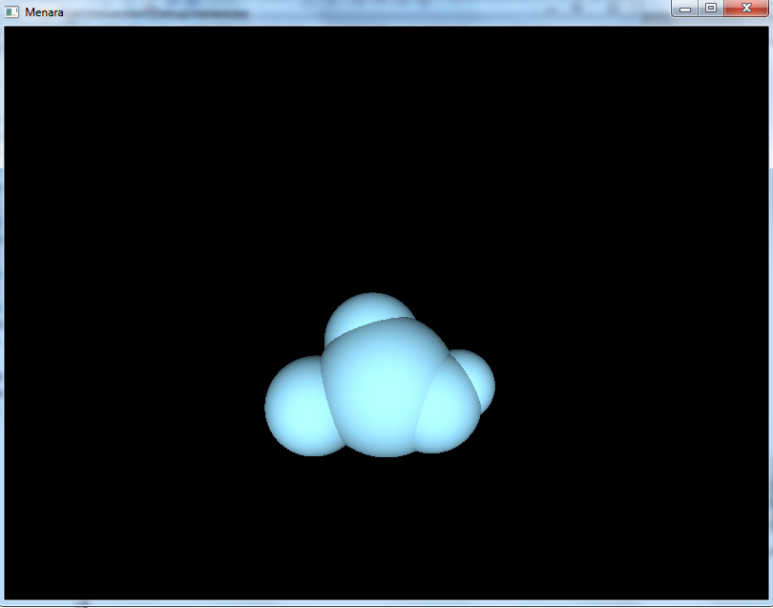

Source Code :

void awan(void)
{
glPushMatrix();
glColorMaterial(GL_FRONT_AND_BACK, GL_AMBIENT_AND_DIFFUSE);
glColor3ub(153, 223, 255);
glutSolidSphere(10, 50, 50);
glPopMatrix();
glPushMatrix();
glTranslatef(10,0,1);
glutSolidSphere(5, 50, 50);
glPopMatrix();
glPushMatrix();
glTranslatef(-2,6,-2);
glutSolidSphere(7, 50, 50);
glPopMatrix();
glPushMatrix();
glTranslatef(-10,-3,0);
glutSolidSphere(7, 50, 50);
glPopMatrix();
glPushMatrix();
glTranslatef(6,-2,2);
glutSolidSphere(7, 50, 50);
glPopMatrix();
}

Pohon
Function : void pohon()
Penjelasan : Fungsi ini bertujuan untuk membuat bagian-bagian dari objek pohon dengan menggunakan glutSolidSphere dan gluCylinder..
Screenshot :
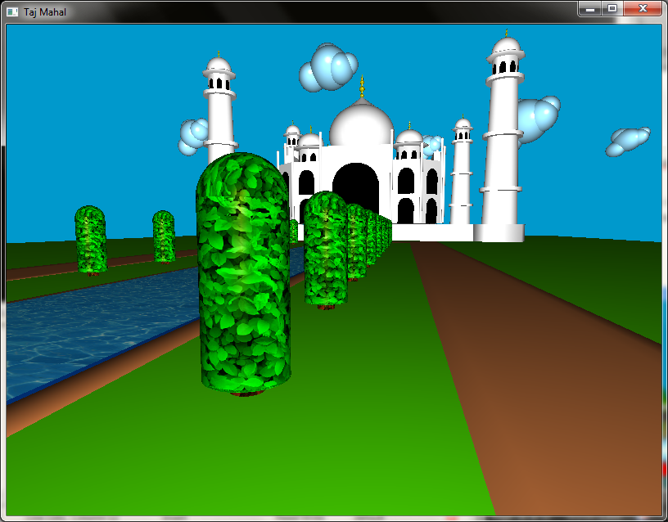

Source Code :
void pohon(){
glPushMatrix();
glColor3f(Green);
glTranslatef(0,-1,0);
glRotated(90,-1,0,0);
gluCylinder(quad,0.5,0.5,2.0,50,50);
glPopMatrix();

glPushMatrix();
glTranslated(0,1,0);
gluSphere(quad,0.5,50,50);
glPopMatrix();

glPushMatrix();
glTranslatef(0,-1,0);
glRotated(270,-1,0,0);
gluDisk(quad,0,0.5,50,1);
glPopMatrix();

glPushMatrix();
glColor3f(Brown);
glTranslatef(0,-1.5,0);
glRotated(90,-1,0,0);
gluCylinder(quad,0.2,0.2,2.0,50,50);

glPopMatrix();
}

Pembangunan Objek Oleh Marni Eka Yulistina

Pintu
Function : void square(), void circle(), void pintumasuk(), void pintubesar(), void tiang(), void pintukecil(), void pintukecilfix(), void pintubesarkecil(), void pintubesarkecilfix()
Penjelasan : Fungsi ini bertujuan untuk membuat pintu. Menggunakan glutSolidCube, void square(), void circle() untuk membuat pintu dan gluCylinder serta glutSolidSphere untuk bagian tiangnya.
Screenshot :
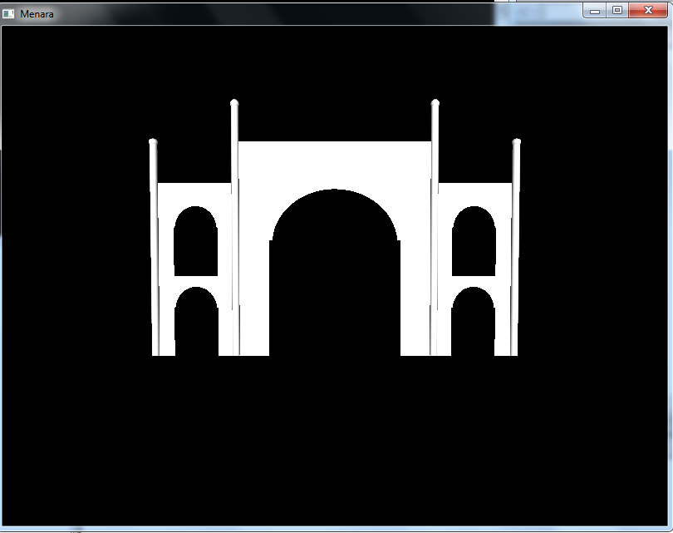

Source Code :
void pintumasuk()
{
// pintu masuk luar
glPushMatrix();
glTranslated(-2.0,-0.61,0.15);
glPushMatrix();
glTranslated(-0.85,-2.3,1.025);
glScaled(5.7,6.2,1.0);
circle();
glPopMatrix();

glPushMatrix();
glTranslated(2.0,-0.3,1.025);
glScaled(3.0,2.2,1.0);
square();
glPopMatrix();
glPopMatrix();

// pintu masuk belakang
glPushMatrix();
glTranslated(-2.0,-0.61,-0.15);
glPushMatrix();
glTranslated(-0.85,-2.3,1.0);
glScaled(5.7,6.2,1.0);
circle();
glPopMatrix();

glPushMatrix();
glTranslated(2.0,-0.3,1.0);
glScaled(3.0,2.2,1.0);
square();
glPopMatrix();
glPopMatrix();
}

void pintubesar()
{
// kubus luar
glPushMatrix();
glColor3f(White);
glTranslated(0.0,0.8,1.0);
glRotated(0.0,-1.0,0.0,0.0);
glScaled(1.37,1.5,0.15);
glutSolidCube(1.95);
glPopMatrix();
glPushMatrix();
glTranslatef(0.0,-0.1,0.0);
glScalef(1.5,1.2,1.0);
pintumasuk();
glPopMatrix();

// tiang kanan
glPushMatrix();
glPushMatrix();
glColor3f(White);
glTranslated(1.35,-0.65,1.18);
glRotated(90,-1.0,0.0,0.0);
gluCylinder(quad,0.05,0.05,3.4,50,50);
glPopMatrix();

glPushMatrix();
glColor3f(White);
glTranslated(1.35,2.75,1.18);
glRotated(90,-1.0,0.0,0.0);
glutSolidSphere(0.06,50,50);
glPopMatrix();
glPopMatrix();

// tiang kiri
glPushMatrix();
glPushMatrix();
glColor3f(White);
glTranslated(-1.35,-0.65,1.18);
glRotated(90,-1.0,0.0,0.0);
gluCylinder(quad,0.05,0.05,3.4,50,50);
glPopMatrix();

glPushMatrix();
glColor3f(White);
glTranslated(-1.35,2.75,1.18);
glRotated(90,-1.0,0.0,0.0);
glutSolidSphere(0.06,50,50);
glPopMatrix();
glPopMatrix();
}

void tiang(){
// tiang kiri
glPushMatrix();
glPushMatrix();
glColor3f(White);
glTranslated(-1.35,-0.65,1.18);
glRotated(90,-1.0,0.0,0.0);
gluCylinder(quad,0.05,0.05,3.4,50,50);
glPopMatrix();

glPushMatrix();
glColor3f(White);
glTranslated(-1.35,2.75,1.18);
glRotated(90,-1.0,0.0,0.0);
glutSolidSphere(0.06,50,50);
glPopMatrix();
glPopMatrix();
}

void pintukecil()
{
// kubus luar
glPushMatrix();
glColor3f(White);
glTranslated(0.0,0.8,1.0);
glRotated(0.0,-1.0,0.0,0.0);
glScaled(1.1,1.3,0.15);
glutSolidCube(1.95);
glPopMatrix();

// pintu masuk luar
glPushMatrix();
glTranslated(-2.0,-0.61,0.15);
glPushMatrix();
glTranslated(-0.85,-2.3,1.025);
glScaled(5.7,6.2,1.0);
circle();
glPopMatrix();
glPushMatrix();
glTranslated(2.0,-0.3,1.025);
glScaled(3.0,2.2,1.0);
square();
glPopMatrix();
glPopMatrix();
// pintu masuk belakang
glPushMatrix();
glTranslated(-2.0,-0.61,-0.15);
glPushMatrix();
glTranslated(-0.85,-2.3,0.975);
glScaled(5.7,6.2,1.0);
circle();
glPopMatrix();

glPushMatrix();
glTranslated(2.0,-0.3,0.975);
glScaled(3.0,2.2,1.0);
square();
glPopMatrix();
glPopMatrix();
}

void pintukecilfix()
{
// pintu kecil
glPushMatrix();
glTranslatef(1.9,-0.43,0.0);
glPushMatrix();
glScalef(0.5,0.5,1.0);
pintukecil();
glPopMatrix();
glPushMatrix();
glTranslatef(0.0,1.1,0.0);
glScalef(0.5,0.5,1.0);
pintukecil();
glPopMatrix();
glPopMatrix();
}

void pintubesarkecil()
{
pintukecilfix();
// 2 pintu kiri
glPushMatrix();
glTranslatef(-1.9,-0.43,0.0);
glPushMatrix();
glScalef(0.5,0.5,1.0);
pintukecil();
glPopMatrix();
glPushMatrix();
glTranslatef(0.0,1.1,0.0);
glScalef(0.5,0.5,1.0);
pintukecil();
glPopMatrix();
glPopMatrix();

//tiang kiri pendek
glPushMatrix();
glTranslatef(-1.1,-0.1,0.0);
glScalef(1.0,0.85,1.0);
tiang();
glPopMatrix();

//tiang kanan pendek
glPushMatrix();
glTranslatef(3.8,-0.1,0.0);
glScalef(1.0,0.85,1.0);
tiang();
glPopMatrix();
pintubesar();
}

// pintu besar kecil
void pintubesarkecilfix()
{
glPushMatrix();
glTranslatef(0.0,0.0,4.5);
pintubesarkecil();
glPopMatrix();
}

Lantai
Function : void lantai(), void tanggadepan(), void tanggasamping(), void lantaifix()
Penjelasan : Fungsi ini bertujuan untuk membuat bagian lantai. Menggunakan glutSolidCube untuk membangun lantai.
Screenshot :
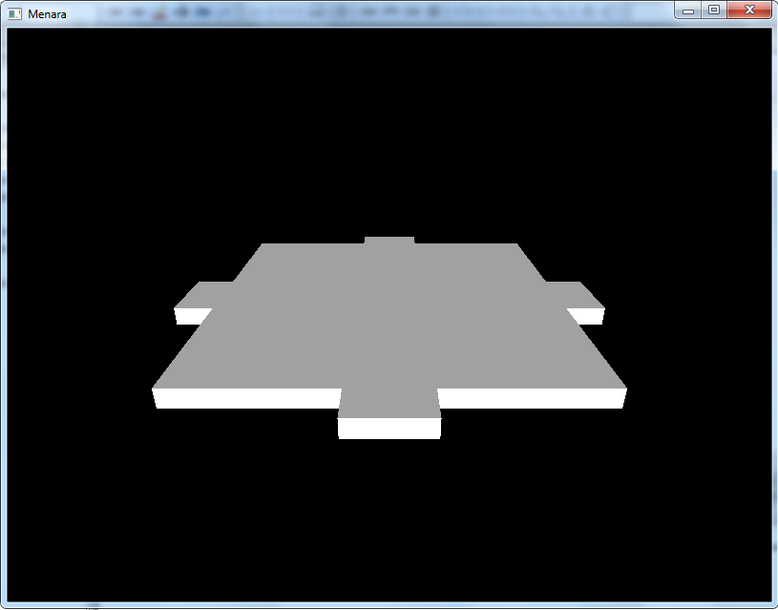

Source Code :
/* lantai */
void lantai()
{
glPushMatrix();
glScalef(5.0,-0.25,5.0);
glutSolidCube(2);
glPopMatrix();
}

void tanggadepan()
{
//tangga depan dan belakang
glPushMatrix();
glScalef(1.0,-0.25,0.5);
glutSolidCube(2);
glPopMatrix();
}

void tanggasamping()
{
//tangga kanan dan kiri
glPushMatrix();
glScalef(0.7,-0.25,1.0);
glutSolidCube(2);
glPopMatrix();
}
void lantaifix()
{
glColor3f(White);
lantai();
//tangga depan
glPushMatrix();
glTranslatef(0.0,0.0,5.5);
tanggadepan();
glPopMatrix();

//tangga belakang
glPushMatrix();
glTranslatef(0.0,0.0,-5.5);
tanggadepan();
glPopMatrix();

//tangga kanan
glPushMatrix();
glTranslatef(5.4,0.0,0.0);
// glRotated(45,1.0,1.0,1.0);
tanggasamping();
glPopMatrix();

//tangga kiri
glPushMatrix();
glTranslatef(-5.4,0.0,0.0);
tanggasamping();
glPopMatrix();
}

Terrain
Function : void drawSceneTanah(Terrain *terrain, GLfloat r, GLfloat g, Glfloat b)
Penjelasan : Fungsi ini bertujuan untuk mengenerate gambar heightmap kedalam bentuk 3D, dan pengaturan skala, panjang dan lebar dari hasil terrain nantinya.
Screenshot :
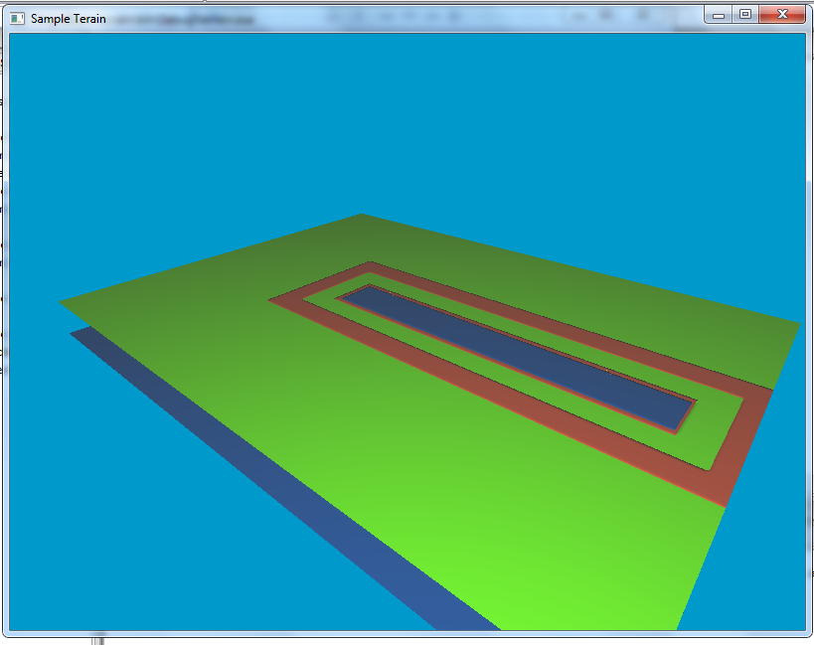

Source Code :
void drawSceneTanah(Terrain *terrain, GLfloat r, GLfloat g, GLfloat b) {

float scale = 400.0f / max(terrain->width() - 1, terrain->length() - 1);
glScalef(scale, scale, scale);
glTranslatef(-(float) (terrain->width() - 1) / 2, 0.0f,
-(float) (terrain->length() - 1) / 2);

glColor3f(r, g, b);
for (int z = 0; z < terrain->length() - 1; z++) {
//Makes OpenGL draw a triangle at every three consecutive vertices
glBegin(GL_TRIANGLE_STRIP);
for (int x = 0; x < terrain->width(); x++) {
Vec3f normal = terrain->getNormal(x, z);
glNormal3f(normal[0], normal[1], normal[2]);
glVertex3f(x, terrain->getHeight(x, z), z);
normal = terrain->getNormal(x, z + 1);
glNormal3f(normal[0], normal[1], normal[2]);
glVertex3f(x, terrain->getHeight(x, z + 1), z + 1);
}
glEnd();
}

}

