Dear Dr. Kruuk,

Thank you for reviewing our manuscript and for giving us the opportunity to address the points raised by you, Dr. Slocombe, and the two reviewers.

An overarching concern was whether our paper addresses fundamental biological principles. In this revision we clarify how our study is, indeed, rooted in biological questions concerning the qualitative differences between the words of human language and communicative signals of non-human animals. In the revised introduction, we clarify the biological nature of the question we ask concerning the origin of spoken words and the role of the human capacity for vocal imitation in this process.

We have substantially edited the introduction to more properly situate our work for the audience of Proceedings B. For example, we present language in the broader context of primate vocal communication, and note aspects of language that distinguishes it from these other forms of communication.

We also address each point made by the reviewers below.  
  
**Referee 1:**

*1. In the introduction the authors write (80-81): does the imitation of a particular water-splashing sound become, over generations of repeated  imitation, a better label for the more general category of water-splashing sounds? What does this mean in linguistic terms? Do the authors refer in any way to the iconicity of language?*

Indeed. This work is situated within the general topic of linguistic iconicity.

On the view that category labels are arbitrary, there is no sense in which one label is any better or worse than any other. We challenge this view by demonstrating that otherwise equal labels may be easier or harder to learn and generalize to new category members. Thus, in this experiment, our measure of what makes one label “better” than another is not derived from linguistic features, but from behavioral measures. We argue that labels that are learned faster and generalized to new category members more easily are de facto better category labels.

Our approach in looking to behavioral measures for determining how closely aligned a particular word form is with its potential meaning very much fits with current views on iconicity in language, as the reviewer notes. We now introduce iconicity earlier in the manuscript, including reference to iconicity in signed languages, and we pose our research questions as aiming to determine whether similar principles might apply in the formation of new spoken words.

*2. In “Collecting vocal imitations”, 111-112, “Participants were allowed to listen  
to each target sound multiple times” How many times were allowed to listen to each target? Was there a maximum number of repetitions allowed to each participant?*

There was no maximum number of repetitions allowed to each participant. The quoted text now reads:

Participants were allowed to listen to each target sound as many times as they wished, but were only allowed a single recording in response.

*3.  Figures in the text, please, the graphs must include the headings on the x and y axes*

We are sorry for this. There was an error in the conversion of our document into the online manuscript management system. A support request was submitted during our initial submission but was not addressed before the manuscript was sent out. Our submission now appears correctly online as it does offline.  
  
**Referee 2:**

*1. My first general issue concerns what these findings tell us. The paper shows that modern English-speaking humans show biases, that are present in their language, in the specific task. Namely, they can imitate sounds (and we have plenty examples of onomatopoaies in English as well across languages), and their imitations become more word-like (and there are plenty indications from previous studies using iterated learning - see point 2 below) that through generations language-like properties emerge in this paradigm. Thus, the findings are not surprising.*  
  
*Still, unsurprising findings can be informative about language evolution. Here, however, I also have a problem. In addition to the usual difficulty in making any sort of claim concerning language origin and evolution starting from modern humans (who already know a language), the present findings do not allow us to claim that imitation in vocalizations is a sine qua non, nor that they have been the first step. They do not falsify the possibility that gesture came first, nor that a combination of gesture and vocalization was key. They simply show that imitation in vocalization might have played a part. Thus, I find the argument proposed in the paper not to be fully justified on the basis of the findings.*

We take the Reviewer’s point that our hypothesis about the formation of conventional words from vocal imitations is not new. We do believe we are among the first to attempt to document the transition from vocal imitations to conventional words in a lab study. Our study is also, to our knowledge, the first to show that simple repeated imitation of environmental sounds can lead to better category labels which at the same time preseving iconic resemblance to the original sound).

We agree with the reviewer that these findings do not directly falsify other hypotheses about language evolution, namely the role of gesture. In light of these points, we have qualified our main argument as a specific test of the minimal conditions under which vocal imitations might give rise to conventional words. In the introduction, we describe our research question as follows:

Thus, converging evidence suggests that people can use vocal imitation as an effective means of communication. At the same time, vocal imitations are not words. If vocal imitation played a role in the origin of some spoken words, then it is necessary to identify the minimal conditions under which vocal imitations can give rise to more word-like vocalizations that can eventually be integrated into a vocabulary of a language. In the present set of studies we ask whether vocal imitations can transition to more word-like forms through sheer repetition — without an explicit intent to communicate. To answer this question, we recruited participants to play an online version of the children’s game of “Telephone”. …

We also included a concluding paragraph discussing the implication of our results for theories of language evolution that emphasize the role of gesture, leaving .

Notably, our hypothesis that vocal imitation may have played a role in the origin of some of the first spoken words does not preclude that gesture played an equal or more important role in establishing the first linguistic conventions (e.g. Fay, Arbib & Garrod, 2013; Goldin-Meadow, 2016; Kendon, 2016). What the present results make clear is that the transition from imitation to word can be a rapid and simple process: the mere act of repeated imitation can drive vocalizations to become more word-like in both form and function while still retaining some resemblance to the real world referents.

*2. There is by now an important tradition within language studies in using the method presented here in Experiment 1 (and multiple variations on this methods). This method is referred as iterated learning has been introduced by Simon Kirby and colleagues (Kirby et al., 2008). It is rather puzzling that the present paper does not make any reference to the previous papers, to the name of the paradigm and, importantly, to the learning mechanisms that have abundantly discussed in the literature as underscoring the processes simulated with the use of this paradigm. This, in my mind, is especially important. On line 419, they write “Our results show that through simple repetition...”, which seems to me to trivialise what is going on in the study. In fact, they don’t really address what is going on – what the learning mechanisms may be that give rise to rendering imitations more word-like through generations. It seems strange to me to use a very particular and well-discussed experimental paradigm and then not discuss at all why you used it or what the effects of it are.*

Not mentioning iterated learning—a literature that is quite familiar to us—was an oversight. We have included a new paragraph in the introduction that describes the relationship between our paradigm and previous uses of iterated learning paradigms in language evolution research. In brief, we are hesitant to call what we observed in our experiments as “learning” because imitators are unguided in their repetition of the acoustic messages, and thus no learning is required. However, what is similar between previous research on iterated transmission and the current study is that the constraints on faithful repetition of the signal are what drive the observed change. In this case, the aspects of an acoustic signal that cannot be repeated by subsequent generations will not survive the transmission to the next generation, leaving only the acoustic elements that are easier for different individuals to recreate. It is this tendency to move toward more reproducible forms that drives what was once an imitation of a specific acoustic event to become a more general representation of a family of related acoustic events.

*3. The authors call ‘imitative’ what, in the literature is more commonly referred as ‘iconic”. They do not define what they mean by ‘imitative’ nor whether ‘imitative’ is still a correct label to use for the word-like productions that they observe in later generations (where the vocalizations are indeed less imitative). This is an important point if we want to understand the mechanisms that underscore the effects found.*

We agree with the reviewer that it is important to be as precise as possible in our use of the terms ‘imitative and ‘iconic’. These terms overlap in meaning, but, as the reviewer notes, they are not entirely interchangeable. In general, we use the term ‘imitative’ (and derivatives) when referring to cases when a vocalization results from an attempt to produce an accurate, high-fidelity representation of a sound. For example, in our instructions, participants were asked to record themselves “imitating” the sound by “recreating it as accurately” as possible. In comparison, we use ‘iconicity’ to refer more broadly to resemblance between the form of a signal (e.g. a vocalization or gesture) and its referent or meaning. Words that bear a recognizable resemblance are ‘iconic’ (which includes words for non-sound concepts, like *teeny*). Iconic words may or may not have been created by an attempt to imitate a sound. In the revision, we aim to be careful with this distinction, and we discuss iconicity more explicitly, for example, on p. 3 referring to “a growing recognition of the importance of iconicity in spoken languages.

*4. I am unsure about the reasoning behind experiment 3. They argue that if vocalizations are more word-like, then they should more likely refer to categories rather than specific exemplars. I am always uneasy when talking about categorization levels as we do not know, really, whether the specific sounds within each category might already be categories standing for various tokens of the same type. That having been said, I know that some people have argued that iconicity is at the level of categories, not exemplars (e.g., Monagham, 2012). However, we also know that speakers may have more or fewer specific labels within a category (e.g., Eskimos have 10 different words for snow, English speakers only have one) depending upon whether it is important to differentiate or not. Hence one can argue that there is a bias toward category-level labels just because making finer distinctions is not so relevant to the task.*

We have clarified the rationale behind Experiment 3. Categorical reference is one of the key design features of language. All words (with the possible exception of proper nouns) denote categories, though the breadth of the category varies, as the reviewer points out. “Insect” denotes a broader category than “wasp”. “Liquid” denotes a broader category than “water”. But despite this, even highly specific words are categorical in that they abstract away from details of individual tokens/exemplars.

One way to think about the relationship between iconicity and categorical reference is that an iconic word-form evokes more specific exemplars while a word-form is highly effective for evoking a category (Edmiston & Lupyan, 2015; Lupyan & Thompson-Schill, 2012). This is what forms the basis for our prediction in Experiment 3. We reason that to the extent that the imitations are becoming more word-like, they should be abstracting more from the particulars of individual exemplars (e.g., a particular water splashing sound), and act as better labels for the category (e.g., the category of water splashing sounds).

With regard to Monaghan et al’s work on what they have referred to as systematicity or non-arbitrary links between phonology and lexical class—we note that these authors do not dispute the existence of non-arbitrary links between forms and meanings of the kind we are investigating here, e.g., (Dingemanse, Blasi, Lupyan, Christiansen, & Monaghan, 2015). That is, non-arbitrariness at the level of lexical-class-to-wordform does not preclude non-arbitrariness at the level of word-meaning -to- wordform.

*5. The different results for spoken and written labels that they got in Experiment 3 may be task related: in the spoken version, there were three questions, only 2 in the written version. This alternative account needs to be addressed.*

*6. Related to 5, the issue of differences in difficulty between questions in Experiment 3, I think, is not sufficiently addressed.*

We believe the Reviewer is referring to the results of Experiment 2 (Fig. 5), and the fact that the “True seed advantage” – the increase in performance when the true seed was present in the options – decreased over generations when matching imitations to seed sounds, but not when matching written transcriptions back to seed sounds.

We admit that the difference between the results for matching vocalizations to the environmental sounds and transcribed vocalizations to the original sounds is unclear. However, we do not believe the difference is due to the number of questions. The reason is that question type was assigned between-subject, and so each line in Fig. 5 comprises responses from an independent sample of observers. Because responses to each question are independent in both versions of the study, there is no way for the specific match questions to impact estimates of the other question accuracies. However, since we are fitting our results with hierarchical models, our estimates may still be influenced by the inclusion of the third question type. We now report a new analysis that compares the two versions of the experiment without the specific match questions. The decrease in the true seed advantage is unaffected by the exclusion.

We have also clarified our explanation of these findings based on the differences in question difficulty.

The emergence of words from vocal imitations

|  |
| --- |
| Pierce Edmiston1, Marcus Perlman2, & Gary Lupyan1 |
|  |
| 1 University of Wisconsin-Madison |
| 2 University of Birmingham |
|  |

# Author note

Pierce Edmiston and Gary Lupyan, Department of Psychology, University of Wisconsin-Madison, Madison, Wisconsin. Marcus Perlman, University of Birmingham, United Kingdom.

Correspondence concerning this article should be addressed to Pierce Edmiston, 1202 W. Johnson St., Madison, WI, 53703. E-mail: [pedmiston@wisc.edu](mailto:pedmiston@wisc.edu)

# Abstract

People have long pondered the origins of language, especially the words that compose them. Here, we report a series of experiments investigating how conventional spoken words might emerge from imitations of environmental sounds. Does the repeated imitation of an environmental sound gradually give rise to more wordlike forms? In what ways do these words resemble the original sounds that motivated them (i.e., iconicity)? Participants played a version of the children’s game “Telephone”. The first generation of participants imitated recognizable environmental sounds (e.g., glass breaking, water splashing). Subsequent generations imitated the previous generation of imitations for a maximum of 8 generations. The results showed that the imitations became more stable and word-like, and later imitations were easier to learn as category labels. At the same time, even after 8 generations, both spoken imitations and their written transcriptions could be matched above chance to the category of environmental sound that motivated them. These results show how repeated imitation can create progressively more word-like forms while continuing to retain a resemblance to the original sound that motivated them, and speak to the possible role of human vocal imitation in explaining the origins of at least some spoken words.

*Keywords:* language evolution, iconicity, vocal imitation, transmission chain

Word count: 7199

# The emergence of words from vocal imitations

Most vocal communication of non-human primate species is based on a repertoire of species-typical calls that are highly similar across generations and between populations (e.g. Seyfarth & Cheney, 1986) (but see, e.g. Crockford, Herbinger, Vigilant, & Boesch, 2004). In contrast, human languages comprise a vast repertoire of learned meaningful elements (words and other morphemes) which can number in the tens of thousands or more (e.g., Brysbaert, Stevens, Mandera, & Keuleers, 2016). Aside from their number, the words of different natural languages are characterized by their extreme diversity (Evans & Levinson, 2009; Lupyan & Dale, 2016; Wierzbicka, 1996). The words used within a speech community change relatively quickly over generations compared to the evolution of vocal signals (e.g., Pagel, Atkinson, & Meade, 2007). At least in part as a consequence of this divergence, most words appear to bear a largely arbitrary relationship between their form and their meaning — seemingly, a product of their idiosyncratic etymological histories (Labov, 1972; Sapir, 1921). The apparently arbitrary nature of spoken vocabularies presents a quandary for the study of language origins. If words of spoken languages are truly arbitrary, by what process were the first words ever coined?

While the origin of most spoken words is hard to discern, the situation is somewhat different for signed languages. In signed languages, the origins of many signs are relatively transparent. Although signed languages rely on the same type of referential symbolism as spoken languages, many individual signs have clear iconic roots, formed from gestures that resemble their meaning (Frishberg, 1975; Goldin-Meadow, 2016; Kendon, 2014; Klima & Bellugi, 1980). For instance, Frishberg (1975) noted the iconic origins of the American Sign Language (ASL) sign for bird, which is formed with a beak-like handshape articulated in front of the nose. Another example is steal, derived from a grabbing motion to represent the act of stealing something. Stokoe (1965) identified about 25% of American Sign Language signs to be iconic, and reviewing the remaining 75% of ASL signs, Wescott (1971) determined that about two-thirds of these seemed plausibly derived from iconic origins. Further support for iconic origins of signed languages comes from observations of deaf children raised without exposure to a signed language, who develop homesign systems to use with their family. These communication systems are generally built from a process in which the children establish conventional gestures through the use of pantomimes and various iconic and indexical gestures (e.g. Goldin-Meadow & Feldman, 1977). Participants in laboratory experiments utilize a similar strategy when they communicate with gestures in iterated communication games (Fay, Lister, Mark Ellison, & Goldin-Meadow, 2014).

In contrast to the visual gestures of signed languages, many have argued that iconic vocalizations could not have played a significant role in the origin of spoken words because the vocal modality simply does not afford much resemblance between form and meaning (M. A. Arbib, 2012; Armstrong & Wilcox, 2007; Corballis, 2003; Hewes, 1973; Hockett, 1978; Tomasello, 2010). It has also been argued that the human capacity for vocal imitation is a domain-specific skill, geared towards learning to speak, rather than the representation of environmental sounds. For example, Pinker and Jackendoff (2005) suggested that, “most humans lack the ability… to convincingly reproduce environmental sounds… Thus ‘capacity for vocal imitation’ in humans might be better described as a capacity to learn to produce speech” (p. 209). Consequently, it is still widely assumed that vocal imitation — or more broadly, the use of any sort of resemblance between form and meaning — cannot be important to understanding the origin of spoken words.

Although most words of contemporary spoken languages are not clearly imitative in origin, there has been a growing recognition of the importance of iconicity in spoken languages (Dingemanse, Blasi, Lupyan, Christiansen, & Monaghan, 2015; Perniss, Thompson, & Vigliocco, 2010) and the common use of vocal imitation and depiction in spoken discourse (Clark & Gerrig, 1990; Lewis, 2009). This has led some to argue for the importance of imitation for understanding the origin of spoken words (e.g., Brown, Black, & Horowitz, 1955; Dingemanse, 2014; Donald, 2016; Imai & Kita, 2014; Perlman, Dale, & Lupyan, 2015). In addition, counter to previous assumptions, people are highly effective at using vocal imitations to refer to environmental sounds such as coins dropping in a jar or mechanical events such as scraping – in some cases, even more effective than when using conventional words (Lemaitre & Rocchesso, 2014). Recent work has also shown that people are able to create novel imitative vocalizations for more abstract meanings (e.g. ‘slow’, ‘rough’, ‘good’, ‘many’) that are understandable to naïve listeners (Perlman et al., 2015). These imitations are effective not because people can mimic environmental sounds with high fidelity, but because people are able to produce imitations that capture the salient features of sounds in ways that are understandable to listeners (Lemaitre, Houix, Voisin, Misdariis, & Susini, 2016). Similarly, the features of onomatopoeic words might highlight distinctive aspects of the sounds they represent. For example, the initial voiced, plosive /b/ in “boom” represents an abrupt, loud onset, the back vowel /u/ a low pitch, and the nasalized /m/ a slow, muffled decay (Rhodes, 1994).

Thus, converging evidence suggests that people can use vocal imitation as an effective means of communication. At the same time, vocal imitations are not words. If vocal imitation played a role in the origin of some spoken words, then it is necessary to identify the minimal conditions under which vocal imitations can give rise to more word-like vocalizations that can eventually be integrated into a vocabulary of a language. In the present set of studies we ask whether vocal imitations can transition to more word-like forms through sheer repetition — without an explicit intent to communicate. To answer this question, we recruited participants to play an online version of the children’s game of “Telephone”. In the children’s game, a spoken message is whispered from one person to the next. In our version, the original message or “seed sound” was a recording of an environmental sound. The initial group of participants (first generation) imitated these seed sounds, the next generation imitated the previous imitators, and so on for up to 8 generations.

Our approach uses a transmission chain methodology similar to that frequently used in experimental studies of language evolution (Tamariz, 2017, for review). As with other transmission chain studies (and iterated learning studies more generally), we seek to discover how various biases and constraints of individuals change the nature of a linguistic signal. Importantly, while typical transmission chain studies focus on the impact of learning biases (e.g., Kirby, Cornish, & Smith, 2008), the present studies involve iterated reproduction that does not involve any learning. Participants simply attempt to imitate a sound as best as they can. The biases we hypothesize to drive vocalizations to become more wordlike are therefore not related to any learning process, but instead are expected to emerge from constraints on the reproducibility of vocalizations. Our aim is thus to determine whether iterated reproduction, even without learning, is a sufficient enough constraint to enable the emergence of more wordlike signals.

After collecting the imitations, we conducted a series of analyses and additional experiments to systematically answer the following questions: First, do imitations stabilize in form and become more word-like as they are repeated? Second, do the imitations retain a resemblance to the original environmental sound that inspired them? If so, it should be possible for naïve participants to match the emergent words back to the original seed sounds. Third, do the imitations become more suitable as categorical labels for the sounds that motivated them? For example, does the imitation of a particular water-splashing sound become, over generations of repeated imitation, a better label for the more general category of water-splashing sounds?

# Experiment 1: Stabilization of imitations through repetition

In the first experiment, we collected the vocal imitations, and assessed the extent to which repeating imitations of environmental sounds over generations of unique speakers results in progressive stabilization toward more word-like forms. After collecting the imitations, we measured changes in the stability of the imitations in three ways. First, we measured changes in the perception of acoustic similarity between subsequent generations of imitations along contiguous transmission chains. Second, we used algorithmic measures of acoustic similarity to assess the similarity of imitations sampled within and between transmission chains. Third, we obtained transcriptions of imitations, and measured the extent to which later generation imitations were transcribed with greater consistency and agreement. The results show that repeated imitation results in vocalizations that are easier to repeat with high fidelity and more consistently transcribed into English orthography.

## Methods

### Selecting seed sounds

To avoid sounds having lexicalized or conventionalized onomatopoeic forms in English, we used inanimate categories of environmental sounds. Using an odd-one-out norming procedure (*N*=105 participants), an initial set of 36 sounds in 6 categories was reduced to a final set of 16 “seed” sounds: 4 sounds in each of 4 categories. The purpose of this norming procedure was to reach a set of approximately equally distinguishable sounds within each category by systematically removing the sounds that stood out in each category. The results of the norming procedure are shown in Fig. S1. The four final categories were: water, glass, tear, zipper. The final 16 seed sounds can be downloaded from here: [osf.io/n6g7d/download](https://osf.io/n6g7d/download).

### Collecting vocal imitations

Participants (*N*=94) recruited from Amazon Mechanical Turk were paid to participate in an online version of the children’s game of “Telephone”. Participants were instructed that they would hear some sound and their task was to reproduce it as accurately as possible using their computer microphone. Full instructions are provided in the Supplemental Materials.

Each participant listened to and imitated four sounds: one from each of the four categories of environmental sounds. Sounds were assigned at random such that participants were unlikely to imitate the same person more than once. Participants were allowed to listen to each target sound as many times as they wished, but were only allowed a single recording in response. Recordings that were too quiet (less than -30 dBFS) were not accepted.

Imitations were monitored by an experimenter to catch any gross errors in recording before they were heard by the next generation of imitators. For example, recordings with loud sounds in the background were removed, and recordings were trimmed to the length of the imitation prior to the next generation. The experimenter also removed sounds that violated the rules of the experiment, e.g., by saying something in English. A total of 115 (24%) imitations were removed prior to subsequent analysis. The final sample contained 365 imitations along 105 contiguous transmission chains (Fig. 1).

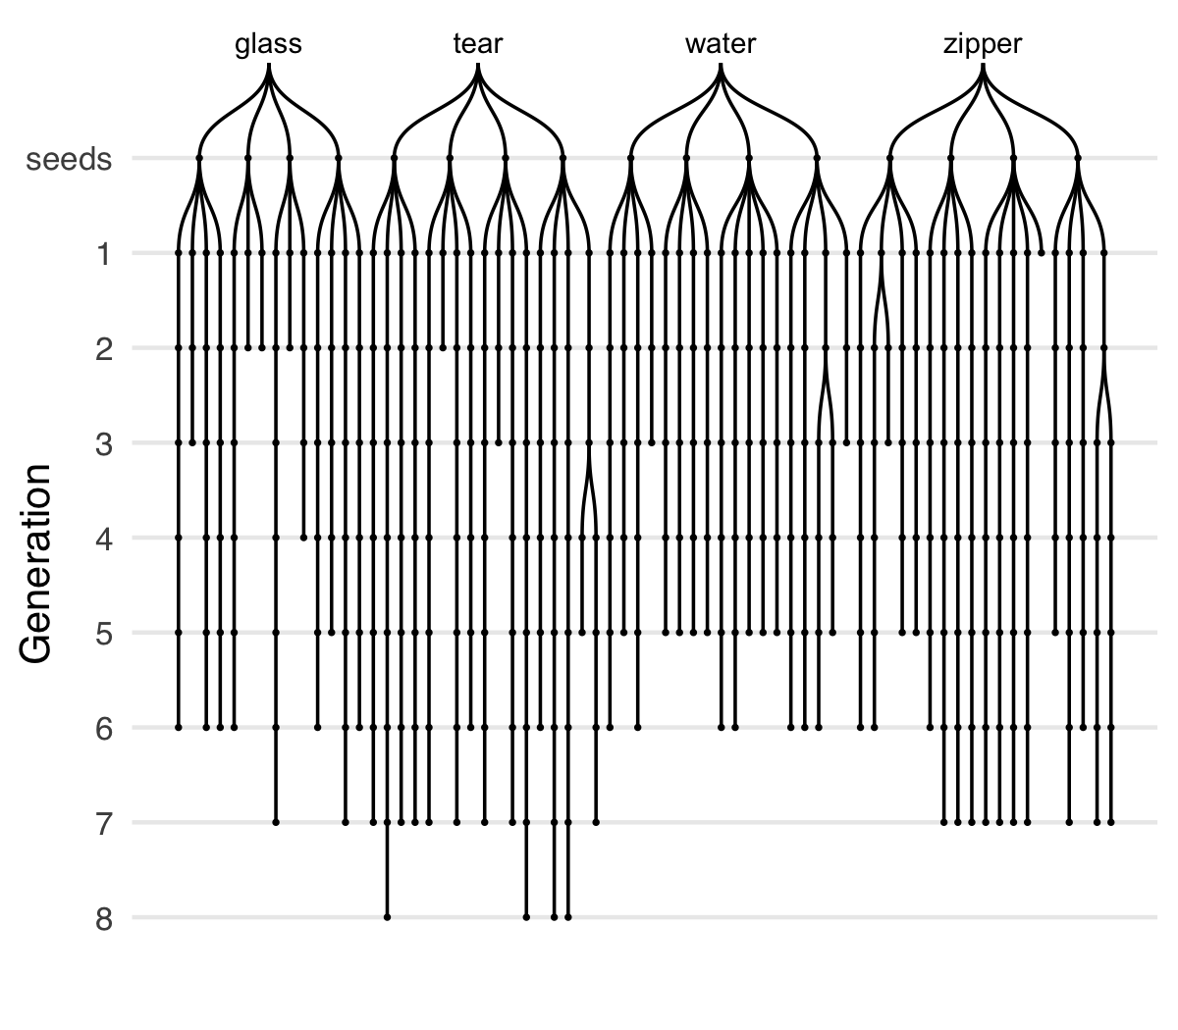

Figure 1 Vocal imitations collected in the transmission chain experiment. Seed sounds (16) were sampled from four categories of environmental sounds: glass, tear, water, zipper. Participants imitated each seed sound, and then the next generation of participants imitated the imitations, and so on, for up to 8 generations. Chains are unbalanced due to random assignment and the exclusion of some low quality recordings.

### Measuring acoustic similarity

#### Acoustic similarity judgments

Acoustic similarity judgments were gathered from five research assistants who listened to pairs of sounds (approx. 300) and rated their subjective similarity. On each trial, raters heard two sounds from subsequent generations played in random order. They then indicated the similarity between the sounds on a 7-point Likert scale from *Entirely different and would never be confused* to *Nearly identical*. Raters were encouraged to use as much of the scale as they could while maximizing the likelihood that, if they did this procedure again, they would reach the same judgments. Full instructions are provided in the Supplemental Materials. Inter-rater reliability was calculated as the intra-class coefficient treating the group as the unit of analysis (Gamer, Lemon, Fellows, & Singh, 2012; Shrout & Fleiss, 1979): ICC = 0.76, 95% CI [0.70, 0.81], F(170, 680) = 4.18, *p* < 0.001. Ratings were normalized for each rater (z-scored) prior to analysis.

#### Algorithmic acoustic similarity

To obtain algorithmic measures of acoustic similarity, we used the acoustic distance functions included in Phonological Corpus Tools (Hall, Allen, Fry, Mackie, & McAuliffe, 2016). We computed Mel-frequency cepstral coefficients (MFCCs) between pairs of imitations using 12 coefficients in order to obtain speaker-independent estimates.

### Collecting transcriptions of imitations

Participants (*N*=216) recruited from Amazon Mechanical Turk were paid to transcribe vocalizations using English orthography, being instructed to write down what they heard as a single “word” so that the written word would sound as much like the sound as possible. Participants were instructed that this was a word creation task and so to avoid transcribing the vocalizations into existing English words. Each participant completed 10 transcriptions. Transcriptions were gathered for the first and the last three generations of imitations collected in the transmission chain experiment. Participants also provided “transcriptions” of the original environmental seed sounds. Analyses of these transcriptions are reported in the Supplementary Materials (Fig. S5).

To measure similarity among transcriptions of the same imitation, we used the SequenceMatcher functions in the difflib package of the Python standard library, which implements a version of Ratcliff and Obershelp’s “gestalt pattern matching” algorithm. Alternative measures of transcription agreement including exact string matching and the length of the longest substring match were also collected.

### Analyses

Statistical analyses were conducted in R using linear mixed-effects models provided by the lme4 package (Bates, Mächler, Bolker, & Walker, 2015). Degrees of freedom and corresponding significance tests for linear mixed-effects models were estimated using the Satterthwaite approximation via the lmerTest package (Kuznetsova, Bruun Brockhoff, & Haubo Bojesen Christensen, 2016). Random effects (intercepts and slopes) for subjects and for items were included wherever appropriate, as described below.

### Data availability

Our data along with all methods, materials, and analysis scripts, are available in public repositories described on the Open Science Framework page for this research here: [osf.io/3navm](https://osf.io/3navm).

## Results

### Acoustic similarity increased through iteration

Imitations of environmental sounds became more stable over the course of being repeated as revealed by increasing acoustic similarity judgments along individual transmission chains. Acoustic similarity ratings were fit with a linear mixed-effects model predicting perceived acoustic similarity from generation with random effects (intercepts and slopes) for raters. To test whether the hypothesized increase in acoustic similarity was true across all seed sounds and categories, we added random effects (intercepts and slopes) for seed sounds nested within categories. The results showed that, across raters and seeds, imitations from later generations were rated as sounding more similar to one another than imitations from earlier generations, *b* = 0.10 (SE = 0.03), *t*(11.9) = 3.03, *p* = 0.011 (Fig. 2). This result suggests that imitations became more stable (i.e., easier to imitate with high fidelity) with each generation of repetition.

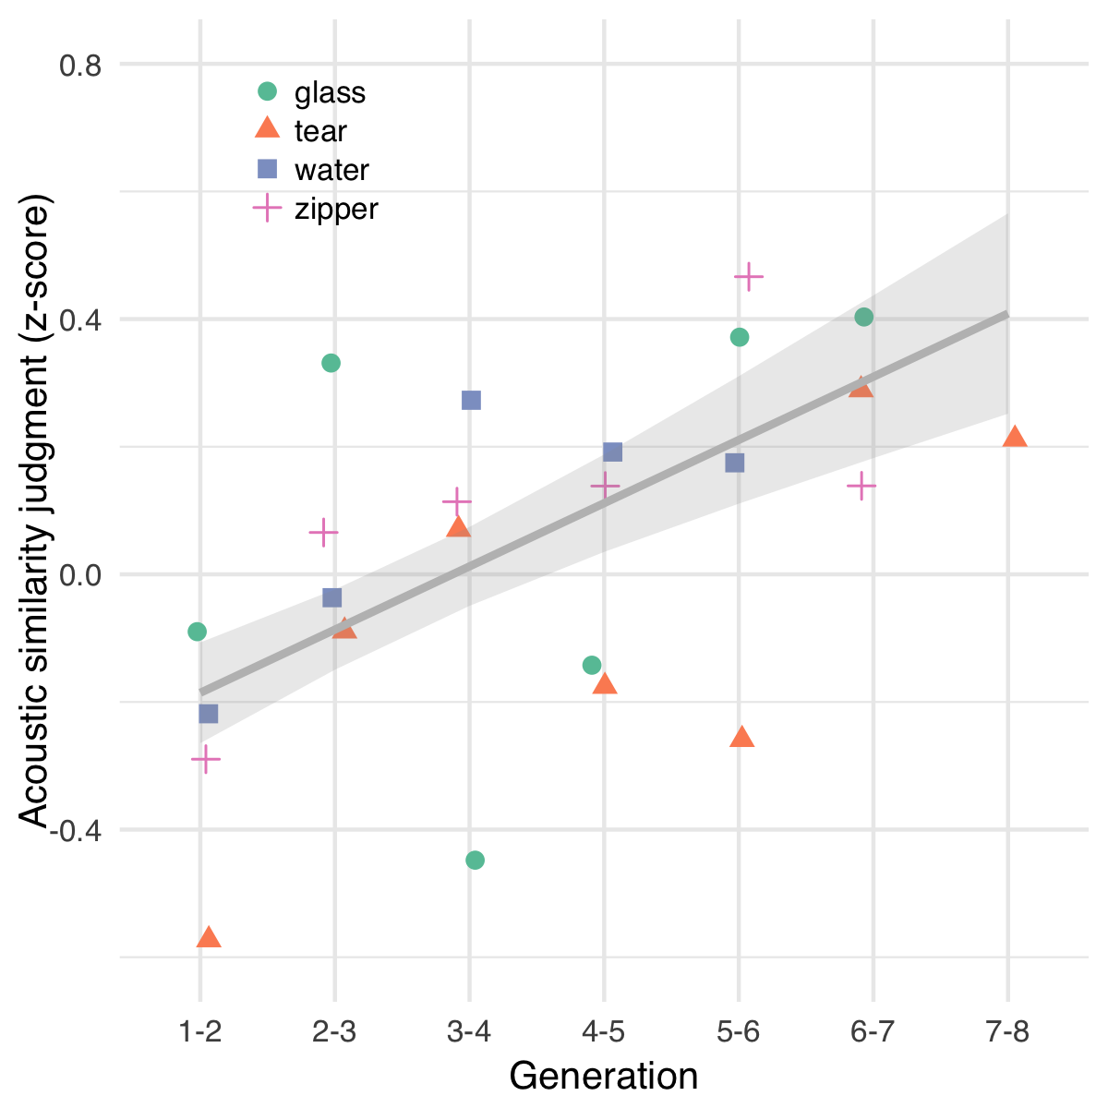

Figure 2 Change in perception of acoustic similarity over generations of iterated imitation. Points depict mean acoustic similarity ratings for pairs of imitations in each category. The predictions of the linear mixed-effects model are shown with ±1 SE. Acoustic similarity increased over generations, indicating that repetition made the vocalizations easier to imitate with high fidelity.

### Acoustic similarity was highest within transmission chains

Increasing similarity along transmission chains could also reflect the continuous degradation of the signal due to repeated imitation, in which case we would expect acoustic similarity to increase both within as well as between transmission chains as a function of generation of imitation. To rule out this alternative explanation, we calculated MFCCs for pairs of sounds sampled from within and between different transmission chains from consecutive generations across categories. To analyze the results, we fit a linear model predicting normalized acoustic similarity scores (z-scores) from the generation of sounds. A hierarchical model was not appropriate for this analysis because the between-chain pairs of sounds were sampled from different categories, preventing any random effects due to category or seed from being included in the model. We found that acoustic similarity increased within chains more than it increased between chains, *b* = -0.07 (SE = 0.03), *t*(6674.0) = -2.13, *p* = 0.033 (Fig. S2). This result supports the conclusion that transmission chains were stabilizing on divergent acoustic forms as opposed to all chains converging on similar forms through continuous degradation.

### Later generation imitations were transcribed more consistently

An additional test of stabilization and word-likeness was to measure whether later generation imitations were transcribed more consistently than first generation imitations. We collected a total of 2163 transcriptions — approximately 20 transcriptions per sound. Of these, 179 transcriptions (8%) were removed because they contained English words. Some examples of the final transcriptions are presented in Table 1.

Table 1 Examples of words transcribed from imitations.

|  |  |  |  |
| --- | --- | --- | --- |
| Category | Seed | First generation | Last generation |
| glass | 1 | tingtingting | deetdedededeet |
| glass | 2 | chirck | correcto |
| glass | 3 | dirrng | wayew |
| glass | 4 | boonk | baroke |
| tear | 1 | scheeept | cheecheea |
| tear | 2 | feeshefee | cheeoooo |
| tear | 3 | hhhweerrr | chhhhhhewwwe |
| tear | 4 | ccccchhhhyeaahh | shhhhh |
| water | 1 | boococucuwich | eeverlusha |
| water | 2 | chwoochwooochwooo | cheiopshpshcheiopsh |
| water | 3 | atoadelchoo | mowah |
| water | 4 | awakawush | galonggalong |
| zipper | 1 | euah | izoo |
| zipper | 2 | zoop | veeeep |
| zipper | 3 | arrgt | owww |
| zipper | 4 | bzzzzup | izzip |

To measure the similarity among transcriptions, we calculated the orthographic distance between the most frequent transcription and all other transcriptions of a given imitation. The orthographic distance measure was a ratio based on longest contiguous matching subsequences between pairs of transcriptions. We then fit a hierarchical linear model predicting orthographic distance from the generation of the imitation (First generation, Last generation) with random effects (intercepts and slopes) for seed sound nested within category[1]. The results showed that transcriptions of last generation imitations were more similar to one another than transcriptions of first generation imitations, *b* = -0.12 (SE = 0.03), *t*(3.0) = -3.62, *p* = 0.035 (Fig. 3). The same result is reached through alternative measures of orthographic distance, such as the percentage of exact transcription matches for each imitation, *b* = 0.10 (SE = 0.03), *t*(90.0) = 2.84, *p* = 0.006, and the length of the longest matching substring, *b* = 0.98 (SE = 0.24), *t*(15.1) = 4.14, *p* < 0.001 (Fig. S3). Differences between transcriptions of human vocalizations and transcriptions directly of environmental sound cues are presented in the Supplementary Materials (Fig. S5).

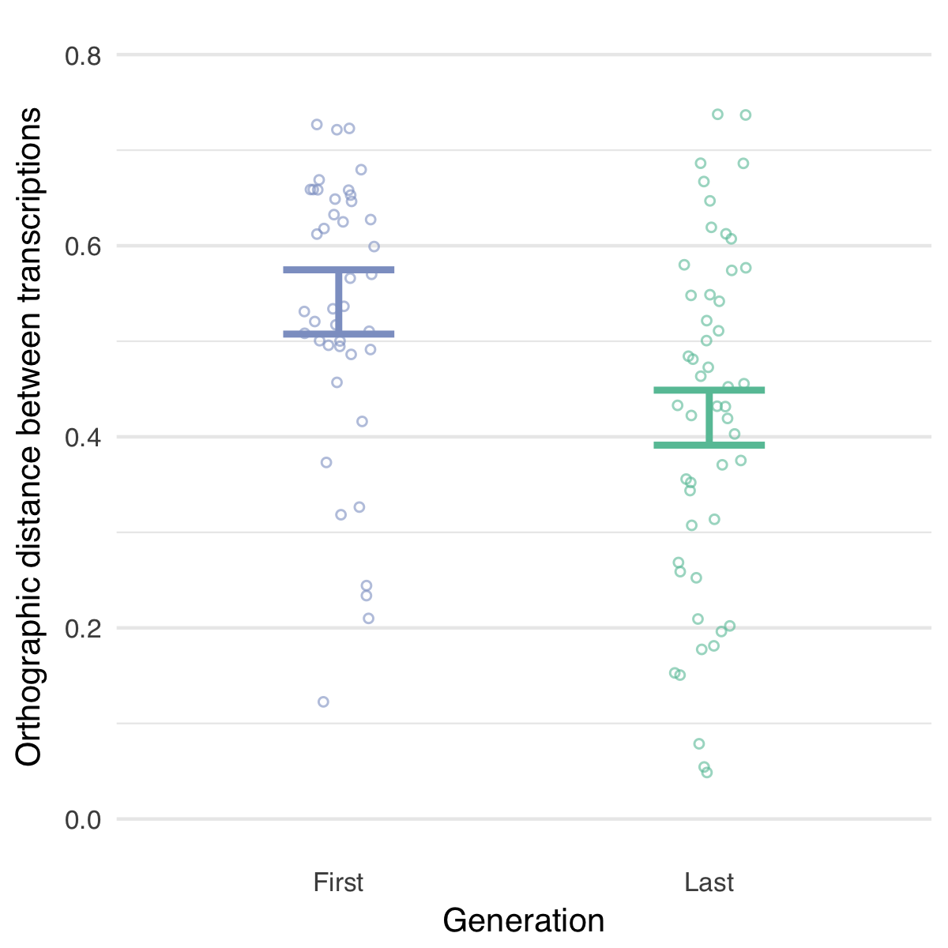

Figure 3 Orthographic agreement among transcriptions of first and last generation imitations. Points depict the mean orthographic distance between the most frequent transcription and all other transcriptions of a given imitation, with error bars denoting ±1 SE of the hierarchical linear model predictions. Transcriptions of later generation imitations were more similar to one another than transcriptions of first generation imitations, suggesting that repeating imitations made them easier to transcribe into English orthography than direct imitations of environmental sounds.

## Discussion

Repeating imitations of environmental sounds over generations of unique speakers was sufficient to create more wordlike forms, even without any explicit intent to communicate. We defined wordlike-ness in terms of acoustic stability and orthographic agreement. With additional repetitions, the acoustic forms of the imitations became more similar to one another, indicating they became easier to repeat with high fidelity. The possibility that this similarity was due to uniform degradation across all transmission chains was ruled out by algorithmic analyses of acoustic similarity within and between chains demonstrating that acoustic similarity increased within chains but not between them. Additionally, later generation imitations were transcribed more consistently into English orthography, further supporting our hypothesis that repeating imitations makes them more word-like.

The results of Experiment 1 demonstrate the ease with which iterated imitation gives rise to new word forms. However, the results do not address how these emergent words relate to the original sounds that were being imitated. As the imitations became more word-like, were they stabilizing on arbitrary acoustic and orthographic forms, or did they maintain some resemblance to the environmental sounds that motivated them? The purpose of Experiment 2 was to assess the extent to which repeated imitations and their transcriptions maintained a resemblance to the original set of seed sounds.

# Experiment 2: Resemblance of imitations to original seed sounds

To assess the resemblance of repeated imitations to the original seed sounds, we measured the ability of participants naïve to the design of the experiment to match imitations and their transcriptions back to their original sound source relative to other seed sounds from either the same category or from different categories (Fig. 4). We used the match accuracies to answer two questions concerning the effect of iterated imitation on resemblance to the original seed sounds. First, we asked whether and for how many generations the imitations and their transcriptions could be matched back to the original sounds. Second, we asked whether repeated imitation resulted in a uniform degradation of the signal in each imitation, or if repeated imitation resulted in some kinds of information degrading more rapidly than others. Specifically, we tested the hypothesis that if imitations were becoming more word-like, then they should also be interpreted more categorically, and thus we expected the imitations to lose individuating information that identifies the specific source of an imitation more rapidly than category information that identifies the general category of environmental sound being imitated.

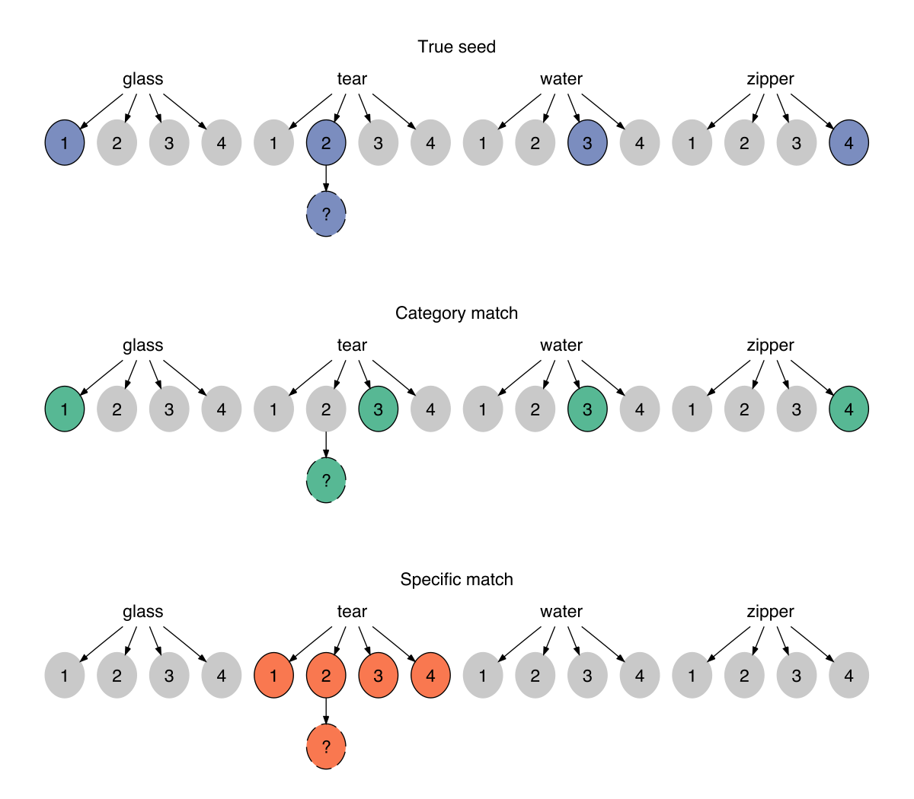

Figure 4 Three types of matching questions used to assess the resemblance between the imitation (and transcriptions of imitations) and the original seed sounds. For each question, participants listened an imitation (dashed circles) or read a transcription of one, and had to guess which of 4 sound choices (solid circles) they thought the person was trying to indicate. True seed questions contained the specific sound that generated the imitation as one of the choices (the correct response). The remaining sound choices were sampled from different categories. Category match questions replaced the original seed sound with another sound from the same category. Specific match questions pitted the actual seed against the other seeds within the same category.

## Methods

### Matching imitations to seed sounds

Participants (*N*=751) recruited from Amazon Mechanical Turk were paid to listen to imitations, one at a time, and for each one, choose one of four possible sounds they thought the person was trying to imitate. The task was not speeded and no feedback was provided. Participants completed 10 questions at a time.

All 365 imitations were tested in each of the three question types depicted in Fig. 4. These questions differed in the relationship between the imitation and the four seed sounds provided as the choices in the question. Question types (True seed, Category match, Specific match) were assigned between-subject. Participants in the True seed and Category match conditions were provided four seed sounds from different categories as choices in each question. Participants in the Specific match condition were provided four seed sounds from the same category.

### Matching transcriptions to seed sounds

Participants (*N*=467) recruited from Amazon Mechanical Turk completed a modified version of the matching survey described above. Instead of listening to imitations, participants now read a word (a transcription of an imitation), which they were told was an invented word. They were instructed that the word was invented to describe one of the four presented sounds, and they had to guess which one. The distractors for all questions were between-category, i.e. true seed and category match. Specific match questions were omitted.

Of the unique transcriptions that were generated for each sound (imitations and seed sounds), only the top four most frequent transcriptions were used in the matching experiment. Participants who failed a catch trial (*N*=6) were excluded, leaving 461 participants in the final sample.

## Results

### Imitations retained category information more than individuating information

Response accuracies in matching imitations to seed sounds were fit by a generalized linear mixed-effects model predicting match accuracy as different from chance (25%) based on the type of question being answered (True seed, Category match, Specific match) and the generation of the imitation. Question types were contrast coded using Category match questions as the baseline condition in comparison to the other two question types each containing the actual seed that generated the imitation as one of the choices. The model included random intercepts for participant[2], and random slopes and intercepts for seed sounds nested within categories.

Accuracy in matching first generation imitations to seed sounds was above chance for all question types, *b* = 1.65 (SE = 0.14) log-odds, odds = 0.50, *z* = 11.58, *p* < 0.001, and decreased steadily over generations, *b* = -0.16 (SE = 0.04) log-odds, *z* = -3.72, *p* < 0.001. We then tested whether this increase in difficulty was constant across the three types of questions or if some question types became more difficult than others. The results are shown in Fig. 5A. Performance decreased over generations more rapidly for questions requiring a within-category distinction than for between-category questions, *b* = -0.08 (SE = 0.03) log-odds, *z* = -2.68, *p* = 0.007, suggesting that between-category information was more resistant to loss through repeated imitation.

An alternative explanation for this result is that the within-category match questions are simply more difficult because the sounds provided as choices are more acoustically similar to one another than the between-category questions, and therefore, performance might be expected to drop off more rapidly with repeated imitation for these more difficult questions[3]. Questions requiring a within-category distinction were indeed more difficult than questions requiring a between-category distinction. If the differences between question types were entirely attributable to the acoustic distance between the distractors in each question, we would expect performance in both between-category question types (true seed and category match) to be equally affected by generational decay. However, performance also decreased for the easiest type of question where the correct answer was the actual seed generating the imitation (True seed questions; see Fig. 4); the advantage of having the true seed among between-category distractors decreased over generations, *b* = -0.07 (SE = 0.02) log-odds, *z* = -2.77, *p* = 0.006. Post-hoc analyses revealed that this decrease in the “true seed advantage” was not dependent on the presence of the low accuracy responses to specific match questions, and the results held when these questions were excluded, *b* = -0.08 (SE = 0.03) log-odds, *z* = -3.10, *p* = 0.002. The observed decrease in the “true seed advantage” (the advantage of having the actual seed among the choices) combined with the increase in the “category advantage” (i.e., the advantage of having between-category distractors) shows that the changes induced by repeated imitation caused the imitations to lose some of properties that linked the earlier imitations to the specific sound that motivated them, while nevertheless preserving a more abstract category-based resemblance.

### Transcriptions retained information about seed sources

We next report the results of matching the written transcriptions of the auditory sounds back to the original environmental sounds. Remarkably, participants were able to guess the correct meaning of a word that was transcribed from an imitation that had been repeated up to 8 times, *b* = 0.83 (SE = 0.13) log-odds, odds = -0.18, *z* = 6.46, *p* < 0.001 (Fig. 5B). This was true for True seed questions containing the actual seed generating the transcribed imitation, *b* = 0.75 (SE = 0.15) log-odds, *z* = 4.87, *p* < 0.001, and for Category match questions where participants had to associate transcriptions with a particular category of environmental sounds, *b* = 1.02 (SE = 0.16) log-odds, *z* = 6.39, *p* < 0.001. The effect of generation did not vary across these question types, *b* = 0.05 (SE = 0.10) log-odds, *z* = 0.47, *p* = 0.638. The results of matching “transcriptions” directly of the environmental sounds are shown in Fig. S5.

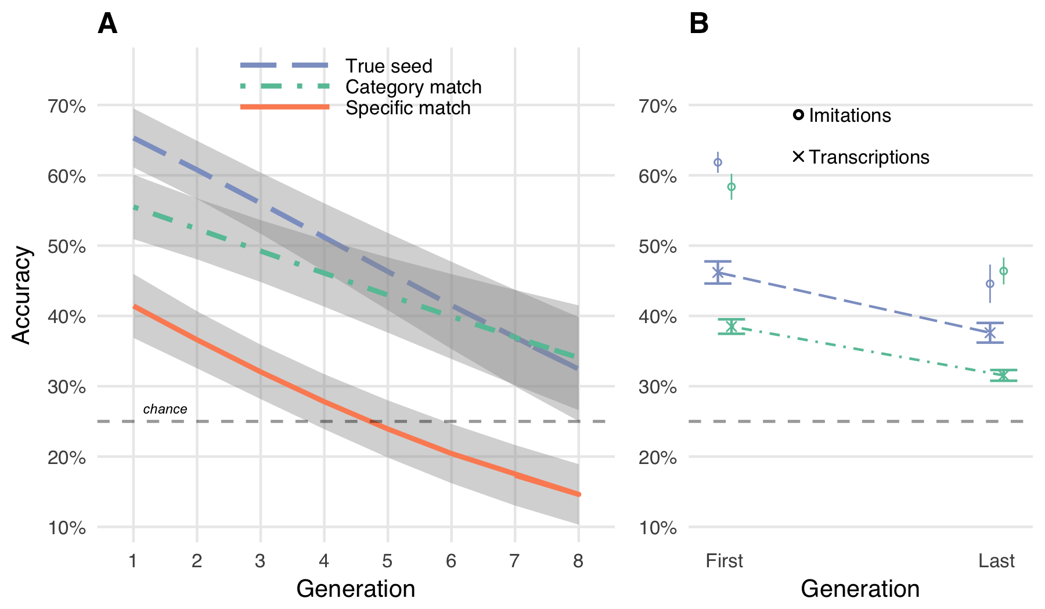

Figure 5 Repeated imitations retained category resemblance. A. Accuracy of matching vocal imitations to original seed sounds as a function of the generation during which the imitation was produced. Curves show predictions of the generalized linear mixed effects models with ±1 SE of the model predictions. The “category advantage” (Category match vs. Specific match) increased over generations, while the “true seed advantage” (True seed v. Category match) decreased (see main text), suggesting that imitations lose within-category information more rapidly than between-category information. B. Accuracy of matching transcriptions of the imitations to original seed sounds (e.g., “boococucuwich” to a water splashing sound). Transcriptions of imitations could still be matched back to the category of sound that motivated the original imitation even after 8 generations. Circles show mean matching accuracy for the corresponding vocal imitations for comparison.

## Discussion

Even after being repeated up to 8 times across 8 different individuals, vocalizations retained a resemblance to the environmental sound that motivated them. This resemblance remained even after the vocalizations were transcribed into orthographic forms. For vocal imitations, but not for transcriptions this resemblance was stronger for the category of environmental sound than the actual seed sound, suggesting that through repetition, the imitations were becoming more categorical. This result highlights another aspect of wordlike-ness achieved through repeated imitation: In addition to being stable in acoustic and orthographic forms, iterated imitation produces vocalizations that are interpreted by naïve listeners in a more categorical way. That is, in the course of being imitated, it became relatively harder to match the vocalization to the original sound that motivated it compared to the category of the sound. Iterated imitation appears to strip the vocalizations of some of the characteristics that individuate each particular sound while maintaining some category-based resemblance (even though participants were never informed about the meaning of the vocalizations and even though they were not trying to communicate).

Orthographic transcription of the vocalizations, like the vocalizations, were able to be matched to the original environmental sounds at levels above chance. Unlike vocalizations, the orthographic transcriptions continued to be matched more accurately to the true seed compared to the category. That is, transcription appears to impact specific and category-level information equally. The difference between matching performance for vocalizations and transcriptions is unlikely to be due to the exclusion of the specific match questions in the written version of the task. If match accuracies for transcriptions in the specific match question type would have been collected, it is possible we would have replicated the increase in the category advantage observed in the imitations, but the inclusion of these questions would not change our failure to find a similar ‘true seed’ advantage. In addition, excluding the specific match questions from the analysis of the imitation match accuracies does not substantively change the results. One possible difference between the acoustic and orthographic forms of the task is that the process of transcribing a non-linguistic vocalization into a written word encourages transcribers to emphasize individuating information about the vocalization. However, the fact that transcriptions of imitations can be matched back to other category members (Category match questions) suggests that transcriptions still carry some category information, so this is not a complete explanation of our results. Another possible reason is that by selecting only the most frequent transcriptions, we unintentionally excluded less frequent transcriptions that were nonetheless more diagnostic of category information.

Experiments 1 and 2 document a process of gradual change from an imitation of an environmental sound to a more wordlike form. But do these emergent words function like other words in the language? In Experiment 3, we test the suitability of words taken from the beginning and end of transmission chains in serving as category labels in a category learning task.

# Experiment 3: Suitability of created words as category labels

One consequence of imitations becoming more wordlike is that they may make for better category labels. For example, an imitation from a later generation, by virtue of having a more word-like form, may be easier to learn as a label for the category of sounds that motivated it than an earlier imitation, which is more closely yoked to a particular environmental sound. To the extent that repeating imitations abstracts away the idiosyncrasies of a particular category member (Edmiston & Lupyan, 2015; Lupyan & Thompson-Schill, 2012), it may also be easier to generalize to new category members. We tested these predictions using a category learning task in which participants learned novel labels for the categories of environmental sounds. The novel labels were transcriptions of either first or last generation imitations gathered in Experiment 1.

## Methods

### Selecting words to learn as category labels

Our transmission chain design and subsequent transcription procedure created 1814 unique words. From these, we sampled words transcribed from first and last generation imitations, as well as transcriptions of the original seed sounds. Our procedure for sampling transcriptions to use as category labels was as follows: First, we removed transcriptions that contained less than 3 unique characters and transcriptions that were over 10 characters long. Of the remaining transcriptions, a sample of 56 were selected that were approximately equally associated with the target category. To measure the association between each imitation and its target category (the category of the seed sound), we used the match accuracy scores reported in Experiment 2. The reason for using this measure of association strength as a control for selecting words to learn as category labels was to be able to select words that were initially equally associated with the target categories. Equating along this dimension allowed for a more focused test of differences between the words in terms of generalization to new category members. The final sample of transcriptions were selected using a bootstrapping procedure which involved selecting a desired mean (the average association strength for eligible transcriptions of last generation imitations) and sampling transcriptions from first generation imitations and from seed sounds until the match accuracy of those imitations matched the desired mean within 1 standard deviation.

### Procedure

Participants (*N*=67) were University of Wisconsin undergraduates who received course credit for participation. Participants were randomly assigned four novel labels to learn for four categories of environmental sounds. Full instructions are provided in the Supplementary Materials. Participants were assigned between-subject to learn labels (transcriptions) of either first or last generation imitations. Some participants learned labels from transcriptions of seed sounds (Fig. S6). On each trial, participants heard one of the 16 seed sounds. After a 1s delay, participants saw a label (one of the transcribed imitations) and responded yes or no using a gamepad controller depending on whether the sound and the word went together. Participants received accuracy feedback (a bell sound and a green checkmark if correct; a buzzing sound and a red “X” if incorrect). Four outlier participants were excluded from the final sample due to high error rates and slow RTs.

Participants categorized all 16 seed sounds over the course of the experiment, but they learned them in blocks of 4 sounds at a time. Within each block of 24 trials, participants heard the same four sounds and the same four words multiple times, with a 50% probability of the sound matching the word on any given trial. At the start of a new block of trials, participants heard four new sounds they had not heard before, and had to learn to associate these new sounds with the words they had learned in the previous blocks.

## Results

### Later generation transcriptions yielded more efficient responding

Participants began by learning through trial-and-error to associate four written labels with four categories of environmental sounds. The small number of categories made this an easy task (mean accuracy after the first block of 24 trials was 81%; Fig. S4). Participants learning transcriptions of first or last generation imitations did not differ in overall accuracy, *p* = 0.887, or reaction time, *p* = 0.616. After this initial learning phase (i.e. after the first block of trials), accuracy performance quickly reached ceiling and did not differ between groups *p* = 0.775. However, the response times of participants learning last generation transcriptions declined more rapidly with practice than participants learning first generation transcriptions, *b* = -114.13 (SE = 52.06), *t*(39.9) = -2.19, *p* = 0.034 (Fig. 6A). These faster responses suggest that, in addition to becoming more stable both in terms of acoustic and orthographic properties, repeating imitations makes them easier to process as category labels. We predict that given a harder task (i.e., more than four categories and 16 exemplars) would yield differences in initial learning rates as well.

### Later generation transcriptions were better generalized

Next, we examined whether transcriptions from last generation imitations were easier to generalize to novel category exemplars. To test this hypothesis, we compared RTs on trials immediately prior to the introduction of novel sounds (new category members) and the first trials after the block transition (±6 trials). The results revealed a reliable interaction between the generation of the transcribed imitation and the block transition, *b* = -110.77 (SE = 52.84), *t*(39.7) = -2.10, *p* = 0.042 (Fig. 6B). This result suggests that transcriptions from later generation imitations were easier to generalize to new category members.

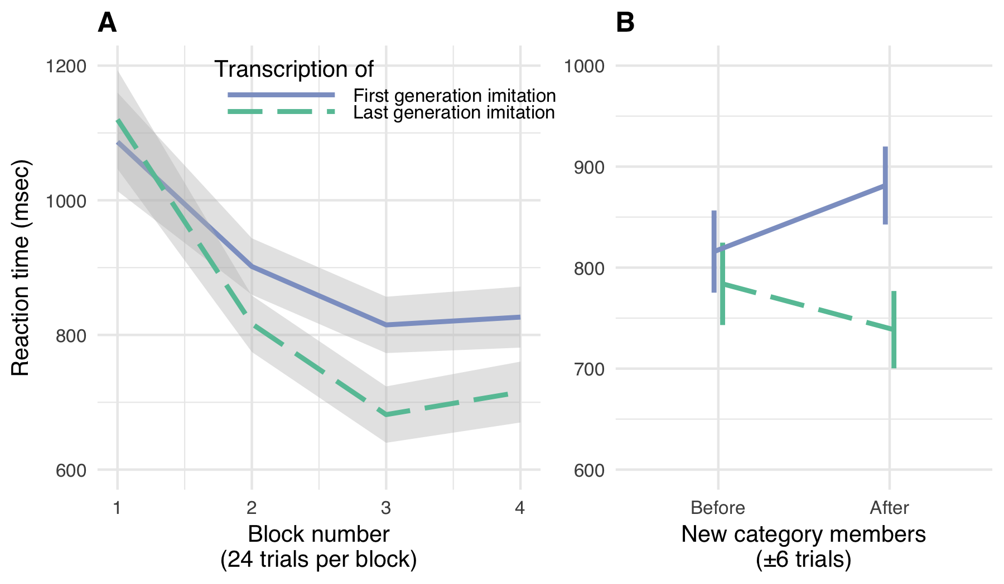

Figure 6 Repeated imitations made for better category labels. Participants learned novel labels (transcriptions of first or last generation imitations) for categories of environmental sounds. A. Mean RTs for correct responses in the category learning experiment with ±1 SE. Participants achieved faster RTs in matching transcribed labels to environmental sounds for labels transcribed from later compared to earlier generation imitations. B. Cost of generalizing to new category members with ±1 SE. After each block of trials, new environmental sounds were introduced, requiring participants to generalize the previously learned category labels to new category members. There was a generalization cost for the first generation labels, but not the last generation labels.

## Discussion

The results of a simple category learning experiment demonstrate a possible benefit to the stabilization of repeated imitations on more wordlike forms. As a consequence of being more wordlike, repeated imitations were responded to more quickly, and generalized to new category members more easily. These results suggest an advantage to repeating imitations from the perspective of the language learner in that they afford better category generalization.

# General Discussion

Accumulating evidence shows that iconic words are prevalent across the spoken languages of the world (Dingemanse et al., 2015; Imai & Kita, 2014; Perniss et al., 2010). And counter to past assumptions about the limitations of human vocal imitation, people are surprisingly effective at using vocal imitation to represent and communicate about the sounds in their environment (Lemaitre et al., 2016) and more abstract meanings (Perlman et al., 2015). These findings raise the hypothesis that early spoken words originated from vocal imitations, perhaps comparable to the way that many of the signs of signed languages appear to be formed originally from pantomimes (Fay, Ellison, & Garrod, 2014; Perlman et al., 2015). Here, we examined whether simply repeating an imitation of an environmental sound—with no intention to create a new word or even to communicate—produces more word-like forms.

Our results show that through unguided repetition, imitative vocalizations became more word-like both in form and function. In form, the vocalizations gradually stabilized over generations, becoming more similar from imitation to imitation. The standardization was also found when the words were transcribed into the English alphabet. Even as the vocalizations became more word-like, they maintained a resemblance to the original environmental sounds that motivated them. Notably, this resemblance appeared to be greater with respect to the category of sound (e.g., water-splashing sounds), rather than to the specific exemplar (a particular water-splashing sound). After eight generations the vocalizations could no longer be matched to the particular sound from which they originated any more accurately than they could be matched to the general category of environmental sound. Thus, information that distinguished an imitation from other sound categories was more resilient to transmission decay than exemplar information within a category. Remarkably, the resemblance to the original sounds was maintained even when the vocalizations were transcribed into a written form: participants were able to match the transcribed vocalizations to the original sound category at levels above chance.

We further tested the hypothesis that repeated imitation led to vocalizations becoming more wordlike by testing the ease with which people learned the (transcribed) vocalizations as category labels (e.g., “pshfft” vs. “shewp” as a label for tearing sounds) (Exp. 3). Labels from the last generation were responded to faster than labels from the first generation, but more importantly the labels from the last generation generalized better to novel category members. This fits with previous research showing that the relatively arbitrary forms that are typical of words (e.g. “dog”) makes them better suited to function as category labels compared to direct auditory cues (e.g., the sound of a dog bark) (Boutonnet & Lupyan, 2015; Edmiston & Lupyan, 2015; Lupyan & Thompson-Schill, 2012).

Even as the vocalizations became more word-like, they nevertheless maintained an imitative quality. After eight generations they could no longer be matched to the particular sound from which they originated any more accurately than they could be matched to the general category of environmental sound. Thus, information that distinguished an imitation from other sound categories was more resilient to transmission decay than exemplar information within a category. Remarkably, even after the vocalizations were transcribed into English orthography, participants were able to guess their original sound category from the written “words”. In contrast to the vocalizations, participants continued to be more accurate at matching late generation transcriptions back to their particular source sound relative to other exemplars from the same category.

Unlike the large number of iconic signs in signed languages (e.g. Goldin-Meadow, 2016), the number of iconic words in spoken languages may appear to be very small (Crystal, 1987; Newmeyer, 1992). However, increasing evidence from disparate language suggests that vocal imitation is, in fact, a widespread source of vocabulary. Cross-linguistic surveys indicate that onomatopoeia—iconic words used to represent sounds—are a universal lexical category found across the world’s languages (Dingemanse, 2012). Even English, a language that has been characterized as relatively limited in iconic vocabulary (Vigliocco, Perniss, & Vinson, 2014), is documented as having hundreds of onomatopoeic words not only for animal and human vocalizations (“meow”, “tweet”, “slurp”, “babble”, murmur”), but also for a variety of environmental sounds (e.g., “ping”, “click”, “plop”) (e.g., Rhodes, 1994; Sobkowiak, 1990). Besides words that directly resemble sounds—the focus of the present study — many languages contain semantically broader inventories of ideophones. These words comprise a grammatically and phonologically distinct class of words that are used to express various sensory-rich meanings, such as qualities related to manner of motion, visual properties, textures and touch, inner feelings and cognitive states (Dingemanse, 2012; Nuckolls, 1999; Voeltz & Kilian-Hatz, 2001). As with onomatopoeia, ideophones are often recognized by naïve listeners as bearing a degree of resemblance to their meaning (Dingemanse, Schuerman, & Reinisch, 2016).

Our study focused on imitations of environmental sounds, and more work remains to be done to determine the extent to which vocal imitation can ground de novo vocabulary creation in other semantic domains (e.g., Lupyan & Perlman, 2015; Perlman et al., 2015). Notably, our hypothesis that vocal imitation may have played a role in the origin of some of the first spoken words does not preclude that gesture played an equal or more important role in establishing the first linguistic conventions (e.g. Fay, Arbib, & Garrod, 2013; Goldin-Meadow, 2016; Kendon, 2014). What the present results make clear is that the transition from imitation to word can be a rapid and simple process: the mere act of repeated imitation can drive vocalizations to become more word-like in both form and function while still retaining some resemblance to the real world referents.

# References

Arbib, M. A. (2012). *How the brain got language: The mirror system hypothesis* (Vol. 16). Oxford University Press.

Armstrong, D. F., & Wilcox, S. (2007). *The gestural origin of language*. Oxford University Press.

Bates, D., Mächler, M., Bolker, B., & Walker, S. (2015). Fitting Linear Mixed-Effects Models Using lme4. *Journal of Statistical Software*, *67*(1), 1–48.

Boutonnet, B., & Lupyan, G. (2015). Words Jump-Start Vision: A Label Advantage in Object Recognition. *Journal of Neuroscience*, *35*(25), 9329–9335.

Brown, R. W., Black, A. H., & Horowitz, A. E. (1955). Phonetic symbolism in natural languages. *Journal of Abnormal Psychology*, *50*(3), 388–393.

Brysbaert, M., Stevens, M., Mandera, P., & Keuleers, E. (2016). How Many Words Do We Know? Practical Estimates of Vocabulary Size Dependent on Word Definition, the Degree of Language Input and the Participant’s Age. *Frontiers in Psychology*, *7*(021006), 55–11.

Clark, H. H., & Gerrig, R. J. (1990). Quotations as demonstrations. *Language*, *66*, 764–805.

Corballis, M. C. (2003). *From hand to mouth: The origins of language*. Princeton University Press.

Crockford, C., Herbinger, I., Vigilant, L., & Boesch, C. (2004). Wild chimpanzees produce group-specific calls: a case for vocal learning? *Ethology*, *110*(3), 221–243.

Crystal, D. (1987). *The Cambridge Encyclopedia of Language* (Vol. 2). Cambridge Univ Press.

Dingemanse, M. (2012). Advances in the Cross-Linguistic Study of Ideophones. *Language and Linguistics Compass*, *6*(10), 654–672.

Dingemanse, M. (2014). Making new ideophones in Siwu: Creative depiction in conversation. *Pragmatics and Society*.

Dingemanse, M., Blasi, D. E., Lupyan, G., Christiansen, M. H., & Monaghan, P. (2015). Arbitrariness, Iconicity, and Systematicity in Language. *Trends in Cognitive Sciences*, *19*(10), 603–615.

Dingemanse, M., Schuerman, W., & Reinisch, E. (2016). What sound symbolism can and cannot do: Testing the iconicity of ideophones from five languages. *Language*, *92*.

Donald, M. (2016). Key cognitive preconditions for the evolution of language. *Psychonomic Bulletin & Review*, 1–5.

Edmiston, P., & Lupyan, G. (2015). What makes words special? Words as unmotivated cues. *Cognition*, *143*(C), 93–100.

Evans, N., & Levinson, S. C. (2009). The myth of language universals: Language diversity and its importance for cognitive science. *Brain and Behavioral Sciences*, *32*, 429–492.

Fay, N., Arbib, M., & Garrod, S. (2013). How to Bootstrap a Human Communication System. *Cognitive Science*, *37*(7), 1356–1367.

Fay, N., Ellison, T. M., & Garrod, S. (2014). Iconicity: From sign to system in human communication and language. *Pragmatics and Cognition*, *22*(2), 244–263.

Fay, N., Lister, C. J., Mark Ellison, T., & Goldin-Meadow, S. (2014). Creating a communication system from scratch: Gesture beats vocalization hands down. *Frontiers in Psychology*, *5*(APR), 663.

Frishberg, N. (1975). Arbitrariness and Iconicity: Historical Change in American Sign Language. *Language*, *51*(3), 696–719.

Gamer, M., Lemon, J., Fellows, I., & Singh, P. (2012). *irr: Various Coefficients of Interrater Reliability and Agreement*.

Goldin-Meadow, S. (2016). What the hands can tell us about language emergence. *Psychonomic Bulletin & Review*, *24*(1), 1–6.

Goldin-Meadow, S., & Feldman, H. (1977). The development of language-like communication without a language model. *Science*, *197*(4301), 401–403.

Hall, K. C., Allen, B., Fry, M., Mackie, S., & McAuliffe, M. (2016). Phonological CorpusTools. *14th Conference for Laboratory Phonology*.

Hewes, G. W. (1973). Primate Communication and the Gestural Origin of Language. *Current Anthropology*, *14*(1/2), 5–24.

Hockett, C. F. (1978). In search of Jove’s brow. *American Speech*, *53*(4), 243–313.

Imai, M., & Kita, S. (2014). The sound symbolism bootstrapping hypothesis for language acquisition and language evolution. *Philosophical Transactions of the Royal Society B: Biological Sciences*, *369*(1651).

Kendon, A. (2014). Semiotic diversity in utterance production and the concept of ’language’. *Philosophical Transactions of the Royal Society B: Biological Sciences*, *369*(1651), 20130293–20130293.

Kirby, S., Cornish, H., & Smith, K. (2008). Cumulative cultural evolution in the laboratory: an experimental approach to the origins of structure in human language. *Proceedings of the National Academy of Sciences*, *105*(31), 10681–10686.

Klima, E. S., & Bellugi, U. (1980). *The signs of language*. Harvard University Press.

Kuznetsova, A., Bruun Brockhoff, P., & Haubo Bojesen Christensen, R. (2016). *lmerTest: Tests in Linear Mixed Effects Models*.

Labov, W. (1972). *Sociolinguistic patterns*. University of Pennsylvania Press.

Lemaitre, G., & Rocchesso, D. (2014). On the effectiveness of vocal imitations and verbal descriptions of sounds. *The Journal of the Acoustical Society of America*, *135*(2), 862–873.

Lemaitre, G., Houix, O., Voisin, F., Misdariis, N., & Susini, P. (2016). Vocal Imitations of Non-Vocal Sounds. *PloS One*, *11*(12), e0168167–28.

Lewis, J. (2009). As well as words: Congo Pygmy hunting, mimicry, and play. In *The cradle of language*. The cradle of language.

Lupyan, G., & Dale, R. (2016). *Why are there different languages? The role of adaptation in linguistic diversity*.

Lupyan, G., & Perlman, M. (2015). The vocal iconicity challenge! In *The th biennial protolanguage conference*. Rome, Italy.

Lupyan, G., & Thompson-Schill, S. L. (2012). The evocative power of words: Activation of concepts by verbal and nonverbal means. *Journal of Experimental Psychology: General*, *141*(1), 170–186.

Newmeyer, F. J. (1992). Iconicity and generative grammar. *Language*.

Nuckolls, J. B. (1999). The case for sound symbolism. *Annual Review of Anthropology*, *28*(1), 225–252.

Pagel, M., Atkinson, Q. D., & Meade, A. (2007). Frequency of word-use predicts rates of lexical evolution throughout Indo-European history. *Nature*, *449*(7163), 717–720.

Perlman, M., Dale, R., & Lupyan, G. (2015). Iconicity can ground the creation of vocal symbols. *Royal Society Open Science*, *2*(8), 150152–16.

Perniss, P., Thompson, R. L., & Vigliocco, G. (2010). Iconicity as a General Property of Language: Evidence from Spoken and Signed Languages. *Frontiers in Psychology*, *1*.

Pinker, S., & Jackendoff, R. (2005). The faculty of language: what’s special about it? *Cognition*, *95*(2), 201–236.

Rhodes, R. (1994). Aural images. *Sound Symbolism*, 276–292.

Sapir, E. (1921). *Language: An introduction to the study of speech*. New York: Harcourt, Brace; Company.

Seyfarth, R. M., & Cheney, D. L. (1986). Vocal development in vervet monkeys. *Animal Behaviour*, *34*, 1640–1658.

Shrout, P. E., & Fleiss, J. L. (1979). Intraclass correlations: uses in assessing rater reliability. *Psychological Bulletin*, *86*(2), 420–428.

Sobkowiak, W. (1990). On the phonostatistics of English onomatopoeia. *Studia Anglica Posnaniensia*, *23*, 15–30.

Stokoe, W. (1965). *Dictionary of the American Sign Language based on scientific principles*. Gallaudet College Press, Washington.

Tamariz, M. (2017). Experimental Studies on the Cultural Evolution of Language. *Annual Review of Linguistics*, *3*(1), 389–407.

Tomasello, M. (2010). *Origins of human communication*. MIT press.

Vigliocco, G., Perniss, P., & Vinson, D. (2014). Language as a multimodal phenomenon: implications for language learning, processing and evolution. *Philosophical Transactions of the Royal Society B: Biological Sciences*, *369*(1651), 20130292–20130292.

Voeltz, F. E., & Kilian-Hatz, C. (2001). *Ideophones* (Vol. 44). John Benjamins Publishing.

Wescott, R. W. (1971). Linguistic iconism. *Linguistic Society of America*, *47*(2), 416–428.

Wierzbicka, A. (1996). *Semantics: Primes and universals: Primes and universals*. Oxford University Press, UK.

1. Random effects for subject were not appropriate because the distance measure was derived from pairwise comparisons of transcriptions generated by different transcribers. As a result, the degrees of freedom for the significance tests for the parameters of this model reflect the Satterthwaite approximation based on the number of seed sounds (16) nested within categories (4), not the number of unique transcribers (*N*=216).
2. Random slopes for generation were not appropriate in the by-subject random effects because data collection was batched by generation of imitation, and therefore each participant did not sample across the range of generations.
3. We observed that performance on some Specific match questions dropped below chance for later generations indicating participants had an apparent aversion to the nominally correct answer. Additional analyses showed that participants were not converging on a single incorrect response. The reason for this pattern is at present unclear. Removing these trials from the analysis does not substantively change the conclusions.