Instructions given to participants

# Instructions for the collecting vocal imitations

Participants played a version of the children’s game of Telephone via a web-based interface. The instructions given to participants were as follows.

We are researchers at the University of Wisconsin-Madison studying how audio messages are passed on from person to person, much like in the children’s game Telephone. If you choose to participate, we will ask you to listen to an audio message recorded by someone else, and then record yourself imitating the message that you heard using your computer’s microphone.

Unlike the children’s game of Telephone, the sounds you will hear will not be recognizable English words, but will be various nonspeech sounds. Your task is the same, however: to recreate the sound you heard as accurately as you can.

The interface you will use for playing the game is shown below. Before you begin, make sure you are using a computer with a working microphone, and that your computer speakers are turned on (or, preferrably, that you are using headphones). If there is TV or music playing in the background, please turn it off or move to a quieter space. To play, first you will click on the top sound wave icon to hear the message you are to imitate. After you listen to the message, then you will click on the bottom sound wave icon to record your imitation.

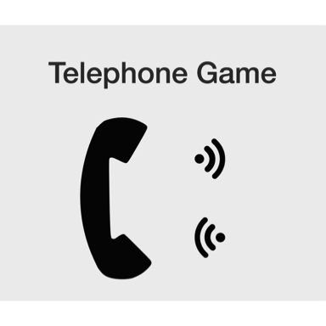

After you submit your recording, the next person who arrives at the site will now hear your recording, and record their own recreation of your recreation (and so on, and so on!). Don’t worry, we will not ask you to provide any information that identifies you. Each player will be asked to imitate several sounds.

# Instructions for acoustic similarity ratings

Research assistants rated the similarity between 324 different pairs of imitations. These pairs comprised consecutive imitations in the transmission chain design, e.g., each message was compared to its response. Message order was randomized on each trial so that participants did not know which message was the original and which message was the imitation. Raters were also blind to the overall generation of the imitations by randomizing generation from trial to trial. To facilitate consistency in rating, pairs of sounds were blocked by category, e.g., all tearing sounds were rated before moving on to other categories of sounds. The instructions given to raters were as follows.

On each trial, you will hear two sounds played in succession. To help you distinguish them, during the first you will see the number 1, and during the second a number 2. After hearing the second sound, you will be asked to rate how similar the two sounds are on a 7-point scale.

A 7 means the sounds are nearly identical. That is, if you were to hear these two sounds played again, you would likely be unable to tell whether they were in the same or different order as the first time you heard them. A 1 on the scale means the sounds are entirely different and you would never confuse them. Each sound in the pair will come from a different speaker, so try to ignore differences due to just people having different voices. For example, a man and a woman saying the same word should get a high rating.

Please try to use as much of the scale as you can while maximizing the likelihood that if you did this again, you would reach the same judgments. If you need to hear the sounds again, you can press ‘r’ to repeat the trial. If one of the sounds is a non-verbal sound (like someone tapping on the mic), or if you only hear a single sound, or if you are otherwise unable to judge the similarity between the sounds, press the ‘e’ key to report the error. Pressing ‘q’ will quit the experiment. Your progress will be saved and you can continue later. Press the SPACEBAR to begin the experiment.

# Instructions for category learning experiment

In the category learning experiment, participants had to learn novel labels for categories of environmental sounds through trial and error. On each trial, they heard an environmental sound (one of the 16 seed sounds) and then read a novel “word”—a transcription of an imitation collected in the transmission chain experiment. Here are the instructions these participants received.

Thanks for participating in the study. In this experiment we are going to have you learn some new words to name different types of sounds. Think about it like you are on an alien planet and you are learning words for some of the sounds that are common on their planet.

In the experiment you’ll learn which names go with which sounds through trial and error. On each trial you will hear one of the sounds and then you’ll see a word for it, and you have to decide whether the word is the correct word. If it is, you’ll press the green button on the gamepad. If it’s not the right word, press the red button.

At first you will have to guess which words go with which sounds, but since you’ll be getting feedback on your performance, you should be able to learn the correct names for the sounds pretty quickly. If you guess correctly you’ll see a green checkmark. If you guess incorrectly you’ll see a red ‘X’.

If you have any questions, now is the time to ask the experimenter. When you feel you understand these instructions and are ready to begin, press the green button.