The effect of visual interference on continuous measures of visual knowledge

Pierce Edmiston

# Data

library(propertyverificationdata)  
data(question_first)  
data(norms)  
  
all_props <- question_first %>%  
 tidy_property_verification_data %>%  
 recode_property_verification_data %>%  
 label_outliers %>%  
 filter(is_subj_outlier == 0) %>%  
 left_join(norms)  
  
question_first <- filter(all_props, is_prop_outlier == 0)

# Amount of visual knowledge

imagery_mod <- glmer(is_error ~ imagery_z * mask_c + (1|subj_id),  
 family = "binomial", data = question_first)

term estimate std.error statistic p.value  
1 (Intercept) -3.34996521 0.06811542 -49.1807137 0.000000e+00  
2 imagery_z 0.19960873 0.03478945 5.7376217 9.601528e-09  
3 mask_c 0.20213813 0.07254824 2.7862580 5.332041e-03  
4 imagery_z:mask_c -0.03992416 0.06949870 -0.5744591 5.656572e-01

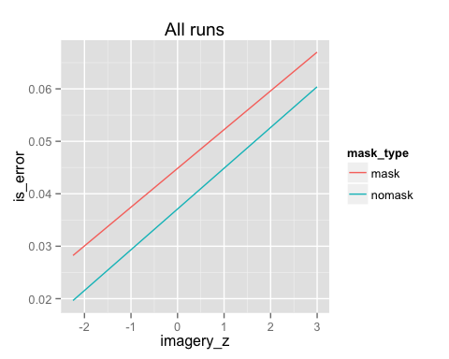

## By experiment

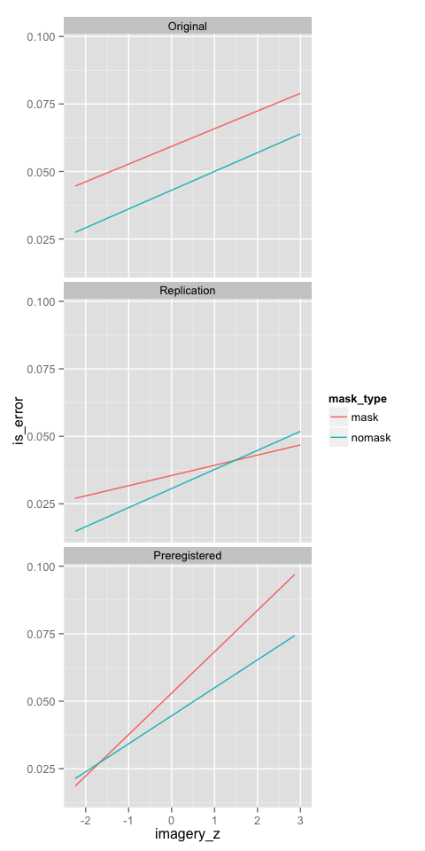

## Outlier propositions had high imagery scores

Why isn't the effect visible in the original experiment? Because outlier propositions had higher imagery scores, and without propositions with high imagery scores, the range of the norming data is too narrow.

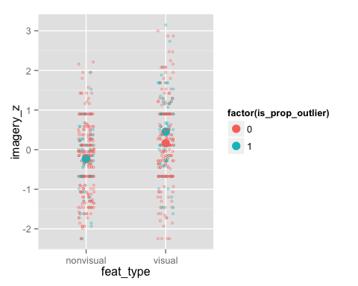

## Reanalyze with outlier propositions

imagery_mod_all <- glmer(is_error ~ imagery_z * mask_c + (1|subj_id),  
 family = "binomial", data = all_props)

term estimate std.error statistic p.value  
1 (Intercept) -2.75685215 0.04629316 -59.5520461 0.000000e+00  
2 imagery_z 0.23374817 0.02564083 9.1162474 7.777058e-20  
3 mask_c 0.08567673 0.05394662 1.5881760 1.122465e-01  
4 imagery_z:mask_c 0.01532703 0.05123735 0.2991378 7.648349e-01

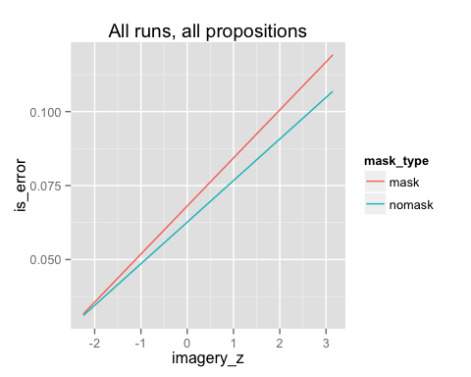 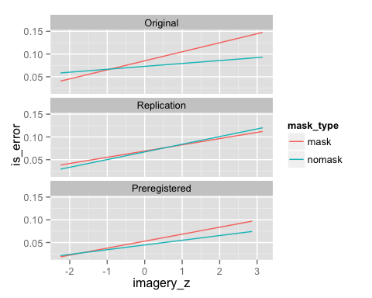

# Amount of encyclopedic knowledge

facts_mod <- glmer(is_error ~ facts_z * mask_c + (1|subj_id),  
 family = "binomial", data = question_first)

term estimate std.error statistic p.value  
1 (Intercept) -3.3364085 0.06799657 -49.067309 0.000000e+00  
2 facts_z 0.1912377 0.03474486 5.504056 3.711523e-08  
3 mask_c 0.2109398 0.07140142 2.954280 3.133992e-03  
4 facts_z:mask_c -0.1065029 0.06897450 -1.544091 1.225662e-01

