Effect of visual interference on visual knowledge

Pierce Edmiston

# Experiment runs

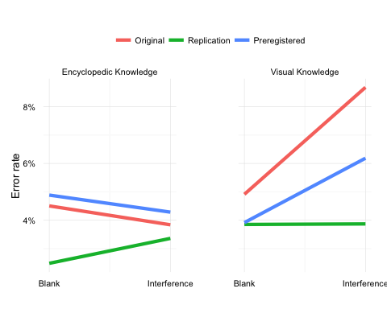

In the original sample, without visual interference, participants were just as likely to make an error on visual questions as they were on nonvisual questions, 0.09 log-odds, 95% CI [-0.33, 0.51], *z* = 0.4335, *p* = 0.6647. With visual interference, errors became significantly more likely on visual questions, 0.62 log-odds, 95% CI [0.25, 1.00], *z* = 3.2770, *p* = 0.0010, but not on nonvisual questions, -0.17 log-odds, 95% CI [-0.61, 0.27], *z* = -0.7504, *p* = 0.4530, resulting in a reliable *interference x question type* interaction, 0.79 log-odds, 95% CI [0.21, 1.37], *z* = 2.7019, *p* = 0.0069. Including the ambiguous propositions did not change this interaction, 0.47 log-odds, 95% CI [0.07, 0.86], *z* = 2.3327, *p* = 0.0197.

When we conducted the same experiment again one year later, we failed to replicate the original findings, -0.32 log-odds, 95% CI [-0.76, 0.11], *z* = -1.4829, *p* = 0.1381, prompting a careful review of our methods. We identified potential problems with response biases in the original design (see **Preregistered replication**, above) and also systematically removed ambiguous propositions from the set of all possible questions. We believe these slight modifications improved our chances of detecting an effect without changing our primary hypothesis. As expected, in the preregistered replication, the *interference x question type* interaction was once again reliable and in the expected direction, 0.59 log-odds, 95% CI [0.11, 1.07], *z* = 2.4198, *p* = 0.0155.

Collapsing across all runs of the experiment supports the main conclusions drawn from the original sample and the preregistered replication. Participants were just as likely to make an error on visual questions as they were on nonvisual questions, 0.14 log-odds, 95% CI [-0.06, 0.35], *z* = 1.3945, *p* = 0.1632. With visual interference, errors became significantly more likely on visual questions, 0.30 log-odds, 95% CI [0.11, 0.49], *z* = 3.1853, *p* = 0.0014, but not on nonvisual questions, 0.04 log-odds, 95% CI [-0.17, 0.25], *z* = 0.4150, *p* = 0.6782, resulting in a marginal *interference x question type* interaction, 0.25 log-odds, 95% CI [-0.03, 0.53], *z* = 1.7990, *p* = 0.0720.

The impact of the ambiguous propositions is visible in **Fig. 3D**. Overall the *interference x question type* interaction was stronger when ambiguous propositions were excluded, 0.25 log-odds, 95% CI [-0.03, 0.53], *z* = 1.7990, *p* = 0.0720, then when they were included, 0.14 log-odds, 95% CI [-0.06, 0.34], *z* = 1.3847, *p* = 0.1661. Given that the correctness of ambiguous propositions by definition cannot be determined, we excluded these propositions in the preregistered replication attempt. Without any ambiguous propositions, visual interference affects performance on visual questions only, 0.59 log-odds, 95% CI [0.11, 1.07], *z* = 2.4198, *p* = 0.0155.

Source: local data frame [2 x 3]  
  
 feat_type nomask mask  
1 visual 4.1% 5.5%  
2 nonvisual 3.6% 3.7%

Source: local data frame [6 x 4]  
  
 exp_run_label feat_type nomask mask  
1 Original visual 4.9% 8.7%  
2 Original nonvisual 4.5% 3.8%  
3 Replication visual 3.9% 3.9%  
4 Replication nonvisual 2.5% 3.4%  
5 Preregistered visual 3.9% 6.2%  
6 Preregistered nonvisual 4.9% 4.3%

## Original

term estimate std.error statistic p.value  
1 (Intercept) -2.9829905 0.1203396 -24.788110 1.204436e-135  
2 feat_c 0.4882538 0.1458096 3.348571 8.122954e-04  
3 mask_c 0.2275249 0.1458594 1.559891 1.187855e-01  
4 feat_c:mask_c 0.7879150 0.2916158 2.701894 6.894568e-03

## Original with ambiguous propositions

term estimate std.error statistic p.value  
1 (Intercept) -2.3535356 0.07394438 -31.828460 2.615158e-222  
2 feat_c 0.3238524 0.10021907 3.231445 1.231659e-03  
3 mask_c 0.1141501 0.10021891 1.139008 2.547000e-01  
4 feat_c:mask_c 0.4674783 0.20040441 2.332675 1.966523e-02

## Replication

term estimate std.error statistic p.value  
1 (Intercept) -3.5305318 0.09603229 -36.764008 6.944736e-296  
2 feat_c 0.2959702 0.10910789 2.712638 6.675006e-03  
3 mask_c 0.1597081 0.10913256 1.463433 1.433490e-01  
4 feat_c:mask_c -0.3237273 0.21831348 -1.482855 1.381128e-01

## Replication with ambiguous propositions

term estimate std.error statistic p.value  
1 (Intercept) -2.64186340 0.05315813 -49.6982051 0.000000e+00  
2 feat_c 0.35460881 0.06847909 5.1783518 2.238548e-07  
3 mask_c 0.04198502 0.06847277 0.6131637 5.397681e-01  
4 feat_c:mask_c -0.14445401 0.13698776 -1.0545030 2.916527e-01

## Preregistered

term estimate std.error statistic p.value  
1 (Intercept) -3.11938239 0.1146526 -27.2072542 5.330307e-163  
2 feat_c 0.07873134 0.1212607 0.6492731 5.161619e-01  
3 mask_c 0.15740982 0.1214299 1.2963023 1.948714e-01  
4 feat_c:mask_c 0.58809453 0.2430355 2.4197885 1.552954e-02

# Overall

term estimate std.error statistic p.value  
1 (Intercept) -3.3058474 0.06650582 -49.707638 0.0000000000  
2 feat_c 0.2691688 0.07029469 3.829148 0.0001285875  
3 mask_c 0.1720414 0.07034400 2.445715 0.0144565031  
4 feat_c:mask_c 0.2532221 0.14076063 1.798956 0.0720256815

## Overall with ambiguous propositions

term estimate std.error statistic p.value  
1 (Intercept) -2.69072190 0.04627697 -58.143869 0.000000e+00  
2 feat_c 0.30137518 0.05097752 5.911923 3.381367e-09  
3 mask_c 0.07567116 0.05099054 1.484024 1.378026e-01  
4 feat_c:mask_c 0.14123294 0.10199464 1.384710 1.661413e-01

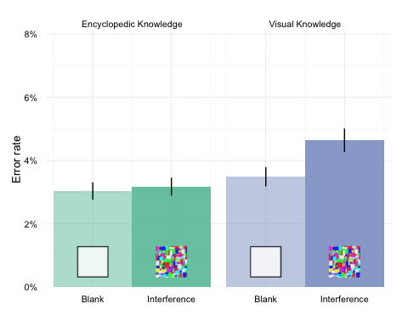

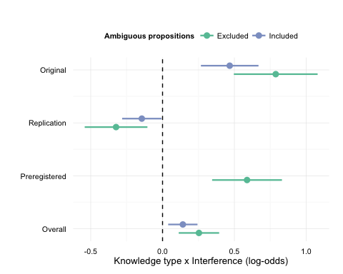

# Fig. 3

