Outlier subjects and propositions

Pierce Edmiston

## Subject outliers

## Source: local data frame [2 x 3]  
##   
## is_subj_outlier n pct  
## 1 0 133 0.8926174  
## 2 1 16 0.1073826

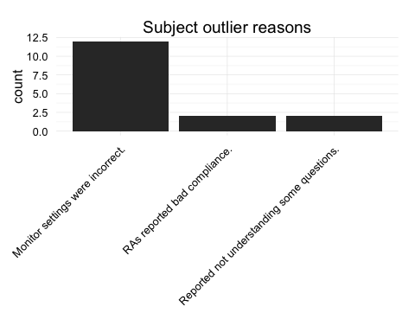

## Proposition outliers

## Source: local data frame [2 x 3]  
##   
## is_prop_outlier n pct  
## 1 0 397 0.7406716  
## 2 1 139 0.2593284

