# CHOOSE ONE BELOW

## Thank you for applying for our 2017 Summer internship program at AEON Predictive Analytics. As mentioned during our phone interview, we require all potential candidates to complete at least one of the below projects, as this help us better vet each of the candidates for their skills and preferred project types. All project must be submitted by May 1st, 2017 and all instructions/resources are provided within each of the project links (within Google Drive) below.

## [Data Science > OCR Store Receipt Identification (2-5 hrs.)](https://drive.google.com/drive/folders/0B4Ea5ipf_nEndmFtUFlrcm1hcFU?usp=sharing)

The goal of this project is to distinguish receipts from a particular STORE NAME vs others with 55%+ accuracy. Example: “Is this receipt a “Walmart” receipt – Yes/No?” The project files include 6,000+ receipt images taken from various camera angels, resolutions, etc, and are named according to the record id within the training/test dataset. Note: extracting information from the receipt such as UPC, dates, etc are optional and can be included as part of your results.csv submission.

## [Data Science > Forex Market API Integration (2-5 hrs.)](https://drive.google.com/drive/folders/0B4Ea5ipf_nEnQk82YmhaVjRWd0E?usp=sharing)

The goal of this project it to setup basic data extraction from the Forex Market using [Interactive Brokers API](http://interactivebrokers.github.io/). The implementation can be done in Python or Java and will require a database for storing the live data stream results. You will need to create at least 1+ graph/plots showing how the changes in bid/ask are changing over time (you pick time window), and extra credit for including predictive metrics (what will the next time series be – Up or Down and by how much??)

## [Data Science > BI Analysis / Summarize Data](https://drive.google.com/drive/folders/0B4Ea5ipf_nEnUENHMVc2MnREeWM?usp=sharing)

The goal of this project is to use your skills to analyze and explain the attached “consumer purchasing” data-set. Once you have understood the data-set, your will need to explain your analysis using reports, diagrams, written explanations and/or a simple application that can summarize your findings. Note: There are two tables (csv) which will require linking via primary key.

## [Research > Walmart App QR Code/Receipt Scanner – How does it work? (3-5 hrs.)](https://drive.google.com/drive/folders/0B4Ea5ipf_nEnUU9ZNTVDUmxsckk?usp=sharing)

The goal of this project is to understand how the QR Codes found on the bottom of Walmart Receipts are used, specifically to find previously purchased items, including the item price, subtotal, tax amount/rate, etc. Currently there are two known apps which use the QR codes to query the items from Walmart and they are “Walmart” (Apple/Google) and “ibotta” (Apple/Google). You will need to understand how each of these apps query this information (i.e. packet sniffers, networking monitoring tools, APK/IPA explorers, etc), then explain the way that they are functioning using diagrams, written explanations and/or a simple application that can re-produce results using any of the provided QR codes.

## [Web/Developer > Simple Bootstrap (1-2 hrs.)](https://drive.google.com/drive/folders/0B4Ea5ipf_nEnX1lnYTVSclRWWEk?usp=sharing)

The goal of this project is to better validate potential job/intern applicants through a web-based application process – Funny that’s how you are applying yourself! Ideally, the company (us) can setup N number of project for which applicants can apply, by following a set of instructions. *Sound familiar?? ☺*

## [Web/Developer PHP > Magento 2.0.13 Theme Modification (4-5 hrs.)](https://drive.google.com/drive/folders/0B4Ea5ipf_nEnNVAxVmRkTTlUT0U?usp=sharing)

Using Magento 2.0.13 and Algolia Search, you will modify an existing theme to match the PDF/PSD designs. This will require installing Magento either locally or within a cloud service like AWS, Google Cloud or Azure (all can have free accounts), as well, you will need to modify the CSS of the theme and integrate any html changes to match the design. Lastly, you will need to import product data into Magento using the provided CSV, that will load all of the product data/facet information for Algolia Search (also need to setup a few account here). You will need to download the Algolia Magento add-on and integrate into your Magento installation, as well, setup the filters as specified in the design/project.

## Questions about the project (or if you get stuck)

Ideally, you should complete the project without any assistance, however we understand that some of the projects may not be as clear as they should have been. ☺ If you have any questions (and have no other choice) ask questions on Slack: [Join the Channel](https://aeoninterns2017.signup.team/) → <https://aeoninterns2017.signup.team/> 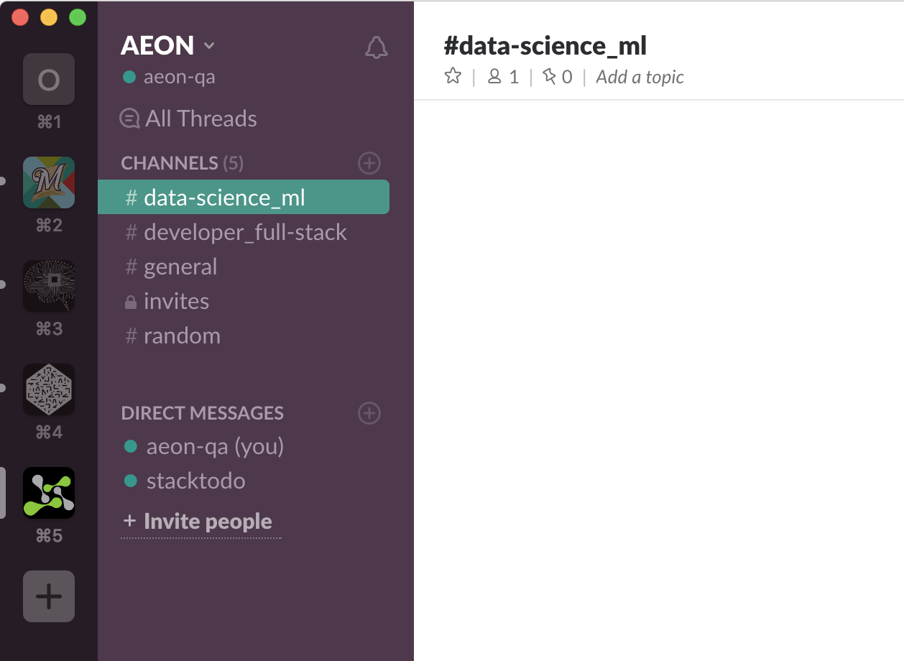

**Please make sure to ask your questions in the specific channel** (i.e. Data Science, Developer, or General)

## Submitting your Project

**Deadline for project submissions are May 1st, 2017**

Each project contains specific instructions for submitting your final project. Please refer to the project info for more details.