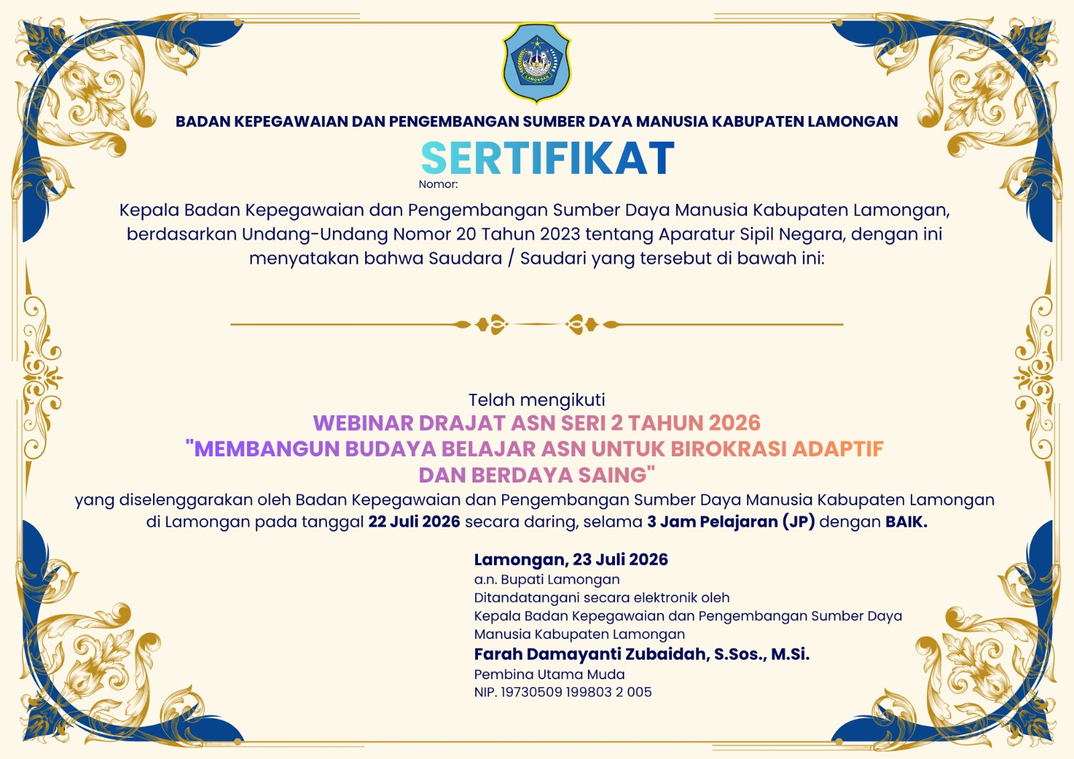
[nomor]
[jabatan]
[opd]
[nip]
[nama]

