Class Activity Written Report

Name : Luqman Khan
SID : S2024266054
Submission Date : 9|11|2026
Submitted to : DR Jameel Ahmad

- Overview
This report summarises the six notebooks submitted for the assignment (TensorFlow/Keras 2.21). All numbers below are taken directly from the saved notebook outputs. Where a notebook was only partly executed, or where two notebooks used different settings, this is stated explicitly rather than filled in. Percentages are accuracies unless noted; "pp" means percentage points.
Table 1. Overview of all tasks
Task | Topic | Dataset | Main result | Status
1 | CNN from scratch | MNIST | Test accuracy 98.93% | Complete
2 | Dense network vs CNN; one-factor experiments | CIFAR-10 | Dense 47.20%; CNN 68.82%; best CNN (dropout 0.25)  74.01% | Complete
3 | Data augmentation | CIFAR-10 | 71.99% to 79.29% with standard augmentation | Complete
4 | Fruit classification (RGB /  Gray / HSV) and detection | Fruits-360 (278 classes) | RGB 94.98%, Gray 93.55%,  HSV 95.43%; detector best F1  0.277 | Complete
5 | VGG16 transfer learning | Fruits-360 (277 classes) | Test accuracy 94.91% (top-5  99.67%) | Partly run: full-data  VGG16 only
6 | Checkpoints, callbacks, fine-tuning, detector | Fruits-360 (120 classes) | 95.48% to 96.94% after fine-tuning | Mostly run: detector evaluation not run

2. Summary of Findings for Each Task

Task 1: CNN from Scratch on MNIST
Setup. MNIST (60,000 training and 10,000 test images) was reshaped to 28x28x1 and scaled to [0,
1]. The CNN was Conv(64, 3x3) - MaxPool - Conv(64, 3x3) - MaxPool - Flatten - Dense(128) -
Dense(10, softmax). The parameter count worked out by hand (640 + 36,928 + 204,928 + 1,290 = 243,786) matches model.summary(). Training used Adam, sparse categorical cross-entropy, 5 epochs, batch size 128 and a 20% validation split.
Table 2. Task 1 results
Training accuracy | Validation accuracy | Test accuracy | Test loss | Parameters
99.38% | 98.92% | 98.93% | 0.0338 | 243,786
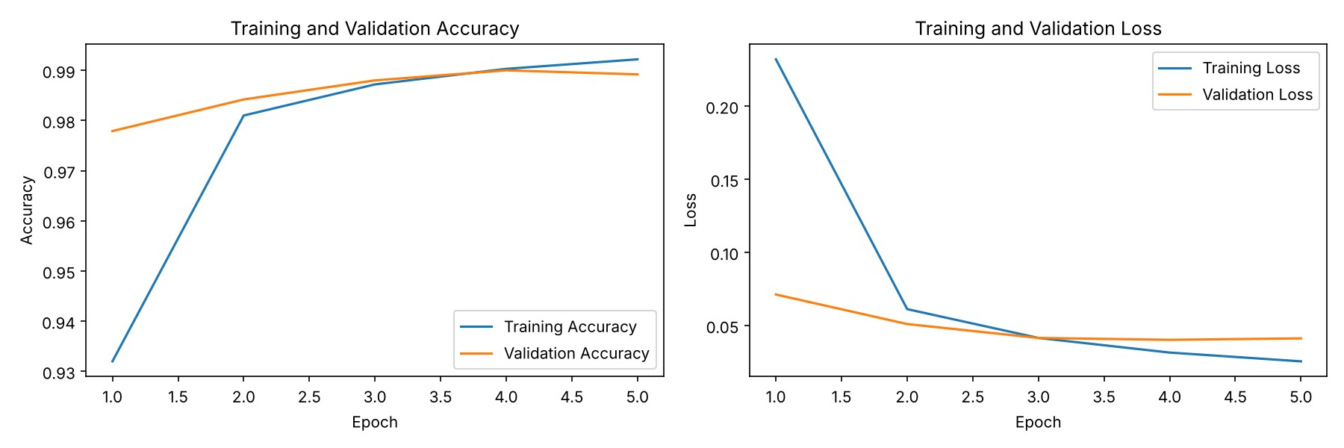
Figure 1. Task 1: training and validation accuracy and loss over 5 epochs.

Findings
The model learns very quickly: validation accuracy is 97.79% after the first epoch and peaks at
99.00% in epoch 4. Validation loss is lowest in epoch 4 (0.0402) and rises slightly in epoch 5 (0.0412) while training loss keeps falling (0.0255), the first sign of overfitting, so about four epochs are enough. The train-to-test gap is only 0.45 pp. The notebook also visualises ten misclassified test images, the 64 first-layer filters and the first-layer feature maps.

Task 2: Dense Network vs CNN on CIFAR-10
Setup. CIFAR-10 (50,000 training and 10,000 test images) was normalised and one-hot encoded.
The dense baseline is Flatten - Dense(256) - Dense(256) - Dense(10) with 855,050 parameters. The CNN has three Conv(3x3, same) + MaxPool blocks with 32, 64 and 128 filters, then Dense(128) and a softmax layer, for 356,810 parameters. All models used 10 epochs and a 20% validation split. Experiments changed one factor at a time: batch size (16, 32, 128, 512), dropout (0.1, 0.25, 0.5), BatchNorm with dropout 0.25, and optimiser (SGD, SGD with momentum 0.9, RMSprop, Adam).
Table 3. Task 2: dense baseline, CNN and all experiments (10 epochs each)
Configuration | Params | Train acc.  (%) | Val acc.  (%) | Test acc. (%) | Time / epoch  (s)
Dense baseline | 855,050 | 49.19 | 45.86 | 47.20 | 4.64
CNN (batch 32, Adam, no dropout) | 356,810 | 87.84 | 68.62 | 68.82 | 7.91
Batch size 16 | 356,810 | 88.45 | 69.90 | 69.12 | 14.79
Batch size 128 | 356,810 | 82.88 | 71.08 | 71.15 | 5.69
Batch size 512 | 356,810 | 72.53 | 68.15 | 68.09 | 3.85
Dropout 0.1 | 356,810 | 81.69 | 73.30 | 73.00 | 7.56
Dropout 0.25 | 356,810 | 74.35 | 74.49 | 74.01 | 6.39
Dropout 0.5 | 356,810 | 63.66 | 67.13 | 66.47 | 6.40
BatchNorm + Dropout 0.25 | 357,706 | 82.57 | 74.24 | 73.47 | 7.24
SGD (lr 0.001) | 356,810 | 38.77 | 39.88 | 40.48 | 5.78
SGD + momentum 0.9 | 356,810 | 68.64 | 64.79 | 64.92 | 6.32
RMSprop | 356,810 | 91.09 | 72.07 | 71.53 | 5.95
Note: for the dense baseline and the CNN row, "Train acc." in the original comparison table was re-evaluated after training (49.19% and 80.83%); the CNN value shown here (87.84%) is the last-epoch running accuracy, the same measure used in the experiment table.
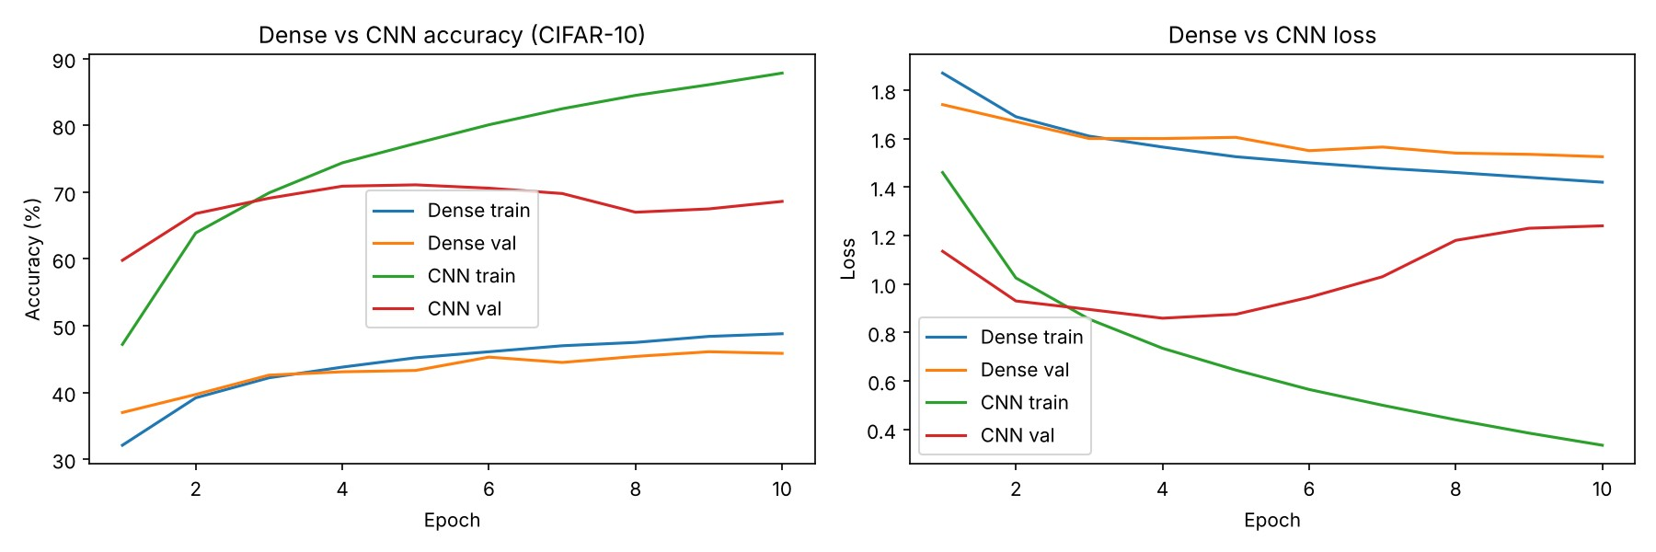
Figure 2. Task 2: dense network vs CNN, training and validation accuracy and loss.

Findings
- CNN vs dense: the CNN is 21.6 pp more accurate (68.82% vs 47.20%) with 58% fewer parameters, because convolution shares weights and exploits local structure. It costs about 1.7x more time per epoch (7.91 s vs 4.64 s).
- Overfitting: the baseline CNN reaches 87.84% training accuracy but only 68.62% validation accuracy. Its validation loss is lowest at epoch 4 (0.859) and then climbs to 1.240.
- Regularisation helped most: dropout 0.25 gave the best test accuracy (74.01%, +5.19 pp over the baseline); BatchNorm + dropout 0.25 gave 73.47%. Dropout 0.5 was too strong and underfit (training accuracy 63.66%).
- Batch size: 128 was best (71.15%), but the spread across sizes is only about 3 pp from a single run each, so it is a weak effect. Batch size 16 was slowest (14.79 s per epoch).
- Optimiser: plain SGD at lr 0.001 barely trained in 10 epochs (40.48%); momentum reached 64.92%; RMSprop 71.53% but with the strongest overfitting (91.09% training accuracy, validation loss 1.42); Adam gave 68.82%.
- Errors: for the best CNN the most confused pairs were cat to dog (189 images), dog to cat (145), deer to horse (113), truck to automobile (94) and deer to bird (86), all visually similar classes.

Task 3: Data Augmentation on CIFAR-10
Setup. The training set was split (stratified) into 40,000 training and 10,000 validation images; the 10,000 test images were kept separate. The Task 2 CNN (no dropout, Adam, batch 32) was trained for 20 epochs three ways: no augmentation; standard augmentation (horizontal flip and 10% width/height shift); and standard augmentation plus rotation (15 degrees) and zoom (0.1).
Table 4. Task 3: effect of augmentation (20 epochs)
Model | Train acc.  (%) | Val acc.  (%) | Test acc.  (%) | Train - val gap (pp) | Time / epoch (s)
No augmentation | 96.43 | 72.02 | 71.99 | 24.41 | 8.75
Standard augmentation | 81.05 | 79.19 | 79.29 | 1.86 | 28.20
Standard + rotation + zoom | 78.18 | 77.49 | 76.79 | 0.69 | 29.11
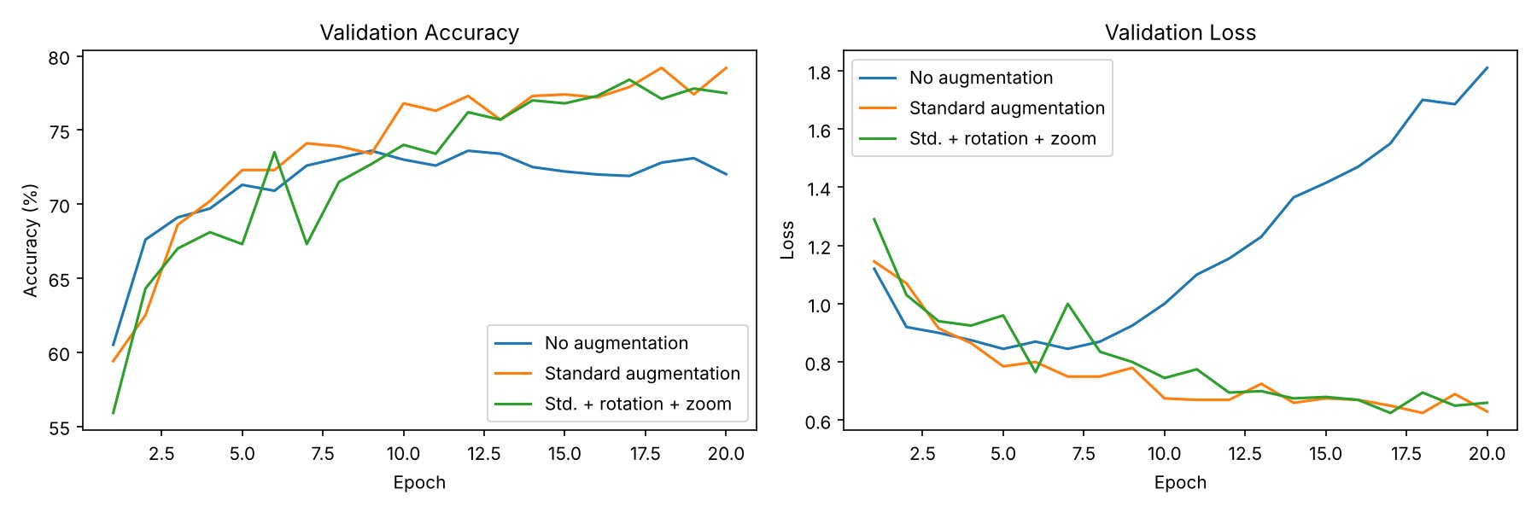
Figure 3. Task 3: validation accuracy and validation loss for the three models.

Findings
- Standard augmentation raised test accuracy by 7.30 pp (71.99% to 79.29%), cut the train-validation gap from 24.41 pp to 1.86 pp and lowered the final validation loss from 1.81 to 0.63. Without augmentation the model memorised the training set (96.43% training accuracy).
- Adding rotation and zoom gave the smallest gap (0.69 pp) but lower test accuracy (76.79%). Training accuracy was only 78.18% and was still rising at epoch 20, so this model is probably under-trained for 20 epochs; 32x32 images also lose content under rotation and zoom.
- Augmentation made each epoch about 3.2x slower (28.2 s vs 8.7 s) because the image generator runs on the CPU.
- Discussion (3d). Augmentation regularises by enlarging the effective training distribution, so the network cannot rely on exact pixel patterns. Vertical flips can hurt on CIFAR-10 because objects have a natural upright orientation (cars, ships, animals), whereas top-down fruit photographs have no canonical "up", so a vertical flip creates realistic images.
- Caveat: the notebook was meant to reuse the best Task 2 configuration, but the Task 2 results were not in memory, so it fell back to the baseline CNN. Gains from augmentation were therefore measured on the model without dropout.

Task 4: Fruit Classification and Detection on Fruits-360
Data. The 100x100 version of Fruits-360 was downloaded with kagglehub: 278 classes, 119,572 training, 29,893 validation (random 20% of the Training folder) and 49,785 test images (199,250 in total).
Model. Four Conv(5x5; 16, 32, 64, 128 filters) + MaxPool(2x2) blocks, Flatten (4,608), Dense(1024), Dense(256) and softmax: 5,323,702 parameters (hand count equals Keras). It was trained three times on RGB, grayscale (1 channel, 5,322,902 parameters) and HSV inputs with Adam (lr 0.001), 25 epochs, batch size 50.
Table 5. Task 4(c): classification results by colour space (25 epochs)
Input | Train acc. (%) | Val acc. (%) | Test acc. (%) | Top-5 test (%) | Time / epoch  (s)
RGB | 99.27 | 99.78 | 94.98 | 98.72 | 53.2
Grayscale | 99.47 | 99.46 | 93.55 | 97.52 | 59.3
HSV | 99.41 | 99.65 | 95.43 | 98.52 | 111.4
Note: HSV training was resumed across Colab sessions, so its time per epoch is not comparable with the others (see Section 4).
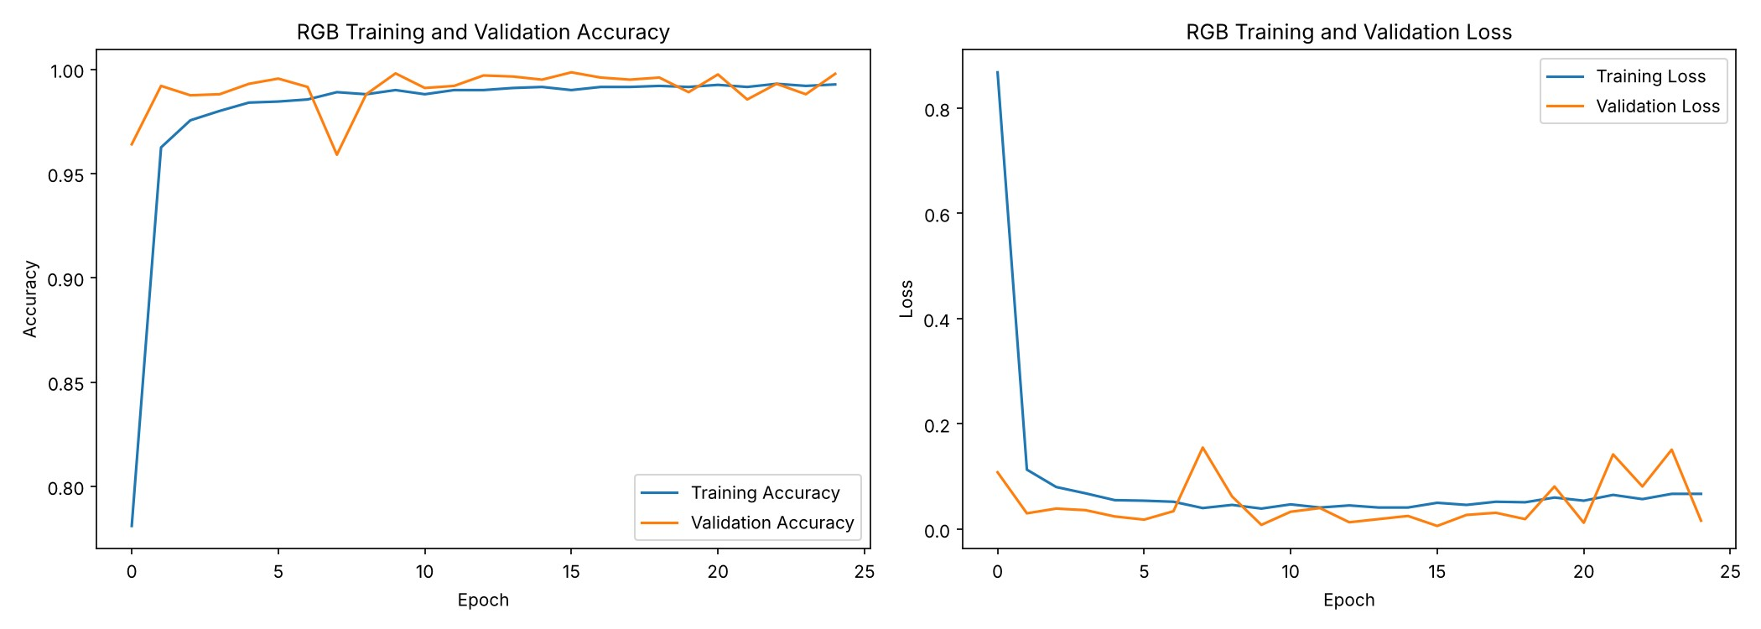
Figure 4. Task 4: training and validation accuracy and loss of the RGB classifier.
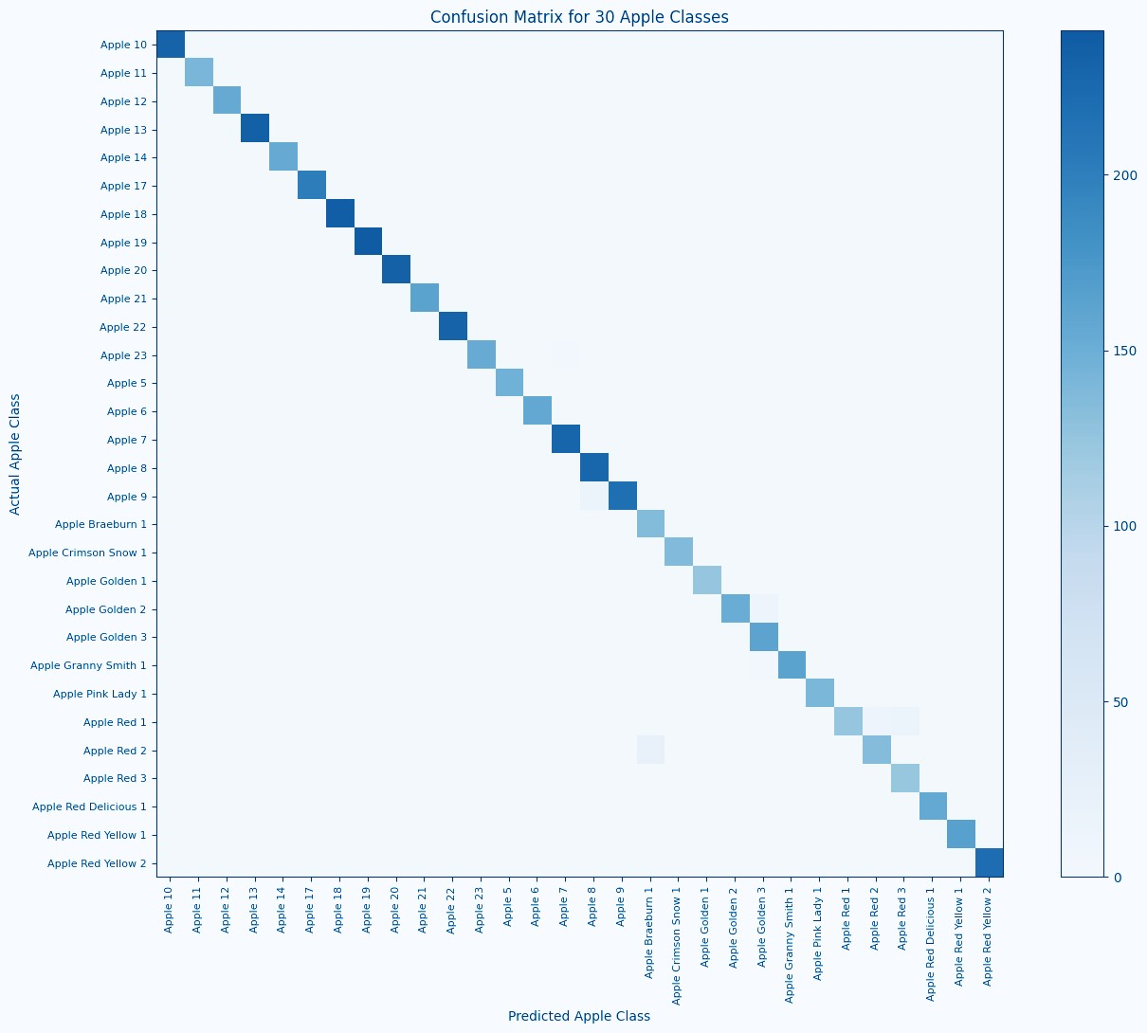
Figure 5. Task 4: confusion matrix of the RGB model on the 30 apple classes (darker means more images).
Detector. A background class was added to the RGB classifier (279 outputs; the notebook calls it the "121-class detector" after the assignment wording). It was initialised from the RGB weights and fine-tuned for 10 epochs (lr 0.0001) on fruit images plus 1,000 background patches (500 empty, 500 partial fruit). Detection used a sliding 100x100 window, per-class non-maximum suppression (IoU 0.3) and a probability threshold. It was tested on 50 synthetic scenes (500x350 white canvas with 3 to 5 non-overlapping fruits, 199 fruits in total). A detection counts as correct if the class matches and IoU is at least 0.5.
Table 6. Task 4(d): detection results for different strides and thresholds
Stride | Threshold | TP | FP | FN | Precision | Recall | F1 | Time / scene (s)
10 | 0.5 | 192 | 2,952 | 7 | 0.061 | 0.965 | 0.115 | 0.733
10 | 0.7 | 191 | 2,309 | 8 | 0.076 | 0.960 | 0.142 | 0.719
10 | 0.9 | 183 | 1,519 | 16 | 0.108 | 0.920 | 0.193 | 0.702
20 | 0.5 | 150 | 1,217 | 49 | 0.110 | 0.754 | 0.192 | 0.298
20 | 0.7 | 145 | 960 | 54 | 0.131 | 0.729 | 0.222 | 0.292
20 | 0.9 | 129 | 603 | 70 | 0.176 | 0.648 | 0.277 | 0.283
40 | 0.5 | 64 | 400 | 135 | 0.138 | 0.322 | 0.193 | 0.128
40 | 0.7 | 60 | 316 | 139 | 0.160 | 0.302 | 0.209 | 0.125
40 | 0.9 | 56 | 191 | 143 | 0.227 | 0.281 | 0.251 | 0.121
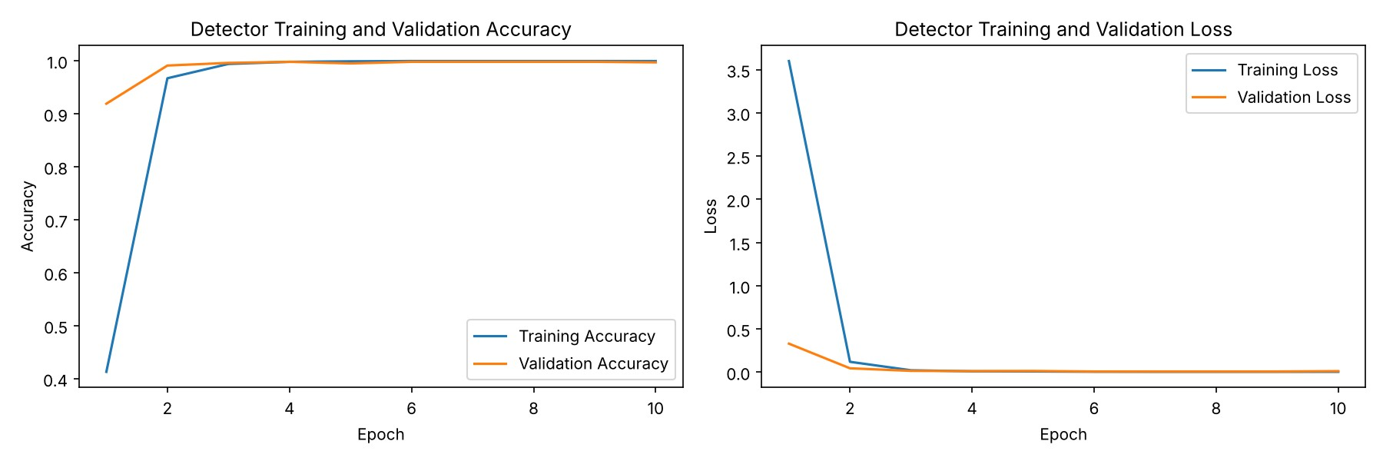
Figure 6. Task 4: detector training and validation accuracy and loss (10 epochs).
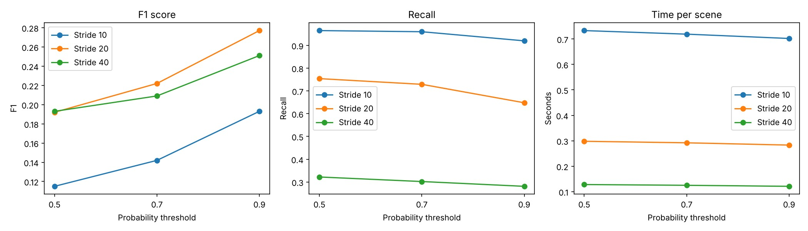
Figure 7. Task 4: detection F1, recall and time per scene against the probability threshold, for three strides.

Findings
- All three classifiers reach about 99.3 to 99.5% training and 99.5 to 99.8% validation accuracy, but only 93.5 to 95.4% on the test set. Fruits-360 images are frames taken from videos of rotating fruit, so a random validation split almost certainly contains near-duplicates of training frames. The separate test set is therefore the reliable figure.
- HSV was best (95.43%), then RGB (94.98%) and grayscale (93.55%), i.e. HSV is 1.88 pp above grayscale. Top-5 accuracy is 97.5 to 98.7%.
- Apple classes (30 classes, 5,506 test images, RGB model): 140 images (2.5%) were predicted as a non-apple class, and the matrix is almost completely diagonal, with only faint confusion between neighbouring varieties (for example Apple Red 1, 2 and 3, and Golden 2 and 3).
- Detection has high recall but very low precision. The best F1 is 0.277 (stride 20, threshold
0.9: precision 17.6%, recall 64.8%, 0.28 s per scene). Stride 10 finds almost every fruit (recall 96.5%) but produces 2,952 false positives for 192 true positives. Stride 40 is fastest (0.12 s) but misses most fruits (recall 28 to 32%). A higher threshold consistently improves precision and F1.
- Why false positives are so many: the classifier was trained on one complete, centred fruit, so windows with partial fruits or parts of two fruits get confident wrong labels. Per-class NMS also does not remove overlapping boxes of different classes: in the first scene the detector returned 12 boxes for 4 fruits.
- Discussion (4e). High test accuracy does not guarantee good detection because the tasks differ. On real market photographs the detector would probably do poorly (domain gap: clutter, lighting, occlusion). YOLO or Faster R-CNN would be better choices.

Task 5: Transfer Learning with VGG16
Setup. Fruits-360 (100x100) with 277 classes (one class is spelled "BlackBerry 4" in Training and "Blackberry 4" in Test, so it was excluded); 119,315 training, 29,711 validation and 49,640 test images. The model is VGG16 with frozen ImageNet weights (14,714,688 parameters) followed by Flatten, Dense(1000, ReLU) and a 277-way softmax: 19,600,965 parameters in total, of which
4,886,277 are trainable. It was trained for 10 epochs with Adam, batch size 50, horizontal flip and 10% shift augmentation.
Table 7. Task 5: VGG16 transfer learning vs the Task 4 scratch CNN (full training data)
Model | Class es | Trainable params | Epoc hs | Train acc. (%) | Val acc. (%) | Test acc. (%) | Top-5 test (%) | Time / epoch (s)
VGG16 transfer  (Task 5) | 277 | 4,886,277 | 10 | 98.48 | 91.45 | 94.91 | 99.67 | 491.1
Scratch RGB CNN  (Task 4) | 278 | 5,323,702 | 25 | 99.27 | 99.78 | 94.98 | 98.72 | 53.2
Note: the two rows were produced in different notebooks with slightly different class sets and validation splits, so this is an indicative comparison, not a controlled one. The 10%-data experiments (scratch CNN vs VGG16) and the final comparison table in the Task 5 notebook were written but not executed, so there are no results for them.
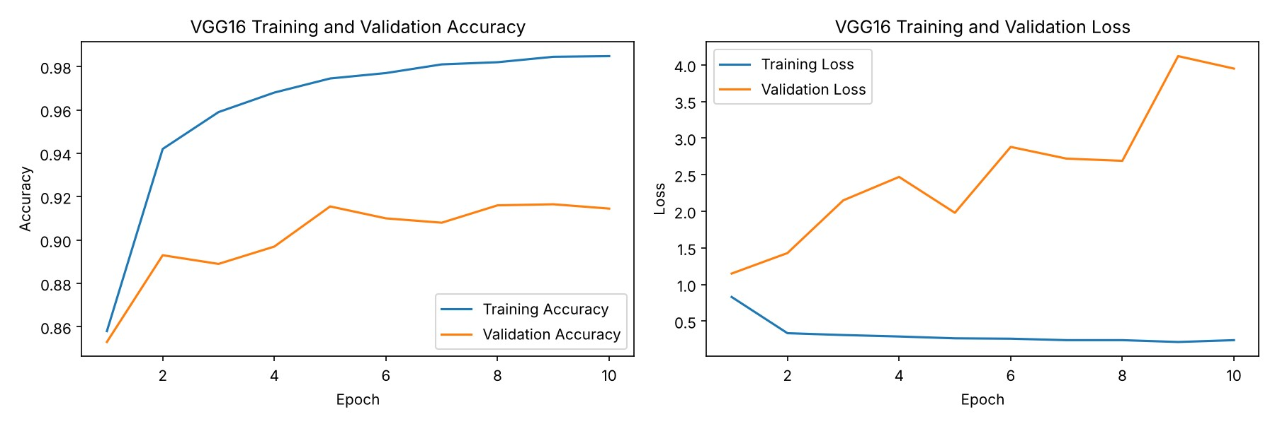
Figure 8. Task 5: VGG16 training and validation accuracy and loss over 10 epochs.

Findings
- With frozen ImageNet features VGG16 reaches 94.91% test accuracy after only 10 epochs, which equals the scratch CNN (94.98%) trained for 25 epochs, and its top-5 accuracy is higher (99.67% vs 98.72%).
- On the full dataset transfer learning gave no accuracy advantage and was 9.2x slower per epoch (491 s vs 53 s), since every image passes through the large frozen VGG16 base. The expected benefit, better results with little data, was not tested because the 10% experiment was not run.
- Validation accuracy plateaued near 91.5% from epoch 5 while validation loss grew from 1.15 to 3.95 while training accuracy reached 98.5%: the Dense(1000) head overfits and becomes over-confident on its mistakes. Validation accuracy (91.45%) is lower than test accuracy (94.91%), the opposite of Task 4; this was not investigated. A likely reason is that Keras' validation_split takes the last part of each class folder rather than a random sample, giving a validation set that is less similar to the training frames than in Task 4.

Task 6: Model Saving, Callbacks and Fine-Tuning
Setup. Fruits-360 restricted to a 120-class subset (plus a Background class for the detector): 50,702 training, 12,620 validation and 21,084 test images. The notebook looked for the Task 5 model on Google Drive, did not find it, and trained a new VGG16 transfer model. Stage 1 used
ModelCheckpoint (best validation accuracy), EarlyStopping (patience 3), BackupAndRestore and CSVLogger for 10 epochs. Stage 2 unfroze VGG16 block 5 (three conv layers and the pooling layer) and fine-tuned for 5 epochs at lr 1e-5. Stage 3 built a 121-class detector from the fine-tuned weights (block 5 still trainable, 5 epochs, lr 1e-5) using 1,000 background patches.
Table 8. Task 6: results of each stage
Stage | Epoc hs | Train acc.  (%) | Val acc. (%) | Test acc.  (%) | Test loss | Time / epoch (s)
1. Frozen base + callbacks | 10 | 98.60 | 93.95 | 95.48 | 1.305 | 269.5
2. Fine-tuned (block 5) | 5 | 99.56 | 93.32 (best  95.78) | 96.94 | 0.807 | 255.7
3. 121-class detector | 5 | 99.38 | 95.37 | not evaluated | not evaluated | about 267
Note: the stage 2 test result comes from the checkpoint with the best validation accuracy (epoch 3, 95.78%), reloaded from disk.
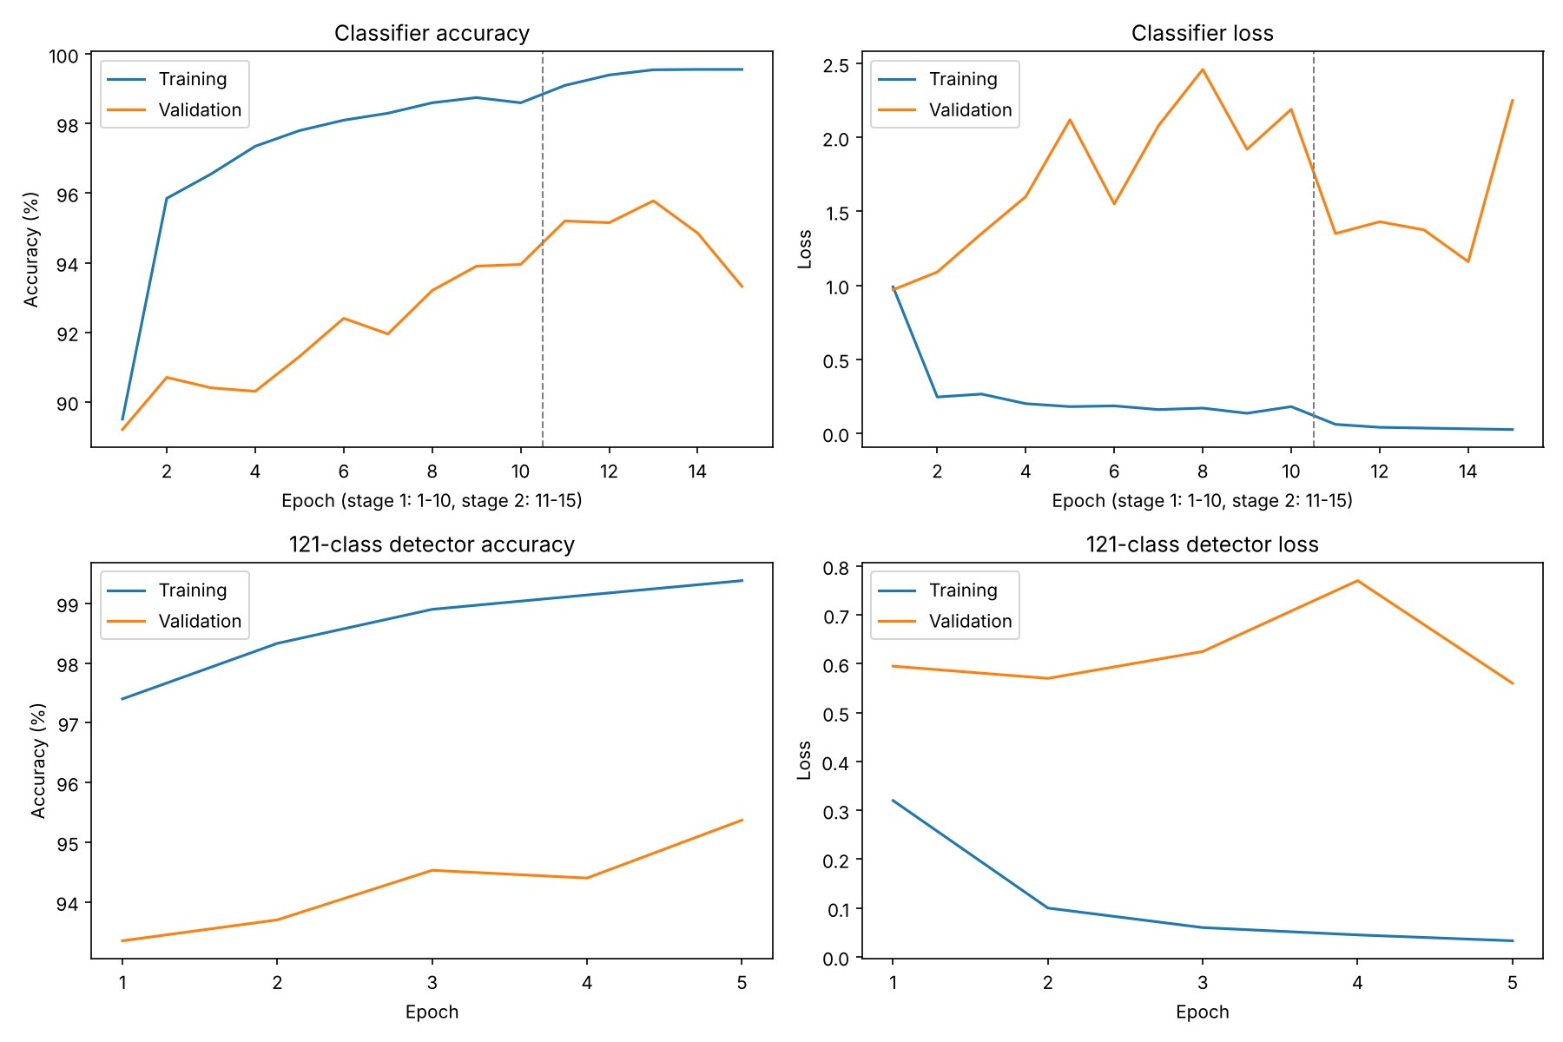
Figure 9. Task 6: classifier training over stages 1 and 2 (dashed line marks the start of fine-tuning) and detector training.

Findings
- Saving and reloading works: predictions of the reloaded best model on 10 test images were identical to the original (maximum difference 0.0); 9 of the 10 were correct (one Cherry Wax Red 3 image was predicted as Apple 17).
- Fine-tuning helps: test accuracy improved from 95.48% to 96.94% (+1.46 pp) and test loss fell from 1.305 to 0.807 (-38%).
- Training accuracy reached 99.6% while validation loss stayed high (1.2 to 2.3), a sign of over-confidence. Validation accuracy peaked at epoch 3 of fine-tuning and then dropped to
93.32%, so keeping the best checkpoint was worthwhile.
- The detector reached 95.37% validation accuracy with the extra Background class. The planned detection evaluation (precision, recall and F1 of the VGG16 detector against the Task 4 detector on 50 scenes) was written but not executed, so no detection metrics are available for Task 6.

3. Comparison of Task 4 Results with Published Results
The reference paper is Muresan and Oltean, "Fruit recognition from images using deep learning" (Acta Universitatis Sapientiae, Informatica 10(1), 2018; arXiv:1712.00580). Two sets of reference values are compared with the results of this work. The first are the values stored in the Task 4 notebook (RGB 98.66%, Grayscale 95.25%, HSV 96.09%). The second are the test accuracies in Table 3 of the paper (arXiv version 10): Grayscale 94.24%, RGB 93.47%, HSV 97.01%. I could not find the notebook values in Tables 3 or 4 of that version of the paper; the highest test accuracy reported there is 97.04%. The source of the notebook values should therefore be confirmed against the assignment sheet.
Table 9. Test accuracy: this work vs published values (%)
Input | This work | Notebook reference | Difference | Paper, Table 3 | Difference
RGB | 94.98 | 98.66 | -3.68 pp | 93.47 | +1.51 pp
Grayscale | 93.55 | 95.25 | -1.70 pp | 94.24 | -0.69 pp
HSV | 95.43 | 96.09 | -0.66 pp | 97.01 | -1.58 pp
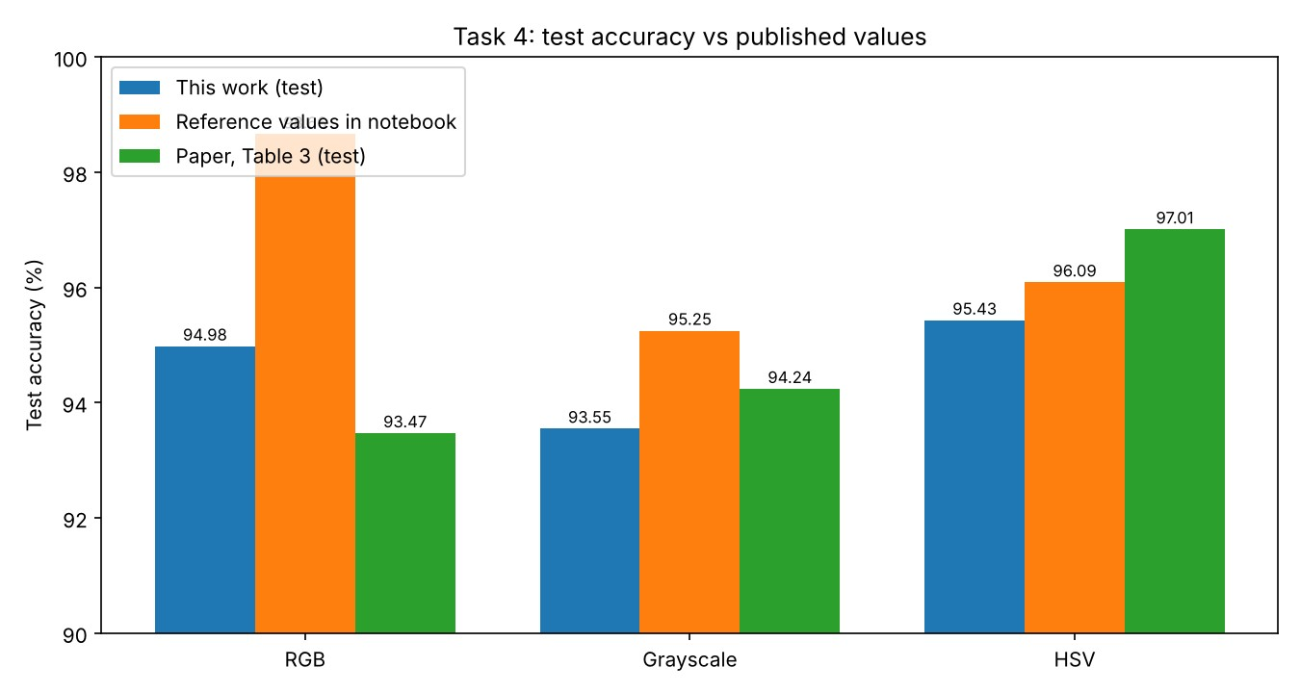
Figure 10. Task 4: test accuracy of this work compared with the published and reference values.
Table 10. Experimental setup: this work vs the paper
Item | This work | Paper
Dataset | Fruits-360, 278 classes, 199,250 images  (119,572 / 29,893 / 49,785 train / val / test) | Fruits-360 (2018 version), 90 classes,  61,934 images (46,371 train / 15,563 test)
Network | 4 x Conv 5x5 (16-32-64-128) + MaxPool,  Dense 1024, Dense 256, softmax | Same convolutional design
Training length | 25 epochs, batch 50 (about 59,800 iterations) | 75,000 iterations, batch 60 (about 97 epochs)
Optimiser, regularisation | Adam, lr 0.001 fixed, no dropout | Adam with decaying learning rate (0.001 to  0.00001), dropout (keep probability 0.8)
Inputs compared | RGB, grayscale, HSV (separately) | Grayscale, RGB, HSV, HSV + grayscale, and HSV + grayscale with hue/saturation changes and flips

Discussion
- Close but not identical. Against the paper's Table 3, our three results lie within 1.6 pp (RGB +1.51, grayscale -0.69, HSV -1.58). Against the notebook reference values the gaps are -0.66 to -3.68 pp, so we cannot claim to match them, and RGB is furthest away.
- Same best input, different ranking. Both studies find HSV best. The paper has RGB lowest (93.47%) and grayscale 94.24%; we have grayscale lowest (93.55%) and RGB 94.98%. The paper also reports that grayscale training gave very high training accuracy but weak test accuracy, which it attributes to overfitting because grayscale loses colour information. We see a similar but smaller effect: grayscale is the lowest on test (93.55%) while its training accuracy (99.47%) is the highest of the three.
- Likely reasons for the differences: (1) our dataset has about 3x more classes (278 vs 90), including 30 apple varieties, which makes the task harder; (2) the paper trained roughly four times longer with a learning-rate schedule and dropout, while we trained 25 epochs without dropout; (3) different random splits, initialisation and framework versions. We did not run controlled experiments that separate these factors, so these are explanations, not demonstrated causes.
- Not reproduced: the paper's best scenario (HSV + grayscale input with hue/saturation changes and flips, 97.04%) was not part of this task, so it is not compared.

4. Challenges Encountered
- Compute and session limits. Epochs took 50 to 500 s for the fruit models, the dataset download was about 8.5 GB, and Colab can disconnect at any time. Tasks 4 to 6 therefore save a checkpoint to Google Drive after every epoch and can resume. This also means some timings mix several sessions (HSV in Task 4 averages 111 s per epoch against 53 s for RGB with identical architecture, which most likely reflects session or hardware differences rather than the colour space).
- Inconsistent datasets across tasks. Task 4 used 278 classes, Task 5 used 277 (after a "BlackBerry 4" / "Blackberry 4" spelling mismatch) and Task 6 used a 120-class subset. The notebooks still call the detector "121-class" although in Task 4 it has 279 outputs. Results from Tasks 4, 5 and 6 are therefore not strictly comparable.
- Dependencies between notebooks. Task 3 could not find the Task 2 results and fell back to the baseline CNN; Task 6 could not find the Task 5 model and retrained it. Both are documented above but weaken the intended comparisons.
- Overfitting and unreliable validation. The CNNs in Tasks 2 and 3, and the VGG16 head in Tasks 5 and 6, overfit quickly (validation loss rising while training accuracy rises). In Task 4 the validation accuracy (about 99.7%) is much higher than test accuracy (about 95%), most likely because of near-duplicate video frames in a random split.
- Detection quality. A sliding-window classifier produces many false positives (precision below 23% in every setting); the scenes are synthetic (fruits pasted on white), and class-wise NMS leaves overlapping boxes of different classes.
- Reference values. The published accuracies stored in the Task 4 notebook could not be matched to the paper's tables (Section 3).
- Incomplete runs. In Task 5 the scratch-CNN, 10%-data and final-table sections were not executed; in Task 6 the detector comparison and final scene visualisation were not executed.
These results are reported as missing instead of estimated.
- Single runs. Every configuration was trained once with seed 42, so differences of 1 to 3 pp (for example between batch sizes) may be within run-to-run variation.

5. Conclusions
- CNNs clearly beat dense networks on images: on CIFAR-10 the CNN was 21.6 pp better with 58% fewer parameters.
- Regularisation is the key lever for small CNNs. Dropout 0.25 added 5.2 pp, and data augmentation was the largest single gain in the whole assignment (+7.30 pp, from 71.99% to 79.29%), while nearly closing the train-validation gap. Heavier augmentation (rotation and zoom) did not help within 20 epochs.
- For Fruits-360, colour information matters: HSV (95.43%) beat RGB (94.98%) and grayscale (93.55%), and the results are within 1.6 pp of the paper's Table 3 despite a harder, larger dataset.
- VGG16 transfer learning matched the scratch CNN on the full data (94.91% vs 94.98%) at about nine times the cost per epoch; its advantage with little data remains untested. Fine-tuning the last VGG16 block gave a further +1.46 pp (95.48% to 96.94%) on the 120-class subset.
- Turning a classifier into a detector by sliding a window works only as a baseline (best F1 0.277); recall is good but precision is poor. Reliable test-set evaluation and checkpointing (keeping the best epoch) were important throughout.

6. Future Work
- Run the missing experiments: the 10%-data comparison of the scratch CNN and VGG16 (Task 5) and the VGG16-vs-Task 4 detector evaluation on the same 50 scenes (Task 6).
- Use one class set and one split for Tasks 4 to 6, and split by video sequence (not randomly) so that validation accuracy is trustworthy.
- Repeat key experiments with several seeds and report mean and standard deviation; add early stopping and learning-rate schedules.
- Re-run Task 3 with the best Task 2 model (dropout 0.25, BatchNorm), train longer with rotation and zoom, and try stronger regularisers such as mixup or cutout and deeper networks such as ResNet.
- Reproduce the paper's best input (HSV + grayscale channels with hue/saturation changes and flips), and add dropout and a decaying learning rate to Task 4.
- Improve detection with class-agnostic NMS, hard-negative background examples (windows that partly overlap a fruit), and real annotated photographs; compare against YOLO or Faster R-CNN.

