**2. Survey Response**

**2.1 Estate Respondents**

The respond rate of this year’s survey was almost the same as compared to last year. Out of 3,643 questionnaires that were mailed out to palm estate, 2,878 estates had responded. This represents 79 per cent if total number of estates compared to 74 per cent that had responded in the last year’s survey. About 61.3 per cent of the respondents were from Peninsular Malaysia, 32.9 per cent from Sabah and the remaining 5.8 per cent from Sarawak. The returned questionnaires represent 2.5 million hectares or 60.68 per cent of the total planted area of 4.17 million hectares in 2006.

**2.1.1 Types of Estate Ownership and Size Distribution**

Responses received covered all ownership categories. However, due to problems of book-keeping, independent and organized smallholders of federal and state land schemes including FELDA, FELCRA and RISDA were excluded in this survey. But, those schemes operating as limited companies (for example FELDA Plantations, ESPEK etc) were included.

This survey shows that about two-thirds of oil palm estates in the country belong to private limited companies. This is followed by public limited companies, which comprise 21.2 per cent of the total number of estate population. Therefore, 83.2 per cent of oil palm estates in the country belong to the private limited and public limited companies. As independent and organized smallholdings are not included in this study, the public or government agencies shown in Figure 1 represent only about 11.5 percent of the total number (as their plantations are already included in the private limited category). Sole proprietors and co-operatives on the other hand, represent only 0.6 per cent and 6 per cent of the estate population respectively

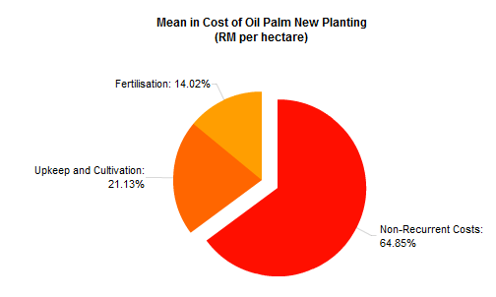

**2.1.2 Average Estate Size**

In 2006, the average size of oil palm estate in Malaysia was 1,039 hectares and the size varied according to region. Oil palm estate in Sarawak are bigger with an average size of 2,467 hectares compared to 957 hectares in Sabah and 947 hectares in Peninsular Malaysia. In general, the largest estates belong to public limited companies with average size of 1,482 hectares (Table 1). The public agency estates rank second in estate size with an average size of 1,152 hectares. Private limited companies have estates with an average size of 1,016 hectares and 409 hectares, respectively. Sole proprietorship owners own the smallest estate size of 236 hectares.

Table 1: Mean Size of Estates According to Ownership Types

|  |  |
| --- | --- |
| Ownership Types | Hectares |
| Sole proprietorship | 236 |
| Partnership | 409 |
| Private Limited Company | 1016 |
| Public Limited companies | 1482 |
| Co-operatives | 576 |
| Public agencies | 1152 |
| Others | 876 |
| All Categories | 1039 |

When classed into six size categories as shown in Figure 2, it is observed that 49.8 per cent of estates are smaller than 500 hectares with 15.9 per cent of them are smaller than 100 hectares. Oil palm estates of sizes between 500 to 2,000 hectares account for 32 per cent of the total population and those larger than 2,000 hectares comprised of 18.2 per cent. Hence, the Malaysian oil palm industry is represented by a large number of small estates with about four out of five estates being smaller than 2,000 hectares.

