Results
Robust analysis of the Boolean model. To test whether simulating only the relevant processes reproduces the full dynamics across the parameter space, we sampled the model parameters, initial concentrations and observational times with Latin hypercube sampling and compared the Boolean (transient) model with the full model (Figure 6). For a 10% observer tolerance (α = 0.1), the mean combined relative error was below the tolerance in 997 of 1,000 simulations, with a median of 0.68% and a 90th percentile of 2.2% (Figure 6a). The number of relevant processes varied widely within and between trajectories (Figure 6b): on average, all four processes were relevant during 19% of the observational window, and only 9.5% of the trajectories (95% CI 7.8–11.5%) kept all processes relevant for the whole window, which represents 0.96% (0.82–1.13%) of the sampled space. Across tolerances spanning five orders of magnitude (α = 10⁻⁵ to 1), the mean error remained below the observer tolerance in at least 99.7% of the simulations, and the error decreased as the tolerance decreased (Figure 6c). As the tolerance increased, the fraction of time with all processes relevant decreased from 0.95 (α = 10⁻⁵) to 0.09 (α = 1), and the share of the sampled space requiring all processes for the whole window decreased from 9.0% to 0.4%. The model with carrying capacity and the simulations that had to be stopped because a population left the physical bounds led to similar or better results (carrying capacity: median error 0.77%, 988 of 999 simulations within 10%; stopped simulations: median error 0.0035% without and 0.0065% with carrying capacity, more than 99.9% of simulations within 10%; Supplementary Figures S3, S4 and S5). For α = 0.1, the carrying-capacity case showed 12 of 1,000 simulations above the tolerance (one of them an extreme outlier). These corresponded to long oscillatory trajectories in which the Boolean model accumulated a persistent delay with respect to the full model; the Boolean trajectories, relevant processes and process weights remained qualitatively in good agreement with the full model (Supplementary Figures S6 and S7).

Methods
Robust analysis. The full and Boolean phage–bacteria models, with and without carrying capacity, were taken unchanged from the project notebook and integrated with solve_ivp (LSODA; relative and absolute tolerances 10⁻¹³ and 10⁻¹⁶) on 10,000 evenly spaced time points over the observational time, τ. In the Boolean model, a process is active when its weight is w ≥ 1. Model parameters (r, a, c, m) and τ were sampled within the ranges in Table 1, initial concentrations within 10³–10¹² bacteria ml⁻¹ and 10³–10¹⁴ phages ml⁻¹, and the carrying capacity within K = 10⁴–10¹³ cells ml⁻¹ with B₀ ≤ K, using log-uniform Latin hypercube sampling (scipy.stats.qmc; seed 2026). Each sample was simulated with the same parameters at α = 10⁻⁵, 10⁻⁴, …, 1. A simulation was stopped when either population, in either model, fell below 10⁻³ ml⁻¹ or exceeded the physical limits of 10¹⁵ bacteria ml⁻¹ or 10¹⁸ phages ml⁻¹ (the volumes of the smallest bacterium, about 10⁻³ µm³, and phage, about 10⁻⁶ µm³, packed into 1 ml); both models were then compared up to the earliest stop time. The sample size was doubled (2,000, 4,000, …) until every α had at least 1,000 simulations covering the full observational window (16,000 samples without and 8,000 with carrying capacity), and 1,000 of these were selected at random for each α; stopped simulations with at least two compared time points were analysed separately. The accuracy of the Boolean model was measured as the mean combined relative error, the time average of ½(|B_{full} − B_{Boolean}|/B_{full} + |P_{full} − P_{Boolean}|/P_{full}) × 100. For each simulation, we also recorded the fraction of time spent with 0 to P relevant processes (P = 4 without and 5 with carrying capacity) and whether all processes were relevant throughout. Extreme outliers were identified with Tukey's far-out test on log₁₀ error (values above Q3 + 3 × IQR) and excluded from the summary statistics, and 95% confidence intervals for proportions used the Wilson score interval. The code and data are available in the project repository (results/alpha-robustness-v2).

Figure
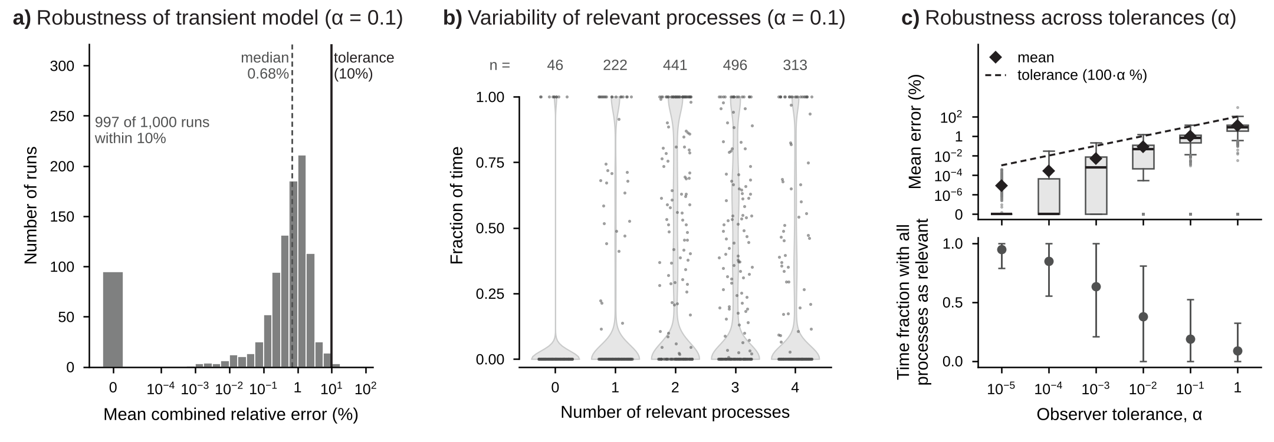
Figure 6. Robust analysis of the Boolean model. Latin hypercube sampling (log-uniform) of the parameters, initial concentrations and observational time of the phage–bacteria (Lotka–Volterra) model; only simulations that remained within the physical bounds for the full observational window are shown (n = 1,000 for α = 0.1). a) Robustness of transient model (α = 0.1): histogram of the mean combined relative error (%) between the transient (Boolean) and full models; the bar labelled 0 counts runs with zero error (all processes relevant throughout), the dashed line marks the median, and the solid black line marks the observer tolerance (10%). b) Variability of relevant processes (α = 0.1): fraction of the observational time that each run spent with 0 to 4 relevant processes (weight w ≥ 1); violins show the distribution across runs, grey points a random sample of 200 runs, and the numbers on top (n) the runs that spent any time with that number of relevant processes. c) Robustness across tolerances (α): top, box plots of the mean combined relative error for α = 10⁻⁵ to 1 (box, interquartile range, IQR; line, median; whiskers, 1.5 × IQR; points, values beyond the whiskers), with the mean (◆) and the observer tolerance, 100·α % (dashed line); zero errors are drawn at the bottom of the axis, labelled 0. Bottom, mean ± standard deviation of the fraction of time with all 4 processes relevant. Extreme outliers (Tukey's far-out test, above Q3 + 3 × IQR of log₁₀ error) are excluded from the statistics and, when present, shown in ochre.

