Figures
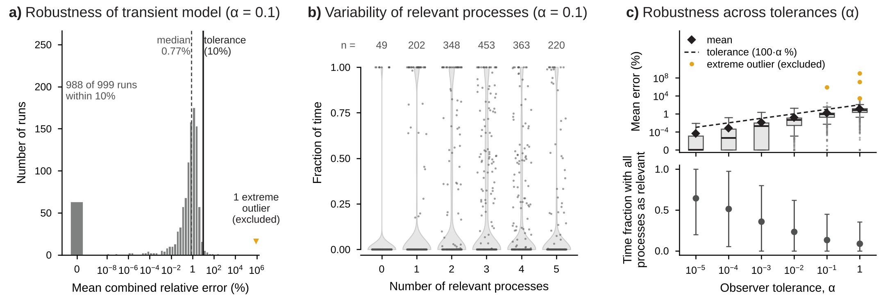
Figure S3. Robust analysis of the Boolean model with carrying capacity. Latin hypercube sampling (log-uniform) of the parameters, initial concentrations, and observational time of the phage–bacteria model with bacterial carrying capacity; only simulations that remained within the physical bounds for the full observational window are shown (n = 1,000 for α = 0.1). a) Histogram of the mean combined relative error (%) between the transient (Boolean) and full models at α = 0.1; the bar labeled 0 counts runs with zero error (all processes relevant throughout), the dashed line marks the median, and the solid black line marks the observer tolerance (10%, corresponding to α = 0.1). b) Fraction of the observational time that each run spent with 0 to 5 relevant processes (weight w ≥ 1) at α = 0.1; violins show the distribution across runs, gray points are a random sample of 200 runs, and the numbers on top (n) are the runs that spent any time with that number of relevant processes. c) Top, box plots of the mean combined relative error for α = 10⁻⁵ to 1 (box, interquartile range, IQR; line, median; whiskers, 1.5 × IQR; points, values beyond the whiskers), with the mean (◆) and the observer tolerance, 100·α % (dashed line); zero errors are drawn at the bottom of the axis, labeled 0. Bottom, mean ± standard deviation of the fraction of observational time with all 5 processes relevant. Extreme outliers (Tukey's far-out test, above Q3 + 3 × IQR of log₁₀ error) are excluded from the statistics and, when present, shown in ochre.
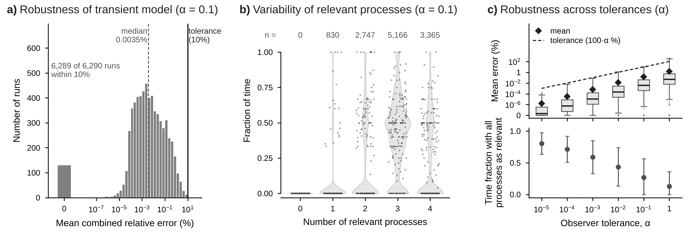
Figure S4. Robust analysis of the Boolean model for stopped simulations. Latin hypercube sampling (log-uniform) of the parameters, initial concentrations, and observational time of the phage–bacteria (Lotka–Volterra) model; only simulations that were stopped because a population left the physical bounds before the end of the observational window are shown, and both models are compared up to the stop time (n = 6,290 for α = 0.1). a) Histogram of the mean combined relative error (%) between the transient (Boolean) and full models at α = 0.1, calculated over the simulated portion of each trajectory; the bar labeled 0 counts runs with zero error (all processes relevant throughout), the dashed line marks the median, and the solid black line marks the observer tolerance (10%, corresponding to α = 0.1). b) Fraction of the simulated time that each run spent with 0 to 4 relevant processes (weight w ≥ 1) at α = 0.1; violins show the distribution across runs, gray points are a random sample of 200 runs, and the numbers on top (n) are the runs that spent any time with that number of relevant processes. c) Top, box plots of the mean combined relative error for α = 10⁻⁵ to 1 (box, interquartile range, IQR; line, median; whiskers, 1.5 × IQR; points, values beyond the whiskers), with the mean (◆) and the observer tolerance, 100·α % (dashed line); zero errors are drawn at the bottom of the axis, labeled 0. Bottom, mean ± standard deviation of the fraction of simulated time with all 4 processes relevant. Extreme outliers (Tukey's far-out test, above Q3 + 3 × IQR of log₁₀ error) are excluded from the statistics and, when present, shown in ochre.
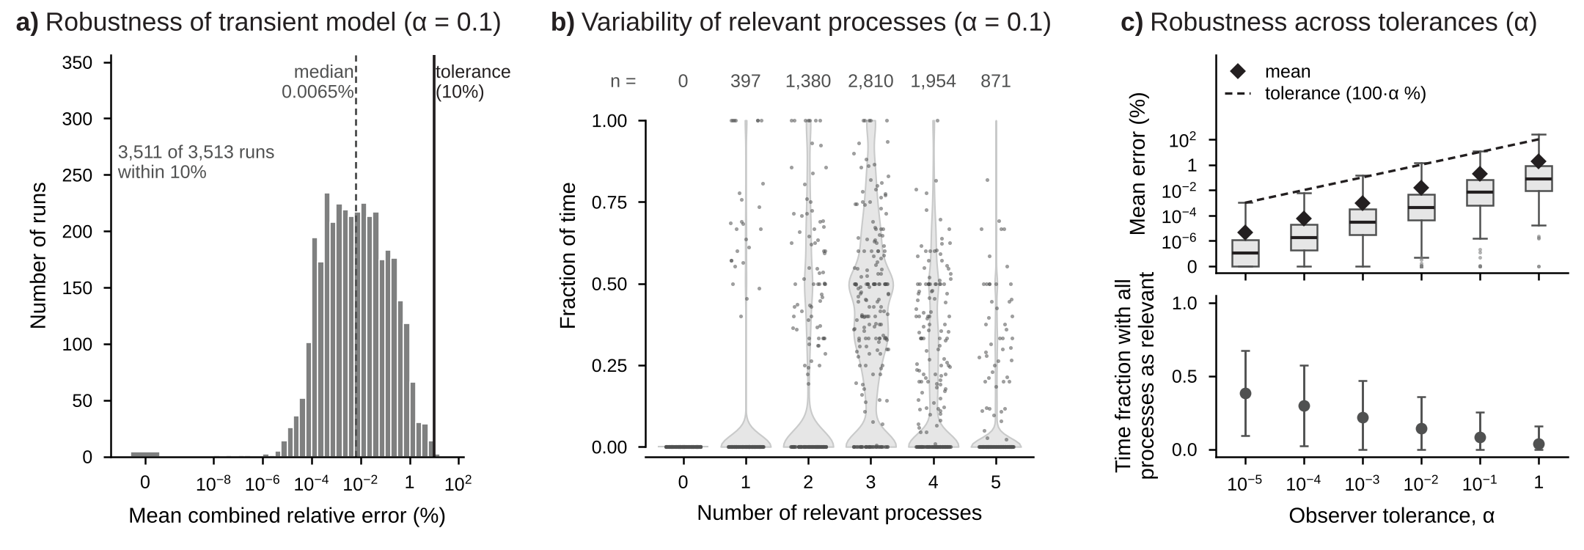
Figure S5. Robust analysis of the Boolean model with carrying capacity for stopped simulations. Latin hypercube sampling (log-uniform) of the parameters, initial concentrations, and observational time of the phage–bacteria model with bacterial carrying capacity; only simulations that were stopped because a population left the physical bounds before the end of the observational window are shown, and both models are compared up to the stop time (n = 3,513 for α = 0.1). a) Histogram of the mean combined relative error (%) between the transient (Boolean) and full models at α = 0.1, calculated over the simulated portion of each trajectory; the bar labeled 0 counts runs with zero error (all processes relevant throughout), the dashed line marks the median, and the solid black line marks the observer tolerance (10%, corresponding to α = 0.1). b) Fraction of the simulated time that each run spent with 0 to 5 relevant processes (weight w ≥ 1) at α = 0.1; violins show the distribution across runs, gray points are a random sample of 200 runs, and the numbers on top (n) are the runs that spent any time with that number of relevant processes. c) Top, box plots of the mean combined relative error for α = 10⁻⁵ to 1 (box, interquartile range, IQR; line, median; whiskers, 1.5 × IQR; points, values beyond the whiskers), with the mean (◆) and the observer tolerance, 100·α % (dashed line); zero errors are drawn at the bottom of the axis, labeled 0. Bottom, mean ± standard deviation of the fraction of simulated time with all 5 processes relevant. Extreme outliers (Tukey's far-out test, above Q3 + 3 × IQR of log₁₀ error) are excluded from the statistics and, when present, shown in ochre.
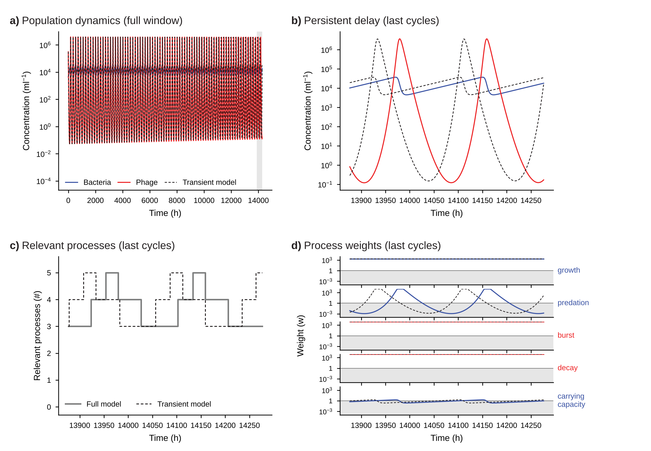
Figure S6. Example of the extreme outlier with carrying capacity: persistent delay. Simulation 178 of the robust analysis of the model with carrying capacity at α = 0.1 (mean combined relative error 8.6 × 10⁵%; extreme outlier). Blue, bacteria and bacterial processes; red, phage and phage processes; dashed black, transient (Boolean) model. a) Bacteria and phage concentrations over the full observational window for the full (solid) and transient (dashed) models; the shaded interval marks the last cycles shown in b–d. b) Concentrations over the last cycles, showing the delay accumulated by the transient model. c) Number of relevant processes (w ≥ 1) in the full (solid gray) and transient (dashed) models. d) Weight of each process in the full (colored) and transient (dashed) models; the gray band marks irrelevant weights (w < 1), and the solid line marks the threshold w = 1.

