CHAPTER 5. PROMINENT SOLUTIONS AND CONTRIBUTIONS
Chapter 4 presented the architecture, detailed design, and construction results of the VoltGO system. Those results show that the system handles several business flows whose value depends on controlled state transitions, data reliability, and coordination between different actors. This chapter analyzes four main contributions of the project: the conflict-controlled charging booking mechanism, the real-time battery swap workflow, the station data verification and risk assessment mechanism, and the loyalty and voucher mechanism that connects service usage with user contribution.

5.1 Conflict-controlled charging booking mechanism with time-limited hold

5.1.1 Problem introduction
Charging booking is a consistency-sensitive operation. A charger unit can serve only one user during a selected time window, so the system must prevent overlapping active bookings. The problem is more than a screen-level availability check. When several users view the same station and select nearby time slots, the backend must validate the latest state before any booking is created.
The intermediate state of a booking also requires control. A user may select a slot and then need time to review price information, apply a voucher, or complete the simulated payment step. If the system saves only confirmed bookings, the selected slot can be taken by another user during confirmation. If the system locks the slot indefinitely, charging resources can be wasted when the user exits the process.
A simple booking flow is not suitable for this requirement because it either delays reservation until payment or holds the resource without a bounded lifecycle. VoltGO addresses this issue by combining service-level validation, a time-limited HOLD state, scheduled expiration, and database-level conflict protection. The contribution is not the existence of a booking screen, but the design of a booking lifecycle that remains consistent under concurrent access.

5.1.2 Solution
The solution separates the availability viewing phase from the booking creation and confirmation phases. Availability queries build a 30-minute slot grid for each charger unit and mark each slot according to the current device state and existing active bookings. This design allows users to compare available choices without changing booking data.
When the user submits a booking request, the backend rechecks the station, charger unit, selected time interval, and active conflicts. A valid request creates a Booking record in the HOLD state with an expiration timestamp. The HOLD state gives the user a short confirmation window while preventing another active booking from using the same charger unit and time range.
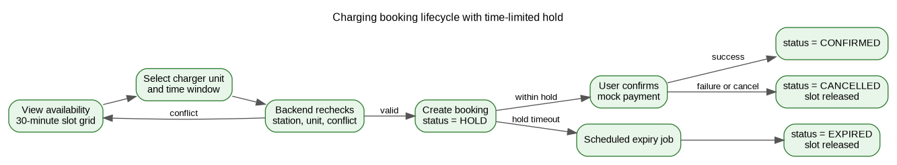
Figure 5.1. Charging booking lifecycle with time-limited hold
The scheduled expiration mechanism releases resources that remain in the HOLD state beyond the allowed confirmation window. This choice avoids permanent slot locking and keeps the booking process predictable. At the same time, the database acts as the final consistency boundary by rejecting overlapping active bookings at the storage layer. Business validation provides meaningful user feedback, while the database constraint protects the system against race conditions.
Listing 5.1. Pseudocode for creating a time-limited charging booking
procedure createBooking(userId, request)
station <- loadPublishedStation(request.stationId)
unit <- loadChargerUnit(request.chargerUnitId)
validateUnitBelongsToStation(unit, station)
validateTimeWindow(request.startTime, request.endTime)
if unit.status is not AVAILABLE then
reject request with unavailable-unit error
end if
if activeBookingExists(unit.id, request.startTime, request.endTime) then
reject request with booking-conflict error
end if
discount <- validateAndApplyVoucherIfPresent(userId, request.voucherCode)
booking <- new Booking(userId, station.id, unit.id)
booking.status <- HOLD
booking.holdExpiresAt <- currentTime + holdDuration
booking.priceSnapshot <- calculatePrice(request, discount)
save booking
create pending payment intent for booking
return booking details with hold expiration time
end procedure

Payment confirmation changes the booking from HOLD to CONFIRMED only when the hold has not expired. Failed payment, user cancellation, or expiration leads to a non-active state and releases the slot for later users. Loyalty points are awarded after the service-related condition is satisfied, not at the moment of viewing availability. This keeps booking, payment, and loyalty data aligned with the actual business result.

5.1.3 Achieved results
The main result of this solution is that a charger unit cannot be used by two active bookings in the same time range. The lifecycle distinguishes HOLD, CONFIRMED, CANCELLED, and EXPIRED states, so the system can explain why a slot is unavailable and when it becomes available again. This model gives users a reasonable confirmation period without sacrificing resource utilization.
The solution also provides a reusable pattern for other reservation flows. Validation occurs before state creation, temporary ownership is bounded by time, and final confirmation depends on a successful business event. Table 5.1 summarizes how this mechanism differs from a simpler booking approach.
Table 5.1. Comparison between a simple booking flow and the VoltGO controlled booking flow
Concern | Simple booking flow | VoltGO controlled flow | Contribution
Conflict handling | Often relies on interface state or late validation. | Rechecks active conflicts at the backend and protects data with storage-level constraints. | Reduces overlapping active bookings.
Intermediate state | Usually has no explicit temporary state. | Uses HOLD with a defined expiration timestamp. | Protects the selected slot during confirmation.
Resource release | Requires manual cancellation or delayed cleanup. | Scheduled jobs expire overdue HOLD bookings. | Returns unused slots to the availability pool.
Payment linkage | Payment and booking states may be loosely connected. | Confirmation updates payment and booking states in one controlled workflow. | Keeps service usage and payment result consistent.
Loyalty linkage | Reward logic may be scattered across screens or controllers. | Points are granted after eligible completion through a dedicated loyalty service. | Keeps incentive logic traceable.

5.2 Real-time battery swap process combined with reservation, confirmation code and hardware simulator

5.2.1 Problem introduction
Battery swapping differs from charging booking because it involves both a reserved service and a physical station operation. The system must control battery slots, reservation status, swap sessions, confirmation codes, and payment states. A static reservation record is not enough because it does not show whether the user has arrived, whether the swap code has been generated, or whether the station display has received the active session information.
The workflow also requires coordination between two clients. The EV Driver Mobile application initiates the process and displays instructions to the user. The Hardware Simulator represents the station display and receives operational information from the backend. Direct communication between these clients would reduce the backend control over business state and would make later hardware integration harder to manage.
A manual code entry process or a purely after-the-fact status update would not meet the requirement. VoltGO needs a backend-centered workflow in which REST APIs handle user actions, WebSocket messages deliver real-time codes to the simulator, and the database stores the state of each step.

5.2.2 Solution
The battery swap solution models the operation as a sequence of business states. The user first creates a reservation at a swap station with available capacity. The system assigns a battery slot, creates a reservation record, and prepares payment information. This step reserves the physical resource before the user arrives at the station.
After arrival, the user starts the swap session. The backend generates a confirmation code, creates a swap session, updates the reservation state, and broadcasts the code to the Hardware Simulator. The user then compares the code shown in the mobile application with the code displayed at the station. This design reduces the risk of starting a session at the wrong station or continuing an outdated reservation.
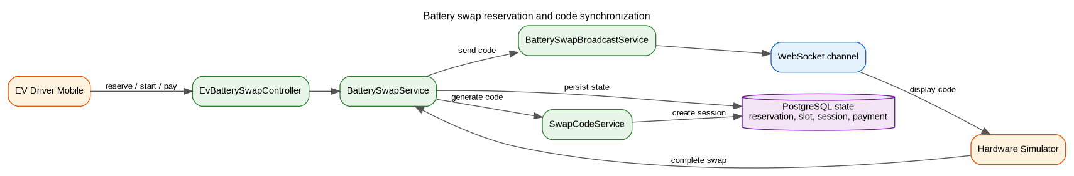
Figure 5.2. Battery swap reservation and real-time code synchronization
WebSocket is used because the simulator must receive the active code when the session starts. A polling-based design would require the station display to repeatedly call the backend and would introduce unnecessary delay. With WebSocket, the simulator keeps an authenticated connection and receives the swap code when the backend broadcasts it for the corresponding device key.
The data model separates BatterySwapReservation, BatterySlot, SwapSession, and SwapPayment. This separation is important because each entity represents a different part of the operation. Reservation records describe user demand, slot records describe physical resource allocation, session records describe code validity, and payment records describe the financial state within the thesis scope.
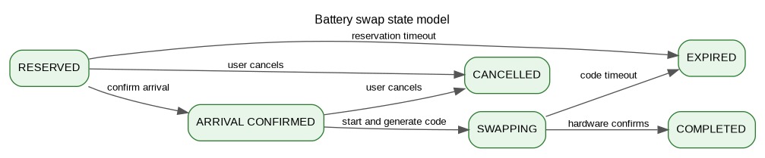
Figure 5.3. Battery swap state model
Listing 5.2. Pseudocode for starting a battery swap session
procedure startAndGenerateCode(userId, reservationId)
reservation <- loadReservation(reservationId)
validateReservationOwner(reservation, userId)
validateReservationIsActive(reservation)
validateReservationNotExpired(reservation)
session <- createSwapSession(reservation.id)
session.swapCode <- generateNumericCode()
session.status <- PENDING
session.expiresAt <- currentTime + codeDuration
save session
reservation.status <- SWAPPING
reservation.startedAt <- currentTime
save reservation
deviceKey <- loadDeviceKey(reservation.stationId)
broadcastSwapCode(deviceKey, session.swapCode)
return session code and expiration time
end procedure

When the simulator confirms completion, the backend updates the swap session, reservation, and slot states. The payment step is then processed through the mocked payment mechanism. Since all state transitions pass through the backend, the simulator can later be replaced by real equipment without changing the core business sequence.

5.2.3 Achieved results
The solution turns battery swapping from a simple reservation into an operational workflow with visible and persisted states. Users can reserve a battery slot, confirm arrival, receive a code, and match the code with the station display. The backend can track the reservation, slot, session, and payment states throughout the process.
The contribution also demonstrates how REST and WebSocket can be combined inside one business operation. REST is used for deliberate user actions, while WebSocket is used for immediate station-display updates. Table 5.2 summarizes the main states and their effects on the mobile application and the simulator.
Table 5.2. Battery swap workflow state table
State | Triggering actor or event | Persisted entity | Visible result
RESERVED | EV User reserves a swap service. | BatterySwapReservation and BatterySlot | The mobile app shows reservation details and expiration time.
ARRIVAL CONFIRMED | EV User confirms arrival at the station. | BatterySwapReservation | The mobile app allows the user to start the swap.
SWAPPING | EV User starts the swap session. | BatterySwapReservation and SwapSession | The mobile app and simulator display the same confirmation code.
COMPLETED | Simulator confirms the physical swap. | SwapSession, BatterySwapReservation, and BatterySlot | The session is marked as completed and the slot state is updated.
PAID | EV User completes mock payment. | SwapPayment | The service payment state becomes visible in the reservation record.
EXPIRED or CANCELLED | Timeout or user cancellation. | BatterySwapReservation and BatterySlot | The reserved resource is released when allowed by the lifecycle.

5.3 Station data field verification and risk assessment mechanism

5.3.1 Problem introduction
Station data reliability is a core issue in an electric vehicle service platform. Users depend on station location, charger type, operating hours, equipment status, and service availability before deciding to travel. Inaccurate data can cause wasted time and reduce trust in the application.
The system must balance update speed and data reliability. Manual review for every change can delay useful updates and overload administrators. Automatic approval can publish incorrect data when a proposed change affects location, ports, operating conditions, or station availability. A suitable solution needs to evaluate change risk and collect field evidence when the risk is not sufficiently low.
A manual-only approval process gives administrators little support for judging the seriousness of a proposed change. A feedback-only process reacts after users have already encountered a problem. VoltGO combines station proposals, issue reports, GPS check-ins, photo evidence, risk scores, and trust scores so that station data can be governed before and after publication.

5.3.2 Solution
The solution uses two complementary layers. The field verification layer checks whether a collaborator physically visits the station and submits evidence. The risk assessment layer evaluates proposed data changes and produces explainable reasons for the administrator. These layers support different decisions but share the same objective of improving station data reliability.
In the verification workflow, an administrator assigns a task to a collaborator. The collaborator travels to the station, performs a GPS check-in, and uploads evidence such as station exterior photos, charger photos, signage photos, or operational notes. The system calculates the distance between the collaborator location and the stored station coordinates before accepting the check-in. This prevents verification from being submitted without field presence.
Figure 5.4. Station data contribution and field verification workflow
Evidence files are stored in MinIO rather than in relational tables. The database retains metadata and file keys, while object storage keeps the image files. This design keeps structured data and file data separated, which is appropriate for a system that may store many verification photos and station images.
The risk assessment layer compares proposed station data with the current published version. For standard charging stations, the system considers factors such as new station creation, GPS coordinate changes, port configuration changes, operating hour changes, and access-related changes. Each triggered factor contributes to the final score and is retained as a reason that the administrator can inspect.
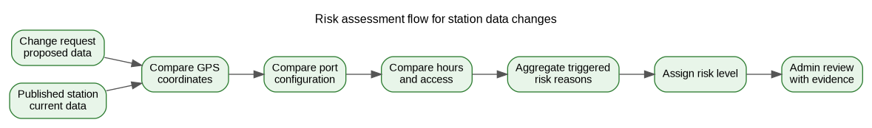
Figure 5.5. Risk assessment flow for station data changes
Battery swap station assessment uses a broader set of categories because the service includes inventory, slot configuration, operational availability, financial information, and safety-related information. Some declared safety and provider factors are foundations for later implementation rather than complete production checks in the current thesis scope. This limitation is stated to avoid overclaiming the maturity of the risk engine.
Listing 5.3. Pseudocode for assessing station data change risk
procedure assessChangeRequest(changeRequest)
proposed <- parseProposedStationData(changeRequest.proposedData)
current <- loadPublishedStationVersion(changeRequest.stationId)
riskScore <- 0
reasons <- empty list
if changeRequest.type is CREATE_STATION then
addReason(reasons, NEW_STATION)
riskScore <- riskScore + 10
end if
if gpsDistance(current.location, proposed.location) > 100 meters then
addReason(reasons, GPS_CHANGED_100M)
riskScore <- riskScore + 50
end if
if portConfigurationChanged(current.ports, proposed.ports) then
addReason(reasons, PORTS_CHANGED)
riskScore <- riskScore + 30
end if
if operatingHoursChanged(current.hours, proposed.hours) then
addReason(reasons, HOURS_CHANGED)
riskScore <- riskScore + 10
end if
riskScore <- min(riskScore, 100)
riskLevel <- classifyRiskLevel(riskScore)
saveRiskResult(changeRequest.id, riskScore, riskLevel, reasons)
return risk result
end procedure

The long-term trust score complements request-level risk assessment. A risk score evaluates one proposed modification, while a trust score reflects accumulated station quality after publication. User ratings, issue history, verification results, and operational signals can contribute to this longer-term view. This distinction helps the administrator treat a single change request and the overall reliability of a station as separate but related concerns.

5.3.3 Achieved results
The verification and risk assessment solution gives VoltGO a structured station data lifecycle. A station update can be proposed, assessed, verified, reviewed, approved, rejected, and later reflected in trust evaluation. The system records not only the final station data but also the reasons and evidence behind the decision.
This contribution improves explainability in administrative decisions. The administrator can review the proposed data, current data, risk reasons, GPS check-in result, evidence files, and historical trust information. Table 5.3 summarizes the main data types used in the decision process.
Table 5.3. Verification and risk assessment data used for administrator decisions
Data type | Produced by | Stored or represented as | Decision support role
Station proposal or change request | EV User, Collaborator, or Admin workflow | ChangeRequest and proposed data snapshot | Shows what data is being added or modified.
GPS check-in | Collaborator Mobile | VerificationCheckin with coordinates and distance | Confirms whether the collaborator is near the station.
Evidence photos | Collaborator Mobile | File keys and metadata linked to verification evidence | Supports visual validation of location and equipment.
Risk reasons and score | Risk assessment engine | riskScore, riskLevel, and riskFactors | Explains why a change requires attention.
Trust score | Trust scoring services | StationTrust or BatterySwapTrust | Provides a long-term reliability signal.
Audit information | Admin workflow | AuditLog | Records who made the final decision and when.

5.4 Loyalty and voucher mechanism tied to service usage and station data contribution

5.4.1 Problem introduction
A station support platform should not only help users complete individual charging or swap transactions. It should also encourage repeated usage and useful user contribution. If users open the application only when they immediately need a station, the platform receives fewer ratings, fewer station reports, and fewer station information proposals. This limits the quality of the shared station database.
The loyalty mechanism must be tied to concrete behaviors rather than being a static point balance. Points should reflect actions such as completing a charging booking, completing a battery swap, rating a station, referring a new user, or submitting a useful station proposal. This is important because station proposals and approved change requests can help the system correct inaccurate location, operating hour, charger, or service information.
A simple implementation that adds points directly inside multiple controllers would make reward policy difficult to maintain. When point values, badge conditions, or voucher rules change, scattered logic becomes hard to update and audit. VoltGO uses a dedicated loyalty service group so that service flows and contribution flows can trigger rewards without duplicating point logic.

5.4.2 Solution
The solution treats loyalty points as a transaction history rather than a single mutable number. Each point addition or deduction creates a LoyaltyPointTransaction with a source, value, timestamp, and related context. LoyaltyUserProfile stores the current balance, lifetime accumulated points, and user tier. This design makes the point balance explainable because the system can trace how it was formed.
Eligible service behaviors call the loyalty layer after the corresponding business result is valid. A completed booking or battery swap can grant points after the service state is confirmed. A station rating can grant points when the rating passes validation rules. A station proposal can grant points when the user submits a change request, and a stronger reward can be associated with proposals that are approved and published. This connection gives users a reason to contribute station data, not only to consume station services.
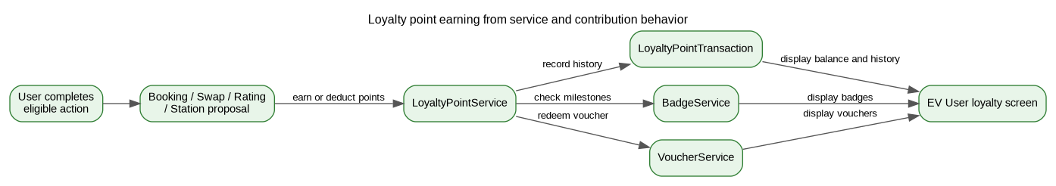
Figure 5.6. Loyalty point earning from service and contribution behavior
Badge checking is separated from point transactions. After an eligible activity, the system can evaluate milestones such as booking count, swap count, rating count, contribution count, or point milestones. This separation allows badge policies to evolve without changing the basic point transaction mechanism.
Voucher management is separated into voucher definitions and voucher redemptions. A VoucherDefinition describes a campaign-level rule, including type, discount value, required points, validity period, and service scope. A VoucherRedemption represents the user-specific voucher code created after points are redeemed. This separation allows many users to redeem the same voucher definition while preserving individual states such as redeemed, used, or expired.
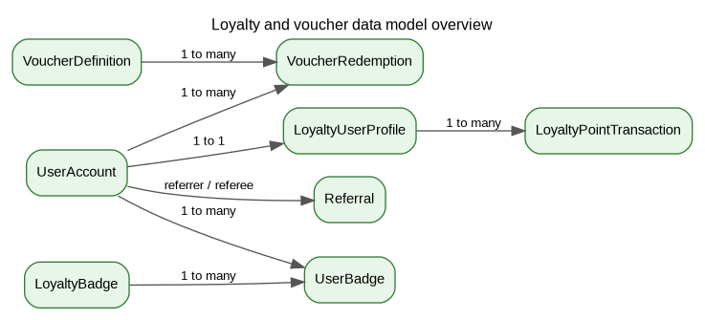
Figure 5.7. Loyalty and voucher data model overview
The loyalty solution is also connected to administrative operation. Administrators can configure voucher definitions, maintain badge policies, moderate ratings, and observe loyalty-related statistics. Within the current scope, some referral and production notification integrations remain areas for future refinement. The implemented structure still provides a basis for connecting incentives with service completion and station data improvement.

5.4.3 Achieved results
The loyalty and voucher solution creates a behavioral incentive layer over the core system functions. Users can earn points from completed services and from contribution-related actions such as station ratings and station information proposals. They can view their point balance, transaction history, badges, and redeemed vouchers. This encourages users to return to the application after a single charging or swap transaction.
From a design perspective, the main contribution is the centralization of point, badge, voucher, and referral policies into dedicated services. This reduces duplication, keeps reward history traceable, and makes policy changes easier to control. The station proposal reward path is especially relevant to VoltGO because it connects user engagement with station data quality. Table 5.4 summarizes the main user behaviors and their system value.
Table 5.4. Loyalty behavior mapping and system value
User behavior | Loyalty effect | Backend component | System value
Complete a charging booking | Earn service usage points. | Booking workflow and LoyaltyPointService | Encourages users to complete bookings through the application.
Complete a battery swap | Earn service usage points. | Battery swap workflow and LoyaltyPointService | Connects the swap workflow with long-term engagement.
Submit a station rating | Earn rating-related points and may progress toward badges. | Rating logic, LoyaltyPointService, and BadgeService | Adds user experience signals to station quality evaluation.
Submit a station proposal or change request | Earn contribution-related points when submitted, with stronger value when approved and published. | Change request workflow and LoyaltyPointService | Motivates users to provide updated station information.
Redeem a voucher | Deduct points and create a user-specific voucher code. | VoucherService and LoyaltyPointService | Turns accumulated engagement into a concrete user benefit.
Refer a new user | Create referral-related point opportunities. | ReferralService and LoyaltyPointService | Supports user acquisition and repeat use.

Chapter 5 Conclusion
Chapter 5 presented four technical contributions of the project. The charging booking mechanism controls time slot conflicts through backend validation, a time-limited HOLD state, scheduled expiration, and database protection. The battery swap process coordinates reservations, battery slots, confirmation codes, WebSocket broadcasting, and the Hardware Simulator. The station verification and risk assessment mechanism improves data reliability through station proposals, GPS check-ins, evidence photos, risk reasons, and trust scores. The loyalty and voucher mechanism links service usage and station data contribution with points, badges, and redeemable benefits.
These solutions show that VoltGO is not limited to displaying station information. The system supports several connected workflows with explicit states and traceable decisions. Chapter 6 will synthesize the achieved results of the project, discuss remaining limitations, and present directions for future development.

