Control

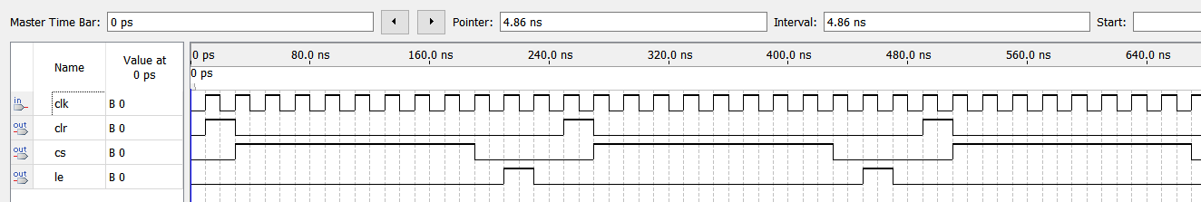

LATCH4

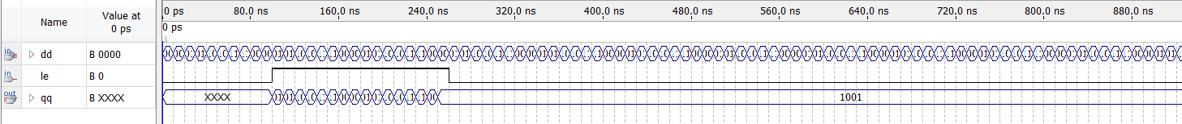

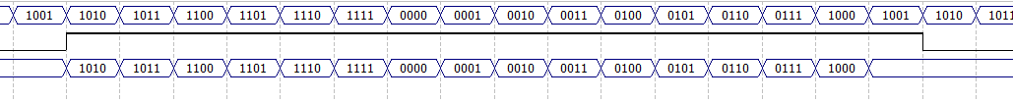

LED7S

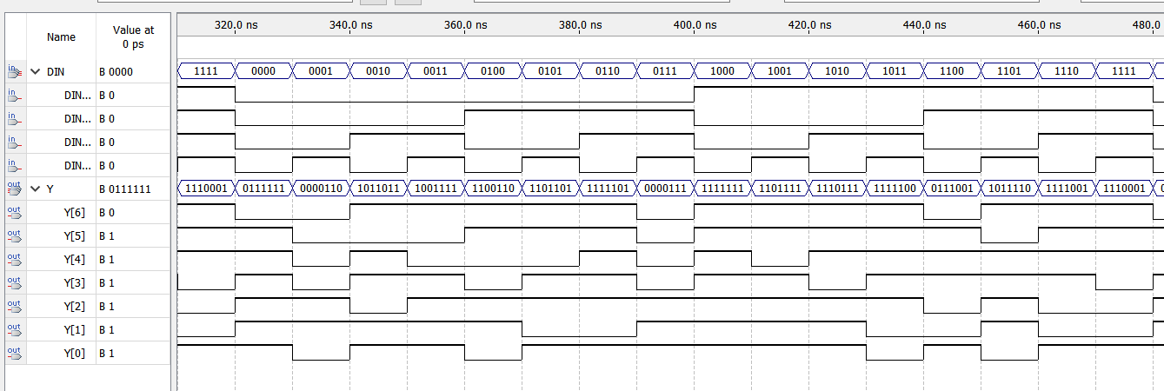

总

