* 收益率序列

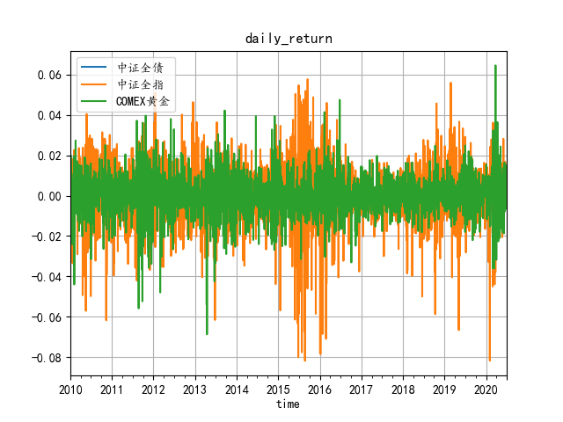

* 对数收益率序列

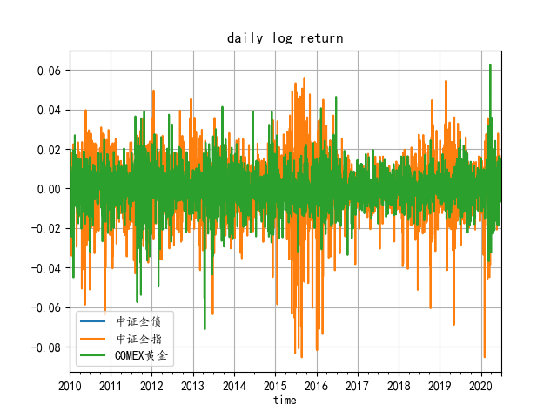

* 资产净值序列

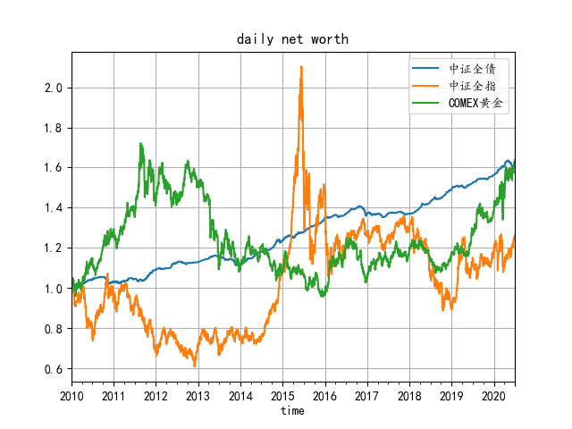

* 资产相关系数

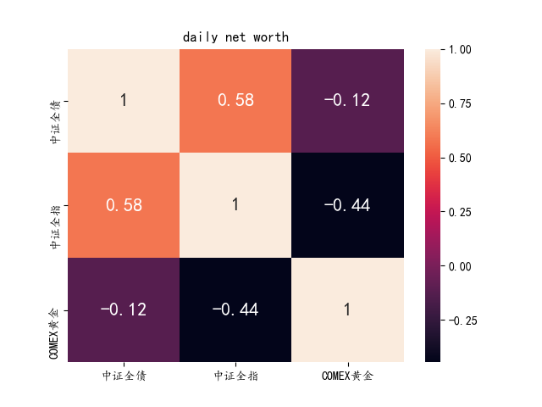

|  |  |  |  |
| --- | --- | --- | --- |
|  | 中证全债 | 中证全指 | COMEX黄金 |
| 中证全债 | 1 | 0.584753908 | -0.117857363 |
| 中证全指 | 0.584753908 | 1 | -0.444765608 |
| COMEX黄金 | -0.117857363 | -0.444765608 | 1 |

* 风险平价模型

|  |  |  |  |
| --- | --- | --- | --- |
| 数据类型 | 中证全债 | 中证全指 | COMEX黄金 |
| 原始风险贡献比例 | 0.336441616 | 0.334688352 | 0.328870032 |
| 风险平价贡献比例 | 0.333333333 | 0.333333333 | 0.333333333 |
| 各资产历史波动率 | 1.016010634 | 1.010716002 | 0.993145418 |
| 风险平价资产配置 | 0.052048542 | 0.866795552 | 0.081155906 |

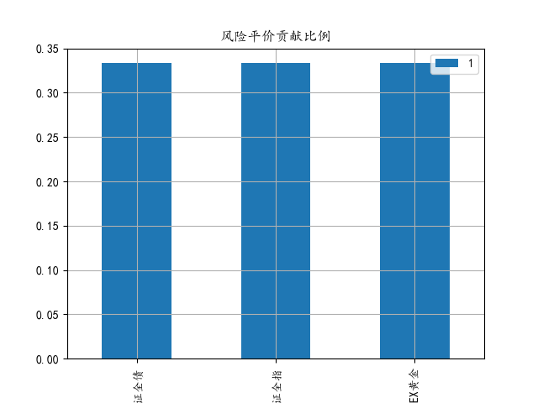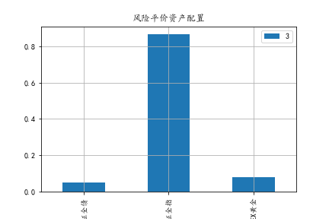

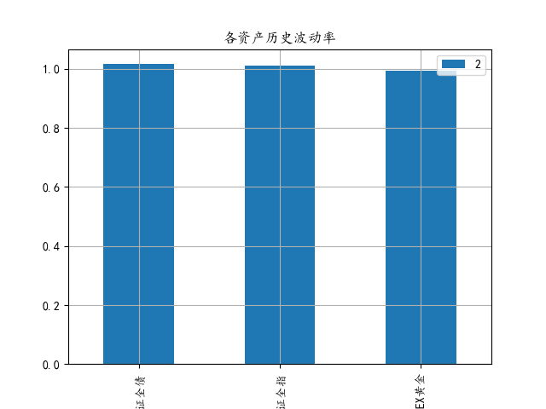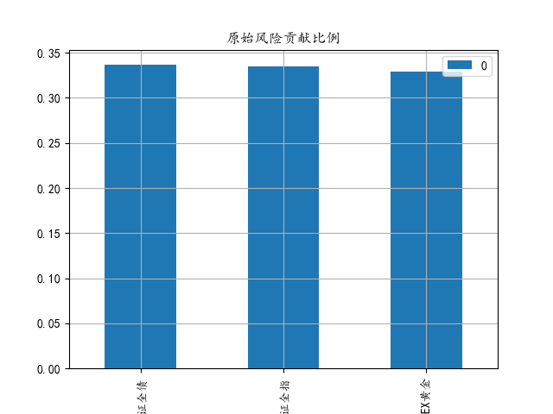

* 组合资产净值曲线

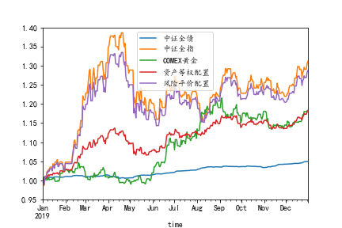

* 组合资产收益率

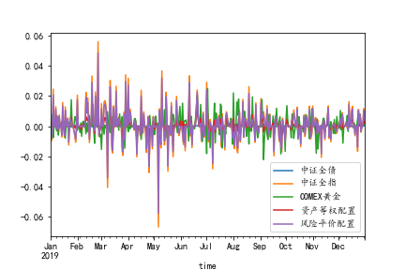

* 组合资产净值表现平价

|  |  |  |  |  |  |  |
| --- | --- | --- | --- | --- | --- | --- |
| portfolio_type | annual_return | annual_volatility | information_ratio | maximum_drawdown | calmar_ratio | sharpe_ratio |
| 中证全债 | 0.049695256 | 0.007169454 | 6.931525782 | -0.008574025 | 5.878590946 | -7517.620831 |
| 中证全指 | 0.312054433 | 0.17115447 | 1.823232742 | -0.228707959 | 1.890794849 | -314.8422041 |
| COMEX黄金 | 0.1837024 | 0.097265133 | 1.88867681 | -0.081653304 | 2.734696553 | -554.070457 |
| 资产等权配置 | 0.184664889 | 0.062696412 | 2.945382067 | -0.060627058 | 3.432573868 | -859.5687179 |
| 风险平价配置 | 0.290165432 | 0.147777036 | 1.963535331 | -0.184090831 | 2.093705476 | -364.6548589 |