***SOFTWARE ANALYSIS AND DESIGN PROJECT: PRACTICE 2***

First, the class diagram is composed by all the classes we have created:

* Application: it has the name of the app and all the methods that are more general and the app permits execute them like login or search.
* User: it has three classes in heracy (host, guest and administrator) so it includes the atributes in common (username, password…).
* House: it has its characteristics, an owner (the host) and an array of offers.
* Offer: the offer can be living or holidays, the difference is the Price and the date so offer has the atributes that both have in common. The methods that offer has, are all which needs an offer (modify, deny, buy…)
* Comment: an offer can have several comments and a comment can have several comments and each of them has a guest that writes it.

The class diagram is below.

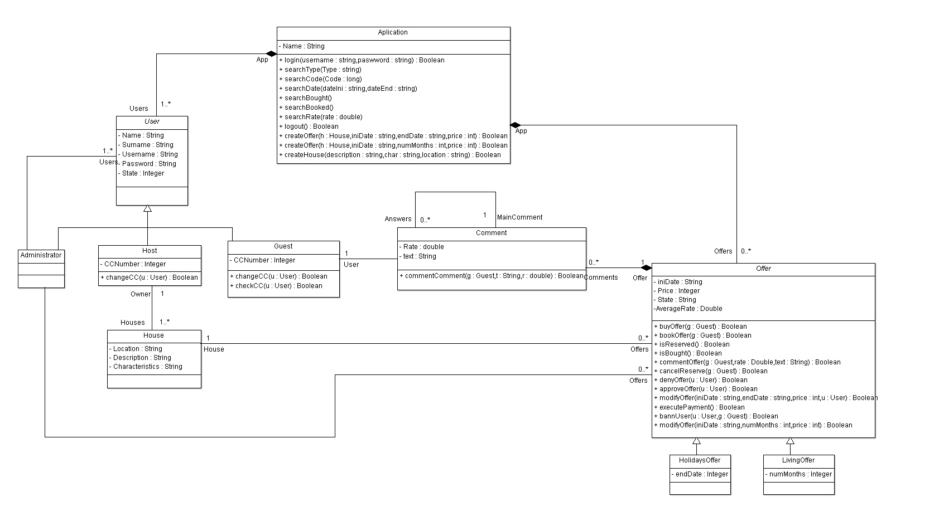

***SEQUENCE DIAGRAMS***

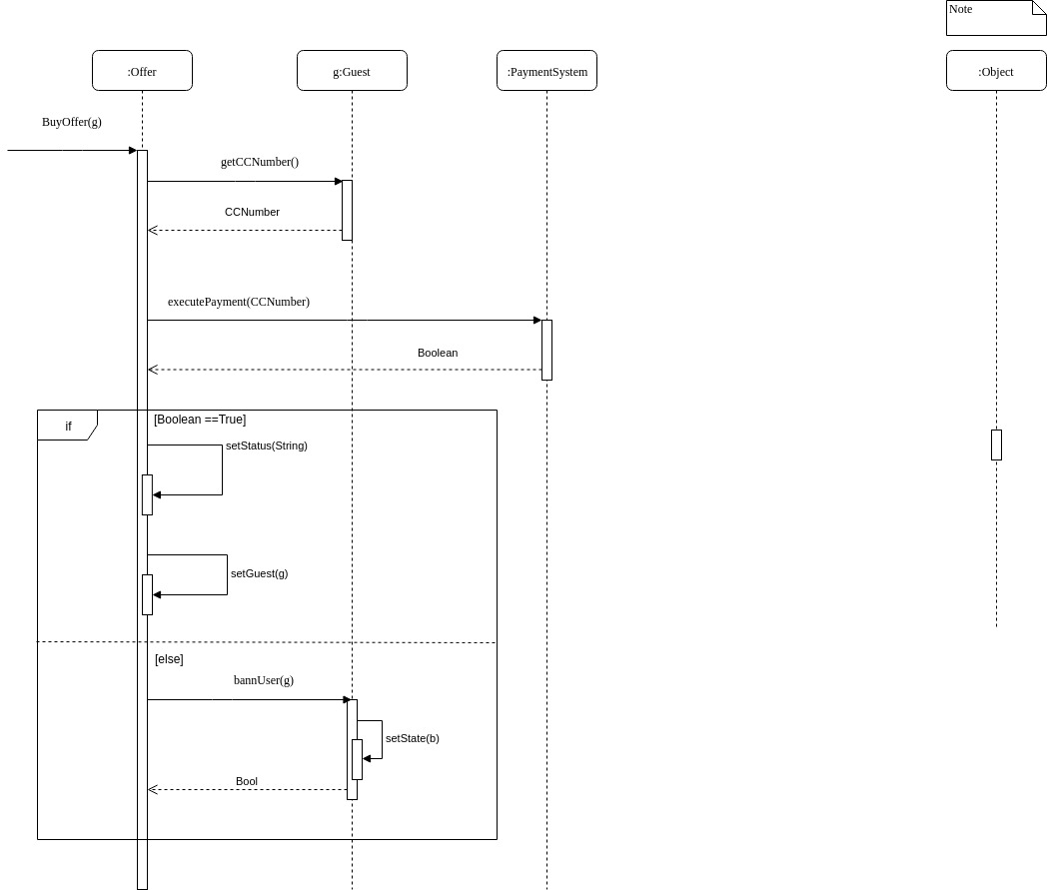

This diagram describes the process of buying an offer. First, the application takes the Credit Card number and then the Payment System processes the payment. If the number is wrong, the administrator bans the user, otherwise the offer is set as bought by the guest.

On the other hand, we have created a sequence diagram about commenting an offer. When a guest writes a comment, the offer creates a new comment on its array of comments setting the rate, text and guest. If the rate is less than 0 or more then 5, the function will return an error.

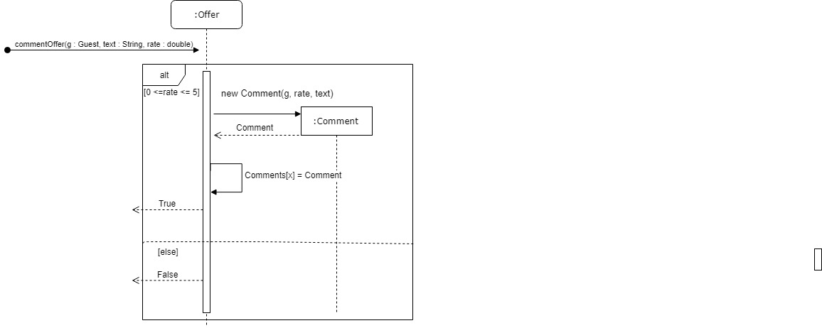

***STATE DIAGRAMS***

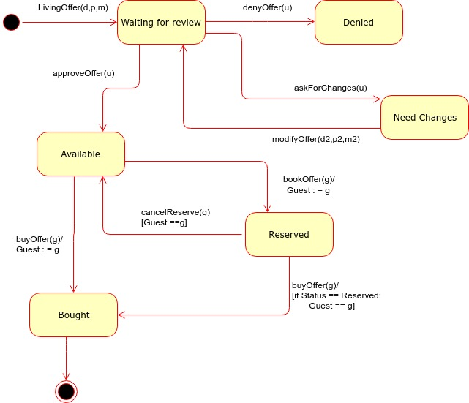This diagram exposes the different states of an offer. First it has to be revised by the admin, who will deny, accept or ask for changes in it. If it’s accepted, then is available and a guest can reserve it and buy it later or buy it directly.

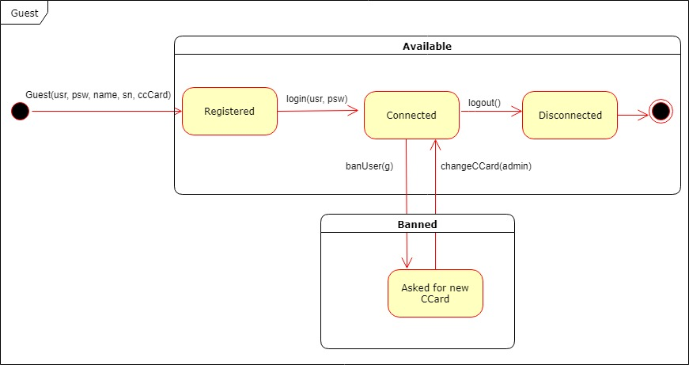On the other hand, we have made the Guest State Diagram. Basically, the guest can be banned or available. If a guest is available she/he is registered in the system so she/he can login, buy, reserve, search and logout, but if she/he is banned, her/his credit card number is false, so the administrator will ask her/his for changes and until the credit card is not true, the guest cannot sign in.

|  |  |  |  |  |  |
| --- | --- | --- | --- | --- | --- |
| Methods | General User | Guest | Host | Administrator | Payment System |
| login() |  | **X** | **X** | **X** |  |
| logout() |  | **X** | **X** | **X** |  |
| searchType() | **X** | **X** |  |  |  |
| searchCode() | **X** | **X** |  |  |  |
| searchDate() | **X** | **X** |  |  |  |
| searchBought() |  | **X** |  |  |  |
| searchBooked() |  | **X** |  |  |  |
| searchRate() |  | **X** |  |  |  |
| createOffer() |  |  | **X** |  |  |
| createHouse() |  |  | **X** |  |  |
| changeCC() |  |  |  | **X** |  |
| checkCC() |  |  |  | **X** |  |
| commentComment() |  | **X** |  |  |  |
| buyOffer() |  | **X** |  |  |  |
| bookOffer() |  | **X** |  |  |  |
| isReserved() |  | **X** | **X** |  |  |
| isBought() |  | **X** | **X** |  |  |
| commentOffer() |  | **X** |  |  |  |
| cancelReserve() |  | **X** |  |  |  |
| denyOffer() |  |  |  | **X** |  |
| approveOffer() |  |  |  | **X** |  |
| modifyOffer() |  |  | **X** |  |  |
| executePayment() |  |  |  |  | **X** |
| bannUser() |  |  |  | **X** |  |