ANALYSTLAB AFRICA | HEALTHCONNECT EXPERIENCE LAB
Week 4 Initial Analysis Document
Data Analytics Track | Improving Patient Appointment Attendance and Healthcare Support Using Data and AI
Field | Detail
Programme | AnalystLab Africa Experience Lab Internship
Week | Week 4 - Project Kickoff and Problem Understanding
Track | Data Analytics
Project | HealthConnect Clinic Experience Lab
Prepared by | Lusani Judith Nempumbuluni
Version / Date | 1.0 | 30 August 2026

1. Business Problem and Track Contribution
HealthConnect Clinic is losing capacity and revenue because a large share of booked appointments are not attended. Empty slots cannot be re-filled at short notice, waiting lists grow, and administrative staff spend time on repetitive enquiries rather than on patient support. The central project question is: how can HealthConnect Clinic use data and AI to reduce missed appointments and improve the patient support experience?
Data Analytics track problem statement
HealthConnect Clinic does not currently know which appointments, patients or booking behaviours are most associated with non-attendance, and therefore cannot target reminders, overbooking or follow-up actions. The Data Analytics track will quantify and explain appointment attendance and no-show patterns in the appointment dataset, define the KPIs the clinic should monitor, and deliver descriptive and diagnostic insight that supports operational decisions and feeds the Data Science and Generative AI tracks.
Role within the wider HealthConnect project
- Provide the shared, validated view of attendance performance (definitions, KPIs and baselines) that all tracks reference.
- Supply the Data Science and ML Engineering tracks with a documented data quality assessment and candidate predictive drivers.
- Supply the Generative AI track with evidence on which patient segments and enquiry-heavy touchpoints the assistant should support.
- Provide the Project Management track with measurable success indicators for the overall solution.
Resources used
Resource | Use in this track
HealthConnect_Appointment_Data.csv | Primary analysis dataset: 5,000 appointment records, 18 variables
HealthConnect_Data_Dictionary.xlsx | Variable definitions, expected types, permitted values and known data caveats
HealthConnect_Clinic_Knowledge_Base.docx | Contextual reference only (clinic services, booking and cancellation procedures)
Week 4 assignment brief | Scope, required outputs and assessment criteria

2. Dataset Overview
The dataset contains 5,000 appointment records and 18 variables covering 1,696 unique patients. Appointments were booked between 07 November 2024 and 27 June 2026, and scheduled between 01 January 2025 and 30 June 2026. Each row represents one scheduled appointment; patients may appear more than once.
Group | Variables | Notes
Identifiers | appointment_id, patient_id | appointment_id is unique; patient_id repeats across visits
Demographics | gender, age, age_group | Adults only (18-80); age_group derived from age
Appointment detail | appointment_type, appointment_date, appointment_day, appointment_time | Four appointment types; three time periods
Booking behaviour | booking_date, booking_lead_days | Lead time 0-60 days, mean 29.6 days
Patient history | previous_appointments, previous_no_shows | Synthetic historical counts per patient
Engagement | reminder_sent, reminder_channel | SMS, WhatsApp, Email or none
Access and service | distance_to_clinic_km, waiting_time_minutes | Both contain limited missing values
Target | appointment_outcome | Attended, No-Show, Cancelled

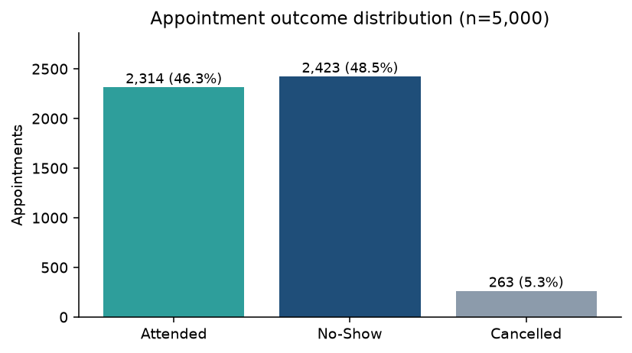
Figure 1: Outcome mix - 48.5% no-show, 46.3% attended, 5.3% cancelled.
The outcome mix is the single most important observation of Week 4: almost one in two booked appointments is missed. The dataset is close to balanced between attended and no-show records, which is favourable for later modelling, but the no-show level is far above what a clinic would consider operationally acceptable.
3. Data Quality Assessment
3.1 Completeness
Variable | Missing records | Missing % | Interpretation and proposed treatment
reminder_channel | 1,366 | 27.3% | Structurally missing - no reminder was sent. Recode to 'None'; not a data defect.
distance_to_clinic_km | 90 | 1.8% | Genuine missing values. Retain rows, flag missingness, exclude from distance-specific analysis.
waiting_time_minutes | 60 | 1.2% | Genuine missing values. Same treatment as distance.

All other 15 variables are 100% complete.
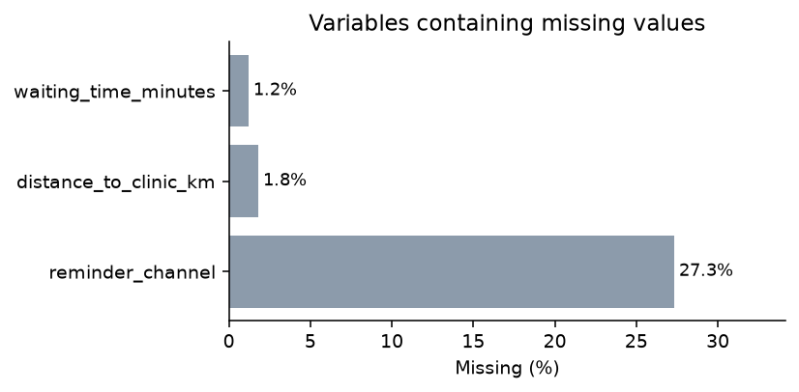
Figure 2: Only three variables contain missing values, and one of them is missing by design.
3.2 Validity, consistency and uniqueness
Thirteen automated integrity checks were run (see reports/data_quality_integrity_checks.csv). All returned zero affected records:
Integrity check | Records affected
Duplicate appointment_id values | 0
Fully duplicated rows | 0
Unparsable booking_date / appointment_date values | 0
Appointments dated before booking (negative lead time) | 0
booking_lead_days not equal to (appointment_date - booking_date) | 0
appointment_day not matching appointment_date weekday | 0
age_group not matching age | 0
previous_no_shows greater than previous_appointments | 0
reminder_channel populated while reminder_sent = No | 0
reminder_channel missing while reminder_sent = Yes | 0
Ages outside the adult range 18-100 | 0
Negative or zero distance_to_clinic_km | 0
Negative waiting_time_minutes | 0

3.3 Overall data quality verdict
- Fit for purpose. The dataset is internally consistent, unique at appointment level, and free of impossible values.
- Only two variables require a missing-value decision, and both affect under 2% of records.
- Dates were supplied in US M/D/YYYY format rather than the ISO format stated in the Data Dictionary - a documented deviation, standardised to YYYY-MM-DD in the cleaned file.
- No personally identifiable information is present, so the data can be analysed and shared within the programme without further anonymisation.
4. Relevant Business Questions
Six questions have been prioritised because each one can be answered with the available data and each leads to an action the clinic can take.
# | Business question | Why it matters
BQ1 | What is the overall no-show rate, and how does it trend by month and by clinic day and time slot? | Establishes the baseline and shows where capacity is lost.
BQ2 | Does booking lead time influence attendance? | Booking-window and scheduling policy is directly controllable.
BQ3 | Are reminders associated with better attendance, and does the channel matter? | Determines where reminder budget and the AI assistant should be pointed.
BQ4 | Which patient segments (age band, gender, prior no-show history) are most likely to miss appointments? | Enables targeted outreach instead of blanket reminders.
BQ5 | Do access and service factors - distance to clinic and waiting time - relate to non-attendance? | Separates patient-side barriers from clinic-side service issues.
BQ6 | Which appointment types and slots lose the most capacity, and what is the size of that loss? | Quantifies the business case and supports overbooking rules.

5. Proposed KPIs
Five KPIs are proposed for Week 5 onwards. Each is linked to a business question. In line with the Week 4 brief these are identified and justified only; they are not yet calculated or visualised.
KPI | Definition | Linked BQ | Justification
No-Show Rate | No-Show appointments / total scheduled appointments | BQ1, BQ6 | Headline measure of the problem and the primary success metric for any intervention.
Attendance Rate | Attended appointments / total scheduled appointments | BQ1 | Positive-framing counterpart used for clinic performance reporting and targets.
Reminder Effectiveness Gap | No-show rate without reminder minus no-show rate with reminder (overall and per channel) | BQ3 | Shows whether reminders earn their cost and which channel to scale.
Repeat No-Show Rate | Patients with 1+ previous no-shows who miss again / all patients with 1+ previous no-shows | BQ4 | Identifies the persistent high-risk group that justifies targeted outreach.
Lost Capacity (Slots and Hours) | Count of missed slots, and share of total booked slots, by appointment type, day and time period | BQ2, BQ5, BQ6 | Translates the no-show rate into an operational and financial impact the clinic can act on.

6. Initial Analysis Approach
6.1 Method and tooling
Phase | Activity | Tool
1. Preparation | Load raw CSV, standardise dates, recode reminder_channel, flag missing values, derive lead-time and distance bands and outcome flags | Python (pandas), Jupyter
2. Profiling | Column profile, integrity checks, distribution review | Python (pandas)
3. Descriptive analysis | Outcome mix, volumes by month, day, time slot and appointment type | Python / SQL
4. Diagnostic analysis | Segment no-show rates, cross-tabulations, correlation of numeric drivers, chi-square tests on categorical drivers | Python (pandas, scipy)
5. Reporting | KPI calculation and an interactive Power BI dashboard with filters for period, type, channel and segment | Power BI
6. Handover | Share validated definitions, driver findings and cleaned dataset with the Data Science and Generative AI tracks | GitHub, Google Drive

6.2 Analytical decisions taken up front
- No-show is defined as appointment_outcome = 'No-Show'. Cancelled appointments (5.3%) are reported separately and excluded from the no-show denominator variant used for driver analysis, because a cancellation is a notified absence and behaviourally different.
- The raw file is never edited. All transformations are written to data/processed/HealthConnect_Appointment_Data_Clean.csv and are reproducible from the notebook.
- Rows with missing distance or waiting time are retained for all analysis except the specific measure that needs them.
- Only variables available at booking time are treated as candidate drivers, so findings remain usable by the Week 5+ prediction work.
6.3 Early signals from initial exploration
These are preliminary observations from Week 4 exploration, not confirmed findings. They will be tested statistically in Week 5.
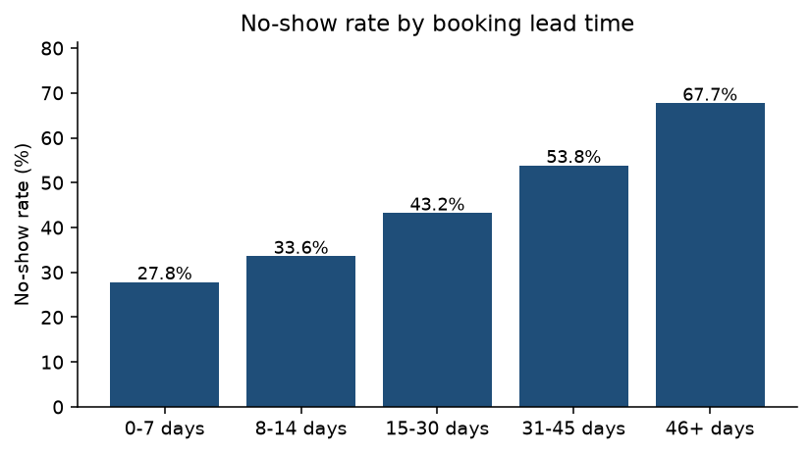
Figure 3: No-show rate rises steadily as the booking lead time increases - the strongest early signal in the data.
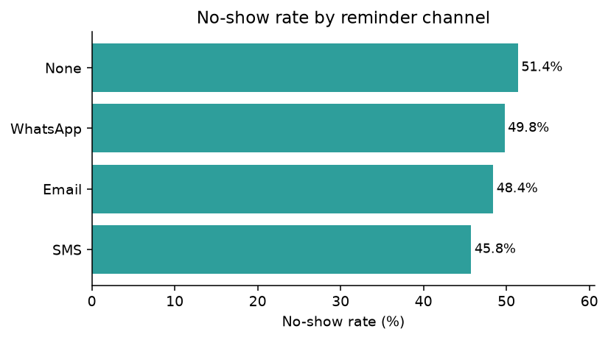
Figure 4: Attendance is slightly better where a reminder was sent, but the difference between channels is small.
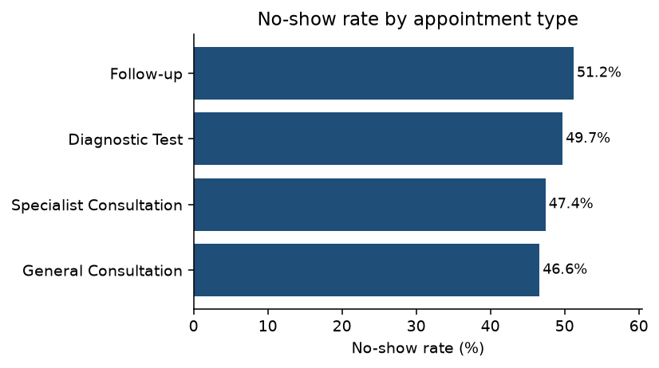
Figure 5: No-show rates are broadly similar across appointment types, with follow-ups marginally worst.
- Booking lead time is the clearest driver: missed appointments were booked on average 34.5 days ahead versus 24.5 days for attended appointments.
- Reminders are associated with a modest improvement only (47.4% no-show with a reminder versus 51.4% without), so reminders alone will not solve the problem.
- Patients who missed appointments have a higher average prior no-show count (0.64 versus 0.46), supporting a behavioural high-risk segment.
- Distance and waiting time show only marginal differences between outcomes and may prove weak drivers.
7. Assumptions, Limitations, Risks and Dependencies
7.1 Assumptions
- The dataset is a representative sample of HealthConnect Clinic appointment activity.
- appointment_outcome is recorded accurately and consistently by clinic staff.
- previous_appointments and previous_no_shows reflect history prior to the recorded appointment and are known at booking time.
- Reminders recorded as sent were actually delivered to and received by the patient.
7.2 Limitations
- The data is fictional and synthetic, so observed relationships may be weaker or less realistic than in a live clinic environment.
- No reason-for-absence, no appointment cost, no clinician, no medical condition and no socio-economic variables are captured, so root causes cannot be fully explained.
- Reminder timing and the number of reminders are not recorded, only whether one was sent and on which channel.
- waiting_time_minutes is described as an estimate and is ambiguous for missed appointments, which limits its use as a driver.
- No cost per missed appointment is supplied, so financial impact can only be expressed in lost slots and hours unless the clinic provides a rate.
7.3 Risks
Risk | Impact | Mitigation
Weak driver signals lead to inconclusive recommendations | High | Combine univariate analysis with statistical testing and segment interactions before concluding.
Inconsistent no-show definitions across tracks | High | Publish the definition in Week 4 and have all tracks adopt it.
Correlation misread as causation by stakeholders | Medium | Label all Week 4-6 findings as associations and state confidence explicitly.
Segment-level analysis creates unfair targeting of patient groups | Medium | Review demographic findings for ethical use; recommend supportive rather than punitive actions.
Scope creep into predictive modelling | Medium | Keep prediction with the Data Science track; Analytics stays descriptive and diagnostic.

7.4 Dependencies
- Continued availability of the appointment dataset and Data Dictionary in their current structure.
- Alignment with the Data Science track on the shared target definition and feature list.
- Mentor confirmation of the KPI set before dashboard build begins in Week 5.
- Access to Power BI (or Tableau) for the reporting layer.
8. Week 5 Focus
- Calculate the five proposed KPIs and establish the baseline values.
- Run full univariate and bivariate analysis with statistical testing on each candidate driver.
- Build the first version of the Power BI attendance dashboard.
- Publish a validated driver list and the cleaned dataset for the Data Science and Generative AI tracks.

