Validation on external data sets
A data set of ELs was obtained from Pearson et al. [{Pearson:2016cm}]. Also, a set of positive CD8 epitopes was downloaded from the IEDB. The epitope set was identified using the following search criteria “T cell assays: IFN-g,” “positive assays only,” “MHC restriction Type: Class I.” Only entries with fully typed HLA restriction, peptides length in the range 8–14 aa, and with annotated source protein sequence were included. Positive entries with a predicted rank score . 10% using NetMHCpan-3.0 were excluded to filter out likely noise (6). For the T cell epitope and EL data sets, negative peptides were obtained by extracting all 8–14-mer peptides from the source proteins of the ELs and subsequently excluding peptide–MHC combinations found with an exact match in the training data (BA and EL data sets). The final eluted data set contained 15,965 positive ligands restricted to 27 HLA molecules, and the IEDB T cell epitope data set contained 1,251 positive T cell epitopes restricted to 80 HLA molecules.
A Frank value was calculated for each positive HLA pair as the ratio of the number of peptides with a prediction score higher than the positive peptide/the number of peptides contained within the source protein. Hence, the Frank value is 0 if the positive peptide has the highest prediction value of all peptides within the source protein and a value of 0.5 in cases in which an equal amount of peptides has a higher and lower prediction value compared with the positive peptide.
An unfiltered EL data set was obtained from Bassani-Sternberg et al.[{BassaniSternberg:2015js}]. This data set consisted of EL data from six cell lines, each with fully typed HLA-A, -B, and -C alleles. A data set was constructed for each cell line, including all 8–13-mer ligands (N) as positives, and five times N random natural negatives for each length of 8–13 aa (i.e., if a data set contained 5,000 ligands, 5 3 5,000 = 25,000 random natural peptides of length 8, 9, 10, 11, 12, and 13 aa were added as negatives, arriving at a final data set with 155,000 [5,000 + 6 3 25,000] peptides).

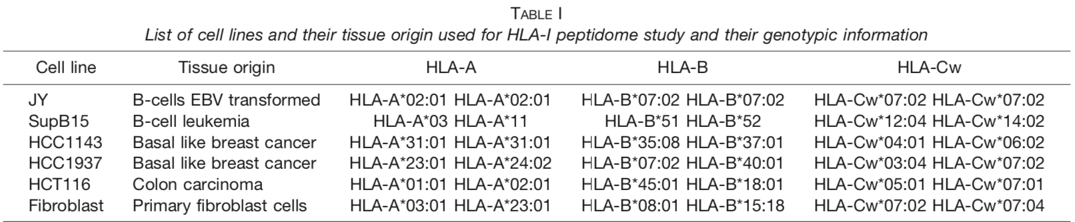
{BassaniSternberg:2015js}:Table1

Results: NIHMS905283-supplement-1

