Mass spectrometry of HLA-I peptidomes
- {BassaniSternberg:2015js}: Bassani-Sternberg, M. & Pletscher-Frankild, S. Mass Spectrometry of Human Leukocyte Antigen Class I Peptidomes Reveals Strong Effects of Protein Abundance and Turnover on Antigen Presentation. Molecular & Cellular … 14, 658–673 (2015).
- We here present a rich and high confidence HLA-I peptidome, established by applying state-of-the-art mass-spectrometric techniques on a collection of seven cell lines. We investigate how abundance affects the propensity of proteins to be presented as measurable HLA peptides and whether or not there are specific protein classes that are overrepresented even independent of abundance. Likewise, we explore how to use in silico immunogenicity tools on the set of identified HLA peptides from cancer-associated proteins, with a view to select vaccine candidates.
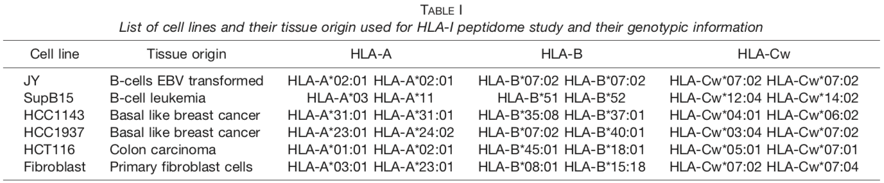

- Data: https://www.mcponline.org/content/suppl/2015/01/09/M114.042812.DC1

