# Binding affinity datasets
The affinity measurement dataset used for training and model selection was assembled from a snapshot of the Immune Epitope Database (IEDB) MHC ligands downloaded on Dec. 1, 2017 augmented with the BD2013 dataset (Kim et al., 2014). IEDB entries with non-class I, non-specific, mutant, or unparseable allele names were dropped, as were those with peptides identified by MS or containing post-translational modifications or noncanonical amino acids. This yielded an IEDB dataset of 143,898 quantitative and 43,978 qualitative affinity measurements. Of 179,692 measurements in the BD2013 dataset (Kim et al., 2014), 57,506 were not also present in the IEDB dataset. After selecting peptides of length 8-15 and dropping alleles with fewer than 25 measurements, the combined dataset consists of 230,735 measurements across 130 alleles.
# Output value of binding prediction model and Loss
As in the NetMHC tools, MHCflurry internally transforms binding affinities to values between 0.0 and 1.0, where 0.0 is a non-binder and 1.0 is a strong binder. The neural networks are trained using the transformed values and the inverse transform is used to return prediction results as nanomolar affinities. The transform is given by 1 log50000(x) where x is the nanomolar affinity. Affinities are capped at 50,000 nM.
Training is attempted for all alleles with at least 25 affinity measurements. Ten percent of the training data is set aside for model selection. Each neural network is trained on a different 90% sample of the remaining data, with the other 10% used as a test set for early stopping. Training proceeds with the RMSprop optimizer using a minibatch size of 128 until the accuracy on the test set has not improved for 20 epochs. At each epoch, 25 synthetic negative peptides for each length 8–15 are randomly generated. These random negative peptides are sampled so as to have the same amino acid distribution as the training peptides and are assigned affinities >20,000 nM. For the MHCflurry (train-MS) variant, the number of random peptides for each length is 0.2n + 25 where n is the number of training peptides.
A modified mean squared error (MSE) loss function that supports data with inequalities is used for both the training loss and test set accuracy metric. For this loss function, measurements are associated with an inequality: (<), (>), or (=). The loss L is defined as:
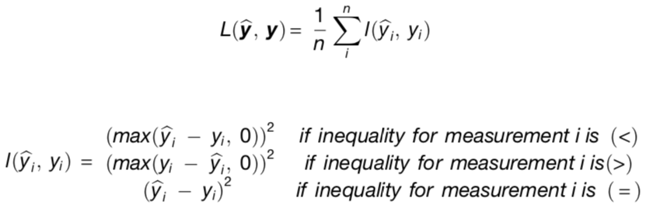

where n is the total number of measurements, and ybi and yi are the predicted and measured values for measurement i, respectively. Quantitative affinity data is associated with an inequality of (=). For qualitative affinity data, we assigned the following inequalities and measurement values: positive-high, < 100 nM; positive, < 500 nM, positive-intermediate, < 1,000 nM; positive-low, < 5,000 nM; negative, > 5,000 nM. In the MHCflurry (train-MS) variant, MS-identified ligands are assigned the value ‘‘< 500 nM.’’

