The final fine-tuned model was evaluated using two external test datasets containing COVID-19 epitope(YLQPRTFLL)-specific TCR CDR3beta sequence data. The F1 score , the harmonic mean of precision and recall, was used to quantify the prediction performance, where an F1 sore reaches its best value at 1 and worst value at 0. The F1 score is defined as:

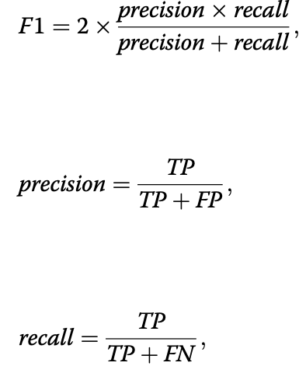

where TP, FP, and FN are the numbers of true positives, false positives, and false negatives, respectively.

