{BulikSullivan:2018cb}: 1. Bulik-Sullivan, B. et al. Deep learning using tumor HLA peptide mass spectrometry datasets improves neoantigen identification. Nature Biotechnology 37, 1–17 (2018).

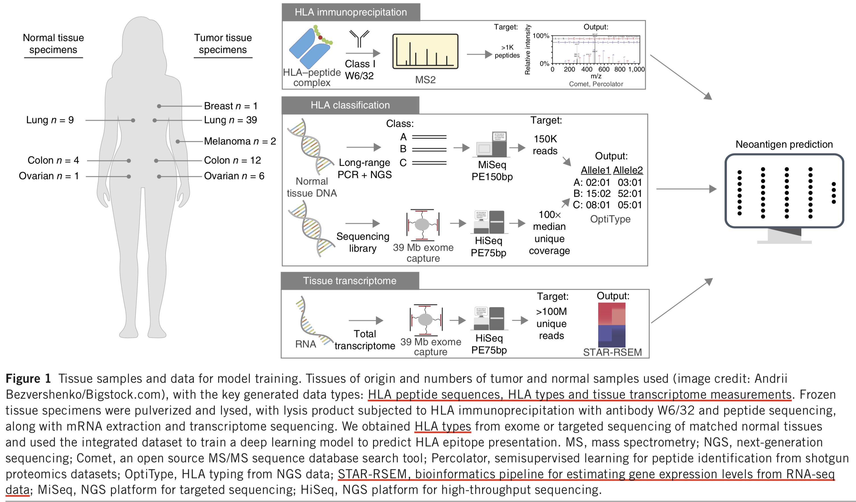

- Data: N/A

