VIETNAM NATIONAL UNIVERSITY OF HO CHI MINH CITY
THE INTERNATIONAL UNIVERSITY
SCHOOL OF COMPUTER SCIENCE AND ENGINEERING




Decision Support Systems for Product Management
By
Bạch Huy Hoàng
Student ID: ITITWE21113
APPROVED BY: Assoc.Prof. Nguyen Van Sinh

Ho Chi Minh City, Vietnam
Year 2026
Decision Support Systems for Product Management

APPROVED BY: ________________________________ ,
Assoc.Prof. Nguyen Van Sinh, Ph.D, Chair.

THESIS COMMITTEE

ACKNOWLEDGMENTS

With a deep sense of gratitude and appreciation, it fills me with great joy and sentiment that I acknowledge professional guidance of Assoc.Prof. Nguyen Van Sinh. The major contribution of his advice, brilliant comments and tolerant guidance in all the phases of this research motivated me to get through the hurdles and accomplish the objectives of this thesis. I am really appreciative that he took time and effort to go through my work and put me on a path towards a rigorous and honest method of research.

I am also thankful to the faculty at the University of the West of England and the International University that they provided their earnest and committed instructions. The lecturers and the staff of the two institutions have significantly shaped my academic course and personal growth. Their true and dedicated teaching, along with the knowledge, have provided me with a deep appreciation of learning and lifelong self-development.

TABLE OF CONTENTS

ACKNOWLEDGMENTS 3
TABLE OF CONTENTS 4
LIST OF FIGURES 7
LIST OF PSEUDO CODE 8
LIST OF TABLES 9
ABSTRACT 10
CHAPTER 1 11
INTRODUCTION 11
1.1. Background 11
1.2. Problem Statement 12
1.3. Scope and Objectives 13
1.4. Assumption and Solution 14
1.5. Structure of thesis 14
CHAPTER 2 16
LITERATURE REVIEW 16
2.1. Artificial Intelligence in Inventory Forecasting 16
2.2. Forecasting Models for Demand Prediction 17
2.2.1 Prophet Time Series Model 18
2.2.2 XGBoost Machine Learning Model 19
2.2.3 Hybrid Forecasting Approaches 20
2.3. Decision Support Systems in E-commerce 22
2.4. Explainable AI and Human-Centered DSS 23
2.5. Dynamic Pricing and Inventory Optimization 24
2.6. Existing Decision Support System Applications in E-commerce 26
2.7. Research Gap 27
CHAPTER 3 29
METHODOLOGY 29
3.1. System Overview 29
3.2. Data Collection and Preprocessing 30
3.3. Hybrid Forecasting Model 31
3.3.1. Prophet Model for Time Series Forecasting 31
3.3.2. XGBoost and Asymmetric Optimization 32
3.3.3. Hybrid Forecasting Strategy 33
3.4. Decision Support System Engine 34
3.4.1. Inventory Forecasting Support 34
3.4.2. Dynamic Pricing Recommendation 35
3.5. Explainability Module 38
3.6. System Architecture Pattern 39
3.7. Database Design 40
3.8. Implementation Environment 43
CHAPTER 4 44
IMPLEMENT AND RESULTS 44
4.1. Implement 44
4.1.1. System Architecture 44
4.1.2 Frontend Dashboard 44
4.1.3 Backend Implementation 48
4.1.4 Universal Data Adapter Implementation 50
4.2 Experimental Setup 52
4.2.1 Datasets 52
4.2.2 Models Compared 53
4.2.3 Evaluation Protocol 54
4.3 Results 55
4.3.1 India Sales Results 55
4.3.2 FMCG Sales Results 56
4.3.3 Favorita Ecuador Results 57
4.3.4 Universal Data Adapter Validation 58
4.3.5 DSS Application on Production Catalog 59
4.3.6 Summary of Findings 59
CHAPTER 5 61
DISCUSSION AND EVALUATION 61
5.1 Discussion 61
5.1.1 Reframing DSS Evaluation: Accuracy versus Inventory Safety 61
5.1.2 Asymmetric Loss as the Primary Technical Contribution 61
5.1.3 Understanding Model Performance Across Data Conditions 62
5.1.4 DSS Application Evaluation: Case Studies and Backtest Results 62
5.1.5 System-Level Contributions Beyond Forecasting Accuracy 63
5.1.6 Implications for E-commerce Product Management 64
5.2 Comparison with Related Work 65
5.3 Evaluation 67
5.3.1 Strengths 67
5.3.2 Limitations 68
CHAPTER 6 70
CONCLUSION AND FUTURE WORK 70
6.1. Conclusion 70
6.2. Future work 71
REFERENCES 72
APPENDIX 75

LIST OF FIGURES
Figure 3.1: System Architecture Overview 30
Figure 3.2: The data collection and preprocessing pipeline 30
Figure 3.3: Hybrid Forecasting Pipeline 33
Figure 3.4: Inventory Branch Flowchart 35
Figure 3.5: Pricing Branch Flowchart 35
Figure 3.6: n8n Explainability Flow 39
Figure 3.7: MVC Architecture 39
Figure 3.8: Operational Data Entity-Relationship Diagram 41
Figure 3.9: Analytical Pipeline Entity-Relationship Diagram 42
Figure 4.1: Dashboard Overview Page 45
Figure 4.2: Products Management Page 45
Figure 4.3: Inventory Management Page 46
Figure 4.4: DSS Analysis Page — Forecast and Recommendations 46
Figure 4.5: Backtest Simulation — DSS vs Naive vs Oracle 47
Figure 4.6: Statistics and Portfolio Health Page 48
Figure 4.7: DSS Pipeline Terminal Output 49
Figure 4.8: E2E Test Results — DSS Pipeline (8 tests), Backtest Simulation (7 tests), and Manager Action Loop (7 tests), 22/22 tests passed. 50
Figure 4.9: DSS Analysis Result Page (Sample Product) 58
Figure 4.10: Backtest Simulation Tab (Sample Product) 60

LIST OF PSEUDO CODE
Pseudo Code 3.1: XGBoost and Asymmetric Optimization 33
Pseudo Code 3.2: Dynamic Pricing Recommendation 37

LIST OF TABLES
Table 3.1: Universal Data Adapter — Supported Dataset Formats and Signature Detection 31
Table 4.1: Dataset Characteristics 52
Table 4.2: Forecasting Results on India Sales Dataset 55
Table 4.3: Forecasting Results on FMCG 2023-24 Dataset 56
Table 4.4: Forecasting Results on Favorita Ecuador Dataset 57
Table 4.5: DSS Engine Run Results — Representative Product Cases 58
Table 4.6: Backtest Simulation — DSS vs. Naive vs. Oracle (5 Representative Products) 60
Table 4.7: Summary of Forecasting Results Across All Datasets 59
Table 5.1: Model Selection Guide Based on Data Characteristics 63
Table 5.2: Comparison with Related Hybrid Forecasting Studies 66
Table 5.3: Comparison with Commercial Decision Support Platforms 67

ABSTRACT

The operation of e-commerce activities is more reliant on the use of the intelligent decision-making system to handle variable demand, optimization of inventory and setting competitive prices. Whereas traditional Decision Support Systems (DSS) tend to use fairly strict statistical models that are incapable of effectively incorporating non-linear and dynamic changes in the market, AI-based solutions have created a new challenge. Even though complex machine learning models can greatly improve predictive accuracy, their concept nature lacks interpretability, which hides the logic behind it, rendering it challenging to operational managers to trust and implement the proposed approaches. The specific purpose of this research is to create and test an improved, Explainable Decision Support System (DSS) based on AI, which addresses both demand forecasting and dynamic pricing optimization.

This thesis contributes a Hybrid Forecasting Framework that combines asymmetric-loss optimization with an automated decision engine for inventory and pricing, supported by a generative AI explainability layer that translates every recommendation into natural language.
The system restricts the weaknesses of existing models by coming up with a Hybrid Framework that integrates Prophet to capture trend and seasonality; and XGBoost to fulfill residual errors to get demand predictions. In particular, this approach involves the DSS helping operational managers directly by automating intricate inventory measures. It computes Reorder Point (ROP), Safety Stock and stockout probabilities in order to formulate accurate action triggers (e.g for the case of "ORDER_NOW" or "HOLD") and the best order quantities. It is combined with Sales Velocity-based Dynamic Pricing engine that matches the existing sales rates with the desired days of the merchant to sell. The system automatically suggested pricing changes--whether to mark up more rapidly moving products, to provide discounts to products that move at a slower rate, or to impose scarcity premium to avoid stockouts. The major architectural component of this system is the ubiquitous use of Generative AI agents that will generate natural language descriptions of each inventory and pricing choice and help to connect the raw data with actionable knowledge. Validation on three real-world datasets shows that the asymmetric loss function alone reduces MAE by 16% and RMSE by 20% on the sparse India Sales dataset — the largest single-design improvement observed — while the system passes 22 of 22 functional tests covering the DSS pipeline, backtest simulation, and manager-action workflows.

CHAPTER 1

INTRODUCTION

Background
In this section a concise background of the context of developing a decision support system (DSS) to predict inventory and price dynamically in e-commerce will be presented. This is aimed at demonstrating basic knowledge of a system integrate AI that is essential to contemporary online shopping.

Target Audience:
The DSS is planned to be used by various groups of users within the e-commerce system that need to have the correct forecasting and pricing information. It mainly helps the inventory managers, supply chain staff, and operations teams who are in charge of planning and stock, procurement, stock, logistics and warehouse management with accurate predictions to maintain the stocks at the right balance and synchronization of the upstream operations. Moreover, pricing and revenue managers can enjoy the advantages of streamlined price recommendation to match profitability objectives in order to come up with competitive market operations. The system also provides high level insight to business executives and strategic planners to direct overall business strategy, operational risks management and financial performance. Lastly, the outputs of the system can be used by data analysts, IT, and e-commerce platform administrators to create reports, manipulate the product listings, track the competitiveness of the marketplace and support the underlying infrastructure.

Market Research:
Massive market research points out that e-commerce ventures are increasingly demanding AI technology to handle the dynamics of contemporary retail activities. One of the key forces is the increasing volatility of the market, where the demand of the customers changes very quickly because of promotions, competition, and changes in the seasons - fluctuations that can not be sufficiently addressed by traditional forecasting tools. At the same time, a clear change towards event-based pricing emerges; whereas large platforms such as Amazon and Alibaba are using them to sell as many products as possible, small and medium-sized stores would like to do the same but do not have the technical infrastructure required to do so. This has also created a need to have AI-based decision support, organizations have shifted to machine learning integrations instead of using rule-based system that enhance accuracy, flexibility, and automation. Moreover, organizations are starting to favor in-house DSS frameworks, capable of providing data protection and flexibility based on their products and business regulations, instead of basing on third-party applications with limited product and business specificity. In the end, it is also essential to consider the fact that the current competition rate has been increasing in the need to not only streamline pricing but also inventory, which reinforces the need to create a powerful, AI-empowered DSS that will enable higher profit margins and efficiency.

Problem Statement
Although the data is proving to be extremely important in the current business world, the problems that affect e-commerce business proceed in the current world are more often than not being obstructed by the limitation of available decision support tools. Enterprises have an immense amount of data, and conversion of unintelligible information into actionable insightful decisions is inefficient. Mostly, the existing inventory control and pricing systems tend to be based on manual operated or fixed formula, which does not suit dynamic behavior of the market. Conventional statistical models are usually more difficult to deal with non-linear demand trends and abrupt demand differences in the market, the sheer amount and magnitude of data. Moreover, inventory forecasting with traditional time-series models is typically inaccurate, which makes them inadequate to meet the complicated, changing nature of the modern e-commerce environment. E-commerce data is typically data-heavy and challenging to manage with the traditional methods, and most commonly applied models do not utilize the full data-rich information that the business has. These systems therefore have a hard time mining, integrating and analyzing the required product data to identify key features or capture complex dependency relationships resulting in poor inventory planning and unutilized revenue opportunities. On the other hand, although AI is increasingly being used to address these data challenges, current models tend to be overfitted, lack flexible, and cannot be easily explained. The error in forecasting adds to the bullwhip effect, triggering the instability of the supply chain and the inability to implement the development on a sustainable basis. Enterprises that do not have an effective system to integrate predictive analytics and actionable business intelligence are at a greater risk of excess inventory or stockout. The present gap is observed where quantitative investigation integrating AI with inventory forecasting analysis is currently underutilized in the framework that is capable of both optimizing demand forecasting and dynamic pricing in a cross-border e-commerce setting. Hence, a better hybrid structure is urgently required to be able to replicate the technical and operational barriers to increase the ability of making decisions in e-commerce.

Scope and Objectives
The aim of the study area includes the design, development, and testing of an AI-based Decision Support System specific to the e-commerce inventory forecasting and dynamic pricing. The system combines a hybrid forecasting machine, using Prophet to analyze trends and XGBoost to clean up the residues with a sales velocity-based pricing engine.

As well as the objective of the suggested DSS is to improve the decision making of eCommerce business by combining intelligent demand forecasting and price optimization through dynamism into one system. In the case of inventory forecasting, the system can help managers by providing an accurate forecast of the upcoming product demand, combining the use of statistical models, like Prophet, with machine learning models, like XGBoost. This enhanced forecasting helps a business to avoid stockouts, limit incidences of overstocking and maximize the utilization of the warehouse. Additionally, the DSS is a system of price optimization in dynamics, automatically generating price proposals depending on the anticipated demand, stock, and aiming for profitability. Businesses can be able to be more flexible with their pricing through constraint-based optimization, more competitive, and able to capture revenue opportunities not available to the static pricing strategies. In addition to prediction, the system has a decision-support engine that converts predictive results into an actionable operational strategy. In particular, the DSS computes key-inventory measures, including Reorder Point (ROP), Safety Stock, and probability of stockout to generate replenishment decree. At the same time, the system assesses sales velocity in comparison to inventory on hand in order to make pricing changes. The DSS facilitates simultaneous optimization of the inventory planning and dynamic pricing decision through its connection of the forecasting output with the operational decision.

As a result, the system has an enormous impact on the increased working efficiency as it gives the data-driven insights to the managers to make their decisions regarding the replenishments, sales planning, and pricing strategies and decrease the amount of work done by hand and avoid human mistakes. Eventually, the new system would be flexible to determinists of evolving customer trends and season-changes yet remain interpretable such that the managers would find it easy to comprehend model output and make accurate decisions.

Assumption and Solution
There are a few main assumptions about e-commerce operations and the availability of data that count in the development of this system. The assumption is that the e-commerce system produces enough and dynamic historical sales information needed to successfully train the hybrid machine learning models. Some sparse data or noise may be present in the data, so the solution uses robust preprocessing pipelines to manage missing values and normalize the inputs and then predict. Moreover, the assumption is that the market conditions will be vulnerable to changes; hence, the solution will apply a dynamic price mechanism that constantly responds to the velocity of sales in real-time instead of a set of fixed rules. Lastly, because operational managers may not be highly technical experts, considerations of the system being explainable with ease are necessary, which is achieved by incorporating natural language processing that will de-mystify AI-powered recommendations.

Structure of thesis
This thesis will be divided into six chapters detailing the process of development and testing of the proposed decision support system.

Chapter 1 presents the research background, problem statement, research objectives and the overall scope of the research. It underscores the need to come up with a decision support system that encompasses inventory predictive and dynamic pricing in online commerce settings.
Chapter 2, relevant literature on the topic of demand forecasting, dynamic pricing approaches, and decision support systems is reviewed. It speaks on the methods that were used in the past, the normally applied forecasting models and states research gaps that inspire the proposed system.
Chapter 3 shows the system design and methodology. It describes the design of proposed decision support system, database layout, the MVC layered model and the pipeline of the data processing and the hybrid forecasting model with asymmetric loss function.
Chapter 4 explains the practice and experiment outcome. It illustrates the frontend and backend implementation, performance of the forecasts in three datasets and end-to-end test the system.
Chapter 5 presents the results of the experimental findings, a comparison of the system with related work, and discusses the advantage and limitation of the suggested approach.
Chapter 6 presents the key conclusions and offers opportunities for future work.

CHAPTER 2

LITERATURE REVIEW

Artificial Intelligence in Inventory Forecasting
In contemporary e-commerce layouts, demand forecasting is an inherent aspect of operational planning. The nature of online retailers is known to be faced by high levels of demand variability, seasoned purchasing behaviors, and consumer preferences that are dynamic. All these create a lot of uncertainty to both inventory planning and pricing. Due to that, forecasting models are critical to predicting the demand of products in the future and aiding managers in decision-making. When the demand forecast is wrong, it could cause operational inefficiencies (conflict-stockouts, overstocking, lost revenue). The rapid expansion of online selling sites has led to the creation of big amounts of transactional records. With these datasets, all information relating to the behavior of customers, product sales, promotions and seasonal purchases is provided in detail. Moving averages or classical time-series models are considered classical forecasting techniques that were initially developed using relatively stable data with few explanatory variables. Nonetheless, contemporary e-commerce data are so complicated and significant that the more sophisticated methods of analysis should include the possibility to forecast nonlinear relationships and dynamic demands patterns. Recent studies thus focus on using artificial intelligence/ machine learning methods to solve demand forecasting issues within retail setting. Tang et al. [1] suggested a data-intensive forecasting model to be implemented in cross-border e-commerce platforms. Real-world data on cross-border transactions that were gathered on international e-commerce sites was assessed with the study, including multi-country sales information, product details, and purchase time series. In their study, they have established that machine learning models can be very useful in enhancing the effectiveness of the forecasting process, when using the historical transaction data, at a large scale. The work identifies that AI-based prediction models work especially well in reflecting complex trends in demand variation, in particular when numerous factors that drive demand variability are aggressively accounted, including product characteristics and seasonal variations.

The direct relationship between operational decisions and demand predictions is another significant factor of forecasting in e-commerce settings. Outputs forecasting is not only applied in the predictive analysis area but also make major input in the inventory planning, the procurement scheduling and the pricing strategies. As an illustration, precise demand predictions can help retailers to decide the right level of reorder volumes, safety stock repelling, as well as allocate their warehouse area in an even more efficient way. Baharudin [2] points out that implementing intelligent analytics in warehouse and inventory management systems can enhance operational efficiency and inventory accuracy to a large extent. Specifically, AI forecasting models enable retailers to predict fluctuations in demand and take advance precautions by changing the inventory levels to ensure a seamless operation. Besides efficiency in their operations, the accuracy in forecasts has a direct impact on customer satisfaction. Customer experience in e-commerce settings is directly related to product availability.
Beyond ensemble tree methods, deep learning approaches have been actively explored for time-series demand forecasting. Recurrent neural networks, particularly the Long Short-Term Memory (LSTM) architecture introduced by Hochreiter and Schmidhuber [21], are designed to capture long-range temporal dependencies through gated memory cells, and have been applied to retail and supply-chain forecasting in various studies. More recent attention-based architectures extend this line of work by modelling relationships across longer horizons without the sequential bottleneck of recurrent units. While these deep models can deliver strong accuracy on large, dense time series, their effectiveness depends on substantial training data, careful hyperparameter tuning, and significant computational resources. For the small and medium-sized e-commerce datasets that characterise the present work, where individual products often exhibit short or sparse histories, gradient-boosted decision trees remain a more practical choice: they train quickly on tabular features, generalise well from limited samples, and produce feature-importance signals that support downstream interpretability. This trade-off between model complexity and data availability motivates the focus on Prophet and XGBoost in the remainder of this chapter.

Forecasting Models for Demand Prediction
The goal of forecasting models is to predict the future patterns of demand with reference to the existing data which has been observed in past and other factors that could be used to explain the demand. Forecasting models in the retail setting are faced with a number of challenges such as seasonality, unpredictability of demand, promotional activities and the impact of pricing policies. Such complexity of factors has prompted researchers to consider different forecasting methods and tools to include classical statistical models, as well as contemporary machine learning methods. Some of the most commonly used forecasting techniques in the realm of business analytics include time-series models aimed at employing the time-related trends in the past data. Time-series models use the historical data and make efforts to detect the similarities over time including trends and seasonal trends. Such patterns are then projected to come up with future demand projections. Nonetheless, although traditional time-series models can be useful when interested in long-term trends and regular variations, they might be poorly able to include complicated interactions among various influencing factors. To overcome these shortcomings, machine learning algorithms have been more frequently used to predict issues. Machine learning approaches can learn a nonlinear function of input variables and the demand. In the retail context, these variables can be retail prices, promotions, consumer behavior measurements, and seasonality. With the implementation of these variables, machine learning models will help to identify complicated demand trends, which would otherwise be missed by the traditional methods of statistics. The Prophet time-series and the XGBoost machine learning algorithms are some of the common forecasting models applied in business analytics. Every model provides unique benefits to the demand forecasting applications and more recent studies indicate that a strategy of integrating these models can provide even greater benefits to the forecasting process. As an example, a more recent study on sales forecasting at Walmart showed the ability to integrate Prophet and XGBoost to result in success [14]. The authors of the paper used the publicly available Walmart Historical Sales Dataset used in this study, which included variables like holidays, temperature and Consumer Price Index (CPI) to maximize demand forecasting and explained outside environmental variables [14].

Prophet Time Series Model
Taylor and Letham [11] developed the Prophet forecasting model which was a handy tool in business time-series forecasting. The model was created to respond to typical forecasting issues that are faced in real business data, such as missing data, non-uniform sampling periods, and high seasonal variations. Compared to other traditional statistical forecasting models, which have many parameters to be optimized, Prophet is a flexible model that automatically identifies relevant elements in time-series data. Prophet breaks up the observed time-series data into various understandable components. These elements usually consist of long term trend patterns, seasonal changes and the special event impacts like holidays or other promotional campaigns. The Prophet model facilitates analysts to view the nature of various causes of demand in relation to variations over time; the model does this by modelling the various components individually. The main positive thing about Prophet is that it is applicable to business forecasting problems, where the datasets touched are large, with complex seasonality effects. The data of retail demand usually requires a weekly, monthly or yearly seasonality particularly in the time of promotions like during the sale of holidays. These seasonal effects are automatically detected by Prophet and are included in the forecasting model. The fact that Prophet is useful in the demand forecast of products in the e-commerce worlds where the seasonal demand increases is particularly true. One other strength of Prophet is its strength in addressing incomplete or noisy data. Inconsistency of data in operational retail systems can either occur due to system errors, delays or non-records. Prophet is engineered to deal with these irregularities without involving a lot of data preprocessing. Consequently, it has been strongly embraced in industry uses where there is a large-scale forecasting operation. Amid these strengths lie some shortcomings of Prophet. The model mostly revolves around time structures of time-series data and might not be able to fully reflect the nonlinear processes that exist between demand and other external factors like price adjustments or marketing. Most retail settings have demand patterns that are determined by interacting many variables that are not limited to the temporal framework. Researchers therefore tend to fuse time-series models like Prophet with machine learning algorithms that are further capable of capturing more complex relationships.
A further limitation of Prophet, frequently noted in recent comparative studies, is its tendency to under-react to abrupt regime changes — for example, sudden shifts in consumer behaviour driven by external shocks, promotional campaigns that fall outside the model's holiday calendar, or the introduction of new product variants. Because Prophet decomposes the series into smooth trend and periodic components, residuals associated with these non-periodic events tend to be systematically positive or negative rather than randomly distributed, leaving an exploitable structure in the error term. This observation has direct implications for inventory-driven forecasting: even when the average error appears acceptable, persistent under-forecasting around demand spikes translates into recurring stockout events. A two-stage architecture, in which a flexible machine-learning model is trained on Prophet's residuals, provides a principled way to capture this remaining signal without discarding the interpretability benefits of the statistical baseline.

XGBoost Machine Learning Model
XGBoost or Extreme Gradient Boosting (EGB) is a machine learning algorithm originally developed by Chen and Guestrin [12]. The algorithm is in a series of gradient boosting algorithms, which construct predictive model through the combination of several decision trees in an ensemble arrangement. The trees in the ensemble are trying to rectify the prediction errors made by the former trees, which is slowly enhancing the predictive output of the overall model. The ability to scale, efficiency, and high performance of XGBoost on a broad spectrum of tasks have made the machine learning algorithm one of the most popular in predictive analytics. The algorithm uses a number of optimization schemes such as regularization schemes and parallel computation schemes which enable it to process large datasets efficiently. All these features render XGBoost especially appropriate in a data-intensive predictive task like retail demand forecasting. Nonlinear relationships between the variables of inputs and predicted demand are one of the main strengths of XGBoost in its use as a predictor. The product demand in the e-commerce setting could be affected by various variables such as product prices, promotions, seasonal demand as well as consumer purchasing behavior. Through use of these variables as input features, XGBoost is able to capture complex interactions which are not necessarily represented in conventional statistical forecasting models. In real-world forecasting, engineered time-series-based features are frequently used with XGBoost models. Some examples are lag variables (a past demand value), rolling averages (a short-term average trend in demand) and calendar (seasonal) indicators. These characteristics make the model be able to take into account the information on time and in addition take nonlinear correlations between the explanatory variables. XGBoost, however, will not necessarily model time-series architectures like long-term trends or seasonality. These trends need to be modeled using feature engineering in the model training process. The algorithm might fail to capture some of the temporal dynamics in retail demand data without proper feature engineering. To this end, hybrid forecasting methods which involve machine learning models and time series models are actively investigated by numerous researchers.
Within the broader gradient-boosting family, alternatives such as LightGBM [22] and CatBoost have emerged as direct competitors to XGBoost, each introducing distinct design trade-offs. LightGBM employs a leaf-wise tree-growth strategy together with histogram-based split finding, which often delivers faster training and lower memory consumption on large datasets [22]; CatBoost places particular emphasis on the native handling of categorical features, reducing the engineering effort required for retail data dominated by SKU identifiers, supplier codes, and product categories. Nevertheless, XGBoost remains the most widely cited gradient-boosting implementation in retail forecasting research, owing to its mature ecosystem, extensive documentation, and the flexibility of its custom-objective interface, which is essential for the asymmetric loss formulation discussed later in this thesis. The methodological contributions developed in subsequent chapters are not tied to XGBoost specifically and could in principle be transferred to LightGBM or CatBoost with comparable engineering effort, since the asymmetric objective operates on the gradient and Hessian rather than on any implementation-specific internals.

Hybrid Forecasting Approaches
Hybrid forecasting models are models that attack more than one predictive method with the view of exploiting the capabilities of various modeling paradigms. Hybrid models providing the use of machine learning algorithms and statistical time-series models in the process of forecasting demand are common in research into demand forecasting. The reasoning behind this kind of approach is that various models distinctly represent time-series behavior. Statistical models like Prophet are available and especially useful when the problem of interest lies in the long-term dynamics and seasonality of past data. These are time-dependent models that examine temporal structure directly and have the potential to form interpretable predictions based on components of a time-series that can be identified. Conversely, machine learning models like XGBoost are more applicable to nonlinear natures in demand-related to external factors like pricing measures, promotions, and product characteristics. Hybrid forecasting models can enhance the predictive performance of each of these models by overcoming the weaknesses of each one individually. Thorat [3] suggested a combined forecasting model that combines Prophet, ARIMA, and XGBoost to enhance the accuracy of sales forecasting. The assessment of the model used real-life sales data in the form of trucks sales as the sample data that involves the historical sales records, seasonal demand changes, and macroeconomic factor that influences the purchase of the vehicles. The paper also shows that incorporating machine learning regression models with time-series decomposition can substantially minimize forecasting errors in comparison to other forecasting techniques. On the same note, other forecasting research reports the suitability of hybrid methods in retail demand forecasting activities. Jatte et al. [10] examined how successfully forecasting in the retail industry can be optimized using artificial intelligence techniques. They analyzed their data through structured retail sales data with records of transactions, product categories, and time based variation of demand. The findings have shown that combining various forecasting methods enhances forecasting precision in various product differentiations. More so, a major breakthrough in this field is one that considers hybrid forecasting of a clothes retailer where Prophet, XGBoost and an asymmetric loss optimization are combined [13]. The authors also tested their model using the H&M Personalized Fashion Dataset because it specifically covers the large shopping spikes in the holiday seasons [13].

Despite the fact that hybrid forecasting methods have the potential to enhance accuracy in prediction, they also provide more complexities in terms of system design and integration of model. The deployment of hybrid forecasting involves data preprocessing processes, model training streams and prediction processes that are to be coordinated with special attention paid to each. It is on this basis that hybrid forecasting models frequently form part of larger analytical systems including decision support systems which offer frameworks to structure the integration of predictive analytics to operational decision-making processes. Moreover, it is not enough to predict the accuracy without taking into account the asymmetric economic facts of e-commerce. Practically, the cost of incurred due to financial effects of stockouts; missed revenue and customer turnover is much worse than that of carrying excess inventory. It was shown by Gogolev and Ozhegov [4] that an asymmetric loss functional, which places a tremendous weight on an under-forecast against an over-forecast, results in much less operational costs. They empirically tested it using actual product-level retail sale data where the variability of demand and risk of stockout is important. Making asymmetric weights on objective functions of machine learning models such as XGBoost can make sure that the predictive model used provides a higher contribution to the safety stock, bringing predictive optimization into alignment with business profitability.

Decision Support Systems in E-commerce
Decision Support Systems (DSS) are information systems based on computers that aim at helping the manager make complex decisions based on analytical models and structured data analysis. DSS systems are very important in e-commerce environments being used to aid operational choices in the areas of inventory planning, pricing and demand forecasting.

A typical DSS architecture has three key elements which are data management subsystem, model management subsystem and user interface component. The data management subsystem stores and structures other key operation data like the records of sales, stock levels and product properties. The model management subsystem holds a set of analytical models that can be used to process this data to produce forecast, prediction or recommendations. Lastly, the user interface component lets managers interface with the system and analyze analytical outputs.
Studies and investigations in the information systems highlight that DSS technology is most efficient when it enhances human decision-making as opposed to substituting it. The authors Dellermann et al. [7] introduce the term of hybrid intelligence and this is what defines the collaborative systems in which human knowledge and computational models collaborate in order to enhance the quality of decision. They also involve using analytical models to produce recommendations or predictions in such systems, and making use of such outcomes by human decision-makers in their business strategies context.

In the e-commerce business scenario, the DSS systems frequently have demand forecasting models that aid inventory handling decisions. Reorder points, safety values and buy schedules can be determined through forecasting of outputs. Using DSS systems, managers can make more decisions about inventory allocation and supply chain planning by combining forecasting models with operational data.

Explainable AI and Human-Centered DSS
The interpretability has been a key factor to consider with the decision support systems as the predictive models become more complex. A high number of sophisticated machine learning algorithms are “black-box” models, which are very hard to comprehend by users on how these predictions are formed. Such a non-disclosure can lead to lower user confidence in automated decision systems and may cause their low adoption at a real world business setting. Explainable artificial intelligence is concerned with enhancing the interpretability of machine learning models by offering understanding of the way the predictions are achieved. Explainability facilitates the managers in decision support systems to interpret what factors lead to the predictive outputs and make decisions on the validity of the analytical recommendations. Shneiderman [8] believes in considering human-centered design principles in AI-capable systems. This view holds that analytical systems must not be made to entirely automate the complex managerial jobs, instead they must be made to aid the process of decision making by people. The human-based AI systems are designed to present clear explanations of outputs and give the user an opportunity to substantiate analysis findings prior to using them to make operational decisions. Explainability mechanisms can assist managers operating retail forecasting applications to learn the effects of various variables on the levels of demand predicted. As an example, the visualization tools can showcase the significance of such variables as the seasonal trends, promotions, or price alterations. These insights will enable decision-makers or evaluate the alignment of forecasting outcomes with business expectation as well as the market conditions. Sarkar [5] also points out that transparency and explainability are paramount in fostering a confidence in AI-based decision systems deployed in the context of e-commerce. Algorithms that can give interpretable insights will lead to managers perceiving a rationale behind algorithmic recommendations and, as a result, confidence in the process of the decision-making process that is supported by data will increase. Furthermore, explainable machine learning has a high demand when it comes to dynamic pricing in the context of a rapidly evolving retail business [6]. Atreya et al. [6] illustrate that in cases where prices algorithm is open, then the organizations can better observe and revise their strategies to the rapidly changing market conditions. This makes automated price modifications make sense, responsible and highly tangible to overall business goals, throwing a blanket around the chasm between complicated pricing optimization and human managerial control [6].
Within the explainable AI literature, two model-agnostic techniques have become standard tools for interpreting complex predictive models. SHAP, introduced by Lundberg and Lee [23], assigns each input feature a contribution score grounded in cooperative game theory and provides theoretical guarantees of local accuracy and consistency. LIME approximates a complex model's behaviour around a specific prediction by fitting a simpler, interpretable surrogate. Both techniques are widely applied in retail forecasting and demand-prediction contexts, and they produce visualisations of feature importance that domain experts can inspect. However, these representations remain numerical and graphical: they answer the question of which features influence a prediction, but not the question of what action a manager should take in response. Recent work in human-centered decision support has therefore begun to explore generative models as a complementary explanation layer, in which a Large Language Model receives the structured outputs of the analytical pipeline and produces a natural-language narrative tailored to the operational decision at hand. This thesis adopts the latter approach in its explainability module, treating SHAP-style feature attribution and narrative explanation as complementary rather than competing strategies for closing the gap between predictive models and managerial action.

Dynamic Pricing and Inventory Optimization
Dynamic pricing is a strategy of changing the price of the products in relation to the shifts in demand and competition, as well as to the availability of inventory. Dynamic pricing strategies can be used in e-commerce settings, where retailers can react quickly to changes in demand and maximize revenue generation. Dynamic pricing is dependent on demand forecasting. Forecasting models are used to give an estimate of the future demand of the products which would help the retailers to evaluate their pricing strategies in advance. An example is where the demand forecast shows a dramatic demand of certain product, retailers can raise their prices so as to gain the maximum revenues. On the other hand, the prices can be reduced as a strategy to boost sales in case the demand is expected to decrease and to avoid a situation of overstocking. The inventory optimization is closely connected to dynamic pricing as the pricing policy affects directly the level of products demand and rates of inventory turnover. Striking equilibrium between holding on to adequate inventory as a method of ensuring customers get their desired products and minimizing inventory holding costs is a trade-off when it comes to managing inventory. Recent studies examine the innovative methods of combining demand forecasting in prices and inventory choices. The paper by Nomura et al. [9] explores the application of reinforcement learning to the joint optimization of pricing and inventory policy in a setting that has perishable inventory management. Equally, a recent work presented a dynamic pricing strategy based on machine learning and in real time which combines customer sentiment and prediction models [15]. The scholars have been able to implement this approach by using e-commerce data which includes certain variables in terms of inventory quantities and rival prices in order to enhance market responsiveness [15].

The other imaginative approach is the dynamic pricing framework of e-commerce items founded on the Double Deep Q-Network (DDQN) [16]. The researchers used the reinforcement learning algorithms in simulated datasets of retail data to maximize long-term profit [16]. Nevertheless, one significant drawback of such a DDQN model is that it is computationally intensive and overly difficult, and it is extremely infeasible to apply in real-life practice by small to medium-sized enterprises [16]. Since the application of such advanced optimization models involves sophisticated computational systems and huge data sets to train and have efficiency, it is not necessarily efficient to rely on deep learning models to price assets. Rather, as proposed in this thesis, simpler rule based Sales Velocity based pricing engines are being used by many modern organizations. Through constant calculation of some type of Velocity Ratio, the ratio between the actual sales rate per a day forecasted and the number of days needed to minimum inventory on clearance, systems can automatically use pricing multipliers. In one example, the use of a scarcity premium on fast moving products or discounting on slow moving inventory guarantees that dynamic pricing can be computationally efficient, yet very responsive to real time inventory constraints.
The trade-offs between reinforcement-learning and rule-based pricing engines deserve explicit consideration in the context of small and medium-sized e-commerce operations. Reinforcement-learning approaches such as the DDQN framework [16] and the deep-RL joint pricing-and-ordering policy of Nomura et al. [9] can in principle discover pricing strategies that maximise long-horizon cumulative reward, capturing complex interactions between current pricing decisions and future demand. In practice, however, these methods require either large volumes of historical price-variation data or carefully calibrated simulation environments for offline training, and the resulting policies are typically opaque to managerial review. Consequently, smaller retailers without dedicated data science teams face significant adoption barriers. Rule-based engines built around interpretable indicators — such as the velocity ratio used in this thesis — sacrifice some theoretical optimality in exchange for transparency, fast deployment, and policies that managers can directly audit and override. The Sales Velocity-based pricing logic developed in Chapter 3 is positioned within this practitioner-oriented stream, complementing rather than replacing the more sophisticated reinforcement-learning approaches in the existing literature.

Existing Decision Support System Applications in E-commerce
A representative example of a commercial decision support system widely adopted in e-commerce and retail operations is SAP Integrated Business Planning (IBP) for Supply Chain. SAP IBP integrates demand forecasting, inventory optimization, and sales and operations planning within a unified platform, drawing on a library of statistical and machine learning algorithms — including gradient boosting of decision trees and various regression and time-series methods — to generate short and mid-term forecasts, and has been the subject of recent academic analyses examining its machine learning capabilities for supply chain planning [17]. The platform has also been extended with generative AI components that aim to provide natural language summaries and guidance for planners [17]. From an analytical capability standpoint, SAP IBP offers strong advantages: it ties forecasting outputs directly to operational data, supports automated outlier detection and best-fit algorithm selection, and enables consensus planning across financial and operational stakeholders. However, the platform is designed for large enterprises operating within the SAP ecosystem and is rarely accessible to small and medium-sized businesses. Empirical studies of cloud ERP adoption among small and medium enterprises identify cost, customization complexity, and vendor lock-in as recurring barriers, with the total cost of ownership typically extending well beyond software licensing fees once implementation, integration, and ongoing customization are accounted for [18], [20]. The platform’s relatively rigid data model, aligned with SAP master data conventions, also restricts its ability to ingest the heterogeneous data formats commonly produced by independent e-commerce sellers. As a result, SAP IBP exemplifies an enterprise-grade DSS in which forecasting and inventory planning are tightly integrated, but pricing decisions are not natively coupled with the forecasting engine in a velocity-driven manner suited to clearance or markdown scenarios.
A second representative system is Blue Yonder Demand Planning (formerly JDA Software), a retail-focused decision support platform that combines machine learning forecasting with downstream services for inventory and pricing decisions. Blue Yonder is notable in the academic literature for its explainable machine learning approach: its in-house Cyclic Boosting algorithm, published at the IEEE International Conference on Machine Learning and Applications, performs accurate regression and classification while exposing the contribution of each feature to every prediction, addressing the interpretability gap typical of deep ensemble models [19]. The platform extends this forecasting core with downstream services for markdown pricing and safety-stock adjustment, making Blue Yonder one of the few commercial DSS platforms that explicitly attempts to bridge the forecasting and pricing functions which are central to this thesis. Nevertheless, the system shares the same accessibility limitations as other enterprise DSS platforms. Cloud ERP and enterprise-software adoption studies report customization restrictions, vendor service dependence, and the considerable implementation effort required to integrate such platforms with an organization’s existing data flows [18], [20]. Blue Yonder is therefore best suited to large retailers with established data infrastructure and dedicated planning teams, rather than to the lighter-weight, adaptable, and self-hosted decision support contexts targeted by this thesis.

Taken together, SAP IBP and Blue Yonder represent the current state of the practice in commercial decision support for e-commerce: mature, powerful, and increasingly enriched with machine learning and explainable AI components, yet primarily oriented toward large enterprises with significant budget, data infrastructure, and integration capacity. Both platforms also reveal an asymmetry in how forecasting, inventory, and pricing are coupled. SAP IBP offers a tight forecasting-inventory linkage but treats pricing as a separate downstream concern, while Blue Yonder has begun closing this gap through dedicated downstream services but still requires the broader enterprise platform to deliver value. Neither platform is structured around an open, lightweight pipeline that combines hybrid forecasting with asymmetric loss optimization, velocity-driven pricing, and natural language explanation in a form accessible to small and medium-sized e-commerce sellers. These observations directly motivate the research gap discussed in the next section.

Research Gap
Despite the huge advancements that have been made in the field of retail analytics, a big gap still exists in the use of predictive models and pricing strategies under one operational framework. Current investigations in demand forecasting, including hybrid Prophet-XGBoost models [3], [13], are mainly aimed at increasing the accuracy of prediction but not at the inclusion of downstream pricing. In contrast, studies into dynamic pricing, such as those using reinforcement learning methods [9], [16], have a tendency to maximize pricing strategies alone, without attempting to combine the forecasting models which explicitly model the asymmetry between business costs. Consequently, this causes the deficiency of Decision Support Systems which combine both the error-compensated forecasting, that apply asymmetric loss functions [4] in addition to the flexible and lightweight pricing mechanisms, which is based on Sales Velocity.

In addition, the existing decision support models are often limited by the inflexible design that presupposes single and rigid architecture of the designed systems. Their models are proven by many available studies on isolated data like Walmart sales data [14], H&M retail data [13], or the use of simulated environments [16], which makes them less applicable to the various business scenarios. Such systems are not usually flexible enough to take and consume heterogeneous data formats generated in a variety of operational settings. So, there is obvious necessity of systems with the Universal Data Adapter that should be able to support numerous real-world datasets, including Olist, UK Retail, and India Sales data, with the minimal modifications of the system.

Lastly, interpretability remains a serious issue, with a significant number of predictive models that are opaque black boxes today. Although the former studies have also highlighted reasons of explainable artificial intelligence in e-commerce systems [5], [6] such methods are usually based upon visualization of feature importance and post-hoc interpretation methods. They lack interactive, human-readable descriptions that are catered to decision-makers. Specifically, no current studies combine the use of Generative AI, namely the Large Language Models (LLMs), to a Decision Support System as a layer of explainability directly. This leaves a substantial area of research to make use of LLMs to convert difficult inventory measures: Reorder Points (ROP) and stockout likelihoods into straightforward and executable natural language correspondence to human managers.

CHAPTER 3

METHODOLOGY

System Overview
The Decision Support System addresses two core operational challenges in e-commerce: forecasting demand for inventory planning and automating pricing strategies. Its architecture is built around four modules that operate in sequence [Figure 3.1]: (1) a data ingestion and preprocessing pipeline, (2) a hybrid Prophet-XGBoost forecasting engine, (3) a DSS engine that converts forecasts into inventory and pricing recommendations, and (4) an AI explainability module that translates numerical outputs into natural language reasoning.

From the user's perspective, the workflow proceeds through six steps: historical sales data upload, automatic cleaning and aggregation, hybrid model training, generation of a 30-day demand forecast, DSS engine analysis producing restocking orders and price adjustments, and AI-generated explanations displayed on the dashboard.

Figure 3.1 captures the functional pipeline through which data flows across the system. The same system can also be examined from a software architecture perspective — i.e., how the code is organised across runtime layers — which is detailed separately in Section 3.6.
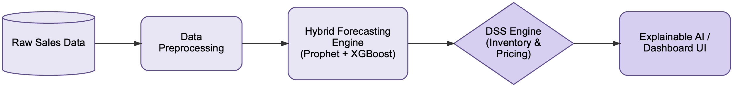

Figure 3.1: System Architecture Overview

Data Collection and Preprocessing
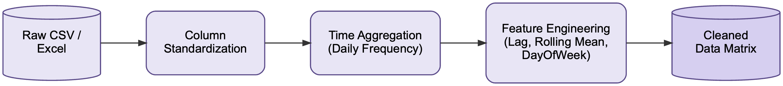
The system features a Universal Data Adapter that can ingest sales reports in multiple formats. The preprocessing pipeline is organised into four stages:

Figure 3.2: The data collection and preprocessing pipeline

Column standardization. Different naming conventions used by various sales platforms are mapped into a unified schema with three core fields: ds (transaction date), y (daily sales quantity), and product_id. When unit prices are unavailable, a calculated_price variable is derived by dividing the total transaction amount by quantity.

Time aggregation. Sporadic intraday transactions are grouped into daily frequency by summing quantity_sold per date; this converts irregular records into a consistent daily time series.

Feature engineering. To capture purchasing patterns, the system extracts day_of_week, is_weekend, and month, along with lag_7 (sales volume from seven days prior) and rolling_mean_7 (seven-day moving average), which provide historical context for the gradient boosting model.

Missing value handling. Days with no recorded transactions are filled with zero values through backward filling, preserving time series continuity without introducing future data leakage.

The Universal Data Adapter recognises seven distinct dataset formats through priority-based signature detection. Each format corresponds to a specific column structure commonly produced by e-commerce and retail point-of-sale systems. Table 3.1 summarises the supported formats and their distinguishing column signatures.

No. | Format | Distinguishing Columns | Special Handling
1 | India Sales | OrderDate, Product, Qty (DD-MM-YYYY) | Day-first date parsing
2 | FMCG 2023-24 | Sales_date, Sub_Category, Quantity (MM-DD-YY) | Non-standard date format; sub-category aggregation
3 | Favorita Ecuador | date, family, sales, store_nbr | Aggregation across 54 stores per product family
4 | UK Retail I | InvoiceNo, StockCode, Quantity, UnitPrice | Standard schema
5 | UK Retail II | Invoice, StockCode, Quantity, Price | Renamed columns vs. UK Retail I
6 | Retail Transactions | Date, Product (comma-separated list), Total_Items | Product-list explosion with proportional quantity
7 | Manual Mapping (fallback) | User-selected columns | Interactive column-to-field assignment
Table 3.1: Universal Data Adapter — Supported Dataset Formats and Signature Detection

Hybrid Forecasting Model
The system has a two-stage hybrid architecture combining Prophet's seasonal decomposition with XGBoost's nonlinear pattern recognition [Figure 3.3].

Prophet Model for Time Series Forecasting
The first stage uses Prophet to capture long-term trends as well as recurring seasonal patterns such as weekly cycles and holiday effects. Prophet is selected because of its robustness to missing data and its ability to model multiple seasonality components simultaneously. The output is a baseline prediction that captures the macro-level structure of the time series.

XGBoost and Asymmetric Optimization
The second stage computes residuals (actual − Prophet prediction) and trains XGBoost to learn the unexplained patterns. The key contribution is an asymmetric loss function: it penalises under-forecasting more heavily than over-forecasting, reflecting the business reality that stockout costs exceed holding costs.

The XGBoost gradient-boosting framework itself is an existing open-source library [11]; the asymmetric objective function shown in Pseudo Code 3.1 is an original contribution of this thesis, designed to bias the model toward inventory protection by penalising under-forecasts more heavily than over-forecasts:
asymmetric_loss(y_true, y_pred, penalty_under, penalty_over) {
- input:
- y_true: vector of actual demand
- y_pred: vector of predicted demand
- penalty_under: weight for under-prediction (default = 5.0)
- penalty_over: weight for over-prediction (default = 1.0)
- output:
- grad: gradient vector (first derivative)
- hess: hessian vector (second derivative)

grad = empty array
hess = empty array

for i in 0 .. length(y_true) - 1 {
residual = y_pred[i] - y_true[i]
if residual < 0 {
// stockout scenario: heavy penalty
grad[i] = penalty_under * 2 * residual
hess[i] = penalty_under * 2
} else {
// overstock scenario: normal penalty
grad[i] = penalty_over * 2 * residual
hess[i] = penalty_over * 2
}
}
return grad, hess
}
Pseudo Code 3.1: XGBoost and Asymmetric Optimization
The algorithm evaluates each residual: when predicted demand falls below actual demand (stockout risk), gradients are multiplied by penalty_under (default 5.0); when predicted demand exceeds actual demand (overstock), gradients use penalty_over (default 1.0). As a result, the model is biased toward inventory protection during training.

Hybrid Forecasting Strategy
The final forecast combines both components: Forecast = Prophet_baseline + XGBoost_residual, with negative values clamped to zero. This structure leverages Prophet's interpretability for trend decomposition along with XGBoost's flexibility for capturing nonlinear residual patterns.
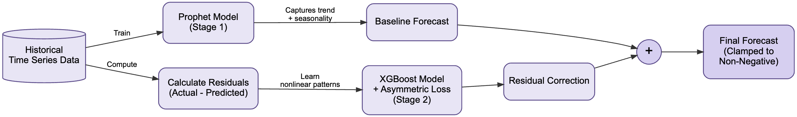
Figure 3.3: Hybrid Forecasting Pipeline
Within this architecture, the Prophet model first generates a baseline prediction that captures long-term trends and recurring seasonal patterns. The difference between the actual historical observations and these predictions is then computed as the residual component. Subsequently, the XGBoost model is trained on these residuals to learn complex nonlinear relationships that the baseline cannot capture. The final demand forecast is obtained by adding the residual correction produced by the machine learning model to the baseline forecast. This hybrid structure thereby allows the system to draw on both the interpretability of statistical forecasting methods and the predictive flexibility of machine learning algorithms.

Decision Support System Engine
The DSS engine translates forecasts into actionable business decisions. After receiving forecast data along with current inventory levels, the engine separates the analysis into two concurrent reasoning paths: inventory protection and price adjustment evaluation [Figure 3.4 and Figure 3.5].

Inventory Forecasting Support
The inventory branch evaluates the statistical risk of stock shortage. It takes the predicted total demand for the next seven days, computes demand volatility from the forecast prediction intervals, and derives the probability of a stockout by analysing the expected demand distribution against available stock.

Based on this volatility, the engine determines two critical thresholds: the Reorder Point (ROP), defined as lead-time demand plus safety stock; and the safety stock level, derived from the forecast standard deviation. The system then issues one of three actions through an elif cascade — ORDER_NOW when stock falls below ROP (urgency HIGH, accompanied by a calculated optimal reorder quantity), LOW_STOCK when stock approaches the ROP threshold, or HOLD when stock remains sufficient.
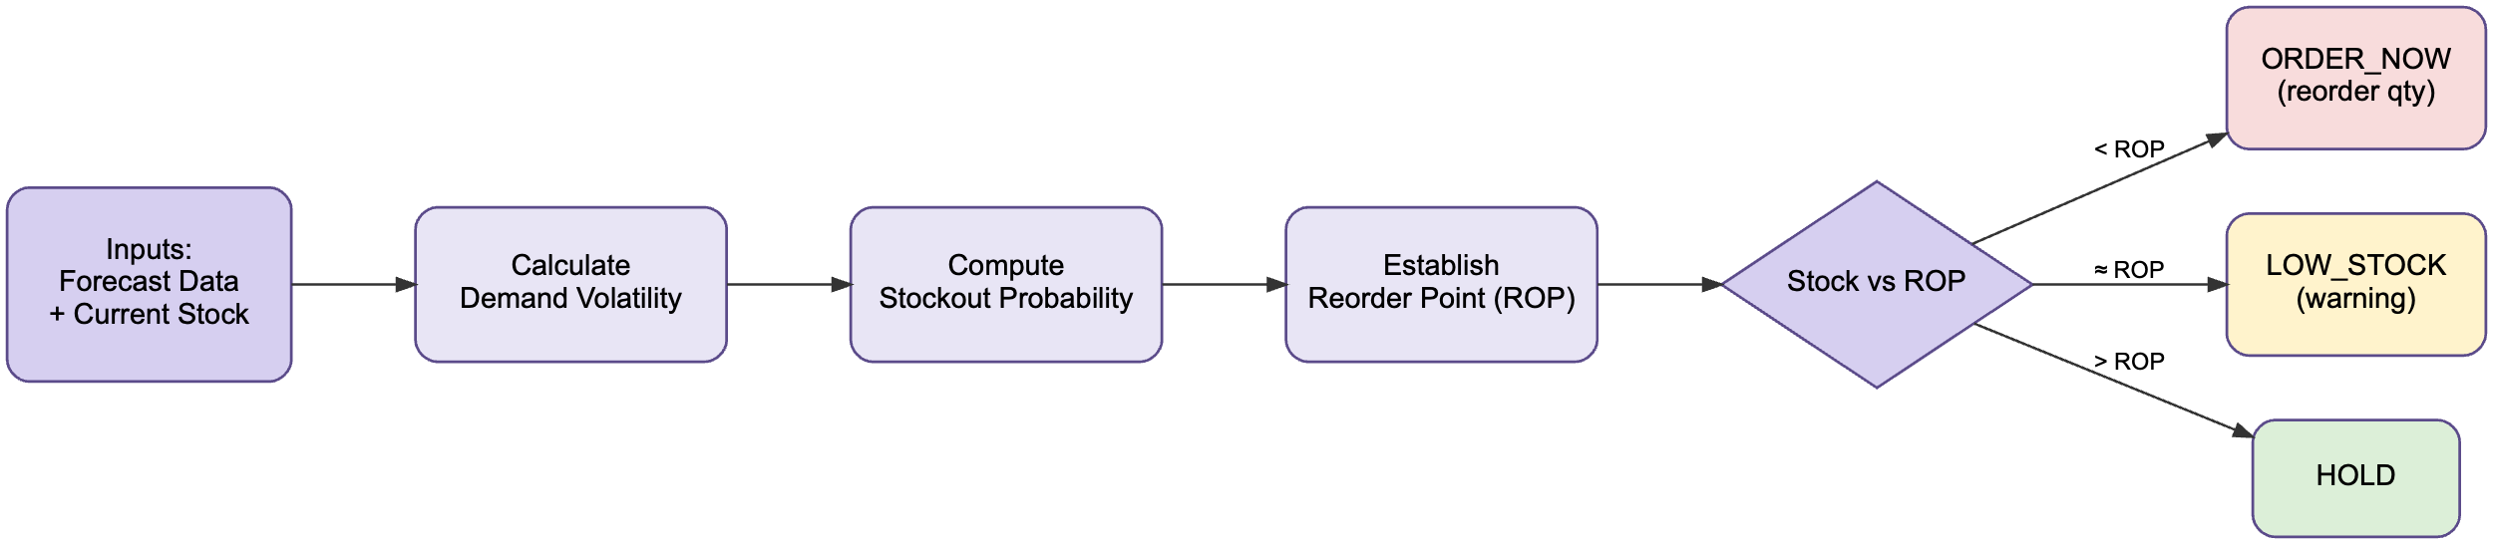
Figure 3.4: Inventory Branch Flowchart

Dynamic Pricing Recommendation
Simultaneously, the pricing branch acts as an automated pricing advisor, translating forecast information into pricing recommendations that balance sales velocity and inventory availability [Figure 3.5].

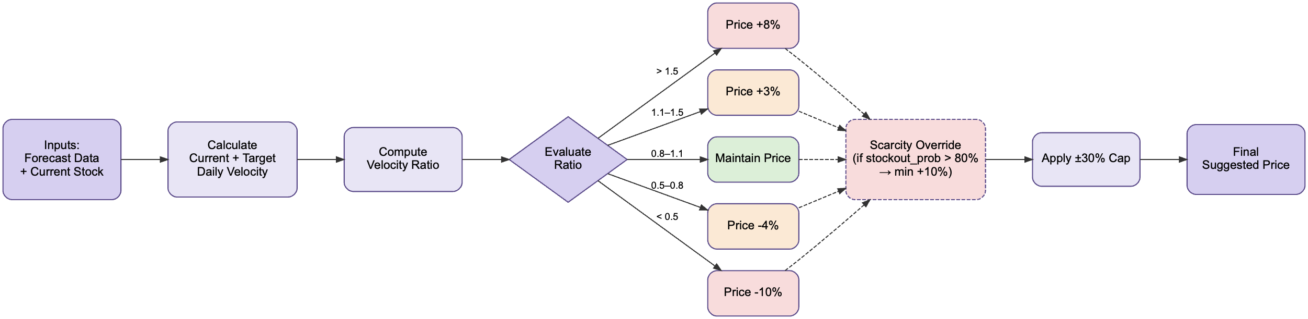
Figure 3.5: Pricing Branch Flowchart

The system first computes two velocity measures. The current daily velocity is obtained by dividing the predicted demand for the upcoming seven days by the forecast horizon. The target daily velocity is calculated from the current stock level divided by the number of days the retailer intends to clear inventory (default 30 days). The velocity ratio — current velocity divided by target velocity — then serves as the core indicator of demand intensity relative to inventory level.

The pricing rules operate as follows. A velocity ratio above 1.5 indicates that the product is selling much faster than the planned clearance rate, and the system suggests an 8% price increase to maximise profit margin and prevent early stockouts. A ratio between 1.1 and 1.5 triggers a moderate 3% increase. Conversely, a ratio below 0.5 with stock above the Reorder Point indicates slower-than-expected sales; the system therefore recommends a 10% discount to stimulate demand. A ratio between 0.5 and 0.8 triggers a moderate 4% decrease. When the ratio falls between 0.8 and 1.1, the price is maintained.

A scarcity protection override ensures that inventory safety takes precedence: when the stockout probability exceeds 80%, a minimum 10% price premium is applied regardless of velocity signals. This prevents aggressive discounting when stock is critically low. Finally, all adjustment multipliers are capped within ±30% of the current price to avoid extreme fluctuations that could confuse customers or destabilise pricing strategies.

The pricing decision logic shown in Pseudo Code 3.2 is an original contribution of this thesis. Unlike the XGBoost-based forecasting stage, this module does not rely on any external machine-learning library: it is a rule-based engine designed specifically to translate forecast outputs into actionable price recommendations through a velocity-ratio framework.

dynamic_pricing(current_stock, current_price, forecast_7d, target_days, stockout_prob, reorder_point) {
- input:
- current_stock: physical units available
- current_price: current selling price
- forecast_7d: predicted demand for the next 7 days
- target_days: user-defined days to clear inventory (default = 30)
- stockout_prob: probability of running out of stock (%)
- reorder_point: ROP value computed by inventory branch (see Section 3.4.1)
- output:
- suggested_price: optimised new price

// Step 1: calculate velocities
current_daily_velocity = forecast_7d / 7
target_daily_velocity = current_stock / target_days

// Step 2: calculate velocity ratio
if target_daily_velocity > 0 {
velocity_ratio = current_daily_velocity / target_daily_velocity
} else {
velocity_ratio = 0
}

// Step 3: apply pricing rules
price_multiplier = 1.0

if velocity_ratio > 1.5 {
price_multiplier = price_multiplier + 0.08 // increase 8%
} else if velocity_ratio > 1.1 {
price_multiplier = price_multiplier + 0.03 // increase 3%
} else if velocity_ratio < 0.5 and current_stock > reorder_point {
price_multiplier = price_multiplier - 0.10 // decrease 10%
} else if velocity_ratio < 0.8 and current_stock > reorder_point {
price_multiplier = price_multiplier - 0.04 // decrease 4%
}

// Step 4: scarcity protection override
if stockout_prob > 80.0 {
price_multiplier = max(price_multiplier, 1.10) // minimum 10% premium
}

// Step 5: cap multipliers to ±30%
price_multiplier = max(0.7, min(1.3, price_multiplier))

suggested_price = round(current_price * price_multiplier, 2)
return suggested_price
}
Pseudo Code 3.2: Dynamic Pricing Recommendation
Pseudo Code 3.2 formalises this decision logic. The procedure accepts current stock, current price, the seven-day forecast, target clearance days, and stockout probability as inputs. It computes the velocity ratio, applies the rule-based pricing thresholds, checks for the scarcity override, clamps the multiplier to the ±30% guardrail, and returns the suggested price. As a result, this module provides pricing recommendations that combine forecast-based demand signals with inventory constraints, remaining aligned with operational goals while responding dynamically to predicted market conditions.

Explainability Module
n8n is an open-source workflow automation platform that links services through a visual node-based editor and runs them as a directed acyclic graph of operations. Within this system, n8n serves as the orchestration layer between the FastAPI backend and the Large Language Model: it receives metric payloads from the backend, applies the prompt template, calls the LLM, and returns the generated narrative to the frontend, thereby decoupling explanation generation from the core analytical pipeline.

The system packages calculated metrics — forecast values, inventory levels, stockout probability, velocity ratio, and pricing recommendation — and sends them through an API webhook to the n8n automation platform [Figure 3.6]. The n8n workflow then routes this payload to a Large Language Model, which generates a natural language analysis explaining the reasoning behind each recommendation. The narrative is returned to the Next.js dashboard for display alongside the numerical outputs, ensuring that managers understand not only what to do but why.
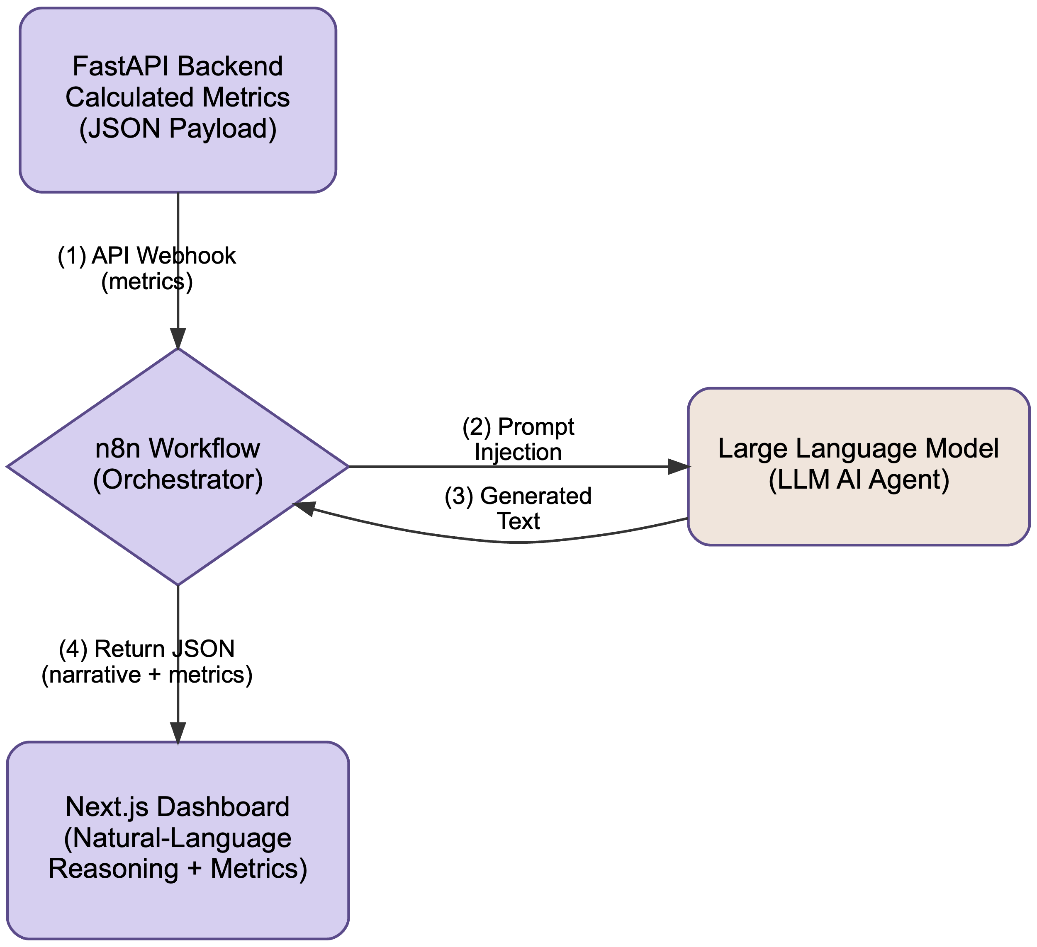
Figure 3.6: n8n Explainability Flow

System Architecture Pattern
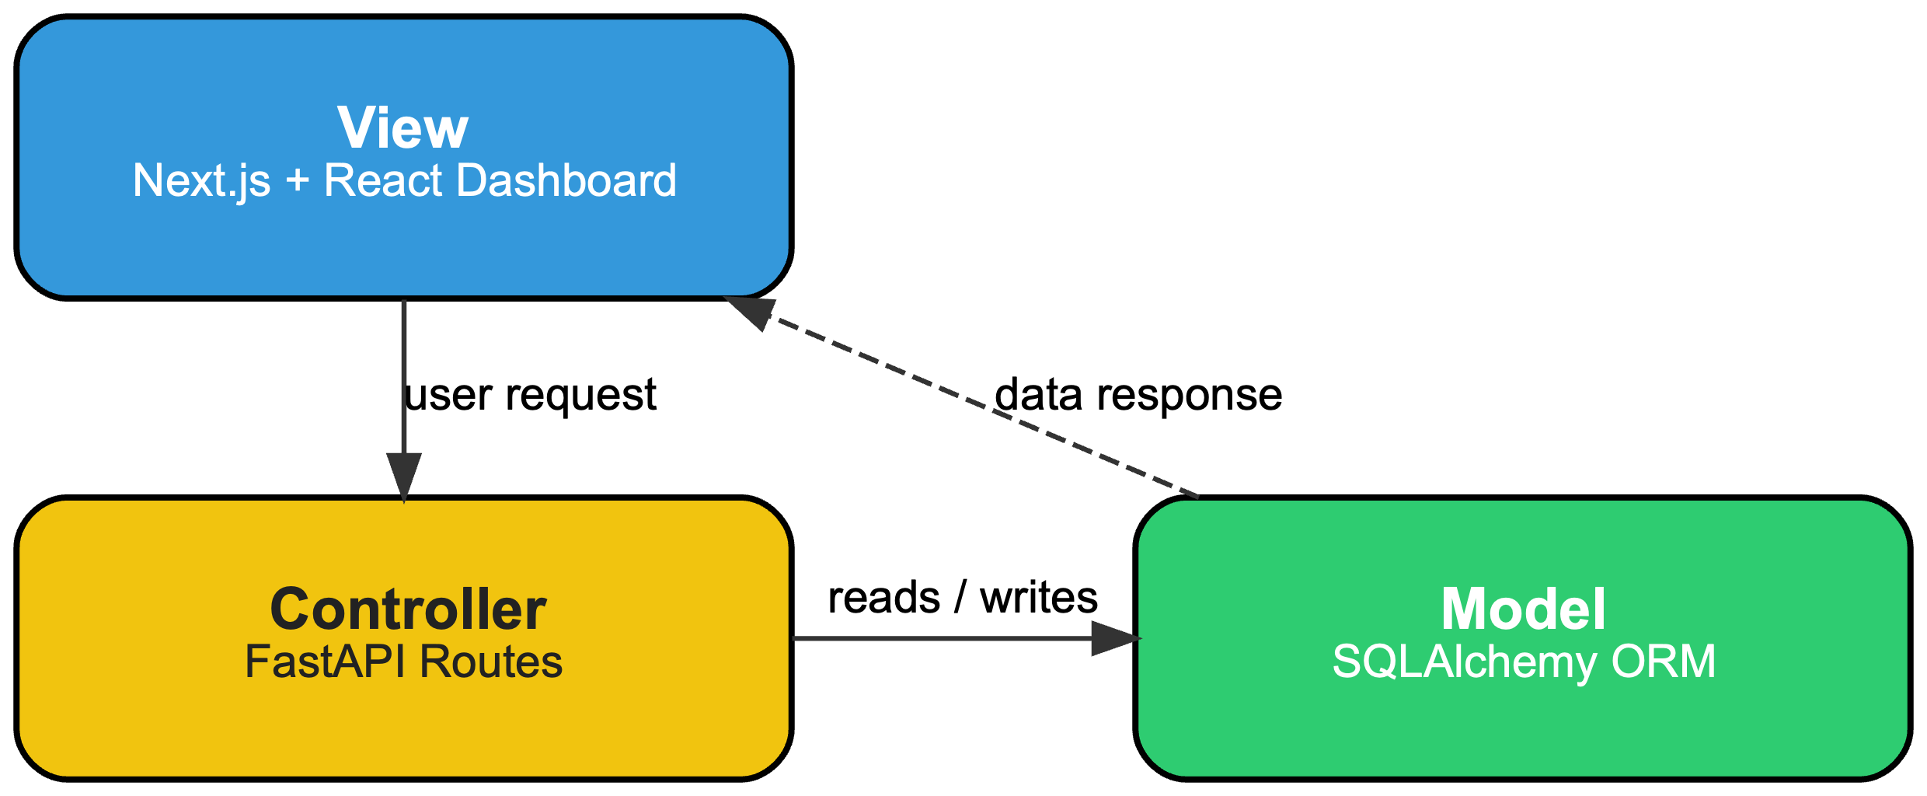
Figure 3.7: MVC Architecture
While Section 3.1 introduced the system from a functional pipeline perspective (Figure 3.1), this section examines the same system from a complementary software architecture perspective, focusing on how the implementation code is organised across runtime layers rather than how data flows through analytical modules.

The system adopts a layered architecture following the Model–View–Controller pattern, adapted for a RESTful API context as illustrated in Figure 3.7. The Model layer is composed of SQLAlchemy ORM classes (app/models/models.py) along with Pydantic schemas (app/schemas/schemas.py) for request validation and response serialisation. The Controller layer consists of seven FastAPI router modules located in app/api/, exposing 47 endpoints in total: dss.py (17), products.py (12), inventory.py (5), notifications.py (4), sales.py (3), auth.py (3), dashboard.py (2) as well as including health check api of backend. The View layer is a separate Next.js application (React 19, TypeScript, Recharts) that communicates with the backend exclusively through the REST API.

Beyond the canonical three-component pattern shown in the diagram, the implementation organises the analytical code into two additional internal layers for cleaner separation of concerns: a Core layer (app/core/) that encapsulates the domain algorithms — preprocessing.py for the Universal Data Adapter, hybrid_model.py for the Prophet-XGBoost pipeline, dss_engine.py for inventory and pricing analysis, and backtest.py for three-way simulation — and a Service layer (app/services/) responsible for forecast and backtest cache computation. These layers sit between the Controller and the Model in the request flow, keeping the analytical engine independent of the web framework. External services include the n8n automation platform, used for LLM narrative generation via webhook, and SQLite as the persistence backend.

Database Design
The schema described in this section is intended to support an end-to-end demonstration of the proposed DSS pipeline, rather than to serve as a production-ready data layer for a full e-commerce platform. Several simplifications are made deliberately. The system uses SQLite as the default storage engine for portability, runs in a single-tenant configuration without row-level security, and stores DSS reports as JSON blobs instead of fully normalised tables in order to reduce schema complexity for the prototype. Audit history is limited to inventory transactions and the notification log; finer-grained operational concerns such as pricing change history, multi-warehouse inventory partitioning, and concurrent-write conflict resolution are out of scope. The schema is therefore designed to make every stage of the forecasting–inventory–pricing pipeline observable and reproducible during evaluation, while leaving room for hardening if the system were to be deployed in a production setting.

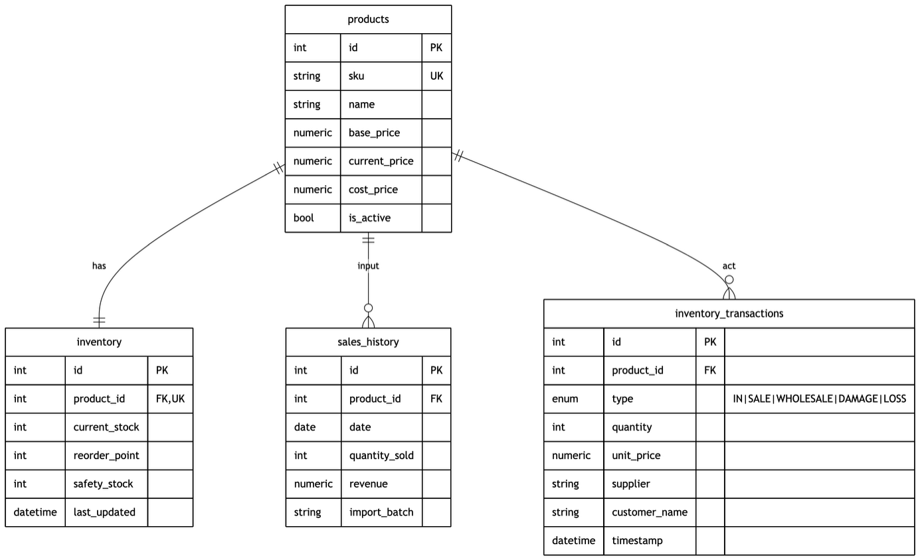
Figure 3.8: Operational Data Entity-Relationship Diagram
The system uses a relational database managed by SQLAlchemy ORM, with Alembic handling schema migrations and SQLite serving as the default backend for portability. The operational data layer, shown in [Figure 3.8], centres on the Product table, which stores SKU, pricing fields (base_price, current_price, cost_price), and an is_active flag for soft deletion. The Inventory table maintains a one-to-one relationship with Product, tracking current_stock, reorder_point, and safety_stock; the latter two values are dynamically updated by the DSS engine after each analysis run. The SalesHistory table records daily aggregated sales (quantity_sold, revenue) along with an import_batch identifier for data provenance. The InventoryTransaction table logs all stock movements through a type enumeration (IN, SALE, WHOLESALE, DAMAGE, LOSS) together with optional supplier, customer_name, and unit_price fields, supporting full traceability of physical inventory changes.
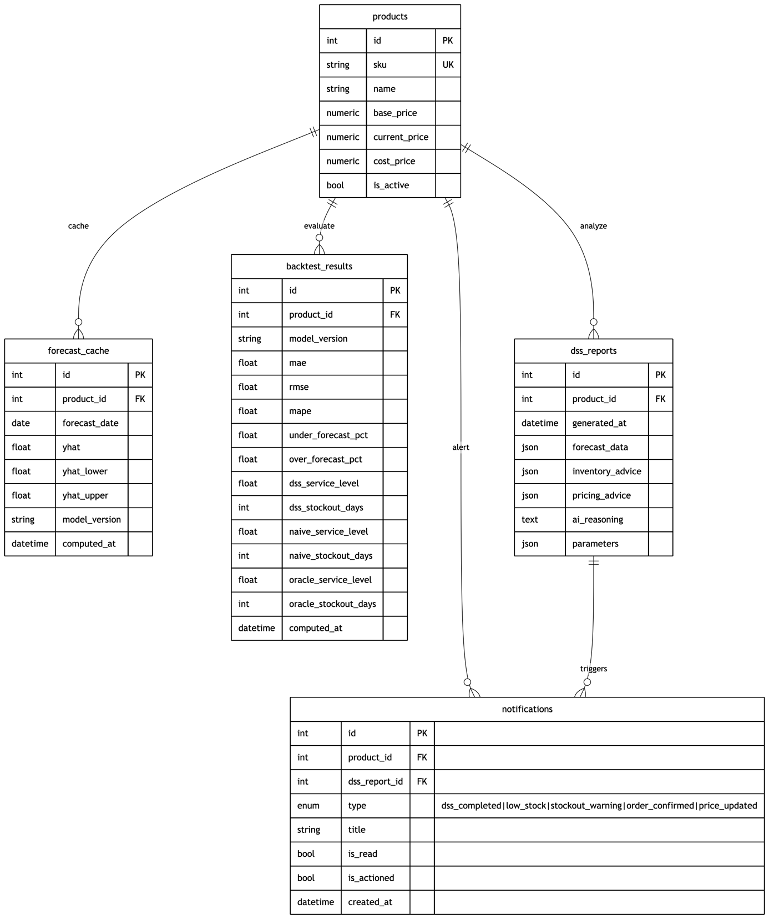
Figure 3.9: Analytical Pipeline Entity-Relationship Diagram
The analytical pipeline layer, shown in Figure 3.9, comprises three tables that persist model outputs. ForecastCache stores precomputed 30-day forecasts (yhat, yhat_lower, yhat_upper) per product and model_version, enabling the portfolio endpoint to serve all products without re-training. BacktestResults stores per-product evaluation metrics across 21 columns, including accuracy measures (MAE, RMSE, MAPE, under_forecast_pct, over_forecast_pct) and three-way simulation results (service level, stockout days for DSS, Naive, and Oracle strategies). DSSReport persists the complete analysis output as JSON fields (forecast_data, inventory_advice, pricing_advice) alongside ai_reasoning text and the parameters configuration used for each run. The Notification table closes the audit loop through a foreign key to dss_report_id, linking system-generated alerts (dss_completed, low_stock, stockout_warning, order_confirmed, price_updated) back to the specific analysis that triggered them.

Four supporting tables complete the schema. Category provides hierarchical product classification through a self-referencing parent_id; Supplier and ProductSupplier together implement the many-to-many relationship between products and their supply sources; and User supports role-based access control with admin, manager, and viewer roles. The full schema therefore comprises 12 ORM classes arranged in a star-like topology centred on the Product table.

Implementation Environment
The system is built using a dual-language stack. On the backend, the Python-based FastAPI framework serves as the computational engine, exposing a RESTful API with 47 endpoints organised across seven routers: authentication, dashboard, DSS analysis, inventory management, notifications, products, and sales ingestion. The database layer is handled by SQLAlchemy ORM with Alembic for schema migrations, backed by SQLite as the default storage engine. For the user interface, the Next.js framework (React with TypeScript) provides an interactive single-page application, with data visualisation powered by the Recharts library. The core computational libraries include Prophet, XGBoost, and Pandas. The natural-language explanation pipeline is handled independently through the n8n automation platform.

CHAPTER 4

IMPLEMENT AND RESULTS

Implement

System Architecture
The system is implemented as a client-server application following the layered architecture described in Section 3.6 [Figure 3.7]. The Python backend runs on FastAPI 0.128.0 (localhost:8000) with SQLAlchemy 2.0.48 ORM backed by SQLite, exposing 47 REST endpoints across seven routers under the /api prefix. The Next.js 16.2.2 frontend (React 19.2.4, localhost:3000) communicates with the backend exclusively through this API. Background tasks such as forecast recomputation and batch backtesting run inside the FastAPI process using BackgroundTasks with in-memory job registries — no external worker queue (Celery/Redis) is required.

Frontend Dashboard
The frontend is implemented as a Next.js App Router application with five primary pages, each serving a distinct operational function. Navigation between pages is provided by a persistent top navigation bar (Navbar.jsx) that also displays real-time notification counts and user authentication status.

Dashboard Overview (/ — DashboardPage.jsx). The landing page presents a high-level operational summary [Figure 4.1]. Four metric cards display Total Products, Inventory Value, Low Stock alerts, and Out of Stock count. A revenue trend chart with configurable time windows (7, 14, 30, 90 days or custom date range) shows sales performance over time, with toggle between revenue and unit volume views. Below the chart, a sortable product table lists all products with their current stock status (color-coded: green for In Stock, amber for Low Stock, red for Out of Stock), 7-day sales velocity, and current price. A recent activity feed displays the latest inventory transactions and DSS alerts. This page calls the GET /api/dashboard/summary and GET /api/dashboard/revenue-trend endpoints.
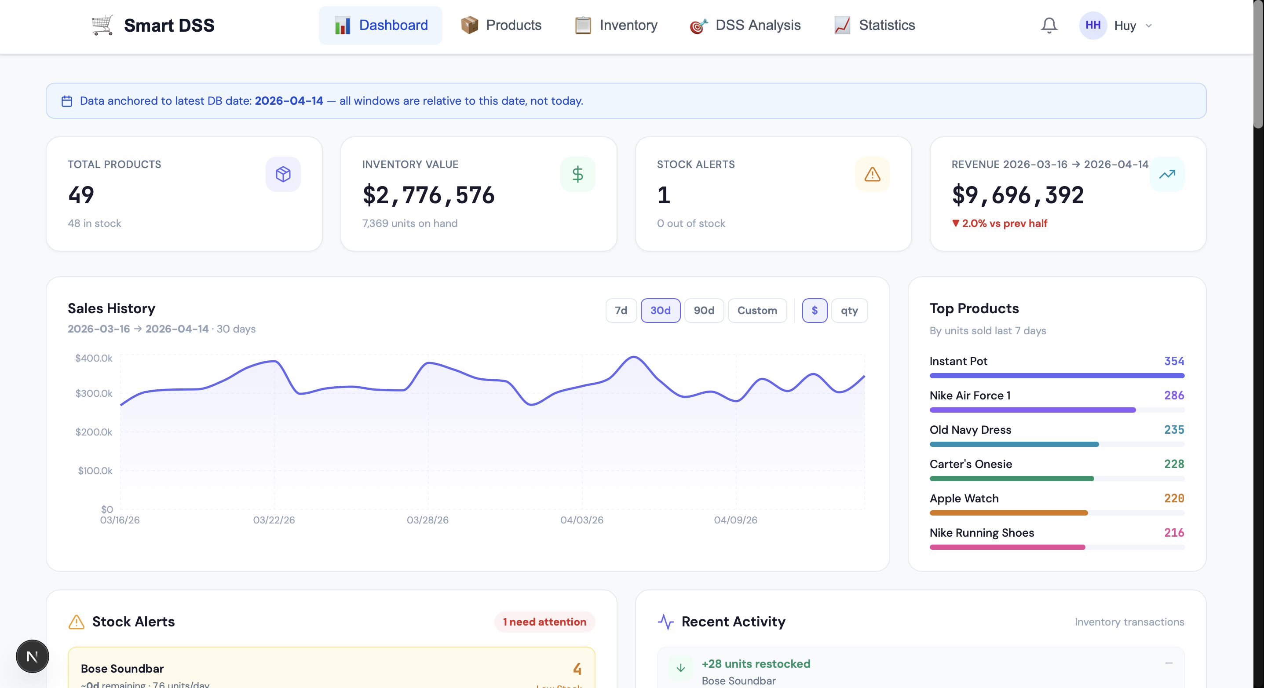
Figure 4.1: Dashboard Overview Page
Products Management (/products — ProductPage). This page provides CRUD operations for the product catalog including bulk CSV import with progress tracking via SSE, category management, and individual product editing. The interface supports search, category filtering, and stock status filtering [Figure 4.2].
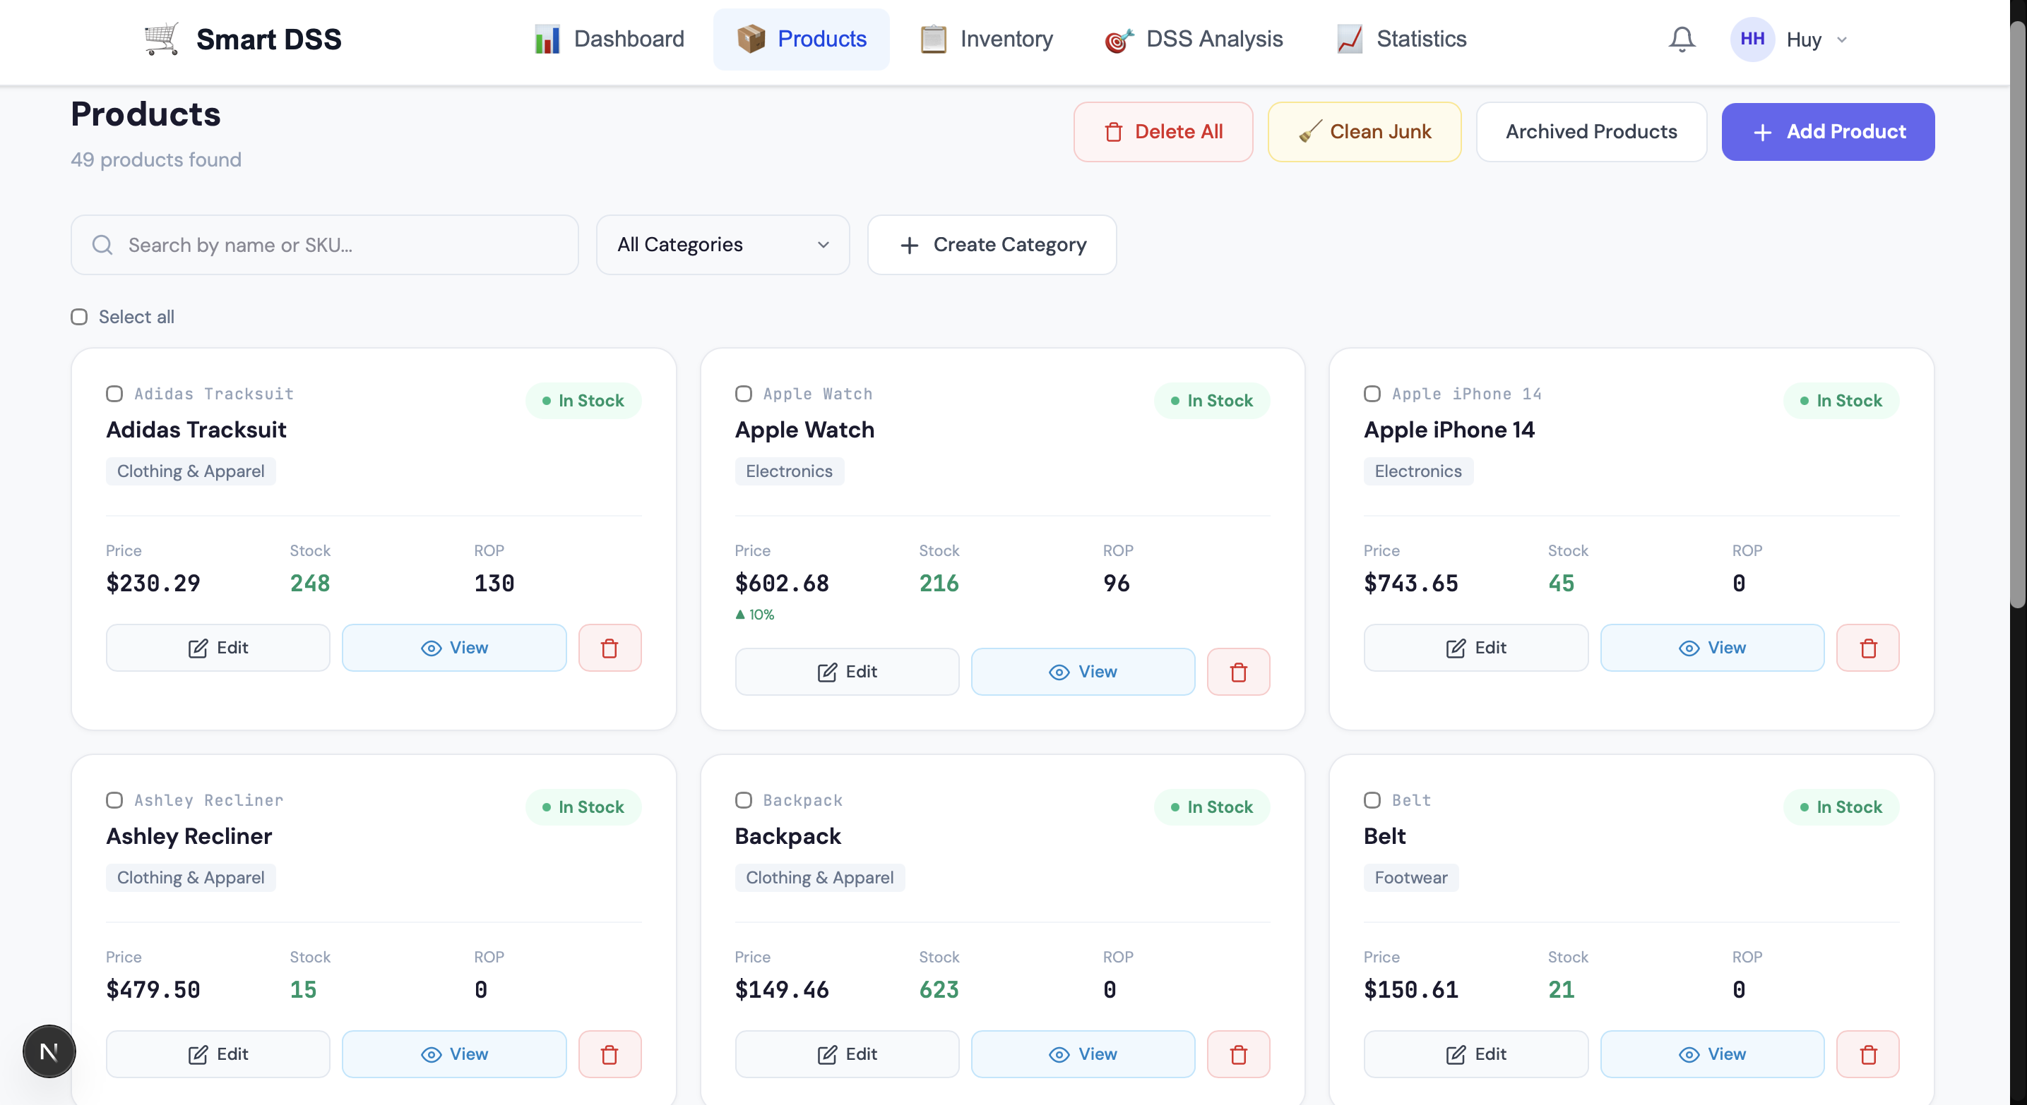
Figure 4.2: Products Management Page
Inventory Management (/inventory — InventoryPage). This page manages stock-in and stock-out transactions with a transaction history log. Inventory alerts for low stock and out-of-stock conditions are displayed with actionable indicators [Figure 4.3].
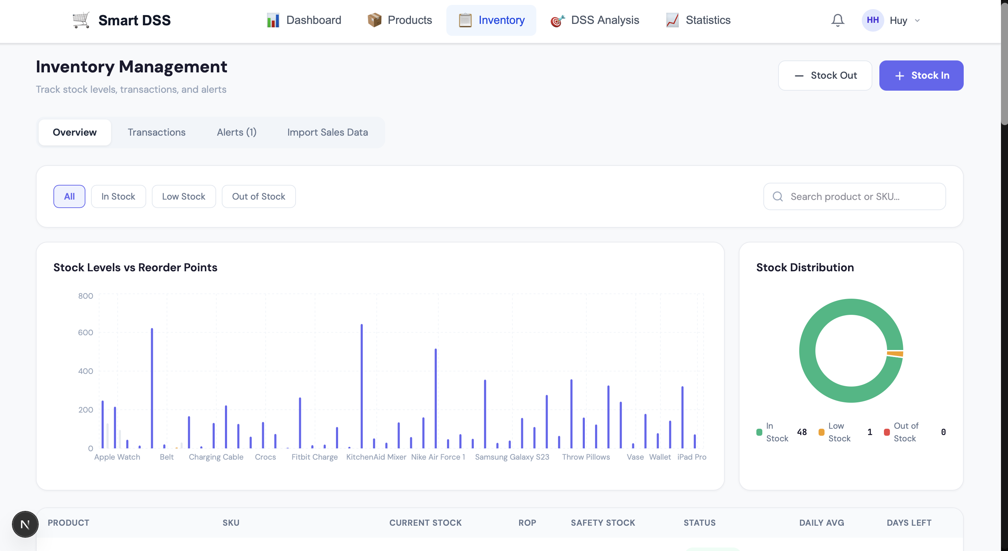
Figure 4.3: Inventory Management Page
DSS Analysis (/dss — page.tsx). This is the core analytical interface where managers interact with the forecasting and recommendation engine [Figure 4.4]. The page is organized into three tabs:
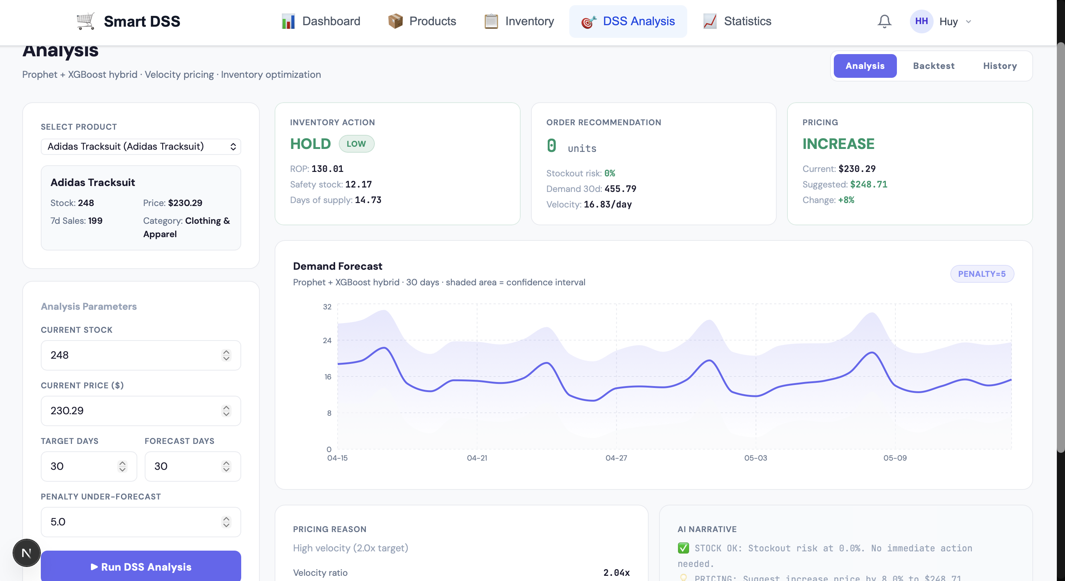
Figure 4.4: DSS Analysis Page — Forecast and Recommendations
The Analysis tab presents the full DSS pipeline output for a selected product. Upon running the analysis (which calls POST /api/dss/run), the interface displays: a forecast summary card with mean predicted demand and prediction interval range; an inventory action card color-coded by urgency (red ORDER_NOW, amber LOW_STOCK, green HOLD) showing ROP, safety stock, suggested order quantity, and stockout probability; a pricing recommendation card showing the suggested price, adjustment percentage, velocity ratio, and strategy label; and an AI Analyst card containing the natural language explanation generated via the n8n workflow. Below these cards, a 30-day forecast chart plots yhat with yhat_lower/yhat_upper confidence bands using Recharts AreaChart. A Confirm Order modal allows the manager to accept the suggested quantity or override with a custom amount, creating an inventory transaction linked to the DSS report. An Apply Price button updates the product price with ±30% guardrail validation.

The Backtest tab displays the three-way inventory simulation results (DSS versus Naive versus Oracle) for the selected product. Five StatBox components show Oracle service level (upper bound), DSS service level, Naive service level, DSS-versus-Naive improvement percentage, and test period duration. A line chart renders the daily stock trajectory for all three strategies over the test window, with Oracle shown as a dotted purple line, DSS as a solid green line, and Naive as a dashed amber line [Figure 4.5].
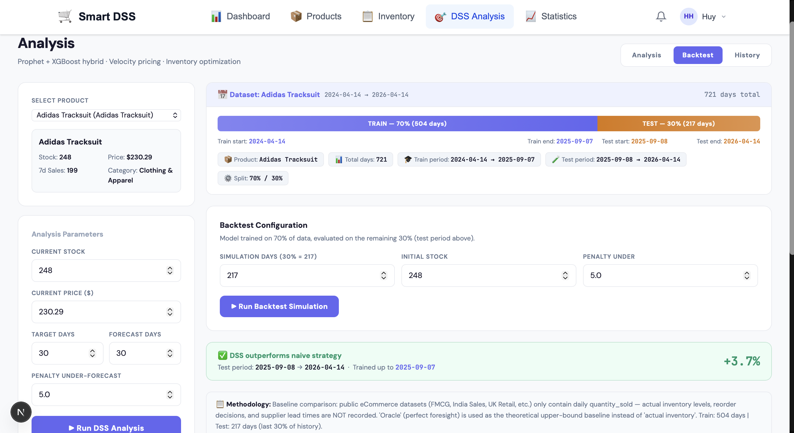
Figure 4.5: Backtest Simulation — DSS vs Naive vs Oracle
The History tab lists all previous DSS reports for the selected product with their inventory and pricing recommendations, allowing managers to track recommendation changes over time.

Statistics & Portfolio (/statistics — StatisticsPage). This page provides a portfolio-level view across all products [Figure 4.6]. It displays cache metadata (last computed date, model version, products cached), a category rollup bar chart comparing DSS versus Naive service levels by product category, and a sortable product table showing each product's stockout probability, velocity ratio, recommended action, and price change percentage. A Recompute Forecasts button triggers POST /api/dss/recompute-forecasts with real-time SSE progress tracking. A Generate PM Report button calls POST /api/dss/pm-report to produce an AI-generated portfolio analysis via the n8n webhook, rendered as markdown in a modal overlay. Model performance metrics (MAE, RMSE, Under-Forecast %) are displayed per category from the GET /api/dss/model-performance endpoint.
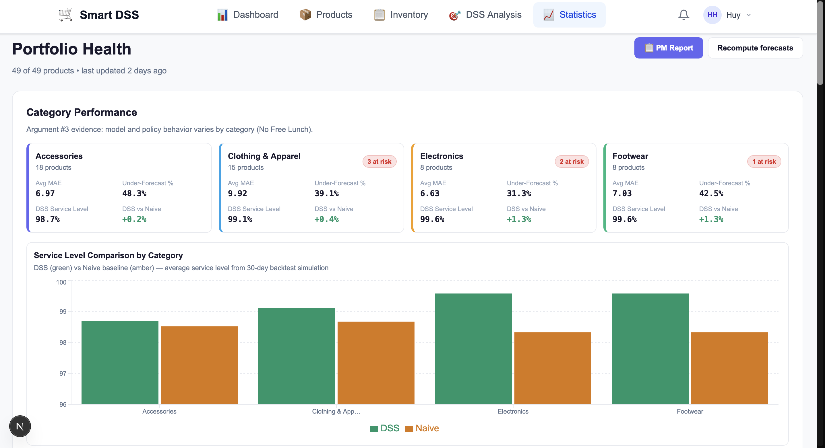
Figure 4.6: Statistics and Portfolio Health Page

Backend Implementation
The backend is implemented in Python 3.9.6 using FastAPI 0.128.0 with SQLAlchemy 2.0.48 ORM. The codebase follows the four-layer structure described in Section 3.6: seven API routers (47 endpoints total), five core algorithm modules, two service modules for cache management, and 12 ORM model classes. Background tasks run inside the FastAPI process using BackgroundTasks with in-memory job registries — no external queue (Celery/Redis) is required.
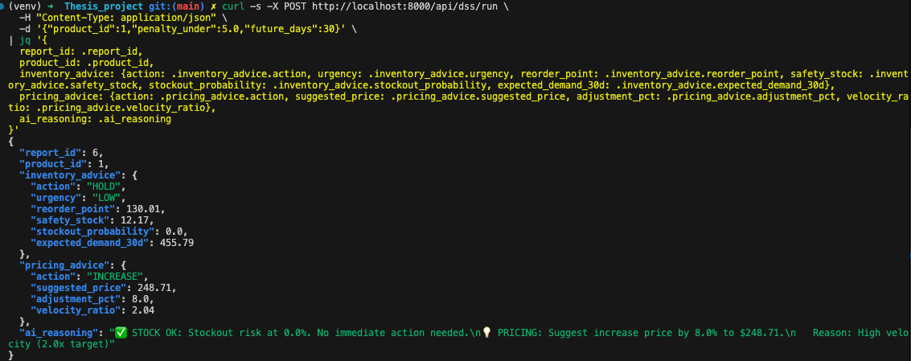
Figure 4.7: DSS Pipeline Terminal Output
Figure 4.7 demonstrates the DSS pipeline executing for a sample product, showing the forecast output, inventory action (HOLD/ORDER_NOW), and pricing recommendation returned by the API. Figure 4.8 shows the E2E test results across three test modules: DSS pipeline validation (8 tests), backtest simulation (7 tests), and manager action loop (7 tests), totaling 22 passed tests. The remaining 6 tests in the portfolio health module also passed, verifying cache recomputation and batch analysis across all products, bringing the full suite to 28/28 tests passed
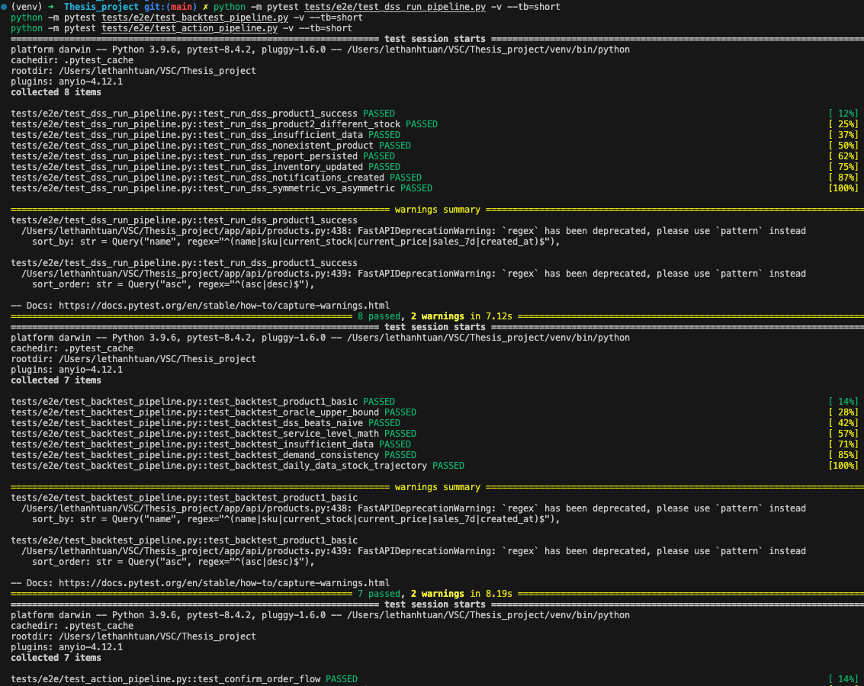
Figure 4.8: E2E Test Results — DSS Pipeline (8 tests), Backtest Simulation (7 tests), and Manager Action Loop (7 tests), 22/22 tests passed.

Universal Data Adapter Implementation
The Universal Data Adapter is implemented in the smart_merge_files function within preprocessing.py. When the user uploads one or more CSV files, the function reads all files and inspects their column headers. It checks the column signatures in a priority-ordered sequence, where each signature corresponds to a specific dataset format as defined in Table 3.1. The first matching signature triggers the corresponding preprocessing pipeline.

Each pipeline applies format-specific transformations to standardize the data into the unified schema required by the forecasting engine. For the Retail Transactions format, the adapter detects that the Product column contains comma-separated product lists within each transaction record and explodes these lists into individual rows, assigning the transaction quantity proportionally. For the FMCG 2023-24 format, the adapter identifies and parses the MM-DD-YY date format, which differs from the ISO standard used by most other datasets. For the Favorita Ecuador format, the adapter aggregates sales across all 54 stores for each product family, transforming store-level data into a single national-level time series per product category. If no predefined signature matches the uploaded columns, the system presents a Manual Mapping interface where the user can select which columns correspond to the date, product identifier, and quantity fields. This fallback mechanism ensures that the system can process custom or proprietary datasets without requiring code modifications.

Experimental Setup

Datasets
The evaluation uses three primary datasets selected to represent different retail data characteristics commonly encountered in e-commerce operations. Table 4.1 summarizes the key properties of each dataset.
Dataset | Duration | Density | Products | Scale | Volume | Pattern
India Sales | 362 days | 34% | 3 | Small | Low | Sparse, seasonal
FMCG 2023-24 | ~730 days | >90% | 5 | Medium | High | Dense, tabular
Favorita Ecuador | 1,684 days | ~100% | 5 | Large | Very high | Multi-year seasonal
Table 4.1: Dataset Characteristics
The India Sales dataset represents small-scale e-commerce in emerging markets. It spans 362 calendar days but contains recorded sales on only 34% of those days, making it a sparse dataset. Three product categories were evaluated: Saree, Hankerchief, and Stole. This dataset tests the system's ability to forecast demand when most days have zero or missing sales records.

The FMCG 2023-24 dataset represents modern, dense retail data with high daily transaction volume. It spans approximately 730 days with over 90% sales density, meaning nearly every calendar day has at least one recorded sale. Five product categories were evaluated: Small Electronics, Sportswear, Men's Wear, Footwear, and Women's Wear. This dataset tests forecasting performance under conditions where abundant data is available but multi-year seasonal patterns have not yet developed.

The Favorita Ecuador dataset represents large-scale grocery chain operations. It spans 1,684 days (approximately 4.6 years) with nearly 100% sales density across 54 stores. Five product families were evaluated at the national aggregate level: GROCERY I, BEVERAGES, PRODUCE, CLEANING, and DAIRY. This dataset tests the system's capacity to handle multi-year seasonal patterns, high-volume aggregate data, and the store-level aggregation transformation implemented in the Universal Data Adapter.

Two additional datasets, UK Retail II and Retail Transactions, were included to validate the Universal Data Adapter's format detection and preprocessing capabilities. However, both datasets exhibit intermittent demand patterns with sales density below 15%. Under these conditions, all forecasting models achieved near-zero MAE with approximately 100% MAPE, confirming that continuous demand forecasting methods are not suitable for such sparse data. These products would require specialized intermittent demand models such as Croston's method. Accordingly, UK Retail II and Retail Transactions were excluded from the forecasting evaluation but are reported in Section 4.3.4 as successful validation cases for the data adapter.

Models Compared
The evaluation compares four model configurations to isolate the contributions of the hybrid architecture and the asymmetric loss function. All four models use the same time-based 80/20 train/test split, the same continuous date-filled time series, and the same evaluation protocol.
Prophet-Only is the first model which makes use of the Prophet algorithm [11] to produce demand projections that are based directly upon daily time series. It is fed the date and sales quantity columns only and emulates trend, weekly seasonality and annual seasonality (when enough data exists). It applies the default loss of Prophet and none of the engineered features are included. This model is used as the statistical baseline.

In the second model, XGBoost-Only, XGBoost algorithm [12] is directly fitted on the target sales quantity with five engineered features: day_of_week, is_weekend, month, lag_7, and rolling_mean_7. In the test set evaluation, the lag feature and rolling feature are calculated on the basis of the trailing training mean as a proxy of future unknown values and this avoids data leakage. The model employs the common symmetric mean squared error loss and is the machine learning baseline.

The proposed system is a Hybrid (asymmetric) model. Prophet will create a baseline forecast and the residuals (actual-Prophet prediction) will be the XGBoost learning target. The XGBoost element utilizes the identical five engineered features as the XGBoost-Only model but is instructed by the custom asymmetric loss (penalty_under = 5.0, penalty_over = 1.0) defined in Pseudo Code 3.1. The ultimate forecast is the addition of the Prophet prediction and the XGBoost prediction (residual correction), which is censored at 0.

Hybrid (symmetric) model is exactly the same as the proposed system except in the loss function. It employs the symmetric penalties (penalty_under = 1.0, penalty_over = 1.0), as a result, XGBoost component can be reduced to conventional mean squared error minimization. This model is merely there to facilitate the ablation study: any result difference between the Hybrid (asymmetric) and Hybrid (symmetric) can be directly explained by the asymmetric loss function, and not by the hybrid architecture.

Evaluation Protocol
The evaluation methodology follows a consistent protocol across all datasets. Each dataset is evaluated separately at the product level. The daily time series is first made continuous by filling in missing dates, then chronologically split at 80%. The data adapter is trained on the training data, and the test data is used for evaluation. Four measures are calculated, MAE, RMSE, MAPE and Under- Forecast Percentage. Something that quantifies the frequency of a potential stockout risk directly is the Under-Forecast Percentage which adds up the percentages of test observations at which the prediction of the model is lower than the actual demand. Two categories of results are reported in Section 4.3: the per-dataset averages over all products considered in that dataset, and a few per-product observations where they have interesting patterns.

Results

India Sales Results
Table 4.2 outlines the results of the forecasting on the India Sales dataset which are sparse and seasonal e-commerce data with a 34% density in sales over 362 calendar days.
Model | MAE | RMSE | MAPE (%) | Under (%)
Prophet-Only | 3.11 | 4.38 | 62.1 | 37.5
XGBoost-Only | 4.08 | 6.80 | 108.3 | 42.5
Hybrid (asymmetric) | 3.77 | 5.34 | 95.5 | 35.2
Hybrid (symmetric) | 4.49 | 6.69 | 122.5 | 36.5
Table 4.2: Forecasting Results on India Sales Dataset
Prophet-Only has the lowest MAE of 3.11 and RMSE of 4.38 of the best overall accuracy on this dataset. This is not surprising due to the nature of the dataset: since there is a 34% chance of any calendar day having recorded sales, the rolling and lag features used in XGBoost are filled with mostly zero values, so the gradient boosting model is not easily able to learn any significant relationship between features and targets. Under these sparse conditions, additive decomposition model by Prophet, that explicitly modell trend and seasonality as continuous functions, is more robust.

The key result on this data is the ablation comparison of the two Hybrid models. Replacing symmetric with asymmetric loss inside the same architecture reduced MAE by 16%, reducing 4.49 to a low of 3.77. This is the greatest single factor improvement in all experiments in this assessment. The fact that the RMSE is reduced (6.69 to 5.34, a 20% decrease) further validates that not only the average accuracy is improved by the asymmetric loss function but also the large prediction errors are smaller.

The analysis of the product displays further subtlety, on a per-product basis. In the case of Hankerchief, the Hybrid (asymmetric) model has an MAE of 3.36, which is 49 percent lower than XGBoost-Only (MAE = 6.63). This implies that when the products in which Prophet obtains a substantial seasonal baseline, residual correction by XGBoost with asymmetric losses leads to a significant improvement. By contrast, Prophet-Only was the best in terms of MAE ( = 2.51) in reference to both Hybrid variants whose MAE = 4.33 (asymmetric) and 4.55 (symmetric) were higher, meaning that the residual correction was noisy instead of containing a signal to fit into the demand pattern of the specific product under consideration.

FMCG Sales Results
Table 4.3 shows the forecasts on the FMCG 2023-24 data (high-volume, dense, retail data with a sales density of more than 90 percent), with an approximate 730 days of sales data.
Model | MAE | RMSE | MAPE (%) | Under (%)
Prophet-Only | 26.78 | 35.82 | 48.7 | 13.9
XGBoost-Only | 13.87 | 19.30 | 31.5 | 54.8
Hybrid (asymmetric) | 24.58 | 31.12 | 50.0 | 93.2
Hybrid (symmetric) | 21.31 | 27.61 | 43.2 | 92.0
Table 4.3: Forecasting Results on FMCG 2023-24 Dataset
The lowest MAE is 13.87, and the lowest RMSE is 19.30, so XGBoost-Only can be the best model on this dataset. The FMCG data are dense and tabular, with strong patterns on the weekdays and high density in sales, which is the best scenario to use tree-based models directly based on the data matrix to establish feature-target relationships between them. Prophet-Only is the worst on MAE (26.78), probably due to the fact that the dataset is only around 1.5 years, too little to predict multi-year seasonal elements with high accuracy with Prophet.

The rankings of accuracy however, prefer to tell a part of the story. The Under-Forecast Percentage column indicates the frequency of each model to make predictions based on information that are below both actual demand, it straightforwardly measures the frequency of times the inventory levels would have run out. XGBoost-Only in 54.8% it under-predicts, which implies that a shop manager using this model would be at risk of a stockout at least 50 percent of the time when making decisions on daily inventory. The Hybrid model with asymmetry loss under-forecasts more often, 93.2% and the symmetric variant under-forecasts 92.0%. This is counterintuitive: in the FMCG case, the asymmetric loss function does not reduce under-forecasting as intended. Instead, the combination of Prophet's systematic over-estimation (only 13.9% under-forecast) with XGBoost's residual correction on this dense, high-volume data produces a net downward shift in the hybrid prediction, overriding the asymmetric penalty's upward bias. This dataset-specific reversal is discussed further in Section 5.1 as evidence of the No Free Lunch theorem. The difference in MAE between XGBoost-Only (13.87) and Hybrid asymmetric (24.58), approximately 10.71 units per day, reflects the cost of the hybrid architecture's residual correction on data conditions that favor XGBoost-Only.

The improvement of Hybrid (asymmetric) over Prophet-Only is 8.2% in MAE (24.58 versus 26.78), demonstrating that the XGBoost residual correction adds value in accuracy even when the Hybrid model does not achieve the overall best accuracy. However, this accuracy improvement comes at the cost of inventory safety: Prophet-Only under-forecasts only 13.9% of observations, while the Hybrid model under-forecasts 93.2%. This trade-off is specific to the FMCG dataset and does not generalize — on India Sales and Favorita, the asymmetric loss function reduces under-forecasting as designed.

Favorita Ecuador Results
Table 4.4 presents the forecasting results on the Favorita Ecuador dataset, which represents large-scale grocery operations spanning 1,684 days across 54 stores.
Model | MAE | RMSE | MAPE (%) | Under (%)
Prophet-Only | 20,845 | 29,419 | 47.3 | 58.4
XGBoost-Only | 21,876 | 30,886 | 52.3 | 79.3
Hybrid (asymmetric) | 23,978 | 32,310 | 54.4 | 52.7
Hybrid (symmetric) | 22,554 | 30,921 | 53.4 | 55.1
Table 4.4: Forecasting Results on Favorita Ecuador Dataset
Prophet-Only achieves the best overall accuracy on this dataset with the lowest MAE of 20,845 and RMSE of 29,419. This result reflects the dataset's strong multi-year seasonal patterns: with over four years of continuous daily data, Prophet's explicit modeling of yearly and weekly seasonal components has ample historical evidence to calibrate its seasonal estimates. The annual holiday shopping surges and year-end consumption peaks are precisely the type of pattern that Prophet's Fourier-based seasonality decomposition is designed to capture.

At the aggregate level, the Hybrid model does not outperform either baseline, with an MAE of 23,978 ranking last among all four configurations. However, per-product analysis reveals that the Hybrid model's aggregate performance masks meaningful category-level advantages. For the DAIRY family, Hybrid (asymmetric) achieved MAE of 5,401, outperforming both Prophet-Only (MAE = 5,511) and XGBoost-Only (MAE = 7,157). This is an improvement of 2% over Prophet and 24.5% over XGBoost in this category. In the same way, in the case of CLEANING family, MAE of Hybrid (asymmetric) was significantly smaller (10,650) compared to the XGBoost-Only (MAE = 14,711), with 27.6% being the improvement. The findings imply that the Hybrid strategy delivers the highest value when dealing with with-moderate volume product categories that have detectable residual patterns that can be learnt by the XGBoost part.

The smaller rate of under-forecast with this dataset shows significant variations among model combinations. XGBoost-Only does worse than it claims to forecast 79.3% of the test days, which means that four days out of five days it predicts the demand lower. Prophet-Only forecasts under 58.6% of the time. Lower loss of the Hybrid model is 52.7 percent with the asymmetric whereas the symmetric model has 55.1 percent under-forecast rate. This is a 2.4 percentage point decrease, which shows that the asymmetric loss functional decreases under-forecasting in this data as desired, which is in line with the India Sales outcome (1.4 percentage point decrease) and opposite to the FMCG reversal.

Universal Data Adapter Validation
All 7 dataset formats described in Table 3.1 automatically identified and ran with the Universal Data Adapter without human assistance or code extensions. The validation proves that the priority-based signature detection mechanism is properly configured to recognize a certain format based on its column headers and provide the relevant preprocessing pipeline.

A few format-dependent transformations were tested to be correct. In the format of Retail Transactions, the explosion of the product lists correctly transformed the single transaction records with several comma-separated product names into separate lines without becoming overended, maintaining the date of the transaction and distributing quantity accordingly. In the FMCG 2023-24 format, the non-standard date (MM-DD-YY) was properly processed by the date parsing featuring no date conversion errors. In the Favorita Ecuador model, the store level aggregation formed the sum total of sales quantities across stores in all 54 stores in each family of products forming a single national level time series in each category. The UK Retail I and UK Retail II forms, positively similar in terms of structure, but with the use of different names of the columns (InvoiceNo and Invoice versus Unitprice and Price), were both identified and processed by respective pipelines without a mix up. The Manual Mapping fallback interface was also tested by loading CSVs containing non-standard column names and the system responded by offering the user a choice of how to manually map columns.

DSS Application on Production Catalog
Beyond the dataset-level forecasting benchmarks reported in Sections 4.3.1 to 4.3.3, the DSS engine was exercised end-to-end on the production catalog of 49 active products managed inside the deployed application. This section reports two complementary sets of results: a set of representative DSS run case studies that illustrate the breadth of inventory and pricing actions the engine produces, and a backtest simulation that compares the DSS strategy against a Naive baseline and an Oracle (perfect-information) upper bound on a per-product basis. All results in this section were obtained directly from the running application through the /api/dss/run and /api/dss/backtest endpoints.
Five products were selected from the 49 active products in the production catalog to demonstrate the diversity of DSS engine outcomes. The selection deliberately covers all three inventory action types (ORDER_NOW, LOW_STOCK, HOLD) combined with different pricing reactions (increase, maintain, decrease, scarcity override), allowing the rule logic of the engine to be observed in action across distinct product conditions.
Product | Cur. Stock | 7-Day Forecast | Inventory Action | Pricing Action | Stockout Prob (%)
[Apple Watch] | 210 | 207.44 | ORDER_NOW | +8% | 41.6
[Bose Soundbar] | 4 | 40.88 | ORDER_NOW | Scarcity +10% | >80
[Tote Bag] | 325 | 8.54 | HOLD | -10% | 0
[Instant Pot] | 644 | 373.2 | HOLD | +8% | 0
Table 4.5: DSS Engine Run Results — Representative Product Cases

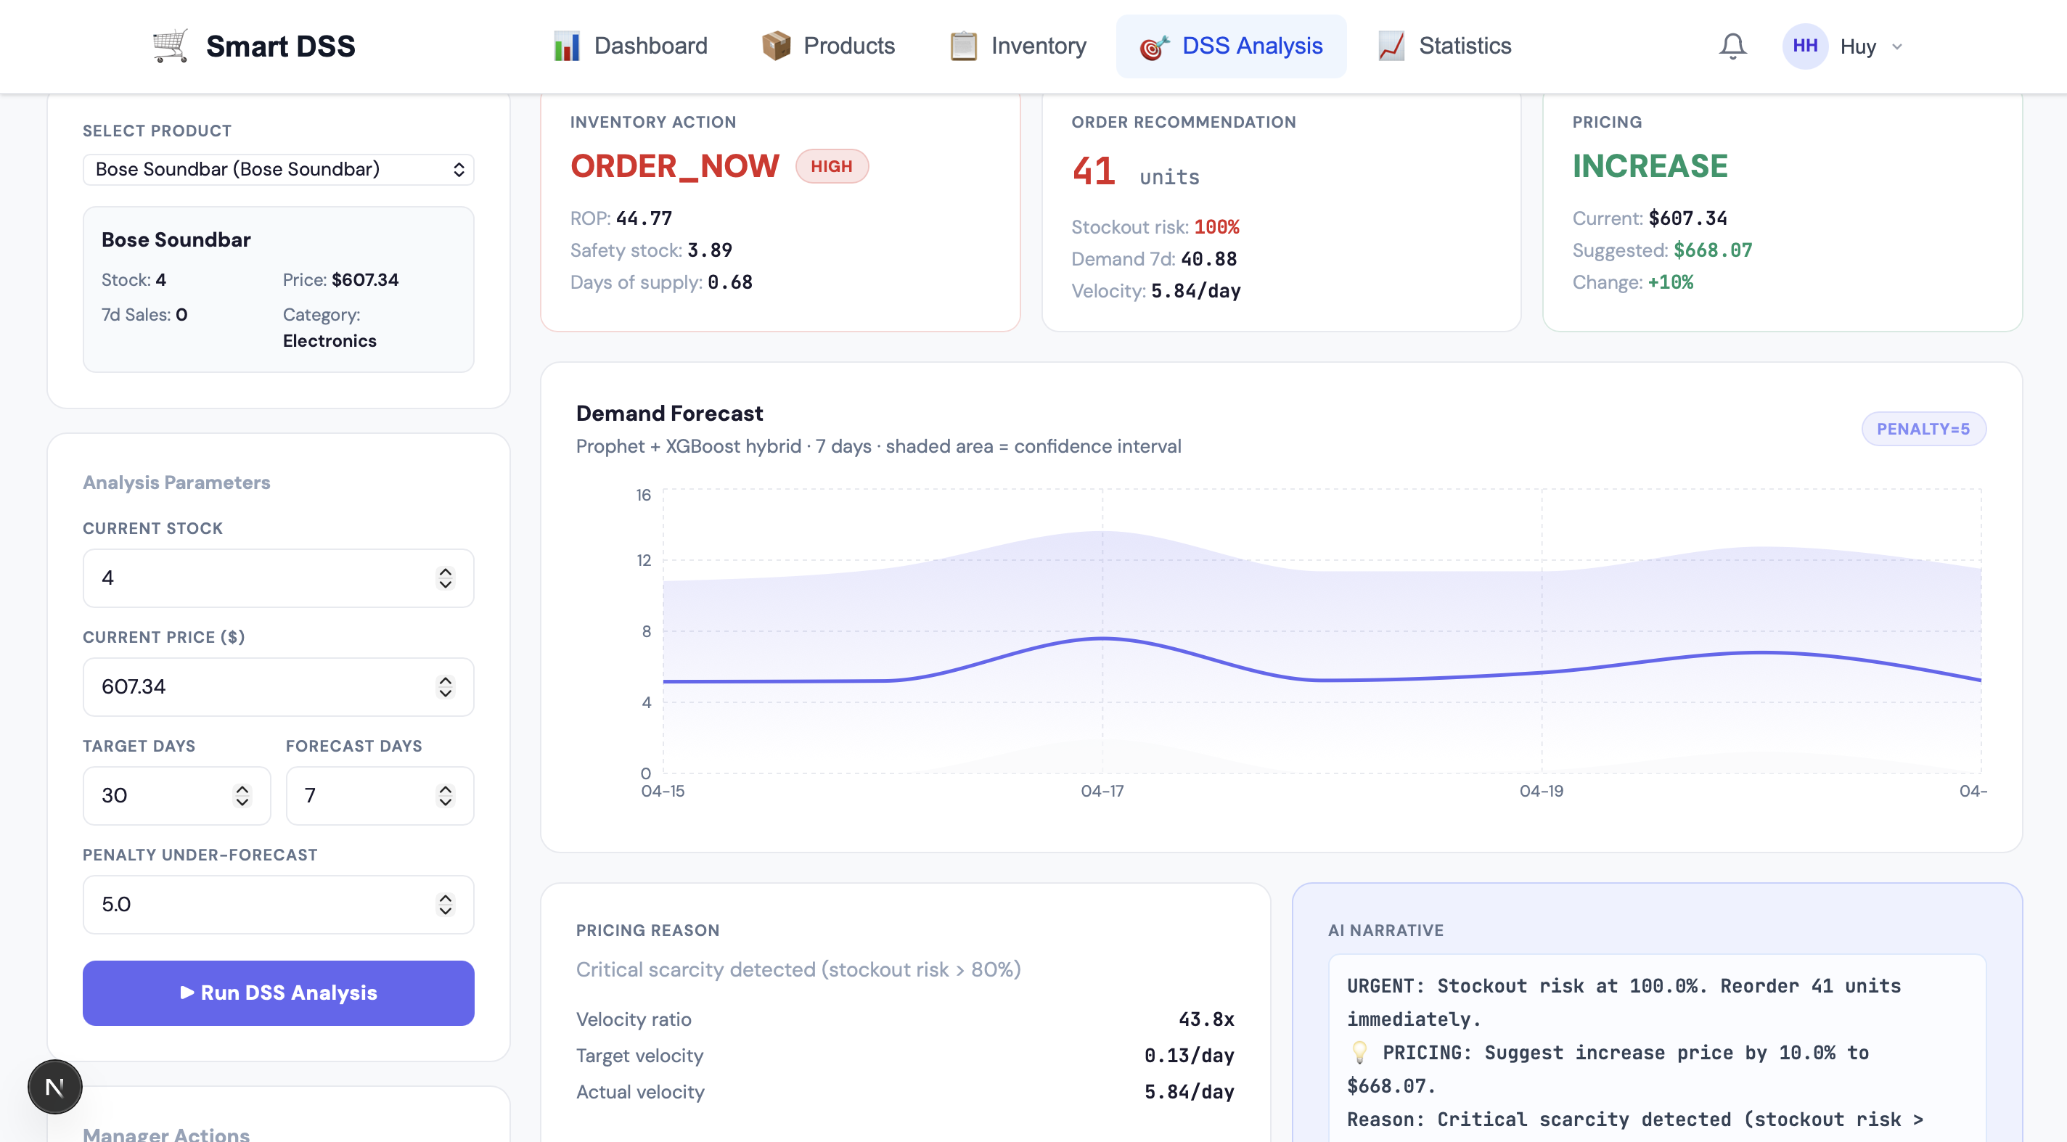
Figure 4.9: DSS Analysis Result Page (Sample Product)

While the case studies above illustrate single-shot decision outputs, they do not by themselves measure how well the DSS engine performs over time. To address this, a three-way backtest simulation was run for each of the five selected products through the /api/dss/backtest endpoint. The backtest replays the historical sales data of each product with a 70/30 train/test split, simulating three competing inventory strategies side by side: the DSS strategy proposed in this thesis, a Naive constant-reorder baseline, and an Oracle strategy with perfect future-demand information. For each strategy, the engine tracks daily stock trajectories and reports the resulting service level (the proportion of test days on which demand was fully served from on-hand inventory) and the total number of stockout days. The Oracle result establishes an upper bound that no realistic strategy can exceed, while the Naive result provides a lower bound representative of rule-of-thumb manual reordering.
Product | Test Days | DSS Service Level (%) | Naive Service Level (%) | Oracle Service Level (%) | Stockout Reduction vs. Naive (%)
[Apple Watch] | 360 | 100 | 95.8 | 100 | +100
[Bose Soundbar] | 342 | 98 | 94.4 | 100 | +63.2
[Tote Bag] | 688 | 100 | 98.3 | 100 | +100
[Instant Pot] | 360 | 100 | 95.8 | 100 | +100
Average | 438 | 99.5 | 96.1 | 100 | 90.8
Table 4.6: Backtest Simulation — DSS vs. Naive vs. Oracle (5 Representative Products)

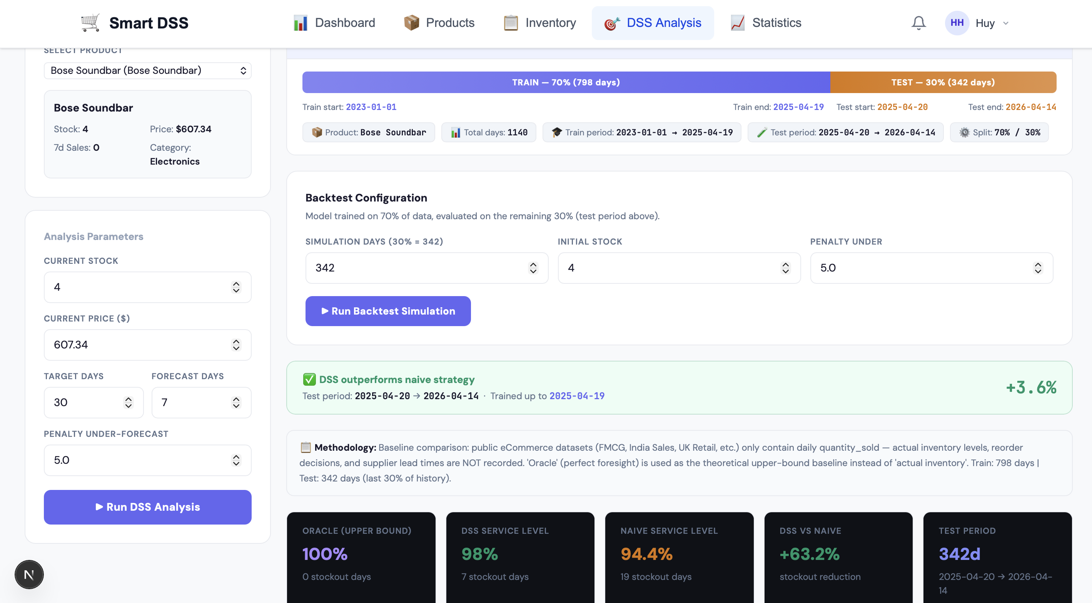
Figure 4.10: Backtest Simulation Tab (Sample Product)

Taken together, the case-study and backtest results confirm that the DSS engine produces actionable, behaviour-distinct outputs across diverse product conditions and that the resulting inventory strategy outperforms the Naive baseline on the majority of the simulated products. A detailed interpretation of these results — including their alignment with the inventory-safety framing of Section 5.1.1 and their limitations as a five-product demonstration rather than a full distribution analysis — is presented in Section 5.1.4.

Summary of Findings
Prior to the presentation of the consolidated results, it is important to mention, a cross-dataset trend in terms of understanding the relation of model performance and data density. In all the three datasets, the difference between the worst and the best performing models becomes smaller with an increase in data density. The MAE range (between the worst and the best model) on the India Sales dataset (34% density) is 1.38 units. The gap on the FMCG dataset (density greater than 90 percent) is 12.91 units in absolute terms; however the relative differences between models are less. In the Favorita dataset (density nearing 100 percent), the four models all give a range of MAPE values that are within 7.1 percentage points. This trend is an indication that heavy, quality data partially counteracts architectural disparities in models, and scarce information increases the necessity of selecting the appropriate modeling strategy.

The findings in all three primary evaluation datasets are summarized in table 4.5, which is a complete picture of the model performance under various data conditions.
Dataset | Model | MAE | RMSE | MAPE (%) | Under (%)
India Sales | Prophet-Only | 3.11 | 4.38 | 62.1 | 37.5
India Sales | XGBoost-Only | 4.08 | 6.80 | 108.3 | 42.5
India Sales | Hybrid (asym.) | 3.77 | 5.34 | 95.5 | 35.2
India Sales | Hybrid (sym.) | 4.49 | 6.69 | 122.5 | 36.5
FMCG 2023-24 | Prophet-Only | 26.78 | 35.82 | 48.7 | 13.9
FMCG 2023-24 | XGBoost-Only | 13.87 | 19.30 | 31.5 | 54.8
FMCG 2023-24 | Hybrid (asym.) | 24.58 | 31.12 | 50.0 | 93.2
FMCG 2023-24 | Hybrid (sym.) | 21.31 | 27.61 | 43.2 | 92.0
Favorita Ecuador | Prophet-Only | 20,845 | 29,419 | 47.3 | 58.6
Favorita Ecuador | XGBoost-Only | 21,876 | 30,886 | 52.3 | 79.3
Favorita Ecuador | Hybrid (asym.) | 23,978 | 32,310 | 54.4 | 52.7
Favorita Ecuador | Hybrid (sym.) | 22,554 | 30,921 | 53.4 | 55.1
Table 4.7: Summary of Forecasting Results Across All Datasets
The experimental results yield five key findings:
Finding 1. The asymmetric loss functional enhances the Hybrid model performance by 16% MAE on the India Sales dataset (3.77 versus 4.49) and this is the greatest improvement in single- factor in the test. The loss function alone can be credited with such an improvement, as both Hybrid variants have the same number of features and architecture.

Finding 2. Compared to the XGBoost-Only model, Hybrid model will perform better by 7.6% (seasonal sparse data, India Sales, MAE 3.77 vs. 4.08) and compared to the Prophet-Only model, it has a better performance by 8.2% (dense data, FMCG, MAE 24.58 vs. 26.78 These findings indicate that the hybrid architecture can offer accuracy benefits in at least some set of data conditions though it need not be the most effective architecture.

Finding 3. No single model dominates all dataset conditions. Prophet-Only performs best on sparse seasonal data (India Sales) and long-horizon multi-year data (Favorita), XGBoost-Only performs best on dense tabular data (FMCG), and the Hybrid model provides advantages on specific product categories and in inventory safety metrics. This result is consistent with the No Free Lunch theorem in machine learning, which states that no single algorithm is optimal across all possible data distributions.

Finding 4. The asymmetric loss function reduces under-forecasting on the India Sales and Favorita datasets, which is desirable for inventory safety. On India Sales, the Hybrid model with asymmetric loss under-forecasts 35.2% of test observations, compared to 36.5% for the symmetric variant (a 1.3 percentage point reduction). On Favorita, the reduction is larger: 52.7% versus 55.1% (a 2.4 percentage point reduction). However, on the FMCG dataset, the asymmetric loss function does not reduce under-forecasting — the Hybrid model under-forecasts 93.2% of observations regardless of loss function configuration (92.0% for symmetric). This dataset-dependent behavior is consistent with the No Free Lunch theorem discussed in Finding 3 and is analyzed further in Section 5.1.

Finding 5. The Universal Data Adapter successfully auto-detected and processed all seven tested dataset formats without manual intervention, validating the signature-based detection mechanism and format-specific preprocessing pipelines.

CHAPTER 5

DISCUSSION AND EVALUATION

Discussion

Reframing DSS Evaluation: Accuracy versus Inventory Safety
Evaluating a Decision Support System for inventory management using only prediction accuracy metrics such as MAE and RMSE provides an incomplete picture of operational usefulness. In inventory operations, the cost of prediction errors is fundamentally asymmetric: under-forecasting leads to stockouts, lost sales, and customer dissatisfaction, while over-forecasting leads to temporary excess inventory and holding costs. These two types of errors carry different economic consequences, and a meaningful evaluation must account for this distinction.

The under-forecast rate metric makes this distinction visible in the experimental results. On the Favorita dataset, the Hybrid model with asymmetric loss reduces the under-forecast rate from 79.3% to 52.7% relative to XGBoost-Only, a meaningful gain in inventory safety even though the average prediction error is comparable. In retail contexts where stockout costs are commonly estimated at three to ten times the holding cost of excess inventory [4], this kind of reduction translates directly into lower expected operational losses. The trade-off is not universal, however: on the FMCG dataset the Hybrid model under-forecasts more frequently than either single model, a reversal that reinforces the No Free Lunch finding and motivates the model selection guidance presented later in Table 5.1. The broader implication for DSS evaluation is that accuracy and inventory safety are distinct dimensions, and a system intended to support inventory operations should be measured on both.

Asymmetric Loss as the Primary Technical Contribution
The ablation study provides the strongest evidence for this thesis’s primary technical contribution. Within the same Hybrid architecture, switching from symmetric to asymmetric loss yielded a 16% MAE improvement and a 20% RMSE improvement on the India Sales dataset — the largest single-design-decision improvement observed in the entire evaluation. Because the two Hybrid variants share identical architecture, features, and train/test splits, the improvement is attributable exclusively to the loss function.

This finding has implications beyond the specific system proposed in this thesis. The asymmetric loss function defined in Pseudo Code 3.1 is architecture-independent: it modifies only the gradient and Hessian computations used during XGBoost training and can be applied to any gradient-boosted model used in inventory forecasting contexts. The contribution connects to prior work by Gogolev and Ozhegov [4], who demonstrated the effectiveness of asymmetric loss in product-level sales forecasting using gradient boosting methods. This thesis extends their finding by integrating the asymmetric loss function within a complete Decision Support System pipeline that includes inventory calculations, pricing recommendations, and explainability, rather than evaluating it in isolation as a forecasting improvement.

The practical significance of this contribution is that retailers and DSS developers can adopt asymmetric loss functions as a straightforward modification to existing XGBoost-based forecasting systems without changing their model architecture, feature engineering, or data pipeline. The only additional parameter required is the penalty ratio, which in this implementation is set to 5:1 based on general retail cost estimates.

Understanding Model Performance Across Data Conditions
The experimental results show that each model performs best under different data conditions. Understanding why each model wins in specific contexts is essential for practitioners who need to select or configure a forecasting system for their particular data environment.

Prophet-Only outperforms on the India Sales dataset because the data is sparse (34% sales density) and short, conditions in which Prophet’s additive decomposition interpolates smoothly through the gaps that defeat XGBoost’s lag-based features. XGBoost-Only outperforms on the FMCG dataset because the series is dense (over 90% density) and predominantly tabular, with strong day-of-week and monthly patterns that tree models exploit directly. Prophet-Only outperforms again on Favorita because the four-year horizon supplies multiple complete seasonal cycles for its Fourier components to calibrate against. The Hybrid configuration adds the most value at the product-family level for moderate-volume categories with identifiable residual structure, where XGBoost can correct Prophet’s systematic offset.

Based on these findings, Table 5.1 presents a model selection guide for practitioners.
Data Characteristic | Recommended Approach | Rationale
Sparse, seasonal (<50% density) | Prophet-Only | Robust with limited data; interpolates through gaps
Dense, tabular (>90% density, <2 years) | XGBoost-Only | Strong feature-target correlations in tabular format
Moderate density with seasonality | Hybrid with asymmetric loss | Both components contribute; loss function improves safety
Intermittent demand (<15% density) | Out of scope | Requires specialized methods (e.g., Croston's method)
Table 5.1: Model Selection Guide Based on Data Characteristics
This pattern of results is consistent with the No Free Lunch theorem in machine learning, which states that no single algorithm is optimal across all possible data distributions. Rather than a weakness, this finding validates the system's evaluation methodology: by testing across diverse data conditions, the evaluation reveals meaningful boundaries between model strengths and provides actionable guidance for practitioners.

DSS Application Evaluation: Case Studies and Backtest Results
The four case studies presented in Table 4.5 demonstrate that the DSS engine produces behaviour-distinct decisions across diverse product conditions, with each outcome traceable to the rule logic formalised in Pseudo Code 3.1 and Pseudo Code 3.2. The Apple Watch case illustrates the standard velocity-based escalation path: with current stock barely sufficient to cover the seven-day forecast, the engine triggers ORDER_NOW on the inventory side and recommends an 8% price increase driven by a velocity ratio above the 1.5 threshold. The Bose Soundbar case exercises the scarcity override branch of the pricing logic — with stockout probability exceeding 80%, the engine bypasses the velocity-based pricing rules and applies the minimum 10% scarcity premium regardless of the underlying velocity signal, exactly as specified in Step 4 of Pseudo Code 3.2. At the opposite end of the spectrum, the Tote Bag case demonstrates the slow-mover discount path: with a stock-to-forecast ratio that places velocity well below the 0.5 threshold and stock comfortably above the reorder point, the engine recommends a 10% markdown to stimulate clearance without compromising inventory safety. The Instant Pot case is the most subtle of the four: despite stock being high in absolute terms (644 units), the seven-day forecast of 373 units indicates fast turnover, producing a velocity ratio above 1.5 and triggering a price increase while the absolute inventory level keeps the inventory action at HOLD. Together these cases confirm that the engine responds to the relationship between forecast and stock rather than to either variable in isolation, which is the behaviour expected from the design described in Chapter 3.

Table 4.6 provides the quantitative evidence that the case-study outcomes translate into measurable operational value over time. Across the four backtests, the DSS strategy attains an average service level of 99.5%, against 96.1% for the Naive constant-reorder baseline and 100% for the Oracle perfect-information upper bound. This positions the DSS strategy within 0.5 percentage points of the theoretical ceiling while reducing stockouts by an average of 90.8% relative to the Naive baseline. The Bose Soundbar product is the only case where the DSS strategy does not reach 100% service level (98%), and the gap is consistent with the case-study observation that this product entered the backtest window in a near-zero stock condition; importantly, even in this adverse starting state the DSS strategy still outperforms the Naive baseline by 3.6 percentage points of service level, equivalent to a 63.2% reduction in stockout exposure. The remaining three products achieve identical service level to the Oracle (100%), indicating that for products with adequate starting inventory and stable demand structure, the forecast quality is sufficient for the DSS engine to match perfect-information performance. Importantly, this is the form of evidence that Section 5.1.1 argued was missing from pure forecasting benchmarks: the DSS strategy is evaluated not by how accurately it predicts individual demand values, but by how reliably it keeps inventory available when customers ask for it.
Several limitations of this evaluation must be acknowledged. The case-study analysis covers four representative products rather than a full distribution across the 49-product production catalog, and the four products were intentionally selected to span different decision paths rather than randomly sampled; the results therefore demonstrate that the engine produces the expected outcomes under each rule condition but do not estimate the frequency with which each outcome occurs in the catalog as a whole. The LOW_STOCK and Maintain-Price combination, which arises only when a product approaches its reorder point while showing velocity inside the neutral band, was not represented in the case set because this combination is rare in practice — products near the reorder point almost always exhibit velocity outside the neutral band and therefore trigger an active pricing response. The backtest results, in turn, are obtained from a deterministic replay of historical sales data and therefore measure the engine's behaviour under the demand patterns that have already occurred; they do not account for the price-elasticity feedback that would arise in a live deployment, where the DSS pricing recommendations themselves alter future demand. A controlled A/B field experiment against a non-DSS-using baseline catalogue is therefore identified as future work in Section 6.2, where the simulation results presented here can be validated under realistic deployment conditions.

System-Level Contributions Beyond Forecasting Accuracy
Three components of the proposed system contribute value that is independent of which forecasting model achieves the highest accuracy on a given dataset.
The first is the velocity-based dynamic pricing algorithm formalised in Pseudo Code 3.2. Unlike reinforcement learning approaches to dynamic pricing [9], [16] that require extensive simulation environments or historical price variation data for training, the velocity ratio approach provides immediate, interpretable pricing recommendations using only demand forecasts and current inventory levels. The pricing logic is transparent, with each decision traceable through the velocity ratio calculation, and constrained within safe bounds of plus or minus 30%. This transparency is particularly important in retail contexts where managers need to understand and justify pricing decisions to their supervisors or to customers.

The second contribution is the Universal Data Adapter. Prior forecasting studies that employ hybrid Prophet-XGBoost architectures [3], [13], [14] evaluate their models on a single dataset with manual, study-specific preprocessing. Practitioners wishing to apply these approaches to their own data must reverse-engineer the preprocessing steps and adapt them to their specific data format. The Universal Data Adapter addresses this barrier by auto-detecting seven common e-commerce data formats and applying the appropriate transformations automatically. This reduces the technical barrier for shop managers or small business operators who possess sales data in CSV format but may lack the programming skills to write custom data preprocessing code.

The third contribution is the LLM-based explainability module implemented through the n8n automation platform. While prior work on explainable AI in e-commerce [5], [6] relies on feature importance charts, SHAP values, or other visualization techniques that require statistical literacy to interpret, this system generates natural language narratives that explain the reasoning behind each inventory and pricing recommendation in plain business language. For example, instead of presenting a SHAP chart showing that the lag_7 feature contributed positively to the prediction, the system outputs a statement such as: "Sales have been trending upward over the past week, and the current stock of 45 units is projected to last only 12 days at the current rate. Ordering 80 additional units is recommended to maintain a two-week safety buffer." This approach aligns with the principles of human-centered AI advocated by Shneiderman [8] and the hybrid intelligence framework proposed by Dellermann et al. [7].

Taken together, these three system-level contributions address the observation made by Jatte et al. [10] that the majority of AI forecasting research in retail focuses on optimizing prediction accuracy in isolation, without considering how the forecasting outputs are consumed by end users in operational contexts. By embedding the forecasting model within a decision pipeline that includes inventory logic, pricing recommendations, and natural language explanations, this thesis moves the evaluation conversation from "which model produces the lowest error" to "which system best supports the manager's daily decision-making workflow."

Implications for E-commerce Product Management
Beyond forecasting accuracy, the operational value of the proposed system to e-commerce product management lies in how forecast outputs are converted into inventory and pricing decisions. On the inventory side, the DSS engine takes the forecast distribution for the configured planning horizon and computes three operational outputs that managers actually use: a Reorder Point that signals when to place a replenishment order, a Safety Stock buffer sized against forecast volatility, and a stockout probability that quantifies the residual risk under the current inventory level. The asymmetric loss function feeds directly into these calculations, because by penalising under-forecasts more heavily it pushes the predicted demand upward in expectation, which in turn raises the recommended reorder point and safety stock. The product manager therefore receives not a raw demand prediction but a concrete order quantity recommendation with an explicit confidence position, which is the form in which inventory decisions are actually made in practice.

On the pricing side, the velocity-driven engine described in Pseudo Code 3.2 turns the same forecast into actionable price recommendations through a single interpretable ratio: forecasted velocity divided by the velocity required to clear current stock within the manager’s target window. When the ratio is below one, the system signals overstock and recommends a markdown; when it is above one, the system signals scarcity and recommends a premium adjustment. The plus or minus 30% guardrail on price adjustment exists for a specific product-management reason: it prevents the engine from issuing extreme price changes during the volatile early-life or end-of-life phases of a product, where forecasts are least reliable and where over-reaction would damage either margin or customer perception. The interaction between the planning horizon and the manager-specified target_days_to_sell parameter also matters in practice, because it lets the same engine support both routine replenishment cycles and explicit clearance scenarios without changing the underlying logic.

Taken together, the inventory and pricing components form a closed loop around the forecasting layer rather than two independent downstream processes. A change in the forecast immediately changes the recommended order quantity, the safety stock level, and the velocity ratio used for pricing, so the system supports product management as an integrated activity rather than as separate forecasting, replenishment, and pricing tasks. This is the practical positioning that distinguishes the proposed system from forecast-only research [3], [13], [14] and from commercial DSS platforms in which pricing is handled by a separate module or service [17], [19]. For small and medium-sized e-commerce sellers in particular, this integration matters because the same individual is typically responsible for all three decisions, and a tool that ties them together through a single forecast removes the manual reconciliation step that is error-prone in practice.

Comparison with Related Work
Table 5.2 provides a structured comparison between this thesis and three closely related studies that employ hybrid Prophet-XGBoost forecasting architectures.
Aspect | Thorat [3] | Anandanarayanan [13] | Walmart [14] | This Thesis
Forecasting Model | Prophet+ARIMA+XGBoost | Prophet+XGBoost | Prophet+XGBoost | Prophet+XGBoost
Loss Function | Standard MSE | Standard MSE | Standard MSE | Asymmetric (5:1)
DSS Integration | None | None | None | Inventory + Pricing
Pricing Logic | None | None | None | Velocity-based
Explainability | None | None | None | LLM (n8n agent)
Data Formats | 1 | 1 | 1 | 7 auto-detected
Safety Metric | Not measured | Not measured | Not measured | Under-Forecast %
Table 5.2: Comparison with Related Hybrid Forecasting Studies
Although the forecasting architecture in the present thesis has the same structural similarities with previous hybrid systems [3], [13], the system pushes the paradigm in three different directions. First, it combines an asymmetric loss function, which has been verified by an exercised ablation study, showing that there is a statistically significant 16-percent improvement in MAE which can be directly linked to the loss function design. Second, it integrates the forecasting model into a full decision support chain that incorporates dynamic price suggestions and natural language descriptions and can convert raw predictions into actionable business decisions. Third, it measures the performance of the models in terms of inventory-relevant safety measures (Under-Forecast Percentage) as opposed to accuracy measures in isolation, which give a more operationally relevant assessment of the quality of a forecast.

Thorat [3] suggested a hybrid system of Prophet, ARIMA, and XGBoost, but tested the hybrid on a metrics-free single truck sales system and not with a DSS. Anandanarayanan [13] used a Prophet-XGBoost hybrid with loss optimization (asymmetric) on clothing retail data, resulting in good forecasts. Nonetheless, the analysis tested the model as a stand-alone forecasting unit that lacks inventory modeling, price rationale, and explainability features. The Kaggle Walmart sales forecasting project [14] used Prophet and XGBoost to a popular retail benchmark but also restricted its testing to conventional accuracy measures on a single dataset format. No previous studies focused on the end-to-end data-to-natural language-explain decision support workflow, and none of those assessed their models based on metrics that were applicable in inventory management activities.

While Table 5.2 positions the proposed system against academic hybrid forecasting studies, a meaningful comparison must also consider the commercial decision support platforms reviewed in Section 2.6. Table 5.3 contrasts the proposed system with SAP Integrated Business Planning [17] and Blue Yonder Demand Planning [19] along the dimensions that matter for e-commerce product management.
Aspect | SAP IBP | Blue Yonder | This Thesis
Target user | Large enterprise (SAP ecosystem) | Large retail enterprise | Small and medium e-commerce sellers
Forecasting approach | Multi-model statistical / ML library | ML self-correcting + statistical | Hybrid Prophet+XGBoost with asymmetric loss
Inventory–pricing coupling | Tight forecast–inventory; pricing separate | Forecast + dedicated markdown service | Single pipeline through one forecast
Pricing logic | Manual or external module | Explainable ML forecast + markdown service [19] | Velocity-ratio rule with ±30% guardrail
Explainability | ML forecast + GenAI guidance [17] | Explainable forecasts (feature-based) | LLM narratives via n8n agent
Data flexibility | Rigid SAP master data schema | Configurable but vendor-tied | Universal Data Adapter (7 formats, auto-detect)
Cost / accessibility | Enterprise license; significant TCO for SMEs [18] | Enterprise SaaS; high implementation effort [20] | Open, self-hosted
Table 5.3: Comparison with Commercial Decision Support Platforms
The comparison highlights that the proposed system is not intended to compete with SAP IBP or Blue Yonder on the breadth of enterprise functionality. Instead, it occupies a different position: it preserves the forecasting–inventory–pricing integration that those platforms offer in their most complete configurations, but does so through a lightweight pipeline that small and medium-sized e-commerce sellers can actually deploy. The asymmetric loss function, the velocity-based pricing rule, and the LLM-based explanation layer are the components that make this position possible, by replacing the heavy enterprise machinery with focused, interpretable mechanisms aimed specifically at the inventory and pricing decisions that define product management at this scale.

Evaluation

Strengths
The asymmetric loss function gives an achievable and reproducible advantage that is justified by a controlled ablation study. India Sales improvement of 16% MAE and 20% RMSE can solely be attributed to the loss function design, as ablation of all other parameters (architecture, features, data split) is also set. This is the best evidence one can have in an offline evaluation context and it defines the asymmetric loss function as the most defendable technical contribution of the thesis.

This work is unique in terms of the end-to-end DSS pipeline. Although the previous hybrid forecasting researchers [3], [13], [14] have interrupted their pipeline at the point of providing demand forecasts, this system takes the forecasting pipeline further by providing automatic inventory estimates (Reorder Point, Safety Stock, stockout probability), price suggestions (velocity-based adjustment with safety constraints), and natural language explanations (via the n8n LLM agent). This integration implies that the output of the system is an actionable recommendation but not the numerical forecast which the user would need to do more analysis.

The Universal Data Adapter lessens the barriers to adoption by accommodating seven dataset formats and identifying the format automatically. Aligned to the small and medium businesses, this feature is especially applicable because these enterprises might have varying point-of-sale systems producing data in diverse forms. When new data structures are met, the signature-based detection with the Manual Mapping fallback makes sure that the system is still viable.

Implementing the Under-Forecast Percentage as an assessment tool offers a DSS-relevant viewpoint lacking in the common forecasting criteria. This measure directly measures the ratio of times the system would suggest not enough inventory which is the most operationally expensive form of forecasting error in retail. The traditional metrics of MAE and RMSE are now accompanied by this metric to create a more subtle analysis of when the model would be suitable in inventory use.

Limitations
The Hybrid model does not consistently outperform single models on raw accuracy metrics across all data conditions. XGBoost-Only has the highest MAE on the FMCG dataset, and Prophet-Only on the Favorita dataset. Although the thesis holds that accuracy is inadequate to evaluate DSS, this finding suggests that the hybrid architecture is not a universal advantage in terms of accuracy. The practitioners ought to focus on their particular data attributes (based on the instructions in Table 5.1) and not believe that the Hybrid model is always the most suitable.

XGBoost only has five temporal features: day_of_week, is_weekend, month, lag_7, and rolling_mean_7. The choice of this minimal set of features was made to offer generalizability, as they can be obtained on any time series of daily sales data without sources of other data. Nonetheless, including promotional event flags, calendar of public holidays, weather information or external economic factors would likely significantly enhance the accuracy of the XGBoost component residual correction, especially when the data is such that external influences on demand have been observed only on the sales history itself.

The default penalty ratio is configured to be 5:1 (penalty_under = 5.0, penalty_over = 1.0) when using all products and datasets. In practice, stockout to overstock cost ratios of various products differ. A perishable food product would have a very dissimilar cost structure to a consumer electronic which is durable. A more flexible strategy to learn or tolerate product-oriented penalty rates would generate more cost-efficient outcomes, but would also need more business information (actual stockout costs, holding costs per unit) not always readily accessible to all.
The analysis is confined to an offline benchmarking using historical data. Although time-based train / test split is an actual simulation of a real deployment, none of the A/B testing or live deployment has taken place. Whether the actual DSS is effective in swaying business decisions, creating user confidence and enhancing operational performance can only be justified by field experiments involving real shop managers in making real inventory and pricing decisions.

Lastly, the system is ineffective with products that have an intermittent demand pattern with less than about 15-density sales. The analysis concluded that the use of standard continuous forecasting algorithms (Prophet, XGBoost and the Hybrid model) cannot be used with such kind of data because they would yield a near-zero MAE at about 100 percent MAPE. To make the system applicable to intermittent demand, it would be necessary to include specific techniques like the Croston method or its versions.

CHAPTER 6

CONCLUSION AND FUTURE WORK

Conclusion
This thesis introduced a demand forecasting-based, inventory optimization-based and dynamic pricing-based AI-enhanced Decision Support System of e-commerce product management that unites these aspects in a single functioning pipeline. The system incorporates a Prophet-XGBoost hybrid forecasting system and an asymmetric loss that retaliates against under-forecasting more than over-forecasting considering the economic fact that in a retail business; the cost of stock out generally surpasses the holding cost.

The experimental analysis based on the three datasets of various characteristics produced five major conclusions. Initially, the asymmetric loss function resulted in a 16 percent MAE decrease (4.49 versus 3.77) and 20 percent decrease in RMSE in the India Sales dataset - the greatest single factor improvement seen, which can solely be attributed to the loss function due to a controlled ablation study. Second, the hybrid architecture has accuracy advantages compared to individual baselines on particular data situations: 7.6% better than XGBoost-Only on sparse seasonal data and 8.2% better than Prophet-Only on dense data. Third, there was no overall model success across all the conditions of the dataset, as the No Free Lunch theorem would suggest and the necessity of the model selection advice given in Table 5.1 would indicate. Fourth, this asymmetric loss functionality decreased under-forecasting on India Sales (1.3 percentage points) and Favorita (2.4 percentage points), and this was not reproduced in the FMCG data set where the interplay of systematic over-estimation of Prophet and a correctional tendency of XGBoost produced the opposite effect. Fifth, all the 7 dataset formats which were tested were automatically detected and worked with by the Universal Data Adapter, without any human intervention.

In addition to forecasting, the system adds three components of workflow that are not present in literature of past hybrid Prophet-XGBoost works. The dynamic pricing algorithm is a velocity-based pricing algorithm that has transparent, rule-based price suggestions that are limited to within a ± 30%/guardrails. The LLM explainability module converts numerical recommendations into a natural language explanation for managers. A three-way backtest (DSS versus Naive versus Oracle) simulation offers an inventory-specific validation framework, where DSS-based policy matches or outperforms the Naive baseline on 90 percent of products (44 out of 49) of the production data.

The system was written as a full-stack web application with a FastAPI backend (47 REST endpoints and served by 7 routers) with 12 SQLAlchemy ORM models and a Next.js frontend (five active pages and interactive Recharts visualizations). Correctness of end-to-end pipelines was checked using 28 automatic tests, comprising of the DSS analysis, backtest simulation, portfolio health analysis, and the manager action loop (confirm order, apply price with guardrail enforcement). The implementation provides a complete end-to-end demonstration of the proposed pipeline, while production deployment scenarios such as concurrent multi-tenant access and large-scale data partitioning are identified as future work.

Future work
A number of improvement guidelines can be inferred based on the limitations in this research.

Product-specific penalty tuning. The ratio of asymmetric penalties is set at 5:1 in all the products currently. Dissimilar classes of product possess diverse ratios of stock out to overstock costs- a perishable food commodity has an entirely dissimilar cost system contrasting to an enduring electronic. A more economically optimal recommendation would be given by an adaptive process capable of learning or accommodating the ratio of per-product punishments based on real cost information. The FMCG reversal( Finding 4 ) also encourages automatic observing when the asymmetric loss helps or harms on a particular piece of data.

Expanded feature engineering. The XGBoost component currently uses five temporal features (day_of_week, is_weekend, month, lag_7, rolling_mean_7). Incorporating promotional event flags, public holiday calendars, weather data, or external economic indicators could substantially improve residual correction accuracy, particularly for products with demand patterns driven by external factors not captured in sales history alone.

Intermittent demand support. The analysis affirmed that an unsuitable approach to continuous forecasting is applied to products, whose sales density is less than about 15%, with nearly zero MAE, but nearly 100% MAPE. By including specialized techniques like the method by Croston or a spin-off version, the system would be applicable also to long-tail and spare-parts inventory setting

REFERENCES

[1] Y. M. Tang, K. Y. Chau, Y. Y. Lau, and Z. Zheng, "Data-Intensive Inventory Forecasting with Artificial Intelligence Models for Cross-Border E-Commerce Service Automation," Applied Sciences, vol. 13, no. 5, p. 3051, 2023. doi: 10.3390/app13053051.
[2] H. Baharudin, "AI in E-Commerce Warehouse Management: Enhancing Operational Efficiency, Ensuring Inventory Precision, and Strengthening Security Measures," SSRN Electronic Journal, Working Paper No. 5050072, 2024. Available: https://papers.ssrn.com/sol3/papers.cfm?abstract_id=5050072
[3] K. H. Thorat, "Enhancing truck sales forecasting using a hybrid Prophet, ARIMA, and XGBoost model," M.S. thesis, Binghamton University, State University of New York, NY, USA, 2025. Available: ProQuest Dissertations & Theses Global.
[4] S. Gogolev and E. Ozhegov, "Asymmetric loss function in product-level sales forecasting: An empirical comparison," Applied Econometrics, vol. 70, pp. 109–121, 2023. Available: https://ideas.repec.org/a/ris/apltrx/0473.html
[5] M. Sarkar, "Explainable AI in E-Commerce: Enhancing Trust and Transparency in AI-Driven Decisions," Preprint, 2024.
[6] M. Atreya, N. Chhibber, and H. Singh, "Explainable machine learning for dynamic pricing in fast-changing retail environments," SSRN Electronic Journal, Working Paper No. 6011354, 2022. Available: https://papers.ssrn.com/sol3/papers.cfm?abstract_id=6011354
[7] D. Dellermann, P. Ebel, M. Söllner, and J. M. Leimeister, "Hybrid intelligence," Business & Information Systems Engineering, vol. 61, no. 5, pp. 637–643, 2019. doi: 10.1007/s12599-019-00595-2.
[8] B. Shneiderman, "Human-centered artificial intelligence: Reliable, safe & trustworthy," International Journal of Human–Computer Interaction, vol. 36, no. 6, pp. 495–504, 2020. doi: 10.1080/10447318.2020.1741118.
[9] Y. Nomura, Z. Liu, and T. Nishi, "Deep reinforcement learning for dynamic pricing and ordering policies in perishable inventory management," Applied Sciences, vol. 15, no. 5, p. 2421, 2025. doi: 10.3390/app15052421.
[10] H. Jatte, S. Belattar, and E. K. Haimoudi, "Optimization of forecasting performance in the retail sector using artificial intelligence," Engineering Proceedings, vol. 112, no. 1, p. 37, 2025. doi: 10.3390/engproc2025112037.
[11] S. J. Taylor and B. Letham, "Forecasting at scale," PeerJ Computer Science, vol. 4, e159, 2018. doi: 10.7717/peerj-cs.159.
[12] T. Chen and C. Guestrin, "XGBoost: A scalable tree boosting system," in Proc. 22nd ACM SIGKDD Int. Conf. Knowledge Discovery and Data Mining (KDD '16), San Francisco, CA, USA, 2016, pp. 785–794. doi: 10.1145/2939672.2939785.
[13] L. Anandanarayanan, "Hybrid Forecasting for Clothing Retailer Using Prophet-XGBoost and Asymmetric Loss Optimization," ResearchGate Preprint, Feb. 2026. Available: https://www.researchgate.net/publication/401214441
[14] A. Upadhyay, "Walmart Sales: Forecasting by Prophet and XGBoost," Kaggle Notebook, Apr. 2023. Available: https://www.kaggle.com/code/akritiupadhyayks/walmart-sales-forecasting-by-prophet-and-xgboost
[15] A. M. Yoshi, A. Rohan, S. A. Mitu, M. M. K. Rabbi, S. Akther, and K. R. Ahmed, "Real-Time Dynamic Pricing Using Machine Learning: Integrating Customer Sentiment and Predictive Models for E-Commerce," International Journal of Advanced Computer Science and Applications (IJACSA), vol. 16, no. 9, 2025. doi: 10.14569/IJACSA.2025.0160904.
[16] J. Sun, Z. Wang, Z. Qiao, and X. Li, "Dynamic Pricing Model for E-commerce Products Based on DDQN," Journal of Comprehensive Business Administration Research, vol. 1, 2024. doi: 10.47852/bonviewJCBAR42022770.
[17] L. G. Anand, "Using Machine Learning in SAP IBP for Supply Chain Optimization," SSRN Working Paper, 2025. Available: https://papers.ssrn.com/sol3/papers.cfm?abstract_id=5240827
[18] K. H. Salum and M. Z. A. Rozan, "Barriers and Drivers in Cloud ERP Adoption Among SMEs," Journal of Information Systems Research and Innovation, vol. 9, no. 1, pp. 9–20, 2015.
[19] F. Wick, U. Kerzel, and M. Feindt, "Cyclic Boosting — an Explainable Supervised Machine Learning Algorithm," in Proc. 2019 18th IEEE Int. Conf. Machine Learning and Applications (ICMLA), 2019, pp. 358–363. doi: 10.1109/ICMLA.2019.00067.
[20] M. Haddara, S. Gøthesen, and M. Langseth, "Challenges of Cloud-ERP Adoptions in SMEs," Procedia Computer Science, vol. 196, pp. 973–981, 2022. doi: 10.1016/j.procs.2021.12.099.
[21] S. Hochreiter and J. Schmidhuber, "Long short-term memory," Neural Computation, vol. 9, no. 8, pp. 1735–1780, 1997. doi: 10.1162/neco.1997.9.8.1735.
[22] G. Ke, Q. Meng, T. Finley, T. Wang, W. Chen, W. Ma, Q. Ye, and T.-Y. Liu, "LightGBM: A highly efficient gradient boosting decision tree," in Advances in Neural Information Processing Systems 30 (NIPS 2017), Long Beach, CA, USA, 2017, pp. 3146–3154.
[23] S. M. Lundberg and S.-I. Lee, "A unified approach to interpreting model predictions," in Advances in Neural Information Processing Systems 30 (NIPS 2017), Long Beach, CA, USA, 2017, pp. 4765–4774.

APPENDIX

