|  |
| --- |
| 上海大智慧股份有限公司 |
| 大智慧移动  自动化用例 |
| 2016-12-30 |
|  |
|  |

**修订记录**

|  |  |  |  |  |  |
| --- | --- | --- | --- | --- | --- |
| 版本 | 章节 | 修订内容 | 修订日期 | 作者 | 批准人 |
| 1.0 | 1 | 首稿 | 2017.01.06 | 鲁砂 |  |
|  |  |  |  |  |  |
|  |  |  |  |  |  |
|  |  |  |  |  |  |
|  |  |  |  |  |  |
|  |  |  |  |  |  |
|  |  |  |  |  |  |

# 1 android自动化用例结构

1：自动化用例编号

格式：DZH_TestCase_ + 模块名称 +　数字标识

* 测试用例不应该包含复杂的业务代码
* 测试用例不应该包含休眠等待
* 测试用例不应该包含UI元素属性

2: 自动化测试步骤检查类(通过文本,ID,类名,描述进行判断)

3: 自选股业务逻辑测试步骤

* 方法命名规则 操作描述+当前所处页面

4: 资源文件(图片等)

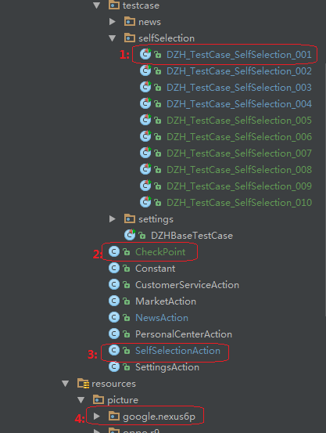

# 2参考用例

public class DZH_TestCase_SelfSelection_010 extends DZHBaseTestCase {  
 private SelfSelectionAction selfSelectionAction;  
 @BeforeMethod  
 public void setUp() {  
 super.setUp();  
 selfSelectionAction = new SelfSelectionAction("master");  
 selfSelectionAction.skipAdv();  
 selfSelectionAction.enterIntoEditSelectionViewOnSelfSelectionView();  
 selfSelectionAction.deleteAllSelfSelectionOrLatestBrowseOnEditSelectionView(true);  
 selfSelectionAction.back();  
 selfSelectionAction.enterIntoEditSelectionViewOnSelfSelectionView();  
 selfSelectionAction.editLatestBrowseOnEditSelectionView();  
 selfSelectionAction.deleteAllSelfSelectionOrLatestBrowseOnEditSelectionView(true);  
 selfSelectionAction.back();  
 }  
 @Test(description = "自选股页面删除自选股")  
 public void testStep() {  
 super.testStep();  
 LogUtil.*getLogger*().info("1：进入自选股页面");  
 LogUtil.*getLogger*().info("2：点击搜索图标");  
 selfSelectionAction.enterIntoSearchStockViewOnSelfSelectionView();  
 LogUtil.*getLogger*().info("3：股票代码输入框输入555");  
 selfSelectionAction.typeTextOnSearchStockView("555");  
 LogUtil.*getLogger*().info("4：依次按顺序添加5个自选股");  
 List<String> stocks = selfSelectionAction.addStocksOnSearchStockView(5);  
 LogUtil.*getLogger*().info("5：返回到自选股页面");  
 selfSelectionAction.back();  
 selfSelectionAction.back();  
 selfSelectionAction.selfStockOperatorOnSelectionView(stocks.get(0),  
 SelfSelectionAction.StockOperator.*DEL*);  
 selfSelectionAction.checkNoExistSpecialSelfStockOnEditSelectionViewOrSelectionView(  
 stocks.get(0));  
 }  
 @AfterMethod  
 public void tearDown() {  
 super.tearDown();  
 selfSelectionAction.enterIntoEditSelectionViewOnSelfSelectionView();  
 selfSelectionAction.deleteAllSelfSelectionOrLatestBrowseOnEditSelectionView(true);  
 selfSelectionAction.back();  
 }  
}

# 3 测试用例失败分析

1：打开 dzh\entry\dzhReport\html\index.html测试报告,查看测试用例失败时的截图和堆栈信息

2：打开 dzh\entry\logs\dzhLog.log 日志文件进行日志分析

3：服务端配置日志输出文件后查看服务端日志

4：查看手机端日志进行分析