2. Simulation and Verification Results
The current testbench uses one DUT instance and directed self-checking tests. The following waveform captures are sufficient for a minimum functional verification report. Only the signals listed for each test need to be visible in SimVision.

2.1 Reset and Idle Behavior
Purpose: Confirm reset initializes the controller, interfaces, STDP outputs, and representative neuron states.
Stimulus: Hold RST_N low for several clock cycles, then release reset with no AER request applied.
Expected behavior: The FSM returns to IDLE, AER request/acknowledge outputs are inactive, STDP outputs are zero, and representative V_M entries are at RESET_VALUE.
Signal | Expected behavior | Why it matters
CLK | Free-running clock | Timing reference.
RST_N | Low during reset, then high | Shows reset interval.
state | IDLE after reset | Confirms controller initialization.
AER_IN_ACK | 0 | No input transaction is active.
AER_OUT_REQ | 0 | No output event is active.
STDP_PRE_SPIKE | 16'h0000 | No pre-spike activity.
STDP_POST_SPIKE | 16'h0000 | No post-spike activity.
V_M[0], V_M[31] | RESET_VALUE | Representative hidden/output state reset.

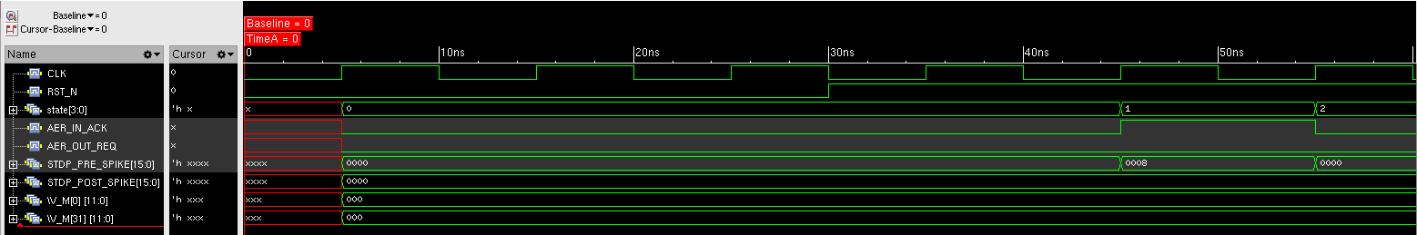

2.2 Hidden-Only Subthreshold Update
Purpose: Verify that one incoming source updates only hidden neuron s when the hidden neuron remains below threshold.
Stimulus: Drive source s=3 with WEIGHT_IN channel 3 set to raw +32 (current Q0.7 convention).
Expected behavior: The input handshake completes, hidden neuron 3 is processed through the shared datapath, V_M[3] becomes raw 64, output neuron 19 remains unchanged, and no AER output is generated.
Signal | Expected behavior | Why it matters
AER_IN_REQ | Input request pulse | Marks the incoming event.
AER_IN_ADDR | 0x13 | Source/channel s=3.
AER_IN_ACK | Pulses high then returns low | Confirms input handshake.
state | IDLE -> WAIT_INPUT_REQ_LOW -> READ_NEURON -> APPLY_LEAK -> ADD_WEIGHT -> THRESHOLD_CHECK -> WRITE_NEURON -> IDLE | Shows normal non-spiking path.
neuron_id | 3 / 0_0011 | Confirms hidden neuron selection.
captured_weight | +32 | Confirms channel weight was latched.
V_M[3] | 0 -> 64 | Confirms hidden-state update.
V_M[19] | Remains 0 | Output layer is not touched.
AER_OUT_REQ | Remains 0 | No external spike below threshold.

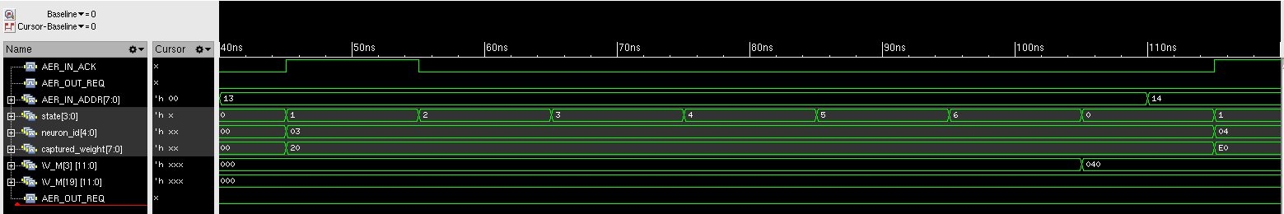

2.3 Hidden Spike Triggers Output Pass
Purpose: Demonstrate the time-multiplexed two-pass behavior when a hidden neuron fires.
Stimulus: Apply repeated +0.25-equivalent events to source 5 until hidden neuron 5 reaches threshold.
Expected behavior: Hidden neuron 5 resets after firing, then the same datapath is reused for output neuron 21 with the same captured weight. The output neuron receives one update but remains subthreshold.
Signal | Expected behavior | Why it matters
state | Hidden READ/LEAK/ADD/CHECK/WRITE followed by a second READ/LEAK/ADD/CHECK/WRITE | Shows one shared datapath reused twice.
neuron_id | 5 then 21 | Shows hidden-to-output layer selection.
captured_weight | Constant during both passes | Same weight is reused.
saved_spike | 1 after hidden threshold crossing | Triggers the output pass.
V_M[5] | Threshold crossing -> RESET_VALUE | Confirms hidden spike/reset.
V_M[21] | 0 -> 64 | Confirms output neuron update.
AER_OUT_REQ | Remains 0 | Hidden spike alone is internal.

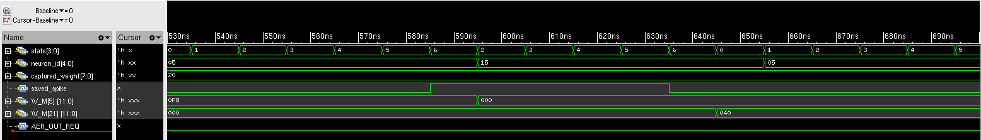

2.4 Output Spike, STDP Post Pulse, and AER Emission
Purpose: Verify the full event path when both the hidden and output neurons fire.
Stimulus: Continue source-5 traffic until output neuron 21 reaches threshold on its sixth output-layer update.
Expected behavior: Output neuron 21 resets, STDP_POST_SPIKE[5] pulses for one clock, AER_OUT_REQ asserts, and AER_OUT_ADDR is 0x25. The request clears after AER_OUT_ACK.
Signal | Expected behavior | Why it matters
state | WRITE_NEURON -> SEND_SPIKE -> WAIT_OUTPUT_ACK_LOW -> IDLE | Shows output transaction control.
V_M[21] | 248 -> 0 | Confirms output threshold crossing and reset.
STDP_POST_SPIKE | Bit 5 pulses for one CLK | Confirms post-synaptic activity indication.
AER_OUT_REQ | 0 -> 1 -> 0 | Shows outgoing AER request.
AER_OUT_ADDR | 0x25 | Confirms Team-2 tile ID and source/channel encoding.
AER_OUT_ACK | Asserts after REQ | Completes outgoing handshake.

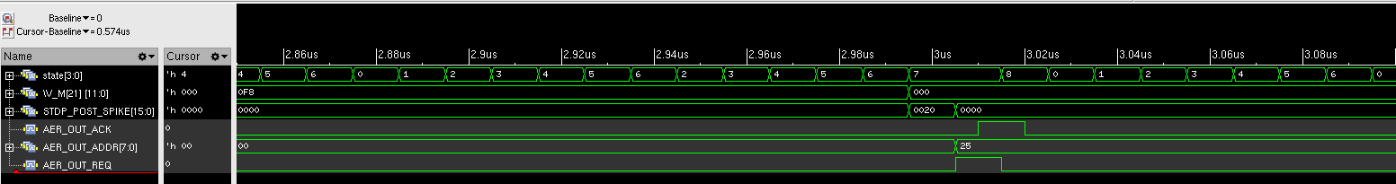

2.5 Captured Weight Stability
Purpose: Verify that a weight is latched at event acceptance and remains constant for both hidden and output passes.
Stimulus: Accept a source-6 event with WEIGHT_IN[6]=+32, then change the live Team-3 weight bus to -64 before processing finishes.
Expected behavior: captured_weight remains +32 throughout the event. Hidden neuron 6 fires using the captured positive weight and output neuron 22 receives the same +32 weight.
Signal | Expected behavior | Why it matters
WEIGHT_IN | Changes from +32 to -64 on channel 6 | Shows live input bus changes mid-event.
captured_weight | Remains +32 | Proves event-local weight capture.
neuron_id | 6 then 22 | Shows both passes use the captured value.
V_M[6] | Fires and resets | Hidden pass uses captured weight.
V_M[22] | 0 -> 64 | Output pass reuses same captured weight.

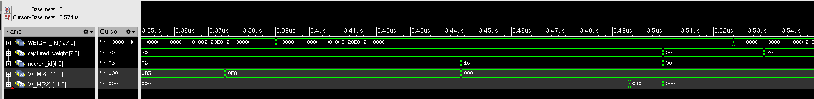

2.6 Periodic Background Leak Sweep
Purpose: Verify the periodic leak scheduler decays stored membrane states without producing AER or STDP activity.
Stimulus: Prepare V_M[0] and V_M[31] to raw 64, then leave the tile idle until one background sweep occurs.
Expected behavior: With beta=0.875, both representative states decay from raw 64 to raw 56. The sweep progresses through the leak states while AER_OUT_REQ and both STDP vectors remain inactive.
Signal | Expected behavior | Why it matters
state | LEAK_READ -> LEAK_APPLY -> LEAK_WRITE | Shows background-leak FSM path.
leak_index | Advances through neuron indices | Shows the sweep traverses the state array.
V_M[0] | 64 -> 56 | Confirms hidden-neuron decay.
V_M[31] | 64 -> 56 | Confirms output-neuron decay.
AER_OUT_REQ | 0 | Background leak must not emit AER.
STDP_PRE_SPIKE | 16'h0000 | Background leak is not pre-synaptic activity.
STDP_POST_SPIKE | 16'h0000 | Background leak is not post-synaptic activity.

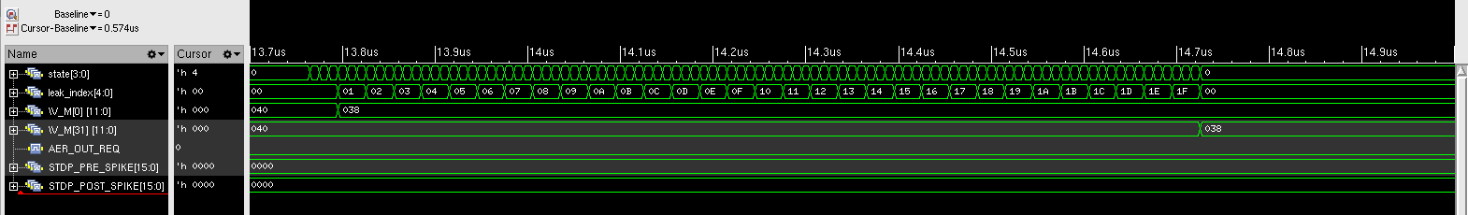

2.7 Foreground Event Preempts and Resumes Background Sweep
Purpose: Verify that foreground AER traffic is not lost while a background sweep is using the shared datapath.
Stimulus: Allow the periodic sweep to begin, then assert and hold an event for source 10 until the DUT acknowledges it.
Expected behavior: The sweep yields after a safe background write, the foreground event is accepted and processed, and the sweep later resumes without restarting from neuron 0.
Signal | Expected behavior | Why it matters
state | Leak states -> event-processing states -> leak states | Shows arbitration between background and foreground work.
leak_index | Pauses and later resumes | Confirms sweep progress is preserved.
AER_IN_REQ | Held high while sweep is active | Models foreground arrival during maintenance.
AER_IN_ACK | Eventually asserts | Proves request is not lost.
neuron_id | 10 during foreground update | Confirms correct event target.
V_M[0] | Remains 56 after resumption | Shows sweep did not restart and decay neuron 0 twice.

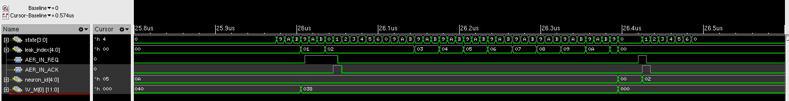

2.8 Reset Cancels Pending Background Leak State
Purpose: Verify reset clears neuron state and prevents stale periodic-leak work from writing after reset.
Stimulus: Prepare a nonzero neuron, wait until a leak request is near, assert reset, then release reset and wait less than one fresh sweep period.
Expected behavior: All neuron states return to RESET_VALUE and remain there. No AER or STDP activity occurs from stale pre-reset leak state.
Signal | Expected behavior | Why it matters
RST_N | Asserted low then released | Marks reset during leak scheduling.
state | Returns to IDLE | Confirms controller restart.
V_M[2] | 64 -> 0 and remains 0 | Confirms stale background write is canceled.
AER_OUT_REQ | 0 | No spurious event after reset.
STDP_PRE_SPIKE | 0 | No stale pre-spike activity.
STDP_POST_SPIKE | 0 | No stale post-spike activity.

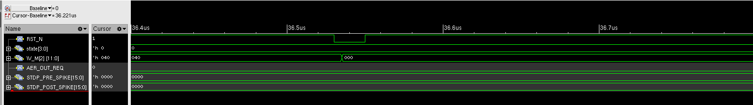

2.9 Verification Summary
Verification point | Expected result | Status
Reset / idle | Known idle state and reset membrane values | PASS
Hidden subthreshold update | Only hidden s updates; no output event | PASS
Hidden spike / output pass | Same datapath and weight reused for output 16+s | PASS
Output spike / AER | POST pulse and correct {0010,s} AER output | PASS
Captured weight | Mid-event WEIGHT_IN changes do not affect active event | PASS
Periodic leak | Representative hidden/output states decay by beta only | PASS
Sweep preemption | Foreground event accepted; sweep resumes correctly | PASS
Reset during leak | No stale background write after reset | PASS

