Team 2 Digital SNN Tile
Microarchitecture Specification
32-neuron (16 hidden + 16 output) time-multiplexed LIF tile

1. Purpose and Scope
This document defines the Team 2 digital SNN tile microarchitecture. It records the architectural choices used by the current RTL implementation, including neuron mapping, the time-multiplexed datapath, LIF arithmetic, weight handling, AER handshakes, STDP pulse generation, scan behavior, and reset behavior.

2. External Interface
Port | Dir. | Width | Meaning / Design Use
CLK | In | 1 | 2 MHz system clock for normal operation.
RST_N | In | 1 | Synchronous active-low reset.
SE | In | 1 | Scan enable; normal neuron/AER processing is paused while asserted.
SI | In | 1 | Serial scan input.
SO | Out | 1 | Serial scan output from V_M[31][11].
AER_IN_REQ | In | 1 | Input AER request.
AER_IN_ADDR | In | 8 | [7:4] sender tile ID; [3:0] source/channel s.
AER_OUT_ACK | In | 1 | Acknowledgement for Team 2 output event.
WEIGHT_IN | In | 128 | 16 signed 8-bit weights; channel n is [8*n +: 8].
AER_IN_ACK | Out | 1 | Input AER acknowledge/backpressure.
AER_OUT_REQ | Out | 1 | Output AER request.
AER_OUT_ADDR | Out | 8 | {4'b0010, s} when output neuron 16+s fires.
STDP_PRE_SPIKE | Out | 16 | One-CLK pulse on bit s when hidden neuron s is updated by an accepted input event.
STDP_POST_SPIKE | Out | 16 | One-CLK pulse on bit s when output neuron 16+s fires.

3. Logical Neuron Organization
The tile stores 32 logical neurons but implements only one physical arithmetic datapath. The upper bit of the internal 5-bit neuron index selects the layer; the lower four bits select channel s.
neuron_id[4:0]
0_ssss -> hidden neuron s (indices 0..15)
1_ssss -> output neuron 16+s (indices 16..31)
Logical range | Layer | Driven by | Can emit
0-15 | Hidden | External AER source s | Internal spike only
16-31 | Output | Hidden spike from channel s | External AER event

4. Per-Event Processing Sequence
- Capture AER source/channel s = AER_IN_ADDR[3:0] and latch WEIGHT_IN[8*s +: 8] according to s.
- Pulse STDP_PRE_SPIKE[s] for one CLK cycle when the input event is accepted.
- Select hidden neuron s (internal index {1'b0, s}) and execute one complete LIF update.
- If the hidden neuron does not fire the block returns to IDLE.
- If the hidden neuron fires, select output neuron 16+s (internal index {1'b1, s}) and execute the same LIF datapath again using the same weight.
- If the output neuron does not fire, the block returns to IDLE.
- If the output neuron fires, pulse STDP_POST_SPIKE[s], then transmit AER_OUT_ADDR = {4'b0010, s} and hold the request/address until acknowledged.

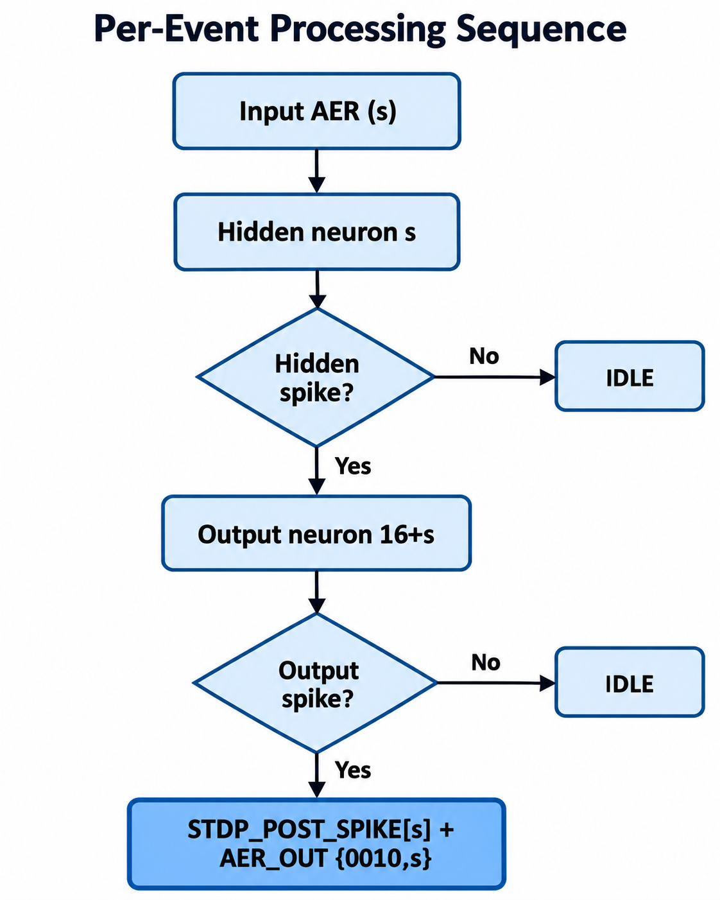

5. Weight Handling
Team 2 selects the channel weight and latches it from team 3 input WEIGHT_IN:
captured_weight <= $signed(WEIGHT_IN[(s * 8) +: 8]);
The captured value is used for the entire event. Therefore, changes on WEIGHT_IN while a hidden/output pass is in flight do not alter that event. The same captured weight is applied to both the input-to-hidden update and, if the hidden neuron fires, the hidden-to-output update as well.
Current numerical convention: the signed 8-bit weight is interpreted by the RTL as Q0.7 and converted to Q4.8 by a one-bit left shift.

6. LIF Model and Fixed-Point Arithmetic
The implemented LIF update is the discrete RC-style model below. It uses multiplicative membrane decay and then applies the captured synaptic weight:
V_leak = V_RESET + beta * (V_old - V_RESET)
V_candidate = V_leak + W_scaled
if V_candidate >= V_THRESHOLD:
spike = 1
V_next = V_RESET
else:
spike = 0
V_next = saturate_Q4.8(V_candidate)
Quantity | Format | Default / Rule
V_M / V_old / V_next | signed 12-bit Q4.8 | Stored per logical neuron.
beta | unsigned Q0.8 | 0.875 = 224/256 = 8'hE0.
V_THRESHOLD | signed Q4.8 | 1.0 = 12'sd256.
V_RESET | signed Q4.8 | 0.0 = 12'sd0.
W | signed 8-bit | Current RTL convention: Q0.7.
W_scaled | signed Q4.8-compatible | Sign-extend and shift left by 1.

The beta multiply retains a wide product before shifting right by eight fractional bits. Threshold comparison is performed on the wide candidate value before storage saturation. On a threshold crossing the neuron performs a hard reset to V_RESET.
For the chosen default V_RESET = 0, the equation simplifies numerically to V_candidate = beta*V_old + W_scaled.

7. Leak Policy
The selected policy is a periodic background leak sweep. A sweep request is generated every LEAK_SWEEP_PERIOD_CYCLES normal-mode system clocks. The current default is 200 cycles, corresponding to 100 microseconds at the nominal 2 MHz CLK. When foreground processing permits, leak_index walks from 0 through 31 and each membrane state receives one decay-only update using the existing beta multiplier: V <- V_RESET + beta*(V - V_RESET).
Foreground AER traffic has priority. If an event arrives during a sweep, the current neuron leak update finishes atomically, the sweep pauses between neurons, the complete foreground event is processed, and the sweep resumes from the saved leak_index. The scheduler keeps at most one pending sweep request. Scan mode pauses the scheduler and sweep progression. Foreground LIF updates still apply their normal beta decay, so a neuron may be decayed by a periodic sweep and again when later targeted by an event.

8. Shared Datapath State Machine
State | Purpose | Primary action / next condition
IDLE | Input acceptance | Latch s and W; select hidden neuron; pulse PRE; assert input ACK.
WAIT_INPUT_REQ_LOW | Finish input four-phase handshake | Wait for AER_IN_REQ=0, lower ACK, begin hidden READ.
READ_NEURON | Read selected logical neuron | current_voltage <- V_M[neuron_id].
APPLY_LEAK | Compute decay product | Form (V_old-V_RESET)*beta.
ADD_WEIGHT | Synaptic integration | Scale product back to Q4.8 and add captured weight.
THRESHOLD_CHECK | Threshold and saturation | Select hard reset on spike, otherwise signed Q4.8 saturation.
WRITE_NEURON | Commit state and route control | Write V_M. Hidden spike -> output pass; output spike -> SEND_SPIKE; otherwise IDLE.
SEND_SPIKE | Output AER request | Drive {0010,s}; hold REQ/address until ACK.
WAIT_OUTPUT_ACK_LOW | Finish output four-phase handshake | Wait for ACK=0, then return IDLE.
LEAK_READ | Background sweep read | Read V_M[leak_index] into current_voltage.
LEAK_APPLY | Background decay multiply | Compute beta*(V-V_RESET) using the shared multiplier.
LEAK_WRITE | Background write-back / arbitration | Write saturated decayed value; advance leak_index; continue or yield to a waiting AER request.

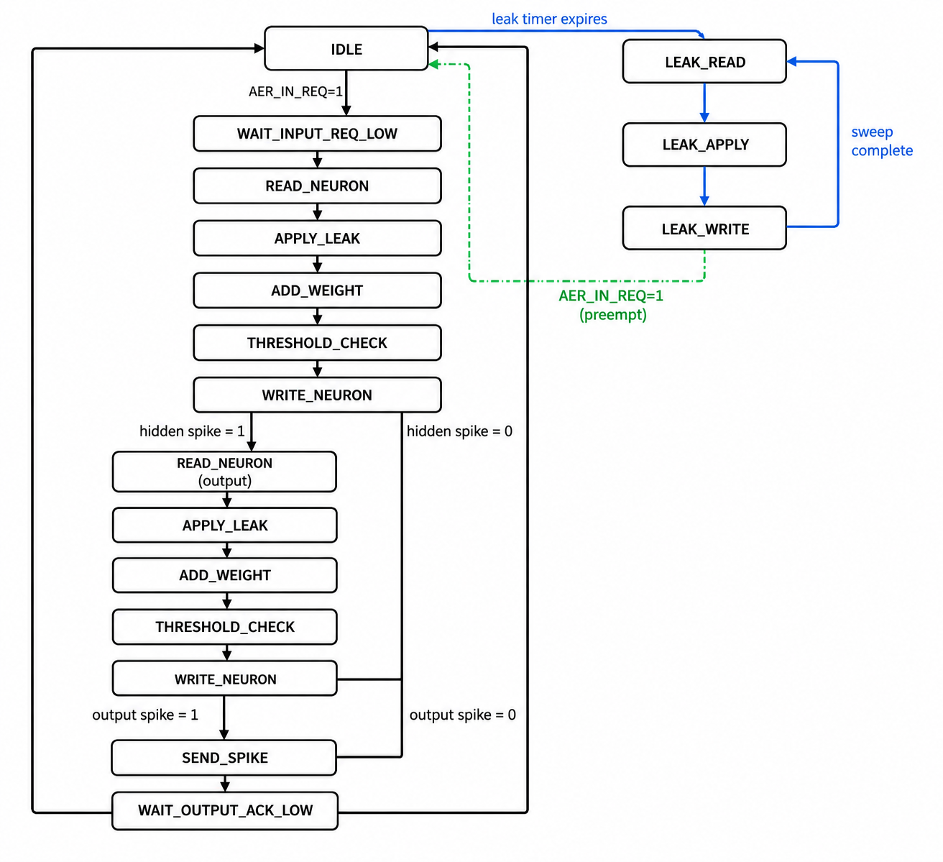

9. Input AER Handshake and Backpressure
The tile processes one input event at a time and contains no queue for additional events. An input event is accepted in IDLE when AER_IN_REQ is high. Team 2 latches the source and weight, asserts AER_IN_ACK, and waits in WAIT_INPUT_REQ_LOW for the sender to deassert AER_IN_REQ. Only then does it lower AER_IN_ACK and begin the LIF update.
The controller does not return to IDLE until all required neuron processing and any output AER transaction have completed. So new input requests are backpressured while the shared datapath or output transaction is busy.

10. Output AER Handshake
Only an output-layer neuron threshold crossing generates an external AER transaction. Hidden-layer spikes remain internal. For output channel s, AER_OUT_ADDR is {4'b0010, s}. AER_OUT_REQ remains asserted with a stable address until AER_OUT_ACK is observed high. The request is then lowered, and the FSM waits for AER_OUT_ACK to return low before accepting another event.

11. STDP Pulse Generation
Signal | Pulse condition | Width
STDP_PRE_SPIKE[s] | Input event on source s is accepted / hidden neuron s is scheduled for update. | Exactly one CLK
STDP_POST_SPIKE[s] | Output neuron 16+s crosses threshold and fires. | Exactly one CLK
Both vectors default to zero every normal clock cycle. The appropriate bit is set only at its defined event point, making the outputs one-cycle pulses synchronous to CLK.

12. Reset Behavior
State/output | Reset value
FSM state | IDLE
All V_M[0:31] | V_RESET (default 0.0 Q4.8)
AER_IN_ACK | 0
AER_OUT_REQ | 0
AER_OUT_ADDR | 0
STDP_PRE_SPIKE | 16'h0000
STDP_POST_SPIKE | 16'h0000
Captured source/weight and pipeline registers | 0 / reset-compatible values

13. Scan Path / SO Behavior
When SE is asserted, normal neuron and AER processing is paused. The 32 membrane registers form one serial scan chain:
SI -> V_M[0] -> V_M[1] -> ... -> V_M[31] -> SO

Each V_M entry is shifted as a 12-bit register. The current scan output is the MSB of the final membrane register:
assign SO = V_M[31][11];

STDP pulse outputs are forced low during scan shifting. The RTL does not advance the normal FSM while SE is asserted.

14. Latency and Throughput Characteristics
After the input request returns low, one foreground neuron pass requires five datapath clock states: READ_NEURON, APPLY_LEAK, ADD_WEIGHT, THRESHOLD_CHECK, and WRITE_NEURON. A hidden-only event therefore performs one pass. A hidden spike performs a second five-state pass for the output neuron. An output spike additionally incurs the downstream AER handshake latency.
A background leak update requires three states per neuron: LEAK_READ, LEAK_APPLY, and LEAK_WRITE. An uninterrupted 32-neuron sweep therefore requires 96 clocks, or 48 us at 2 MHz. Sweep requests are generated every 200 clocks by default (100 us). Foreground AER events can defer or pause a sweep, so actual decay timing may be longer under load. The multi-cycle organization avoids adding another multiplier and limits combinational depth for subthreshold operation.

15. Saturation and Corner Events
- Stored membrane range is signed 12-bit Q4.8 raw [-2048, 2047], corresponding to [-8.0, 7.99609375].
- A threshold crossing takes priority over ordinary storage saturation and performs a hard reset.
- Negative candidate values are allowed and saturate at the signed minimum if they underflow.
- The accepted event's weight is isolated from mid-event WEIGHT_IN changes by captured_weight.
- One input event produces at most one external output AER event.

16. Verification Requirements
- Reset and idle behavior, including periodic sweep triggering and background leak progression.
- Positive and negative weights.
- Q-format arithmetic, beta decay, signed saturation, and threshold boundary behavior.
- Hidden neuron fires while output neuron remains subthreshold.
- Hidden and output neurons both fire in the full two-pass path.
- Two events targeting different channels preserve independent membrane state.
- WEIGHT_IN changes during an in-flight event do not alter the captured weight.
- Input backpressure while processing and while output AER is blocked; foreground AER preemption of a background sweep between neurons.
- Stable AER_OUT_ADDR while AER_OUT_REQ is active.
- Exact one-cycle STDP_PRE_SPIKE and STDP_POST_SPIKE timing.
- Scan-chain continuity and reset initialization of all 32 membrane registers; scan enable pauses the sweep scheduler and sweep state progression.

17. Explicit Design Decisions and Assumptions
Decision | Current choice
Neuron mapping | 16 hidden + 16 output; 0_ssss / 1_ssss
Time multiplexing | One shared datapath; only targeted neuron(s) processed
Weight source | WEIGHT_IN from Team 3
Weight reuse | Same latched W[s] used for hidden and output passes
LIF equation | V_reset + beta*(V_old-V_reset) + W_scaled
Beta | 0.875 Q0.8
Threshold | 1.0 Q4.8
Reset | 0.0 Q4.8 hard reset
Weight binary point | Q0.7 in current RTL
Leak for untouched neurons | No automatic/background leak
STDP PRE semantics | Pulse when input event schedules hidden update
STDP POST semantics | Pulse when output neuron fires
Scan | All 32 V_M registers form SI-to-SO chain
Background sweep period | 200 CLK cycles (100 us at 2 MHz), parameterized

