2. Simulation and Verification Results
Four DUT instances were instantiated with different parameter configs for positive weight behavior, negative weight behavior, maximum signed weight, and minimum signed weight. The testbench verifies both functional datapath behavior and AER handshake behavior.

DUT Configurations
DUT | Weight | Threshold | Reset | Primary purpose
dut_pos | +1 | 500 | 0 | Normal positive update, threshold crossing, spike generation
dut_neg | -1 | 500 | 0 | Signed negative arithmetic
dut_max | +127 | 2047 | -123 | Maximum signed weight/upper bound spike case
dut_min | -128 | 2047 | 0 | Minimum signed weight/negative saturation

2.1 Reset and Idle Behavior
Purpose: Reset must place the block in a deterministic idle condition before any AER transaction begins.
Stimulus: Assert RST_N low, then release reset without applying an input event.
Expected behavior: The FSM is in IDLE, AER_IN_ACK and AER_OUT_REQ are low, representative neuron states are zero, and no unintended transaction begins.
Important Signals:
Signal | Expected behavior | Why it matters
CLK | Free running clock | Provides timing reference for reset release and FSM behavior.
RST_N | Low during reset, then rises | Shows when reset is applied and released.
state | IDLE after reset | Confirms controller returns to the idle state.
AER_IN_ACK | 0 | No input transaction should be acknowledged.
AER_OUT_REQ | 0 | No output spike should be requested.
V_M[0] | 0 | Representative neuron state is cleared.
V_M[1] | 0 | Second representative neuron state is also cleared.

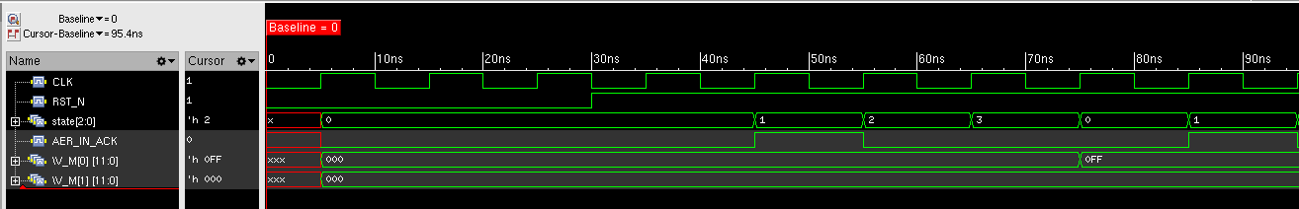

2.2 Normal Positive Weight Neuron Update
Purpose: A normal AER event must be accepted, processed through the shared datapath, written back to the selected neuron, and completed without generating a spike when the threshold is not reached.
Stimulus: Send a positive weight event to a neuron initially at 0 using dut_pos.
Expected behaviour: The input is acknowledged, the selected neuron is processed, candidate/next voltage evaluate to +255, V_M updates from 0 to 255, and AER_OUT_REQ remains low because 255 < 500.
Important Signals:
Signal | Expected behavior | Why it matters
AER_IN_REQ | Pulses high for the input request | Marks the incoming AER transaction.
AER_IN_ADDR | Shows the selected neuron address | Confirms which neuron is targeted.
AER_IN_ACK | Pulses high after acceptance | Confirms the request was accepted.
state | 0 -> 1 -> 2 -> 3 -> 0 | Shows the normal non spiking FSM path.
neuron_id | Matches the requested neuron | Confirms correct temporary address to neuron selection.
candidate_voltage | +255 | Shows the combinational datapath result.
next_voltage | +255 | Shows the value chosen for write back.
saved_next_voltage | +255 | Shows the transaction result captured by the FSM.
V_M[0] | 0 -> 255 | Confirms state write back.
AER_OUT_REQ | Remains 0 | No spike should be generated below threshold.

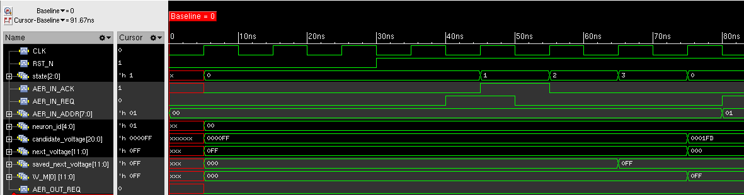

2.3 All 32 Neurons Are Updateable
Purpose: Every entry in the 32 neuron state array must be individually selectable and writable under the current temporary neuron selection convention.
Stimulus: Sequentially apply requests with AER_IN_ADDR values 0x00 through 0x1F.
Expected behaviour: Each address is acknowledged and the corresponding V_M entry is updated. Representative first, middle, and last neurons should visibly change from 0 to 255.
Important Signals:
Signal | Expected behavior | Why it matters
AER_IN_REQ | Repeated request pulses | Shows a sequence of independent transactions.
AER_IN_ADDR | 00 -> 01 -> ... -> 1F | Shows all 32 address values are exercised.
AER_IN_ACK | One ACK per accepted transaction | Confirms each request is accepted.
neuron_id | Tracks addresses 0-31 | Confirms temporary selection logic reaches every neuron.
V_M[0] | 0 -> 255 | Representative first neuron.
V_M[15] | 0 -> 255 | Representative middle neuron.
V_M[31] | 0 -> 255 | Representative final neuron.

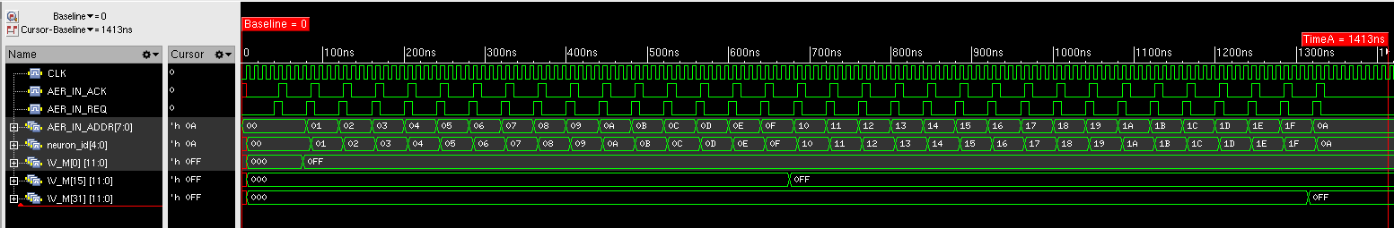

2.4 Independent State Between Different Neurons
Purpose: Updating one neuron must not corrupt the stored membrane voltage of another neuron.
Stimulus: Start neurons 10 and 11 at 255, then issue another event only to neuron 10.
Expected behaviour: Neuron 10 crosses threshold and resets to 0 while neuron 11 remains at 255.
Important Signals:
Signal | Expected behavior | Why it matters
AER_IN_ADDR | 0x0A | Targets neuron 10.
AER_IN_REQ | Pulses high | Starts the second update.
AER_IN_ACK | Pulses high | Confirms the event is accepted.
state | Processes neuron 10 through the FSM | Shows control sequencing.
neuron_id | 10 | Confirms the intended neuron is active.
V_M[10] | 255 -> 0 | Target neuron is updated/reset after spike.
V_M[11] | Remains 255 | Non-target neuron is preserved.
saved_spike | Becomes 1 | Confirms the neuron 10 transaction crossed threshold.
AER_OUT_REQ | Asserts | Spike generated for neuron 10.

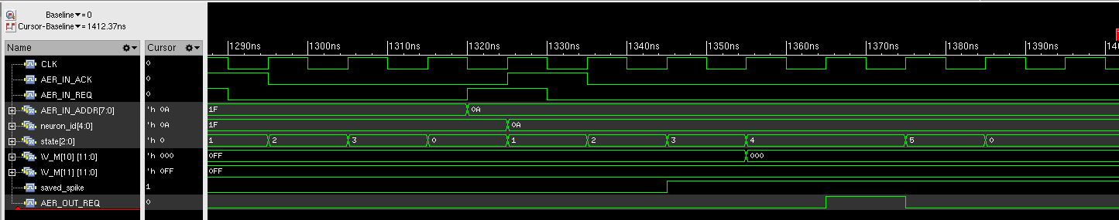

2.5 Threshold Detection and Post Spike Reset
Purpose: The LIF datapath must detect when the updated membrane voltage reaches or exceeds threshold and replace the candidate value with RESET_VALUE.
Stimulus: Apply a second positive event to a neuron already at 255 using threshold 500 and reset 0.
Expected behaviour: The candidate is approximately 509, spike_detected asserts, saved_spike captures 1, saved_next_voltage becomes 0, and V_M is written with 0.
Important Signals:
Signal | Expected behavior | Why it matters
candidate_voltage | Approximately 509 | Shows the pre threshold arithmetic result.
spike_detected | 1 while candidate >= threshold | Live combinational threshold comparison.
saved_spike | 1 | Latched spike decision for the transaction.
saved_next_voltage | 0 | Latched reset value to be written.
V_M[10] | 255 -> 0 | Confirms post spike reset is committed.

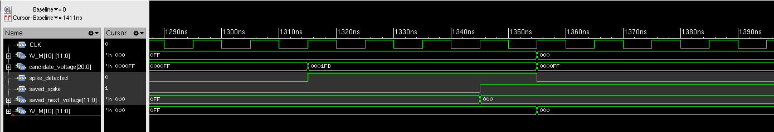

2.6 Outgoing Spike and AER Address Generation
Purpose: A threshold crossing must produce an outgoing AER request with the expected Team-2 address encoding.
Stimulus: Use the neuron #10 threshold crossing from the previous test.
Expected behaviour: AER_OUT_REQ asserts and AER_OUT_ADDR becomes 0x2A: upper nibble 0x2 for Team 2 and lower nibble 0xA for the source neuron under the current interface convention.
Important Signals:
Signal | Expected behavior | Why it matters
saved_spike | 1 | Indicates that the transaction generated a spike.
AER_OUT_REQ | 0 -> 1 | Starts the outgoing AER transaction.
AER_OUT_ADDR | 0x2A | Confirms expected tile/source encoding.
AER_OUT_ACK | Eventually asserts | Shows the downstream receiver acknowledges the event.

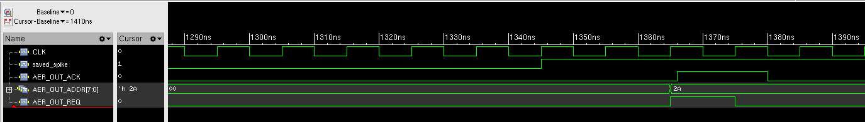

2.7 Negative Weight Arithmetic
Purpose: The signed datapath must correctly handle a negative synaptic weight and update neuron state in the negative direction without falsely generating a spike.
Stimulus: Use dut_neg with W = -1 and send events to neurons 5 and 6.
Expected behaviour: Each selected neuron changes from 0 to -255 and AER_OUT_REQ remains low.
Important Signals:
Signal | Expected behavior | Why it matters
AER_IN_REQ | Request pulse for each neuron | Starts each negative weight transaction.
AER_IN_ADDR | 0x05 then 0x06 | Selects neurons 5 and 6.
AER_IN_ACK | ACK for each request | Confirms each transaction is accepted.
state | Normal non-spiking path | Shows controller sequencing.
neuron_id | 5 then 6 | Confirms target selection.
candidate_voltage | -255 | Shows signed negative arithmetic.
next_voltage | -255 | Shows selected write back value.
saved_next_voltage | -255 | Latched transaction result.
V_M[5] | 0 -> -255 | First negative update.
V_M[6] | 0 -> -255 | Second independent negative update.
AER_OUT_REQ | Remains 0 | Negative update must not cause a positive threshold spike.

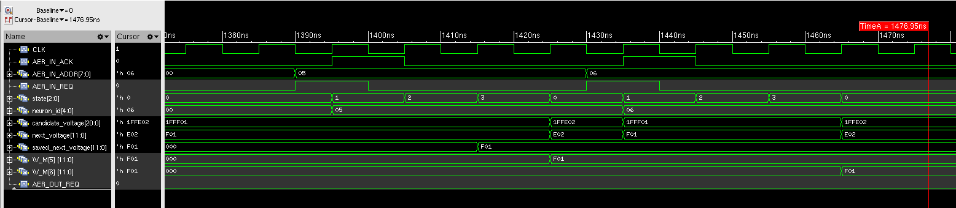

2.8 Input Rejection While Datapath Is Busy
Purpose: Because the tile uses one shared arithmetic datapath, a second input event must not be accepted while another neuron update is still in progress.
Stimulus: Begin processing neuron 20, then assert another request targeting neuron 21 before the first transaction finishes.
Expected behaviour: The second request receives no acknowledgement and V_M[21] remains unchanged while neuron 20 completes.
Important Signals:
Signal | Expected behavior | Why it matters
AER_IN_REQ | Shows the attempted second request | Indicates new traffic arrives while busy.
AER_IN_ADDR | Changes to neuron 21 | Identifies the rejected second target.
AER_IN_ACK | Remains low for the second request | Proves it is not accepted.
state | Non idle while second request is present | Shows the datapath/controller is busy.
neuron_id | Remains associated with active transaction | Shows the current event is preserved.
V_M[20] | Completes its active update | Confirms the original transaction finishes.
V_M[21] | Unchanged | Confirms the rejected request causes no state write.

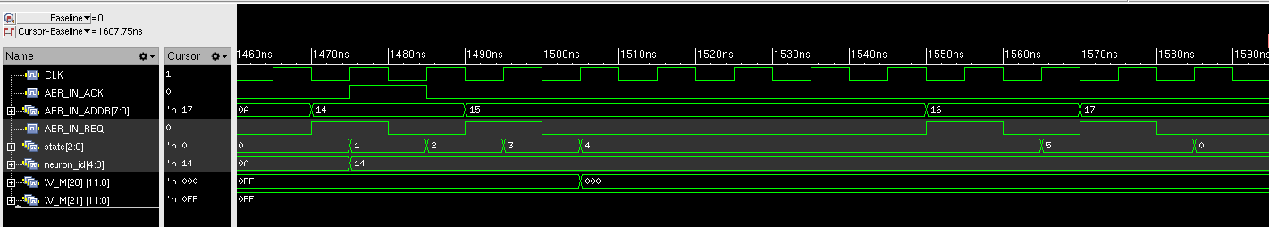

2.9 Output Backpressure
Purpose: The block must preserve an outgoing spike when the downstream receiver is not ready.
Stimulus: Generate a spike and hold AER_OUT_ACK low for several cycles.
Expected behaviour: AER_OUT_REQ remains asserted and AER_OUT_ADDR remains unchanged until ACK is received.
Important Signals:
Signal | Expected behavior | Why it matters
AER_OUT_REQ | Stays high while ACK=0 | Preserves the pending outgoing event.
AER_OUT_ADDR | Stable at the spike address | Prevents address corruption under backpressure.
AER_OUT_ACK | Held low, then rises | Models downstream backpressure and eventual acceptance.
state | Remains in output wait state | Shows controller does not complete the transaction prematurely.

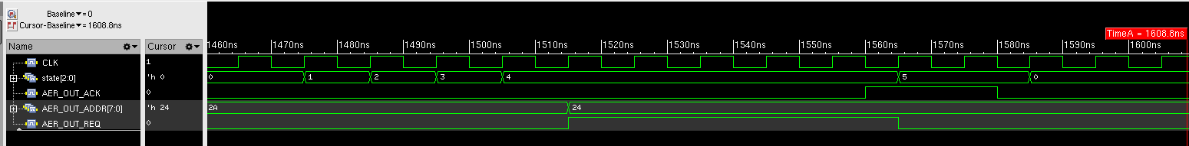

2.10 Reject New Input While Output Is Blocked
Purpose: A new neuron update must not begin while an outgoing spike transaction is still pending.
Stimulus: While AER_OUT_REQ is high and AER_OUT_ACK is low, apply a new input event for neuron 22.
Expected behaviour: AER_IN_ACK remains low and V_M[22] does not change until the output transaction completes.
Important Signals:
Signal | Expected behavior | Why it matters
AER_IN_REQ | Asserts during blocked output | Creates the attempted new input transaction.
AER_IN_ADDR | Targets neuron 22 | Identifies the rejected target.
AER_IN_ACK | Remains 0 | Confirms new input is not accepted.
V_M[22] | Unchanged | Confirms no hidden state update occurs.
AER_OUT_REQ | Remains 1 | Shows the previous output event is still active.
AER_OUT_ACK | Remains 0 during rejection | Confirms output is still blocked.
state | Remains in output transaction state | Shows controller cannot return to input processing yet.

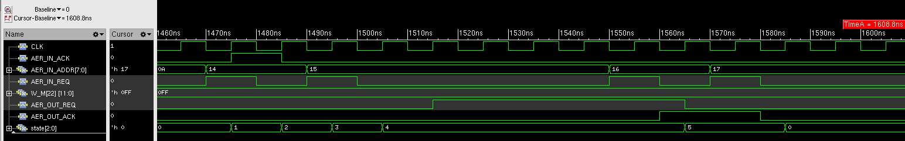

2.11 Correct Completion of the Output Handshake
Purpose: The outgoing AER request/acknowledge sequence must complete in the expected four phase order and return the controller to IDLE.
Stimulus: Allow AER_OUT_ACK to assert after a pending AER_OUT_REQ, then release ACK.
Expected behaviour: The sequence is REQ up, ACK up, REQ down, ACK down, followed by state returning to IDLE.
Important Signals:
Signal | Expected behavior | Why it matters
AER_OUT_REQ | Rises first, then falls after ACK | Sender side of the handshake.
AER_OUT_ACK | Rises after REQ, then falls after REQ | Receiver side of the handshake.
state | SEND_SPIKE -> WAIT_OUTPUT_ACK_LOW -> IDLE | Confirms correct control sequencing and recovery.

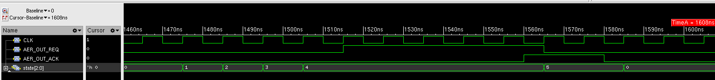

2.12 Maximum Signed Weight
Purpose: The datapath must correctly handle the maximum legal signed 8 bit weight and produce the expected threshold crossing/spike behavior.
Stimulus: Use dut_max with W = +127, THRESHOLD = 2047, RESET = -123 and target neuron 9.
Expected behaviour: The candidate voltage exceeds threshold, the transaction records a spike, V_M[9] is written with -123, and an output event with address 0x29 is generated.
Important Signals:
Signal | Expected behavior | Why it matters
W | +127 | Confirms maximum signed positive weight configuration.
THRESHOLD_V | 2047 | Shows upper configured threshold.
RESET_V | -123 | Shows configured post spike reset value.
AER_IN_ADDR | 0x09 | Targets neuron 9.
state | Spiking FSM path | Shows control transitions through output generation.
neuron_id | 9 | Confirms target selection.
candidate_voltage | Large positive value > 2047 | Shows upper bound arithmetic case.
spike_detected | 1 | Live threshold result.
saved_spike | 1 | Latched transaction spike decision.
saved_next_voltage | -123 | Latched reset value.
V_M[9] | 0 -> -123 | Confirms post spike write back.
AER_OUT_REQ | Asserts | Outgoing event generated.
AER_OUT_ADDR | 0x29 | Expected Team2/source address.

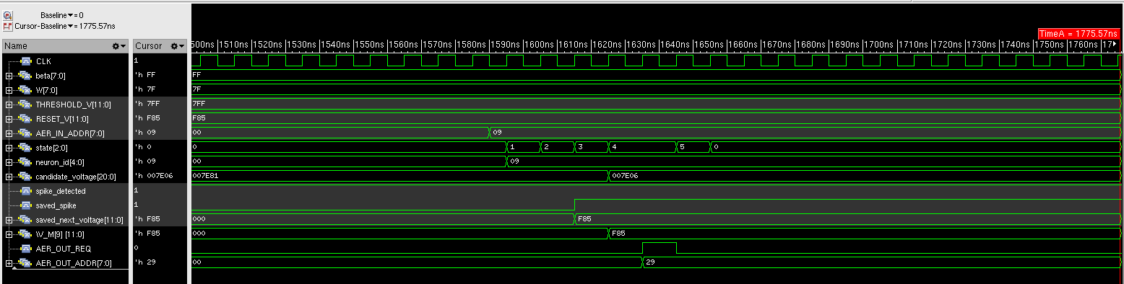

2.13 Minimum Signed Weight and Negative Saturation
Purpose: The datapath must correctly handle the minimum legal signed 8 bit weight and clamp an out of range negative result instead of wrapping around.
Stimulus: Use dut_min with W = -128 and target neuron 12. Apply the minimum weight update twice.
Expected behaviour: The raw candidate falls below -2048, next_voltage and saved_next_voltage clamp to -2048, V_M[12] becomes -2048, and a second update leaves it at -2048 with no spike.
Important Signals:
Signal | Expected behavior | Why it matters
W | -128 | Confirms minimum signed 8 bit weight configuration.
state | Normal non-spiking update path | Shows control flow.
neuron_id | 12 | Confirms target selection.
candidate_voltage | Below -2048 | Shows out of range negative arithmetic result.
next_voltage | -2048 | Shows lower saturation/clamp decision.
saved_next_voltage | -2048 | Latched saturated write back value.
V_M[12] | 0 -> -2048, then remains -2048 | Proves saturation without wraparound.
AER_OUT_REQ | Remains 0 | Negative saturation must not generate a positive threshold spike.

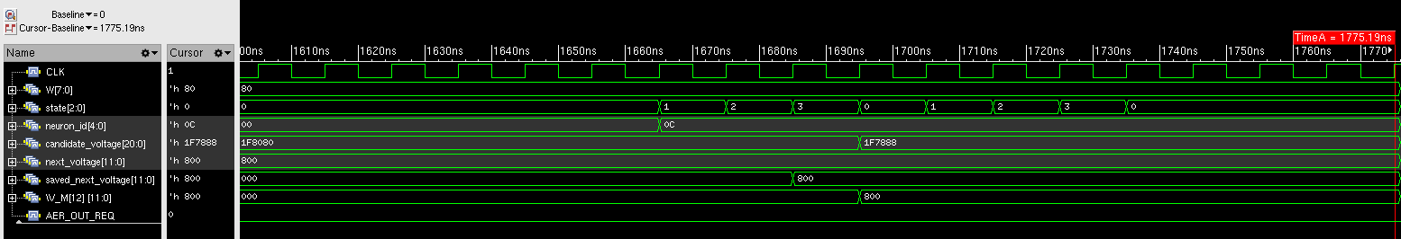

Verification Summary
Verification point | Expected result | Status
Reset / idle | Known state after reset | PASS
Normal positive update | 0 -> 255, no spike | PASS
All 32 neurons | Every neuron entry updateable | PASS
Independent state | Non-target neuron unchanged | PASS
Threshold / reset | Threshold crossing causes reset | PASS
Outgoing spike | REQ/address generated correctly | PASS
Negative weight | 0 -> -255, no spike | PASS
Busy input rejection | Second request not accepted | PASS
Output backpressure | REQ/address held stable | PASS
Input blocked by output | New request rejected | PASS
Handshake completion | REQ/ACK sequence returns to IDLE | PASS
Maximum weight | +127 threshold/spike/reset case | PASS
Minimum weight | -128 saturates at -2048 | PASS

Testbench summary: (xrun.log uploaded to repo)
============================================================
TESTS RUN : 344
TESTS FAILED : 0
RESULT : PASS
============================================================

