**DOKUMENTASI UJI KOMPETENSI KEAHLIAN UKK**



Nama : Lusiawati

Kelas : XII PPLG

Nisn : 2210913

DOKUMENTASI UKK

1. **Program yang di install**

* XAMPP
* Visual Studio Code
* Chrome
* File Manager

1. **Spesifikasi Laptop**

* Device name DESKTOP-O54E22Q
* Processor Intel(R) Core(TM) i5-8250U CPU @ 1.60GHz 1.80 GHz
* Installed RAM 8.00 GB (7.86 GB usable)
* Device ID 2BFDA054-7479-4344-8900-B1386EE5D502
* Product ID 00326-10000-00000-AA384
* System type 64-bit operating system, x64-based processor
* Pen and touch No pen or touch input is available for this display
* Edition Windows 11 Home
* Version 24H2
* Installed on ‎12/‎28/‎2024
* OS build 26100.3037
* Experience Windows Feature Experience Pack 1000.26100.48.0

1. **Desain Interface**

* **Login**

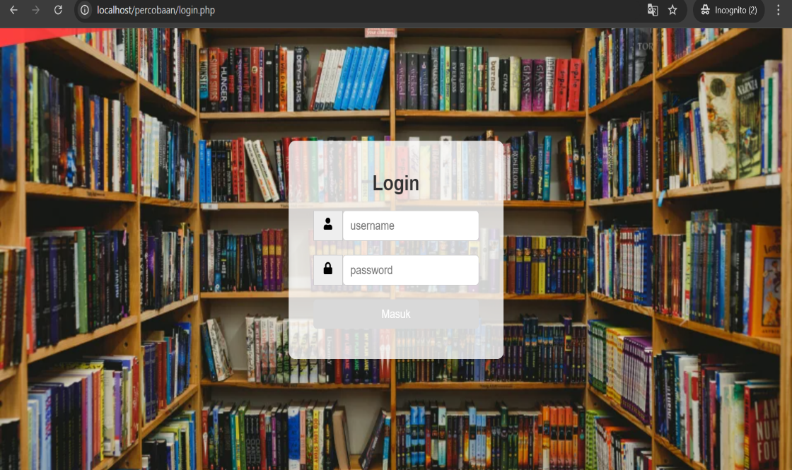

* **Dashboard**

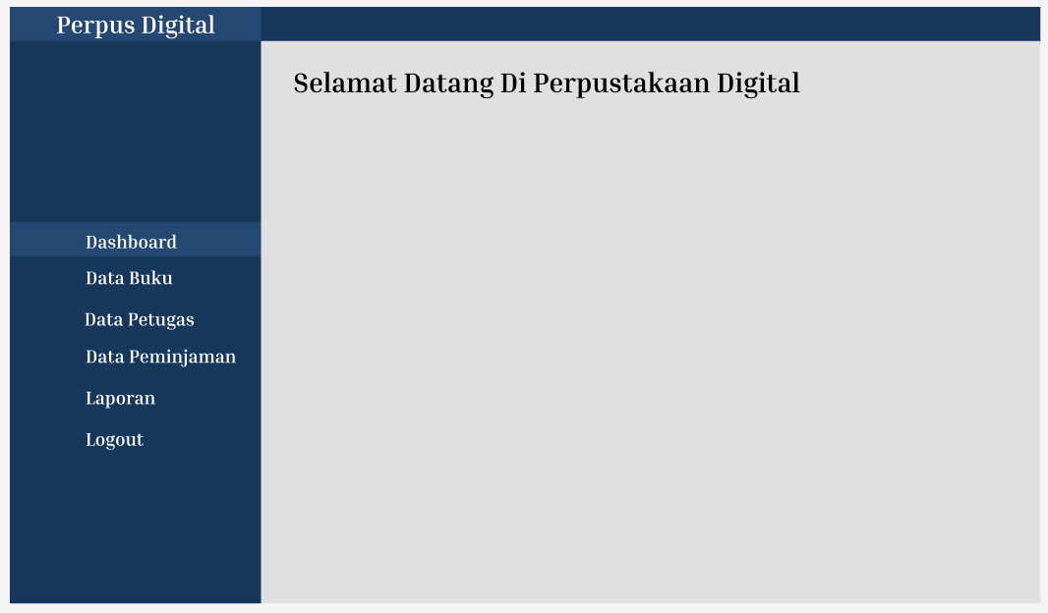

* **Data Buku**

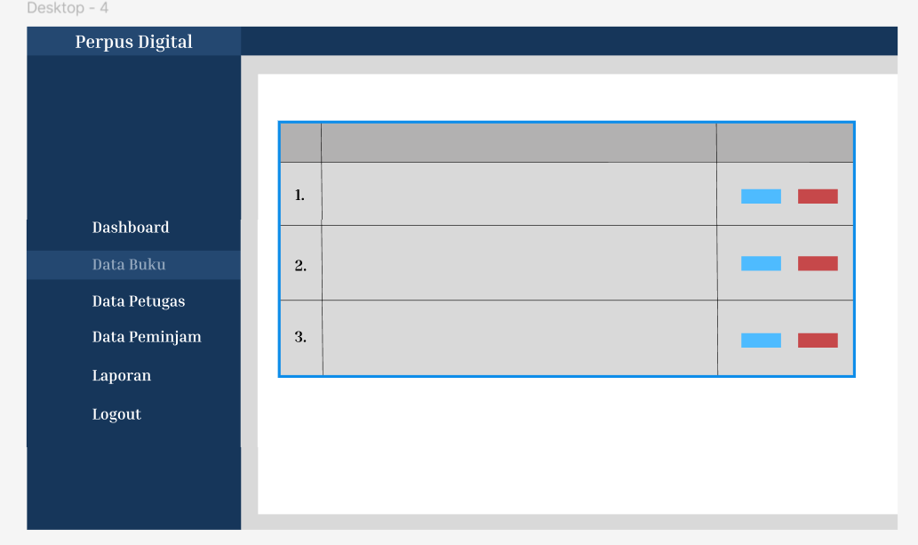

* **Data Petugas**

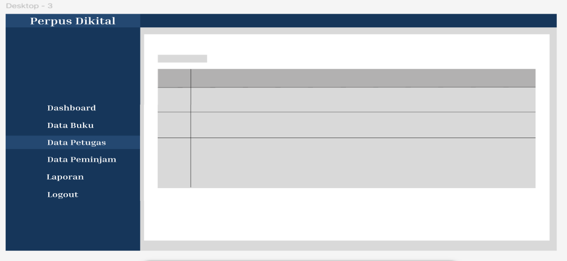

* **Data Peminjaman**

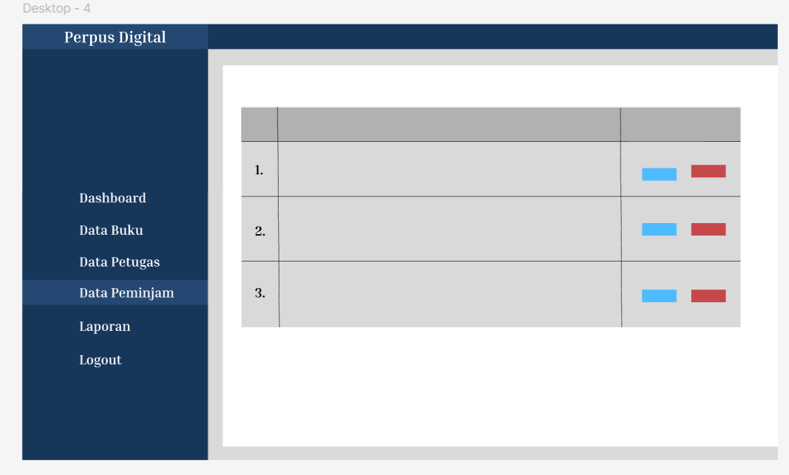

* **Laporan**

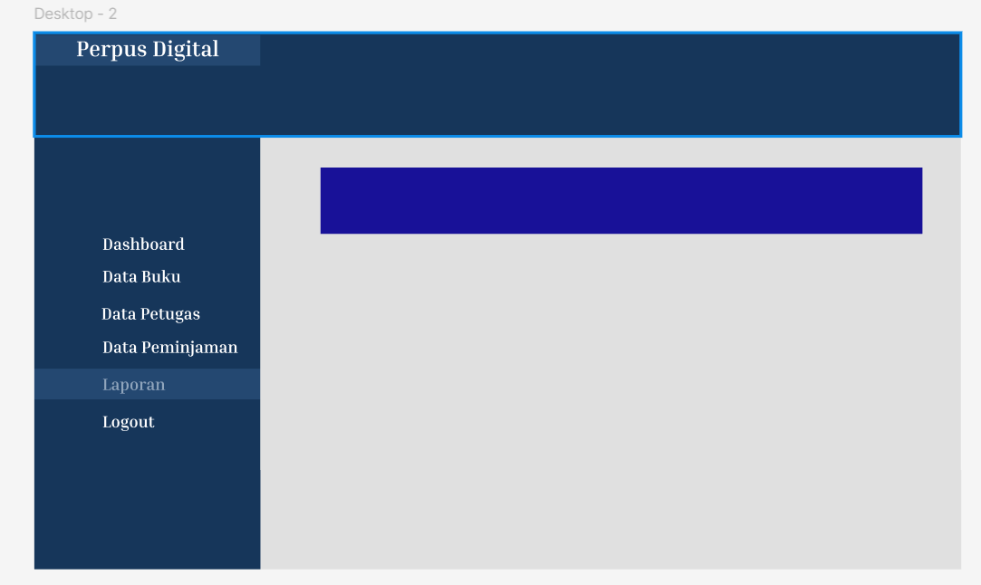

* **Logout**

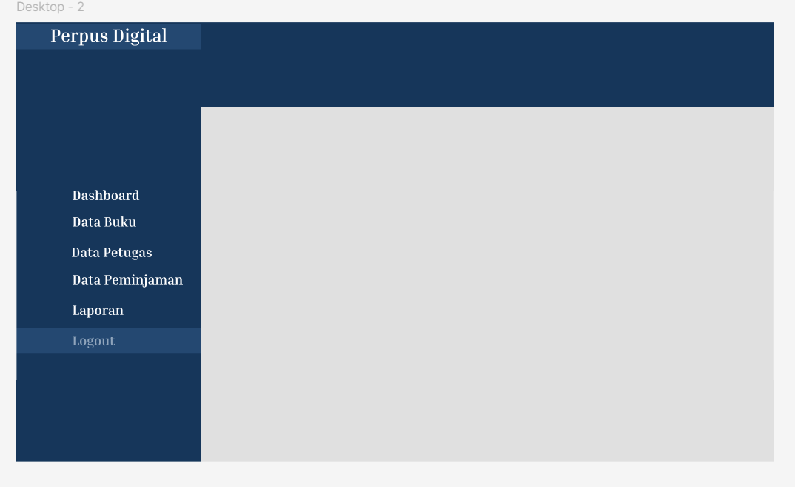

1. **Dvd**

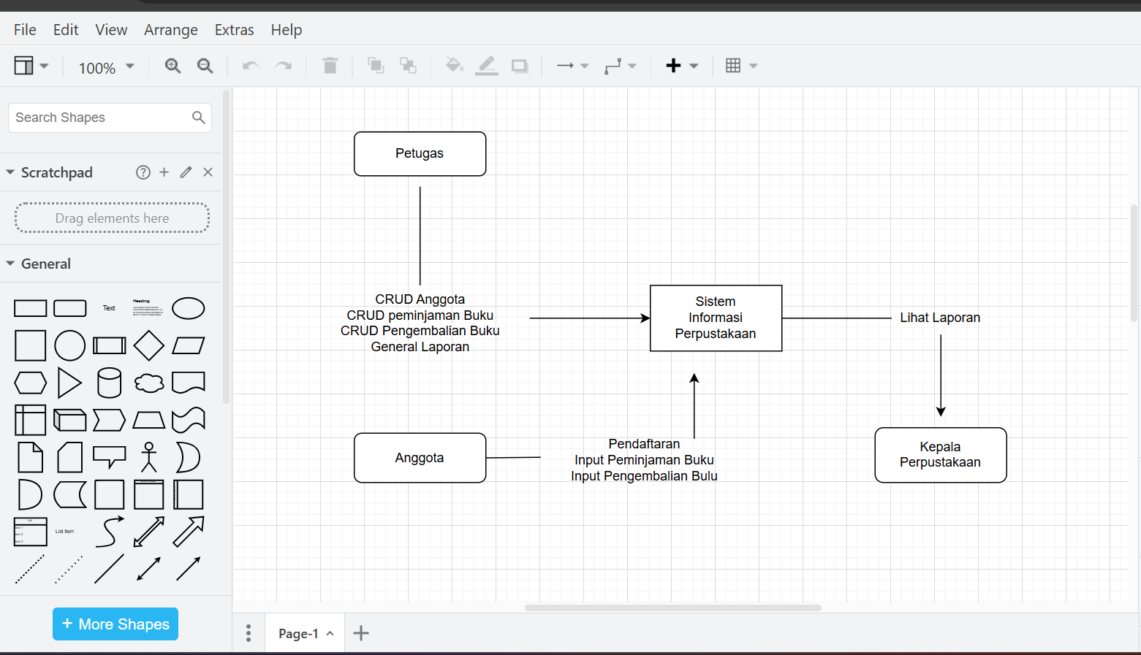

1. **System Yang Dibuat**

* **Login**

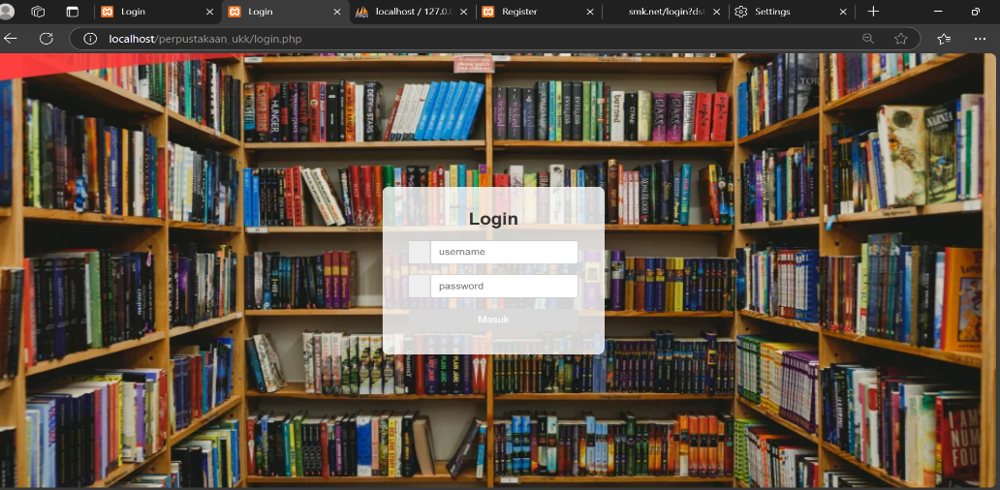

* **Dashboard**

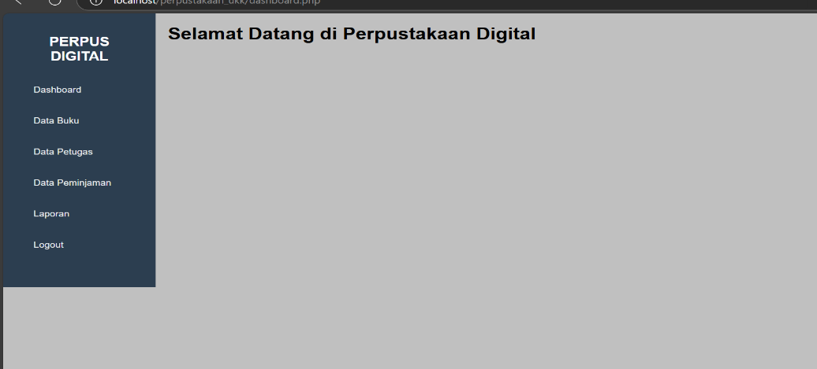

* **Data Buku**

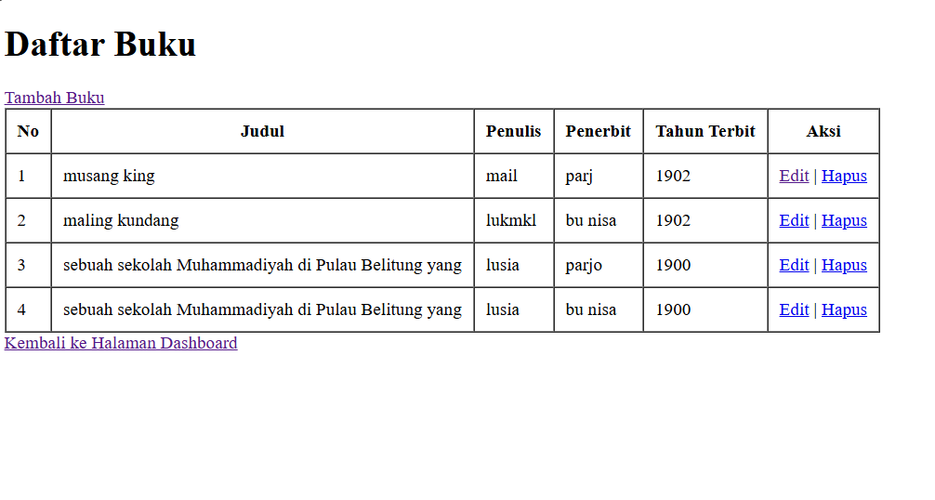

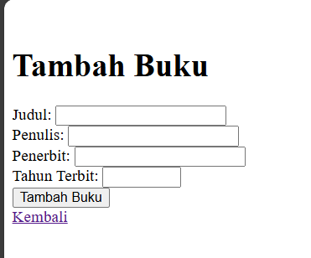

* **Data Petugas**



**Error karena belum kesambung ke database**

* **Data Peminjaman**

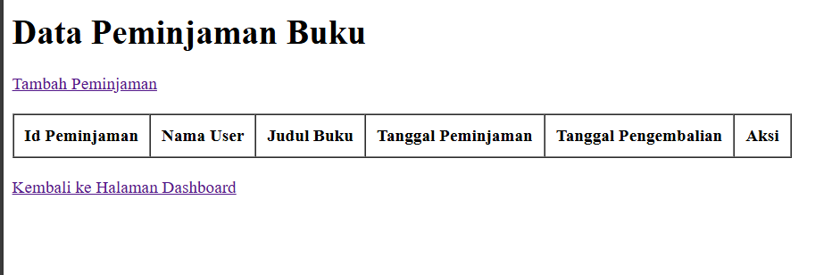

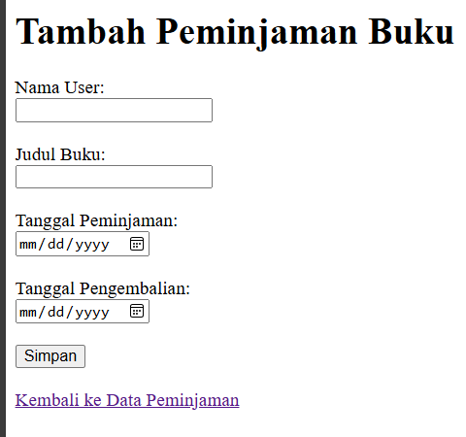

* **Laporan**

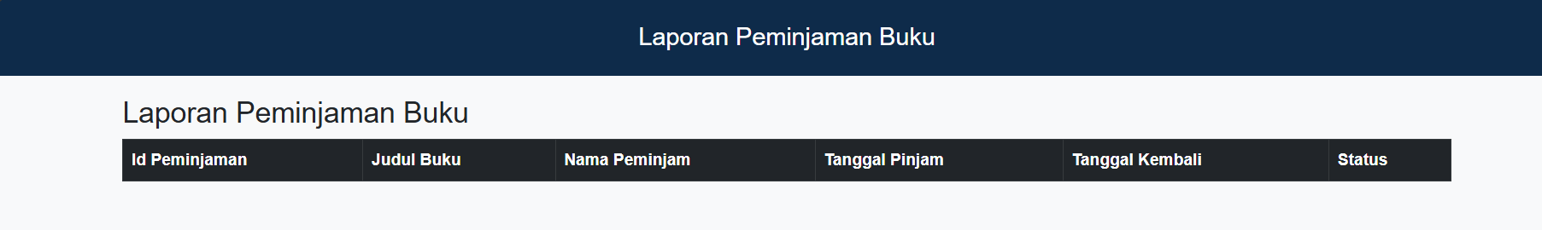

* **Logout**

