Costlier Candles, Quiet Prophets: How Religion Meets Inflation in the Croatian Digital Media Space, 2021–2026
LUKA ŠIKIĆ * Catholic University of Croatia (Hrvatsko katoličko sveučilište) Department of Communication Studies Zagreb, Croatia
Original scientific paper UDK: [to be assigned by the journal] doi: [to be assigned by the journal] Received: [month, year — assigned on submission]

Catholic Social Teaching (CST) assigns the Church a distinctive voice in economic hardship: to name inflation as an injustice that falls hardest on the poor. We ask what that voice actually sounds like in a national digital media space during a cost-of-living shock. Using the DigiKat corpus — 710,307 religion-salient Croatian/Bosnian media posts (January 2021–June 2026) — we isolate every post that mentions inflation and, crucially, distinguish genuine religion–inflation linkage from incidental co-occurrence. Most co-mentions prove incidental; after coding 1,450 proximity-selected candidates with three independent large-language-model annotators (inter-annotator agreement 0.97; human validation pending) and setting aside foreign-country inflation, a measured domestic core of 520 posts remains — 0.07% of the (web-portal-dominated) corpus and 6.5% of inflation-mentioning posts. Within it, religion meets inflation overwhelmingly as an economic object: a macro-register combining the rising cost of religious life and the Church-as-institution accounts for ≈72% (individually 37% and 34%, an ordering within coding noise; an upper bound on the object reading, since the institution register includes clergy as commentators). Charity accounts for 17%, while the structural / CST-justice register is marginal — 3% under strict coding, at most ≈8% if latent structural framing in adjacent posts is counted. We formalize and evaluate four theory-derived expectations. Media inflation-attention is strongly price-coupled (H1 partially supported: Pearson r ≈ 0.73 with the Croatian HICP within the seam-free monitoring window, with 2.4-fold higher mean attention above the literature-derived ≈4% threshold, though energy couples only weakly), and religious coverage appears to resonate with rather than lead real conditions (H2, provisional); yet the religious justice voice does not fill that attention (P3: not visible in the digital-news measure; the actor-level claim is not testable here); framing is episodic rather than thematic (P4 supported, in part by construction). We argue that the justice-centred frame CST foregrounds has low visibility in the digital public sphere — the Church surfaces as an institution whose services became more expensive, not as a prophetic voice — while cautioning that media-visibility is a weak proxy for the institution’s conduct. Beyond the substantive finding, the paper offers a transferable methodological caution: in keyword-filtered corpora, co-occurrence is not engagement, and linkage must be measured, not counted.
Keywords: digital religion, inflation salience, Catholic Social Teaching, media framing, agenda-setting, Croatia, computational text analysis.

* Luka Šikić, Catholic University of Croatia, Department of Communication Studies / Hrvatsko katoličko sveučilište, Odjel za komunikologiju, Ilica 242, 10000 Zagreb, Croatia / Hrvatska, luka.sikic.gm@gmail.com

INTRODUCTION
Between 2021 and 2026 Croatia lived through the sharpest cost-of-living shock in a generation, compounded by the adoption of the euro on 1 January 2023. Catholic Social Teaching has an unusually explicit stance on such moments: from the “preferential option for the poor” to Pope Francis’s “this economy kills” (ova ekonomija ubija), doctrine frames economic hardship as a structural injustice the Church is called to name on behalf of the vulnerable. In a country where the Catholic Church is a dominant cultural institution and operates one of Europe’s more developed religious media ecosystems, one might expect the digital public sphere to carry an audible religious-economic voice when prices spike.
This paper asks a deliberately simple question: when inflation surfaces in religion-salient Croatian digital discourse, who carries it, and in what register? We do not assume the Church is loud on the economy; we measure whether it is, and how. The answer turns out to be less about prophecy than about price lists.
Three contributions follow. Substantively, we provide the first measurement of the religious register of inflation discourse across an entire national digital media space, and document a gap between CST’s normative promise and observed practice. We combine this description with four theory-derived hypotheses and propositions (see below): one — that media inflation-attention tracks real prices — is tested quantitatively against the Harmonised Index of Consumer Prices (HICP) and partially supported, while the CST-derived expectation of a prophetic justice voice is evaluated and found not to be visible in the digital-news measure — a news corpus cannot test the actor-level claim about the Church itself. Methodologically, we show that the naïve approach — counting posts where religion and inflation co-occur — overstates genuine engagement by roughly an order of magnitude (≈8,000 co-mentions versus 520 measured), and we demonstrate a validated pipeline for measuring linkage rather than co-occurrence.

BACKGROUND AND HYPOTHESES
The study sits at the intersection of three literatures that are each well developed but rarely meet.
Inflation salience and media agenda-setting. Public and media attention to inflation is non-linear: it stays flat until inflation crosses a threshold of roughly 2–4%, then jumps (Korenok, Munro & Chen, 2026; Pfäuti, 2024). Coverage is less about the headline rate than about who is hurt and which component — the “heating or eating” framing of food versus energy (Champagne et al., 2024) — and the European Central Bank now maintains a dictionary-based media inflation-attention index (Aarab et al., 2025). Agenda-setting theory (McCombs & Shaw, 1972) is the backdrop, with an open question of whether media set or merely reflect attention (Wlezien & Soroka, 2024). A second level of that theory matters here: attribute agenda-setting (McCombs, 2004) holds that media transfer not only the salience of an issue but the salience of its attributes — and our register question is precisely an attribute question, asking not whether religion-and-inflation is on the agenda but which of its faces (the fee, the charity, the injustice) becomes salient. This literature is almost entirely secular and Anglophone/euro-area; it says nothing about the religious media sphere as an inflation channel.
CST economic framing. The theological distinction between charity (relieving symptoms) and justice (changing structures) maps closely onto Iyengar’s (1991) episodic-versus-thematic framing and gives us a measurable construct. The structural critique is not only a Francis-era phenomenon (Benedict XVI, 2009; Francis, 2013). But existing studies examine secular press coverage of poverty, not religious media as the storyteller.
Croatian Catholic media are well studied on identity, nation, and culture-war themes, but their coverage of the economy has never been measured, still less linked to a live cost-of-living shock.
The gap — and a fourth, methodological one. No work has asked what register religion takes when it meets inflation in a whole national digital space. And studies of “religion and X” in large corpora routinely equate co-occurrence with engagement; we show below why that is unsafe here.

Hypotheses and propositions
The study is primarily descriptive, but prior theory licenses explicit, testable expectations. We state two directional hypotheses — where theory predicts a direction and the data permit a quantitative test — and two theory-derived propositions, evaluated by pattern-matching against the coded evidence in the interpretive tradition (Yin, 2018).
- H1 (attention–price coupling). From inflation-salience and agenda-setting theory, media attention to inflation should rise with the real HICP and jump once inflation crosses a ≈4% threshold, with the food and energy components at least as salient as the headline rate. Tested against Croatian HICP (see Results).
- H2 (resonance, not setting). From the setter-versus-resonance debate, religious inflation coverage should resonate with real conditions rather than lead them — entering the discourse reactively, as an affected party. Assessed via the temporal pattern; a formal lead–lag test is left to future work.
- P3 (prophetic-actor proposition). If the Church functions as a prophetic economic actor in the digital public sphere, the structural / CST-justice register should be non-trivial and should rise with hardship. Evaluated against the coded register distribution and its time path.
- P4 (episodic over thematic; Iyengar, 1991). Religious framing of inflation should be predominantly episodic (relief, institutional, the price of services) rather than thematic (structural critique). Evaluated against the register distribution.
We deliberately avoid inferential machinery the observational, batch-confounded data cannot bear: H1 is tested by correlation and a threshold contrast, the propositions by pattern-matching.

DATA AND METHODS
Corpus. The DigiKat master is a topical corpus of 710,307 Croatian/Bosnian media posts (2021-01 → 2026-06) retained by a religious-content filter (≥2 distinct religious-term matches). It is religion-salient posts across the whole media space, not a Catholic-outlet archive: secular mainstream outlets dominate, and the core is 96% web-portal content (Facebook 2%, other platforms negligible). A provenance marker (data_source) reflects two collection streams — a monitoring query covering ≈2021–2024 and a filter-based backfill covering ≈2024–2026 — that are not comparable (see “Temporal dynamics” below); we condition on it in all temporal analysis.
Inflation tagging. We tagged every post whose title or body matches an anchored inflation lexicon (inflacij*, poskup* “to become more expensive”, rast/porast/skok cijen* “price rises”, trošak života “cost of living”, kupovna moć “purchasing power”), deliberately excluding the bare word cijena “price” to avoid devotional false positives (e.g. “the price of salvation”). A metaphor guard removes figurative uses (“inflation of words/values”). This yields 8,019 clean inflation-mentioning posts (1.13% of the corpus).
Linkage, not co-occurrence. A long news article can mention inflation in one paragraph and a saint’s feast in another with no connection. We therefore measured, for each inflation post, whether a religious term (project lexicon of 95 terms, tightened for economic homonyms such as gospodarstvo “economy” vs Gospa “Our Lady”) appears within ±220 characters of an inflation mention. This proximity filter is deliberately recall-oriented (validated recall ≈0.89): it generates 1,450 candidate linked posts while accepting false positives, which the coding stage removes. We code the full linked set (1,450) rather than the classifier’s narrower domestic-linked subset (1,103), because the automatic foreign/domestic flag is unreliable (held-out precision ≈0.39); the annotators, not the flag, decide foreign versus domestic.
Coding. All 1,450 candidates were coded by three independent annotators (large-language-model annotators applying a fixed codebook), majority-adjudicated; 1,447/1,450 were coded by all three. Each post was labelled on four axes: whether it is genuinely about inflation/cost of living; whether religion is genuinely linked to the inflation content (versus incidental, a geographic landmark, a metaphor, a hashtag, or a secular organisation containing a religious word, e.g. Crveni križ = Red Cross, Papa-test = Pap smear); whether the inflation is foreign or domestic; and, when linked, its register: cost of religious life (the price of religious goods/services rising), Church-as-institution (clergy/Pope/parish as actor or commentator), structural / CST justice, charity (Caritas/relief), devotional, or other.
Validation. On a stratified held-out sample of 80 posts (disjoint from any tuning data), inter-annotator agreement was high — infl 0.975, link 0.967, foreign 0.992 — confirming the constructs are reliably measurable; register is the harder judgement (held-out agreement 0.46). The proximity filter’s held-out precision for domestic linkage was modest (≈0.38–0.46) with recall ≈0.89 — i.e. a filter, not a labeller; the full-pool coding confirmed this (45% of candidates coded as genuinely linked). We therefore report coded figures throughout and never regex counts. Annotators are LLM-based, so the agreement is inter-model reliability rather than a human gold standard; a human double-coding pass is planned (see Limitations).
Price data. Croatian HICP annual rate of change (monthly; all-items, food, energy) was obtained from Eurostat (prc_hicp_manr) for 2021–2025.
Analysis. We report the corpus-to-core funnel; the register distribution and its outlet, temporal, and tonal structure; and a test of H1 correlating monthly inflation-attention with HICP. Because the corpus changes collection instrument at 2024, all temporal analysis is conducted within the 2021–2024 monitoring stream and the batch-pooled series is reported only for completeness.

RESULTS

Co-occurrence is not engagement
The path from corpus to measured core is steep (Table 1). Of 710,307 posts, 8,019 (1.13%) mention inflation. Of those, the recall-oriented filter flags 1,450 as candidate-linked; coding confirms only 652 as genuine religion–inflation linkage, of which 132 concern foreign inflation, leaving a domestic measured core of 520 posts — 0.07% of the corpus and 6.5% of inflation-mentioning posts. A naïve co-occurrence count would have reported the phenomenon as an order of magnitude larger than it is; even among the proximity-flagged candidates, just 45% survive coding. The 520 is itself a floor rather than a point estimate: at the filter’s validated recall of ≈0.89 (estimated on an 80-post held-out sample), roughly sixty genuine domestic posts are missed before coding (recall-corrected ≈584); all shares below use the measured 520 as the denominator.
Table 1 From corpus to measured core
Stage | n | % of corpus
Full religion-filtered corpus | 710,307 | 100.000
Mentions inflation (clean) | 8,019 | 1.129
Linked candidates (filter, recall ≈0.89) | 1,450 | 0.204
Confirmed religion-linked (coded) | 652 | 0.092
… foreign inflation | 132 | 0.019
… domestic (measured core) | 520 | 0.073
Source: Authors’ calculation from the DigiKat corpus.

Who carries it
Genuine religion×inflation discourse is overwhelmingly a secular-media phenomenon: 442 of 520 posts (85%) come from secular/mainstream outlets, 75 (14%) from Catholic outlets, and 3 from business press (Table 3). The single largest producer is the Catholic aggregator hkm.hr (56 posts), followed by mainstream titles (slobodnadalmacija.hr 17, novilist.hr 16, 24sata.hr 12, jutarnji.hr 11, večernji.hr 10). The Church’s own outlets are not where this discourse mainly lives.

The register of religious-economic discourse
The central result is the register distribution (Table 2, Figure 1). Religion meets domestic inflation as, in order: the cost of religious life (37.3%), the Church-as-institution (34.4%), charity (16.7%), devotional framing (5.0%), and structural / CST justice at just 2.9% (15 posts).
Two cautions attach to this table. First, the two leading registers are close, share vocabulary (crkva, biskup), and register was the lowest-agreement coding axis (0.46), so their ordering is within coding noise; the robust statement is that together they form an economic-object macro-register of ≈72% (373 posts). Second, the 3% justice figure is a strict-coding floor: broadening to posts in other registers whose text carries latent structural language (chiefly 18 charity posts, e.g. Caritas discussing structural poverty) raises the upper bound to ≈8% (43 posts). Justice is marginal on either definition.
Table 2 Register of the domestic core (n = 520)
Register | n | %
Cost of religious life | 194 | 37.3
Church-as-institution | 179 | 34.4
Charity / relief | 87 | 16.7
Devotional | 26 | 5.0
Structural / CST justice | 15 | 2.9
Disputed (pending human tiebreak) | 12 | 2.3
Other | 7 | 1.3
Source: Authors’ calculation from the DigiKat corpus.
Figure 1 Register composition of the measured core
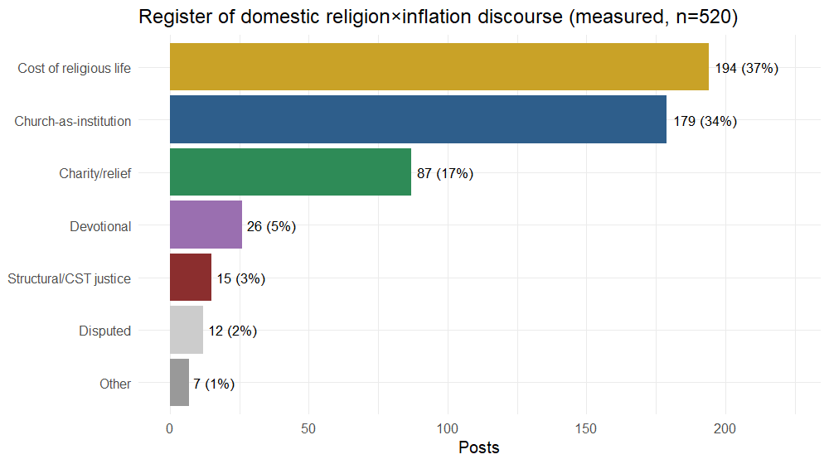
Figure 1
Source: Authors’ calculation from the DigiKat corpus.
The two dominant registers describe the Church as an economic object, not a moral voice: masses, church fees, weddings, funerals and pilgrimages that became more expensive (“cost of religious life”), and clergy or dioceses appearing in economic news as commentators or affected parties (“institution”). The second register also carries a definitional caveat: it includes clergy appearing as commentators — speaking subjects, some of whom voice moral or economic judgements — alongside the Church as an affected party, so the “economic-object” reading of the ≈72% macro-register is an upper bound; splitting the institution register into subject and object is deferred to the planned human coding round (see Limitations).
An outlet pattern is visible but must be read cautiously (Table 3, Figure 2). The “cost of religious life” register is almost entirely a secular story — 189 of 194 such posts are secular outlets reporting that the Church raised its prices. A tempting reading is that Catholic outlets, when they engage, tilt toward charity (27/75 = 36% of the Catholic core vs 58/442 = 13% of the secular core). We do not press this claim: the Catholic subsample is small (n = 75), 75% of it is the single aggregator hkm.hr (56 posts) whose own top register is institution (27), not charity (18), and stripping hkm.hr leaves just 19 posts. We therefore report the direction as a hypothesis for a larger Catholic-outlet sample, not a finding. What is robust across outlets is the near-absence of the justice register (10 secular, 5 Catholic).
Table 3 Register by outlet type (counts)
Register | Secular/other | Catholic | Business
Cost of religious life | 189 | 4 | 1
Church-as-institution | 147 | 32 | 0
Charity / relief | 58 | 27 | 2
Devotional | 22 | 4 | 0
Structural / CST justice | 10 | 5 | 0
Other / disputed | 16 | 3 | 0
Source: Authors’ calculation from the DigiKat corpus.
Figure 2 Register composition by outlet type (shares)
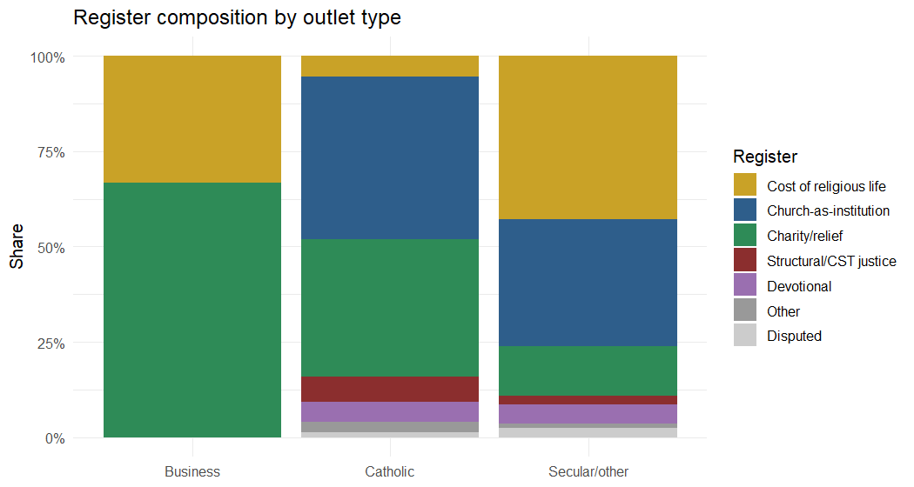
Figure 2
Source: Authors’ calculation from the DigiKat corpus.

Temporal dynamics (read within collection stream)
An important caveat governs this section. The two collection streams are not comparable: at 2024, where they overlap, 86% of original_dta candidates but only 21% of filtered_religious candidates survive coding as genuine domestic linkage. Cross-year volume must therefore be read within a stream, not across the 2024 seam (Figure 3).
Within the clean 2021–2024 monitoring stream, the core rises sharply to a 2022 peak (201 posts) — the height of the energy shock — and declines thereafter (2023: 100; 2024: 64). This within-instrument decline is genuine, not a collection artifact. The later backfill figures (2025: 66; 2026: 53) come from a different instrument and are not evidence of a continued decline.
Figure 3 Measured core volume by collection stream (batch-confound check)
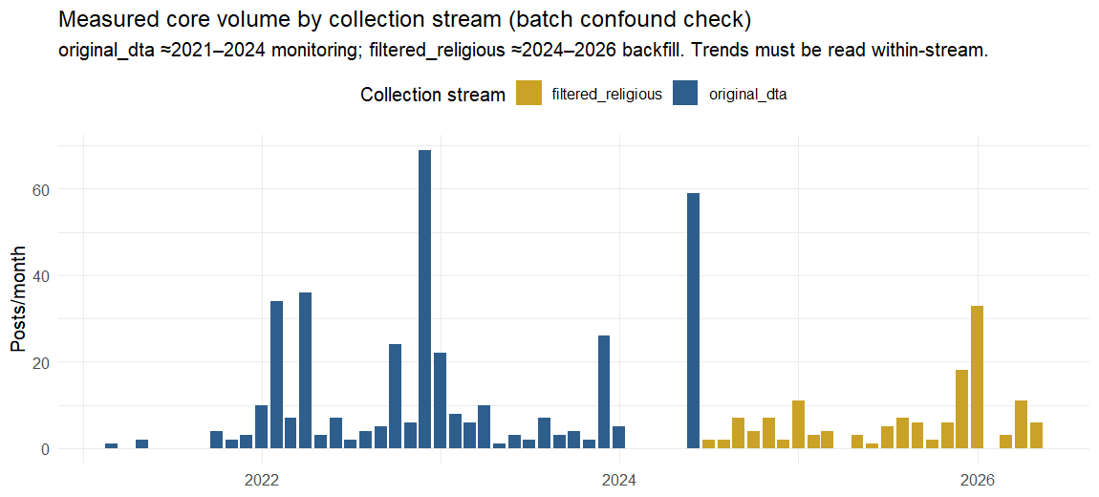
Figure 3
Source: Authors’ calculation from the DigiKat corpus.
Within that same window, the register composition shifts (Figure 4, Table 4): the institution register dominates the 2022 shock (105 posts) — clergy commenting on the crisis — and recedes (38 in 2023, 9 in 2024), while cost-of-religious-life rises (41 → 39 → 61), tracking the church-fee revisions around the euro changeover (1 January 2023). The discourse thus appears to migrate from acute-crisis commentary toward institutional price adjustment. The euro changeover itself is a cross-sectoral media event — it generated price-transparency and rounding-up coverage across the whole economy — so part of the cost-of-religious-life rise that follows the changeover plausibly tracks changeover journalism rather than inflation dynamics alone. We treat this register shift as suggestive rather than established: part of it spans the stream seam and awaits a stream-conditioned re-coding. At no point, in either stream, does the justice register gain traction.
Table 4 Register by year (counts, full core)
Year | Institution | Cost-relig-life | Charity | Devotional | Justice | Other/disputed
2021 | 8 | 0 | 0 | 1 | 2 | 1
2022 | 105 | 41 | 34 | 13 | 1 | 7
2023 | 38 | 39 | 11 | 5 | 5 | 2
2024 | 9 | 61 | 12 | 0 | 4 | 2
2025 | 16 | 13 | 26 | 4 | 2 | 5
2026 | 3 | 40 | 4 | 3 | 1 | 2
Note: 2021–2023 are entirely the monitoring stream; 2024 mixes both streams (64 monitoring + 24 backfill = 88); 2025–2026 are entirely the backfill stream. Read across the 2024 seam with caution (see “Temporal dynamics”); the within-stream monitoring series is 2021→12, 2022→201, 2023→100, 2024→64. Source: Authors’ calculation from the DigiKat corpus.
Figure 4 Register over time (monthly, measured core)
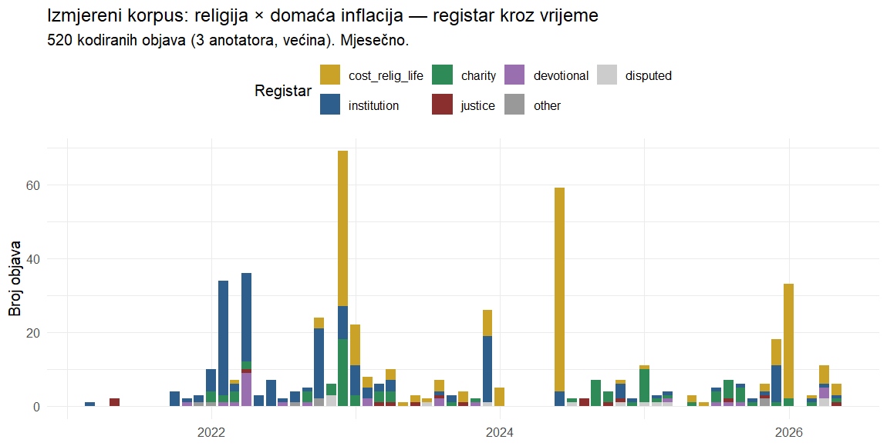
Figure 4
Source: Authors’ calculation from the DigiKat corpus.

Tone
Vendor auto-sentiment (indicative only) splits meaningfully by register (Table 5, Figure 5). The core is 43% negative, 32% positive, 25% neutral overall, but “cost of religious life” is markedly negative (100 of 194, 51%), consistent with public grumbling about church price hikes, whereas “Church-as-institution” is the most positive register (83 of 179, 46%), consistent with pastoral or commentary framing. The rare justice posts lean negative (9 of 15).
Table 5 Auto-sentiment by register (counts; vendor labels, indicative)
Register | Negative | Neutral | Positive
Cost of religious life | 100 | 56 | 38
Church-as-institution | 51 | 45 | 83
Charity / relief | 38 | 12 | 37
Devotional | 15 | 8 | 3
Structural / CST justice | 9 | 4 | 2
Source: Authors’ calculation from the DigiKat corpus (vendor auto-sentiment labels, indicative only).
Figure 5 Auto-sentiment by register (shares)
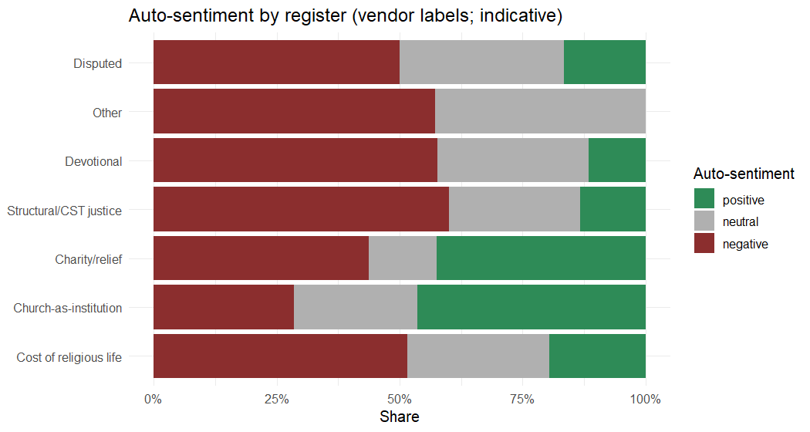
Figure 5
Source: Authors’ calculation from the DigiKat corpus.

H1 — inflation attention tracks real prices
To test H1 we correlate monthly inflation-attention (the share of corpus posts mentioning inflation) with the Croatian HICP annual rate of change (headline, food, energy), within the 2021–2024 monitoring stream — 39 months with coverage: 37 consecutive months through January 2024, plus two thin months (June–July 2024) as the stream winds down, so the series is not fully contiguous; the batch-pooled series is reported for completeness only. Within the clean window, attention tracks inflation strongly (Table 6, Figure 6): Pearson r = 0.73 with headline HICP (nominal p < 0.001; see the inference cautions below), 0.72 with food, and 0.44 with energy (Spearman ρ comparable). The threshold form of H1 also holds descriptively: mean attention is 0.49% of posts in months with headline HICP below 4% (12 months) and 1.17% at or above (27 months) — a 2.4-fold jump around the ≈4% attention threshold documented cross-nationally.
Three cautions temper the inference. First, the HICP annual rate of change is a 12-month trailing construct, so consecutive monthly observations overlap by eleven months and are strongly autocorrelated — and the attention series is itself persistent — so the effective number of independent observations is well below the stated n = 39, and the nominal p-value overstates precision; a HAC re-estimate and a first-differenced (month-on-month) specification are planned before submission, and until then the correlation should be read as descriptive. Second, the ≈4% cutpoint is imposed from the cross-national literature, not estimated from these data; 39 months cannot identify a breakpoint, no formal test of the two-bin contrast is reported, and the 12 below-threshold months are temporally clustered — ten at the start of 2021 and two at the 2024 tail — so the contrast cannot distinguish a genuine discontinuity from the smooth coupling already described. Third, as noted under temporal dynamics, the January 2023 euro changeover flooded all sectors with price coverage, so part of the 2023 attention is plausibly changeover journalism rather than a response to the inflation rate as such.
On this evidence H1 is partially supported: the attention–price coupling and the descriptive threshold pattern hold, and food inflation tracks attention as strongly as the headline, but energy couples only weakly (r = 0.44) — energy’s large, partly negative swings in 2023–2024 loosen its link to attention, so the “food-and-energy” salience clause holds for food but not energy here. This component reading is indirect: we correlate aggregate attention with each HICP component, which captures comovement rather than component-specific salience, so the weak energy result is suggestive rather than decisive. The coupling is not an artifact of the ragged window tail — restricting to the contiguous 2021–2023 block gives r = 0.77 (n = 36), and dropping the thinnest tail month gives r = 0.72 — while the batch-pooled series attenuates it (headline r = 0.63), consistent with the 2024 seam adding noise. The religion-linked core is too sparse for a monthly test, but its annual volume aligns with inflation (both peak in 2022).
Table 6 Inflation-attention vs HICP (monthly, within the 2021–2024 stream; n = 39 months with coverage, not fully contiguous)
HICP component | Pearson r | Spearman ρ
Headline | 0.73 | 0.75
Food | 0.72 | 0.74
Energy | 0.44 | 0.43
Source: Authors’ calculation from the DigiKat corpus and Eurostat (prc_hicp_manr).
Figure 6 Inflation-attention vs HICP, 2021–2024 monitoring stream
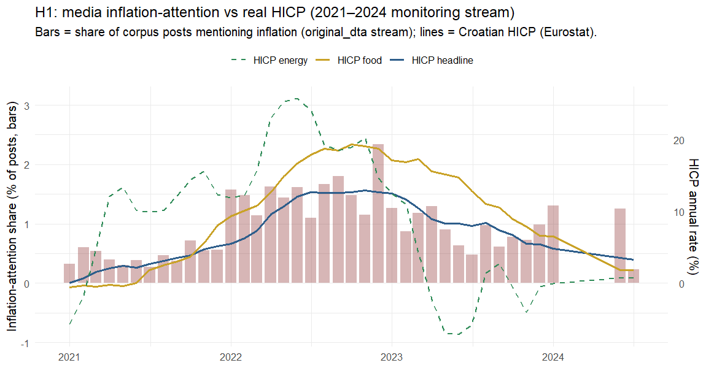
Figure 6
Source: Authors’ calculation from the DigiKat corpus and Eurostat (prc_hicp_manr).

DISCUSSION
The Church as economic object, not moral voice. The dominant way religion meets inflation in Croatian digital discourse is not the pulpit but the price list. Seven in ten linked posts (the ≈72% economic-object macro-register — itself an upper bound on the object reading, since the institution register also contains clergy as commentators; see Results) describe either the rising cost of religious life or the Church as an institution caught in economic news; charity adds a sixth; the structural-justice critique CST foregrounds is marginal (3% strict, ≤8% broad). We frame this as a claim about digital-public visibility, not the Church’s pastoral conduct: homilies, pastoral letters and Caritas fieldwork are structurally under-represented in a media-monitoring corpus of news posts, so the low visibility of the justice frame is weak evidence about institutional silence as such (see Limitations). What the data support is that, in the national digital public sphere, the frame that surfaces around inflation is overwhelmingly the fee and the institution, not the prophecy.
A rival explanation: newsroom gatekeeping. The register distribution is produced by editorial selection at least as much as by what religious actors say. Standard news values — conflict, concrete numbers, institutional controversy — favour the church-fee story over the pastoral letter: a diocese raising the price of a funeral is news, a homily on structural poverty rarely is. Since 85% of the measured core is secular outlets’ output, the distribution we observe is largely what newsrooms judged newsworthy about religion during the shock. The “quiet prophets” pattern may therefore be partly editorial deafness rather than clerical silence. On the present data the two readings — a Church that does not speak structurally, and media that do not relay it when it does — cannot be separated; the planned secular benchmark and a supply-side corpus of Church-authored texts (see Limitations) are designed to separate them.
Attention existed; a prophetic voice did not fill it. The two results interlock. H1 indicates that media inflation-attention is real and price-coupled — attention rose with prices (see Results). Yet within that attention, once linkage is measured, the religious engagement is small and, where present, non-prophetic. The public conversation about inflation was there for a religious justice voice to enter; little of one is visible in the measured discourse.
A possible division of narrative labour (hypothesis). The register–outlet pattern hints at two storytellers: secular media supplying the “costlier candles” story — reporting, often critically and in negative tone, that the Church raised the price of masses, weddings and funerals around the euro changeover — and Catholic outlets leaning, in their thin non-aggregator tail, toward “quiet charity.” As noted above, the Catholic subsample is too small and too aggregator-dominated to establish this contrast, so we advance it only as a hypothesis. What both kinds of outlet share is the near-absence of the prophetic, structural voice.
Mechanism and timing. Within the 2021–2024 stream, the pattern is consistent with an agenda-setting reading: the religious linkage flares during the acute 2022 shock (institutional commentary) and recedes as prices stabilise, while church-fee coverage rises around euro adoption. On this within-stream evidence the dynamic looks closer to resonance than to setting (H2, provisional) — religion enters inflation discourse reactively, as an affected party, not as an agenda-setter for economic justice.
Why it matters. For sociology of religion, the finding qualifies accounts of the Croatian Church as a strong public actor: on the economy, at least, its digital-public presence is thin and non-prophetic. For media studies, it extends inflation-salience research into the religious sphere and shows the “who is hurt” framing has a specifically institutional variant — “who charges more.” For CST scholarship, the absence poses the question: why the doctrinal justice frame does not travel into the national digital public sphere.
Implications for social policy. Three implications follow. First, if agenda-setting research is right that media frames shape which policy responses the public regards as warranted, then a digital sphere in which religion meets inflation as fees and institutional news — rather than as structural injustice — contributes little to building public support for redistributive or anti-poverty responses to a cost-of-living shock, despite doctrine that points exactly there. Second, the visible charity register (17%) documents the place the country’s principal faith-based relief network actually occupies in the digital public sphere: Caritas appears as an episodic relief actor in the mixed economy of welfare, not as an advocate for structural reform — the familiar charity-versus-justice tension in faith-based provision, here measured rather than asserted. Third, the dominant cost-of-religious-life register identifies a concrete social-policy object: fees for weddings, funerals and other rites of passage function as quasi-obligatory expenditures for religiously observant low-income households, a neglected component of cost-of-living measurement that the euro-changeover fee resets made briefly and unusually visible.
Hypothesis scorecard. H1 (attention–price coupling) partially supported — the coupling holds, energy couples only weakly; H2 (resonance not setting) provisionally consistent, pending a lead–lag test; P3 (prophetic actor) not visible in the digital-news measure — the actor-level claim is not testable here; P4 (episodic over thematic) supported, in part by construction (see Appendix C).

METHODOLOGICAL CONTRIBUTION: CO-OCCURRENCE IS NOT ENGAGEMENT
Independent of the substantive story, the study is a cautionary demonstration. Had we counted co-occurrence, we would have reported thousands of “religious engagements with inflation.” Measured, genuine domestic linkage is 520 posts. The gap is not noise to tolerate but signal to remove: keyword-filtered corpora manufacture incidental co-mention at scale. Our pipeline — anchored lexicons with metaphor and homonym guards, a recall-oriented proximity filter, and multi-annotator coding with reported inter-annotator agreement — is a reusable template for any “religion and X” (or “A and B”) corpus study.

LIMITATIONS
- Collection-batch confound. The corpus mixes two streams with very different confirmation rates at their 2024 overlap (0.86 vs 0.21). We read temporal trends within stream and do not claim a decline across the 2024 seam. A stream-conditioned re-coding is the single highest-value robustness check.
- LLM annotators. Inter-annotator agreement is high (0.97), but this is inter-model reliability, not a human gold standard; a human double-coding of a ≥100-post slice (including the foreign/domestic boundary that defines the 520) is required before final publication, along with resolution of 12 “disputed” register cases.
- Subject/object conflation in the institution register. As defined, Church-as-institution mixes the institution as an affected party with clergy as commentators — speaking subjects. The “economic-object” macro-register (≈72%) therefore overstates the object reading to an unknown degree and should be read as an upper bound. The human coding round will split this register into affected-party versus commentator, and the macro-register figure will be recomputed on that split.
- Residual false positives. Even after majority coding, a few core posts are misclassified; a high-confidence subset (3/3 agreement, 518 posts) is available for sensitivity analysis.
- Register ordering / justice floor. Register was the lowest-agreement axis; the 37% vs 34% ordering is within noise (we report the ≈72% macro-register), and 3% justice is a strict floor (≤8% broadly construed). The proximity filter’s misses may also be register-non-random: long-form thematic argument is likelier to exceed a ±220-character window, so filter design as well as strict coding may depress the justice floor — a planned window-sensitivity check addresses this.
- HICP scope. H1 is tested at the level of corpus-wide inflation-attention; a monthly HICP overlay on the religion-linked core specifically is too sparse to test, and the H2 lead–lag test against public search interest is future work.
- No secular benchmark yet. Because the corpus is religion-filtered, we cannot yet say whether structural framing is rarer in religious than in secular inflation coverage; a benchmark on non-religious inflation posts is needed before any claim that the Church specifically underuses the justice frame.
- Filtered baseline & platform coverage. “Secular” here means secular outlets’ religion-adjacent output, not their full inflation coverage; and the core is 96% web, so claims generalize to the web-portal public sphere rather than to all platforms.

CONCLUSION
When prices rose in Croatia, religion did enter the digital conversation about inflation — but as an institution whose candles, masses and fees had become more expensive, and whose charities responded, far more than as a prophetic voice for the poor. Media attention to inflation tracked real prices closely; the religious structural-justice frame did not fill that attention. Costlier candles, quiet prophets. Whether this reflects a genuinely quiet Church, newsroom gatekeeping that finds fees more newsworthy than prophecy, or a justice voice carried in channels a news corpus does not capture is the question the absence opens — one the planned secular benchmark and supply-side corpus of Church-authored texts are designed to answer, with a lead–lag test and human validation securing the ground beneath them.

DATA AND CODE AVAILABILITY
Tracked aggregates, coded outputs, tables and figures are in the study output/ directory (analysis_core_coded.csv, the tables/ folder, hicp_hr.csv). The underlying master corpus contains scraped post text and is not redistributable; analyses are reproducible from the numbered pipeline scripts (Appendix A) given access to the master. The measured-core file carries URLs and text excerpts and is held internally pending a statistical-disclosure review.

ETHICS AND DISCLOSURE
The corpus consists of publicly posted media content collected via a commercial monitoring service. The paper reports only aggregate counts and shares; no personal data, account identifiers, or verbatim private content are published. Outlet names are public publishers. A disclosure/PII screen is run before any data extract is shared.

ACKNOWLEDGMENTS
This research was conducted within the DigiKat project at the Catholic University of Croatia (Hrvatsko katoličko sveučilište), Department of Communication Studies. This is a working manuscript (first complete version, 1 July 2026); authorship and author order are to be finalized. Released under CC BY 4.0; open-science (FAIR) principles apply.

REFERENCES
- Aarab, I., Bańbura, M., Bobeica, E., & Leguay, T. (2025). Tracking inflation attention. ECB Economic Bulletin 6/2025.
- Benedict XVI (2009). Caritas in Veritate.
- Champagne, C., et al. (2024). “Heating or eating”: framing the cost-of-living crisis. Social Science & Medicine, 360, 117312.
- Francis (2013). Evangelii Gaudium.
- Geiß, S. (2022). Conditional agenda-setting. Communication Research, 49(2), 296–323.
- Gutiérrez, G. (1971/1973). A Theology of Liberation. Orbis.
- Iyengar, S. (1991). Is Anyone Responsible? University of Chicago Press.
- Korenok, O., Munro, D., & Chen, J. (2026). Inflation and attention thresholds. Review of Economics and Statistics, 108(3), 842–850.
- Lamla, M. J., & Maag, T. (2012). The role of media for inflation expectations. Journal of Money, Credit and Banking, 44(7), 1325–1350.
- McCombs, M. (2004). Setting the Agenda: The Mass Media and Public Opinion. Polity Press.
- McCombs, M. E., & Shaw, D. L. (1972). The agenda-setting function of mass media. Public Opinion Quarterly, 36(2), 176–187.
- Pfäuti, O. (2024). The inflation attention threshold. arXiv:2308.09480.
- Wlezien, C., & Soroka, S. (2024). Media and the public’s attention. American Political Science Review, 118(3), 1563–1569.
- Yin, R. K. (2018). Case Study Research and Applications: Design and Methods (6th ed.). Sage.
Some literature entries remain to be verified against Hrčak / CrossRef before submission; see LITERATURE.md. Data source: Croatian HICP annual rate of change (Eurostat prc_hicp_manr, all-items/food/energy, monthly), retrieved 2026-07-01 (output/hicp_hr.csv).

APPENDIX A. REPRODUCIBILITY
Pipeline: 10_rerun_fixed.R (tagging + linkage + fixes) → 13_make_coding_pool.R (1,450-candidate pool + annotation batches) → the code-candidate-pool workflow (3 annotators × 20 batches, majority) → 14_finalize_coded.R (measured core) → 15_paper_analysis.R (register/outlet/sentiment tables + figures) → 16_review_response.R (stream conditioning; hkm.hr decomposition; latent-justice bound) → 17_h1_hicp.R (H1 test). Run against the master (R path in CLAUDE.local.md). Coded data: output/analysis_core_coded.{rds,csv}.

APPENDIX B. CODING PROTOCOL AND VALIDATION
Four axes (see Data and Methods). Held-out validation (n = 80): inter-annotator agreement infl 0.975 / link 0.967 / foreign 0.992 / register 0.46; classifier held-out precision (domestic linkage) ≈0.38–0.46, recall ≈0.89; full-pool coding confirmed 45% of candidates as genuinely linked. Full log: VALIDATION.md, REVIEW_RESPONSE.md.

APPENDIX C. HYPOTHESIS SCORECARD
Table C1 Hypothesis scorecard
# | Statement | Test | Verdict
H1 | Attention rises with HICP; jumps above ≈4%; food/energy ≥ headline | Correlation + threshold contrast (Results) | Partially supported (r ≈ 0.73; 0.49→1.17% at threshold; food ≈ headline, but energy couples only weakly, r = 0.44)
H2 | Religious coverage resonates rather than leads | Temporal pattern (Results, Discussion) | Provisionally consistent; lead–lag test pending
P3 | If prophetic actor, justice register non-trivial and rises with hardship | Pattern-matching (Results) | Not visible in the digital-news measure (3% strict / ≤8% broad; no rise); the actor-level claim is not testable in a news corpus
P4 | Framing episodic, not thematic | Register distribution (Results) | Supported (episodic registers $gg$ thematic justice), though partly by construction: justice is definitionally the thematic register
Source: Authors’ compilation.

Sažetak
SKUPLJE SVIJEĆE, TIHI PROROCI: KAKO SE RELIGIJA SUSREĆE S INFLACIJOM U HRVATSKOME DIGITALNOM MEDIJSKOM PROSTORU, 2021.–2026.
Luka Šikić Hrvatsko katoličko sveučilište, Odjel za komunikologiju Zagreb, Hrvatska
Katolički socijalni nauk (KSN) Crkvi pripisuje osobit glas u vremenima gospodarske krize: imenovati inflaciju kao nepravdu koja najteže pogađa siromašne. Pitamo kako taj glas doista zvuči u nacionalnome digitalnom medijskom prostoru tijekom šoka troškova života. Koristeći se korpusom DigiKat — 710.307 religijski relevantnih hrvatskih/bosanskih medijskih objava (siječanj 2021. – lipanj 2026.) — izdvajamo svaku objavu koja spominje inflaciju te razlikujemo istinsku povezanost religije i inflacije od slučajnoga supojavljivanja. Većina supojavljivanja pokazuje se slučajnom; nakon kodiranja 1.450 objava odabranih prema blizini, uz tri neovisna anotatora temeljena na velikim jezičnim modelima (slaganje među anotatorima 0,97; ljudska validacija predstoji) i izdvajanje inozemne inflacije, ostaje izmjereni domaći korpus od 520 objava — 0,07 % korpusa i 6,5 % objava koje spominju inflaciju. Unutar njega religija se s inflacijom susreće pretežno kao s gospodarskim predmetom: makroregistar koji spaja rastući trošak religijskoga života i Crkvu kao instituciju čini ≈72 % (gornja granica predmetnoga čitanja, jer registar institucije uključuje i kler kao komentatore), dok je strukturni registar pravde (KSN) tek rubna pojava — 3 % pri strogom kodiranju, najviše ≈8 % šire shvaćeno. Medijska pozornost na inflaciju snažno je vezana uz cijene (H1 djelomično potvrđena: Pearsonov r ≈ 0,73 s hrvatskim HICP-om, no energetska je komponenta tek slabo povezana), a religijsko izvještavanje prije rezonira sa stvarnim uvjetima nego što ih predvodi (H2, provizorno); no religijski glas pravde ne ispunjava tu pozornost (P3: nije vidljiv u digitalnome medijskom pokazatelju, a tvrdnja na razini samoga aktera ovdje nije provjerljiva); uokvirivanje je epizodično, a ne tematsko (P4 potvrđena, dijelom po konstrukciji). Zaključujemo da okvir usmjeren na pravdu, koji KSN ističe, ima nisku vidljivost u digitalnoj javnoj sferi — Crkva se pojavljuje kao institucija čije su usluge poskupjele, a ne kao proročki glas — uz opomenu da je medijska vidljivost slab pokazatelj postupanja same institucije. Uz sadržajni nalaz, rad nudi i prenosivu metodološku pouku: u korpusima filtriranima ključnim riječima supojavljivanje nije angažman, a povezanost treba mjeriti, a ne brojati.
Ključne riječi: digitalna religija, istaknutost inflacije, katolički socijalni nauk, medijsko uokvirivanje, postavljanje dnevnoga reda, Hrvatska, računalna analiza teksta.

