Native advertising as a content marketing strategy

2024-09-17

Purpose – The objective of this study is to determine the content characteristics of native advertisements (as one of the content marketing strategies) on the most-read Croatian internet portals. Specifically, the study aims to identify key characteristics of headlines and content, and their relationship with audience reach. Design/Methodology/Approach – A machine-based pre-analysis that included all posts on Croatian internet portals during the observed period resulted in defining a final sample of 543 native ads on the most influential online media in the Croatian digital space, based on visitor criteria. The research on a sample of 543 native advertisements was conducted using content analysis methodology. Findings and implications – The findings reveal that nearly 80% of headlines contain at least one clickbait characteristic, with the style of uncertainty being the most frequently employed and effective. Half of the ads did not include any statements or sources, with the most common sources being individuals from the organization or company. The effectiveness of different source types varies across industries, with multiple sources proving most effective in sectors like non-alcoholic beverages and construction, while direct user testimonials are more impactful in technology and finance. Limitations – Due to the focus on native advertisements published in Croatian media space, results may not fully reflect the global native advertising landscape. The selected sample was based on the most-read portals according to visitor numbers, which may not represent niche platforms or smaller but influential digital spaces. Lastly, the time frame for data collection might not capture trends or changes in native advertising strategies over time, limiting the ability to generalize the findings beyond the observed period. Originality – The research underscores the significant role of clickbait headlines, visual content, and source credibility in the success of native advertising as a content marketing strategy.

Table of Contents

# Introduction

The concentration of so-called hybrid forms of media content in the contemporary online environment is becoming increasingly intense (Balasubramanian 1994; Macnamara 2014; Taiminen, Luoma-aho, and Tolvanen 2015). Among the most prominent forms are sponsored content (Tutaj and Van Reijmersdal 2012), content marketing (Pulizzi 2014; Pulizzi and Piper 2023), brand journalism (Cole and Greer 2013), and native advertising (Verčič and Tkalac Verčič 2016). For most researchers, the latter term will serve as an umbrella term that attempts to simplify the classification of hybrid forms, as native advertising by definition implies a paid advertisement that resembles editorial content, aiming to attract the target audience with useful content while simultaneously promoting the brand, values, and products (Cole and Greer 2013; Howe and Teufel 2014; Wojdynski and Evans 2016). On the other hand, the research by (Taiminen, Luoma-aho, and Tolvanen 2015) showed that most public relations and marketing professionals preferred to use the term “content marketing” when discussing commercial hybrid forms of online content. In addition to the obvious terminological confusion, three other problematic areas of native advertising need to be highlighted:

Application area: Is native advertising a public relations technique, a marketing tool, or a tactic that does not differ from traditional advertising in any way?

Authorship of native ads: Who creatively signs them and who is responsible for their content?

Legal and ethical framework: How is native advertising legally defined, and what is the practice of media houses in labelling such advertisements (Trbušić, Maleš, and Šikić 2024)?

The theoretical basis of this paper is the thesis that native advertising is “an extension of content marketing and provides marketers with a platform to place content in front of a wider audience they wouldn’t ordinarily reach” (Crook 2022). Although there are authors who highlight certain criteria by which content marketing differs from native advertising, which will be described in more detail later in the paper, the ultimate goal is common: to drive profitable customer action. The profitability of such market communication for organizations and brands is demonstrated by recent metrics. Figures show that 47% of marketing professionals globally believe in the effectiveness of this type of advertising (Kloot 2022), and that in 2023, spending on native advertising in the United States increased by 12% compared to the previous year (E-marketer 2023). Thus, with more than 97 billion US dollars invested, native advertising holds the largest share (59.7%) of the total expenditure for all types of advertising (E-marketer 2023).

# Native advertising and content marketing – two faces of the same coin?

(Du Plessis 2015a) defines content marketing as sharing brand content via owned media to gain earned media, which clearly implies that it is not a type of media content that is paid for, as (native) advertising certainly is. In this context, Du Plessis employs the classic PESO model of media content in public relations (Dietrich 2014), which distinguishes paid media (advertising or other sponsored content); earned media (publicity generated from media pitches or news releases); shared media (content shared and re-shared on social media); and owned media (such as company’s website, newsletter, or email communications). The order in the PESO model has long reflected the priorities of organizations in media strategy planning. However, recent research (Macnamara et al. 2016) indicates a shift in the order in practice, with the dominance shifting to the SOEP model instead of the classic PESO model. The reasons for this are manifold, but the most indicative is that owned and earned media content are trusted more than paid media, while shared media (i.e., “recommendations from people I know” and “consumer opinions posted online”) are the most trusted information sources of all (Nielsen 2015). Like Du Plessis, other authors (Handley and Chapman 2011; Halvorson and Rach 2012) also differentiate content marketing from other forms of hybrid content exclusively based on the distribution channel (owned media). However, there are authors who leave much more room for interpretation, not strictly confining it to owned media that later generates earned media (publicity). Their definitions are more focused on the strategy, intent, and ultimate goal of content marketing, rather than on the tactics and type of media content within the PESO framework. For instance, they highlight that content marketing is “a strategic marketing approach focused on creating and distributing valuable, relevant, and consistent content” (Pulizzi and Piper 2023; Institute, n.d.), which is disseminated on various platforms such as newspapers, magazines, TV, or radio channels (Holliman and Rowley 2014).

The distribution of valuable, relevant, and consistent content is also at the core of native advertising (Campbell and Marks 2015; Kim 2017), which is especially evident in so-called branded or native content. According to the Interactive Advertising Bureau (IAB), there are three fundamental forms of native advertising: In-Feed/In-Content native advertising, Content Recommendation Ads, and Branded/native content. The latter refers to “paid content by a brand that is published in the same format as full-fledged editorial content on the publisher’s website, usually in collaboration with the publisher’s own teams” ((IAB) 2019). This form of native advertising will be the focus of the research part of this paper for two main reasons: it conceptually correlates with the forms and tactics of content marketing, and it is the only form among the mentioned types of native advertising that can be approached analytically.

Types and tactics of content marketing typically include blogs, infographics, video content, photos, webinars, podcasts and social media (Halligan and Shah 2010; Handley and Chapman 2011; Bloomstein 2012; Wuebben 2011; Publishers 2020), but also paid ads (Baker 2024), such as sponsored advertising options on social media, affiliate marketing, remarketing, native ads etc. (Jefferson and Tanton 2015). It is yet another proof of the inconsistent interpretation of content marketing as something that is disseminated exclusively via owned media. It is more appropriate to consider content marketing as a set of tactics that, among other things, can drive traffic back to the website of some company or product (owned media). It is also noticeable that some authors of definitions avoid identifying content marketing with product advertising which aims at the purchase of a product or service (Patrutiu Baltes 2015), seeking to further differentiate it from other related marketing tactics. The fact is that content marketing is part of an inbound marketing strategy, which, unlike the outbound strategy, is focused on “attracting valuable consumers (potential, existing, or aspirational) who choose to interact with a particular company that provides them with something useful” (Opreana and Vinerean 2015). However, it is misguided to claim that the ultimate goal of any marketing communication, including content marketing, is not sales or gaining profit (Rowley 2008; Pulizzi and Piper 2023). Furthermore, both academics and practitioners agree that content marketing relies on a consumer-centric strategy (Ho, Pang, and Choy 2020). In conclusion, regardless of the type of marketing communication, whether it is content marketing, native advertising, or brand journalism - although one can discuss nuanced tactics and approaches to attract consumers into the marketing funnel and later motivate them for retention and advocacy phases - profitable customer action remains the intrinsic motive of every organization or brand.

Previous research does not encompass the analysis of native advertising as part of content marketing; rather, these concepts have been the focus of separate studies. Thus, insights in the context of native advertising relate to the analysis of readers’ cognitive perception of native ads and their persuasive elements (Wojdynski and Evans 2016), analysis of communication strategies in native ads (Wang and Li 2017), perception of the organization or the sponsor of native ads and its socially responsible activities (Jung and Heo 2018; Krouwer, Poels, and Paulussen 2020; Beckert et al. 2020; Wu and Overton 2021), perception of the credibility of online portals that publish native ads (Howe and Teufel 2014), and analysis of the basic features of native ads based on the most-read selected Croatian online portals (Trbušić, Maleš, and Šikić 2024). Research in the field of content marketing primarily reflects valuable theoretical contributions, such as conceptual definitions, classification of types and forms of content marketing, identification of strategies and tactics of content marketing in the digital environment (Koiso-Kanttila 2004; Rowley 2008; Handley and Chapman 2011; Bloomstein 2012; Wuebben 2011; Pulizzi 2014; Jefferson and Tanton 2015; Vinerean 2017; Pulizzi and Piper 2023), and the definition of six fundamental elements of content marketing which should be considered by marketers (Du Plessis 2015a, 2015b). Empirically, content marketing has been analysed as part of B2B strategies on digital channels (Holliman and Rowley 2014) or in the context of content creation practices in successful companies (**duplessis2015c?**; Ho, Pang, and Choy 2020). Additionally, studies have addressed the causal linkage between content marketing and online consumer behaviour (Du Plessis 2022) and content marketing as part of business strategy in the luxury industry (Ríos 2016).

# Methodology and analytical design

The objective of this study is to determine the content characteristics of native advertisements (as one of the content marketing strategies) on the most-read Croatian internet portals. Additionally, the study aims to establish whether there is a relationship between the characteristics of native ad headlines and content with audience reach. Attention is also directed towards the specific practices observed in different industries, particularly the diverse approaches employed by sponsors of native advertisements.

Import libraries/click to see the code

library(dplyr)  
library(readr)  
library(ggplot2)  
library(ggthemes)  
library(tidyverse)  
library(readxl)  
library(xlsx)  
library(here)  
library(knitr)  
library(kableExtra)

The data used in the study consists of native advertisements published over a six-month period (December 2021 – May 2022) on the six most-read Croatian internet portals (index.hr, jutarnji.hr, vecernji.hr, 24sata.hr, telegram.hr, slobodnadalmacija.hr) (Peruško 2023). The data was sampled based on the combination of machine and human filtering of the population of posts on Croatian internet portals during the observed period, totalling over 1.5 million posts on 5,104 web pages. The machine search was conducted based on selected keywords and phrases (“paid content”, “sponsored content”, “native”, “content provided by”, “content created by”, “powered by” and “tnative”) in the content or headlines of the article. This procedure resulted in 811 articles. After the thorough human filtering, irrelevant articles were manually excluded and the final empirical sample consisted of 543 native articles. Prior to determining the research sample, it was confirmed that all analysed internet portals offer native advertising services through a review of their publicly available marketing, advertising, and public relations pricing lists.

Import data/click to see the code

dta <- read.xlsx(here("analysis", "data", "raw_data", "dta.xlsx"), sheetIndex = 1) %>%  
 select(FROM,REACH, INDUSTRIJA, CLICKBAIT, OPREMA, `IZVORI...IZJAVE`)

Of the total sample of 543 native advertisements, 177 posts, or 32.6%, were from the portal jutarnji.hr, 103 posts or 18.97% from vecernji.hr, and 99 posts or 18.23% from telegram.hr. The portal 24sata.hr accounted for 88 analysed articles or 16.21%, index.hr for 62 or 11.42%, and slobodnadalmacija.hr for 14 native articles or 2.58%.

The research on a sample of 543 native advertisements published between December 1, 2021, and May 30, 2022, on the six selected Croatian internet portals, was conducted using content analysis methodology. An analytical matrix was applied, containing five general categories (general identification elements, content emphasis, headline characteristics, content characteristics, audience engagement), within which 19 variables were observed for each of the 543 ads. The authors independently read and analysed all identified ads and then compared results, achieving full agreement across all variables.

For the purposes of this study, two general categories were selected for the analysis, in line with content marketing types and typologies: headline characteristics and content characteristics of native advertisements. The focus was on categorizing headline types, their connection with the advertiser’s brand, and identifying the type of clickbait headline. The content analysis of native articles focused on the type of visual equipment (photo, video, infographic, graphics, combinations of these) and its relationship with the advertiser’s visual identity, as well as the representation of different types of sources/statements (source from the organization/company, brand ambassador, influencer/celebrity, direct user of the product or service, multiple sources) in native ads. The study also examined whether certain types of native ad headlines were more prevalent or characteristic of different industries. Similarly, the types of statements found in the analysed native ads were compared and observed concerning the industry type and the reach of each ad.

# Results and discussion

Of the total 543 analysed native advertisements published over a six-month period (December 2021 – May 2022) on six Croatian internet portals that meet the criteria of visit frequency and relevance (jutarnji.hr, index.hr, vecernji.hr, 24sata.hr, telegram.hr, slobodnadalmacija.hr), nearly four-fifths (79.01%) were found to contain clickbait headlines.

Some descriptive statistics

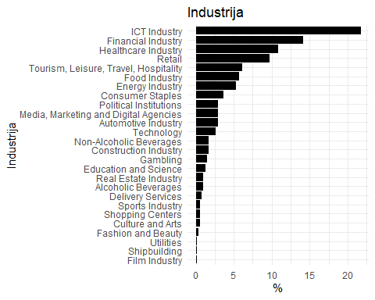

Pregled po industrijama

Industry

Broj objava

%

ICT Industry

118

21.73

Financial Industry

77

14.18

Healthcare Industry

59

10.87

Retail

53

9.76

Tourism, Leisure, Travel, Hospitality

33

6.08

Food Industry

31

5.71

Energy Industry

29

5.34

Consumer Staples

20

3.68

Political Institutions

16

2.95

Automotive Industry

16

2.95

Media, Marketing and Digital Agencies

16

2.95

Technology

14

2.58

Construction Industry

9

1.66

Non-Alcoholic Beverages

9

1.66

Gambling

8

1.47

Education and Science

7

1.29

Alcoholic Beverages

5

0.92

Real Estate Industry

5

0.92

Delivery Services

4

0.74

Sports Industry

3

0.55

Culture and Arts

3

0.55

Shopping Centers

3

0.55

Fashion and Beauty

2

0.37

Film Industry

1

0.18

Shipbuilding

1

0.18

Utilities

1

0.18

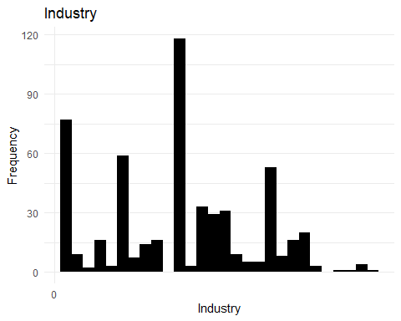

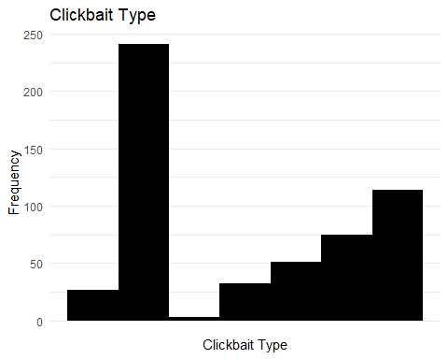

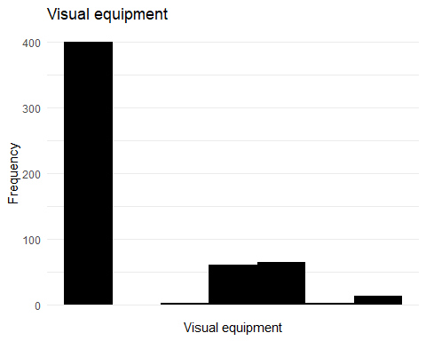

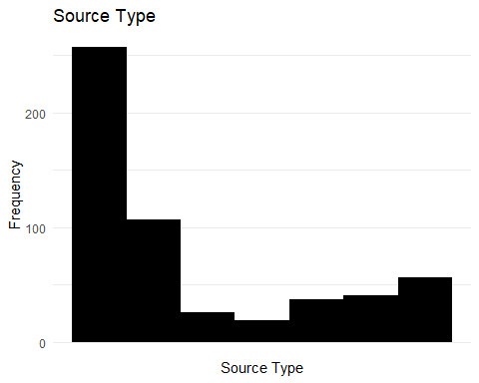

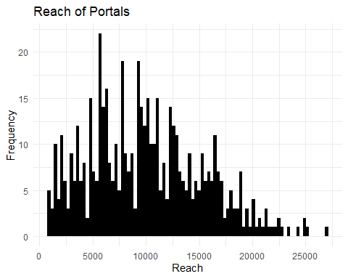

## Shapiro-Wilk test for normality

##   
## Shapiro-Wilk normality test  
##   
## data: dta$REACH  
## W = 0.59762, p-value < 2.2e-16

##   
## Shapiro-Wilk normality test  
##   
## data: filtered_dta$REACH  
## W = 0.9763, p-value = 1.282e-07

## Kruskal-Wallis test CLICKBAIT vs REACH

##   
## Kruskal-Wallis rank sum test  
##   
## data: REACH by CLICKBAIT  
## Kruskal-Wallis chi-squared = 28.45, df = 6, p-value = 7.728e-05

## Kruskal-Wallis test OPREMA vs REACH

kruskal.test(REACH ~ OPREMA, data = dta)

##   
## Kruskal-Wallis rank sum test  
##   
## data: REACH by OPREMA  
## Kruskal-Wallis chi-squared = 1.9535, df = 5, p-value = 0.8555

## Kruskal-Wallis test IZJAVA vs REACH

kruskal.test(REACH ~ IZVORI...IZJAVE , data = dta)

##   
## Kruskal-Wallis rank sum test  
##   
## data: REACH by IZVORI...IZJAVE  
## Kruskal-Wallis chi-squared = 33.341, df = 6, p-value = 9.015e-06

## Kruskal-Wallis test INDUSTRIJA vs REACH

kruskal.test(REACH ~ INDUSTRIJA , data = dta)

##   
## Kruskal-Wallis rank sum test  
##   
## data: REACH by INDUSTRIJA  
## Kruskal-Wallis chi-squared = 68.282, df = 25, p-value = 6.903e-06

## Chi-sq INDUSTRIJA vs IZVOR

chisq.test(dta$INDUSTRIJA, dta$IZVORI...IZJAVE)

## Warning in chisq.test(dta$INDUSTRIJA, dta$IZVORI...IZJAVE): Chi-squared  
## approximation may be incorrect

##   
## Pearson's Chi-squared test  
##   
## data: dta$INDUSTRIJA and dta$IZVORI...IZJAVE  
## X-squared = 254.72, df = 150, p-value = 2.036e-07

## Chi-sq INDUSTRIJA vs CLICKBAIT

chisq.test(dta$INDUSTRIJA, dta$CLICKBAIT)

## Warning in chisq.test(dta$INDUSTRIJA, dta$CLICKBAIT): Chi-squared approximation  
## may be incorrect

##   
## Pearson's Chi-squared test  
##   
## data: dta$INDUSTRIJA and dta$CLICKBAIT  
## X-squared = 264.45, df = 150, p-value = 2.4e-08

In determining clickbait headlines, the categorization provided by (Chen, Conroy, and Rubin 2015) was used: vague pronouns, uncertainty, reverse narrative style, emphasis on emotions, and the use of numbers. The study revealed that the most prevalent clickbait headlines were those characterized by uncertainty (44.38%). Multiple combinations of styles within headlines were observed in 13.81% of the ads, while 20.99% of the headlines exhibited no clickbait characteristics at all. Headlines dominated by numerical content appeared in 9.39% of cases, while 5.89% of headlines emphasized emotional appeal. Headlines using vague pronouns were noted in 4.97% of cases, and the reverse narrative style was registered in 0.55% of the ads.

Table 1: Prevalence and reach of clickbait headline characteristics in the analysed native ads (n=543)

Clickbait Type

Count

Mean Reach

Median Reach

Min Reach

Max Reach

Total Reach

Std. Deviation

Use of vague pronouns

27

11954.889

10701

5688

24296

322782

4770.362

Uncertainty

241

11202.718

10051

963

142818

2699855

10441.003

Reverse narrative style

3

6861.667

5688

5688

9209

20585

2032.850

Emphasis on emotions

32

7367.219

6125

1531

19962

235751

5062.087

Use of numbers

51

10610.373

10418

2129

18790

541129

3985.181

Multiple combinations

75

12504.333

10891

963

80240

937825

9946.855

Not a clickbait headline

114

8990.412

8400

963

32270

1024907

5974.087

In the further analysis of data displayed in Table 1, various clickbait headline techniques were examined to determine their effectiveness in driving audience engagement. The data provide insights into how different strategies influence the reach of advertisements, emphasizing the role of headlines as a primary trigger for audience interaction. This comprehensive analysis provides a clear view of the effectiveness of different clickbait headline techniques in engaging audiences. Techniques such as uncertainty and multiple combinations of clickbait elements stand out as particularly effective, while approaches like reverse narrative style and emphasis on emotions are less impactful in terms of reach.

In most of the analysed native ads (94.48%), the advertiser’s brand name was not mentioned in the headline, while in 5.52% of cases, or in thirty out of the 543 articles, the brand name was included in the headline. This is, of course, in line with the habitus of native advertising, which is subtle, unobtrusive, and does not immediately reveal that it is, in fact, advertising. Most headlines, 71.09%, were declarative sentences, while one-fifth of the headlines (20.26%) were interrogative, and 8.95% were exclamatory sentences. In terms of content characteristics of the observed native ads, it is noteworthy that all analysed ads featured visual content, with photographs being the most prominent, either alone or in combination with other types of visual content.

Table 2. Type of visual equipment (n=543)

Oprema

Count

Mean Reach

Median Reach

Min Reach

Max Reach

Total Reach

Std. Deviation

Photo content

400

10641.20

9396.0

963

142818

4256479

9394.578

Graphics or infographics

3

11003.67

14613.0

1283

17115

33011

8510.789

Photo and video content

60

10789.38

10163.5

1107

33929

647363

5745.285

Photo and graphics content

65

10561.25

10098.0

1356

39990

686481

6888.970

Video and graphics content

2

7569.00

7569.0

5163

9975

15138

3402.598

Photo, video, and graphics content

13

11104.77

11100.0

1873

20398

144362

5815.540

The advertiser’s logo, or elements of the advertiser’s visual identity, were included in the visual content of the analysed native ads in 34.44% of cases, while in 356 out of 543 analysed articles, this was not the case, meaning they did not contain a visual link to the advertiser.

Table 3. Representation of different types of sources in the statements and reach (n=543)

Source Type

Count

Mean Reach

Median Reach

Min Reach

Max Reach

Total Reach

Std. Deviation

No source / statement

257

10025.148

9396.0

963

33929

2576463

5281.731

Source from the organization / company

107

9940.280

8580.0

1107

80240

1063610

8622.927

Brand ambassador

26

10057.192

9719.0

1558

31308

261487

7743.891

Influencer / celebrity

19

14645.789

14797.0

9975

21300

278270

3371.755

Direct user of the product or service

37

9844.324

10051.0

2088

18962

364240

3873.951

Multiple sources

41

17113.122

12781.0

3211

142818

701638

21412.843

Source unrelated to the product or service

56

9591.536

8898.5

963

32380

537126

7276.383

In the analysis of Table 3, various types of sources were examined in relation to their impact on the reach of native ads. The findings reveal distinct differences in the effectiveness of advertising strategies based on the source type. Native ads featuring a statement from brand ambassador have an average reach of 10,057.192, similar in effectiveness to ads without a source. The median reach is 9,719, indicating consistent performance just below the mean. The minimum reach is 1,558, reflecting a decent baseline level of engagement. The maximum reach is 31,308 and the total reach is 261,487, which, while lower, still represents a significant impact given the smaller number of ads in this category.

As final of the categories, native ads featuring a statement given by influencer or celebrity achieve one of the highest average reaches at 14,645.789, indicating strong effectiveness compared to other types of sources. The median reach is 14,797, suggesting very consistent and high engagement. The minimum reach is 9,975, the highest minimum reach across all categories, showing that these ads generally perform well. The maximum reach is 21,300, indicating strong potential for high engagement, though not as high as ads using multiple sources. The total reach is 278,270, which is impressive given the relatively small number of ads, highlighting the high effectiveness of this strategy.

Table 4: Representation of different industries and reach (n=543)

Industry

Count

Mean Reach

Median Reach

Min Reach

Max Reach

Total Reach

Std. Deviation

Financial Industry

77

9954.519

9494.0

963

22011

766498

4996.629

Construction Industry

9

10097.556

11848.0

2158

15056

90878

4365.824

Fashion and Beauty

2

12362.500

12362.5

5122

19603

24725

10239.613

Political Institutions

16

14634.875

10436.5

5688

80240

234158

17810.104

Sports Industry

3

15844.333

18721.0

9209

19603

47533

5763.264

Healthcare Industry

59

7887.136

5688.0

963

39990

465341

7242.079

Education and Science

7

26258.143

6504.0

3118

142818

183807

51497.756

Technology

14

10315.214

8804.0

2042

30835

144413

7088.705

Automotive Industry

16

8804.438

8196.0

3163

17938

140871

4597.393

ICT Industry

118

10691.220

9975.0

1107

32380

1261564

6414.278

Culture and Arts

3

6309.000

7696.0

1632

9599

18927

4160.661

Tourism, Leisure, Travel, Hospitality

33

11049.424

10054.0

3675

33929

364631

5434.500

Energy Industry

29

10038.862

9396.0

963

22730

291127

5935.653

Food Industry

31

12482.355

12396.0

3150

25340

386953

5193.607

Non-Alcoholic Beverages

9

14011.889

12781.0

5688

27100

126107

7934.529

Alcoholic Beverages

5

4575.200

3212.0

1531

10996

22876

3708.727

Real Estate Industry

5

16369.200

16141.0

12693

22350

81846

3639.547

Retail

53

8918.717

7175.0

2042

22454

472692

4995.752

Gambling

8

12895.000

13300.0

9208

16672

103160

2345.400

Media, Marketing and Digital Agencies

16

11318.000

11188.0

2042

16526

181088

3784.881

Consumer Staples

20

14162.850

15062.0

7175

21381

283257

3924.731

Shopping Centers

3

9570.333

10611.0

5832

12268

28711

3341.821

Film Industry

1

10208.000

10208.0

10208

10208

10208

NA

Shipbuilding

1

9558.000

9558.0

9558

9558

9558

NA

Delivery Services

4

6601.250

5081.5

3754

12488

26405

4036.852

Utilities

1

15500.000

15500.0

15500

15500

15500

NA

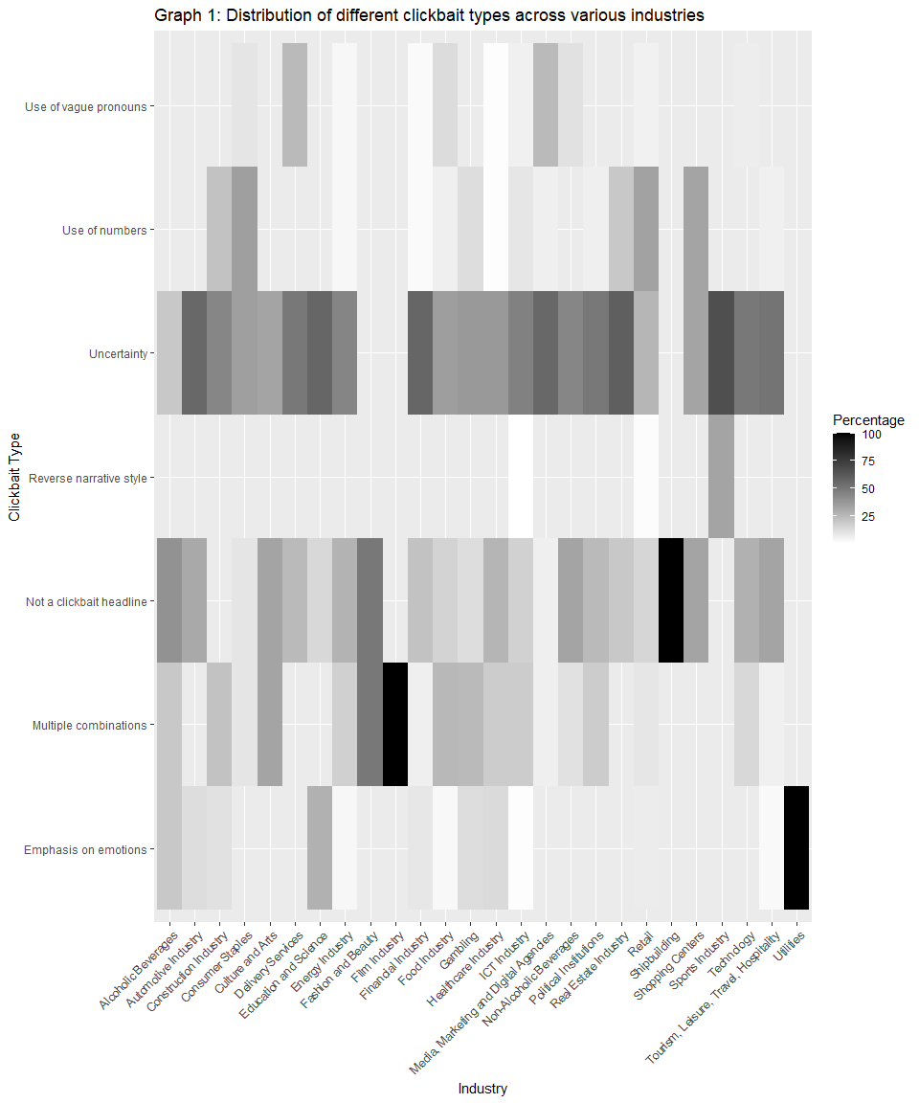

The Graph 1 illustrates the prevalence of various clickbait headline techniques across a range of industries. The chart visually represents how different sectors employ specific strategies to attract audience engagement, with colour intensity indicating the percentage of ads that utilize each technique within each industry (darkest shade of blue indicate maximal prevalence of each technique within the industry, while lighter shades close to purple and all the way to white, indicate lower intensity – as shown in legend).

In general, the data reveal that most industries adopt a mix of clickbait strategies, tailored to the nature of their content and target audience. However, distinct patterns emerge, showing that certain sectors exhibit a clear preference for specific techniques. For instance, industries dealing with uncertainty, especially in contemporary times, such as financial services, healthcare and energetics sector, tend to favour headlines that evoke uncertainty to engage readers, which is also most widely used technique across industries.

Conversely, sectors like shipbuilding prefer straightforward, non-clickbait headlines, likely reflecting the technical and factual nature of their content, while this technique is also widely used in fashion industry, as the data displayed in Histogram 1 is showing. When it comes to the specific types of clickbait, the use of multiple combinations of techniques is particularly prominent in the movie industry along with fashion, and arts & culture sector, indicating this strategic approach to maximizing engagement. The reverse narrative style, though generally less commonly used, finds notable application in the sports industry, suggesting that reversing the expected narrative could be effective in this sector. This technique is also used in minimal amounts in retail and ICT industries, while the other industries tend not to apply this strategy in their native advertising.

Vague pronouns is also lesser used technique, and it is more favoured approach in media, marketing and digital agencies, along with postal services. In contrast, emotional emphasis is more frequently used in the utility services sector, science and education and alcoholic beverages industry, where emotionally charged messaging can influence consumer behaviour. The use of numbers in headlines is moderately preferred in the retail industries, along with furniture and home appliances industry, and shopping centres where presenting clear, quantifiable information can appeal to a detail-oriented audience.

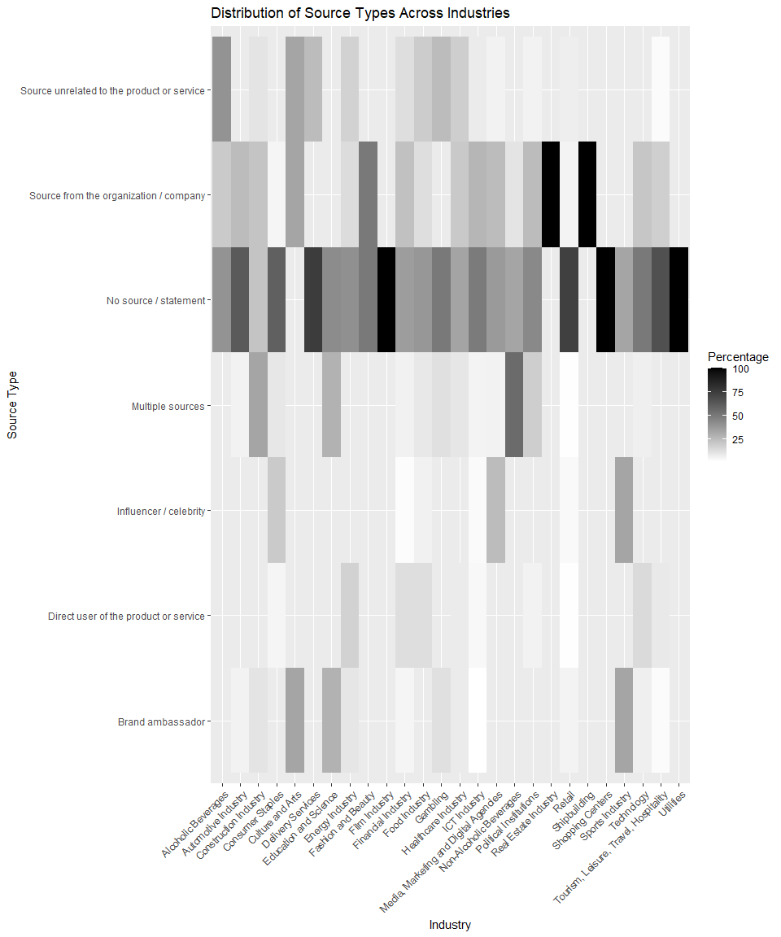

The Graph 2 illustrates how different types of sources are distributed across various industries in the context of advertising or content creation. The vertical axis lists the source types, while the horizontal axis represents different industries.

In general, the histogram shows that industries tend to favour certain source types depending on the nature of the industry and its target audience. For example, the “No Source or Statement” category is prominently used across multiple industries, particularly in the movies industry, utility services sector and shopping centres, with maximum prevalence in those areas. The same category, which implies lacking any sources in native adverts is also widely used in automotive industries, along with retail, furniture and home appliances tourism, and postal services. This technique is significantly present in all of industries except shipbuilding, real estate and arts & culture sector, with no articles without statement in this analysis. The use of sources from within the organization or company is second most widely employed technique, and it is most common in sectors like shipbuilding and real estate, where insider knowledge and authority are crucial for establishing trust with the audience. Fashion and beauty industry also widely use this approach, along with arts & culture and ICT sectors, and in political institutions.

The use of multiple sources is widespread, particularly in the non-alcoholic beverages industry, construction industry, along with science and education sector and political institutions, indicating that these industries may benefit from leveraging diverse references to enhance credibility and appeal to a more discerning audience. The “Direct User of the Product or Service” category of statements in analysed native articles is used in energetics, technological, financial, and food industries, reflecting the importance of authentic, relatable endorsements in areas where personal experience is particularly valued by consumers, but this category is generally used in lesser amount within different industries compared to other industries.

Industries such as alcoholic beverages and arts & culture occasionally employ sources unrelated to the product or service, which is the technique also used in betting & lottery sector and postal services, most probably to introduce a fresh perspective or to lend authority from a seemingly impartial standpoint. This technique is less common but can be effective in adding an element of unexpected credibility.

The “Influencer/Celebrity” category is notably prominent in sports industry, and is also used in media, marketing and digital agencies, along with furniture and home appliances industry, implying that these sectors rely on aspirational appeal and the social influence of well-known figures to drive engagement. Similarly to previous category, the use of brand ambassadors shows strength in sports industry, where a consistent and trustworthy spokesperson can help bridge the gap between complex products and the consumer, but this technique is also used in arts & culture and science & education sectors.

Pored deskriptivnog pregleda podataka, provedena je i statistička analiza razlika u dosegu publike između različitih stilova clickbaita, vrste opreme, tipa izvora i industrija te statistička analiza povezanosti industrija i tipova izvora, te industrija i stilova clickbaita. Pošto Shapiro-Wilk test normalnosti distribucije za podatke o dosegu publike(W=0. 9763,p<0.001) ukazuje na značajno odstupanje od normalne distribucije, za testiranje razlika u dosegu publike korišten je neparametrijski Kruskal-Wallisov test.

Kruskal-Wallisov test razlike u dosegu publike s obzirom na prisutnost karakteristika clickbaita (χ2=28.45, p<0.001) je potvrdio postojanje statistički značajnih razlika. Sukladno tome je moguće zaključiti da upotreba clickbaita u naslovima značajno utječe na doseg publike, pri čemu određeni stilovi clickbaita potencijalno privlače veću pažnju i angažman. Postojanje značajne razlike u dosegu publike također je potvrtrđeno s obzirom na tip izvora korištenih u oglasima (χ2=33.34, p<0.001). Takav rezultat u ukazuje da različite vrste izvora, kao što su direktna svjedočanstva korisnika ili predstavnici organizacija, imaju mjerljiv utjecaj na uspjeh članka. Nadalje, industrija u kojoj su oglasi objavljeni također ima značajan utjecaj na doseg (χ2=68.28, p<0.001) pa je moguće ustvrditi da određene industrije učinkovitije angažiraju publiku. S druge strane, Kruskal-Wallisov test nije pokazao značajne razlike u dosegu s obzirom na vrstu korištene opreme (χ2=1.95, p=0.8555), što ukazuje da vrsta opreme spomenuta u sadržaju nema utjecaj na doseg. Provedeni testovi neovisnosti kategorija su potvrdili postojnje značajne povezanosti između industrija i tipova korištenih izvora te upotrebe clickbaita (χ2=254.72, p<0.001) te između industrija i karakteristika clickbaita (χ2=264.45, p<0.001). Takvi rezultati ukazuju da različite industrije preferiraju specifične vrste izvora u svojim oglasima te različite industrije koriste različite clickbait strategije.

Općenito je moguće zaključiti da rezultati naglašavaju značajnu ulogu clickbait naslova, vjerodostojnosti izvora i vrste industrije u utjecaju na doseg publike. Nalazi također pokazuju da, iako neki faktori, poput opreme, nemaju značajan utjecaj na doseg, druge karakteristike sadržaja ključni su pokretači uspjeha u digitalnom oglašavanju. Dodati što pokazuju industrije…jednom rečenicom ili dvije.

# Conclusion

The theoretical basis of this paper was the thesis that native advertising is “an extension of content marketing and provides marketers with a platform to place content in front of a wider audience they wouldn’t ordinarily reach” (Crook, 2022). Although there are authors who highlight certain criteria by which content marketing differs from native advertising, the ultimate goal is common: to drive profitable customer action. Based on the findings of this research, several conclusions can be drawn. The analysis of 543 native ads published on six Croatian online portals reveals a predominant use of clickbait headlines, with nearly 80% of headlines containing at least one clickbait characteristic. The most frequently employed technique is the style of uncertainty, which significantly contributes to audience engagement, as evidenced by its high average and total reach. This indicates that uncertainty-driven headlines are particularly effective in attracting readers. This is evidence that advertisers, through their content, aim to promote a “culture of fear”, a concept typically explored by sociologists (Maskalan, 2014; Furedi, 1997) in the context of political actions, but which is also applicable in the advertising industry. This is particularly due to the fact that fear/insecurity appeals can encourage people to change their attitudes and purchasing preferences (Foxall et al., 2007; Kesić, 2003). Martin Lindstrom (2008) anticipated that contemporary advertising would increasingly be based on somatic markers triggered by fear and a sense of insecurity. In other words, advertisers will try to convince us that by not purchasing their product, we become insecure, dissatisfied, and unfree, which is evident in this analysis as well.

Interestingly, a smaller portion of the headlines (5.52%) mentioned the brand, suggesting that most ads are neutral in terms of direct brand promotion. All analysed ads included visual elements, with photographs being the most common, either alone or combined with other types of visual content. The presence of the advertiser’s logo or elements of their visual identity in 34.44% of the ads further underscores the importance of visual branding in native advertising.

Regarding the content characteristics of native ads, the analysis also considered the types of sources or statements used. The data show that almost half of the ads did not include any statements or sources, which is particularly common in certain industries such as retail, utility services, and shopping centres. When sources were used, the most frequent were individuals from the organization or company, indicating the value placed on insider credibility. Multiple sources and unrelated sources were less commonly used, but they demonstrated strong potential for high engagement, particularly when diverse perspectives were presented. The effectiveness of different source types varies across industries. For instance, the use of multiple sources is most effective in the non-alcoholic beverages and construction industries, where diverse references can enhance credibility. In contrast, direct user testimonials are more effective in sectors like technology and finance, where personal experience adds value to the advertising message. Clickbait techniques such as the use of numbers and vague pronouns also show varying levels of effectiveness depending on the industry. The retail and furniture industries, for example, favour the use of numbers to appeal to detail-oriented audiences. In contrast, emotional emphasis is more commonly used in sectors like utility services and education, where emotionally charged content can influence consumer behaviour.

Overall, this research highlights the strategic use of clickbait headlines and source types in native advertising as a content marketing strategy. The findings suggest that while certain techniques like uncertainty and multiple sources are particularly effective, the choice of strategy should be carefully tailored to the industry and target audience to maximize engagement. The data underscore the importance of understanding the specific characteristics and preferences of different sectors when designing native ads, as well as the significant role of visual content and source credibility in achieving advertising success.

# References

Baker, K. 2024. “The Ultimate Guide to Content Marketing in 2024.” <https://blog.hubspot.com/marketing/content-marketing>.

Balasubramanian, S. K. 1994. “Beyond Advertising and Publicity: Hybrid Messages and Public Policy Issues.” *Journal of Advertising* 23 (4): 29–46.

Beckert, J., T. Koch, B. Viererbl, N. Denner, and C. Peter. 2020. “Advertising in Disguise? How Disclosure and Content Features Influence the Effects of Native Advertising.” *Communications* 45 (3): 303–24.

Bloomstein, M. 2012. *Content Strategy at Work*. Waltham, MA: Elsevier.

Campbell, C., and L. J. Marks. 2015. “Good Native Advertising Isn’t a Secret.” *Business Horizons* 58 (6): 599–606.

Chen, Yimin, Niall J. Conroy, and Victoria L. Rubin. 2015. “Misleading Online Content: Recognizing Clickbait as ‘False News’.” In *Proceedings of the 2015 ACM on Workshop on Multimodal Deception Detection*, 15–19. ACM.

Cole, J. T., and J. D. Greer. 2013. “Audience Response to Brand Journalism: The Effect of Frame, Source, and Involvement.” *Journalism & Mass Communication Quarterly* 90 (4): 673–90.

Crook, I. 2022. “Native Advertising Vs Content Marketing. What’s the Difference?” <https://www.nativeadvertisinginstitute.com/blog/difference-between-native-advertising-and-content-marketing>.

Dietrich, G. 2014. *Spin Sucks: Communication and Reputation Management in the Digital Age*. Que Publishing.

Du Plessis, C. 2015a. “Academic Guidelines for Content Marketing: Research-Based Recommendations for Better Practice.” In *ECSM2015 - Proceedings of the 2nd European Conference on Social Media 2015*, 122.

———. 2015b. “An Exploratory Analysis of Essential Elements of Content Marketing.” In *Proceedings of the 2nd European Conference on Social Media*, edited by A. Mesquita and P. Peres, 122–29. ACAD CONFERENCES LTD.

———. 2022. “A Scoping Review of the Effect of Content Marketing on Online Consumer Behavior.” *Sage Open* 12 (2).

E-marketer. 2023. “US Native Ad Spending, 2019-2023.” <https://www.insiderintelligence.com/chart/261233/US-Native-Ad-Spending-2019-2023-billions-change-of-total-display-ad-spending>.

Halligan, B., and D. Shah. 2010. *Inbound Marketing*. Hoboken, NJ: Wiley.

Halvorson, K., and M. Rach. 2012. *Content Strategy for the Web*. Berkeley, CA: New Riders.

Handley, A., and C. C. Chapman. 2011. *Content Rules*. Hoboken, NJ: Wiley.

Ho, J., C. Pang, and C. Choy. 2020. “Content Marketing Capability Building: A Conceptual Framework.” *Journal of Research in Interactive Marketing* 14 (1): 133–51.

Holliman, G., and J. Rowley. 2014. “Business to Business Digital Content Marketing: Marketers’ Perceptions of Best Practice.” *Journal of Research in Interactive Marketing* 8 (4): 269–93.

Howe, P., and B. Teufel. 2014. “Native Advertising and Digital Natives: The Effects of Age and Advertisement Format on News Website Credibility Judgments.” *ISOJ* 4 (1): 78–90.

(IAB), Interacting Advertising Bureau. 2019. “Native Advertising Playbook 2.0.” <https://www.iab.com/wp-content/uploads/2019/05/IAB-Native-Advertising-Playbook-2_0_Final.pdf>.

Institute, Content Marketing. n.d. “What Is Content Marketing?” <https://contentmarketinginstitute.com/what-is-content-marketing/>.

Jefferson, S., and S. Tanton. 2015. *Valuable Content Marketing*. London: Kogan Page.

Jung, A., and J. Heo. 2018. “Ad Disclosure Vs. Ad Recognition: How Persuasion Knowledge Influences Native Advertising Evaluation.” *Journal of Interactive Advertising* 19 (1): 9–14.

Kim, J. 2017. “Native Advertising: Current Status and Research Agenda.” *Journal of Interactive Advertising* 17 (2): 79.

Kloot, L. 2022. “Top Native Advertising Statistics for 2022.” <https://www.outbrain.com/blog/native-advertising-statistics/>.

Koiso-Kanttila, N. 2004. “Digital Content Marketing: A Literature Synthesis.” *Journal of Marketing Management* 20 (1-2): 45–65.

Krouwer, S., K. Poels, and S. Paulussen. 2020. “Moving Towards Transparency for Native Advertisements on News Websites: A Test of More Detailed Disclosures.” *International Journal of Advertising* 39 (1): 51–73.

Macnamara, J. 2014. “Journalism–PR Relations Revisited: The Good News, the Bad News, and Insights into Tomorrow’s News.” *Public Relations Review* 40 (5): 739–50.

Macnamara, J., M. Lwin, A. Adi, and A. Zerfass. 2016. “‘PESO’ Media Strategy Shifts to ‘SOEP’: Opportunities and Ethical Dilemmas.” *Public Relations Review* 42 (3): 377–85.

Nielsen. 2015. “Global Trust in Advertising: Winning Strategies for an Evolving Landscape.” <https://www.nielsen.com/wp-content/uploads/sites/2/2019/04/global-trust-in-advertising-report-sept-2015-1.pdf>.

Opreana, A., and S. Vinerean. 2015. “A New Development in Online Marketing: Introducing Digital Inbound Marketing.” *Expert Journal of Marketing* 3 (1): 29–34.

Patrutiu Baltes, L. 2015. “Content Marketing - the Fundamental Tool of Digital Marketing.” *Bulletin of the Transilvania University of Braşov. Series V: Economic Sciences* 8 (2): 111–18.

Peruško, Z. 2023. “Croatia: Reuters Institute for the Study of Journalism.” <https://reutersinstitute.politics.ox.ac.uk/digital-news-report/2023/croatia>.

Publishers, Vibrant. 2020. *Digital Marketing. Essentials You Always Wanted to Know*. Vibrant Publishers.

Pulizzi, J. 2014. *Epic Content Marketing. How to Tell a Different Story, Break Through the Clutter, and Win More Customers by Marketing Less*. McGraw Hill Education.

Pulizzi, J., and Piper. 2023. *Epic Content Marketing. Break Through the Clutter with a Different Story, Get the Most Out of Your Content, and Build a Community in Web3*. McGraw Hill Education.

Ríos, A. 2016. “The Impact of the Digital Revolution in the Development of Market and Communication Strategies for the Luxury Sector (Fashion Luxury).” *Central European Business Review* 5: 17–36.

Rowley, J. 2008. “Understanding Digital Content Marketing.” *Journal of Marketing Management* 24 (5-6): 517–40.

Taiminen, K., V. Luoma-aho, and K. Tolvanen. 2015. “The Transparent Communicative Organization and New Hybrid Forms of Content.” *Public Relations Review* 41 (5): 734–43.

Trbušić, D., D. Maleš, and L. Šikić. 2024. “Obilježja Nativnog Oglašavanja Na Najčitanijim Hrvatskim Internetskim Portalima.” *Medijska Istraživanja* 30 (1): 153–76.

Tutaj, K., and E. A. Van Reijmersdal. 2012. “Effects of Online Advertising Format and Persuasion Knowledge on Audience Reactions.” *Journal of Marketing Communications* 18 (1): 5–18.

Verčič, D., and A. Tkalac Verčič. 2016. “The New Publicity: From Reflexive to Reflective Mediatisation.” *Public Relations Review* 42 (4): 493–98.

Vinerean, S. 2017. “Content Marketing Strategy. Definition, Objectives and Tactics.” *Expert Journal of Marketing* 5 (2): 92–98.

Wang, Y., and Y. Li. 2017. “Understanding ‘Native Advertising’ from the Perspective of Communication Strategies.” *Journal of Promotion Management* 23 (6): 913–29.

Wojdynski, B. W., and N. J. Evans. 2016. “Going Native: Effects of Disclosure Position and Language on the Recognition and Evaluation of Online Native Advertising.” *Journal of Advertising* 45 (2): 157–68.

Wu, L., and H. Overton. 2021. “Is Native Advertising Effective for Corporate Social Responsibility Messaging? How Advertising Recognition Affects Consumer Responses to Proactive Versus Reactive Csr.” *Journal of Advertising Research* 61 (4): 382–96.

Wuebben, J. 2011. *Content Is Currency*. Boston, MA: Nicholas Brealey.