***Install Jenkins server on local or remote machine, change port;***

Jenkins has been installed on Windows 10 machine. The port has been changed from the jenkins.xml file :--httpPort=8081

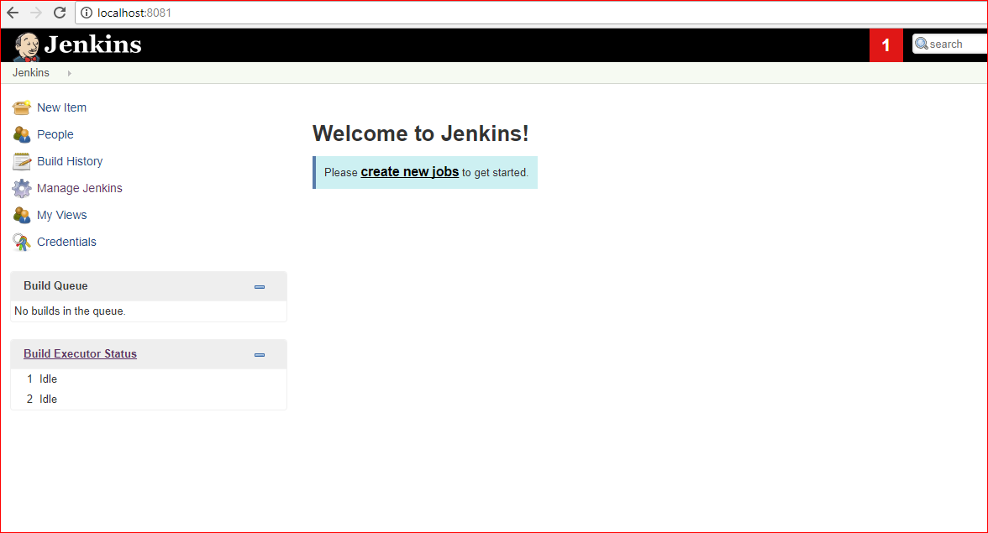

*Create slave node on remote or local machine (you may use the same (one) machine for master and slave);*

* Go to Manage Jenkins → Configure Global Security → set Agents to random

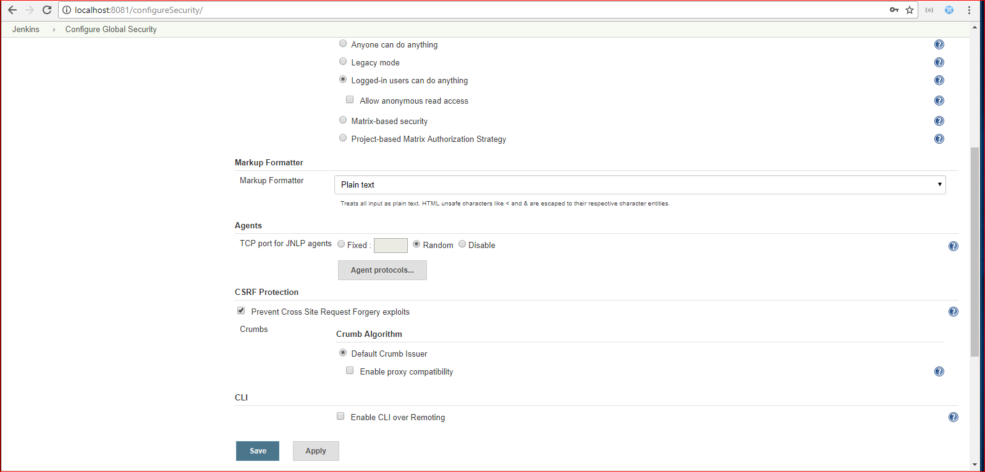

* Create slave node: Go to Manage Jenkins → Manage nodes → New Node → set the name of slave node → Mark the Permanent Agent and click OK

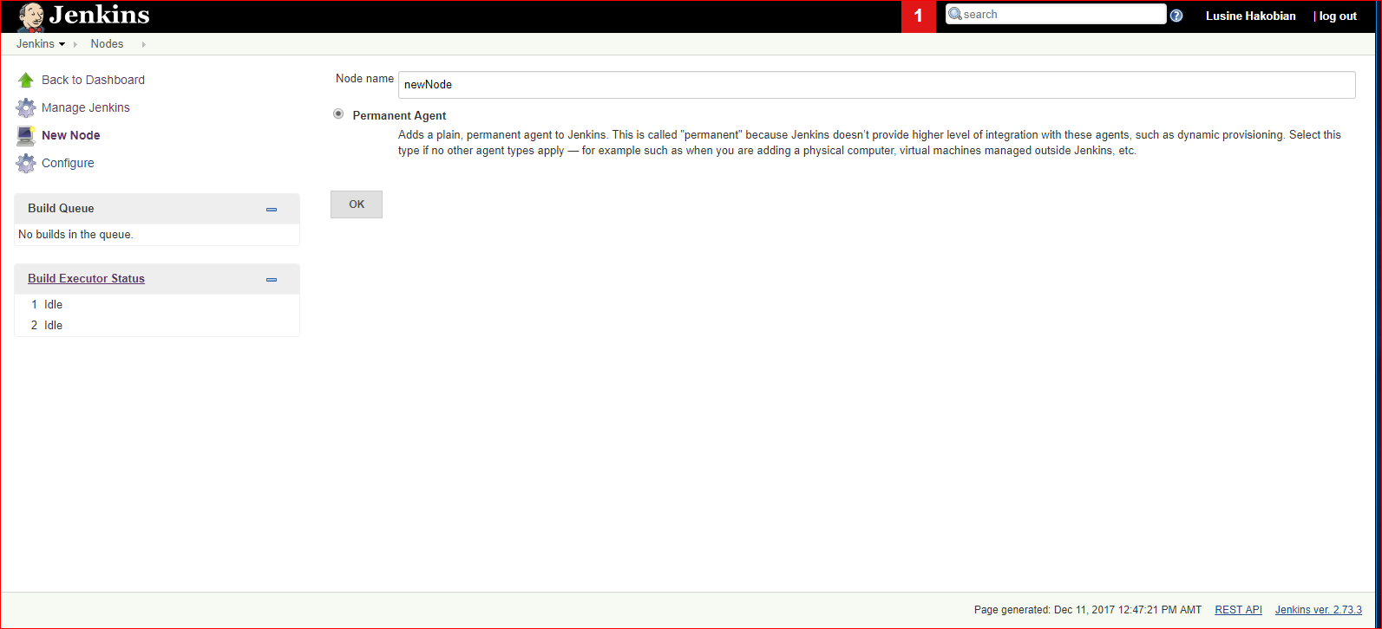

* In the Opened window enter the node name, remote directory path, label, Launch method

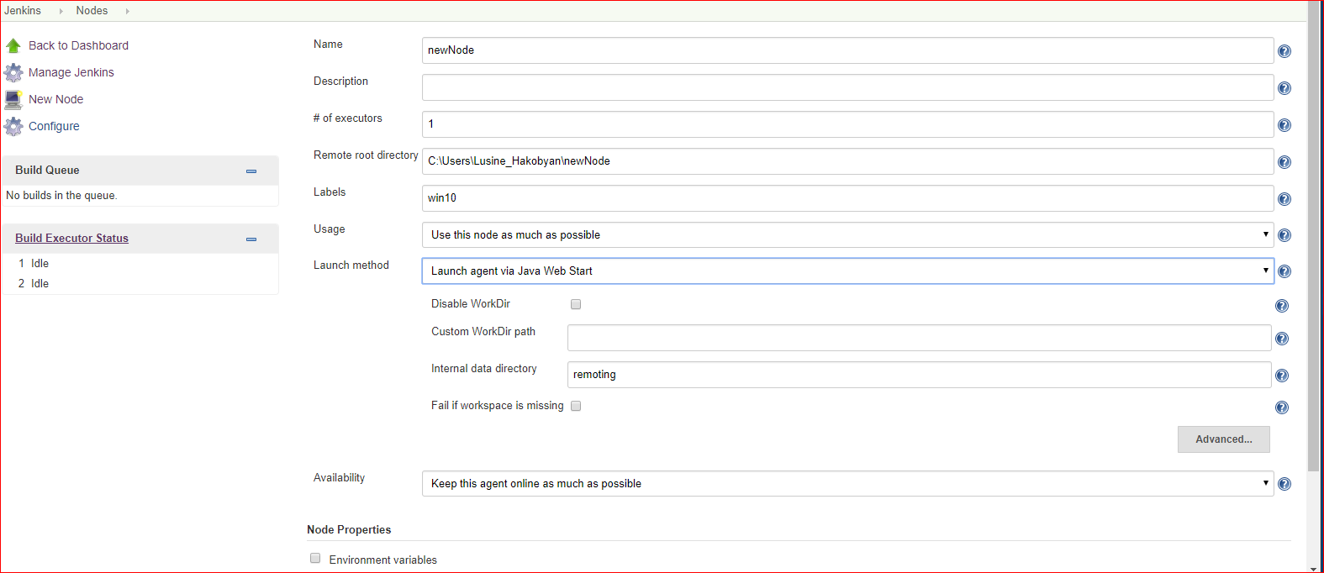

* Go to Manage Jenkins → Configure System → set computer name instead of localhost

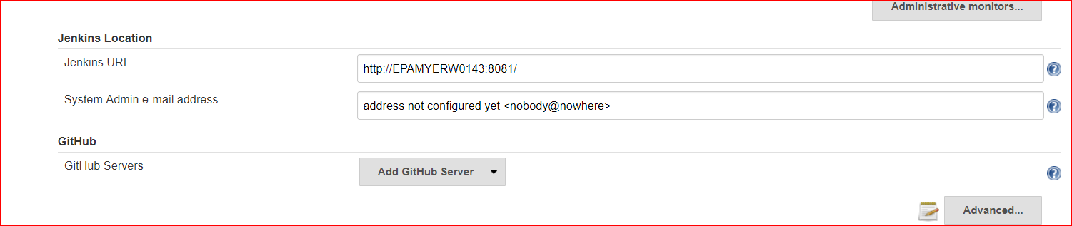

* Download slave.jar from the opened window and run the mentioned command from command line:

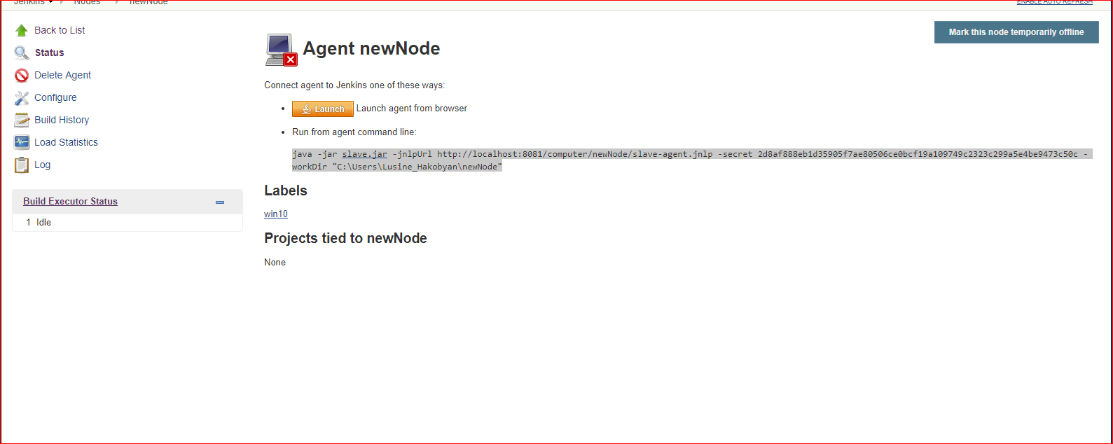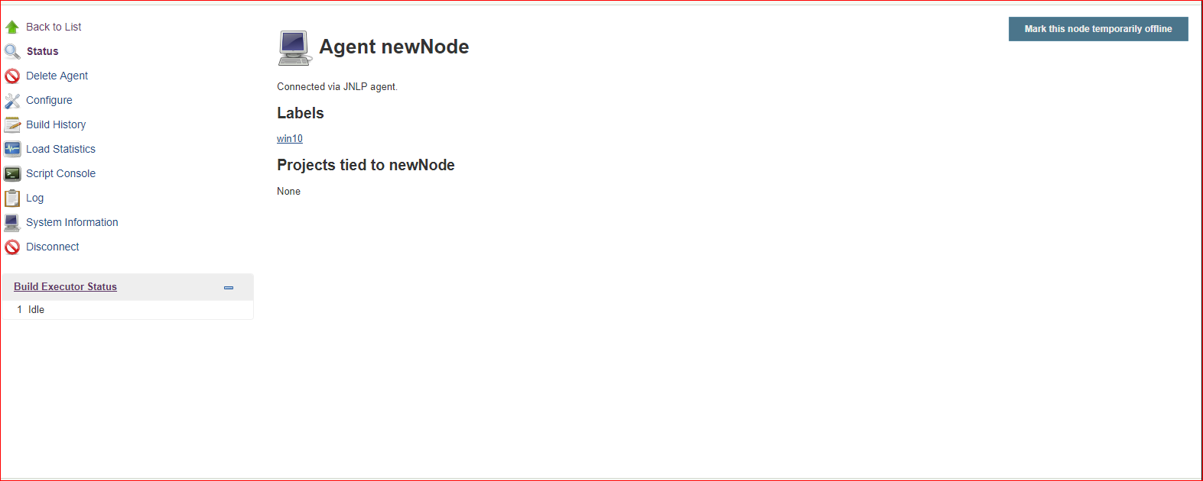

2. Job Configuration

Click on Create New Job → set the name, choose freestyle project.



Make sure that Git plugin and GitHub plugin are installed.

From Source Code Management select git and add path to the repository

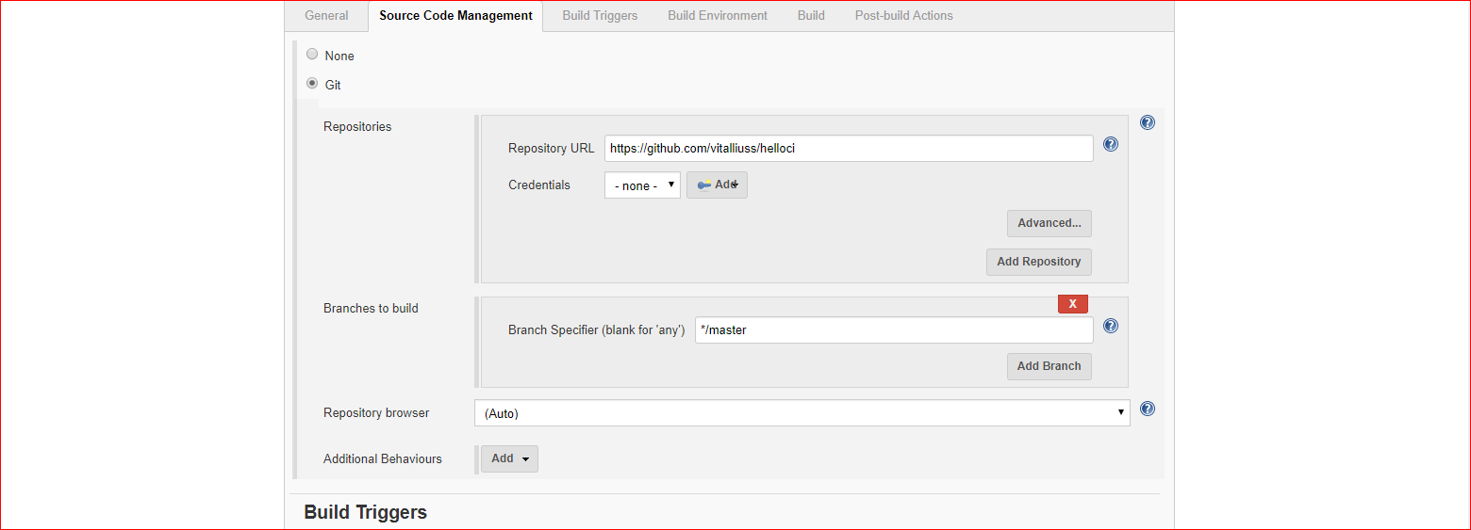

From Git Triggers section select the following options:

* Build periodically – For the midnight builds
* GitHub hook trigger for GITScm polling and Poll SCM(check the checkbox Ignore post-commit hooks) – for the builds after commit to VSC

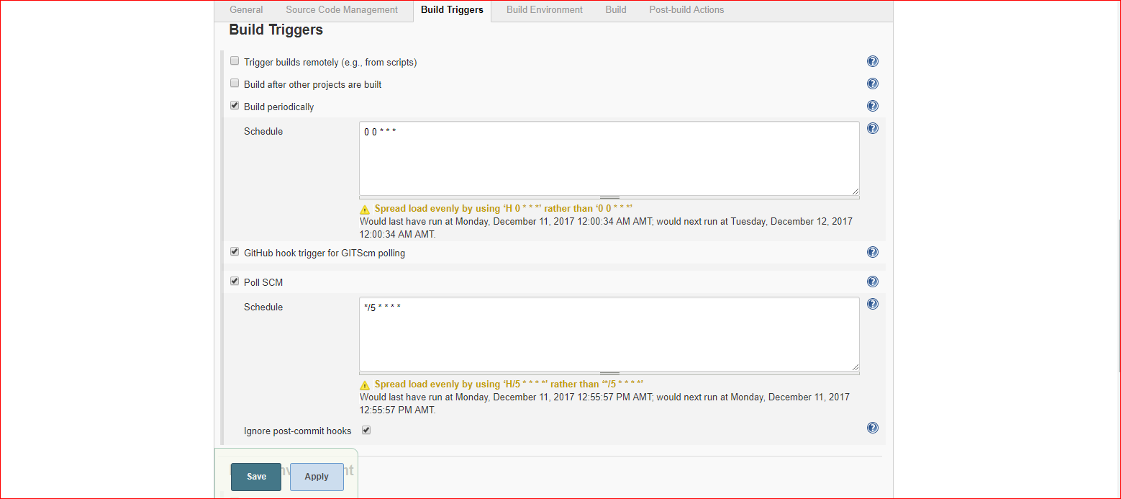

From Build choose 'Invoke top-level Maven Targets' . Set the goal 'test', and for the POM path to pom.xml(Java/pom.xml for this case)

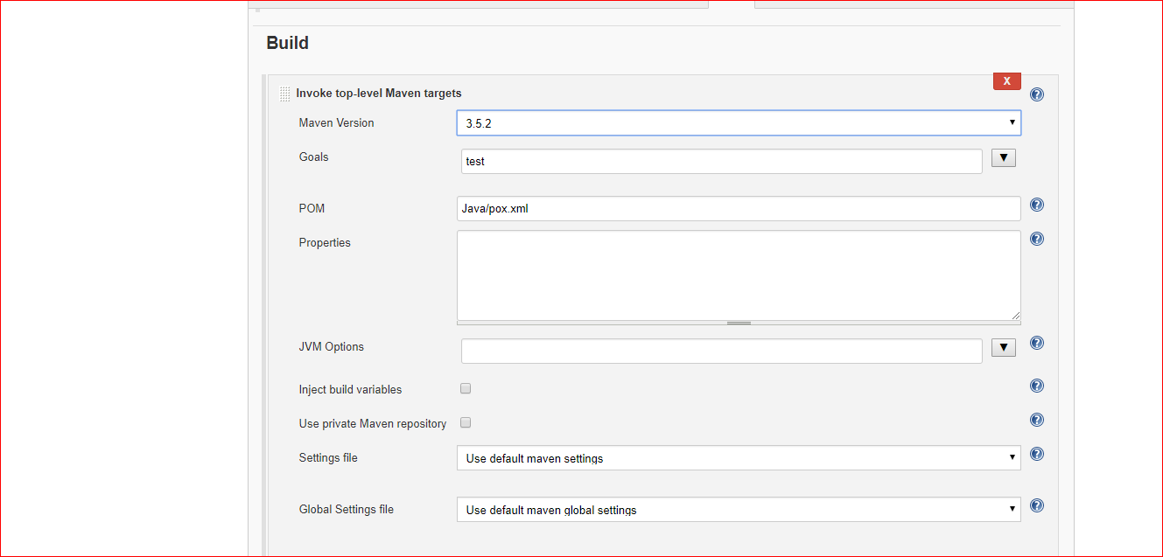

Also we need to specify git, Maven paths and versions from Manage Jenkins → Global Tool Configuration.

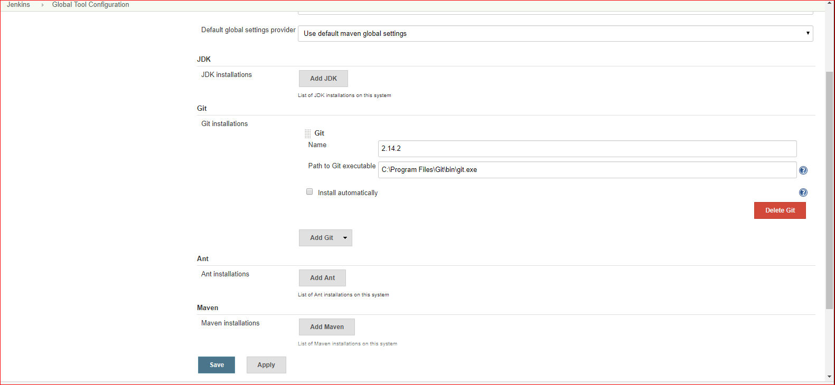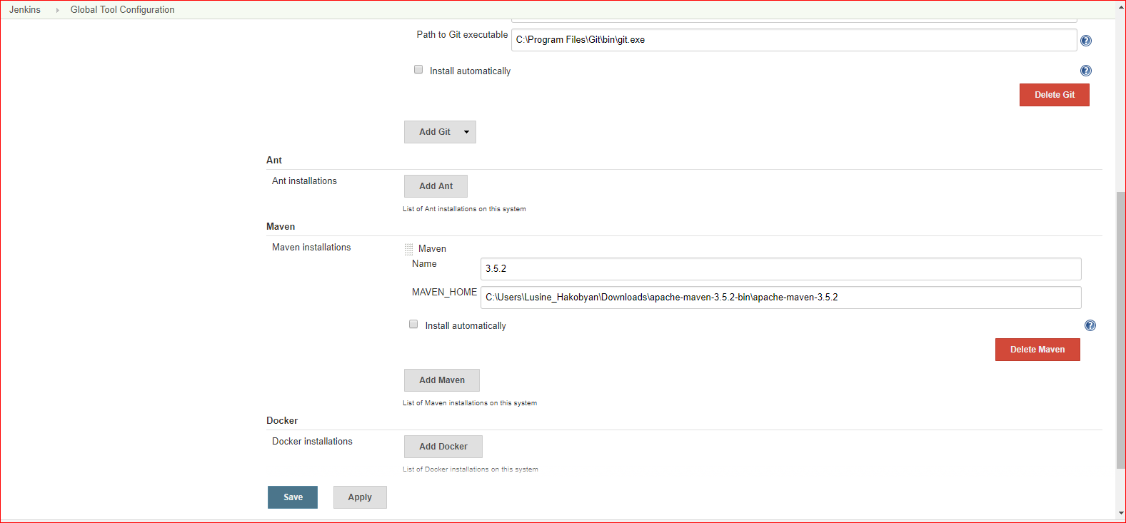

Job should run on slave only:

Connect project to slave node:

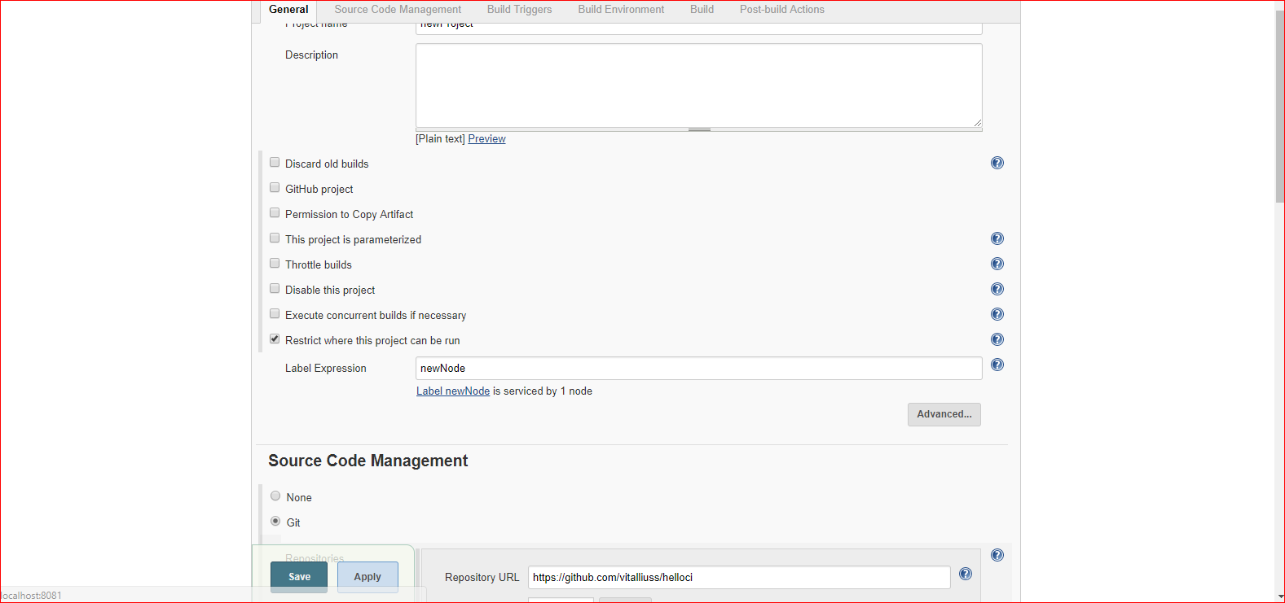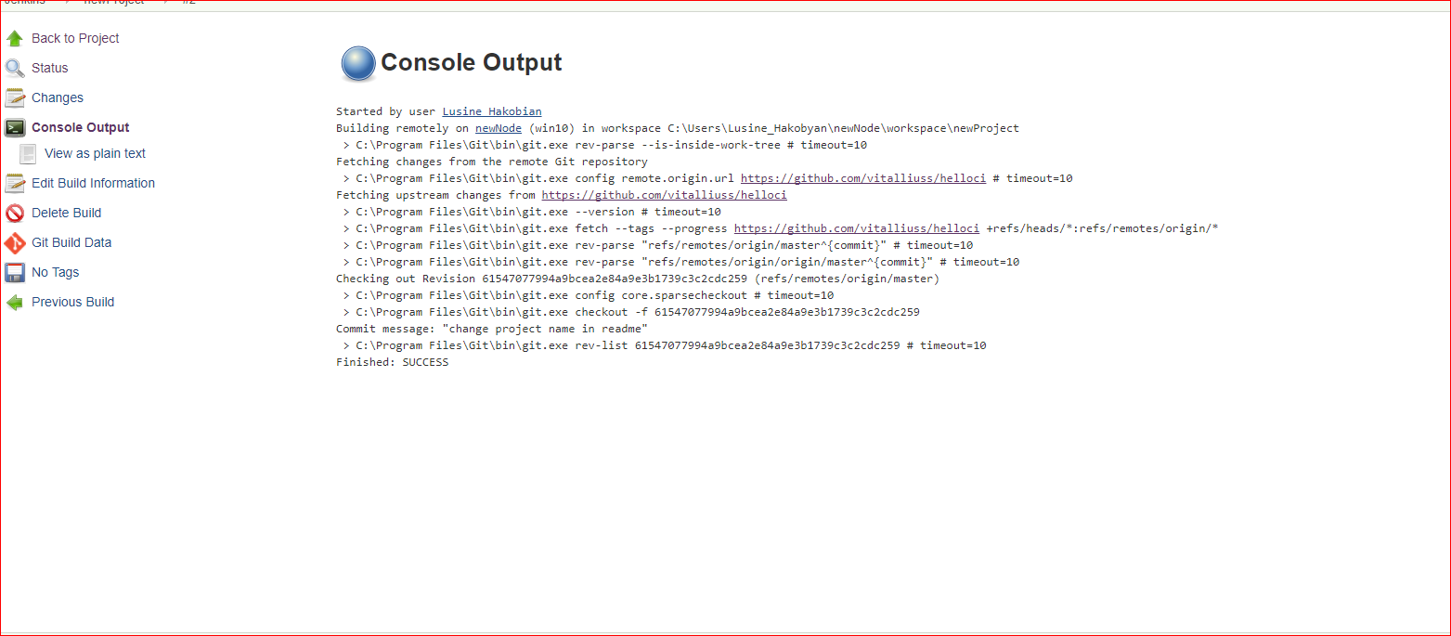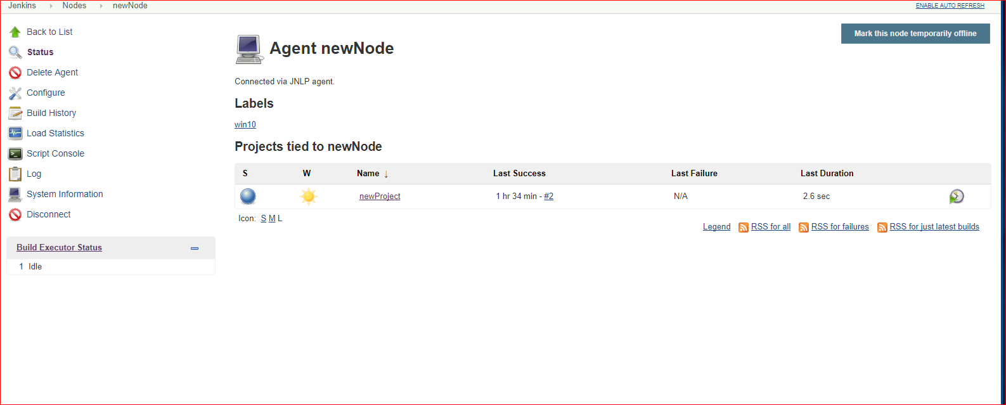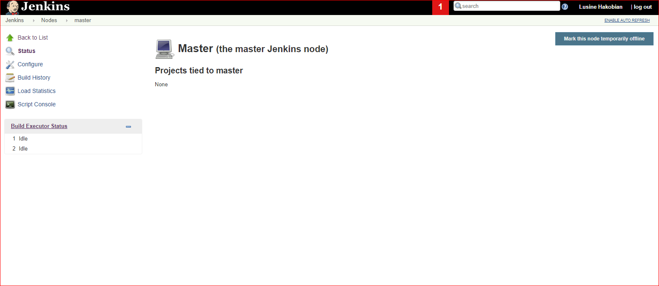

**Jenkins installation and configuration on Linux(Ubuntu 14.04)**

Jenkins has been installed on Ubuntu 14.14 using the following command:

sudo apt-get install jenkins

Port has been changed from the '/etc/default/jenkins' file, setting the value of HTTP_PORT=8081

For slave nodes creation there is need to do the same steps as in windows OS.

Go to Manage Jenkins → Configure Global security → set Agents to Random

Create slave node from → Manage Jenkins → manage Nodes → new Nodes . In the opened window specify node name, choose Permanent Agent and clock on 'OK' button.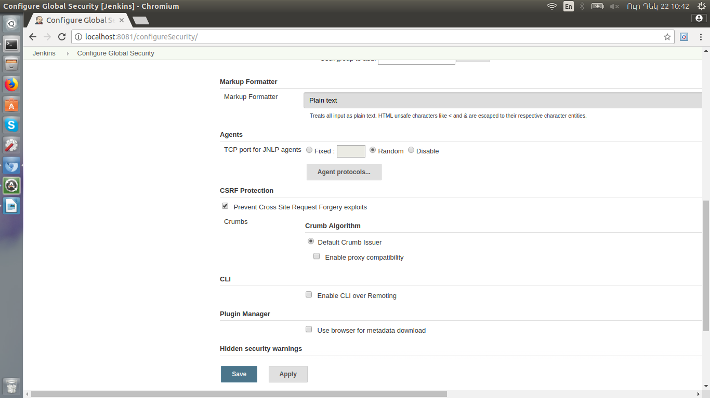

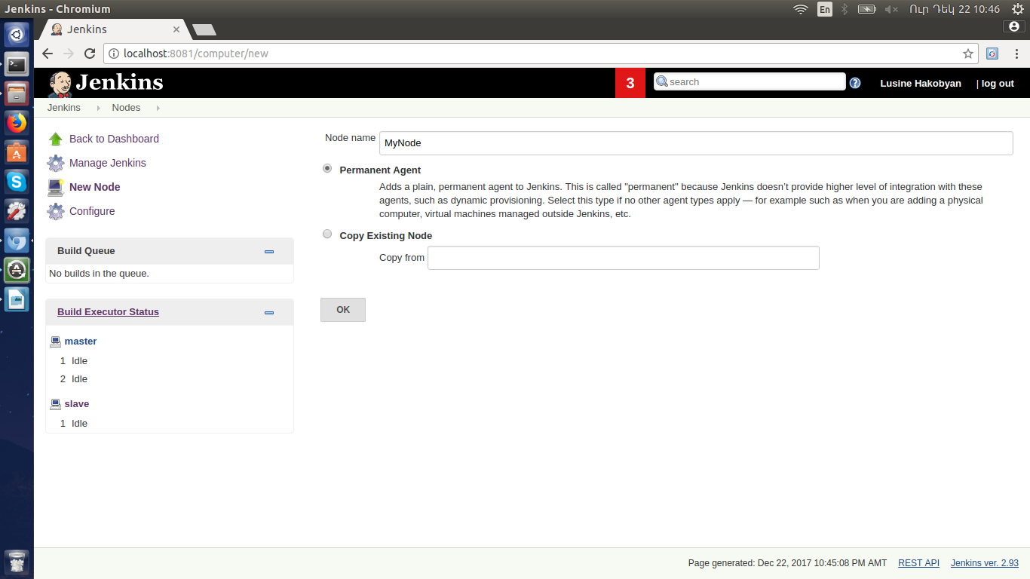

Specify 'Remote directory name', Label, Launch method'

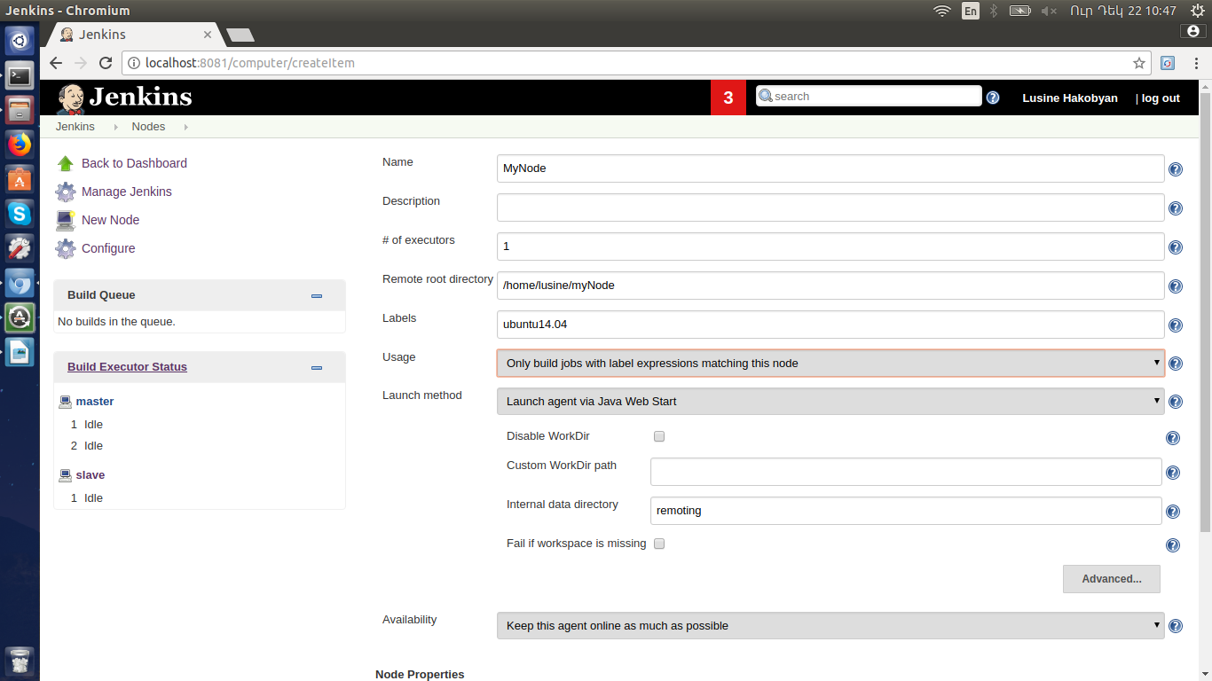

Then there is need to download agent.jar and run the provided command from Linux terminal:

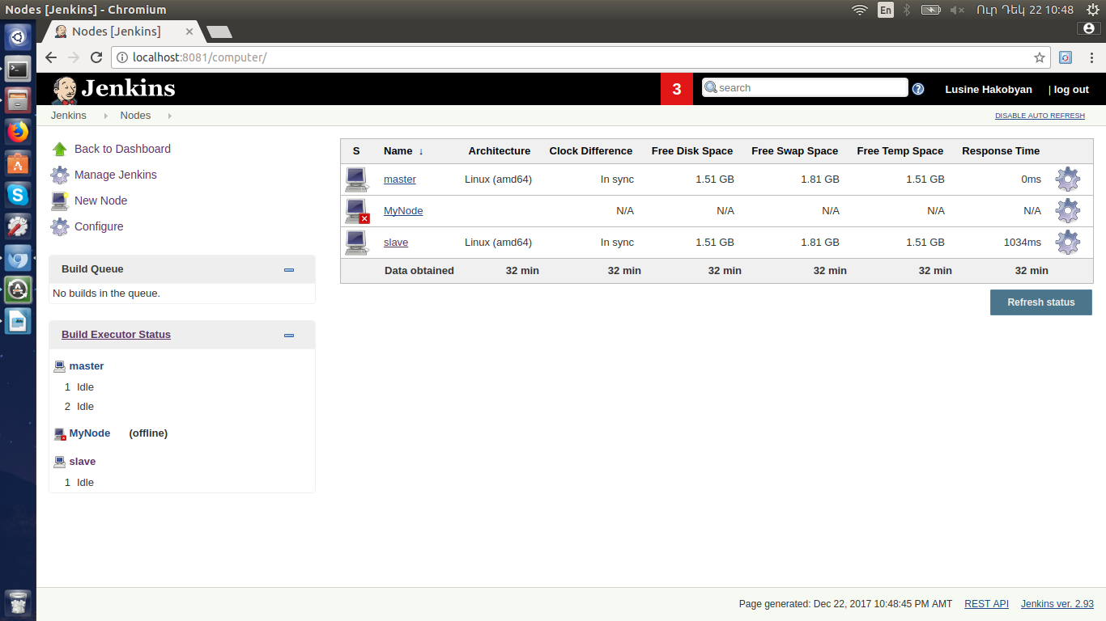

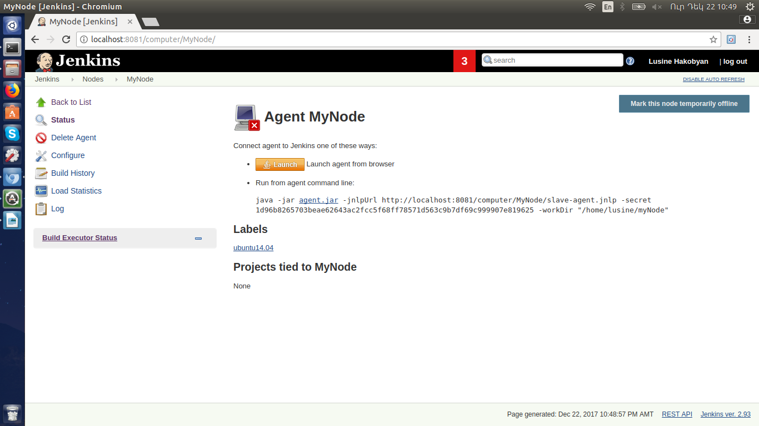

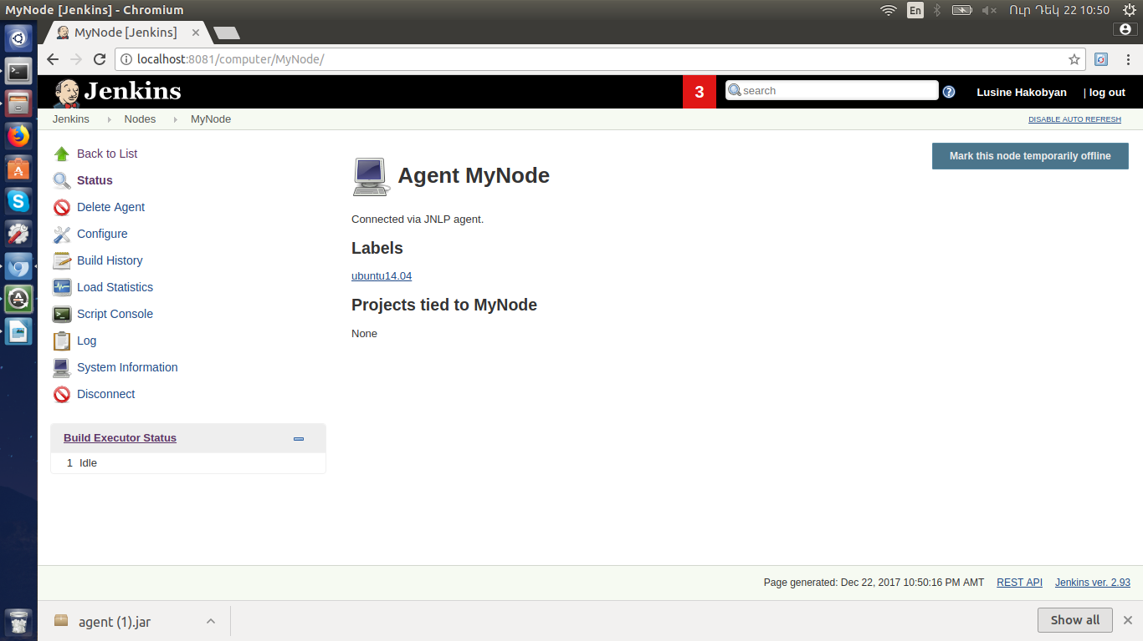

There is need to specify git and Maven paths and version from Manage Jenkins → Global Tool Configuration:

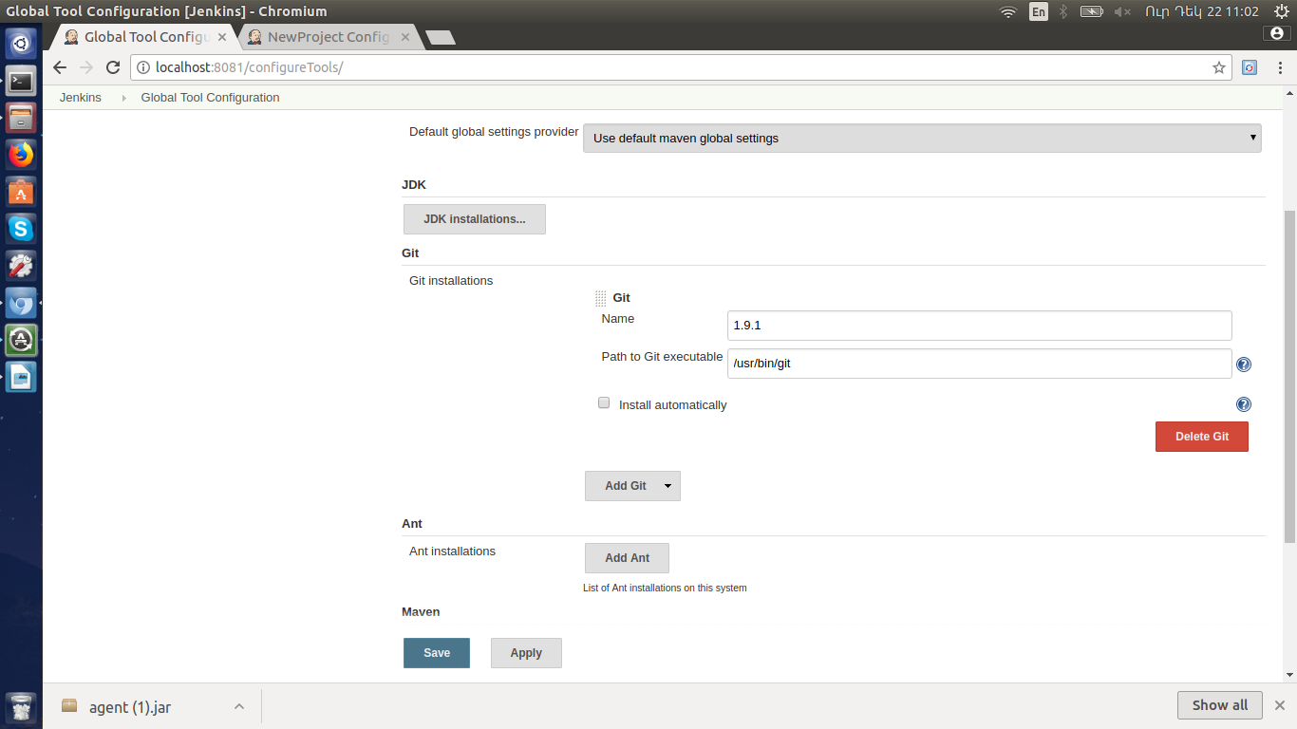

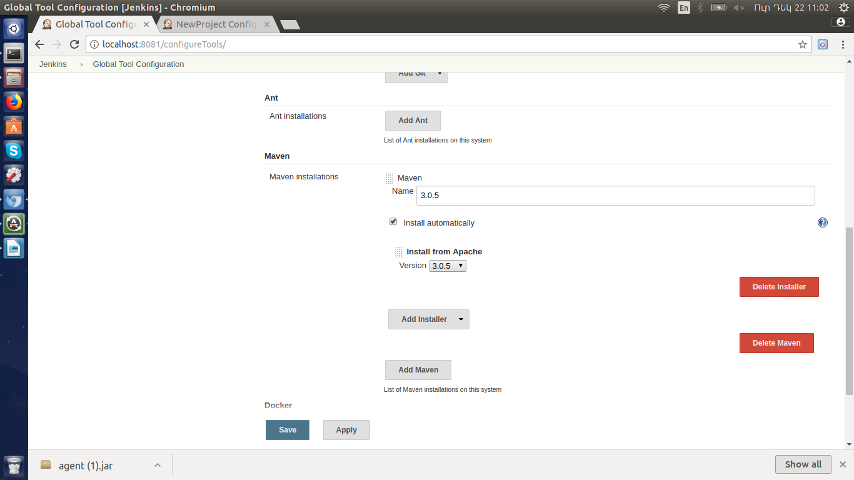

Create new project and configure jenkins to run only on slave node:. Go to Add Item, specify name of the project and select the type:

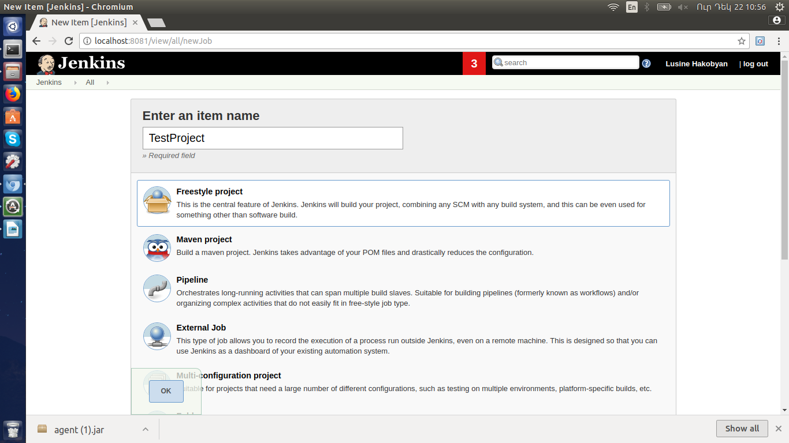

Configure the project to run only on slave node:

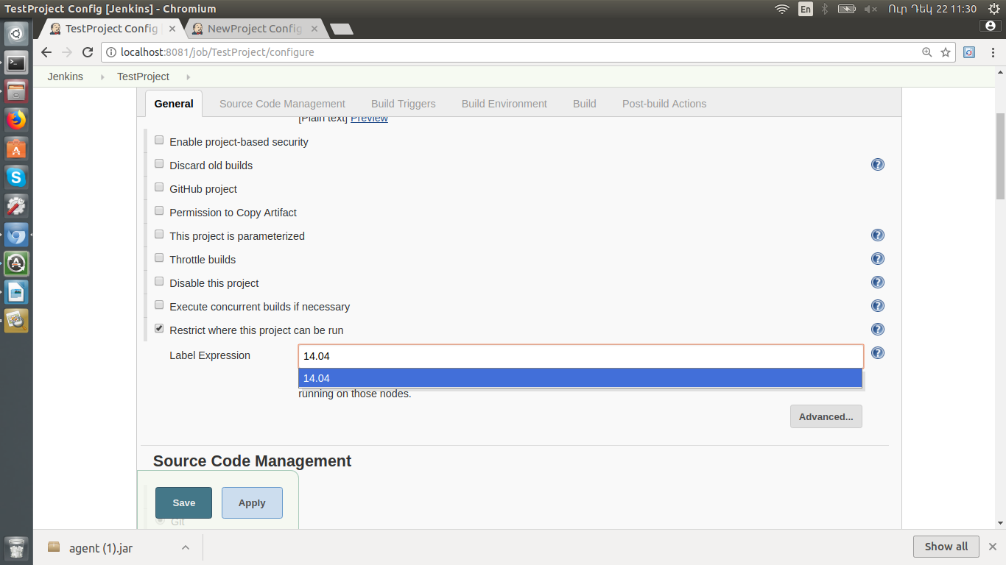

Specify path to GitHub project:

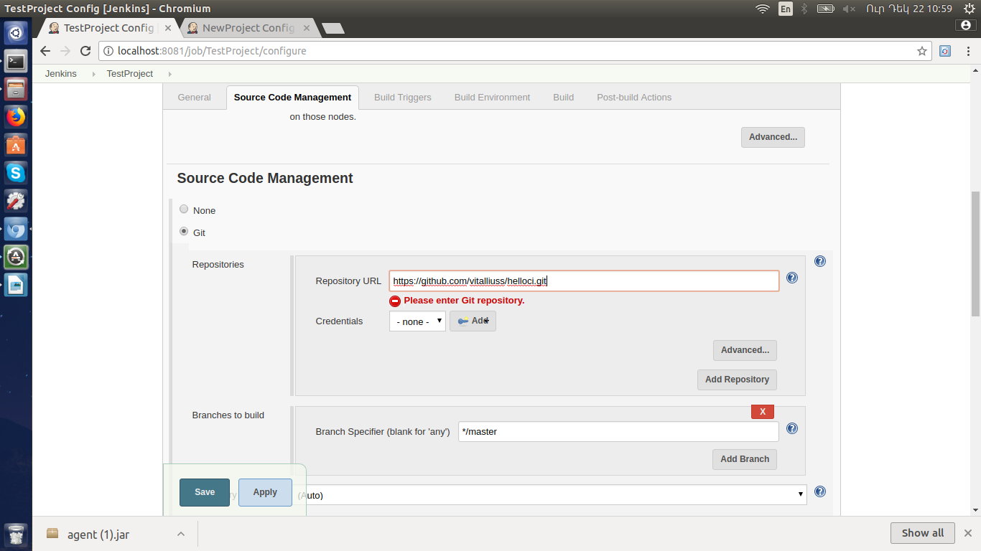

Configure build schedule:

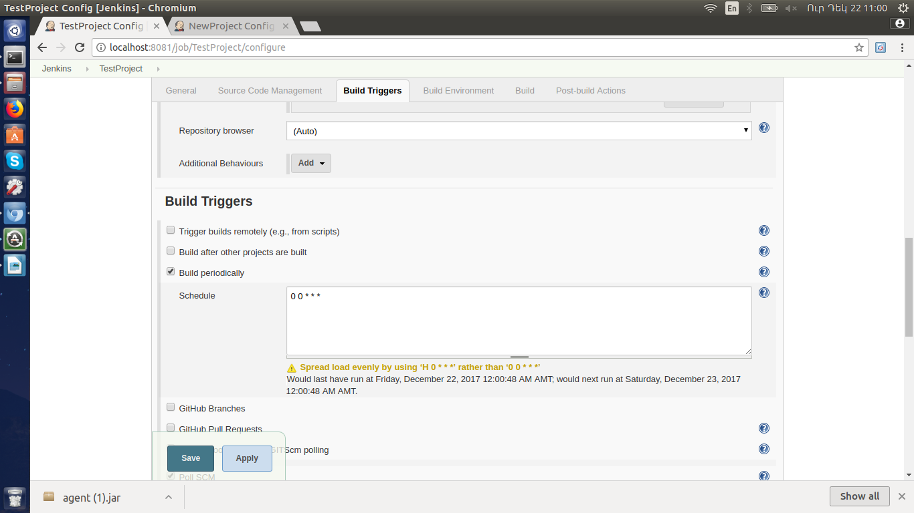

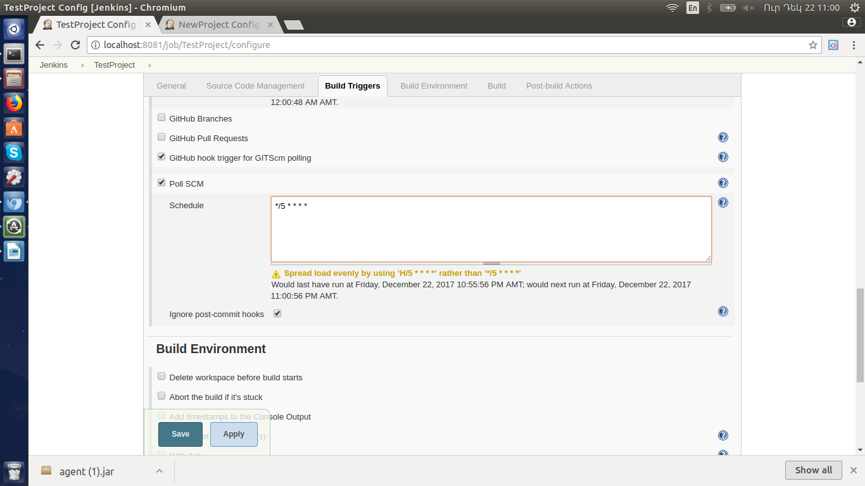

From Build choose 'Invoke top-level Maven Targets' . Set the goal 'test', and for the POM path to pom.xml(Java/pom.xml for this case):

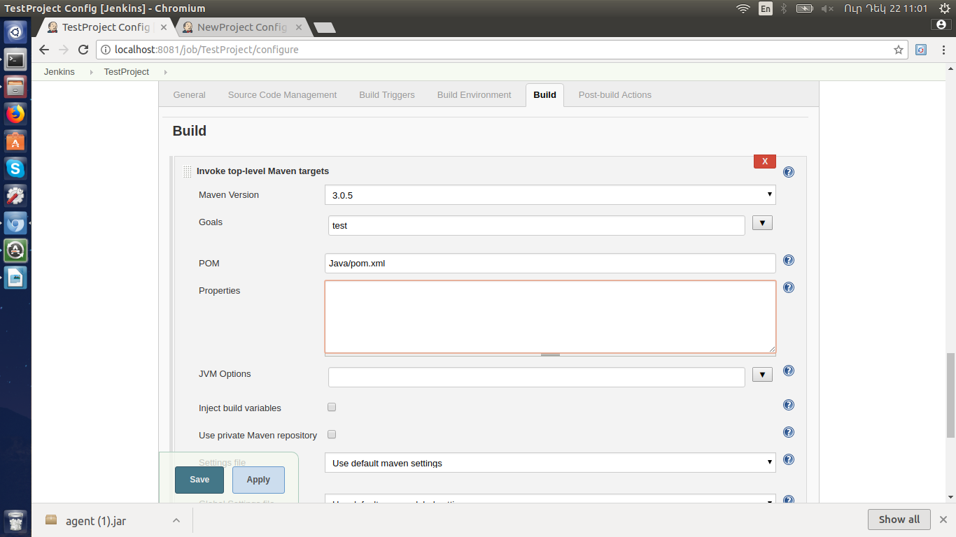

For Junit reports generation

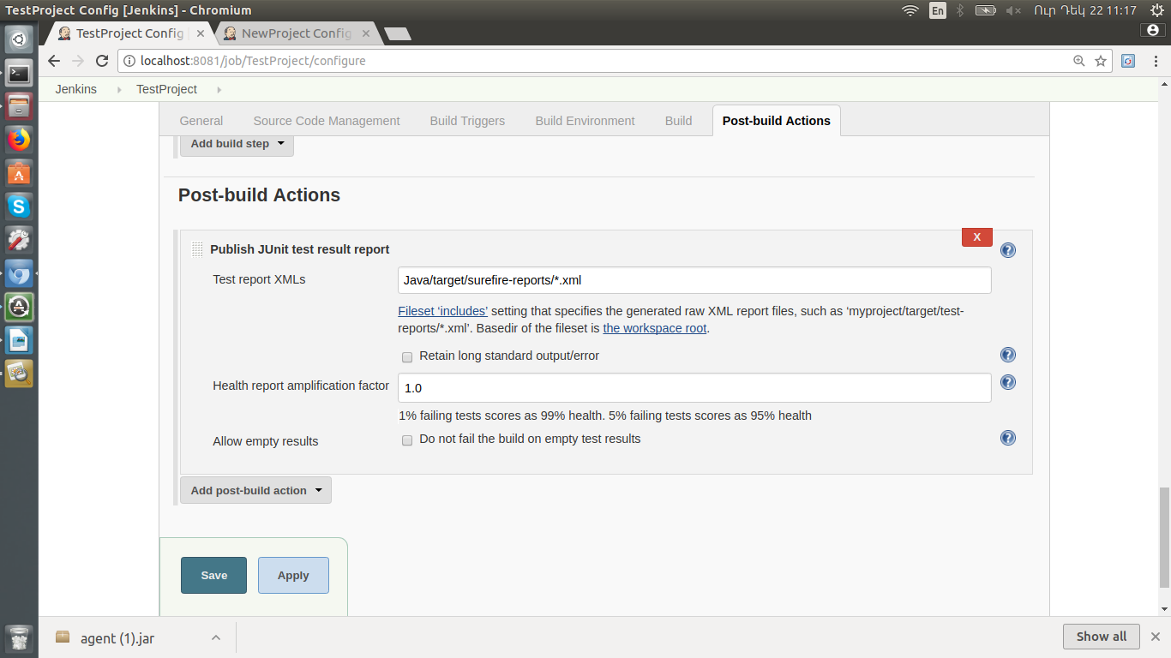

Build Project:

