**Jenkins installation and configuration on Linux(Ubuntu 14.04)**

Jenkins has been installed on Ubuntu 14.14 using the following command:

sudo apt-get install jenkins

Port has been changed from the '/etc/default/jenkins' file, setting the value of HTTP_PORT=8081

For slave nodes creation there is need to do the same steps as in windows OS.

Go to Manage Jenkins → Configure Global security → set Agents to Random

Create slave node from → Manage Jenkins → manage Nodes → new Nodes . In the opened window specify node name, choose Permanent Agent and clock on 'OK' button.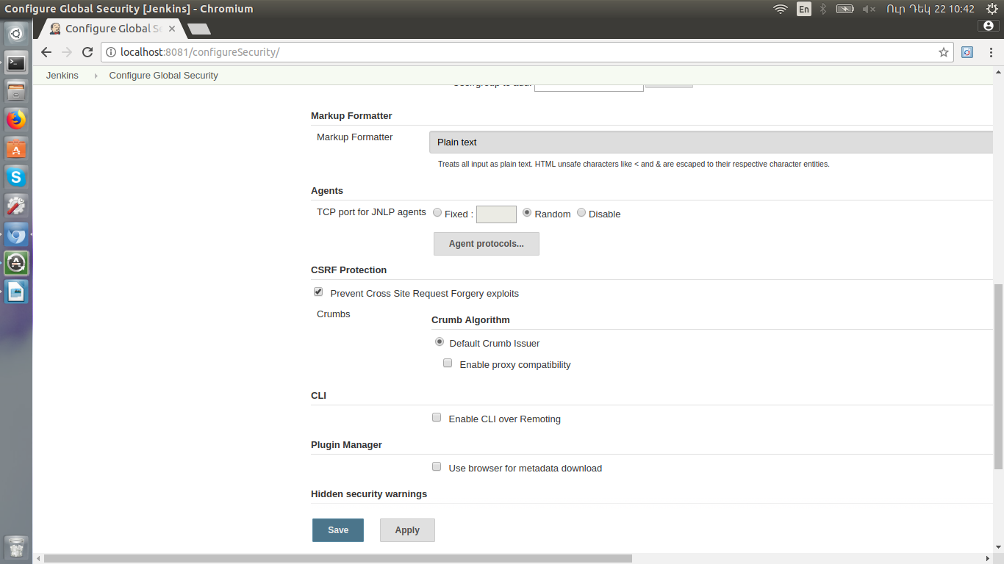

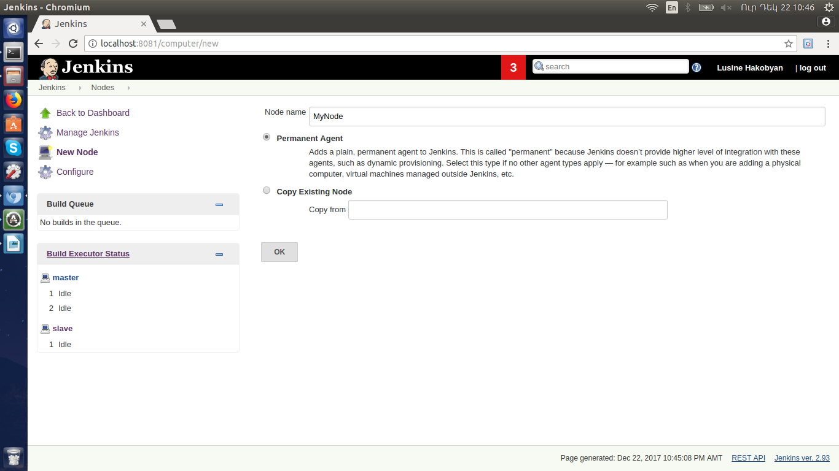

Specify 'Remote directory name', Label, Launch method'

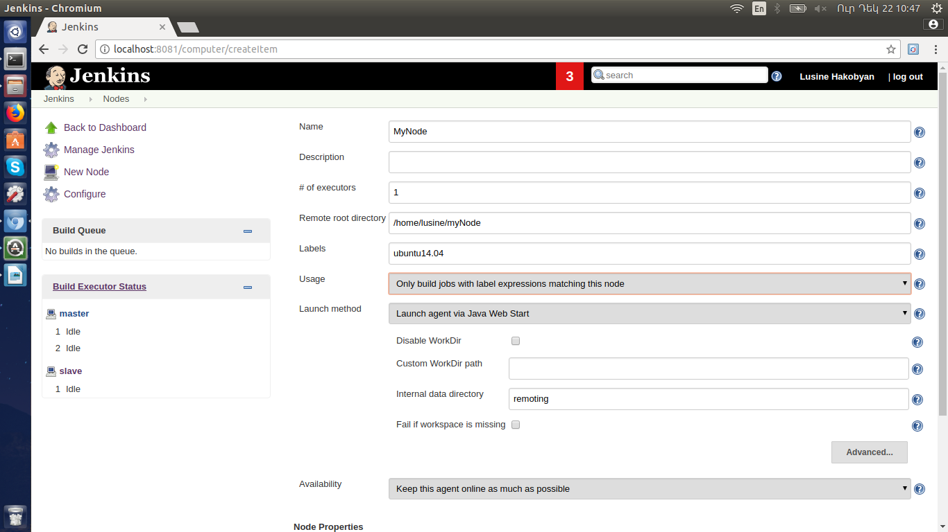

Then there is need to download agent.jar and run the provided command from Linux terminal:

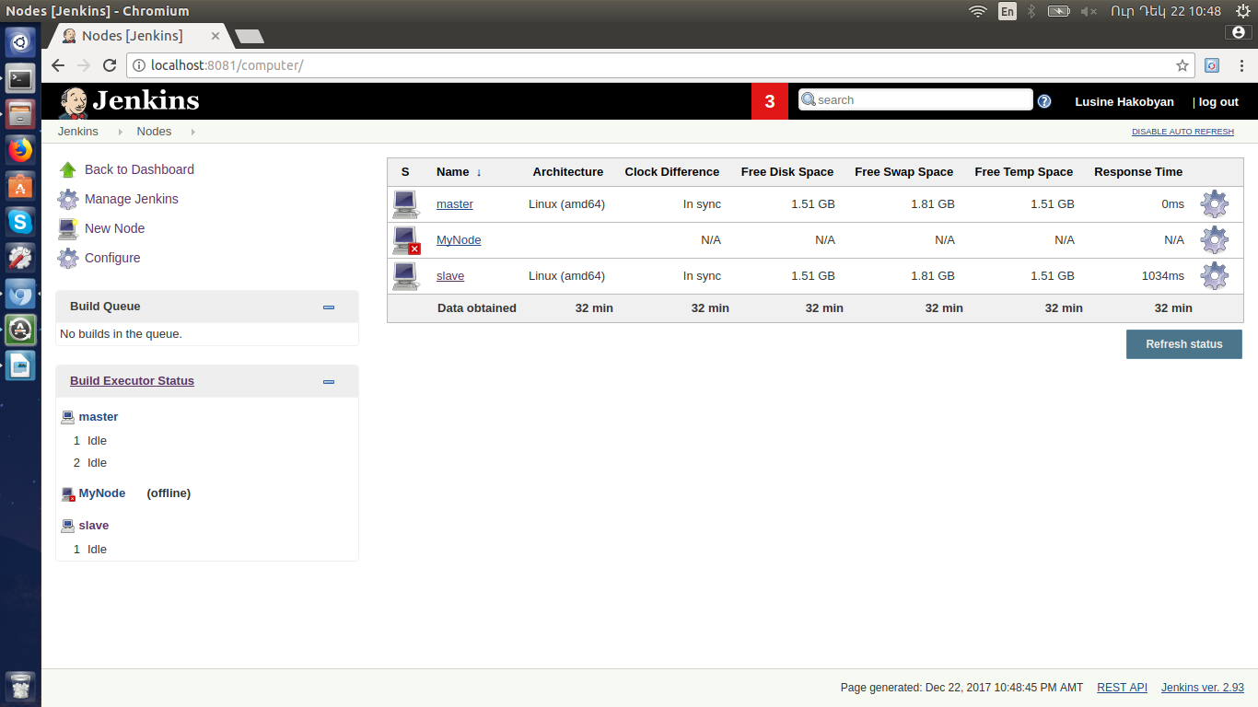

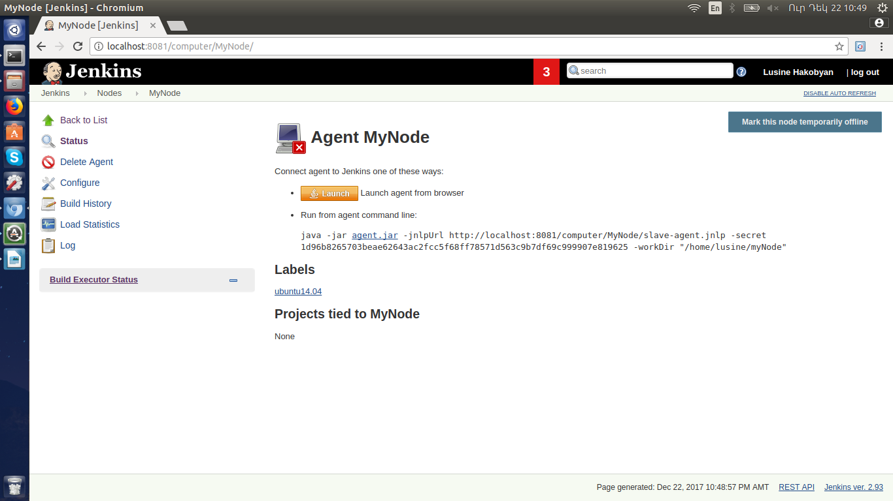

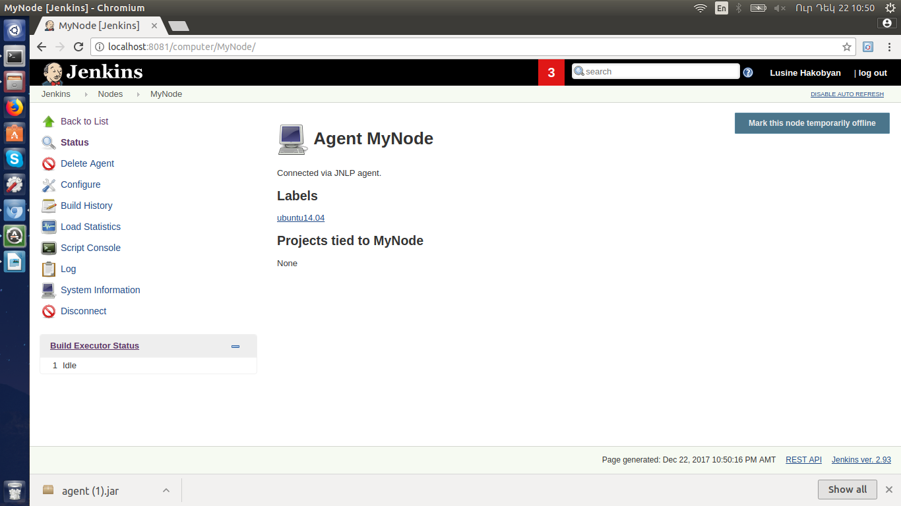

There is need to specify git and Maven paths and version from Manage Jenkins → Global Tool Configuration:

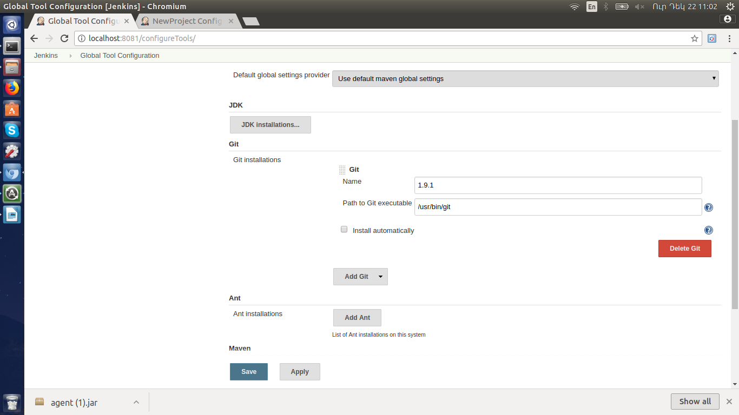

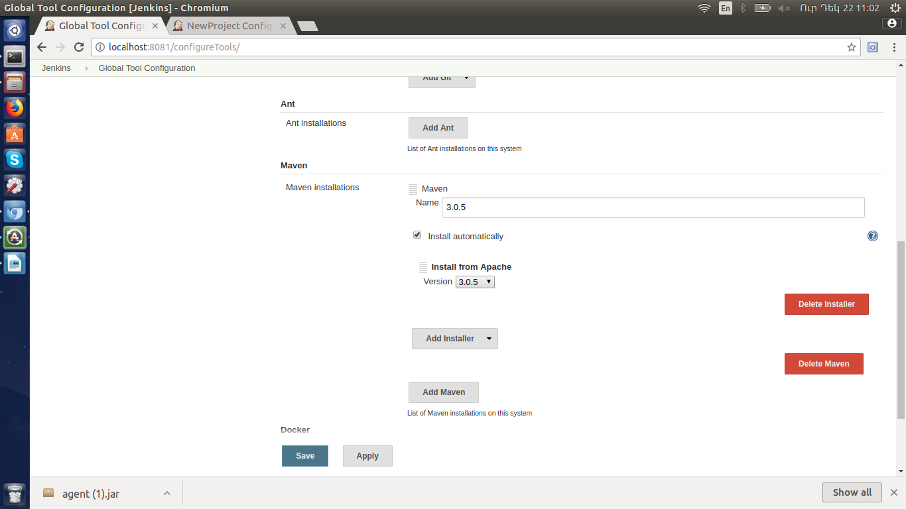

Create new project and configure jenkins to run only on slave node:. Go to Add Item, specify name of the project and select the type:

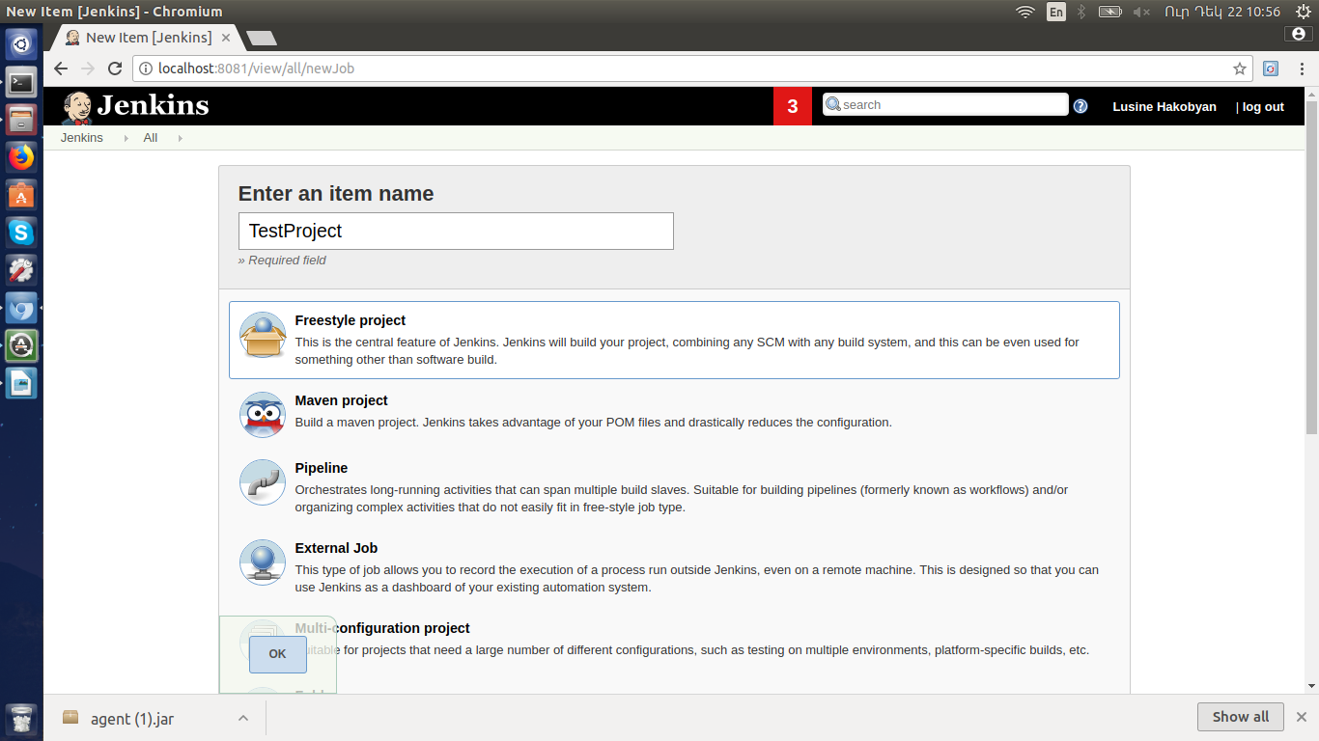

Configure the project to run only on slave node:

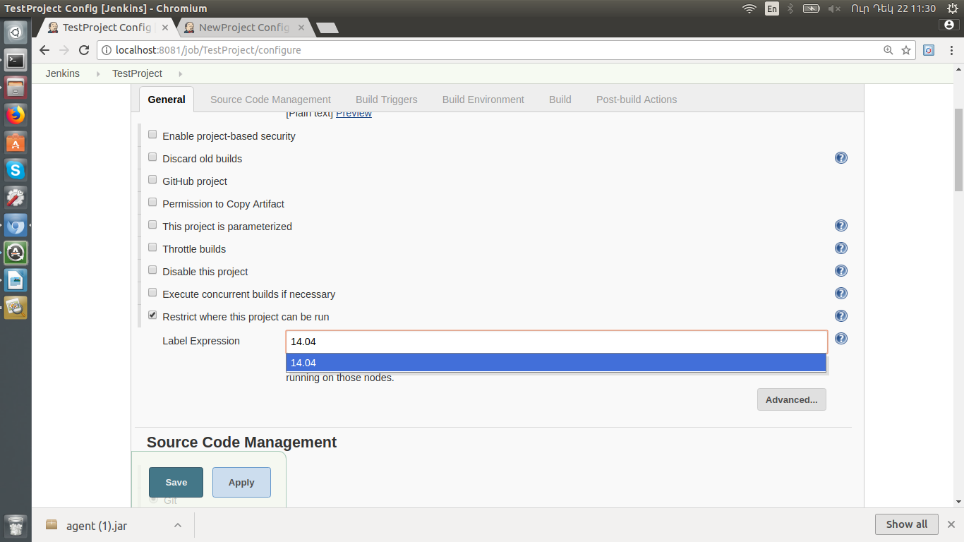

Specify path to GitHub project:

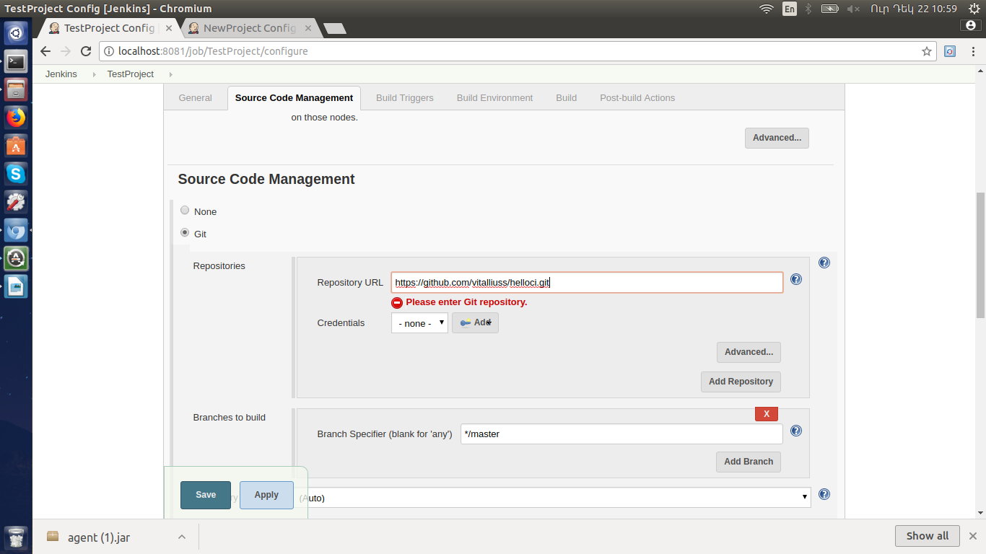

Configure build schedule:

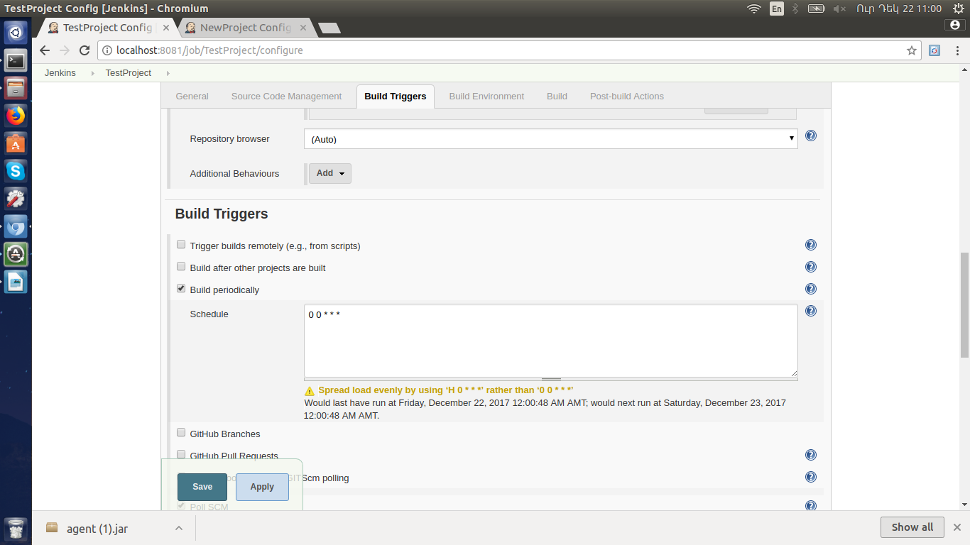

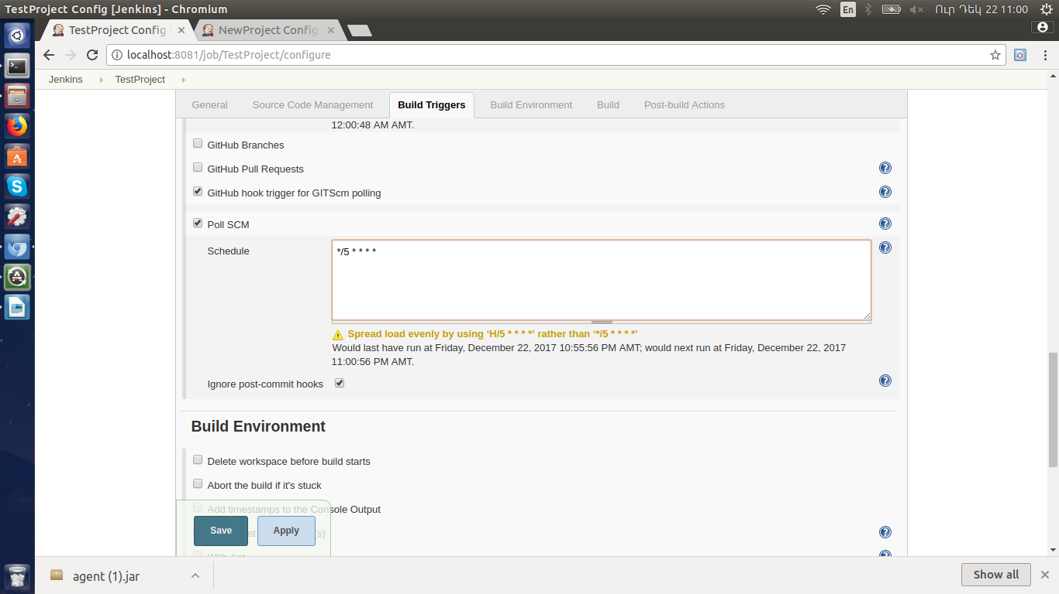

From Build choose 'Invoke top-level Maven Targets' . Set the goal 'test', and for the POM path to pom.xml(Java/pom.xml for this case):

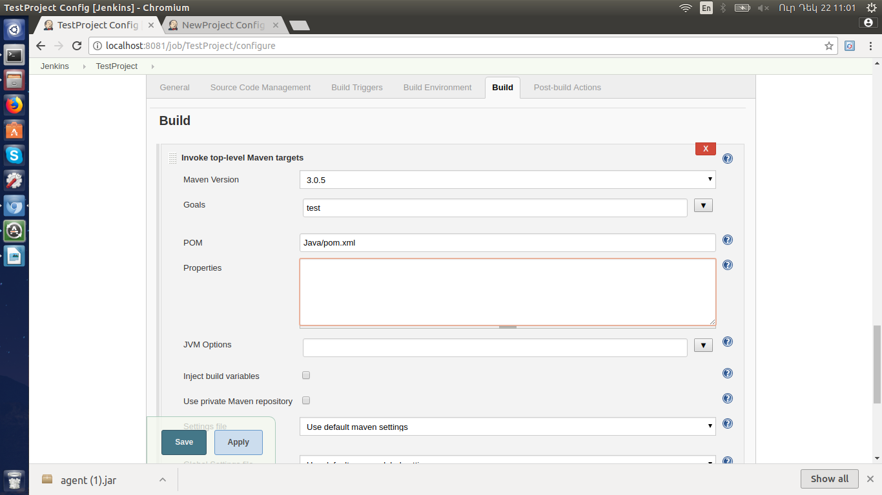

For Junit reports generation

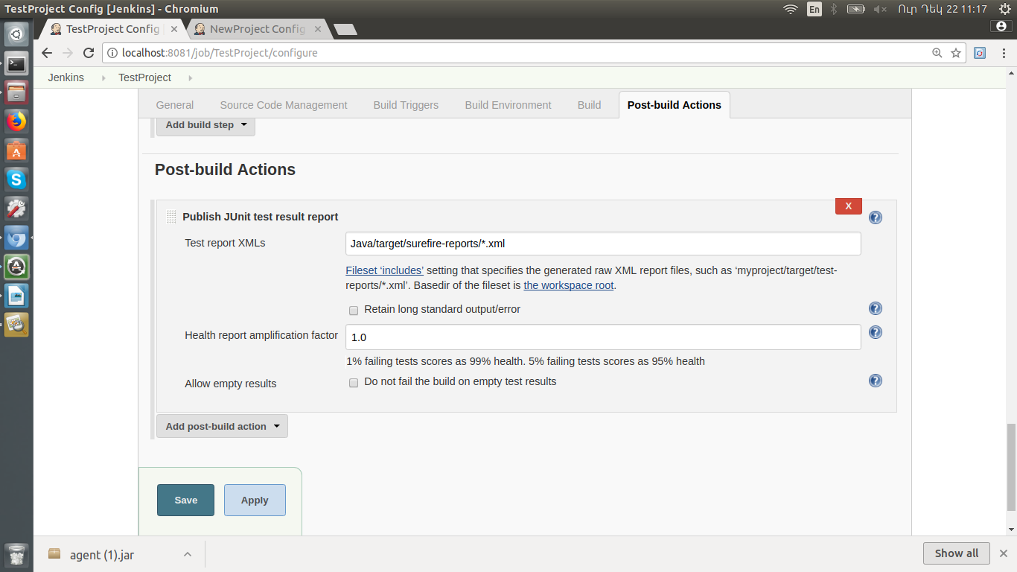

Build Project:

