*Install Jenkins server on local or remote machine, change port;*

Jenkins has been installed on Windows 10 machine. The port has been changed from the jenkins.xml file :--httpPort=8081

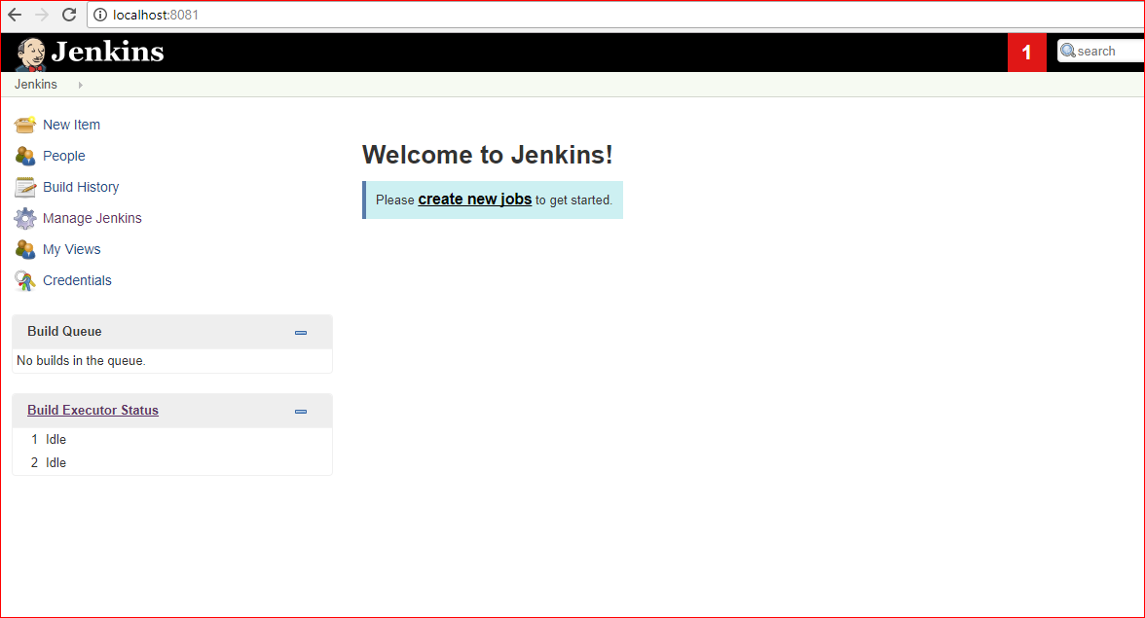

*Create slave node on remote or local machine (you may use the same (one) machine for master and slave);*

* Go to Manage Jenkins → Configure Global Security → set Agents to random

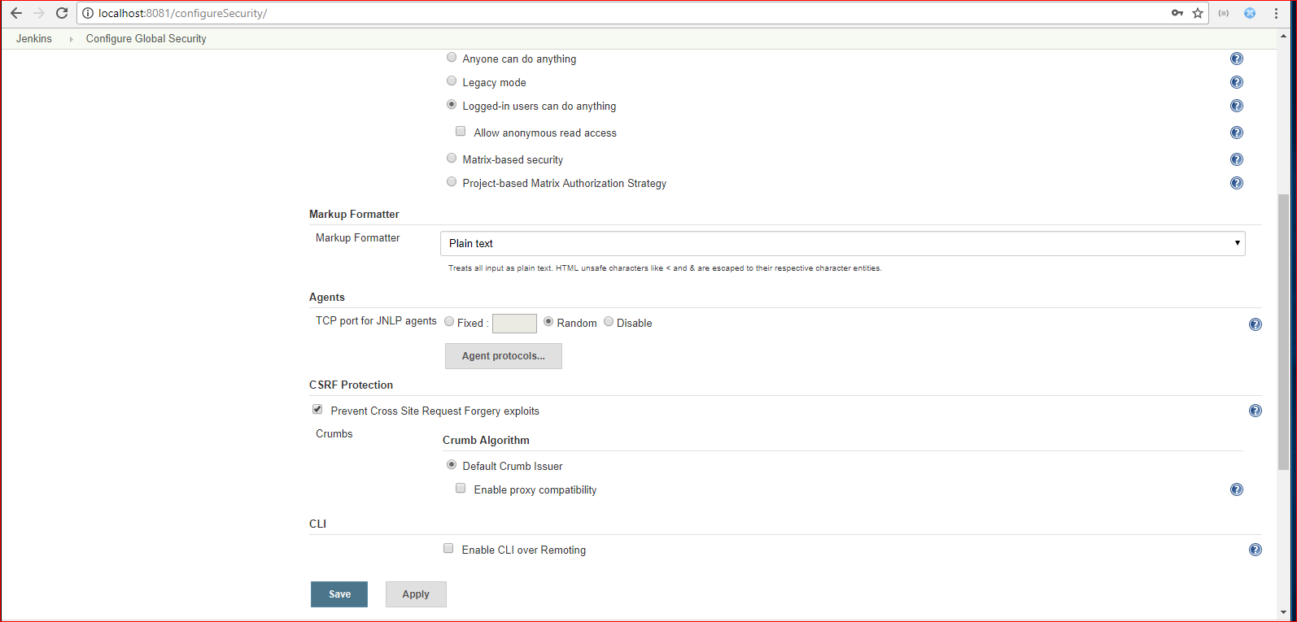

* Create slave node: Go to Manage Jenkins → Manage nodes → New Node → set the name of slave node → Mark the Permanent Agent and click OK

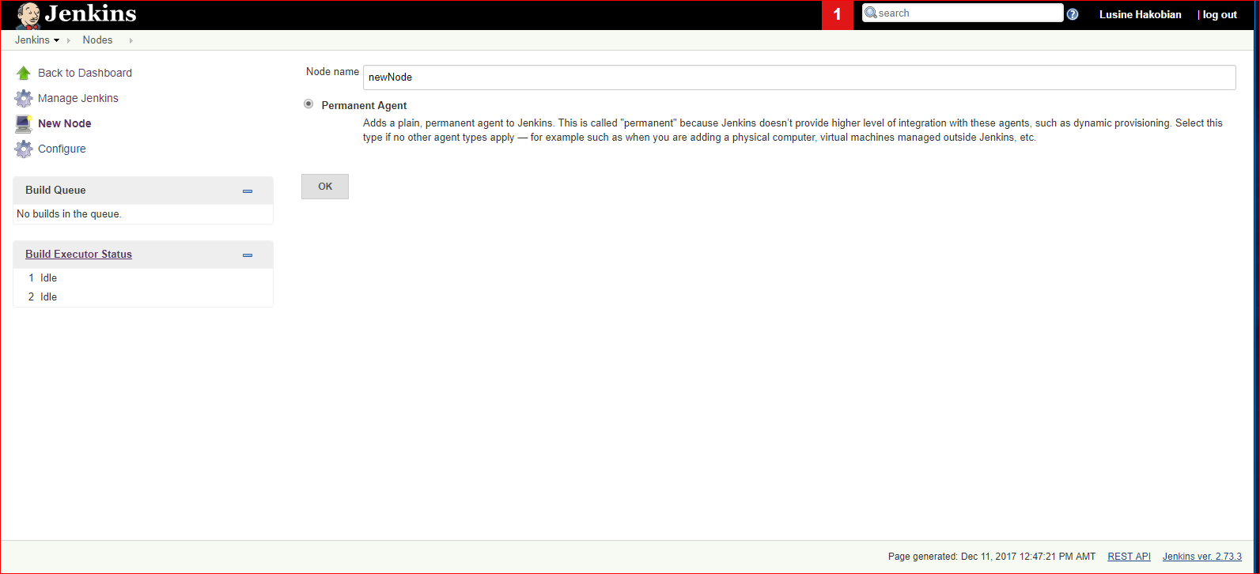

* In the Opened window enter the node name, remote directory path, label, Launch method

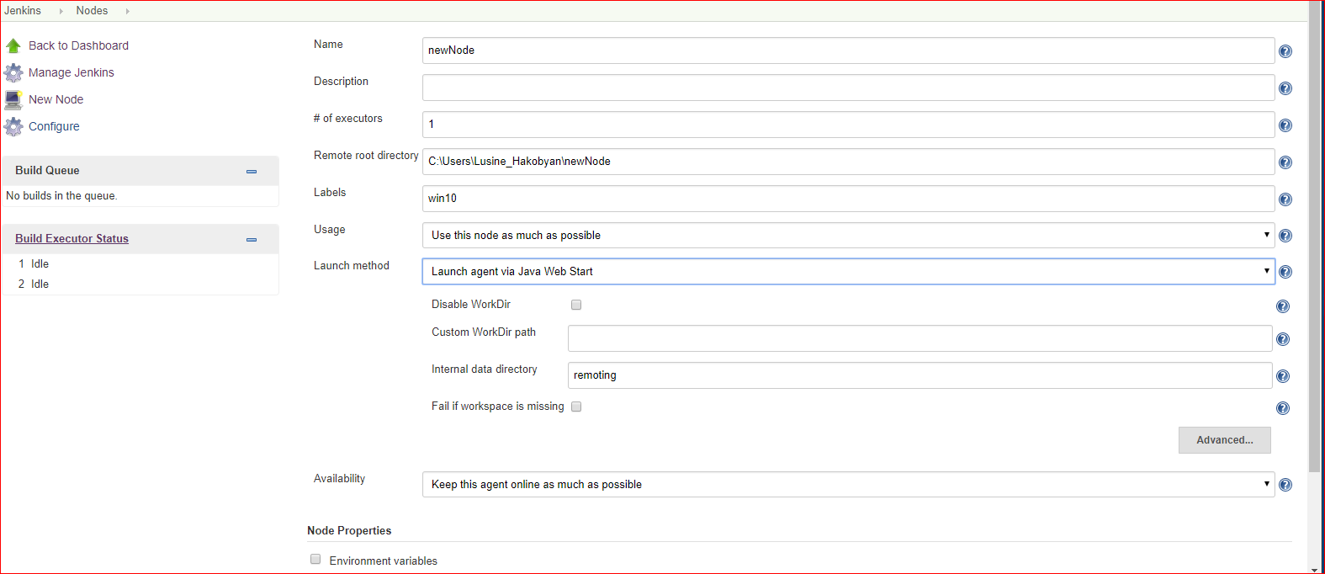

* Go to Manage Jenkins → Configure System → set slave node name

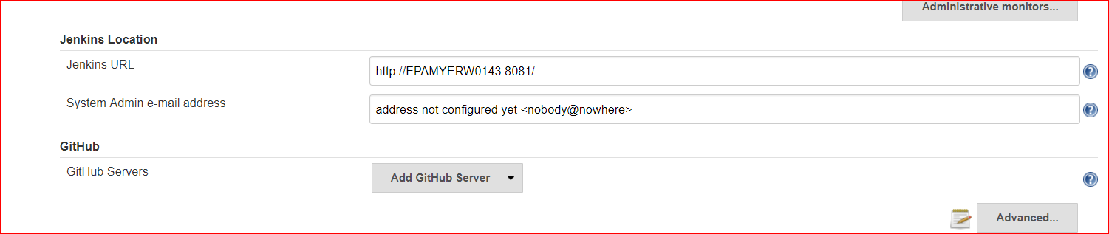

* Download agent.jar from the opened window and run the mentioned command from command line:

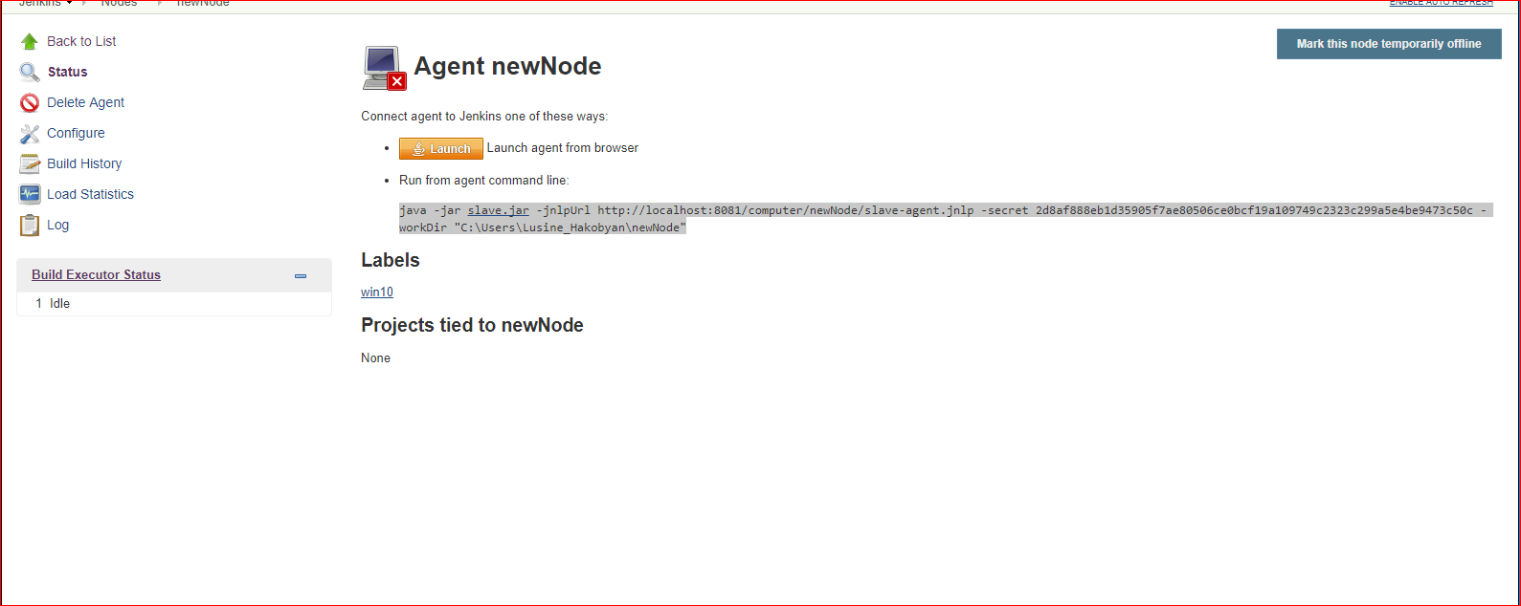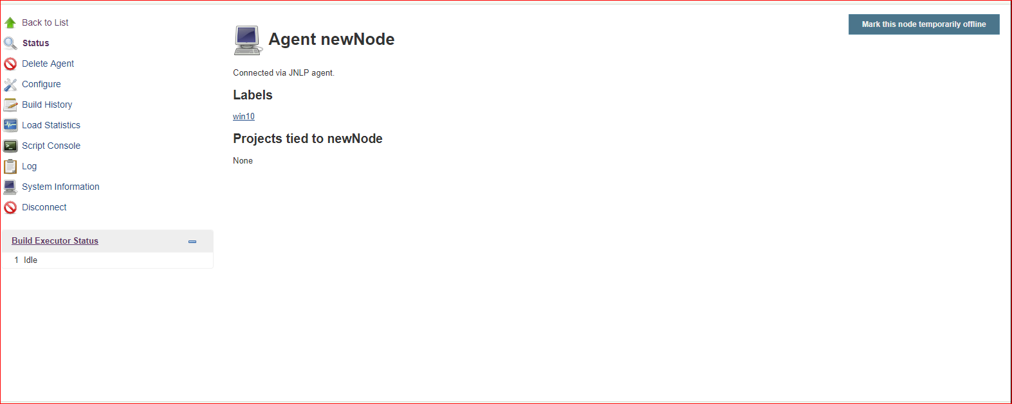

2. Job Configuration

Click on Create New Job → set the name, choose freestyle project.



Make sure that Git plugin and GitHub plugin are installed.

From Source Code Management select git and add path to the repository

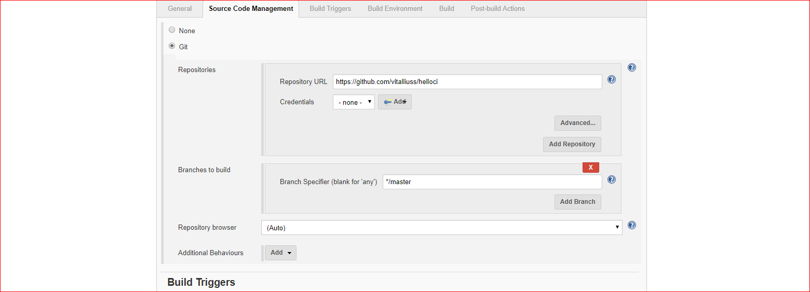

From Git Triggers section select the following options:

* Build periodically – For the midnight builds
* GitHub hook trigger for GITScm polling and Poll SCM(check the checkbox Ignore post-commit hooks) – for the builds after commit to VSC

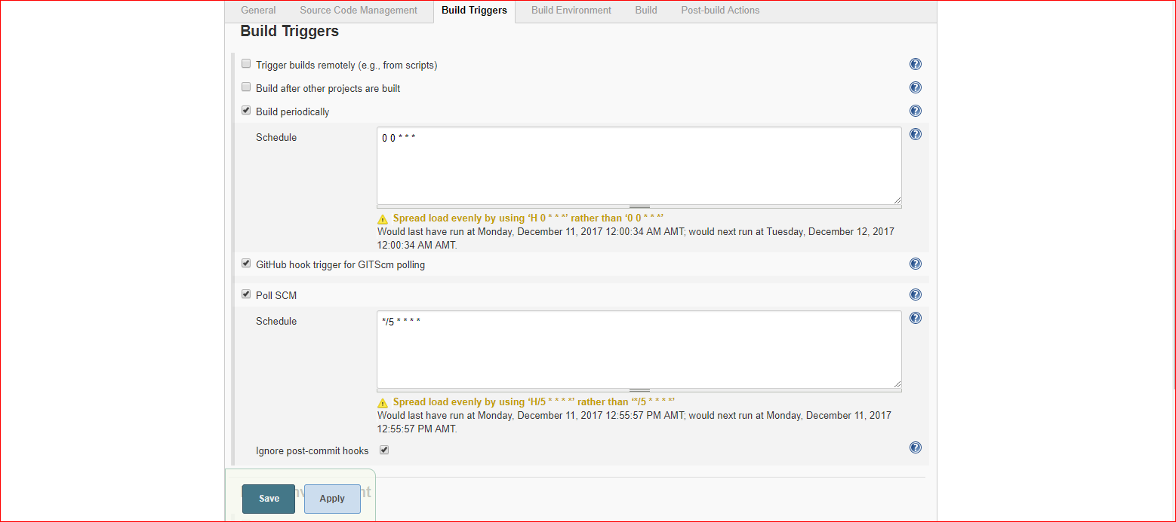

From Build choose 'Invoke top-level Maven Targets' . Set the goal 'test', and for the POM path to pom.xml(Java/pom.xml for this case)

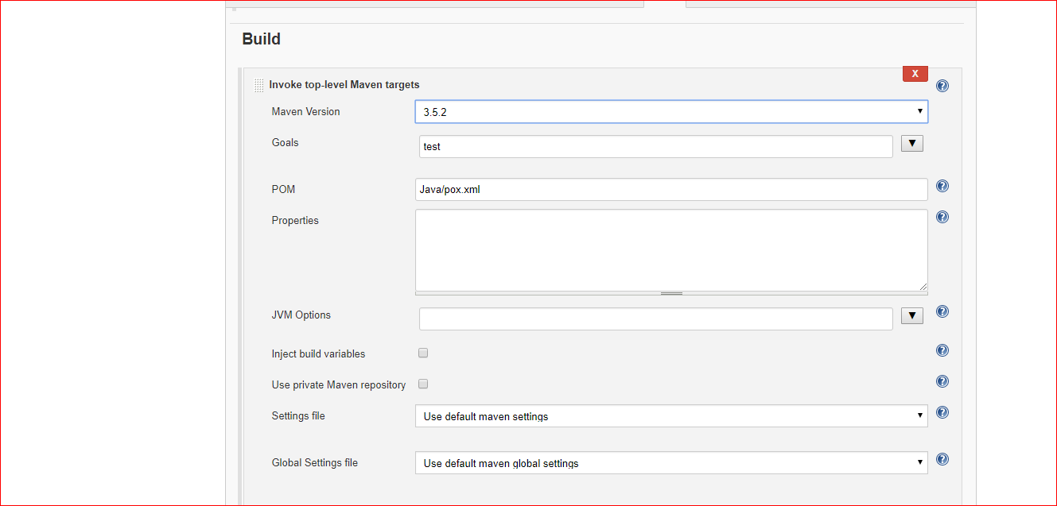

Also we need to specify git, Maven paths and versions from Manage Jenkins → Global Tool Configuration.

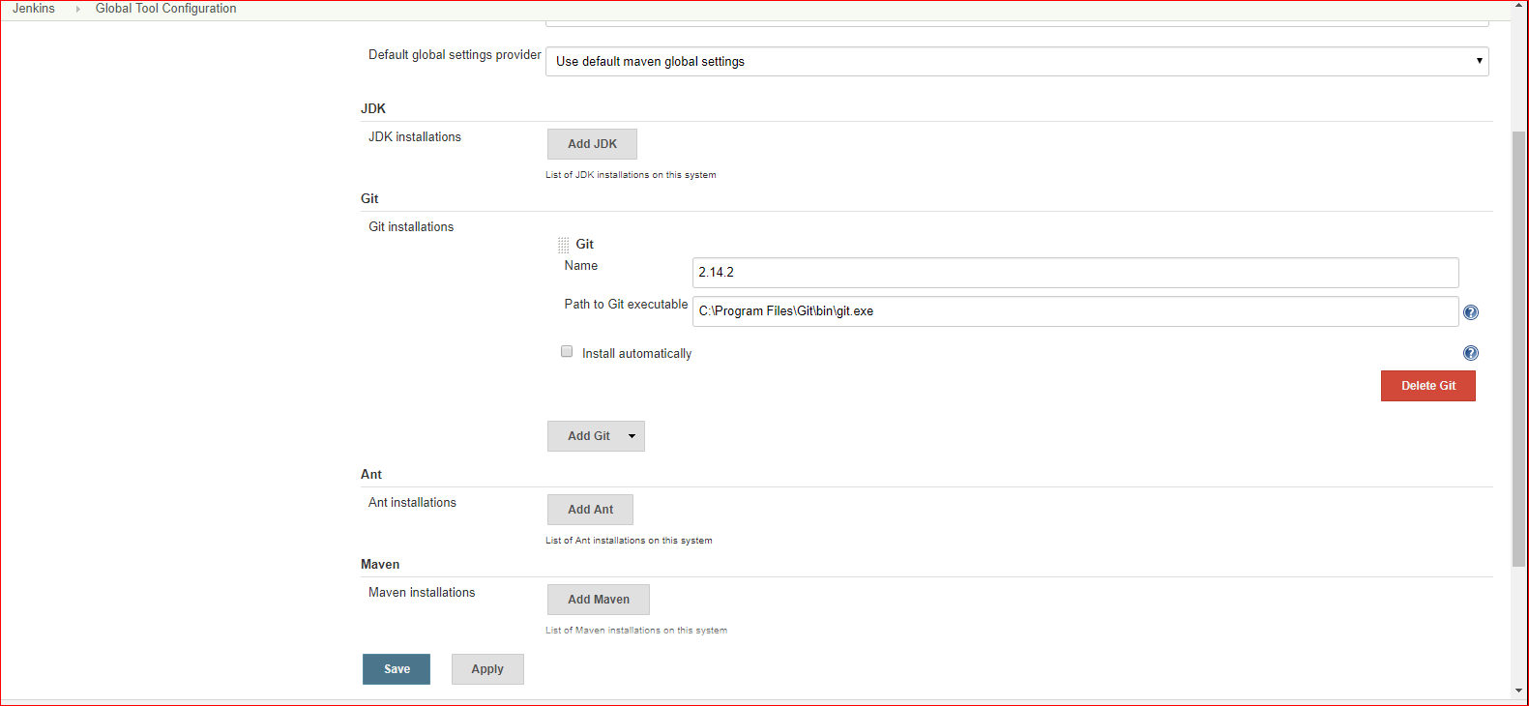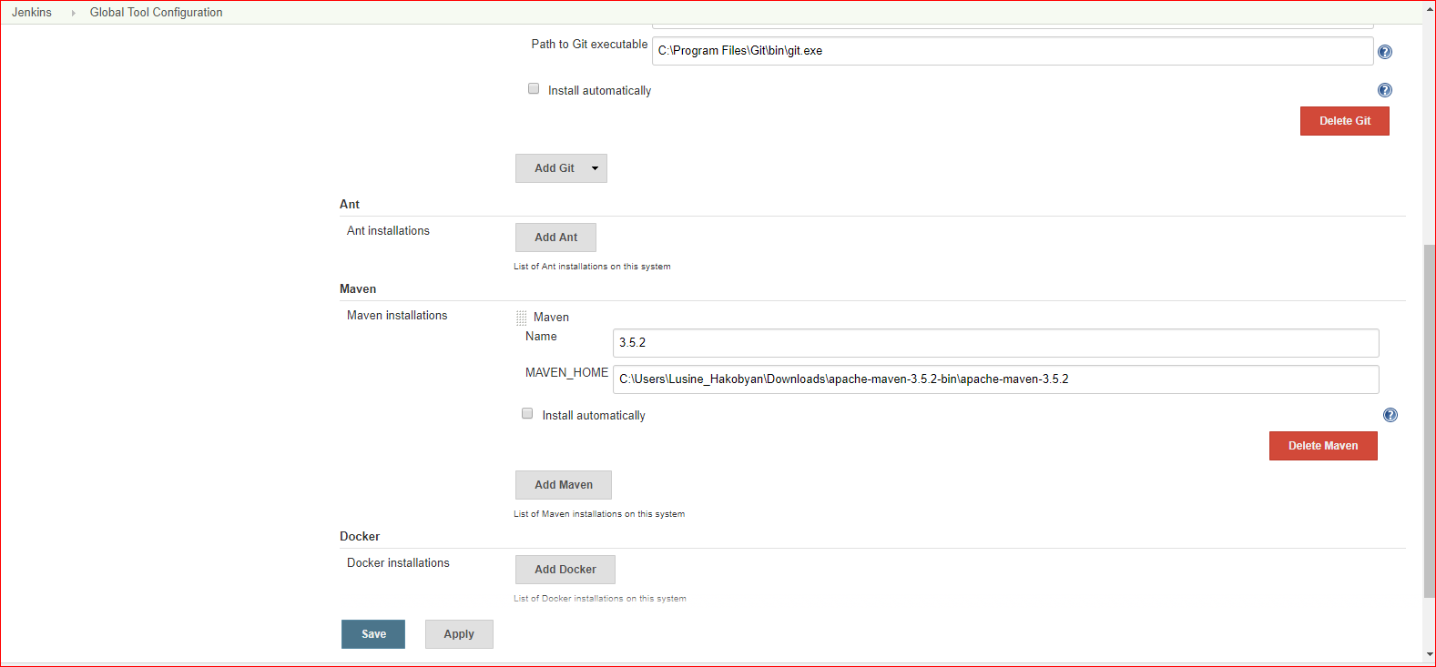

Job should run on slave only:

Connect project to slave node:

