**SQL Queries**

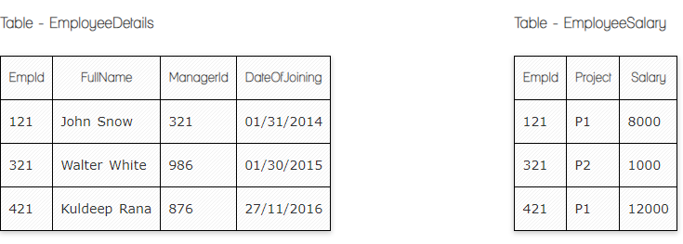

**Ques.1. Write a SQL query to fetch employee names having salary greater than or equal to 5000 and less than or equal 10000.**

**Your Answer:**

**SELECT** FullName

**FROM** EmployeeDetails

**WHERE** EmpId **IN**

(**SELECT** EmpId **FROM** EmpolyeeSalary

**WHERE** Salary **BETWEEN** 5000 **AND** 10000);

**Ques.2․ Write a SQL query to right join both tables and draw the results.**

**Your Answer:**

**Select FullName, Employeesalary .EmpId, Employeesalary.Salary**

**from Employeesalary**

**Right Join EmployeeDetails**

**on EmployeeDetails.EmpId = EmployeeSalary.EmpId**

|  |  |  |
| --- | --- | --- |
| **EmpId** | **Salary** | **FullName** |
| **121** | **8000** | **John** |
| **321** | **1000** | **Walter** |
| **420** | **12000** | **Null** |

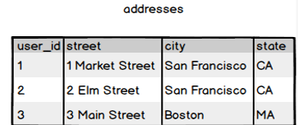

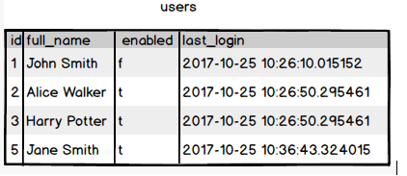

**Ques.3. Write a SQL query to fetch all users full_name from San Francisco.**

**Your Answer:**

SELECT full_name FROM users

INNER JOIN addresses ON addresses.user_id = users.id

WHERE city= 'San Francisco';

**Ques.4. Write a SQL query to fetch all users full_name who are from 3 Main street or San Francisco**

**Your Answer:**

SELECT full_name FROM users

INNER JOIN addresses ON addresses.user_id = users.id

WHERE street= '3 Main Street' or city= 'San Francisco';

--(or WHERE street in ('Tumanyan', 'Abovyan'))

**Ques.5. Write a SQL query to fetch user full_name who is equal to user_id from Boston (find user_id value in sub_query)**

**Your Answer:**

--select full_name FROM users

WHERE id in (SELECT user_id from addresses WHERE city= 'Boston' )