Do the ‘influencers’ actually affect the music created by the followers?

我们根据第一问得到的音乐家重要性程度，分别抽取了作为：祖宗节点“的5位有影响力的音乐家

|  |  |  |
| --- | --- | --- |
| 姓名 | 影响力 | 子节点数目 |
| The Beatles | 0.004985323 | 66 |
| The Rolling Stones | 0.0026815640000000004 | 116 |
| Miles Davis | 0.001709217 | 87 |
| Jimi Hendrix | 0.00166882 | 50 |
| Stevie Wonder | 0.00160634 | 65 |

和6位普通音乐家

|  |  |  |
| --- | --- | --- |
| 姓名 | 影响力 | 子节点数目 |
| Doris Day | 0.00027660099999999996 | 24 |
| Neil Diamond | 0.000276504 | 48 |
| The Moonglows | 0.000273544 | 21 |
| Todd Rundgren | 0.00027351599999999996 | 42 |
| Guitar Slim | 0.00021460200000000002 | 56 |
| Toni Braxton | 0.000214368 | 29 |

同第四问第一句话，我们计算出这些艺术家的追随者与其6个指标的相似程度，归纳如下：

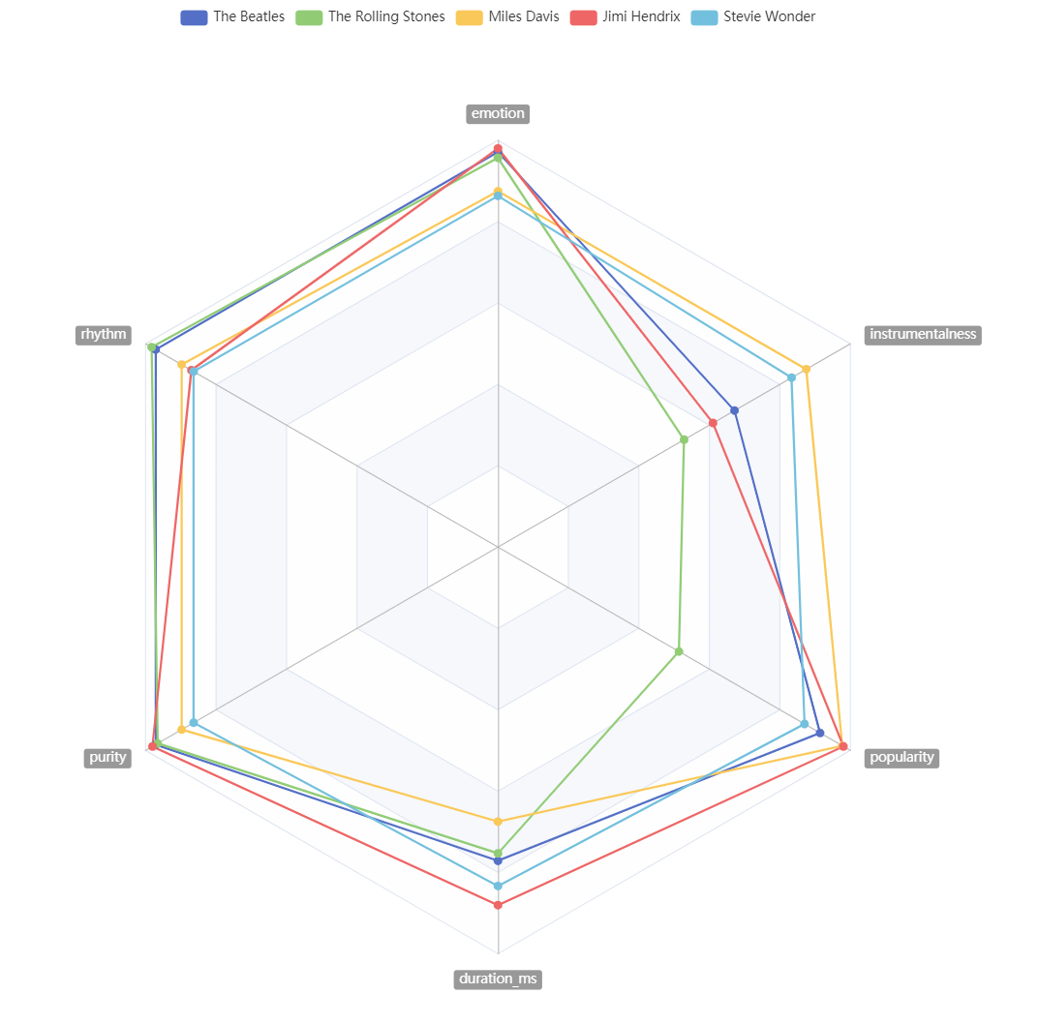

影响力高的艺术家的追随者和艺术家6项指标的相似度

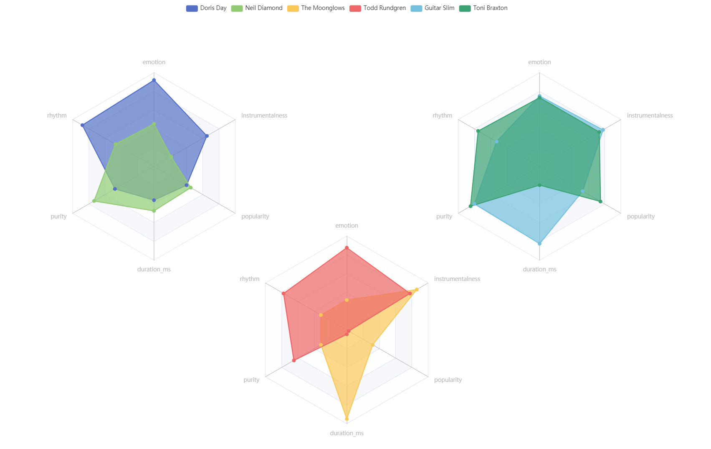

普通艺术家的追随者和艺术家6项指标的相似度

显然，对于影响力较高的艺术家，他们的追随者在各项音乐特征上与他们所追随的艺术家相似性更大，尤其现在之前证明更有影响力的emotion、rhythm、purity上;而对于普通艺术家，他们的追随者与其的相似性则各有千秋。

由此证明the ‘influencers’ actually affect the music created by the followers

以下是画图的代码，分别将其扔到这两个网址即可输出上文图片：

<https://echarts.apache.org/examples/zh/editor.html?c=radar>

<https://echarts.apache.org/examples/zh/editor.html?c=radar>

图1：

option = {

title: {

text: ''

},

tooltip: {},

legend: {

data: ['The Beatles',

'The Rolling Stones',

'Miles Davis',

'Jimi Hendrix',

'Stevie Wonder','Doris Day',

'Neil Diamond',

'The Moonglows',

'Todd Rundgren',

'Guitar Slim',

'Toni Braxton']

},

radar: {

// shape: 'circle',

name: {

textStyle: {

color: '#fff',

backgroundColor: '#999',

borderRadius: 3,

padding: [3, 5]

}

},

indicator: [

{text: 'emotion', max: 1},

{text: 'rhythm', max: 1},

{text: 'purity', max: 1},

{text: 'duration_ms', max: 1},

{text: 'popularity', max: 1},

{text: 'instrumentalness', max: 1}

]

},

series: [{

name: '预算 vs 开销（Budget vs spending）',

type: 'radar',

// areaStyle: {normal: {}},

data: [

{

value: [0.9714285714285714, 0.9714285714285714, 0.9714285714285714, 0.7714285714285714, 0.9142857142857143, 0.6714285714285714],

name: 'The Beatles'

},

{

value:[0.9572649572649573, 0.9829059829059829, 0.9658119658119658, 0.752991452991453, 0.513675213675214, 0.5282051282051282],

name: 'The Rolling Stones'

},

{

value: [0.875, 0.8977272727272727, 0.8977272727272727, 0.675, 0.9772727272727273, 0.875],

name: 'Miles Davis'

},

{

value:[0.9803921568627451, 0.87, 0.9803921568627451, 0.8803921568627451, 0.9803921568627451, 0.6103921568627451],

name: 'Jimi Hendrix'

},

{

value:[0.8636363636363636, 0.8636363636363636, 0.8636363636363636, 0.8333333333333334, 0.87, 0.8333333333333334],

name: 'Stevie Wonder'

},

]

}]

};

图2

option = {

title: {

text: ''

},

tooltip: {

trigger: 'axis'

},

legend: {

left: 'center',

data: ['The Beatles',

'The Rolling Stones',

'Miles Davis',

'Jimi Hendrix',

'Stevie Wonder','Doris Day',

'Neil Diamond',

'The Moonglows',

'Todd Rundgren',

'Guitar Slim',

'Toni Braxton']

},

radar: [

{

indicator: [

{text: 'emotion', max: 1},

{text: 'rhythm', max: 1},

{text: 'purity', max: 1},

{text: 'duration_ms', max: 1},

{text: 'popularity', max: 1},

{text: 'instrumentalness', max: 1}

],

center: ['25%', '35%'],

radius: 200

},

{

indicator: [

{text: 'emotion', max: 1},

{text: 'rhythm', max: 1},

{text: 'purity', max: 1},

{text: 'duration_ms', max: 1},

{text: 'popularity', max: 1},

{text: 'instrumentalness', max: 1}

],

radius: 200,

center: ['50%', '70%'],

},

{

indicator: [

{text: 'emotion', max: 1},

{text: 'rhythm', max: 1},

{text: 'purity', max: 1},

{text: 'duration_ms', max: 1},

{text: 'popularity', max: 1},

{text: 'instrumentalness', max: 1}

],

radius: 200,

center: ['75%', '35%'],

},

],

series: [

{

type: 'radar',

tooltip: {

trigger: 'item'

},

areaStyle: {},

data: [

{

value:[0.92, 0.88, 0.48, 0.36, 0.4, 0.65],

name: 'Doris Day'

},

{

value: [0.453, 0.47368421052631576, 0.7368421052631579, 0.47368421052631576, 0.4523, 0.21052631578947367],

name: 'Neil Diamond'

},

]

},

{

type: 'radar',

radarIndex: 1,

areaStyle: {},

data: [

{

value:[0.3181818181818182, 0.3181818181818182, 0.3181818181818182, 0.95, 0.3181818181818182, 0.86],

name: 'The Moonglows'

},

{

value:[0.8767441860465116, 0.7767441860465116, 0.65, 0.046511627906976744, 0.023255813953488372, 0.7767441860465116],

name: 'Todd Rundgren'

},

]

},

{

type: 'radar',

radarIndex: 2,

areaStyle: {},

data: [

{

value:[0.75, 0.5294117647058824, 0.8, 0.8235294117647058, 0.5294117647058824, 0.78],

name: 'Guitar Slim'

},

{

value:[0.7333333333333333, 0.7553,0.849, 0.2, 0.7486, 0.7333333333333333],

name: 'Toni Braxton'

},

]

}

]

};