Unit 5: Light Search and Rescue Operations

In this unit you will learn about:

- Search and Rescue Sizeup: How to size up the situation in which the search and rescue teams will operate.

- Conducting Search Operations: How to search systematically for disaster victims.

- Conducting Rescue Operations: Safe techniques for lifting, leveraging, cribbing, and victim removal.

Unit 5: Light Search and Rescue Operations

Introduction and Unit Overview
Search and rescue consists of three separate operations:

- Sizeup involves assessing the situation and determining a safe action plan.

- Search involves locating victims and documenting their location.

- Rescue involves the procedures and methods required to extricate the victims.

Experience from previous disasters has shown that immediately after almost every disaster, the first response to trapped victims is by spontaneous, untrained, and well-intentioned persons who rush to the site of a collapse in an attempt to free the victims.

More often than not, these spontaneous rescue efforts result in serious injuries and compounded problems.

However well-meaning, rescue efforts should be planned and practiced in advance.

The decision to attempt a rescue should be based on two factors:

- The risks involved to the rescuer

- The overall goal of doing the greatest good for the greatest number of people

The goals of search and rescue operations are to:

- Rescue the greatest number of people in the shortest amount of time.

- Rescue lightly trapped victims first.

The most important person in a rescue attempt is the rescuer.

Effective search and rescue operations hinge on:

- Effective sizeup.

- Rescuer safety.

- Victim safety.

This unit will focus on the components of an effective search and rescue operation—sizeup, search, and rescue—and the methods and techniques that rescuers can use to locate and safely remove victims.

Introduction and Unit Overview (Continued)

Objectives

At the end of this unit, you should be able to:

- Identify sizeup requirements for potential search and rescue situations.

- Describe the most common techniques for searching a structure.

- Use safe techniques for debris removal and victim extrication.

- Describe ways to protect rescuers during search and rescue operations.

Search and Rescue Sizeup
Like every other CERT operation, search and rescue requires sizeup at the beginning of the operation and continually as long as the operation continues.

Sizeup is a 9-step process that was presented in Unit 2. This section will focus on sizeup as it relates to search and rescue operations.

CERT Search and Rescue Sizeup Checklist

Step 1: Gather Facts

Time

- Does the time of day or week affect search and rescue efforts?  How? |  | 
Type Of Construction

- What type(s) of structure(s) is(are) involved?

- What type(s) of construction is (are) involved?

Occupancy

- Are the structures occupied?  If yes, how many people are likely to be affected? |  | 
- Are there special considerations (e.g. children, elderly)?  If yes, what are the special considerations? |  | 

CERT Search and Rescue Sizeup Checklist

 | Yes |  | No
Step 1: Gather Facts (Continued)

Weather

- Will weather conditions affect your safety?  If yes, how will your safety be affected? |  | 
- Will weather conditions affect the search and rescue situation?  If yes, how will the search and rescue situation be affected? |  | 
Hazards

- Are hazardous materials involved?  If yes, what hazardous materials? |  | 
- Are any other types of hazards likely to be involved?  If yes, what other hazards? |  | 

CERT Search and Rescue Sizeup Checklist

 | Yes |  | No
Step 2: Assess and Communicate the Damage

- Take a lap around the building. Is the damage beyond the CERT team’s capability? |  | 
If yes, what special requirements or qualifications are required?

- Are normal communication channels functioning? |  | 

Step 3: Consider Probabilities

Life Hazards

- Are there potentially life-threatening hazards?  If yes, what are the hazards? |  |  | 
Additional Damage

- Is there great risk or potential for more disaster activity that will impact personal safety?  If yes, what are the known risks? |  |  | 

Step 4: Assess Your Own Situation

- What resources are available with which you can attempt the search and rescue?

- What equipment is available?

CERT Search and Rescue Sizeup Checklist

 | Yes |  | No

Step 5: Establish Priorities

- Can a search and rescue be safely attempted by CERT members?  If no, do not attempt a search and rescue. |  | 
- Are there other, more pressing needs at the moment?  If yes, list. |  | 

Step 6: Make Decisions

- Where will deployment of available resources do the most good while maintaining an adequate margin of safety?

Step 7: Develop Plan of Action

- Determine how personnel and other resources should be deployed.

CERT Search and Rescue Sizeup Checklist

Step 8: Take Action

- Put the plans into effect.

Step 9: Evaluate Progress

- Continually size up the situation to identify changes in the:

- Scope of the problem.
- Safety risks.
- Resource availability.

- Adjust strategies as required.

Search and Rescue Sizeup (Continued)

Step 1: Gather Facts

The facts of the situation must guide your search and rescue efforts.

When gathering facts, you need to consider:

- The time of the event and day of the week. At night, more people will be in their homes, so the greatest need for search and rescue will be in residential settings. Conversely, during the day, people will be at work, so the need will be in commercial buildings.

Some emergency services are not available—or not available in the same numbers—during the evenings or on weekends. Search and rescue operations may also be affected by where people are located in their homes and the amount of daylight available.

- The type of structure. The purpose for which the structure was designed may indicate the likely number of victims, and their location.

- Construction type. Some types of construction are more susceptible to damage than others.

- Weather. Severe weather will have an effect on victims and rescuers alike and will certainly hamper rescue efforts. Forecasts of severe weather should be considered as a limiting factor on the time period during which search and rescue can occur.

- Hazards. Knowledge of other potential hazards in the general and immediate areas is important to search and rescue efforts. Time lost trying to locate and shut off utilities, for example, can have a big impact in terms of loss of life.

Search and Rescue Sizeup (Continued)

Exercise: Gathering Facts

Purpose: This exercise is an interactive activity to give you the opportunity to consider some of the facts that CERT search and rescue teams will need to gather during sizeup.

Instructions: Use the following steps to complete this exercise:

- Read Scenario 5-1 on the following page.

- Brainstorm the following questions:

- What does this scenario tell you about the facts that must be gathered?
- What impact could these facts have on search and rescue operations?

Scenario 5-1

At 2:30 p.m. on Tuesday, August 9, a squall line passed through your town. Because of the difference in barometric pressure on either side of the front, the squall line was preceded by a “gust front” with straight-line winds of more than 70 miles per hour. The gust front was followed by continued strong winds and extremely heavy rain. Electricity was knocked out throughout the town.

You activate in accordance with standard operating procedures (SOPs) for CERT. On the way to the staging area at the local high school, you notice considerable damage, including felled trees and utility lines. Many streets are impassable, making you take a roundabout route to the high school. As you make your way to the staging area, you see that the roof has blown off a large portion of a local strip shopping center and that the exterior wall on the west end of the structure has collapsed.

After reaching the staging area, you check in with the Logistics Team Leader, who assigns you to Search and Rescue Team 2. Although CERT teams cannot venture into the section of the shopping center that has collapsed, Search and Rescue Team 2 will be searching near the collapsed area to see if there are victims in that area.

Questions:

- What does this scenario tell you about the probable density for the affected area?

- What does this scenario tell you about the facts that must be gathered?

Scenario 5-1 (Continued)

- What impact could these facts have on search and rescue operations?

- What kinds of search and rescue operations are probable?

- What, if any, are the constraints that search and rescue personnel may face in this scenario?

- Can these constraints be overcome within the established CERT mission? If so, how?

Search and Rescue Sizeup (Continued)

Step 2: Assess and Communicate Damage

There are general guidelines for assessing damage. When in doubt about the condition of a building, always use the more restrictive assessment. For example, if you are unsure about whether a building is moderately or heavily damaged, assume heavy damage. The CERT mission changes depending on the amount of structural damage.

CERT Mission by Structural Damage Category

If Structural Damage Is . . . | Then The CERT Mission Is . . .
Light: | To locate, triage, and prioritize removal of victims to designated treatment areas by the medical operation teams.
Moderate: | To locate, stabilize, and immediately evacuate victims to a safe area while minimizing the number of rescuers inside the building.
Heavy: | To secure the building perimeter and warn others about the danger of entering the building.
Slight damage includes:

- Superficial damage.

- Broken windows.

- Fallen or cracked plaster.

- Minor damage to the interior contents.

Moderate damage includes:

- Visible signs of damage.

- Decorative work damaged or fallen.

- Many visible cracks in plaster.

- Major damage to interior content.

(Note that a moderately damaged building is still attached to the foundation.)

Search and Rescue Sizeup (Continued)
Heavy damage includes:

- Partial or total collapse.

- Tilting.

- Obvious structural instability.

- Heavy smoke or fire.

- Hazardous materials inside.

- Gas leaks.

- Rising or moving water.

(Note that a heavily damaged building is not attached to the foundation.)

Do not enter a building with heavy damage under any circumstances.

Look at a building from all sides by doing a "lap around."

Communicate your findings to the CERT command post or responding agencies.

After—or in conjunction with— the damage assessment, CERT personnel must consider probable amounts of damage based on the type and age of construction. Experienced search and rescue personnel can determine probable damage to a structure based on the event and the types of structures involved.

Search and Rescue Sizeup (Continued)

Step 3: Consider Probabilities

Because the CERTs will be working in such close proximity to the dangerous situation, considering what will probably happen and what could happen are of critical importance. Identify potentially life-threatening hazards with an eye toward:

- How stable the situation really is. Even within a structure that appears from the outside to have only minimal or moderate damage, nonstructural damage or instability inside the structure can pose real danger to the rescue team. CERT members should think about what they already know about the structure that’s been damaged. Are lawn chemicals, paints, or other potentially hazardous materials stored within the structure? How are they stored? Where are they? It won’t take CERT members much time to answer these types of questions, but the answers could make a huge difference in how they approach the search.

- What else could go wrong. Based on the information gathered during steps 1 and 2 of the sizeup, CERT members should take a few moments to play “What if?” to try to identify additional risks that they may face. What if the electricity fails during the search? What if a wall that appears stable shifts and collapses? Applying “Murphy’s Law” to the situation could save the CERT team’s lives.

- What it all means for the search and rescue. Based on the probabilities, CERTs should think about what they can do to reduce the risks associated with the probabilities they have identified. Is a spotter necessary to look for movement that could indicate a possible collapse and warn the rescue team? Is some remedial action required to stabilize nonstructural hazards before beginning the search? CERT search and rescue teams must remember that their own safety is the first priority.

Step 4: Assess Your Situation

Sizeup is a building process, with each step building upon the previous steps until the decision is made to begin the search and rescue operation (or that the situation is unsafe). Draw on everything you’ve learned from steps 1 through 3 to assess your situation to determine:

- Whether the situation is safe enough to continue.

- The risks that rescuers will face if they continue.

- What resources will be needed to conduct the operation safely (and what resources are available).

Assessing resources is extremely important to search and rescue operations.

Search and Rescue Sizeup (Continued)

Search and Rescue Resource Planning Questions

 | Resource | Planning Questions
 | Personnel | - Who lives and/or works in the area?  - During which hours are these people most likely to be available?  - What skills or hobbies do they have that might be useful in search and rescue operations?  - What might be the most effective means of mobilizing their efforts?
 | Equipment | - What equipment is available locally that might be useful for search and rescue?  - Where is it located?  - How can it be accessed?  - On which structures (or types of structures) might it be most effective?
 | Tools | - What tools are available that might be useful for lifting, moving, or cutting disaster debris?

Step 5: Establish Priorities

After evaluating the situation, the next step is to determine:

- What should be done. . .

- In what order.

The safety of CERT members is always the first priority and will dictate some of your other priorities. For example, removing or mitigating known hazards must be completed before teams begin to search. Think through the situation logically to determine how you should approach the operation.

Search and Rescue Sizeup (Continued)

Step 6: Make Decisions

You are at the point in the sizeup where you will make decisions about where to deploy your resources to do the most good, while maintaining an adequate margin of safety. Many of your decisions will be based on the priorities established during step 5. Those priorities are based on (in order):

- The safety of CERT members.

- Life safety for victims and others.

- Protection of the environment.

- Protection of property.

Step 7: Develop Plan of Action

Step 7 is where all of the information you have about the situation comes together. During step 7, the team leader will decide specifically how the team will conduct its operation, considering the highest priority tasks first.

Action plans do not need to be written, but, when search and rescue operations are required, the situation is probably complex enough that a written plan of some type should be developed. Even a simple written plan will:

- Help focus the operation on established priorities and decisions.

- Provide documentation to be given to responding agencies when they arrive.

- Provide documentation that can be used, if necessary, after the incident.

Keep a notebook for jotting notes when developing an action plan. These notes should include changes to the plan that are made based on new information that comes in.

Step 8: Take Action and Step 9: Evaluate Progress

The plan developed during step 7 is put into action during step 8. Step 9, Evaluate Progress, is the most critical, not only in terms of evaluating whether the plan works, but also from a safety standpoint.

Sizeup is ongoing. Information gained during step 9 needs to be fed back into the decisionmaking process for possible revision of priorities and updated action planning.

Search and Rescue Sizeup (Continued)

Safety Considerations

Regardless of the severity of structural damage, rescuer safety must be the primary concern.

The two most frequent causes of rescuer deaths are:

- Disorientation.

- Secondary collapse.

Follow these guidelines during all search and rescue operations:

- Use a buddy system. Always work in pairs, with a third person acting as a runner.

- Be alert for hazards (e.g., power lines, natural gas leaks, hazardous materials, sharp objects, etc.).

You should never attempt to search an area where water is present.

- Use safety equipment. Wearing gloves and a helmet will protect a rescuer's hands and head. Also, the primary cause of rescuer problems after working in a structural collapse is breathing dust, so a dust mask is essential. (However, a dust mask will not filter out harmful materials.)

- Have backup teams available to allow rotating of teams, prevent fatigue, and ensure help if a team gets into trouble. Have teams drink fluids and eat to keep themselves fresh.

Successful search and rescue depends on teamwork.

Search and Rescue Sizeup (Continued)

Exercise: Search and Rescue Sizeup

Purpose: This exercise is an interactive activity to give you an opportunity to practice some of the thinking processes involved in planning and search and rescue sizeup. The brainstorming required will help you to begin to assess your neighborhood or workplace in terms of building structures, hazardous materials, safety precautions that need to be taken, etc. The exercise will be based on several different types of local buildings (one for each small group) for the most probable type of disaster that the community will face.

Instructions: Use the following steps to complete this exercise:

- Given the disaster and the specific building assigned to your group, answer the following questions:

- What are the pertinent facts that must be gathered?
- What kind of prediction can you make regarding damage, based on the incident and the building construction?
- What probable search and rescue problems can you identify?
- What specific safety considerations can you identify?

- Select a spokesperson to present your group's responses to the class.

Conducting Search Operations
When the decision is made to initiate search operations, CERT members must inspect the area assigned by the CERT Area Team Leader.

The search operation involves two processes:

- Employing search techniques based on the sizeup

- Locating potential victims

By using these processes, search operations will be more efficient, thorough, and safe. They will also facilitate later rescue operations.

Locating Potential Victims

The first step in locating potential victims is to conduct a sizeup of the situation inside the structure to gather more precise information about damage and to develop priorities and plans.

The data gathered will provide more information about areas of entrapment—or voids.

There are several types of voids:

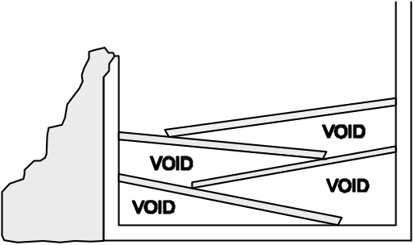

Pancake Void

Pancake Void, in which floors collapse diagonally onto each other, creating voids in the areas where the floors remain attached to the walls.

Pancake voids are most common in buildings that were constructed before 1933. They are created by weakening or destruction of load-bearing walls, which allows the floors to collapse into each other. Pancake voids are the most difficult and time-consuming to search.

Remember the dangers of unreinforced masonry structures. If CERT members see pancake voids, this is considered heavy damage, and they should get out immediately.

Conducting Search Operations (Continued)
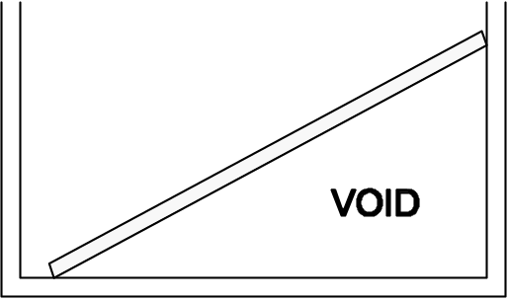

Lean-to-Void

Lean-To Void, in which a collapsed wall or floor leans against an outside wall, creating a void where the floor remains attached to the wall.

Lean-to voids are created when a collapsed wall or floor is resting against an outside wall. A victim trapped in a lean-to void has the greatest chance of being alive.

Lean-to voids also indicate structural instability. If CERT members see lean-to voids, they should note the location for professional responders but leave the building immediately!

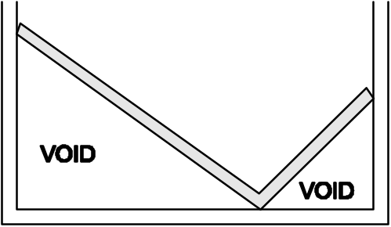

“V” Void

“V” void, in which the floor or wall collapses at or near the center, creating voids on either end next to the walls.

“V” voids are created by a “V” collapse of a floor or wall (the middle collapses and the ends lean against an outside wall). Remind the group that a “V” void creates two lean-to voids, one on either side of the collapse, in which victims can be trapped—but the sloping floor caused by the “V” collapse presents a severe potential hazard to the rescue team.

If CERT members encounter “V” voids, they should leave the building immediately.

Individual voids are spaces into which the victim may have crawled for protection. Examples of individual voids include bathtubs and the space underneath desks. Children may seek shelter in smaller spaces like cabinets.

Conducting Search Operations (Continued)
After identifying the possible areas of entrapment, CERT members must:

- Determine the potential number of victims.

- Identify the most probable areas of entrapment.

Some of this information may be known through planning, but CERT members may need to get some information by talking to bystanders or those who are familiar with the structure.

CERT members should ask questions when talking with these individuals, including:

- How many people live (or work) in the building?

- Where would they be at this time?

- What is the building layout?

- What have you seen or heard?

- Has anyone come out?

- What are the normal exit routes from the building?

Bystanders may be confused by the event. They may tend to exaggerate potential numbers or may not even remember the event accurately. Gather as much information as you can, though, because it will be useful for planning search priorities and implementing the search.

Search Methodology

An effective search methodology:

- Indicates rescuer location.

- Prevents duplication of effort.

Conducting Search Operations (Continued)
Experienced search and rescue personnel have found these search methods to be effective:

- Begin the search by calling out to victims. Shout something like, "If anyone can hear my voice, come here." If any victims respond, give them further directions such as "Stay here" or "Wait outside" (depending on the condition of the building). Ask victims who respond for any information that they may have about the building or others who may be trapped.

- Use a systematic search pattern. Ensure that all areas of the building are covered. Examples of systematic search patterns to use include:

- Bottom-up/top-down.
- Right wall/left wall.

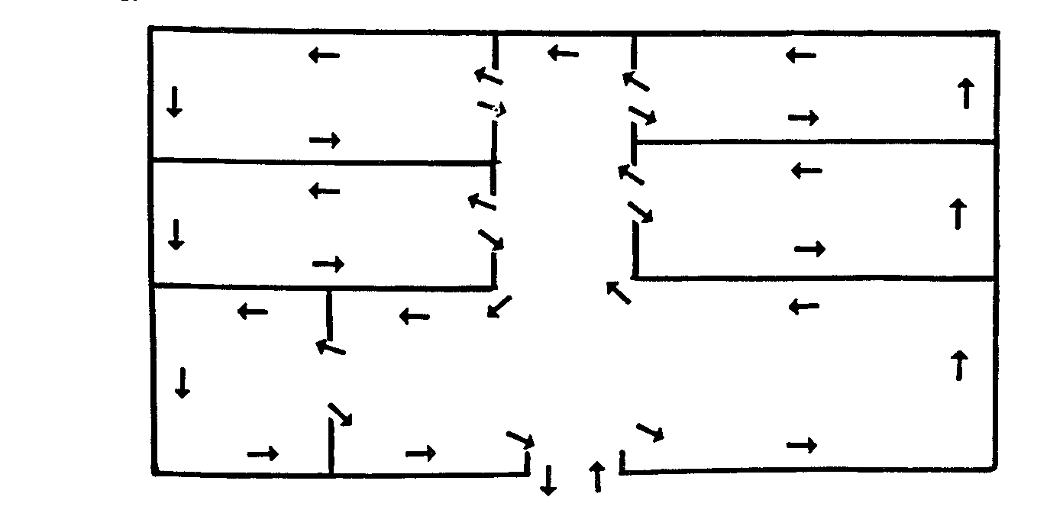
Sample Systematic Room Search

Systematic Room-Search Pattern, bottom-up/top-down or right wall/left wall to ensure that the entire building is searched.

- Stop frequently to listen. Listen for tapping, movement, or voices.

- Triangulate. Triangulation enables rescuers to view a single location from several perspectives. Three rescuers, guided by victim sounds, form a triangle around the area and direct flashlights into the area. The light shining from different directions will eliminate shadows that could otherwise hide victims.

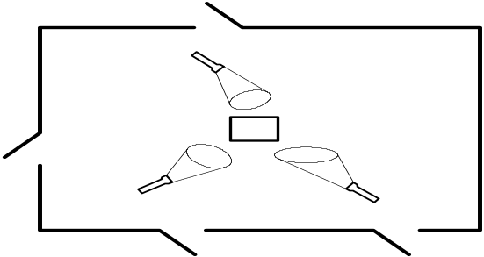

Triangulation

Triangulation: Three rescuers guided by victim sounds form a triangle around the area and direct flashlights into the areas. The light will help eliminate shadows.

Conducting Search Operations (Continued)
- Mark searched areas to document results. Make a single diagonal slash next to the door just before entering a structure. Make an opposite slash (creating an "X") when all occupants have been removed and search and rescue efforts have been completed. The "X" signals to other potential searchers that the area has already been searched. This method:

- Indicates rescuer location.
- Prevents duplication of effort.

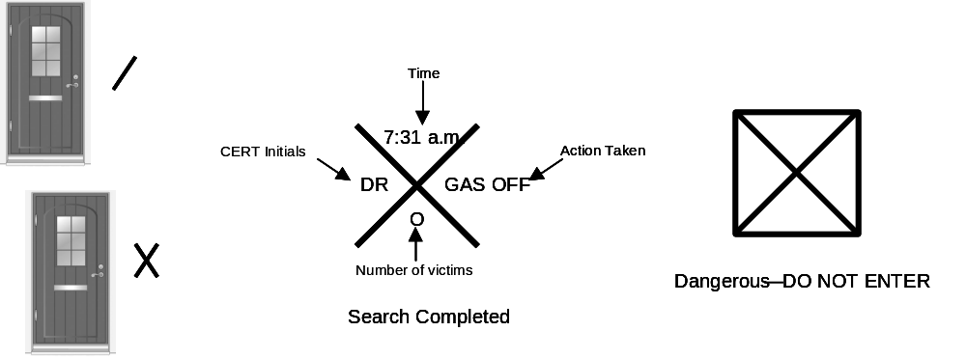
Marking Searched Areas

- Report results. Keep complete records both of removed victims and of victims who remain trapped or are dead. Report this information to emergency services personnel when they reach the scene.

Conducting Rescue Operations
Rescues involve three primary functions:

- Creating a safe rescue environment by lifting objects out of the way, using tools to move objects, and removing debris.

- Triaging or stabilizing victims.

- Removing victims in a moderately damaged building. Call in the medical team in a lightly damaged building.

Conducting Rescue Operations (Continued)

Creating a Safe Environment

There are three goals for all rescue operations:

- To maintain rescuer safety

- To triage in lightly and moderately damaged buildings

- To evacuate victims as quickly as possible from moderately damaged buildings while minimizing additional injury

None of these goals can be achieved without creating as safe an environment as possible before attempting rescue. There are, therefore, certain precautions that rescuers must take to minimize risk.

- Know your limitations. Many volunteers have been injured or killed during rescue operations because they did not pay attention to their own physical and mental limitations. CERT rescuers should take the time to eat, drink fluids, rest, and relax so that they can return with a clear mind and improved energy.

- Follow safety procedures. CERT members should always use the proper safety equipment required for the situation and follow established procedures, including:

- Working in pairs.
- Never entering an unstable structure.
- Lifting by bending the knees, keeping the back straight, and pushing up with the legs.
- Carrying the load close to the body.
- Lifting and carrying no more than is reasonable.

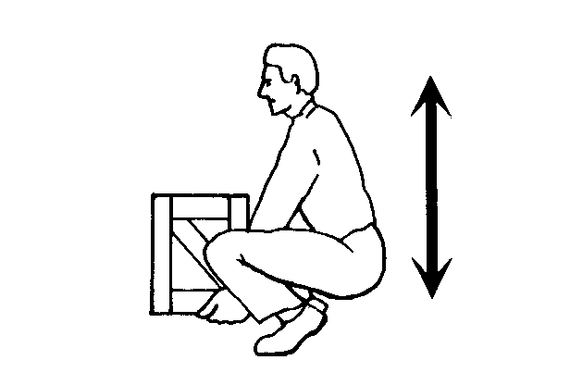
Proper Body Position for Lifting

Proper Body Position for Lifting showing the back straight and lifting with the knees.

Conducting Rescue Operations (Continued)
You may encounter situations in which debris needs to be moved to free victims. In these situations, CERT rescuers should consider leveraging and cribbing to move and stabilize the debris until the rescue is complete.

- Leveraging is accomplished by wedging a lever under the object that needs to be moved, with a stationary object underneath it to act as a fulcrum. When the lever is forced down over the fulcrum, the far end of the lever will lift the object.

- A crib is a wooden framework used for support or strengthening. Box cribbing means arranging pairs of wood pieces alternately to form a stable rectangle.

Leveraging and cribbing are used together by alternately lifting the object and placing cribbing materials underneath the lifted edge to stabilize it. Safety is number 1: "Lift an inch; crib an inch."

Leveraging and cribbing should be gradual—both for stability and to make the job easier. It may also be necessary to use leveraging and cribbing at more than one location (e.g., front and back) to ensure stability.

When you are able to achieve sufficient lift, remove the victim and reverse the leveraging and cribbing procedure to lower the object.

When you must remove debris to locate victims, you should set up a human chain and pass the debris from one person to the next. Set up the chain in a position that will not interfere with rescue operations. Wear leather gloves to protect your hands.

Removing Victims

There are two basic types of removal:

- Self-removal or assist

- Lifts and drags

It is usually best to allow an ambulatory victim to extricate himself or herself. However, sometimes ambulatory victims are not as strong and uninjured as they think that they are. When victims become free from entrapment, they may need assistance to exit the structure.

Conducting Rescue Operations (Continued)
The type of extrication method selected should depend on the:

- General stability of the immediate environment.

- Number of rescuers available.

- Strength and ability of the rescuers.

- Condition of the victim.

If safety and time permit, you should not use lifts and drags to remove victims when closed-head or spinal injury is suspected. In such cases, the spine must be stabilized using a backboard. Doors, tables, and similar materials can be used as improvised backboards. The backboard must be able to carry the person, and proper lifting techniques must be used. When moving victims, rescuers must use teamwork and communication, and keep the victim's spine in a straight line. Remember, rescuer safety and the condition of the building will dictate the approach.

There are several types of lifts and carries. For example, if the rescuer is physically able and the victim is small, he or she may use the one-person arm carry to lift and carry the victim by:

- Reaching around the victim's back and under the knees.

- Lifting the victim while keeping the rescuer's back straight and lifting with the legs.

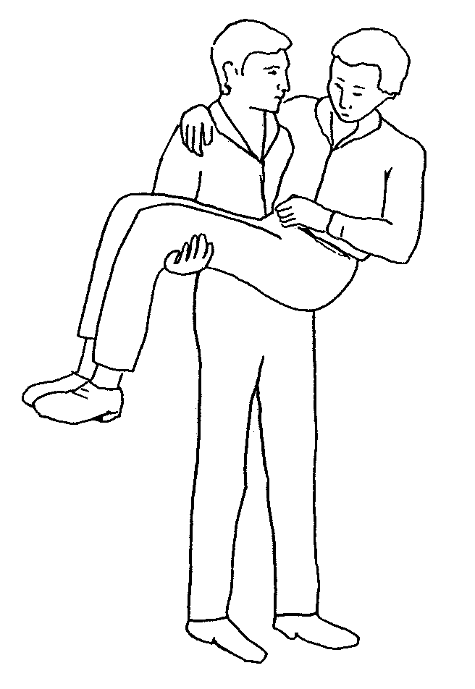
One-Person Arm Carry

One-Person Arm Carry, which shows the rescuer holding the victim around the victim’s back and under the knees.

Note: Consider the size of the victim and the distance he or she needs to be carried before using this carry.

Conducting Rescue Operations (Continued)
Another way for a single rescuer to lift a victim safely is by using the one-person pack-strap carry. Using this method, the rescuer should follow the steps outlined below:

- Step 1: Stand with his or her back to the victim.

- Step 2: Place the victim's arms over the rescuer's shoulders and grab the hands in front of the rescuer's chest.

- Step 3: Hoist the victim by bending forward slightly, until his or her feet just clear the floor.

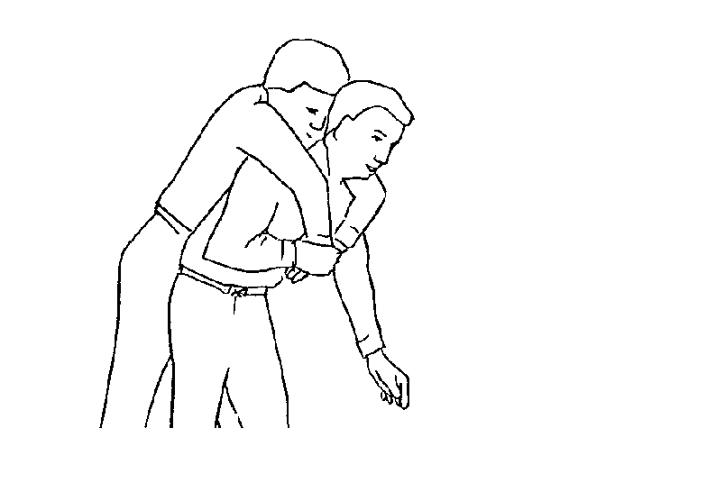
One-Person Pack-Strap Carry

One-Person Pack-Strap Carry in which the rescuer places the victim’s arms over his or her shoulder and grabs the victim’s hands over his or her chest, then hoists the victim by bending over slightly.

Victim removal is easier when multiple rescuers are available. With two rescuers, a victim may be removed using a two-person lift.

- Rescuer 1: Squat at the victim's head and grasp the victim from behind around the midsection. Reach under the arms and grasp the victim's forearms.

- Rescuer 2: Squat between the victim's knees, facing either toward or away from the victim. Grasp the outside of the victim's legs at the knees.

- Both rescuers: Rise to a standing position, keeping backs straight and lifting with the legs. Walk the victim to safety.

Conducting Rescue Operations (Continued)
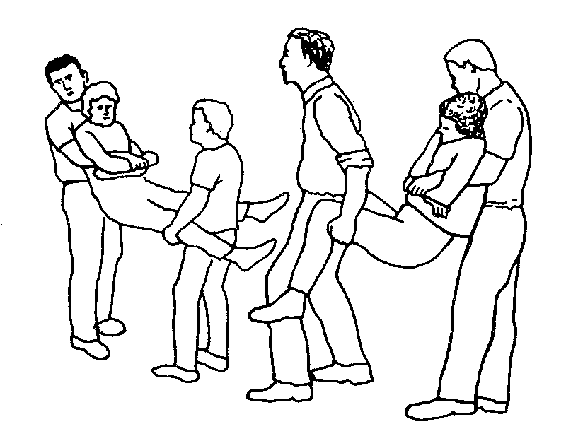
Two-Person Carry

Two-Person Carry in which rescuer 1 squats at the victim’s head and grasps the victim from behind at the midsection. Rescuer 2 squats between the victim’s knees, grasping the outside of the knees. Both rescuers rise to a standing position.
Two rescuers can also remove a victim by seating him or her on a chair:

- Rescuer 1: Facing the back of the chair, grasp the back uprights.

- Rescuer 2: Facing away from the victim, reach back and grasp the two front legs of the chair.

- Both rescuers: Tilt the chair back, lift, and walk out.

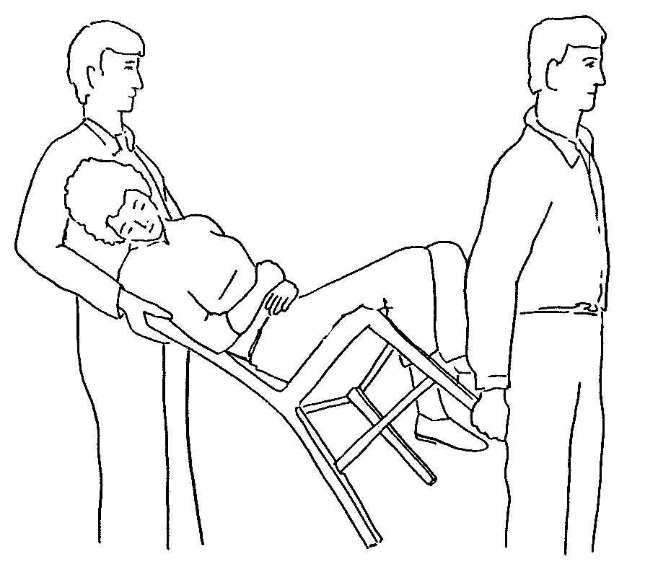
Chair Carry

Chair Carry in which the victim is placed in a chair and tilted backward as rescuers lift the victim. This carry requires two rescuers.

Conducting Rescue Operations (Continued)
You can use the blanket carry for victims who cannot be removed by other means. The blanket carry requires at least six rescuers to ensure stability for the victim, and one rescuer must be designated the lead person:

- Step 1: Lay a blanket next to the victim.

- Step 2: Tuck the blanket under the victim, and roll the victim into the center of the blanket.

- Step 3: With three rescuers squatting on each side and grasping a “handle,” the lead person checks the team for even weight distribution and correct lifting position.

- Step 4: The lead person calls out, “Ready to lift on the count of three: One, two, three, lift.”

- Step 5: The team lifts and stands in unison— keeping the victim level—and carries the victim feet first.

The team must also lower the victim together, using the following steps:

- Step 1: The lead person calls out, “Ready to lower on the count of three: One, two, three, lower.”

- Step 2: The team lowers the victim in unison, exercising caution to keep the victim level.

A variety of materials—such as blankets—can be used as improvised stretchers.

Rescuers can also drag a victim out of a confined area by grasping either under the arms or by the feet and pulling across the floor. However, unless there is no other way to remove the victim and the victim’s removal is time critical, you should not use this drag when debris may cause additional injury.

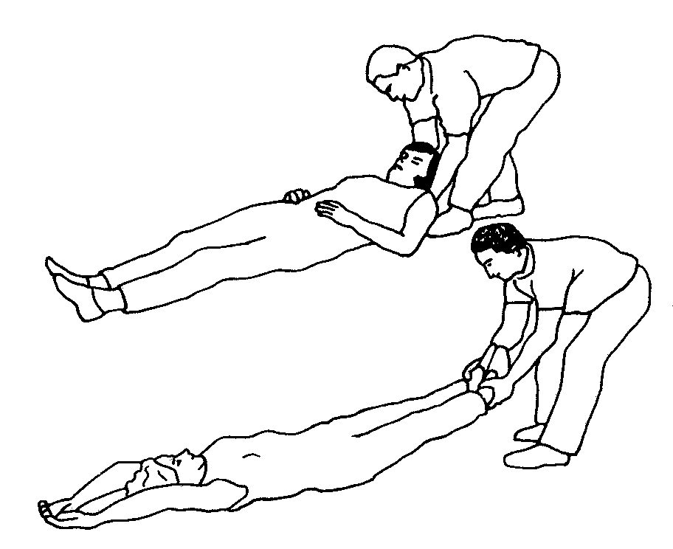
Correct Drag Techniques

Correct Drag Technique, showing the rescuer grasping the victim by either the feet or shoulders and dragging him or her clear of the hazard.

Conducting Rescue Operations (Continued)
When necessary, one rescuer can use the blanket drag by following these steps:

- Step 1: Wrap the victim in a blanket.

- Step 2: Squat down and grasp an edge of the blanket.

- Step 3: Drag the victim across the floor.

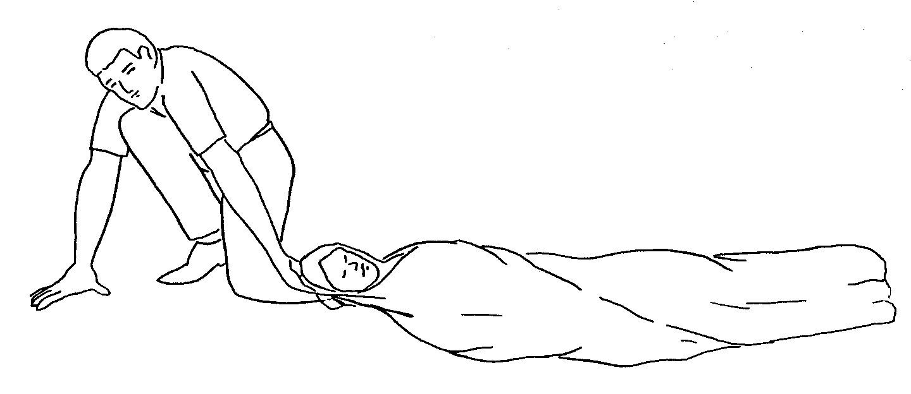
Blanket Drag

Blanket Drag, showing the victim wrapped in a blanket with the rescuer squatting at the victim’s head. The rescuer grasps the blanket behind the victim’s head and drags him or her clear of the hazard.

Exercise: Removing Victims

Purpose: This exercise will provide you with an opportunity to practice the removal of victims from a collapse situation, using leveraging/cribbing and drags and carries. You will be assigned into groups and assigned to do a room search, locate victims, and remove the victims.

Instructions: Use the following steps to complete this exercise:

- Enter your assigned "collapse site" room, do a room search, locate the victims and use leveraging and cribbing procedures to free them, and use appropriate lifts and drags to remove the victims from the room (and, if possible, from the building).

- Rotate roles so that there are two new victims. Repeat the exercise until everyone has had an opportunity to practice being a rescuer.

Unit Summary
Search and rescue consists of three different activities that must be planned carefully and practiced in advance. The decision to attempt a rescue should be based on:

- The risks involved.

- Achievement of the overall goal of doing the greatest good for the greatest number.

The objectives of search and rescue are to:

- Maintain rescuer safety at all times.

- Rescue the greatest number of people in the shortest amount of time.

- Rescue the lightly trapped victims first.

CERTs are restricted to light search and rescue. Their mission when dealing with heavily damaged structures or situations that are clearly unsafe (e.g., rising or swiftly-moving water) is to warn others.

Search and rescue sizeup follows the same process as does sizeup for other CERT operations. Sizeup continues throughout search and rescue efforts and provides information about how to proceed. Should sizeup indicate that evacuation is necessary, the CERT mission is to ensure safety and organization during the evacuation.

When the decision to begin search operations is made, CERT searchers must:

- Employ appropriate search techniques.

- Locate potential victims.

Locating victims means completing a size up of the building interior to identify areas of entrapment, then conducting a search that:

- Is systematic and thorough.

- Avoids unnecessary duplication of effort.

- Documents results.

Unit Summary (Continued)
Rescue involves three main functions:

- Creating a safe environment

- Triaging or stabilizing victims

- Removing victims based on the sizeup

Rescue operations hinge on maintaining rescuer safety, which requires CERT members to recognize their own limitations. CERT members should never attempt anything that exceeds their limitations at that point in time.

Leveraging and cribbing may be used to remove debris and give access to trapped victims.

Victims can be removed in a number of ways, depending on:

- Their condition.

- The number of rescuers available.

- The strength and ability of the rescuers.

- The stability of the environment.

If the building’s condition allows, victims with suspected head or spine injury should be stabilized on some type of backboard before being removed. If possible, these removals should be deferred to trained EMS personnel.

Homework Assignment

Read and become familiar with Unit 6: CERT Organization and Unit 7: Disaster Psychology before the next session.

