Summary: NAM-Y Impact on AQ Forecasts

NOAA’s AQ team evaluated the NAM experimental (NAM-Y) Summer 2007 retrospective forecast simulations that were run with NDAS cycling for the AQ retrospective period (Aug. 5-18, 2007). High ozone events were observed over most parts of the CONUS during this period. NAM-Y was evaluated for low-level and boundary layer parameters to which photochemical processes are especially sensitive. Weather fields shown below were plotted on the EMC AQ web page: http://www.emc.ncep.noaa.gov/mmb/aq. Also summarized below are additional weather information from EMC’s land-surface group, and information on comparisons of predicted ozone concentrations.

Fields Compared. August 5-18, 2007 | Comparison ; NAM-Y vs. NAM (CONUS-wide) | Features: especially SoCal
- 3 hourly 2m & 850 mb  - temperatures,  - winds  - relative humidity | 2m: slightly warmer 0.1 deg C  Slightly weaker  Slightly drier | So. Cal: slightly cooler offshore and along coast; during episode 2-4 deg C warmer.  850 m: regionally mixed: slightly warmer 0.5 deg C (introducing bias E, W regions); slightly cooler (0.2 -0.4 deg C) for sub-regions in SW, Gulf Mexico) reducing warm bias  Slightly weaker
- Surface longwave, shortwave, sensible and latent heat fluxes | increased | S. Cal: increased downward shortwave inland and during ozone episode  Elsewhere: Increased locally ahead of slower front and Tropical Storm Erin
- Planetary boundary layer heights | Higher over Eastern and Central US by 200-400m; increases high bias | Generally lower over Pacific Coast by ~200 m
- Cloud cover and cloud water | Slightly drier | During Aug 14-15 episode: drier, lower cloud water
- Surface ozone conc.: daily max 8-hr avg | Increase in bias ~ 2ppb | Pacific Coast area, pos. bias is reduced  Spatial patterns of elevated O₃ downwind of LA basin show lower peak O₃ concentration: on some days (Aug 14-17) this improves agreement with observation
- Frontal passage | Appearance of TS Erin and one cold front are slower by ~12 hours.  O₃ enrichment associated with advancing cold fronts is more pronounced: 5ppb in NE, 1-2 ppb in SE | TS. Erin: longer ozone-building episode prior to arrival off Gulf Coast, raises high bias near Houston.
- Canopy Conductance | Generally NAM-Y canopy conductance is slightly lower in East and very slightly higher in west, and much lower in eastern Canada. | Large differences in both directions seem associated with differences in clouds and precipitation
- Dry deposition velocity (V_{d}) for ozone | Generally slight decrease in V_{d} for ozone caused mostly by slight increase in aerodynamic resistance. This decrease in V_{d} could contribute to slight increase in ambient O₃
Domain-wide comparisons of NAM and NAM-Y were supplemented with comparisons for sub-regions, with emphasis on challenging areas for O3 predictions: the LA basin, and Central California valley and Gulf Coast regions. For the Pacific region, NAM-Y low level winds were slightly weaker especially on the windward side of the mountains probably in response to the new gravity wave processes introduced. Lighter winds may help CMAQ forecasts in the California Central Valley where ozone is often under-predicted. NAM-Y temperatures were cooler off-shore and along the Northern and Central California Coast, possible because the marine boundary layer and resulting cloud cover in NAM-Y was able to move on-shore earlier. However, during the very stagnant and high ozone event of Aug. 14-15, 2007, the NAM-Y forecasts were much warmer (as much as 2-4 deg C) with less cloud water especially inland and more downward shortwave radiation in Southern California. The changes in cloud water and cloud cover may have an impact on CMAQ photolysis and aqueous phase chemical reactions.

NOAA’s AQ team noted that NAM-Y - CMAQ ozone was over-predicted ahead of the cold front that affected the Midwest and North East from Aug 12th-15th. Warm temperature biases for the Northeast sub-region were worsened by about 1 deg C as the cold front approached with NAM-Y, implying that its movement and associated cloud cover was too slow. Over the Midwest, the NAM-Y temperature errors were too warm on Aug 14 and 16th by about 0.5 deg C. No consistent differences in winds were noted for these regions.

The EMC land surface group performed a quantitative evaluation of NAM-Y 2m temperature, RH and 10 m winds for August 1-31, 2007 over the larger Western and Eastern US sub-regions. Overall differences for these large domains were small with both areas showing slightly warmer and dryer conditions. 10 m wind biases were increased in the East but little impact was noted in the west. At upper levels, EMC noted that warm biases of about +0.5 deg. C were introduced for the Eastern US at 850 mb and for the Western US at 850 and 700 mb. RH moist biases were also reduced slightly (3-5%) for the Eastern US at these levels.

EMC then produced sub-region statistics for the Southwest and Gulf of Mexico regions. For the Southwest coastal region that includes Central and Southern California, the warm biases were reduced by around 0.2-0.4 degrees C and the RH dry bias was improved slightly. Wind errors were similar. Over the Gulf or Mexico, the impact was small for temperature and RH, but the low wind bias was made slightly worse. However, the day-time temperature error increased by about 1 degree C from the 16th – 18th during the time that TS Erin was affecting the Gulf. Low wind biases were also worsened by about 1 m/s during this time.

In addition, the AQ group quantitatively evaluated the predicted NAM-Y PBL height for the larger sub-regions. NAM-Y TKE derived boundary layer heights in the late afternoon were generally higher over the Eastern and Central U.S. by as much as 200-400 m on average. These characteristics result in larger boundary layer height errors since the operational NAM boundary layer heights were already overestimated for this period. However, the impact on PBL heights generated by the bulk Richardson number method was smaller. For the Western U.S. NAM-Y did not exhibit any bias except along the Pacific Coast where boundary layer heights were generally lower for San Diego. These patterns are in agreement with the cooler, cloudier conditions noted above for this coastal region.
Surface temperature and relative humidity forecast errors are shown below for NAM (black line) and NAM-Y (red line) over the CONUS
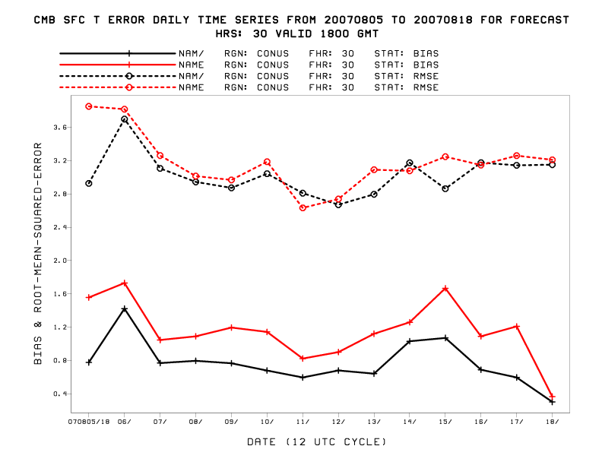

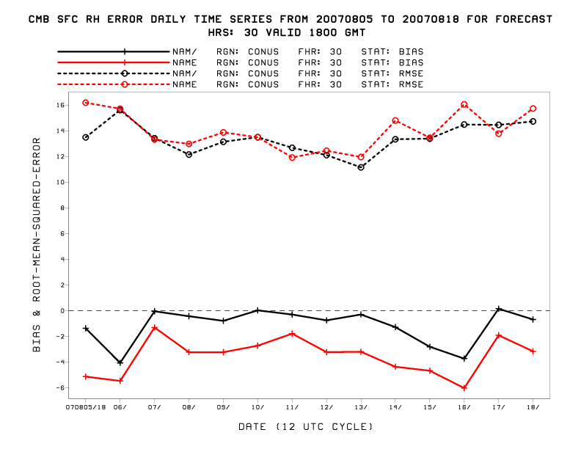
Surface temperature and relative humidity forecast errors are shown below for NAM (black & blue lines) and NAM-Y (= NAM-E; red & green lines) over the SW coast and Gulf of Mexico regions respectively.
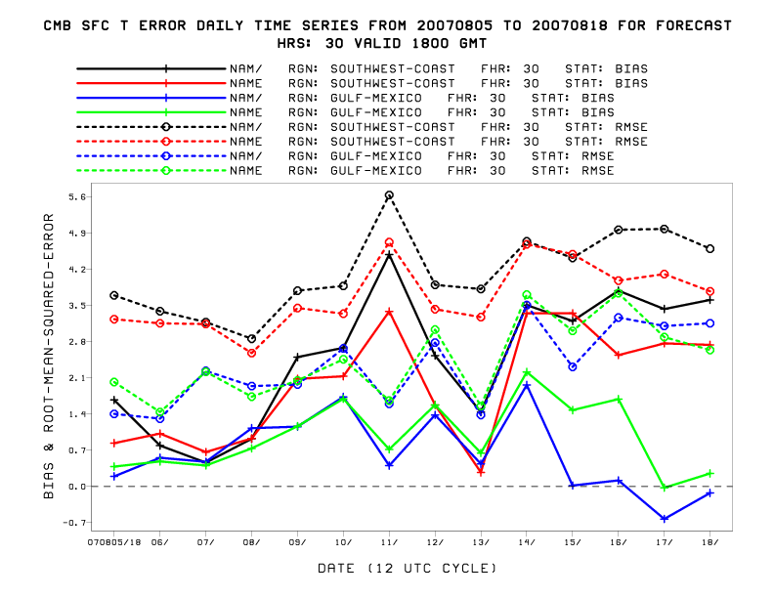
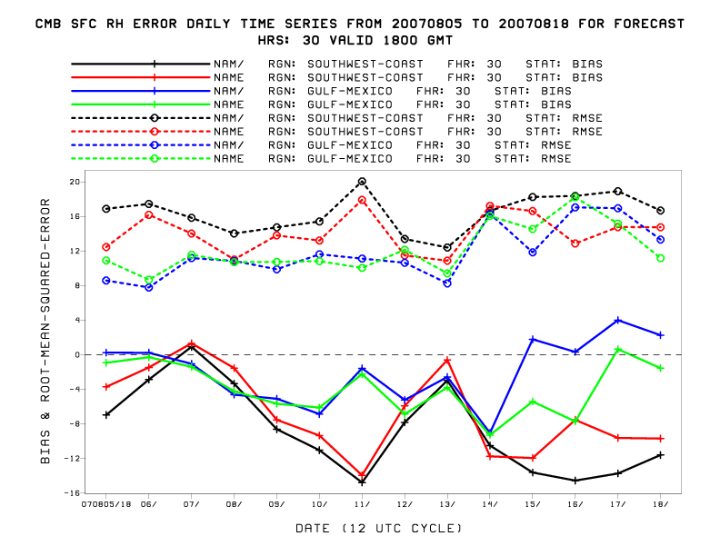Comparisons of predicted ozone are shown below. 