USDA Foreign Agricultural Service
GAIN Report

Template Version 2.09

Global Agriculture Information Network

Required Report - Public distribution
Date: 11/14/2008
GAIN Report Number: JA8713
JA8713
Japan
Retail Food Sector
Annual Report
2008

Approved by:
Michael Conlon, Director, ATO Japan
AmConGen
Prepared by:
Masahiro Matsumoto, ATO Osaka, John Mark Looney

Report Highlights:
Food and beverage retail sales increased by one percent to $370.5 billion in 2007 because of the sharp increase in economic activity in the 4th quarter of 2007 and the rise in food prices. Although the total number of retail food outlets has also been decreasing, convenience stores and conventional supermarkets have continued to increase steadily over the years. Consumers’ concern about food safety has been increasing due to the recent food safety scandals.

Includes PSD Changes: No
Includes Trade Matrix: No
Annual Report
Osaka ATO [JA3]
[JA]

Japanese Retail Food Sector Report in 2008

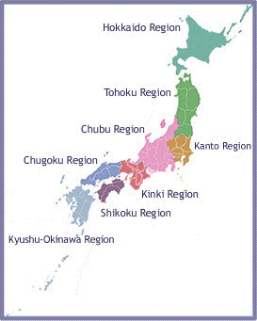

U. S. Agricultural Trade Office
JAPAN

Table of Contents
I. Japanese Retail Market Summary 4
1. Trends in the Retail Food Sales 4
2. The Number of Retail Establishments is Declining 5
3. Food & Beverage Sales Around Japan 7
4. The Popularity of Home Meal Replacements (HMR) Increases 7
5. Healthy Foods Offer Expanded Opportunities 8
6. Usage of Private Brands Expands 9
II. Trends in the Retail Industry 10
1. Large-scale Supermarkets and Conventional Supermarkets 10
2. Convenience Stores 11
3. Department Stores 12
III. Road Map for Market Entry 14
1. Food Distribution System in Japan 14
A. Distribution Structure for National and Conventional Supermarkets 14
B. Distribution Structure for Department Stores 15
C. Distribution Structure for Convenience Stores 15
D. Co-ops and voluntary chains 15
E. Most traditional stores 16
F. Specialty stores 16
G. Online Sales - 16
2. International Competition of Food Exports to Japan 16
IV. Consumer Purchasing Behavior 19
1. Demographic Trends 19
2. Strong Interests in Healthy Foods 20
3. Safety Issues 21
4. Imported Food Products 21
VI. Best Product Prospects 25
VII. Post Contact and Further Information 28

I. Japanese Retail Market Summary

Total retail sales in Japan (food and beverages, general merchandises and fabrics, apparel and accessories) amounted to $614.6 billion in 2007, with total food and beverage retail sales accounting for $370.6 billion of that figure. Total retail sales have been flat in recent years due low domestic consumption caused by negative population growth, an aging population and a sluggish economy. Annual gross profits of Seven & I and Aeon, Japan’s largest and second largest retail group respectively, declined in 2007.

Even though Japan’s overall retail trade has been generally flat over the last several years, sales in the retail food and beverage sector increased by around $3 billion in 2007 because of a sharp rise in food prices. For example, the Japanese government has increased the price it charges to flour mills for wheat by 40% over the last year. Prices of many basic food products in Japan including noodles, bread, egg, cooking oil, milk and milk products, soy sauce, meat, fish, etc. have also significantly increased. Butter is in short supply and many municipal governments are increasing school lunch fees to accommodate high food prices.

Figure 1. Total Retail Sales (million US$)
 | Total | Food & Beverage | General Merchandise | Fabrics, Apparel, & Accessories
2005 | 620,136 | 369,136 | 150,000 | 101,000
2006 | 614,700 | 367,700 | 148,000 | 99,000
2007 | 614,582 | 370,582 | 147,000 | 97,000
Source: METI

1. Trends in the Retail Food Sales

Overall retail food sales in Japan are typified by:
- The value of retail food sales increased slightly nationwide in 2007
- Decreasing number of food and beverage retail outlets
- Strong concern about food safety - Anshin (reassurance) and Anzen (safety)
- Increasing food prices
- Continuous growth in “home meal replacements” (HMR)
- Strong interests in “healthy foods”
- Expanding usage of private brands
- Diversification of store concepts
- Increasing consolidation in the food industry
- Growth in imported food

The value of overall retail food sales increased slightly in 2007 to $370.6 billion. Amidst this backdrop, there has been an industry restructuring in nearly every key segment, with all types of food retailers scrambling to find new ways of satisfying consumer needs.

Figure 2. Total Food Retail (Million US$)
 | Total | Large-scale Supermarket & Conventional Supermarkets | Department Stores | Convenience Stores | Specialty/One Category/Mom & Pop Stores/Others
2005 | 369,136 | 67,578 | 20,099 | 66,905 | 214,554
2006 | 367,700 | 67,922 | 19,975 | 67,191 | 212,612
2007 | 370,582 | 69,965 | 19,734 | 68,087 | 212,796
Source: METI

A large-scale supermarket is defined as a store that sells clothing, food and living-related products. A conventional supermarket is defined as a store in which over 70% of the products sold is food. A specialty store is defined as a store specializing in foreign foods, discount foods, natural/healthy foods, etc, that tend to be smaller in size. One category store is defined as a store in which over 90% of the products are one type of food, such as meat and fish. A Mom and Pop store is defined as a grocery store that is small and a family-run operation.

Figure 3: Percentage of the Sales of Each Retail Format in 2007
Figure 3: Percentage of Food Sales for Each Retail
Format in 2007
Specialty/One
Category/Mom &
Pop Stores/Others
58%
Large Scale &Conventional

Supermarkets
19%
Department Stores
5%
Convenience Stores
18%
Source: METI

2. The Number of Retail Establishments is Declining

One of the effects of industry restructuring is that the number of stores selling food and beverages, with the exception of convenience stores and conventional supermarkets, has continued to decrease steadily over the last several years. Supermarkets and convenience stores continue to be the primary distribution channel for food in Japan. Large-scale supermarkets appear to have lost some ground to regional supermarkets. The clear losers in the long-term are “traditional food stores,” “one-category,” and “Mom and Pop stores” that are declining in importance.
Figure 4: Decreasing Number of Retail Establishments
Type of Stores | 2004 | 2007 | Growth Rate (%) ‘04/’07
Total | 1,238,049 | 1,136,755 | - 8
Department Stores | 308 | 272 | - 2
Large Scale Supermarket | 1,675 | 1,583 | - 5
Specialty/One Category & Pop Stores/Others | 36,220 | 34,954 | - 3
Convenience Stores | 42,738 | 43,318 | 0.1
Drug Stores | 13,095 | 12,671 | - 3
Conventional Supermarket | 56,221 | 57,511 | 0.2
Other Specialized Stores | 1,085,122 | 984,600 | - 9
Other Supermarket | 2,680 | 1,846 | - 31
Source: METI

Figure 5: Number of Retail Establishments (2007)
Other
Specialized
Stores,
984,600
Department
Stores, 272
Large Scale
Supermarkets,
1,583
Specialty/One
Category/Mom
& Pop
Stores/Others,
34,954
Convenience
Drug Stores,
12,671
Conventional
Supermarket,
57,511
Other
Supermarkets,
1,846
Stores,
43,318
Source: METI

3. Food & Beverage Sales Around Japan

Five out of eight prefectures showed positive sales growth from 2002 to 2006 (see Figure 6). Japanese real economic growth rate increased 1.6% in 2007, including a 3.5% annualized rate in the 4th quarter. Investments and exports to Asia and Europe were responsible for this spike in growth. In fact, Japan’s economy had been recovering in recent years, having recorded 6 years of continuous growth from 2002. However, sales in Osaka, Japan’s second largest markets, declined. The economy of Osaka has been generally weaker than in other parts of Japan. It is important to keep in mind that even in an environment of stagnant sales geographic markets in Japan are quite sizeable – often exceeding that of entire countries. For example, Kyushu alone possesses a GDP that exceeds that of South Korea, Australia and the Netherlands.

Figure 6: Prefectural Population and Sales Trend (2006)
Prefecture | Population | Overall Food Sales (million US$) | Food Purchasing per household (US $) | Sales Growth Rate '02~'06
Hokkaido | 5,600,705 | 15,500 | 7,266 | 0.8%
Miyagi  *(Tohoku) | 2,340,485 | 6,000 | 8,162 | 0%
Tokyo  *(Kanto) | 12,361,736 | 44,200 | 9,371 | 8%
Aichi  *(Chubu) | 7,145,614 | 17,700 | 8,157 | 4.0%
Osaka  *(Kinki) | 8,665,105 | 24,700 | 7,983 | - 5.0%
Hiroshima  *(Chugoku) | 2,867,423 | 7,800 | 8,105 | - 1.0%
Ehime  *(Shikoku) | 1,479,775 | 3,900 | 7,717 | 3.0%
Fukuoka  *(Kyushu) | 5,030,311 | 13,900 | 8,001 | 8.1%
Others | 81,562,317 | 234,000 | ~~ | ~~
Total | 127,053,471 | 367,700 | 8,103** | 1%
** Denotes average of all prefectures
Source: Food Supermarket Yearbook
* See Japanese map of front page to locate the regions.

4. The Popularity of Home Meal Replacements (HMR) Increases

The HMR market (ready-to-cook, ready-to-heat and ready-to-eat meals) continues to represent the fastest growth opportunity in the Japanese food sector. Driven by such macro trends as an increasing number of single households, the aging population of Japan and an increasing number of working women, etc, consumer demand for HMR products is so strong that all retail food outlets are adding to or expanding their offerings in this area.

The expanding retail presence of “delicatessen” in supermarkets of all sizes – as well as in department stores and convenience stores – attests to the popularity of the HMR market. HMR sales are also increasing at a brisk rate in the fast food industry.

5. Healthy Foods Offer Expanded Opportunities

Driven by the aging population of Japan and by concerns regarding food safety, consumer interest in healthy and organic foods has been increasing. While interest is strongest among those aged 50 and above, expanding interest can also be seen in the younger age groups.

The healthy food category (or functional foods) has been growing steadily since the mid 1990’s. In Japan, functional food can be divided into “Foods for Specific Health Use,” or FOSHU, and health-enhanced food. Among the numerous attributes that serve to distinguish one from the other, the most important is that FOSHU products require government approval, while health-enhanced food products do not. What motivates companies to pursue the FOSHU designation, rather than avoid the often-lengthy approval process, is that they can affix the FOSHU seal on the product in question should it meet the Minster of Health Labor and Welfare (MHLW) criteria. The fastest growing healthy food category is the nutritional reinforcement beverage segment.

Figure 7. The Healthy Food Market Has the Potential to Grow Further
(million Dollar)
 | 2003 |  | 2004 |  | 2005 |  | 2006 |  | 2007
Supplement | 3,954 | 31.9% | 4,228 | 31.7% | 4,469 | 33.0% | 4,493 | 31.9% | 4,574 |  | 32.1%
Diet Food and Beverage | 490 | 4.0% | 521 | 3.9% | 550 | 4.1% | 599 | 4.0% | 632 |  | 4.4%
Balanced Nutritional Food and Beverage | 333 | 2.7% | 330 | 2.5% | 318 | 2.4% | 332 | 2.7% | 403 |  | 2.8%
Nutritional Reinforcement Food | 223 | 1.8% | 217 | 1.6% | 246 | 1.8% | 264 | 1.8% | 288 |  | 2.0%
Nutritional Reinforcement Beverage | 4,425 | 35.7% | 4,845 | 36.3% | 4,858 | 35.9% | 4,768 | 35.7% | 4,775 |  | 33.5%
Food for Specified Health Uses (FOSHU) | 1,409 | 11.4% | 1,548 | 11.6% | 1,620 | 12.0% | 1,703 | 11.4% | 1,770 |  | 12.4%
FOSHU (Beverage) | 1,564 | 12.6% | 1,654 | 12.4% | 1,466 | 10.8% | 1,646 | 12.6% | 1,795 |  | 12.6%
Total | 12,398 | 100.0% | 13,343 | 100.0% | 13,527 | 100.0% | 13,805 | 100.0% | 14,237 |  | 100.0%
Source: Agriculture, forest and fishery finance corp.

Figure 8: Healthy Food Market Has Potential to Grow Further
0
1,800

3,600

5,400
7,200
9,100

10,900
12,700
14,500
16,000

2003
2004
2005
2006
2007
Balanced Nutritional Food
and Beverage

Nutritional Reinforcement
Food
Diet Food and Beverage
Foshu (Beverage)
Foshu (Food)
Supplement
Nutritional Reinforcement
Beverage
Source: Agriculture, Forest and Fishery Finance Corp.

6. Usage of Private Brands Expands

The majority of major food retailers now feature their own private brands – a concept that reflects the voice of the customer in keeping with supermarkets’ expanding role as the “custodians of safety and lower price.” In the wake of recent food scandals (i.e., Chinese dumpling, false labeling, etc.), consumers’ concern about food safety has increased, and trust for food handlers has deteriorated. Food retailers have accordingly positioned themselves as the gatekeepers of food safety, and have begun to focus more on quality control (i.e., country of origin, level of pesticides used, presence of genetically modified ingredients, shelf life, etc). The price of raw materials have risen drastically; therefore consumers are tempted to buy lower priced products to save money.

The general concept of private brands is to offer the same quality of product but with a price significantly lower than national brands. Thus, the sales of private brand products have been rapidly increasing. At present, about 70% of the supermarkets handle private brands and 60 percent are planning to increase private brands offerings. The addition and expansion of private brand offerings is part of this overall positioning as the gatekeepers of food safety and price. The widening of this trend can be seen in the expansion of private brand product offerings for products such as processed foods to perishable products including fresh produce and meat.

II. Trends in the Retail Industry

1. Large-scale Supermarkets and Conventional Supermarkets

Large-scale supermarkets and conventional supermarkets accounted for 19% of the retail food market (US$70 billion) in 2007. Seven & I and Aeon have been expanding the total business by acquisitions. Seven & I recently acquired Millennium Retailing, which is the holding company of Sogo and Seibu Department Store. Aeon acquired Daiei and Maruetsu, two large supermarket chains, in 2007. International retailer, Carrefour Japan, was also acquired by Aeon. The world largest retailer, Wal-Mart, which acquired the majority share of Seiyu, has been struggling in the Japanese market. Moreover, many medium- and large-scale supermarkets have suffered bankruptcy in recent years. The big two retail group, Aeon and Seven & I, have started to request a reduction in the prices from national brand manufacturers, leveraging their huge buying power.

Price competition has become more intense and is a major feature of the supermarket business in Japan. Supermarkets are seeking to reduce costs and improve their infrastructures through the introduction of management systems and the improvement of procurement processes as well as through the closure of unprofitable stores in their efforts to improve efficiency. The companies which have succeeded to reduce management cost and to prevent losses have regained their profit. In general, gross profit rate of the chain stores decreased in 2007. Aeon and Seven & I have started to introduce electronic money payment which enables them to collect purchasing information.

Company profiles

The following tables summarize key details regarding the top 20 supermarkets by total sales in Japan.

Figure 9. Top 20 Supermarkets by Total Sales in 2007
Rank | Company Names | Total Sales (US$ million) | Food Sales (US$ million)* | Ratio of Food Sales  (%) | Number of Outlets | Location of HQ & Stores | Growth Rate  ’06-’07  (%)
1 | Aeon | 43,820 | 24,364 | 55.6 | 569 | Chiba  Nationwide | 22.5
2 | Ito-Yokado | 12,630 | 5,709 | 45.2 | 179 | Tokyo  Nationwide | - 1.5
3 | Uny | 10,310 | 5,990 | 58.1 | 229 | Aichi  Chubu | - 1.0
4 | Daiei | 10,140 | 6,449 | 63.6 | 207 | Tokyo  Nationwide | - 6.8
5 | Seiyu | 8,370 | Not disclosed | - | 392 | Tokyo  Nationwide | - 0.9
6 | Izumi | 3,990 | 2,242 | 56.2 | 72 | Hiroshima Western Japan | 5.3
7 | Life | 3,730 | 2,950 | 79.1 | 201 | Osaka  Nationwide | 5.0
8 | Heiwado | 3,570 | 2,199 | 61.6 | 104 | Shiga  Kinki & Chugoku | 2.0

9 | Izumiya | 3,230 | 1,835 | 56.8 | 87 | Osaka  Kinki | 0.6
10 | Maruetsu | 3,050 | 2,800 | 91.8 | 239 | Tokyo  Kanto | 2.6
11 | York Benimaru | 3,000 | 2,121 | 70.7 | 154 | Fukushima  Tohoku | 5.2
12 | Fuji | 2,920 | 1,679 | 57.5 | 91 | Ehime  Shikou | - 1.7
13 | Barrow | 2,890 | 1,502 | 52 | 120 | Gifu  Chubu | 10.0
14 | Tokyu Store | 2,820 | 1,968 | 69.8 | 96 | Tokyo  Kanto | 1.2
15 | *Coop Kobe | 2,440 | 2,196 | ** 90 | 150 | Hyogo  Hyogo | 5.7
16 | Okuwa | 2,290 | 1,807 | 78.5 | 138 | Wakayama  Kinki | 2.9
17 | Aeon Kyushu | 2,180 | 822 | 37.7 | 48 | Fukuoka  Kyushu | 14.3
18 | *Coop Sapporo | 2,160 | 1,944 | ** 90 | 94 | Hokkaido  Hokkaido | 7.4
19 | Inageya | 2,070 | 1,730 | 83.6 | 126 | Tokyo  Kanto | 3.2
20 | Kasumi | 1,660 | 1,560 | 94 | 105 | Ibaragi  Kanto | 7.4
Source: Nikkei MJ and Nihon Shokuryo Shinbun
* Used share of food sales in 2006 due to no disclosure in 2007.
** ATO’s assumptions

2. Convenience Stores

Convenience stores occupy 18% of the retail market, with sales of US$68 billion in 2007 (see Figure 2 and 3). Sales increased only by 1.3 percent in 2007, which follows a 1.0 percent increase in 2006. The slower growth is a reflection of a reduction in the number of store openings. In addition, closure of many unprofitable stores has accelerated. The rapid growth experienced by convenience stores has ended, and many companies have been forced into structural reform. Because locations to open new stores have been limited, convenience stores have been reviewing the existing stores. The sales of the existing stores (exclude new stores) decreased from the previous year, except those of Family-Mart.

Nowadays, companies’ growth can no longer rely on new store openings as they had in the past. The price competition from both supermarkets and take-out shops has forced convenience stores to reduce their prices. In addition, there are an increasing number of supermarkets that are extending their hours of operation – and these, too, compete with convenience stores. In short, convenience stores now experience competition from a variety of other types of outlets, because they have been so successful that other distribution outlets have begun to imitate them, with similar product offerings, longer hours, etc.

In order to survive and expand, convenience store operators are employing new strategies – such as offering new services or private brands. In particular, alliances with other businesses are growing. Lawson has opened “Fresh Lawson,” a new experimental store concept that sells perishable products. Lawson also acquired a 33% stake of the convenience store “99 Plus,” which also sells perishable products. Most convenience stores in Japan have plans to increase their assortment of perishable products.

Convenience stores are also trying to expand their customer bases to include not only the younger generations but, the older generations as well. Most of the convenience stores have already begun targeting the elderly by promoting safe and healthy food products in addition to offering services such as post office boxes, ATMs (Automated Teller Machines), and various payment systems (i.e., consumers can pay utility bills at their local convenience store).

Company Profiles

The following table (Figure 10) summarizes key details regarding the top 10 convenience stores in Japan.
-
Figure 10. Top 10 Convenience Stores in 2007
Rank | Company Name | Total Sales (US$ million) | No. of Outlets | Location | Growth Rate '06~'07
1 | Seven-Eleven | 21,830 | 12,034 | Nationwide | 1.6%
2 | Lawson | 12,000 | 8,587 | Nationwide | 2.1%
3 | Family Mart | 10,170 | 7,187 | Nationwide | 5.2%
4 | Circle K/Sunkus | 8,300 | 6,139 | Nationwide | -1.5%
5 | Mini-Stop | 2,590 | 1,895 | Kanto, Chubu | 5.6%
6 | Daily Yamazaki | 1,820 | 1,622 | Nationwide | -5.1%
7 | AM/PM | 1,740 | 1,169 | Nationwide | -5.4%
8 | Seiko Mart | 1,290 | 1,031 | Hokkaido, | 0.4%
9 | 99+ (Shop 99) | 1,210 | 837 | Nationwide | -0.8%
10 | 3-F | 1,000 | 722 | Kanto | 1.2%
Source: Nikkei MJ

3. Department Stores

Department store sales accounted for only 5% of the total retail food market with sales of US$19 billion in 2007. Significant restructuring among major department stores has been increasing. For example, the major department store Sogo filed for chapter eleven bankruptcy and merged with Seibu Department Store, which is now Millennium Retailing Co. The second largest department store, Isetan, merged with the third largest department store Mitsukoshi. The Kansai region’s large department store Hankyu merged with its strongest competitor, Hanshin Department Store. They now operate under a name, H2O Retailing. Daimaru Department Store merged with Matsuzakaya and established J Front Retailing.

Food sales at department stores have continuously declined for the past several years with a dramatic decrease in sales from 2000 to 2002 related to store closures.

It is important to note the “depachika” phenomenon when discussing the retail food sector of a department store. Depachika means the basement floor of the department store where fresh food halls are traditionally located. Depachika was quiet and did ordinary retail food business. The major change with Depachika is an increasing number of shops that deal with high-quality HMR. In fact, this was responsible for spurring the high-quality HMR market in Japan. In addition, the main tenants are branches of famous restaurants. The Depachika phenomenon turned the basement floor from nothing special into an attractive place and a means of bringing customers to department stores. Similar to the supermarket and convenience store segments, the environment of the department stores is highly competitive, with restructuring and merger and acquisition activity occurring in many companies. Some have modified their business structures, or opened new departments to improve sales. On the positive side, department stores, which have been an underexploited channel, have become willing to consider new ideas, which might offer opportunities for U.S. exporters.

Company Profiles
Figure 11 summarizes key details regarding the top 10 department stores in Japan.

Figure 11. Top 10 Department Stores in 2007
Rank | Company Name | Total Sales (US$ million) | Food Sales (US$ million) | Growth Rate (Food)  ‘06~’07 | Number of Outlets
1 | Takashimaya | 9,479 | 1,856 | 2.7% | 20
2 | Isetan | 7,143 | 748 | 0.3% | 10
3 | Mitsukoshi | 7,036 | 1,695 | - 3.8% | 18
4 | Sogo | 4,564 | No disclosing | - | 12
5 | Marui | 4,532 | No disclosing | - | 17
6 | Daimaru | 4,382 | 962 | 2.0% | 24
7 | Seibu | 4,255 | No disclosing | - | 16
8 | Tokyu | 2,735 | No disclosing | - | 12
9 | Kintetsu | 2,731 | 783 | 0% | 9
10 | Hankyu | 2,676 | 695 | 0.9% | 11
Source: Nikkei MJ, Nihon Shokuryo Shinbun

III. Road Map for Market Entry

1. Food Distribution System in Japan

When considering market entry in Japan’s relatively developed food market, it is important to keep the following points in mind:
- Overall, traditional entry points via importers are beginning to make way for other more diverse avenues. For example, even within one food retail organization (i.e., large-scale supermarket, regional supermarket chain, convenience store chain, etc.), there may be several routes for procurement – including importers, wholesalers, etc.
- Large-scale supermarkets still rely primarily on importers and wholesalers. Most are engaged to some degree in developing and maintaining private labels, which they tend to outsource to food processors.
- Conventional supermarkets tend to depend more on wholesalers. They usually procure from a number of regional/local and national wholesalers who buy imported food products from trading houses and importers. Wholesalers and big trading houses are generally interested in handling high volume products, not niche-oriented products.

A. Distribution Structure for National and Conventional Supermarkets - Giant nationwide supermarket chains including Aeon and Seven & I mainly purchase their foods through three channels: (1) direct from the importers; (2) direct from the manufacturers and processors; and (3) wholesalers and distributors. Conventional supermarkets purchase through similar distribution channels, although they mainly purchase from wholesalers, whereas the major national chains rely more on direct routes.

Figure: 13
Importer
Consumers
Trading
Company
U.S. Exporter
Wholesaler
National
Supermarket
Conventional
Supermarket
Co-op and Voluntary Chain Store

B. Distribution Structure for Department Stores - Food items at department stores are procured almost entirely through wholesalers and tenant merchants. Imported products reaching department store “tenant merchant” shelves is dependent upon the wholesaler purchasing these products from importers or trading companies. Tenant merchant companies mainly purchase the ingredients for their products from wholesalers and then manufacture the products to be sold.

Figure 14:

Consumers
U.S. Exporter
Wholesaler
*ADO
Department Store
Trading Company
Importer
Tenants

*ADO - All Nippon Department Stores Development Organization

C. Distribution Structure for Convenience Stores - Convenience store chains utilize trading companies and wholesalers, depending on the type of product. Due to limited space, convenience stores can only handle a few brands per category. Product performance is reviewed continuously, and slow moving products are replaced quickly, ensuring the highest turnover possible. Their management systems present the most significant challenges for imported packaged processed foods, since they require that U.S. exporters: 1) modify product taste/specifications to fit the tastes of Japanese consumers; 2) shorten delivery time to ensure freshness; and 3) update and introduce new products frequently.

D. Co-ops and voluntary chains use a variety of sources, including importers, wholesalers and direct importing. Serving voluntary chains, there are several major joint procurement organizations: CGC Japan, Nichiryu, All Japan Supermarket Association (AJS) and Consumer Cooperatives (Co-ops). Their major role is to develop private brand products with Japanese food processors and overseas sources to sell to member retailers. Some of these organizations directly import non-branded food products that are “volume” oriented in nature.

E. Most traditional stores (i.e., Mom & Pop and one category stores) depend on wholesalers. Penetration of imported foods into these shops and stores is relatively low.

F. Specialty stores (i.e., foreign foods, discount foods, etc.) also primarily depend on wholesalers. Selected coffee shop chains, discount stores and natural food specialty stores with chain operations may be worth development for U.S. food exporters.

G. Online Sales - Finally, online sales including TV, mail order offers yet another possible channel that U.S. exporters can consider for retail food distribution. Majority of the sales are still non foods, but food and beverage sales are increasingly being purchased online.

2. International Competition of Food Exports to Japan

Overall, the United States has maintained its position as the largest exporter of food products to the Japanese market, representing 24.6% of all imported value in 2007. The next highest share is held by China (15.5% of all imported value), and all other countries are far less (see figures 16).

Although food products from China pose a real threat to U.S. exports because of their lower prices – especially those produced in China by Japanese-owned and contracted companies – the spate of food scandals occurring over the past few years has caused consumers to demand higher levels of food safety. Specifically, in 2007 and 2008 there were a number of imported foods from China (i.e., frozen dumpling, milk products, eels, etc.) that were found to contain prohibited chemicals and false labeling. This led to a significant decrease in food imports from China in 2008.

Because of the uneven nature of Chinese food safety, U.S. exporters have an opportunity to build on America’s existing image of providing “safe” and “high quality” food products.

Figure 15: Major Food Exporters to Japan
Rank | 2001 |  |  | 2003
Rank |  | Value | % |  | Value | %
1 | U.S.A. | 11,407 | 26.5% | U.S.A. | 11,587 | 26.3%
2 | China | 6,069 | 14.1% | China | 6,251 | 14.2%
3 | Australia | 3,001 | 7.0% | Australia | 2,999 | 6.8%
4 | Canada | 2,582 | 6.0% | Canada | 2,615 | 5.9%
5 | Thailand | 2,359 | 5.5% | Thailand | 2,450 | 5.6%
6 | Korea | 1,491 | 3.5% | Korea | 1,312 | 3.0%
7 | Denmark | 1,181 | 2.8% | Denmark | 1,308 | 3.0%
8 | France | 1,098 | 2.6% | France | 1,298 | 2.9%
9 | Russia | 1,058 | 2.5% | Russia | 1,055 | 2.4%
10 | Taiwan | 856 | 2.0% | Taiwan | 1,049 | 2.4%
 | World Total | 43,006 | 100% | World Total | 44,076 | 100%
(Figure continued on next page)

Figure 15: Major Food Exporters to Japan (cont.)
Rank | 2005 |  |  | 2007
Rank |  | Value | % |  | Value | %
1 | U.S.A. | 11,117 | 22.1% | U.S.A. | 12,656 | 24.6%
2 | China | 8,148 | 16.2% | China | 7,978 | 15.5%
3 | Australia | 4,629 | 9.2% | Australia | 4,040 | 7.8%
4 | Canada | 3,073 | 6.1% | Canada | 3,148 | 6.1%
5 | Thailand | 2,521 | 5.0% | Thailand | 2,634 | 5.1%
6 | France | 1,466 | 2.9% | France | 1,731 | 3.4%
7 | Brazil | 1,495 | 3.0% | Brazil | 1,404 | 2.7%
8 | Chile | 1,384 | 2.7% | Chile | 1,378 | 2.7%
9 | Korea | 1,351 | 2.7% | Korea | 1,150 | 2.2%
10 | New Zealand | 1,124 | 2.2% | New Zealand | 1,061 | 2.1%
 | World Total | 50,384 | 100% | World Total | 51,520 | 100%

Figure 16. Major Food Exporters to Japan in 2007
Korea, 2.2%
New Zealand, 2.1%
Chile, 2.7%
U.S.A., 24.6%
China, 15.5%
Australia, 7.8%
Canada, 6.1%
Thailand, 5.1%
France, 3.4%
Brazil, 2.7%
Source: JETRO

3. Summary of Key Advantages and Current Position of the U.S. Food Products in the Japanese Market (Figure 17):

Key Words | Advantages | Current Position
Food Safety | U.S. agriculture can successfully differentiate itself from Japan and third countries on food safety issues by HACCP, GAP, ISO, etc. | Chinese dumpling (gyoza) and milk products accelerated Japanese consumers’ strong concern with imported foods.  Differences in regulations between the United States and Japan on MRLs (maximum residue levels) and Food Sanitation Law, etc. make import of agricultural products risky.
Health Consciousness | The organic and natural food industry in the U.S. is advanced in terms of certification, HACCP, number of stores, etc. There are many kinds of organic and natural foods in the United States. | U.S. certified organic foods are not automatically sold as organic foods in Japan. Prices of natural and organic foods are higher than conventional foods.
Stable Supply | The U.S. is the largest exporter of food products to Japan. As a largest supplier of food products in the world, the U.S. has a great opportunity to expand exports to Japan. | Japan’s food self sufficiency rate is only 39% and it has been declining due to aging population and the declining farm population.
Price and Quality | U.S. food products are competitive in prices and high in quality. In addition, there are many kinds of products. | In general, Japanese products are high quality but they are expensive. However, Japanese consumers trust Japanese products and have concerns about the quality of imported products.
Cultural Influences | Japanese consumers are strongly influenced by U.S. food culture such as McDonald, KFC, Starbucks, Coca-Cola, etc. | Most of the U.S. food products in the Japanese market are already common.

IV. Consumer Purchasing Behavior

1. Demographic Trends

Elderly Population Is Growing Rapidly

As has been widely reported, Japan has the fastest growing elderly population (over 65) in the world, expected to reach 25% of the total population by the year 2015. This demographic tidal wave is creating significant new opportunities for sales of health-oriented food products. Figure 18 illustrates the growth trend of the aged in comparison to the decline of those in younger age brackets.

Food consumption by the elderly has been increasing due to the fact that Japan’s population is rapidly aging. This trend is not just a result of the increasing number of elderly; this group’s consumption patterns are also very active. One possible reason for this is the older generation’s greater “spare time” (either because their children are independent or they are retired). They also have high disposable incomes because they are finished paying off most of their debts. According to the Ministry of Public Management, Home Affairs, Posts and Telecommunications Statistics Bureau, the average savings for households of those aged over 60 is US$171,000 – the highest of all household incomes by age group.

Figure 18: Forecast for Elderly Population
Year | Population (1,000 People)
Year | Total | Age 0-14 Yrs. | Age 15-64 Yrs | 65 and Over
2005 | 127,768 | 17,585 | 84,422 | 25,761
2010 | 127,176 | 16,479 | 81,285 | 29,412
2015 | 125,430 | 14,841 | 76,807 | 33,781
2020 | 122,735 | 13,201 | 73,635 | 35,899
2025 | 119,270 | 11,956 | 70,960 | 36,354
2030 | 115,224 | 11,150 | 67,404 | 36,670
2035 | 110,679 | 10,512 | 62,919 | 37,249
2040 | 105,695 | 9,833 | 57,335 | 38,527
2045 | 100,443 | 9,036 | 53,000 | 38,407
2050 | 95,152 | 8,214 | 49,297 | 37,641

Figure 19. Elderly Population Is Growing Rapidly
0.0%
10.0%
20.0%
30.0%
40.0%
50.0%
60.0%
70.0%
Year
2005
2010
2015
2020
2025
2030
2035
2040
2045
Age 0-14 Yrs.
Age 15-64 Yrs.
65 and Over
Source: Ministry of Public Management, Home Affairs,
Posts and Telecommunications, Statistics Bureau

2. Strong Interests in Healthy Foods

Purchases of healthy food products is particularly strong among consumers over 50 years old. Those companies with health-oriented products should clearly consider the importance of the aging demographic segment in Japan.

Japanese consumers of all ages have expressed an interest in “organic” foods (see figure 20). However, purchases of organic products does not appear to follow the high level of interest. The main reason is that organic food is expensive compared to regular food. Moreover, consumers do not fully understand the positive effects of “organic products.” However due to continuous food safety scandals, consumers’ interest has been increasing. If there are more supermarkets selling natural and organic foods throughout Japan like the United States, the consumption might drastically increase.

Figure 20. Organic Food Product Consumption by Age Group
76%
78%
68%
64%
59%
71%
18%
18%
24%
28%
35%
23%
6%
3%
8%
7%
6%
6%
0%
20%
40%
60%
80%
100%
60 Yrs and Over
50-59 Yrs
41-49 Yrs
30-39 Yrs.
20-29 Yrs.
Total
Does Purchase
Does Not Purchase
Unsure
No Answer
Source: Agriculture, forest and fishery finance corp.

3. Safety Issues
Due to continuous food safety scandals, consumers’ concern about food safety has been increasing. The followings are some of the food safety scandals that occurred in 2007:
a. False labeling of the country of origin -
Chinese eels were sold as domestic eels.
b. False variety of chicken -
Cheaper normal chicken was sold at higher price as famous Hinai chicken.
c. False labeling of shelf life and reuse of outdated products -
Famous Akafukumochi (rice cake with bean paste) and Shiroi Koibito (chocolate) sold
after the expiration date and reused raw materials.
d. False labeling of beef -
A well known traditional high class Japanese restaurant sold cheaper and lower class beef as Matsuzaka Beef that is well known as highest class domestic beef. This restaurant also reused left over food.
e. 10 people reported food poisoning by imported Chinese dumpling (gyoza) and subsequently 450 people throughout Japan reported feeling ill.

4. Imported Food Products

Most Japanese consumers actively choose “Kokusan,” or domestic products, due to anxiety over the imported food products. They have a perception that imported food products are inexpensive but unsafe, especially Chinese food products. Previously there were many consumers who claimed that they could not determine whether a product was domestic or imported. However, labeling of the country of origin at the retail stores has been enforced by law; and now all products must label the country of origin, with some exceptions for processed foods.

It is important to note that “good taste” and “high quality” are not major reasons for purchasing imported products (see figure 21). The position of U.S. food products are also in the zone of inexpensive and not so safe (see figure 22).

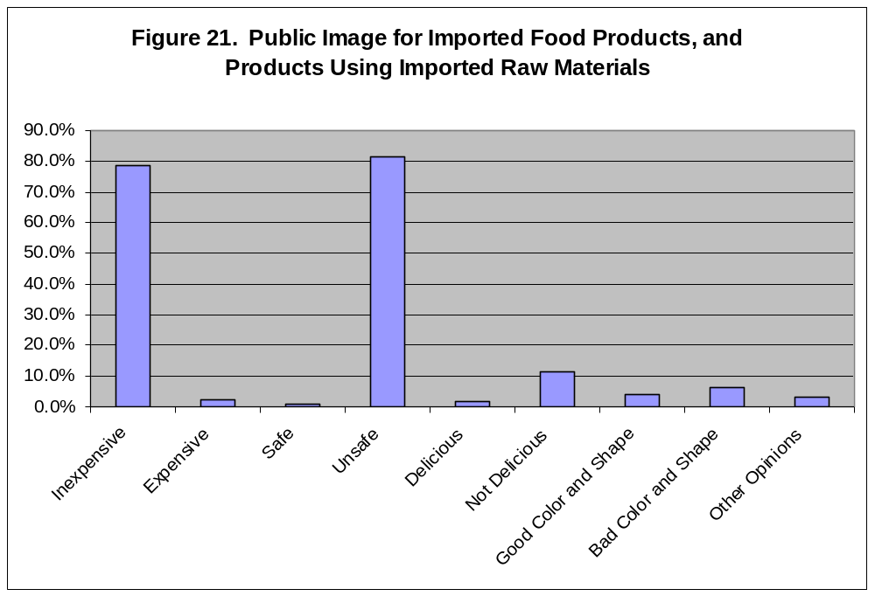
Source: Agriculture, Forest and fishery Finance Corporation

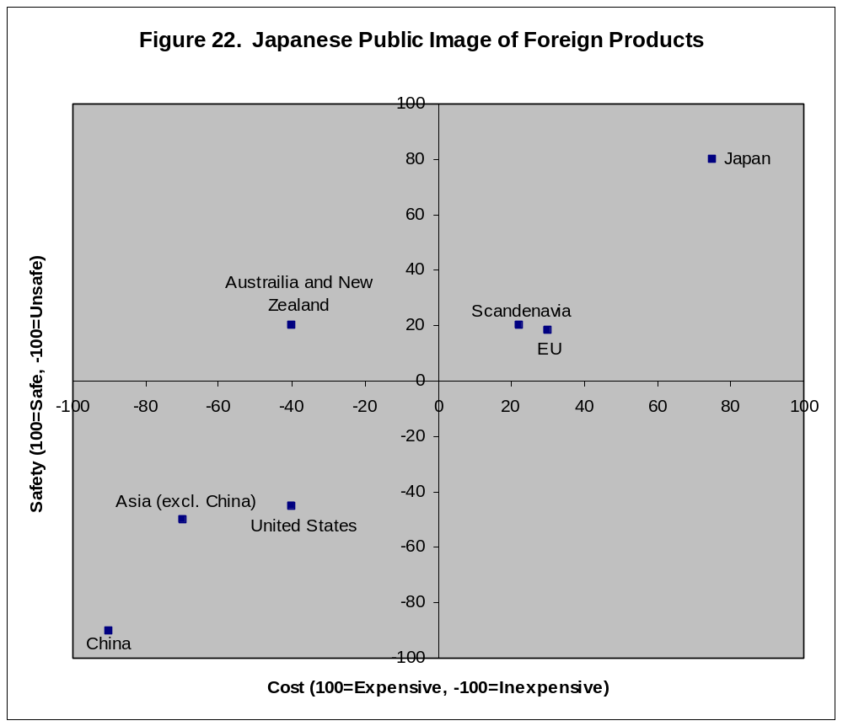
Source: Agriculture, Forest and Fishery Finance Corporation

Figure 23. Japanese Food Imports by Product (2006-2007)
(Thousand US$)
0
2,000
4,000
6,000
8,000
10,000
12,000
14,000
16,000
Seafood
Meat
Grain
Vegetables
Fruits
Oilcake seeds
Beverages
Coffee, Cocoa, Tea, Spices
Processed feedstuff, etc.
Dairy Products, eggs
Other Processed Foods
Animal/Vegetable oils and fats
Sugar
Nuts
Live Animals
2006
2007
Source: JETRO

VI. Best Product Prospects

The following table lists products that can be considered “best” import prospects. Some products were selected based on high volume, demonstrated growth, and U.S. competitiveness. However, other products were selected based a growing demographics (e.g. aging population) or a growing trend (healthy food) or because they represent a unique concept that offers significant potential.

Best Import Prospects
Product Category | HS Code | 2007 Market Size (1,000 MT) | 2007 World Imports (1000 MT) | 5-Yr Avg. Annual Import Growth | Import Tariff Rate | Key Constraints to Market Development | Market Attractiveness for U.S.A.
Pork | 0203 | 1627 | 755 | -3% | JPY361~482 per kg | Currently, market growth of U.S. beef is not expected to effect consumption of pork, but if Japan were to end age restrictions on beef, pork consumption would fall. | In 2008, pork imports from Jan-Jul have increased by 22% from 2007. This is mainly due to increased production and feed cost of domestic producers
Snack Food (excl. nuts) | 1905.90 2106.90.924 | 327 | 106 | 47% | 6%~34% | Snack food companies have had products pulled from shelves due to Chinese tainted milk scandal. This could affect U.S. suppliers who use milk products from China as ingredients. | Suppliers that can offer custom packaging and flexibility on ingredients and production process will have greater success over others. Products containing healthy, functional ingredients have stronger consumer appeal.
Frozen Vegetables | 0710 2004 | 871 | 773 | 11% | 6%~23.8% | Recent pesticide contamination in Chinese food products may deter consumers from purchasing frozen food Products. Also, Japanese frozen food companies are becoming more active overseas to bring frozen products into Japan. | The market for imported frozen vegetables has quadrupled over the last 20 years. As Japanese consumers become more familiar with frozen foods, demand will increase. Also, the U.S. is the largest supplier of frozen potato products.
Peanuts | 1202 |  | 36 | -4.74% | JPY617~726 per kg and/or 10% | China will resume exporting soon, after quality issue is resolved. Peanuts from China are inexpensive compared to peanuts from the United States.  MRL and aflatoxin are barriers for U.S. shellers to meet Japanese regulations | China, which supplies 74% of Japan’s peanut market, has stopped exporting peanuts to Japan due to quality issues. This leaves the industry with a severe shortage of peanuts.
High Quality Natural Fruit Juice | 2009 | 901,673 KL | 321673 KL | 31% | JPY23~27 per kg or 5.4%~29.8% | Strong competition from China and Brazil, with some lesser-producing countries gaining market share as well. | World imports are increasing in Japan as consumers become more health conscious. Imports from the U.S. increased by 22% in 2007, and are expected to increase in 2008. Orange and grapefruit juice have the largest share.
Berries | 0810.20 0810.40 0811.20 | 6.2 | 4.7 | 38% | 6%~9.6% | The U.S. market share of imports has decreased from 40% to 32% in the last 5 years, and world imports are expected to be low in 2008. Promotional effort is needed. | Varieties falling under HS code 0810.20 have seen a steady increase over the last 5 years. Increasing competition from Mexico is still minor.
Tree Nuts | 0801 0802 | 79 | 65.6 | -24% | Free~12% | The U.S. does produce significant imports to Japan of products in HS 0801. While competition is not increasing their market share, U.S. producers should keep safety issues a top priority to ensure U.S. imports remain high. | Increasing consumer awareness and health benefits of nuts has increased consumption recently. Producers should continue promotion in baking and confectionary sectors, as well as exploring new sectors.
Wine | 2204 | 239,796 KL | 174.441 KL | 0.25% | 15% or JPY125 per liter, whichever is the less, subject to a minimum customs duty of JPY67 per liter. | Japanese wine market is very competitive, with France and Italy leading exports respectively, and The U.S. following with 14.6% of the import market in 2007. While the U.S. has excelled in the lower end of the market, the development of mid-range products will be a challenge for the United States. | Total imports have remained stable, confirming that the Japanese wine market has recovered. The value of U.S. imports has increased due to marketing programs, the strong yen, and increasing sales of more moderately priced New World and California wines.
Pet Food | 2309 | 773 | 407 | -8% | Free~PY59.5 per kg, plus JPY6 for every 1% exceeding 10% by weight of lactose contained. | Contaminated pet food from China has led the Japanese government to create regulations for per food applying to manufacturing, import and distribution. Producers should be sure their products comply. | While the number of pets in Japan is increasing, pet size is decreasing, resulting in less consumption. U.S. producers should concentrate on high-quality products for smaller animals.
Cakes, Waffles, Pies | 1905 | 608 | 112 | 51% | 9%~29.8%% | Rising price of inputs has decreased total world imports into Japan. China has increased market share while the U.S. has decreased over the last 5 years. | The average price for U.S. products remains competitive with China, possible allowing the U.S. to acquire market share in the wake of Chinese tainted food scandals.
Salmon | 0302.12 0303.11 0303.19 0303.22 | 387 | 152 | -17% | 3.5% | Farm raised frozen Salmon from Norway and Chile continues to dominate the market along with an increase in fresh salmon exports from Canada. Prices have risen due to the increase in global oil prices. Reduction in Japanese fish purchases due to a shift towards increased meat consumption. | There is an increase in the demand for US “natural” and “wild” salmon as opposed to the farm raised salmon. Seasonal promotion remains a plus.
Non-alcoholic Beverages | 2202.90 2209.00 | 74,862 KL | 72,675 KL | 107% | 9.6%~13.4% | Competition from the major Japanese domestic brands and the growing variety of other imported non-alcoholic beverages. | Market is continually growing with a strong demand for health conscious and diet drinks. The higher cost of beer and other alcoholic beverages will result in the continued attraction of these alternative products.
Functional Foods | -- | JPY1.2 trillion | -- | -- | See specific product category | Japan has important food standard requirements that must be met. For the Japanese to recognize any new beneficial aspects of food, scientific evidence, education and promotion is necessary. | Market growing very rapidly; grown 61% in the past 6 years. The aging population is growing segment of interest, as well as products targeting specific health conditions.
Food Preparation Products | 2106.9 | -- | 369 | 36% | 9%~29.8% +JPY1,159per kg | Health issues are a major concern in Japan. Japanese consumers consider Japanese products to be safer than over-seas products, so producers should make sure their products comply with Japanese regulations and be willing to tailor their product to the Japanese market. | Key market drivers such as declining home cooking and greater demand for convenience and ready-to-eat foods indicate that demand for processed food products should continue to grow for the foreseeable future.
Craft Beer | 2203 | 3,491,118 KL | 31,830 KL | -11% | Free | Japanese government imposes higher tax on beer compared with other liquors.  Five major domestic brewers control 98.4% of the beer market | Redevelopment projects create new pubs and restaurants increasing opportunity and market places for craft beer.  Holidays and special occasions offer good times to market high quality products.

Sources: ATOs; Ministry of Agriculture, Forestry and Fisheries; Ministry of Economy, Trade and Industry; Ministry of Finance; Japan Frozen Food Association; Chocolate and Cocoa Association of Japan; Pet Food Manufacturers Association; Zenkoku Seiryou Inryou Kogyokai; Fuji Keizai; Brewers Association of Japan. Note: The 2007 market size is an estimate made by ATO.

VII. Post Contact and Further Information

If you have any questions or comments regarding this reports or need assistance exporting to Japan, please contact the U.S. Agricultural Trade Offices in Tokyo or Osaka at the following addresses:

Tokyo | Osaka
U.S. Agricultural Trade Office  U.S. Embassy, Tokyo  1-10-5 Akasaka, Minato-ku  Tokyo 107-8420  Tel: 81-3-3505-6050  Fax: 81-3-3582-6429  E-mail: atotokyo@fas.usda.gov | U.S. Agricultural Trade Office  U.S. Consulate General, Osaka-Kobe  2-11-5, Nishi-tenma, Kita-ku,  Osaka 530-8543  Tel: 81-6-6315-5904  Fax: 81-6-6315-5906  E-mail: atoosaka@fas.usda.gov

For further information, please access the U.S. Agricultural Trade Office, Japan web site at:
http://www.usdajapan.org/

