Design Document

for the

Clinical and Translational Sciences Data Standards Repository (ctsDSR)
Version 1.0

Table of Contents
1. Introduction 1
2. Overview of the system 1
3. System Architecture 1
I. ctsDSR Model 2
A. Administration and Identification classes 3
B. Classification classes 5
C. Naming and Definition Classes 6
D. Metadata classes 7
II. Design for the ctsDSR Model Loader 15
A. Loading data to ctsDSR 16
B. Design Goals 16
C. Architecture Overview 16
D. Design Patterns 17
E. Main Classes 18
F. UML Diagrams 19
III. Configuration Properties 21
4. Glossary 22
5. References 23
6. Appendix 24
I. XMI to ctsDSR Objects Mapping 24

Revision History
Name | Date | Reason For Changes | Version
Preeti Lodha | 20/1/09 | Draft | 1.0
Preeti Lodha | 22/1/09 | Changes as per comments from Srikanth Adiga | 1.1
Preeti Lodha | 27/1/09 | Changes as per comments from Srikanth and Mukesh | 1.2
Preeti Lodha | 28/1/09 | Changes as per comments from Srikanth | 1.3
Preeti Lodha | 29/1/09 | Updation of design details in section II and III | 1.4

Introduction
This document describes the design of the first prototype version of federated metadata repository, Clinical and Translational Metadata Repository (ctsDSR). The document gives an overview of the system and explains the ctsDSR architecture followed by the ctsDSR’s UML model details. The next section describes the design for the ctsDSR Model Loader which is the interface to import data to ctsDSR. The last section describes the way some of the administration data not available in the XMI is imported to ctsDSR.

Overview of the system
The main aim of the system is to build a metadata repository which can be used to store, share, and aid reuse of metadata defined using Dynamic Extensions (DE) across applications locally and remotely in a caBIG Compatible manner. Initially the focus will be on developing a Proof of Concept (POC) which accepts the UML model as an XMI and loads the metadata to ctsDSR. It has been initially assumed that the new models will be independently defined in DE, exported as XMI (version 1.3) and semantically annotated using the SIW. The fully annotated XMI will then be exported from the SIW and be loaded into the ctsDSR so that metadata of the new DE model may be shared in an ISO-11179 compliant fashion. No direct communication between the DE and the ctsDSR application is needed in this POC. Validations to check if the XMI is completely annotated will be added in future versions of ctsDSR. In future the system also aims to have plugins to interact with DE and UML Modeling tools like EA and/or Argo UML.

System Architecture
The design for the ctsDSR is based on the “caCORE” applications development framework. The model for ctsDSR is an ISO 11179 compliant model prepared based on the gap analysis done for models of existing metadata repositories like cgMDR, caDSR and DE. This model has also been reviewed by Denise Warzel who is the Project manager for Core Infrastructure, caCORE Product Line and caDSR at the NCI. Kindly refer the ctsDSR model from link available in Section 5.
ctsDSR provides an interface through which the UML models can be uploaded to the system in the form of an XMI which has been exported from DE and annotated using SIW. Important administration data which is required as per ISO 11179 and not available in the XMI is imported using a configuration file ctsDSRConfigurations.xml. Kindly refer section [3-III] for more details.
ctsDSR exposes the caGrid API (caGrid 1.2) and the caCORE API (caCORE 4.1) enabling syntactic and semantic interoperability between diverse applications. Kindly refer links for caCORE and caGrid framework available in Section 5.
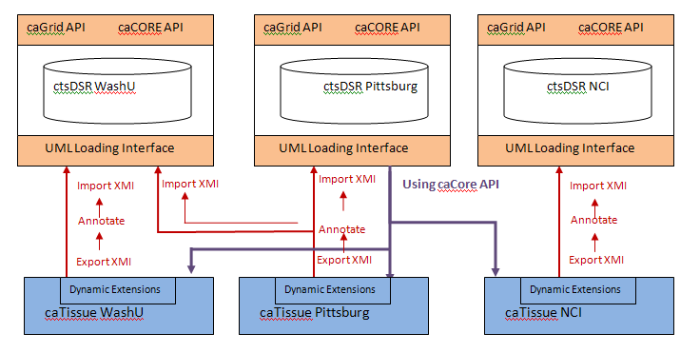
Figure 1 ctsDSR Architecture
The diagram above explains the architecture for ctsDSR.
As depicted in the above figure, several caTissue instances deployed at different locations like WashU, Pittsburgh, NCI, etc can independently create extensions to the static model using DE. To allow other applications with similar interests to reuse these CDE’s/models defined using DE, they need to be registered in ctsDSR. This can be done by exporting the model from DE, annotating them using SIW and importing the annotated model in ctsDSR. There may be several instances of the ctsDSR deployed. The same model may be registered in one or more ctsDSRs. ctsDSR exposes these models via the caCORE and caGrid API allowing sharing of these models/CDEs without the need of registering them on caDSR.
- ctsDSR Model
This section details out the classes in the ctsDSR model which are used to store the metadata and various other details as per ISO 11179 specification. This is a hybrid model developed based on the gap analysis done between models of already existing metadata registries like caDSR, cgMDR and DE. A detailed study of each of the models was done to find out what is mandatory as per ISO specifications and minimally required to store all details about any UML model. Based on this study and the gap analysis between the three models, we have come up with this model for ctsDSR which closely resembles the cgMDR model, with a few extensions taken from the caDSR model as per discussions with Denise Warzel, who is the project manager for caDSR at NCI.
This section uses a metamodel to describe the structure of a Metadata Registry. The registry in turn will be used to describe and model other data, for example about enterprise, public administration or business applications. The registry metamodel is specified as a conceptual data model, i.e. one that describes how relevant information is structured in the natural world. This section is sub-divided into the following
- Administration and Identification classes: Support the administrative aspects of Items in a registry
- Classification classes: Provide logical grouping of items
- Naming and Definition Classes: These are used to manage the names and definitions of items in various contexts.
- Metadata classes: Responsible for actual storage of Object Classes, their attributes, value domain, Data Element Concepts, data elements, etc.

- Administration and Identification classes
The Administration and Identification region supports the administrative aspects of items in a registry. This region addresses:
- The identification and registration of items submitted to the registry
- The organizations that have submitted items to the registry, and/or that are responsible for items within the registry, including Registration Authorities
- Contact information for organizations
- Supporting documentation
- Relationships among administered items.
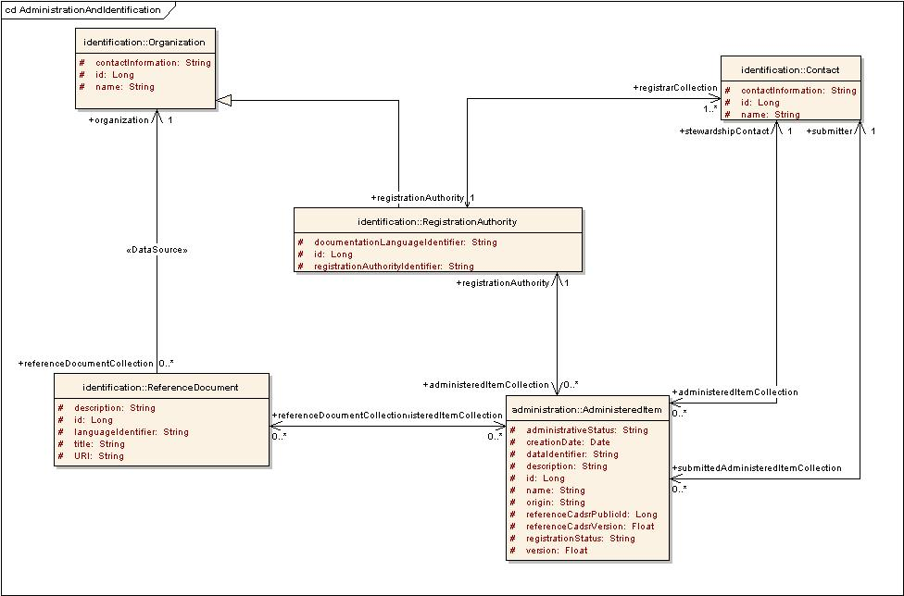
Figure 2: Administration and Identification
Below are the details for each of the above classes.
- AdministeredItem: AdministeredItem is any registry item for which administrative information is recorded. All the administration data for the item is maintained in this data structure. It stores important information about a registry item like its administrative status, registration status, name, unique identifier, version etc. An AdministeredItem is registered by a RegistrationAuthority represented by the relationship registrationAuthority. The contact information for the person who submitted the AdministeredItem is represented by the relationship submitter. An AdministeredItem is administered by a contact represented by the relationship stewardshipContact. An Administered Item may be described by zero or more Reference Documents as represented by the relationship referenceDocumentCollection. It also has field’s referenceCadsrPublicId and referenceCadsrVersion which will be used to store references to caDSR public Id and Version if any are available from the XMI.
- RegistrationAuthority: A RegistrationAuthority is any Organization authorized to register metadata. A Registration Authority is a subtype of Organization and inherits all of its attributes and relationships. An AdministeredItem has a RegistrationAuthority that is its owner, shown by the relationship registrationAuthority. A RegistrationAuthority may register many Administered Items
- Contact: Contact is used to specify the contact information for registrarCollection, stewardshipContact and submitter. Contains details like the contactName and contactInformation which is the communication information for the person to contact. Every contact is a part of some RegistrationAuthority.

- Organization: This contains the details of the Organization which submitted the item in the metadata repository. Contains details like name and contactInformation for the Organization.

- ReferenceDocument: This stores details about a document that provides pertinent details for consultation about a subject. An AdministeredItem may be described by one or more Reference documents which are submitted by the Organization submitting the item.
- Classification classes
The Classification region provides a facility to register and administer Classification Schemes and their constituent Classification Scheme Items. Optionally, a Classification Scheme may be used to classify items within the registry.
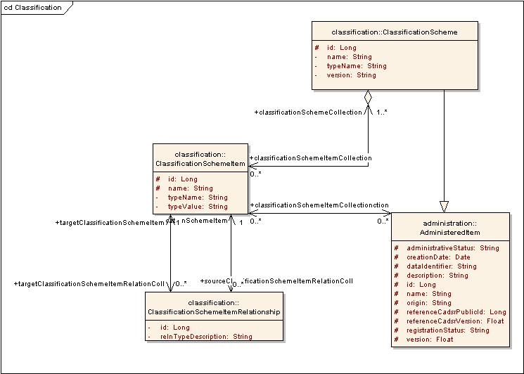
Figure 3 Classification Region
Below is a brief description of each of the classes
- ClassificationScheme: ClassificationScheme is the descriptive information for an arrangement or division of objects into groups based on characteristics, which the objects have in common. A ClassificationScheme may be taxonomy, a network, ontology, or any other terminological system. A ClassificationScheme is a sub-type of AdministeredItem, inheriting its attributes and relationships, which allows it to be identified, named, defined and optionally classified

- ClassificationSchemeItem: A ClassificationSchemeItem represents an individual item within a ClassificationScheme. This may be a node in a taxonomy or ontology, a term in a thesaurus, etc. Usually stores details for packages in UML Model. An AdministeredItem may be classified in zero or more Classification Schemes, by associating it with one or more ClassificationSchemeItem

- ClassificationSchemeItemRelationship: The relationship between various ClassificationSchemeItems within a ClassificationScheme is described by the ClassificationSchemeItemRelationship. Such relationships serve to assist navigation through a large number of ClassificationScheme Items. For e.g. one ClassificationSchemeItem may be a specialization of the other. This “IS-A” relationship is stored in the ClassificationSchemeItemRelationship.

- Naming and Definition Classes
The Naming and Definition region is used to manage the names and definitions of AdministeredItem and the contexts for the names. It is recognized that an AdministeredItem may have many names that will vary depending on discipline, locality, technology, etc. In the POC we will not be concentrating much on populating these classes and maintaining alternate names and definitions. We can take this up in later versions.
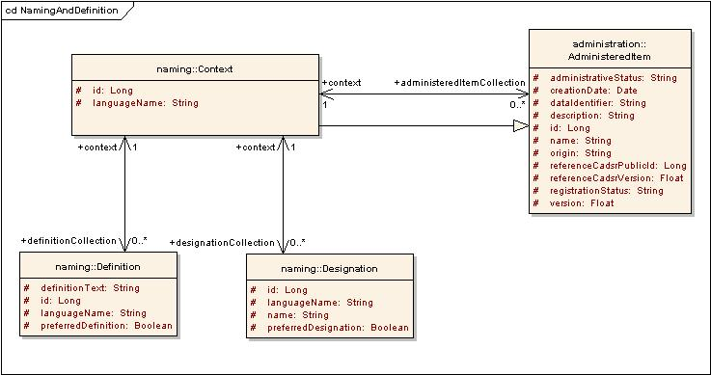
Figure 4 Naming and Definition
Below is a brief description of the classes above:
- Context: Each AdministeredItem is named and defined within one or more Contexts. A Context defines the scope within which the subject data has meaning. A Context may be a business domain, an information subject area, an information system, a database, file, data model, standard document, or any other environment determined by the owner of the registry. Each Context is itself managed as an Administered Item within the registry and is given a Definition and a Designation.
- Definition: It is where the definition for an AdministeredItem is specified in a particular language for a particular Context. Where multiple Definitions are provided within the same context, one of them may be specified as the preferredDefinition

- Designation: It is where the name for an Administered Item is specified in a particular language for a particular Context. Where multiple Designations are provided within the same Context, one of them may be specified as the preferredDesignation

- Metadata classes
This section provides the basic conceptual model, including the basic attributes and relationships, for a metadata registry.

Data Element Concept

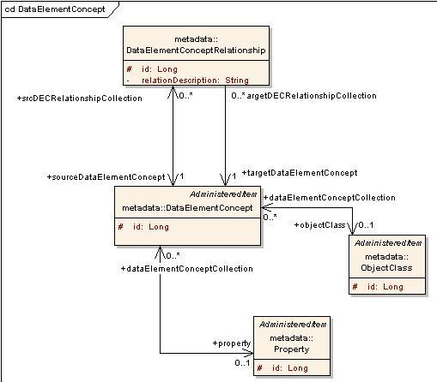
Figure 5: Data Element Concept
Below is a brief description of the classes above.
- ObjectClass: This class represents and stores data about the “class” within a UML Model. Being a subclass of AdministeredItem, an ObjectClass inherits its attributes and relationships and allows it to be identified, named, defined and optionally classified within a ClassificationScheme. An ObjectClass may be registered as an AdministeredItem without necessarily being associated with a DataElementConcept or a Property.

- Property: This class represents and stores data about an “attribute” of a class within a UML Model. A Property is a characteristic of an ObjectClass. It may be any feature that humans naturally use to distinguish one individual object from another. As it is a subclass of an AdministeredItem, a Property carries its own administration information, allowing it to be identified, named, defined and optionally classified within a ClassificationScheme. A Property may be registered as an AdministeredItem without necessarily being associated with a DataElementConcept or an ObjectClass.

- DataElementConcept: A DataElementConcept may have zero or one ObjectClass and zero or one Property. The union of a Property and an ObjectClass provides significance beyond either that of the Property or the ObjectClass. Being a subclass of an AdministeredItem, a DataElementConcept carries its own administration information, allowing it to be identified, named, defined and optionally classified within a ClassificationScheme

- DataElementConceptRelationship: A DataElementConcept may be associated with other DataElementConcepts, via the DataElementConceptRelationship. The nature of the relationship is described using the relationDescription.

Conceptual Domain
A conceptual domain is a set of value meanings. Many value domains may be in the extension of the same conceptual domain, but a value domain is associated with one conceptual domain. Every DataElementConcept is represented by a conceptual domain

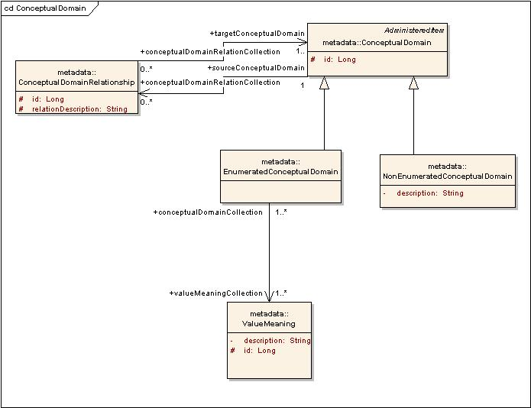
Figure 6 Conceptual Domain
Below is a brief description of the classes above
- ValueMeaning: This defines the meaning or semantic content of a Value. It stores the set of logical values for a Conceptual Domain

- ConceptualDomain: A ConceptualDomain is a set of value meanings. Many value domains may be in the extension of the same ConceptualDomain, but a ValueDomain is associated with one ConceptualDomain. As an AdministeredItem, a ConceptualDomain carries its own administration information, allowing it to be identified, named, defined and optionally classified within a Classification Scheme

- EnumeratedConceptualDomain: A ConceptualDomain sometimes contains a finite allowed inventory of notions that can be enumerated. Such a ConceptualDomain is referred to as an EnumeratedConceptual Domain

- NonEnumeratedConceptualDomain: A ConceptualDomain that cannot be expressed as a finite set of Value Meanings is called a NonEnumeratedConceptual Domain. It may be expressed via a description or specification, such as a rule, a procedure, or a range (i.e., interval).

- ConceptualDomainRelationShip: A ConceptualDomain may be associated with other ConceptualDomains, via the ConceptualDomainRelationship The nature of the relationship is described using the relationdescription.

Value Domain
One of the key components of a representation is the ValueDomain. A ValueDomain provides representation, but has no implication as to what DataElementConcept the values are associated or what the values mean. A ValueDomain is associated with a Conceptual Domain. A ValueDomain provides a representation for the Conceptual Domain. An example of a Conceptual Domain and a set of Value Domains is ISO 3166, Codes for the representation of names of countries. For instance, ISO 3166 describes the set of seven Value Domains: short name in English, official name in English, short name in French, official name in French, alpha-2 code,alpha-3 code and numeric code.
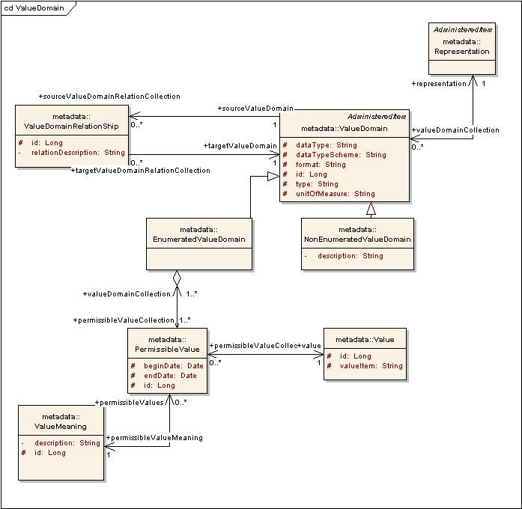
Figure 7 Value Domain
Below is a brief description of the classes above
- ValueDomain: It represents the values associated with an UML model attribute. It is the set of values for one or more DataElements. It is used for validation of data in information systems and in data exchange. It is also an integral part of the metadata needed to describe a DataElement. In particular, a ValueDomain is a guide to the content, form, and structure of the data represented by a DataElement. As an AdministeredItem, a ValueDomain carries its own administration information, allowing it to be identified, named, defined and optionally classified within a Classification Scheme

- EnumeratedValueDomain: An EnumeratedValueDomain is one where the Value Domain is expressed as an explicit set of one or more Permissible Values

- NonEnumeratedValueDomain: This is a ValueDomain which is expressed via a description or specification, such as a rule, a procedure, or a range (i.e., interval), rather than as an explicit set of PermissibleValues.

- PermissibleValue: This class stores the links to values for a DataElement. A PermissibleValue is an expression of a ValueMeaning within an EnumeratedValueDomain. It is one of a set of such values that comprises an EnumeratedValueDomain. Each PermissibleValue is associated with a ValueMeaning

- Value: This is the actual value associated with a PermissibleValue in an EnumeratedValueDomain. The same Value can be shared by one or more PermissibleValues

- ValueDomainRelationShip: A ValueDomain may be associated with other ValueDomains, via the ValueDomainRelationship. The nature of the relationship is described using the relationDescription.

- Representation: This is the classification scheme for representation. The set of classes make it easy to distinguish among the elements in the registry. For instance, a DataElement categorized with the Representation class 'amount' is different from an element categorized as 'number'. Being a subclass of AdministeredItem, a Representation class carries its own administration information, allowing it to be identified, named, defined and optionally classified in a ClassificationScheme. Representation class is a mechanism by which the functional and/or presentational category of an item may be conveyed to a user.

Data Element
A DataElement is considered to be a basic unit of data of interest to an organization. It is a unit of data for which the definition, identification, representation, and permissible values are specified by means of a set of attributes. A DataElement is the association among a DataElementConcept, a ValueDomain and optionally a Representation. A DataElement cannot be registered as an AdministeredItem without being associated with a DataElementConcept and a ValueDomain.
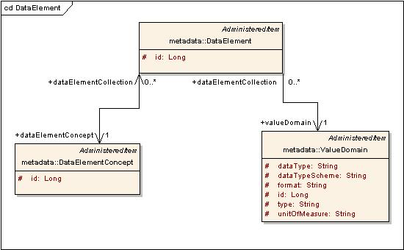
Figure 8 Data Element
- DataElement: . A DataElement is the association among a DataElementConcept, a ValueDomain and optionally a Representation. Being a subclass of AdministeredItem, a DataElement carries its own administration information, allowing it to be identified, named, defined and optionally classified in a ClassificationScheme. A DataElement is formed when a DataElementConcept is assigned a representation. One of the key components of a representation is the ValueDomain, i.e. restricted valid values.

Data Element Derivation

A DataElement may be derived from other DataElements by applying certain rules/formulas. It may be simple arithmetic or logical operations or some complex formulas which might be applied on one or more DataElements resulting in one or more derivedDataElementCollection

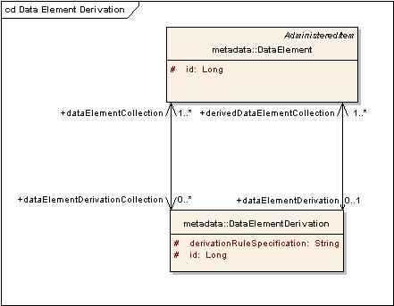
Figure 9 Data Element Derivation
The above diagram represents the way to handle DataElementDerivations.
DataElementDerivation: It is the relationship among a DataElement which is derived, the rule controlling its derivation i.e. derivationRuleSpecification, and the DataElement(s) from which it is derived.

Object class Associations

This depicts the association between classes within an UML Model. One class may be related to another in one of the several ways i.e. 1:Many, Many:1, Many:Many, etc as per UML Standards.

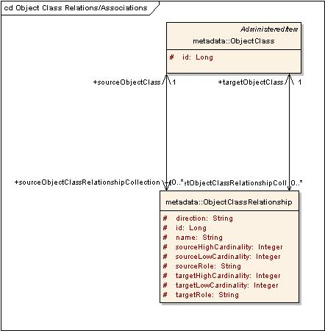
Figure 10 Object Class Associations
- ObjectClassRelationShip: This class stores all details about the relationship of an ObjectClass with another. This is not mandatory as per ISO Specifications, but has been added for integrity.

Concept Mappings
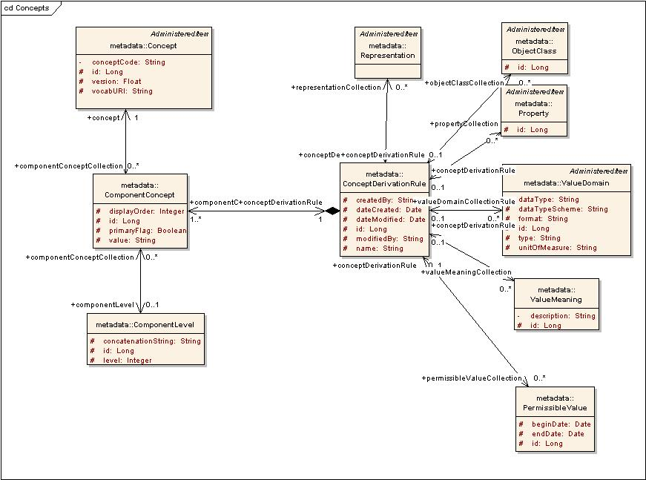
Figure 11 Concepts
- Concept: It is a unit of knowledge created by a unique combination of characteristics. Each concept is referred from a vocabulary and its combination helps in uniquely identifying any item in registry assisting its search and reuse. Each Concept is uniquely identified by its concept code and the vocabURI
- ConceptDerivationRule: This class acts as a medium to group a set of oncepts associated with a registry item in a particular order.
- ComponentConcept: This class actually stores details about the order of concepts, if it is a primary/qualifier concept, etc for a ConceptDerivationRule.
- ComponentLevel: Two or more Concepts may be logically be grouped together within a ConceptDerivationRule with relations like “and”, “or”, etc. ComponentLevel stores details about such relationships if any exist.

- Design for the ctsDSR Model Loader
This section elaborates on the mechanism for loading data, design considerations and classes involved in the ctsDSR Model Loader utility used to load metadata into the ctsDSR. The design for the ctsDSR Model Loader resembles the design for caDSR UML Loader. It follows the same design architecture as the caDSR UML Loader with the removal of a few components related to XMI validations, etc
- Loading data to ctsDSR
ctsDSR Model Loader is the tool used to register UML model metadata into the ctsDSR. ctsDSR has at its backend a MySQL DB as the data repository. ctsDSR uses the Hibernate framework to persist the objects to the backend repository.
The name of the XMI file containing the UML model, the name and version of the project being uploaded are input as command line arguments to ctsDSR Model Loader. Other administration details which are not available as a part of the XMI are accepted as a configuration XML ctsDSRConfigurations.xml available in the class-path. This file contains the configurations for administrative data e.g. organization registering the model, contact person, etc with some default values which can be edited as required. Kindly refer section 3(III) for further details on the configuration file.
The model XMI and the configurations XML are parsed by the ctsDSR Model Loader to build ctsDSR model objects and persisted to the backend database using Hibernate.
- Design Goals
The purpose of the architecture is to keep ctsDSR Model Loader modular. The design makes extensive use of the strategy pattern, allowing each portion to be replaced by another, if need be. From a design perspective, the ctsDSR Model Loader makes no assumption that the data will be read from XMI or persisted to a ctsDSR model.
- Architecture Overview

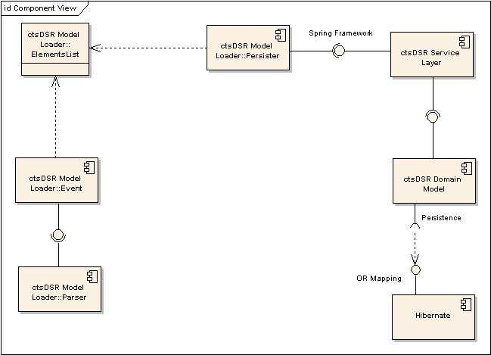
Figure 12 ctsDSR Model LoaderArchitecture
ctsDSR Model Loader consists of four major components:
- The Parser component responsible for opening and parsing the XMI and XML files
- The Event component manages events sent by the parser component
- The ElementsList component stores in ctsDSR format all the UML/configuration elements that make up the XMI/XML file
- The Persister component responsible for sending ctsDSR objects to the service layer.
ctsDSR Model Loader uses the ctsDSR Service layer to interact with the persistence layer. The service layer uses Spring Framework to expose services and Hibernate for persistence.
- Design Patterns

Singleton
The singleton pattern solves the issue of having multiple instances of a class within one virtual machine. ElementsList implements the singleton pattern since it is essential that ctsDSR Model Loader classes share one and only one instance of ElementsList.

Strategy
The strategy pattern is useful when one wants to replace one algorithm by another one without affecting the client using them. XMIParser, XMLConfigurationParser, UMLDefaultHandler and UMLPersister all implement the strategy pattern. Each one of these classes can be independently replaced by another implementation.
- Main Classes
As depicted in figure 13 above, the main interfaces involved are the Parser, EventHandler, ElementsList and the Persister. The Parser parses the XMI and XML and sends notifications to the EventHandler in form of events like newAttributeEvent, newAssociationEvent, etc. The EventHandler accepts the events and transforms them to ctsDSR domain objects. These objects are stored in the ElementsList singleton object which is accessed by the Persister to persist objects to datasource.

- Parser
The parser interface defines the parse(String filename) method. Classes implementing this interface define what technology to use for parsing the input file. XMIParser implements the interface and as the name suggests, expects an XMI file. It uses the Netbeans MDR API to read XMI. XMLConfigurationParser also implements the interface and parses the XML file containing configurations (ctsDSRConfigurations.xml). It uses the DOM parser implementation to parse the XML.
Parser also defines the setEventHandler method. The parser creates events and fires them to a handler. XMIParser creates UML related events, such as NewAttribute or NewAssociation. XMLConfigurationParser creates other events, such as NewRegistrationAuthority or NewSubmissionContact. Parser expects an UMLHandler generalization of EventHandler.
- EventHandler
The Parser creates events and fires them to the EventHandler. Events are UML/configuration related, such as NewClassEvent, NewAttributeEvent, NewRegistrationAuthorityEvent,. The UMLDefaultHandler implementation of EventHandler has the task of receiving events and transforming them into ctsDSR objects.
- ElementsList
The ElementsList encapsulates a list of objects to be persisted. The EventHandler populates this list as it receives events from the parser. This is a singleton object.
- Persister
The Persister interface defines the persist() method. UMLPersister implements Persister and uses the Strategy pattern to delegate work to other Persisters. As the name suggests, Persisters are responsible for sending object to the DAO layer to be persisted. In the case of UMLPersister, calls to other Persisters are also ordered because, for example, ObjectClasses must be persisted before ObjectClassRelationships. It is the responsibility of the Persister to verify whether objects already exist or not.
Note: To avoid complexity, list of all persisters have not been added in figure 15 below.
The complete list of Persisters is mentioned below
  - PropertyPersister: T o persist Property
  - PackagePersister: To persist package related information to corresponding domain objects.
  - DEPersister: To persist DataElements
  - OcRecPersister: To persist ObjectClassRelationships
  - DECPersister: To persist DataElementConcepts.
  - ObjectClassPersister: To persist ObjectClass
  - ConceptPersister: To persist Concepts and related data structures
  - ValueDomainPersister: To persist ValueDomain information
  - RegistrationAuthorityPersister: To persist RegistrationAuthority information
  - ContactPersister: To persist contact information for submissionContact, stewardshipContact, etc
  - ClassificationSchemePersister: To persist the Classifications and ClassificationSchemeItems along with their relationships.
- UMLLoader
UMLLoader is the captain of all classes. UMLLoader is responsible for instantiating the Parsers, Listener, and Persister, thus acting as a factory for those interfaces. It also is responsible for initializing the ElementsList.
- UML Diagrams

Sequence Diagram

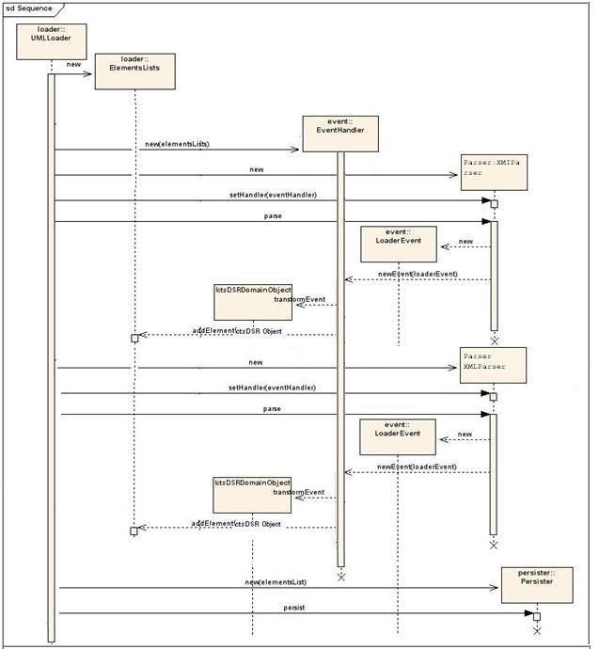
Figure 13 UML Loading Sequence Diagram

Class Diagram

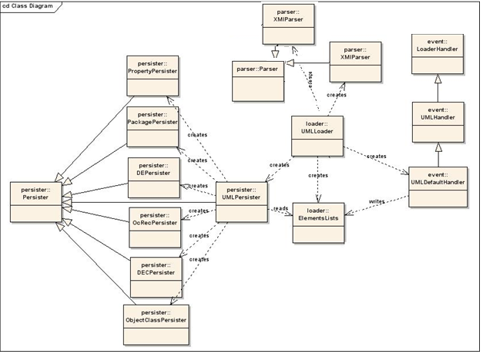
Figure 14 UML Loading Class Diagram
- Configuration Properties
Certain properties/attributes which are required for storage of metadata are not available from the XMI file. These include the administration and identification data. To capture this data an XML configuration file (ctsDSRConfigurations.xml) needs to be appropriately edited by the model owner. It contains tagged values for each of the attributes required to be stored in the repository and not available in the XMI.
Currently this file contains configurations for the following:
- Registration Authority
- Stewardship Contact
- Submission Contact
- Organization submitting the model
- Reference documents
- Context
The schema for the XML is as depicted in the following diagram.
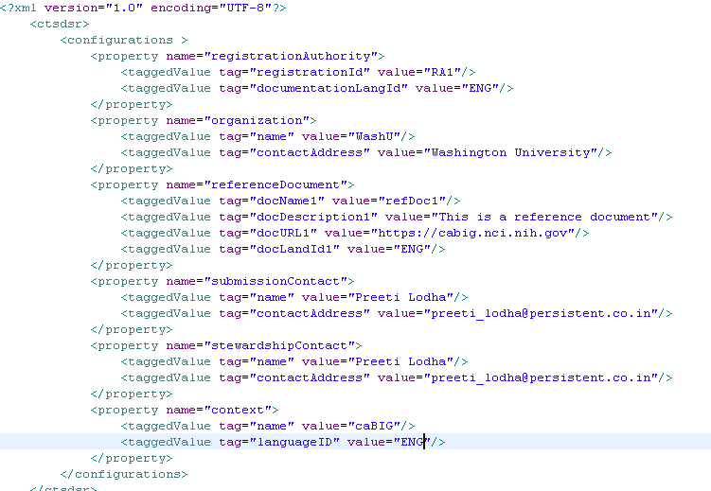
Figure 15: ctsDSRProperties.xml

Glossary
Term | Meaning
POC | Proof Of Concept
XMI | XML Metadata Interchange. This is an OMG standard for exchanging metadata information via eXtensible Markup Language (XML).
Metadata | Metadata is definitional data that provides information about or documentation of other data managed within an application or environment.
DE | This is the feature used by applications like caTissue and caElmir to extend static models and define new models to capture research data
ctsDSR | Clinical and Translational Sciences Data Standards Repository- This is the name given to the proposed federated metadata repository
administrativeStatus | designation of the status in the administrative process of a registration authority for handling registration  requests
registrationStatus | designation of the status in the registration life-cycle of an administered item
NCI | National Cancer Institute
caDSR | The caDSR is a database and a set of APIs and tools used to create, edit, control, deploy and find common data elements (CDEs) for metadata consumers and for UML model development. The common data elements are developed by the NCI, together with caBIG® partners in the research community
cgMDR | The CancerGrid metadata registry software is an open standards, open source implementation of ISO11179-3 allowing users to set up a local metadata registry and populate it with metadata element definitions appropriate to their needs.

References
ctsDSR Presentation | https://gforge.nci.nih.gov/docman/view.php/578/16038/ctsDSR%20Presentation_Final.pptx
ctsDSR Gap Analysis Document | https://gforge.nci.nih.gov/docman/view.php/578/16036/GapAnalysis-caDSR-cgMDR-DynExt%20Final.doc
ctsDSR Vision And Scope Document | https://gforge.nci.nih.gov/docman/view.php/578/16037/ctsDSR_Vision_and_Scope_Final.doc
ctsDSR Implementation Plan | https://gforge.nci.nih.gov/docman/view.php/578/16035/ctsDSR%20Implementation%20Plan%20Final.doc
ctsDSR Model | https://gforge.nci.nih.gov/docman/view.php/578/16277/ctsDSR.eap
caCORE Framework | https://wiki.nci.nih.gov/display/caDSR/Overview+of+caCORE
caCORE SDK | http://ncicb.nci.nih.gov/infrastructure/cacoresdk
caGrid Framework | https://cabig-kc.nci.nih.gov/CaGrid/KC/index.php/CaGrid_Overview
caDSR | http://ncicb.nci.nih.gov/NCICB/infrastructure/cacore_overview/cadsr
cgMDR | https://wiki.nci.nih.gov/display/caDSR/cgMDR
caBIG | https://cabig.nci.nih.gov/

Appendix
- XMI to ctsDSR Objects Mapping
ctsDSR closely resembles to the way the XMI data is mapped to the domain objects. The tagged values from the XMI are treated the same way as in the UML Loader for caDSR. Kindly refer the following document for the mappings from UML Model/XMI to ctsDSR.
https://gforge.nci.nih.gov/docman/view.php/16/15449/caCORE_SIW-UMLLoader_v40_TechnicalGuide.pdf

Kindly refer glossary for the definition of the term.
Kindly refer glossary for the definition of the term.

