horizontal line

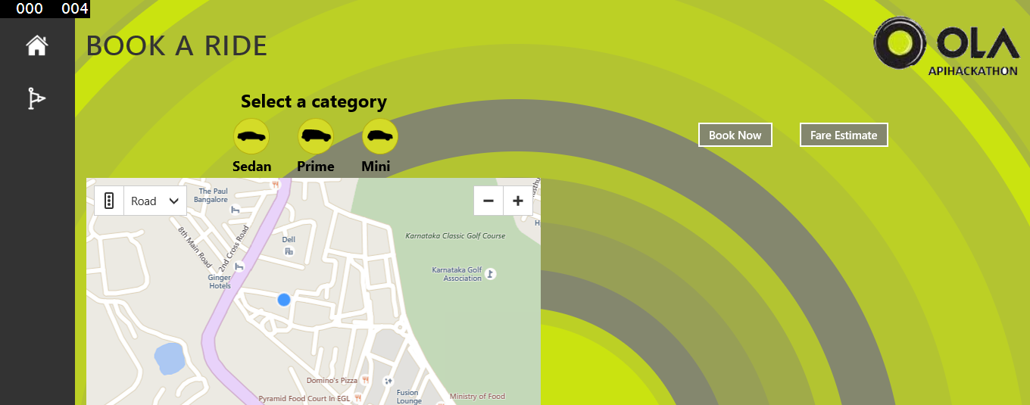

OlaAPIHackathon

Sept, 26-27

**─**

# Overview

Ola API’s are a platform for third parties to integrate ola app with their app and allow users to book the ride , find estimate of their ride & track the ride.

# Goals

1. Complete the registration & Oauth2 process to enable the use of ola API’s.
2. Create a view which allows user to check for the availability of ola cabs, book a ride , calculate the ride estimate, track ride & cancel the ride.
3. Create a view which allows drivers to accept the ride, make them available for ride, end the ride
4. Integrate with google or bing map api’s to find out nearest locations of interest, user can check their ride estimate for the destinations.
5. Introduce a raise panic button (SOS) as a safety feature for a user.

# Implementations & How to use the app

1. Created a MVVMCross project so that same code can be used by Android, iOS & Windows platform.
2. Added a Windows RT project.
3. Changed the package manifesto and capabilities or the app, also added the tile, badge & splash screen.
4. Launch the app

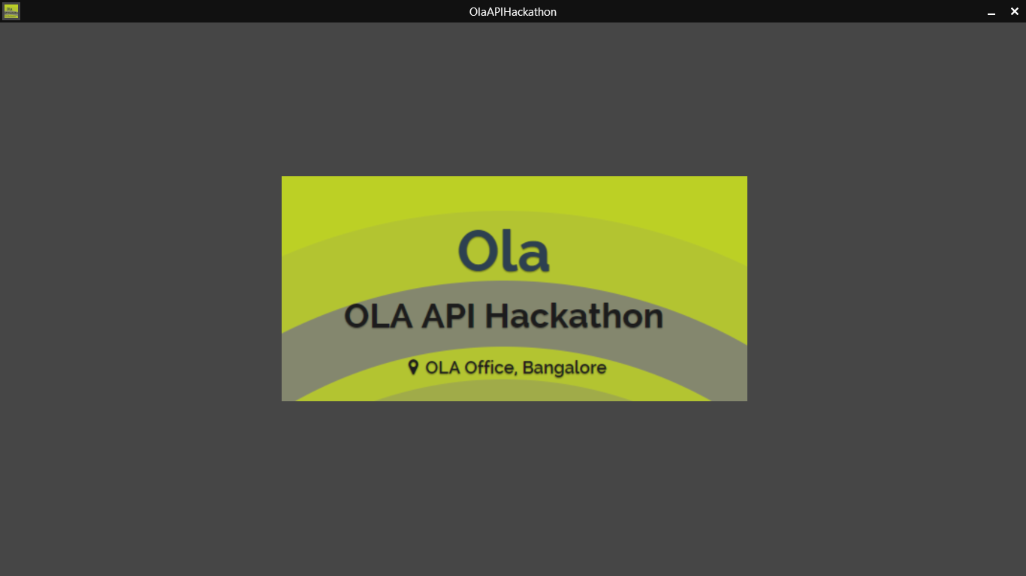

5. Check Availability

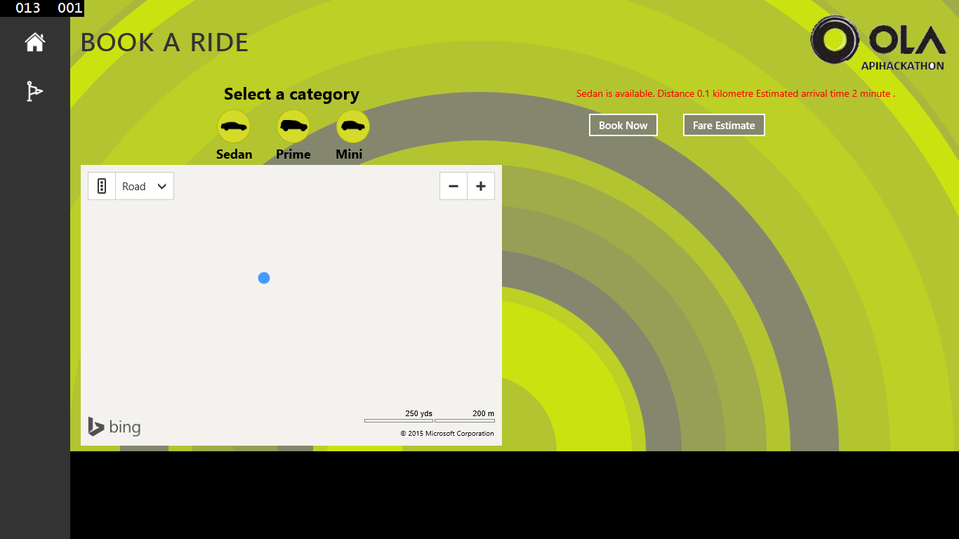

6. Book a ride

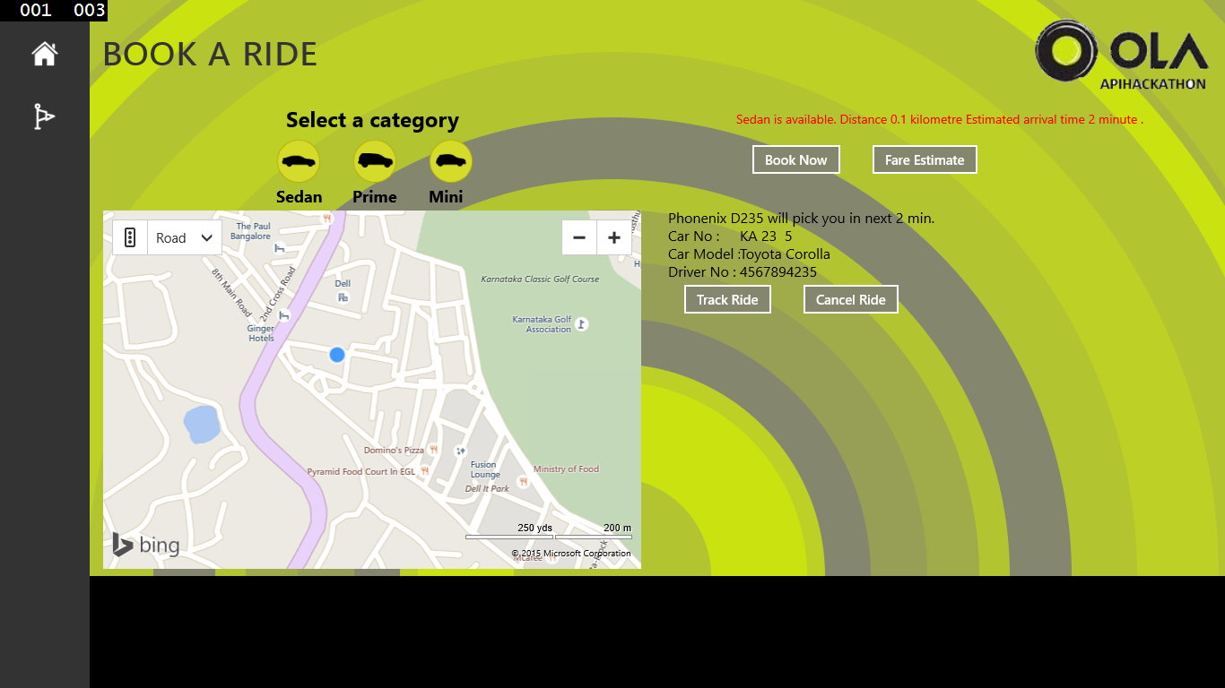

7. Cance a Ride.

8. Trake Estimate.