Step1:用最简单的网络，全链接层，跑通整个流程，包括加载数据，训练，启动模拟器，运行算法。

Step2:用模拟器采集数据，跑两圈：

step3:重新训练

Step4:改进模型为LeNet:

改进方法：

Strategies for Collecting Data
Now that you have driven the simulator and know how to record data, it's time to think about collecting data that will ensure a successful model. There are a few general concepts to think about that we will later discuss in more detail:
- the car should stay in the center of the road as much as possible
- if the car veers off to the side, it should recover back to center
- driving counter-clockwise can help the model generalize
- flipping the images is a quick way to augment the data
- collecting data from the second track can also help generalize the model
- we want to avoid overfitting or underfitting when training the model
- knowing when to stop collecting more data

采集数据方法：
two or three laps of center lane driving
one lap of recovery driving from the sides
one lap focusing on driving smoothly around curves

Validating Your Network
In order to validate your network, you'll want to compare model performance on the training set and a validation set. The validation set should contain image and steering data that was not used for training. A rule of thumb could be to use 80% of your data for training and 20% for validation or 70% and 30%. Be sure to randomly shuffle the data before splitting into training and validation sets.
If model predictions are poor on both the training and validation set (for example, mean squared error is high on both), then this is evidence of underfitting. Possible solutions could be to
- increase the number of epochs
- add more convolutions to the network.
When the model predicts well on the training set but poorly on the validation set (for example, low mean squared error for training set, high mean squared error for validation set), this is evidence of overfitting. If the model is overfitting, a few ideas could be to
- use dropout or pooling layers
- use fewer convolution or fewer fully connected layers
- collect more data or further augment the data set
Ideally, the model will make good predictions on both the training and validation sets. The implication is that when the network sees an image, it can successfully predict what angle was being driven at that moment.

Testing Your Network
Once you're satisfied that the model is making good predictions on the training and validation sets, you can test your model by launching the simulator and entering autonomous mode.
The car will just sit there until your Python server connects to it and provides it steering angles. Here’s how you start your Python server:
python drive.py model.h5
Once the model is up and running in drive.py, you should see the car move around (and hopefully not off) the track! If your model has low mean squared error on the training and validation sets but is driving off the track, this could be because of the data collection process. It's important to feed the network examples of good driving behavior so that the vehicle stays in the center and recovers when getting too close to the sides of the road.

Lambda Layers
In Keras, lambda layers can be used to create arbitrary functions that operate on each image as it passes through the layer.
In this project, a lambda layer is a convenient way to parallelize image normalization. The lambda layer will also ensure that the model will normalize input images when making predictions in drive.py.
That lambda layer could take each pixel in an image and run it through the formulas:
pixel_normalized = pixel / 255
pixel_mean_centered = pixel_normalized - 0.5
A lambda layer will look something like:
Lambda(lambda x: (x / 255.0) - 0.5)
Below is some example code for how a lambda layer can be used.
from keras.models import Sequential, Model
from keras.layers import Lambda

# set up lambda layer
model = Sequential()
model.add(Lambda(lambda x: (x / 255.0) - 0.5, input_shape=(160,320,3)))
...
The cv2 library also has similar functionality with the flip method.
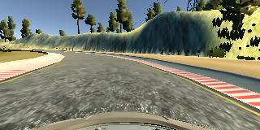
Image captured by the center camera
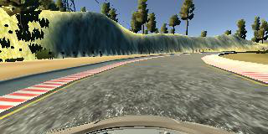
Flipped image from the center camera

Driving Counter-Clockwise
Track one has a left turn bias. If you only drive around the first track in a clock-wise direction, the data will be biased towards left turns. One way to combat the bias is to turn the car around and record counter-clockwise laps around the track. Driving counter-clockwise is also like giving the model a new track to learn from, so the model will generalize better.

Using Both Tracks
If you end up using data from only track one, the convolutional neural network could essentially memorize the track. Consider using data from both track one and track two to make a more generalized model.

Collecting Enough Data
How do you know when you have collected enough data? Machine learning involves trying out ideas and testing them to see if they work. If the model is over or underfitting, then try to figure out why and adjust accordingly.
Since this model outputs a single continuous numeric value, one appropriate error metric would be mean squared error. If the mean squared error is high on both a training and validation set, the model is underfitting. If the mean squared error is low on a training set but high on a validation set, the model is overfitting. Collecting more data can help improve a model when the model is overfitting.
What if the model has a low mean squared error on both the training and validation sets, but the car is falling off the track?
Try to figure out the cases where the vehicle is falling off the track. Does it occur only on turns? Then maybe it's important to collect more turning data. The vehicle's driving behavior is only as good as the behavior of the driver who provided the data.
Here are some general guidelines for data collection:
- two or three laps of center lane driving
- one lap of recovery driving from the sides
- one lap focusing on driving smoothly around curves

Model History Object
When calling model.fit() or model.fit_generator(), Keras outputs a history object that contains the training and validation loss for each epoch. Here is an example of how you can use the history object to visualize the loss:
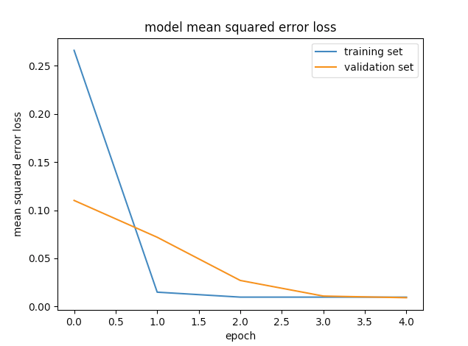
The following code shows how to use the model.fit() history object to produce the visualization.
from keras.models import Model
import matplotlib.pyplot as plt

history_object = model.fit_generator(train_generator, samples_per_epoch =
len(train_samples), validation_data =
validation_generator,
nb_val_samples = len(validation_samples),
nb_epoch=5, verbose=1)

### print the keys contained in the history object
print(history_object.history.keys())

### plot the training and validation loss for each epoch
plt.plot(history_object.history['loss'])
plt.plot(history_object.history['val_loss'])
plt.title('model mean squared error loss')
plt.ylabel('mean squared error loss')
plt.xlabel('epoch')
plt.legend(['training set', 'validation set'], loc='upper right')
plt.show()
下一项

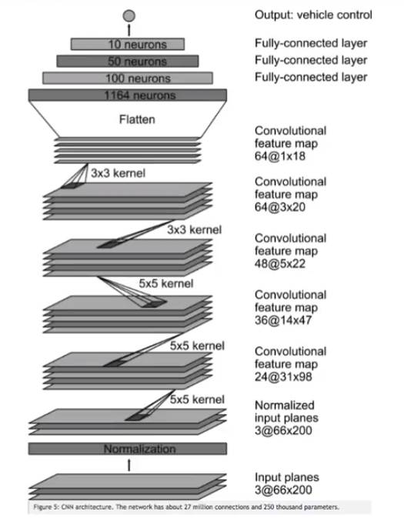

运行，保存自动驾驶测试过程

Recording Video in Autonomous Mode
Because your hardware setup might be different from a reviewer's hardware setup, driving behavior could be different on your machine than on the reviewer's. To help with reviewing your submission, we require that you submit a video recording of your vehicle driving autonomously around the track. The video should include at least one full lap around the track. Keep in mind the rubric specifications:
"No tire may leave the drivable portion of the track surface. The car may not pop up onto ledges or roll over any surfaces that would otherwise be considered unsafe (if humans were in the vehicle)."
In the GitHub repo, we have included a file called video.py, which can be used to create the video recording when in autonomous mode.
The README file in the GitHub repo contains instructions about how to make the video recording. Here are the instructions as well:
python drive.py model.h5 run1
The fourth argument, run1, is the directory in which to save the images seen by the agent. If the directory already exists, it'll be overwritten.
ls run1

[2017-01-09 16:10:23 EST] 12KiB 2017_01_09_21_10_23_424.jpg
[2017-01-09 16:10:23 EST] 12KiB 2017_01_09_21_10_23_451.jpg
[2017-01-09 16:10:23 EST] 12KiB 2017_01_09_21_10_23_477.jpg
[2017-01-09 16:10:23 EST] 12KiB 2017_01_09_21_10_23_528.jpg
[2017-01-09 16:10:23 EST] 12KiB 2017_01_09_21_10_23_573.jpg
[2017-01-09 16:10:23 EST] 12KiB 2017_01_09_21_10_23_618.jpg
[2017-01-09 16:10:23 EST] 12KiB 2017_01_09_21_10_23_697.jpg
[2017-01-09 16:10:23 EST] 12KiB 2017_01_09_21_10_23_723.jpg
[2017-01-09 16:10:23 EST] 12KiB 2017_01_09_21_10_23_749.jpg
[2017-01-09 16:10:23 EST] 12KiB 2017_01_09_21_10_23_817.jpg
...
The image file name is a timestamp of when the image was seen.. This information is used by video.py to create a chronological video of the agent driving.

Using video.py
python video.py run1
Creates a video based on images found in the run1 directory. The name of the video will be the name of the directory followed by '.mp4', so, in this case the video will be run1.mp4.
Optionally, one can specify the FPS (frames per second) of the video:
python video.py run1 --fps 48
The video will run at 48 FPS. The default FPS is 60.

