1.CNN：重要概念：；
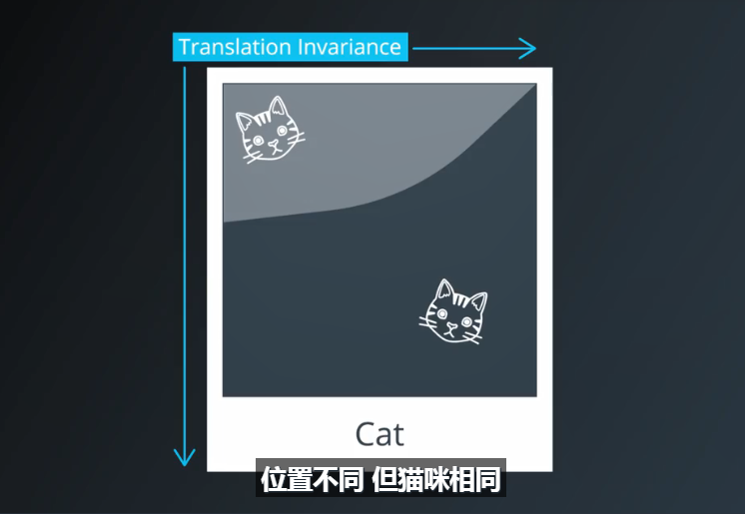

当知道两个输入可能包含相同类型信息时，你可以共享它们的权重，并利用这些输入共同训练权重。
统计不变量，即基本上不会随时间或空间改变的事物，无处不在；
对于图像，权重共享的思想引出了卷积网络的研究；
对于一般的文本和序列，则涉及嵌入和循环神经网络。
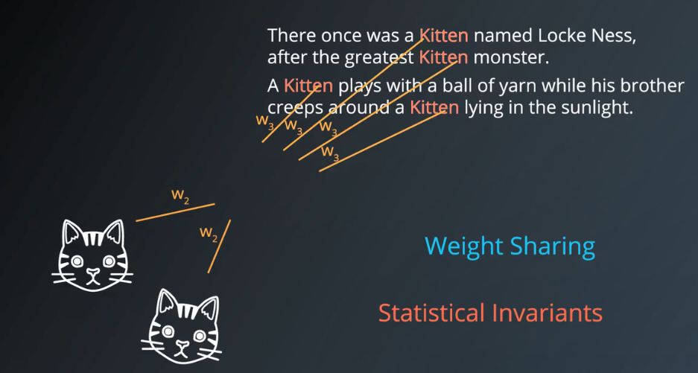

CovNet 是一种空间上共享参数的神经网络

假设有如下测试图作为输入：
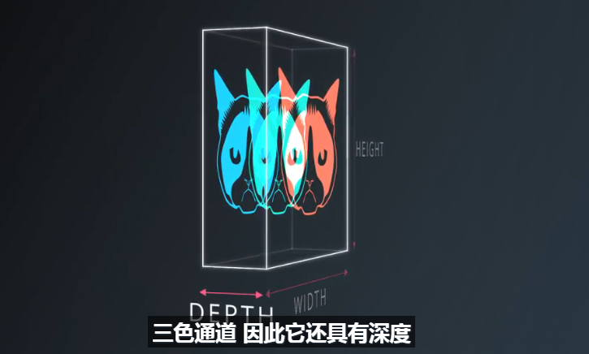

运行一个具有K个输出的小神经网络
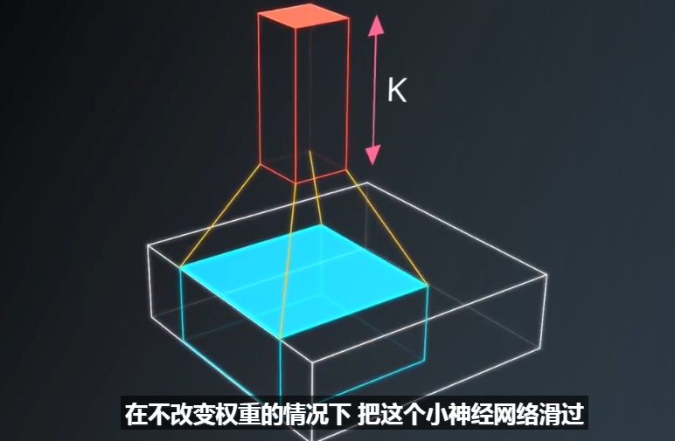

在输出端，我们画出一幅新图片，一般来说它的宽，高，深度都与原图不同。
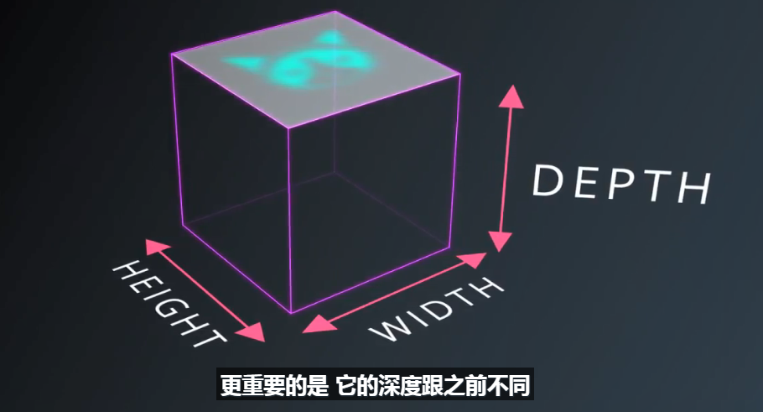

这种操作，就叫卷积，如何设置的块(patch)与原图一样大，就是一个普通网络；
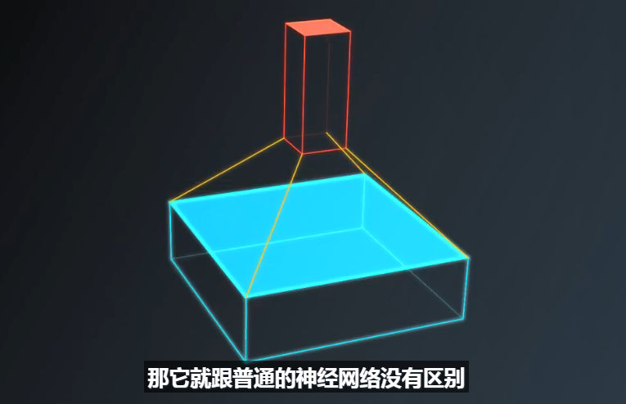

正由于使用了小块，我们在整个空间共享较少的权重，卷积网络本质上就是一个深度网络，但用共享权重的“卷积层”替代了一般的“全连接层”。

总的想法是让它们形成金字塔状，金字塔底部是一个非常大而浅的图片，仅包含RGB三通道，通过卷积操作逐渐挤压空间的维度，同时不断增加深度，使深度信息大体上可以表示出复杂的语义。
在金字塔尖顶端可以放一个分类器，所有空间信息都被压缩成一个表示，仅映射到图片内容的参数被保留。
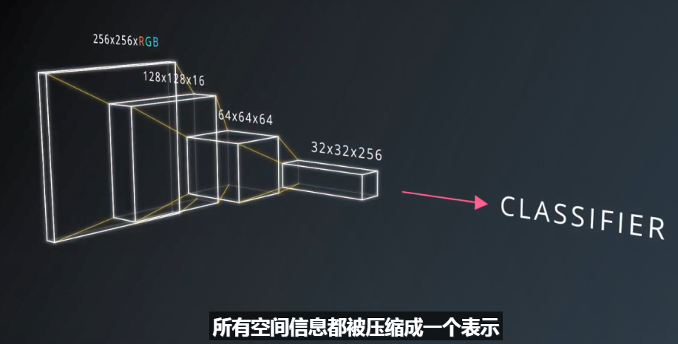

Remember that the CNN isn't "programmed" to look for certain characteristics. Rather, it learns on its own which characteristics to notice.

CNN相关概念：

图片宽、高、深度（每一层，都是一个特征图）；

patch/kernel:卷积核
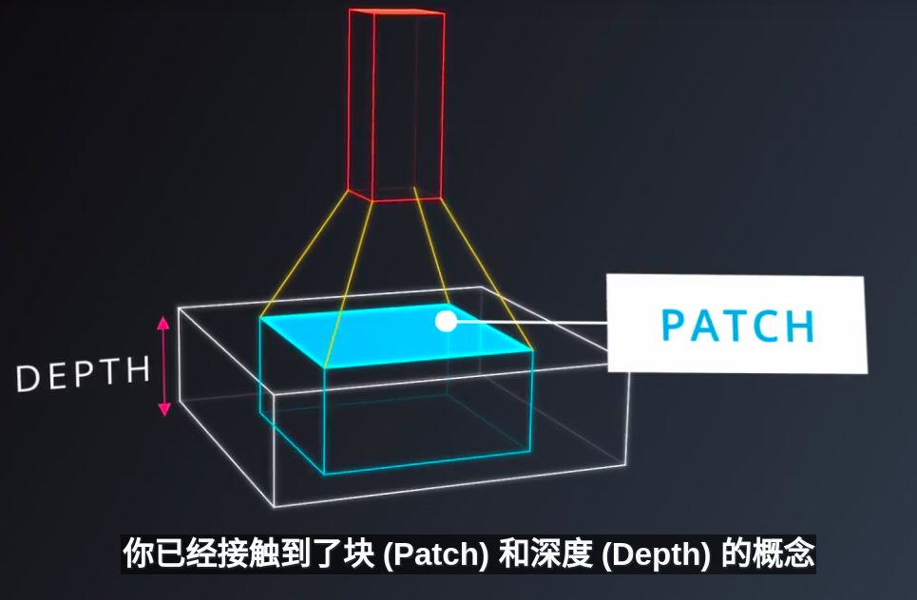
步幅stride:

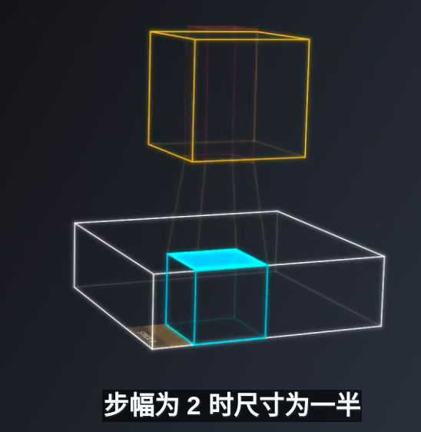

有效填充VALID PADDING
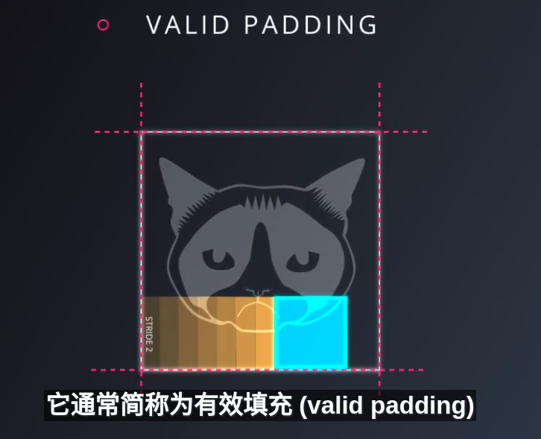
相同填充SAME PADDING
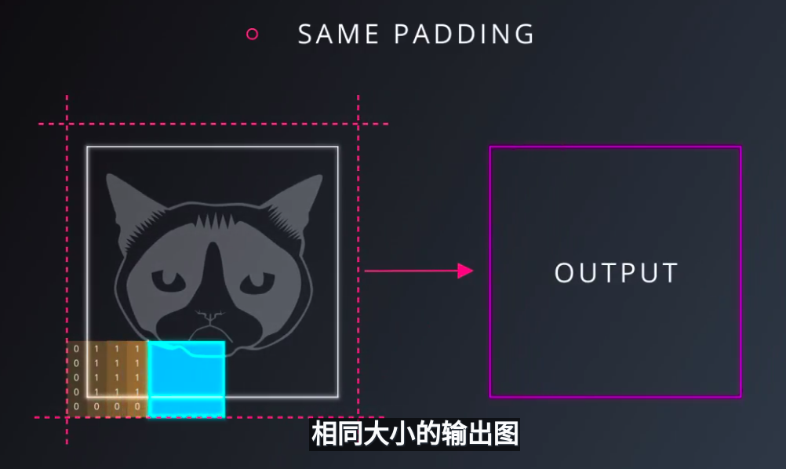
CNN识别图像过程：
With deep learning, we don't actually program the CNN to recognize these specific features. Rather, the CNN learns on its own to recognize such objects through forward propagation and backpropagation!
It's amazing how well a CNN can learn to classify images, even though we never program the CNN with information about specific features to look for.
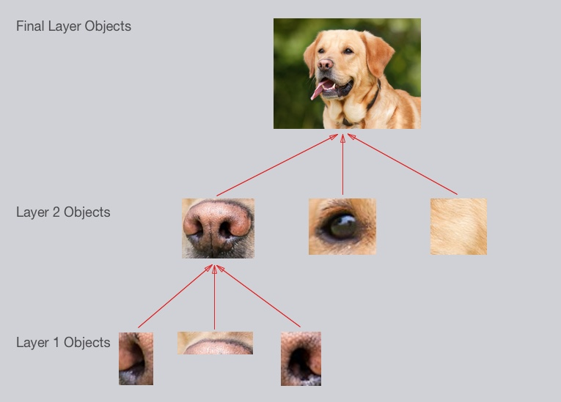

Once again, the CNN learns all of this on its own. We don't ever have to tell the CNN to go looking for lines or curves or noses or fur. The CNN just learns from the training set and discovers which characteristics of a Golden Retriever are worth looking for.
That's a good start! Hopefully you've developed some intuition about how CNNs work.
10.Filter Depth
It's common to have more than one filter. Different filters pick up different qualities of a patch. For example, one filter might look for a particular color, while another might look for a kind of object of a specific shape. The amount of filters in a convolutional layer is called the filter depth.
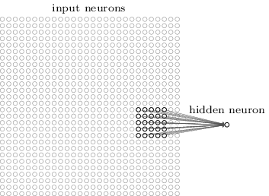
Multiple neurons can be useful because a patch can have multiple interesting characteristics that we want to capture.
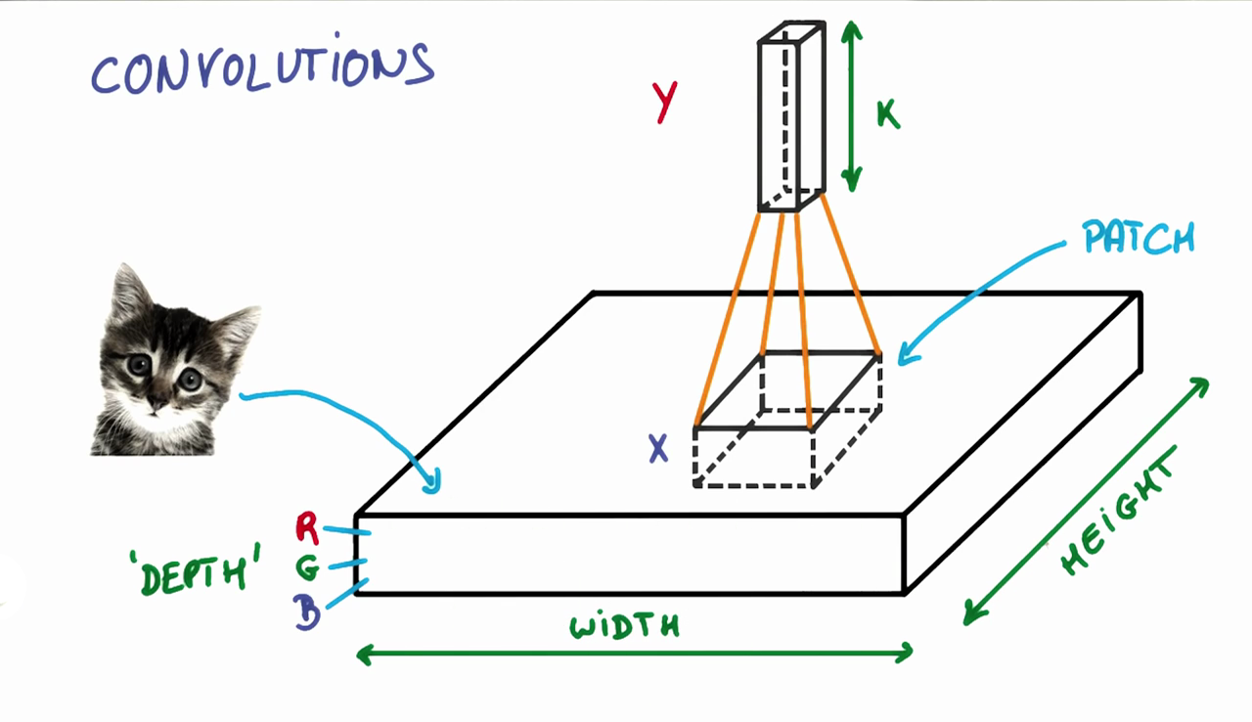
11.Feature Map Sizes
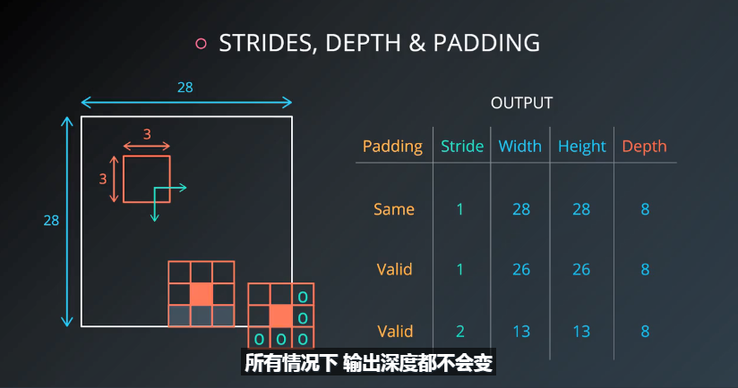
构建一个简单卷积网路，你不必自己实现，把卷基层垒起来就可以，然后尝试用降为的方法，一层一层地增加网络的深度，只要得出一个又深又窄的表示，把它整体地连接到几层常规的全连接层，就可以训练这个分类器了。
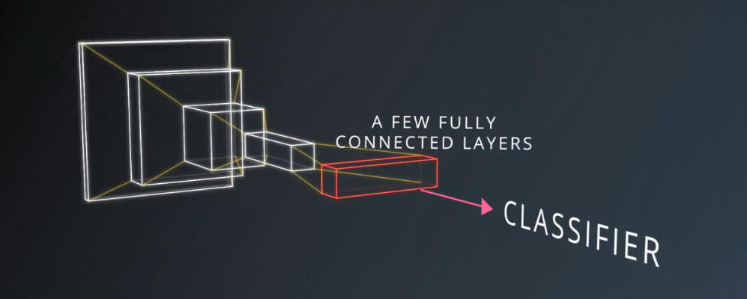

12.CNN求导：
与普通网络一样求导
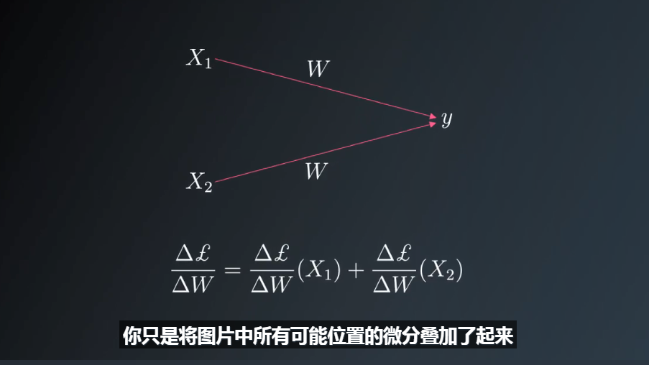
13.CNN参数

Dimensionality
From what we've learned so far, how can we calculate the number of neurons of each layer in our CNN?
Given:
- our input layer has a width of W and a height of H
- our convolutional layer has a filter size F
- we have a stride of S
- a padding of P
- and the number of filters K,
the following formula gives us the width of the next layer: W_out =[ (W−F+2P)/S] + 1.
The output height would be H_out = [(H-F+2P)/S] + 1.
And the output depth would be equal to the number of filters D_out = K.
The output volume would be W_out * H_out * D_out.
Knowing the dimensionality of each additional layer helps us understand how large our model is and how our decisions around filter size and stride affect the size of our network.
Eg:

Setup
H = height, W = width, D = depth
- We have an input of shape 32x32x3 (HxWxD)
- 20 filters of shape 8x8x3 (HxWxD)
- A stride of 2 for both the height and width (S)
- With padding of size 1 (P)
Recall the formula for calculating the new height or width:
new_height = (input_height - filter_height + 2 * P)/S + 1
new_width = (input_width - filter_width + 2 * P)/S + 1
==>new image:14x14x20

14.CNN实现
input = tf.placeholder(tf.float32, (None, 32, 32, 3))
filter_weights = tf.Variable(tf.truncated_normal((8, 8, 3, 20))) # (height, width, input_depth, output_depth)
filter_bias = tf.Variable(tf.zeros(20))
strides = [1, 2, 2, 1] # (batch, height, width, depth)
padding = 'SAME'
conv = tf.nn.conv2d(input, filter_weights, strides, padding) + filter_bias
SAME Padding, the output height and width are computed as:
out_height = ceil(float(in_height) / float(strides[1]))
out_width = ceil(float(in_width) / float(strides[2]))
VALID Padding, the output height and width are computed as:
out_height = ceil(float(in_height - filter_height + 1) / float(strides[1]))
out_width = ceil(float(in_width - filter_width + 1) / float(strides[2]))

15.参数所占内存
Setup
H = height, W = width, D = depth
- We have an input of shape 32x32x3 (HxWxD)
- 20 filters of shape 8x8x3 (HxWxD)
- A stride of 2 for both the height and width (S)
- Zero padding of size 1 (P)

Output Layer
- 14x14x20 (HxWxD)

Solution
There are 756560 total parameters. That's a HUGE amount! Here's how we calculate it:
(8 * 8 * 3 + 1) * (14 * 14 * 20) = 756560
8 * 8 * 3 is the number of weights, we add 1 for the bias. Remember, each weight is assigned to every single part of the output (14 * 14 * 20). So we multiply these two numbers together and we get the final answer.
CNN共享参数模型：

Solution
There are 3860 total parameters. That's 196 times fewer parameters! Here's how the answer is calculated:
(8 * 8 * 3 + 1) * 20 = 3840 + 20 = 3860
That's 3840 weights and 20 biases. This should look similar to the answer from the previous quiz. The difference being it's just 20 instead of (14 * 14 * 20). Remember, with weight sharing we use the same filter for an entire depth slice. Because of this we can get rid of 14 * 14 and be left with only 20.

17.CNN可视化

Layer 1：识别出简单线条
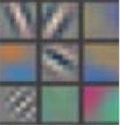

Layer2: The second layer of the CNN captures complex ideas.
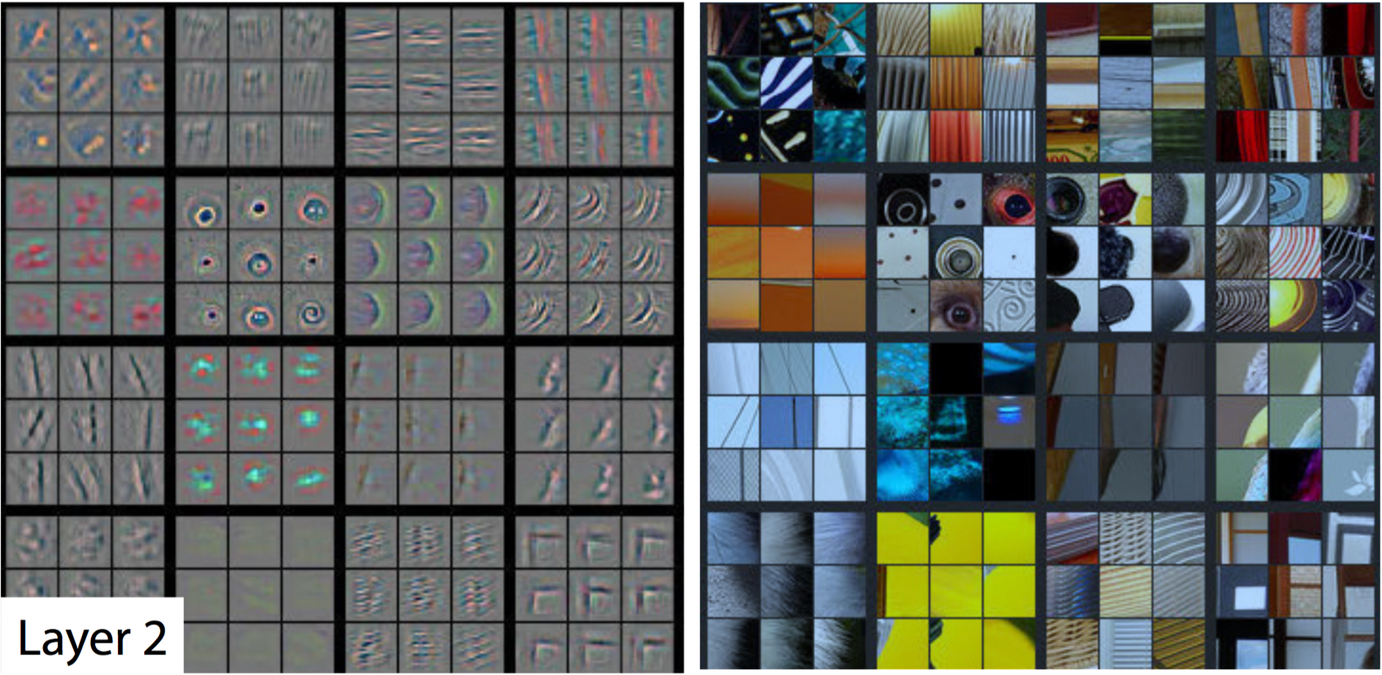
Layer3:
The third layer picks out complex combinations of features from the second layer. T
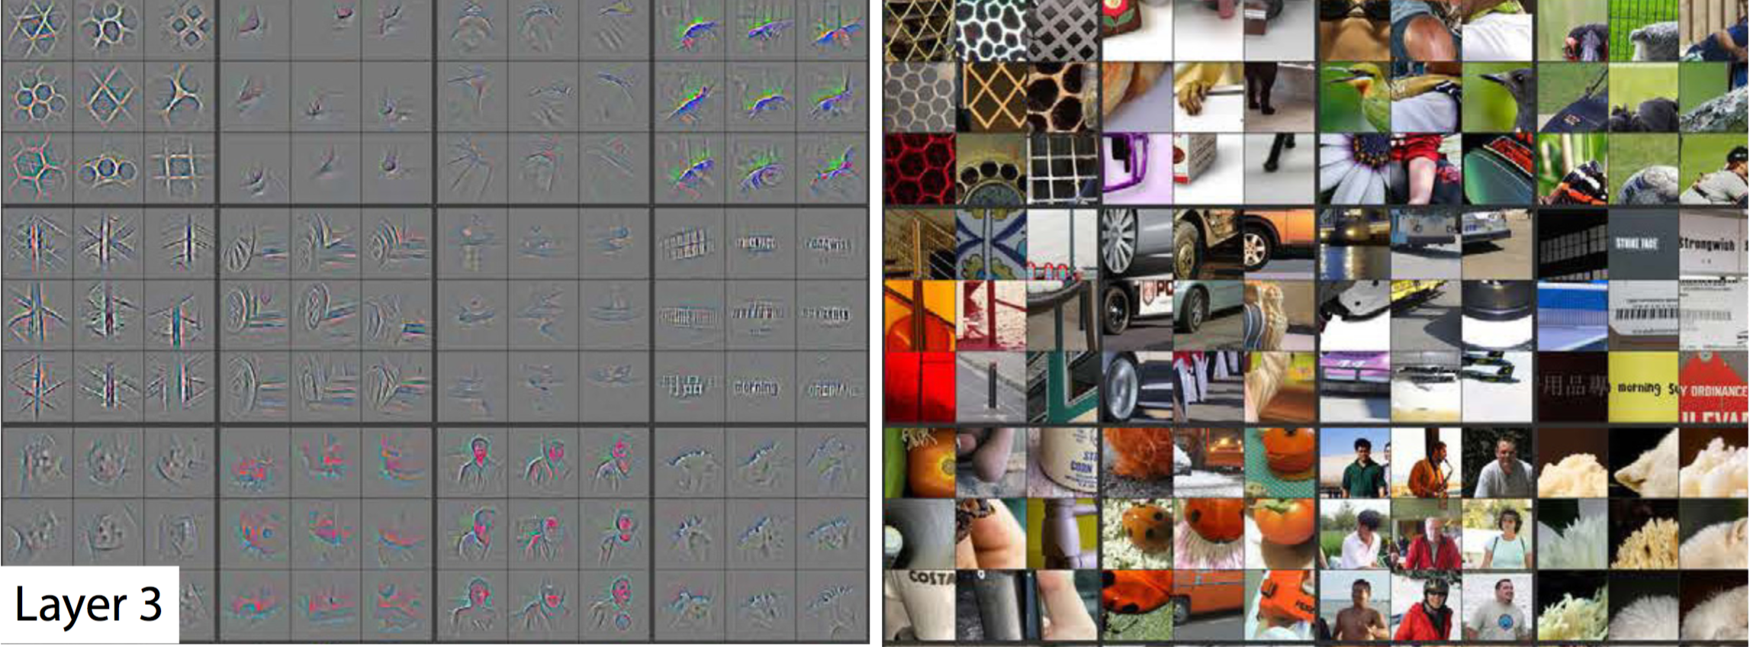

layer5:he last layer picks out the highest order ideas that we care about for classification, like dog faces, bird faces, and bicycles.

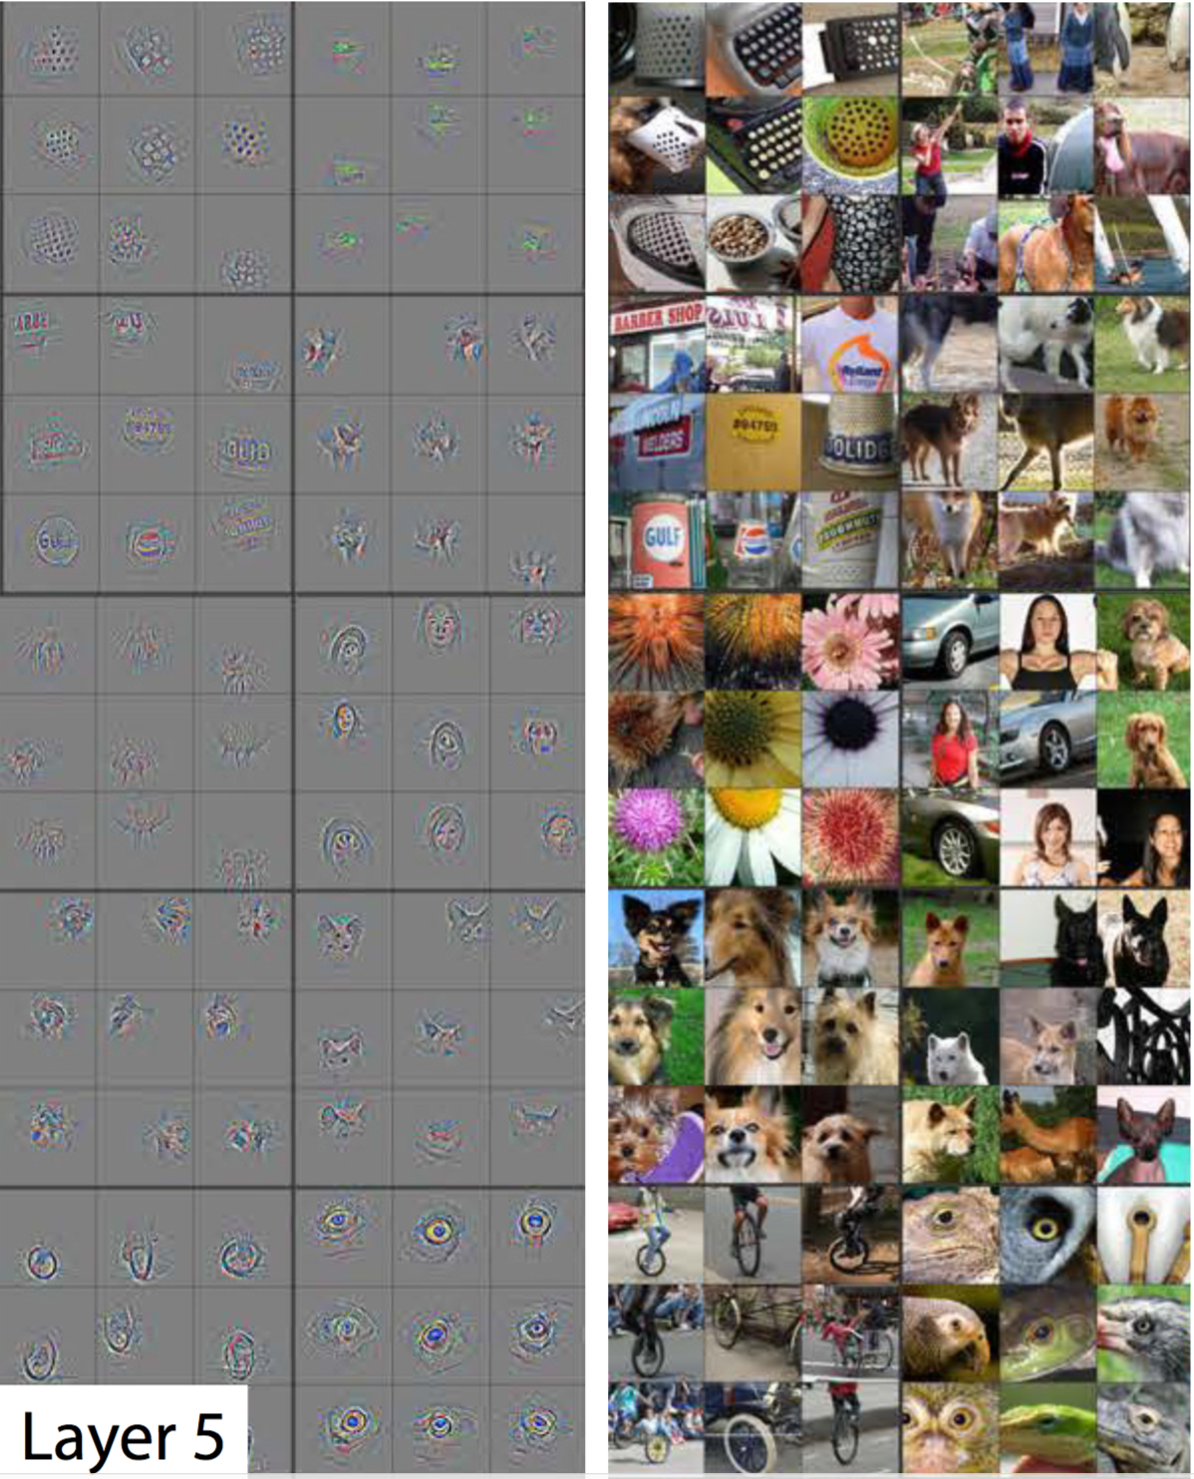
18.TensorFlow 实现Convolution Layer
TensorFlow provides the tf.nn.conv2d() and tf.nn.bias_add() functions to create your own convolutional layers.
# Output depth
k_output = 64

# Image Properties
image_width = 10
image_height = 10
color_channels = 3

# Convolution filter
filter_size_width = 5
filter_size_height = 5

# Input/Image
input = tf.placeholder(
tf.float32,
shape=[None, image_height, image_width, color_channels])

# Weight and bias
weight = tf.Variable(tf.truncated_normal(
[filter_size_height, filter_size_width, color_channels, k_output]))
bias = tf.Variable(tf.zeros(k_output))

# Apply Convolution
conv_layer = tf.nn.conv2d(input, weight, strides=[1, 2, 2, 1], padding='SAME')
# Add bias
conv_layer = tf.nn.bias_add(conv_layer, bias)
# Apply activation function
conv_layer = tf.nn.relu(conv_layer)

We are generally always going to set the stride for batch and input_channels (i.e. the first and fourth element in the strides array) to be 1

19.池化pooling
采用stride=1，不丢失信息，通过某种方法把相邻的所有卷积结合在一起，从而降低空间尺寸，叫做池化；
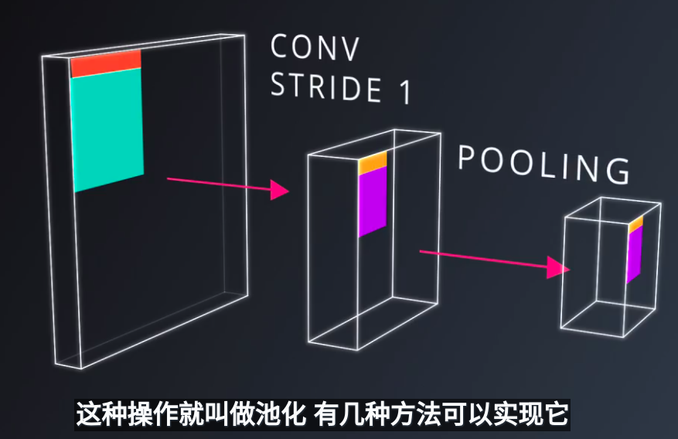

最大池化：
特点：不会增加参数数量，提高模型准确性，更多计算量，有更多超参数可以调；
池区尺寸Pooling Size，池化歩幅Pooling Stride,
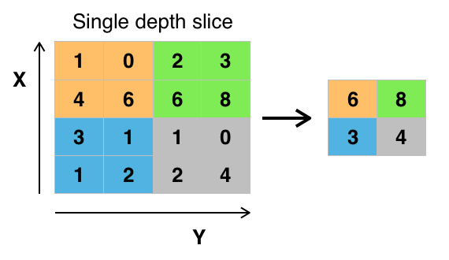

一个典型的CNN，包含卷积层和池化层；


平均池化：

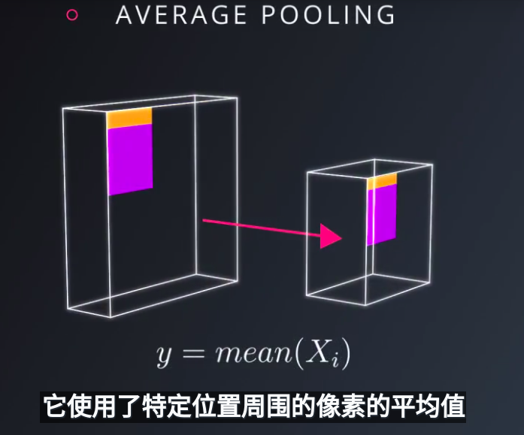

池化参数计算：

Setup
H = height, W = width, D = depth
- We have an input of shape 4x4x5 (HxWxD)
- Filter of shape 2x2 (HxW)
- A stride of 2 for both the height and width (S)
Recall the formula for calculating the new height or width:
new_height = (input_height - filter_height)/S + 1
new_width = (input_width - filter_width)/S + 1
20.NOTE: For a pooling layer the output depth is the same as the input depth. Additionally, the pooling operation is applied individually for each depth slice.

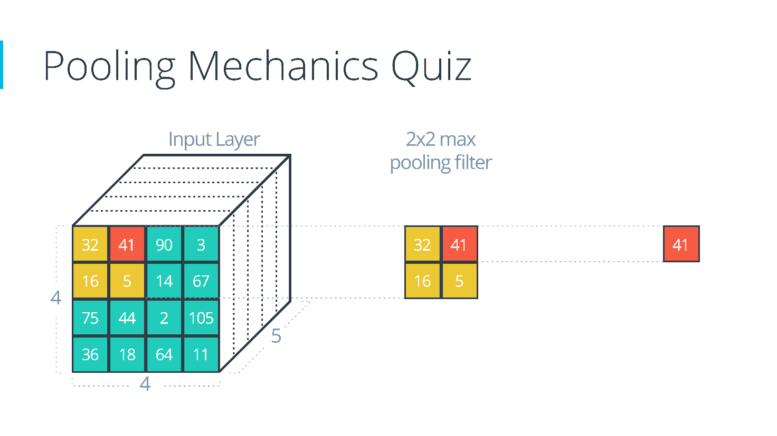

Solution
The answer is 2x2x5. Here's how it's calculated using the formula:
(4 - 2)/2 + 1 = 2
(4 - 2)/2 + 1 = 2

21. 1X1卷积
在卷积操作中散布一些1x1卷积，是一种使模型变得更深的低耗高效方法，并且会有更多的参数，
但并未完全改神经网络结构，计算简单，只是矩阵相乘并且参数较少。

在构建神经网络时，使用池化，1x1卷接是非常成功的通用策略，相对于金字塔式的结构它们使得卷积网络更加的简洁高效；

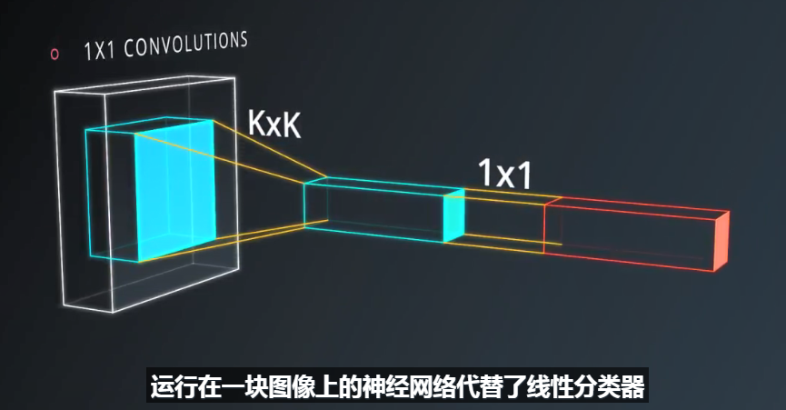

22.inception module
不局限于单个模块，而是将多个模块组合，如平均池化后接1x1卷积，直接3x3等，最后将这些运算的输出连成一串。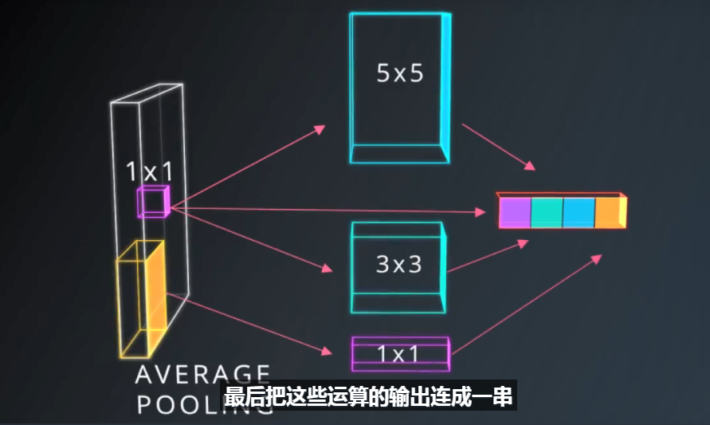
它看起来很复杂，担有趣的是根据你选择参数的方式，模型中的参数总数可能非常少，但模型的性能比你使用简单卷积时要好..

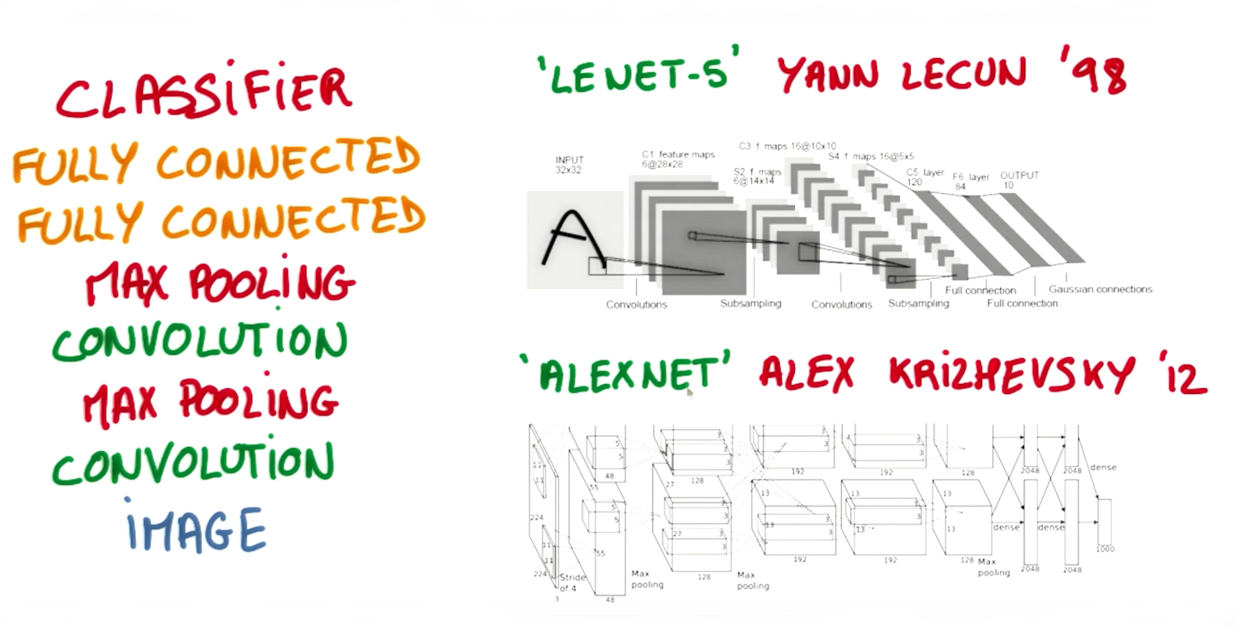

def conv2d(input_array):
# Filter (weights and bias)
# The shape of the filter weight is (height, width, input_depth, output_depth)
# The shape of the filter bias is (output_depth,)
# TODO: Define the filter weights `F_W` and filter bias `F_b`.
# NOTE: Remember to wrap them in `tf.Variable`, they are trainable parameters after all.
F_W = tf.Variable(tf.truncated_normal((2,2,1,3)))
F_b = tf.Variable(tf.zeros(3))
# TODO: Set the stride for each dimension (batch_size, height, width, depth)
strides = [1, 2, 2, 1]
# TODO: set the padding, either 'VALID' or 'SAME'.
padding = 'VALID'
# https://www.tensorflow.org/versions/r0.11/api_docs/python/nn.html#conv2d
# `tf.nn.conv2d` does not include the bias computation so we have to add it ourselves after.
return tf.nn.conv2d(input_array, F_W, strides, padding) + F_b

更多CNN资源
- Andrej Karpathy's CS231n Stanford course on Convolutional Neural Networks.
：http://cs231n.github.io/
- Michael Nielsen's free book on Deep Learning.
http://neuralnetworksanddeeplearning.com/
- Goodfellow, Bengio, and Courville's more advanced free book on Deep Learning.
http://www.deeplearningbook.org/

改进LeNet网络模型的方法：
Strategies to Improve Your Classification Model
Looking at where to go next what could you do to further improve this model? There are several broad categories, to try.

experiment with different network architectures, or just change the dimensions of the LeNet layers
add regularization features like drop out or L2 regularization to make sure the network doesn't overfit the training data
tune the hyperparameters
improve the data pre-processing with steps like normalization and setting a zero mean
augment the training data by rotating or shifting images or by changing colors
There are a lot of fun experiments you can run on this network so give it a shot and see how well you can do. Good luck.

