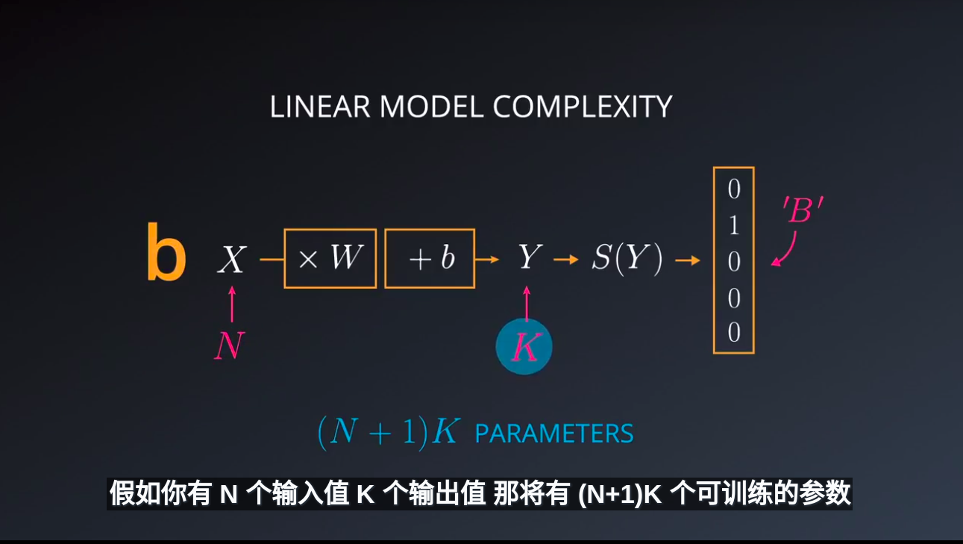
DNN基础：
1.GPU具有强大的矩阵相乘能力;成本低廉，且非常快；
2.从数学讲，线性运算非常稳定；矩阵的导数是常量，数学上没有什么比常量更稳定

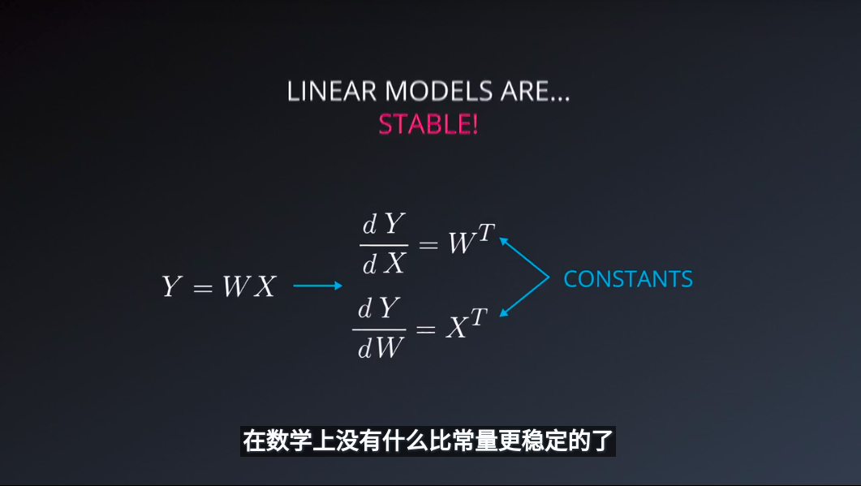
2.最简单的非线性函数
A Rectified linear unit (ReLU) is type of activation function that is defined as f(x) = max(0, x). The function returns 0 if x is negative, otherwise it returns x. TensorFlow provides the ReLU function as tf.nn.relu(), as shown below.
# Hidden Layer with ReLU activation function
hidden_layer = tf.add(tf.matmul(features, hidden_weights), hidden_biases)
hidden_layer = tf.nn.relu(hidden_layer)

output = tf.add(tf.matmul(hidden_layer, output_weights), output_biases)
3.链式法则，反向传播
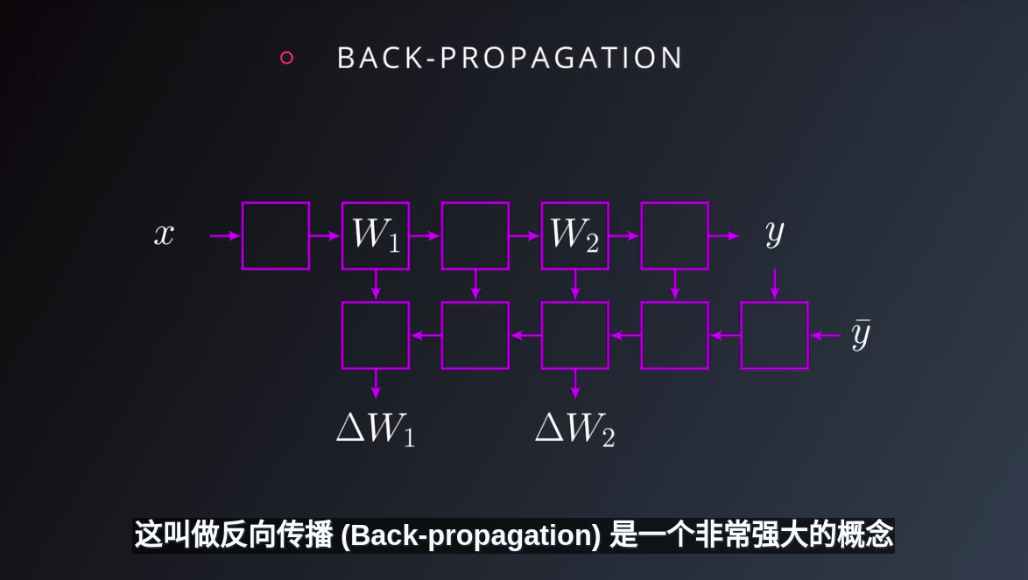
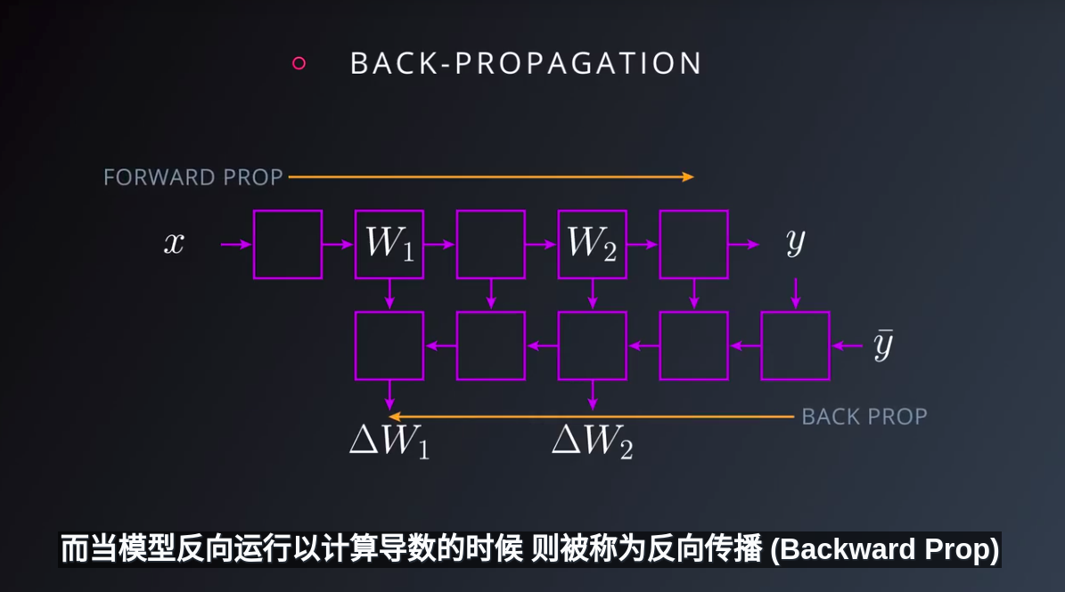
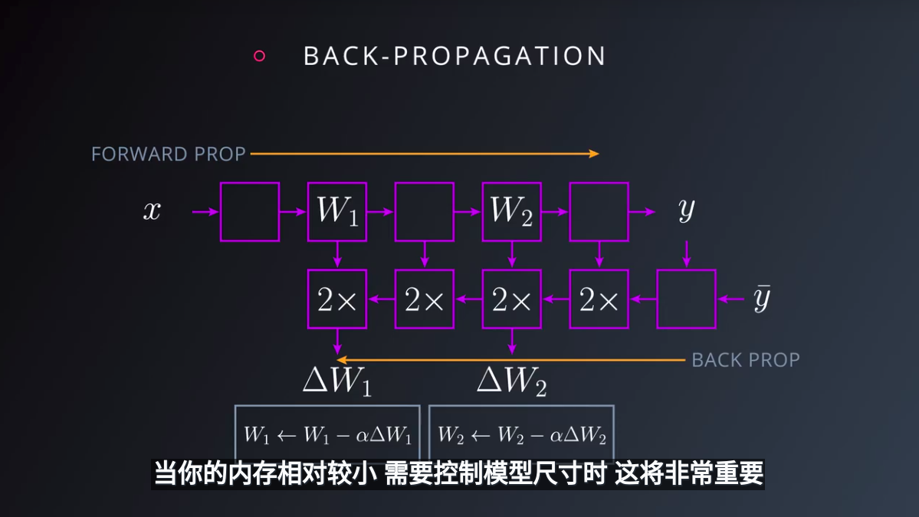
4.DNN：通过增加网络层数，1.可以减少所需参数个数；2.更深的网络模型，往往会呈现出层次化的结构；更够学习到更抽象的内容
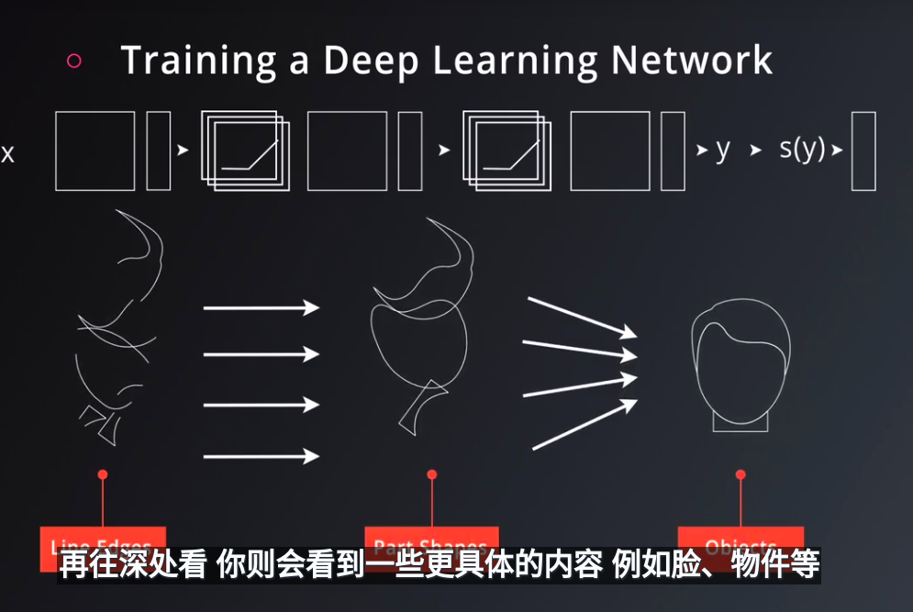

5.Save and Restore TensorFlow Models
Fortunately, TensorFlow gives you the ability to save your progress using a class called tf.train.Saver. This class provides the functionality to save any tf.Variable to your file system.
import tensorflow as tf

# The file path to save the data
save_file = './model.ckpt'

# Two Tensor Variables: weights and bias
weights = tf.Variable(tf.truncated_normal([2, 3]))
bias = tf.Variable(tf.truncated_normal([3]))

# Class used to save and/or restore Tensor Variables
saver = tf.train.Saver()

with tf.Session() as sess:
# Initialize all the Variables
sess.run(tf.global_variables_initializer())

# Show the values of weights and bias
print('Weights:')
print(sess.run(weights))
print('Bias:')
print(sess.run(bias))

# Save the model
saver.save(sess, save_file)
# Remove the previous weights and bias
tf.reset_default_graph()

# Two Variables: weights and bias
weights = tf.Variable(tf.truncated_normal([2, 3]))
bias = tf.Variable(tf.truncated_normal([3]))

# Class used to save and/or restore Tensor Variables
saver = tf.train.Saver()

with tf.Session() as sess:
# Load the weights and bias
saver.restore(sess, save_file)

# Show the values of weights and bias
print('Weight:')
print(sess.run(weights))
print('Bias:')
print(sess.run(bias))
6.Finetuning
weights = tf.Variable(tf.truncated_normal([2, 3]), name='weights_0')
bias = tf.Variable(tf.truncated_normal([3]), name='bias_0')
7.regularization
防止过拟合方法1：当验证集性能停止提高时，立即停止训练
提前终止，是提高过拟合最佳方式；
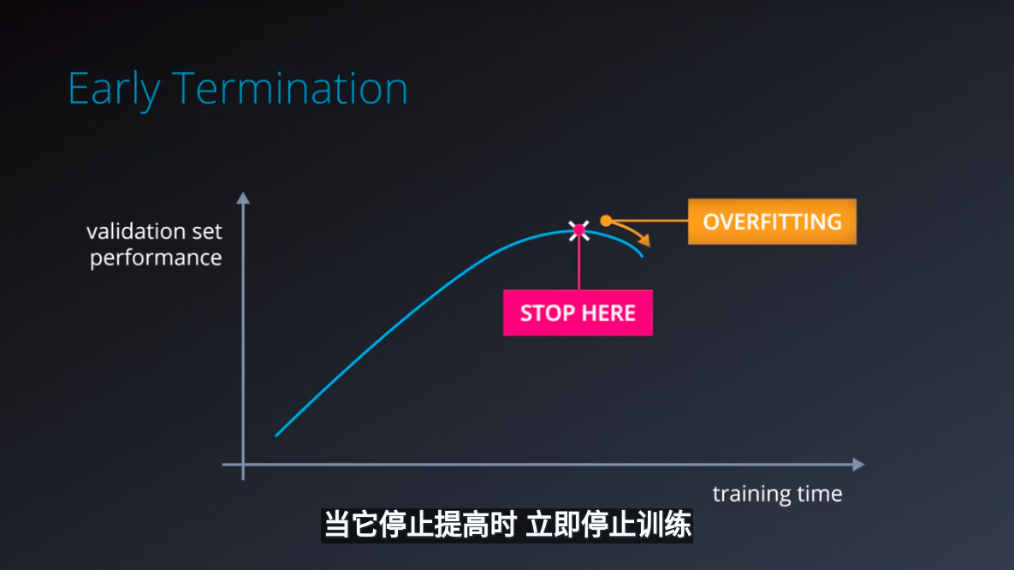
方法2：使用正则化
正则化，是指对你的网络应用人为约束，隐式的减少自由参数的数量，
同时不会使其变得更难以优化；
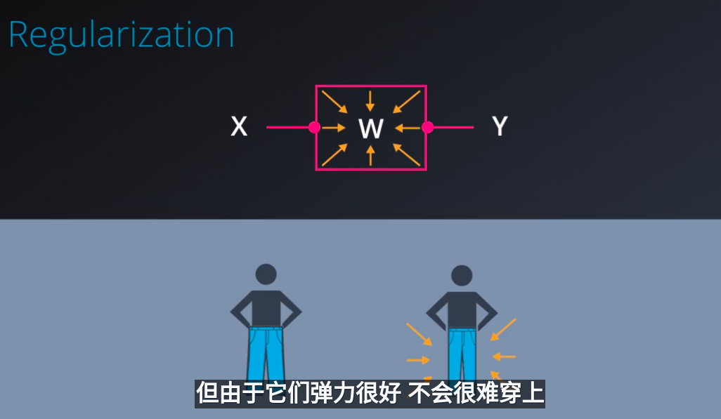
L2正则化：它的思想是向损失函数添加另一个项，用于惩罚大的权重；通常方法是将你的权重的L2范数添加到损失函数乘以一个小的常数，
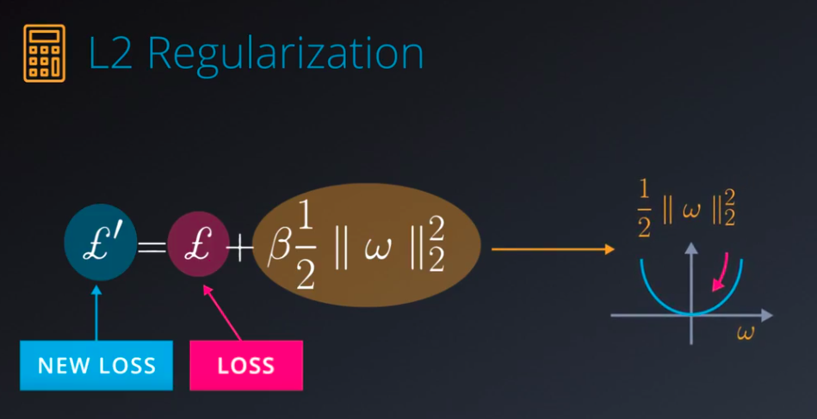
L2正则化的优点是很简单，不需要修改网络，也很容易求导
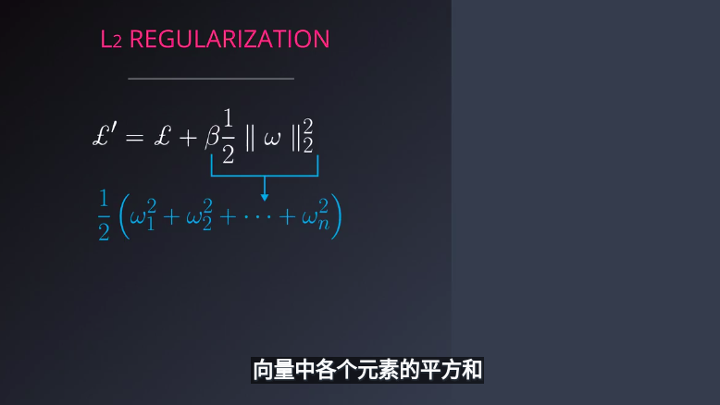
8.dropout:Dropout is a regularization technique for reducing overfitting.
原理：将两层之间的激活值，随机设置一半为0,着牙，基本上随机地将流经网络的一半数据完全摧毁，然后再一次随机这么做；
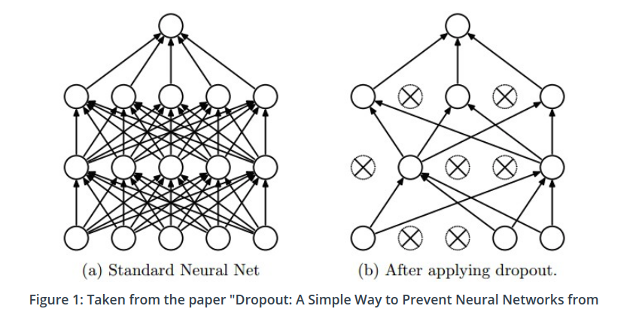

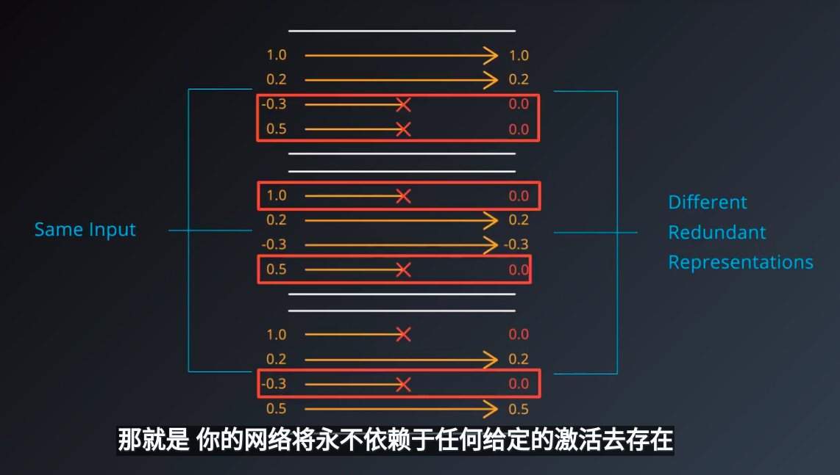

所以被迫学习了一切冗余信息，以确保至少将一些信息保存下来；这听起来效率低下，但在实践中，它使网络更加稳固，并能防止过拟合；
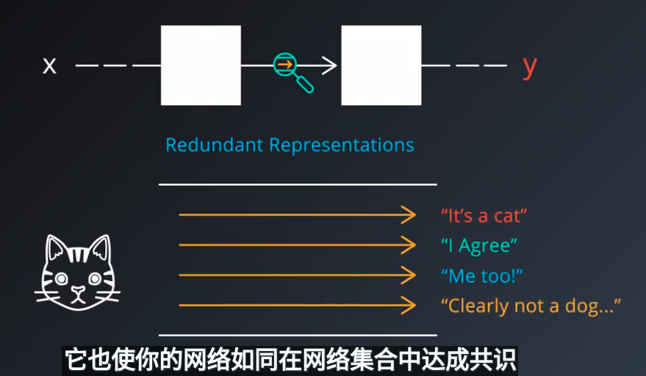
使用dropout技巧
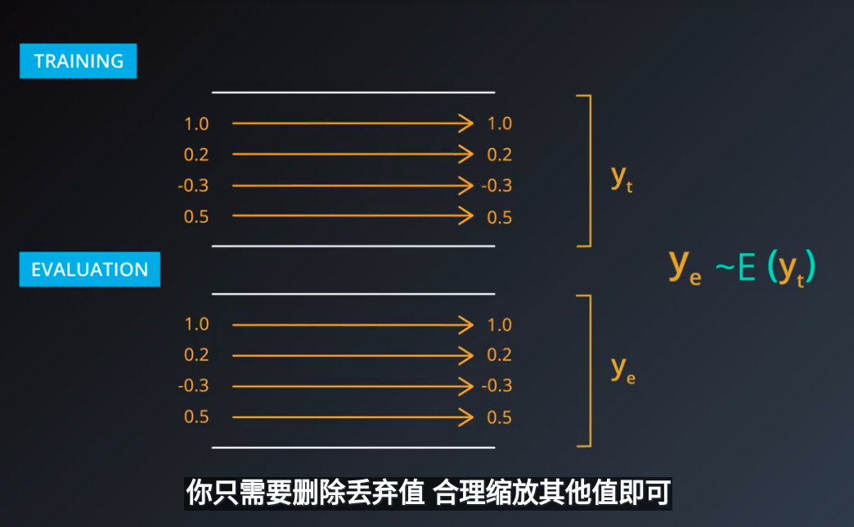
tensorflow实现
keep_prob = tf.placeholder(tf.float32) # probability to keep units

hidden_layer = tf.add(tf.matmul(features, weights[0]), biases[0])
hidden_layer = tf.nn.relu(hidden_layer)
hidden_layer = tf.nn.dropout(hidden_layer, keep_prob)

logits = tf.add(tf.matmul(hidden_layer, weights[1]), biases[1])
The tf.nn.dropout() function takes in two parameters:
- hidden_layer: the tensor to which you would like to apply dropout
- keep_prob: the probability of keeping (i.e. not dropping) any given unit

