 **American International University- Bangladesh**

**CSC 3215: Web Technologies**

**CO2 and CO4 Evaluation**

**Finished Project Report**

**Summer 2020-2021**

**Project Title: Inventory Management System**

**Section: D**

|  |  |
| --- | --- |
| Student Name | Student Id |
| LUTFA NOOR LABONY | 18-36187-1 |

**Project Description:**

Online Inventory Management System is system that takes care of everything that a real estate Shops wants to do. Inventory Management System is developed for real estate Shops. It is very strong and easy to use that makes quick ordering and handling process. The real estate Inventory management system is web based System and you can access it from anywhere.

In the project we have tried to implement the Database management system, which is built in version by php which we know as name as php myadmin. After Php validation, we can implement new validation process by the JavaScript. We can also use the JavaScript built-in products, like Ajax . Before implement this objective we have face some problems but after getting the knowledge we can implement those things properly and try to made a model web project.

**Project Folder Structure:**

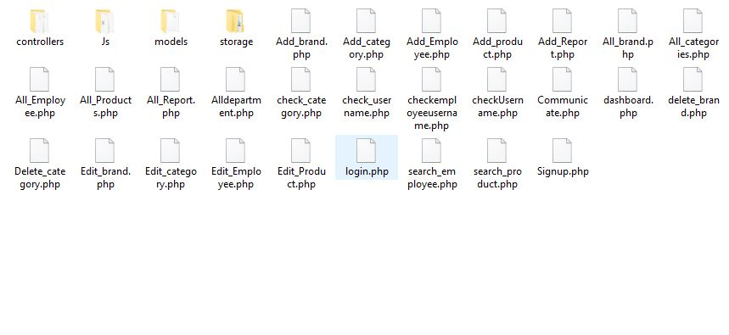

**N.B: Here all the users folder structure are same as Employee.**

**Core Modules of the Project:**

**login.php**

<?php

session_start();

include'controllers/UserController.php';

?>

<!DOCTYPE html>

<html>

<head>

<meta charset="utf-8">

<title></title>

</head>

<script >

var hasError=false;

function get(id){

return document.getElementById(id);

}

function validate(){

refresh();

if(get("uname").value==""){

hasError = true;

get("err_uname").innerHTML = "*Username Req";

}

if(get("pass").value==""){

hasError = true;

get("err_pass").innerHTML = "*Password Req";

}

return !hasError;

}

function refresh(){

hasError = false;

get("err_uname").innerHTML ="";

get("err_pass").innerHTML ="";

}

</script>

<style >

.img{

display: flex;

justify-content: center;

}

</style>

<body style="background: #f5f5ef; margin: 50px;">

<div class="img">

<img src="storage/SystemPictures/logo.png">

</div>

<h1 style="text-align: center;">Login</h1>

<h5><?php echo $err_db; ?></h5>

<form action="" onsubmit="return validate()" method="post" style="text-align: center;">

<h4>UserName:</h4>

<input type="text" name="uname" id="uname" value="<?php echo $username; ?>" >

<br>

<span id="err_uname"><?php echo $err_username;?></span>

<h4>Password:</h4>

<input type="Password" name="password" id="pass"value="<?php echo $password; ?>">

<br>

<span id="err_pass"><?php echo $err_password; ?></span>

<br>

<br>

<input type="submit" name="btn_login" value="Login">

<br>

<a href="Signup.php">Not registered yet!Sign Up</a>

</form>

</body>

</html>

# Add_Products.php

*<?php*

*require_once'controllers/ProductController.php' ;*

*require_once'controllers/CategoryController.php';*

*$cat=getAllcategories();*

*?>*

*<!DOCTYPE html>*

*<html>*

*<head>*

*<meta charset="utf-8">*

*<title></title>*

*</head>*

*<script>*

*var hasError=false;*

*function get(id)*

*{*

*return document.getElementById(id);*

*}*

*function validate()*

*{*

*refresh();*

*if(get("name").value == "")*

*{*

*hasError = true;*

*get("err_name").innerHTML = "*Name Req";*

*}*

*else if(get("name").value.length <=2)*

*{*

*hasError = true;*

*get("err_name").innerHTML = "*Name must be > 2 characters";*

*}*

*if(get("cat").selectedIndex == 0){*

*hasError = true;*

*get("err_cat").innerHTML = "*Category Req";*

*}*

*if(get("price").value == "")*

*{*

*hasError = true;*

*get("err_price").innerHTML = "*Price Req";*

*}*

*if(get("qty").value == "")*

*{*

*hasError = true;*

*get("err_qty").innerHTML = "*Quantity Req";*

*}*

*if(get("desc").value == "")*

*{*

*hasError = true;*

*get("err_desc").innerHTML = "*Description Req";*

*}*

*if(get("img").value == "")*

*{*

*hasError = true;*

*get("err_img").innerHTML = "*Image Req";*

*}*

*return !hasError;*

*}*

*function refresh()*

*{*

*hasError = false;*

*get("err_name").innerHTML ="";*

*get("err_cat").innerHTML ="";*

*get("err_price").innerHTML ="";*

*get("err_qty").innerHTML ="";*

*get("err_desc").innerHTML ="";*

*get("err_img").innerHTML ="";*

*}*

*</script>*

*<body style="background: #f5f5ef; ">*

*<h1 style="text-align: center;" >ADD PRODUCT</h1>*

*<h5><?php echo $err_db; ?></h5>*

*<form action="" onsubmit="return validate()" method="post" enctype="multipart/form-data" style="text-align: center;">*

*<h4>Name</h4>*

*<input id="name" name="name" value="<?php echo $name;?>" type="text"><br>*

*<span id="err_name"><?php echo $err_name;?></span>*

*<h4>Category</h4>*

*<select id="cat" name="c_id" >*

*<option disabled selected >Choose</option>*

*<?php*

*foreach ($cat as $c) {*

*echo "<option value='".$c["id"]."'>".$c["name"]."</option>";*

*}*

*?>*

*</select>*

*<br>*

*<span id="err_cat"> <?php echo $err_c_id;?> </span>*

*<h4 >Price</h4>*

*<input id = "price" type="text" name="price" value="<?php $price ?>">*

*<br>*

*<span id="err_price"><?php echo $err_price;?></span>*

*<br>*

*<h4>Quantity</h4>*

*<input id="qty" type="text" name="qty" value="<?php $quantity ?>">*

*<br>*

*<span id="err_qty"> <?php echo $err_quantity;?> </span>*

*<br>*

*<h4>Description</h4>*

*<input id="desc" type="text" name="desc" value="<?php $description ?>">*

*<br>*

*<span id="err_desc"> <?php echo $err_description;?> </span>*

*<h4>Image</h4>*

*<input id="img" type="file" name="p_img" value="<?php $img ?>" style="padding-left: 100px;">*

*<br>*

*<span id="err_img"> <?php echo $err_img;?> </span>*

*<br><br>*

*<input type="submit" name="add_product" value="Add Product">*

*<a href="dashboard.php">Back</a>*

*</body>*

*</html>*

***Add_Employee.php***

*<?php*

*require_once 'controllers/Employee_Controller.php';*

*require_once 'Controllers/DepartmentControllers.php';*

*$dept=getAlldepartment();*

*?>*

*<!DOCTYPE html>*

*<html>*

*<head>*

*<meta charset="utf-8">*

*<title></title>*

*</head>*

*<script>*

*var hasError=false;*

*function get(id)*

*{*

*return document.getElementById(id);*

*}*

*function validate()*

*{*

*refresh();*

*if(get("name").value == "")*

*{*

*hasError = true;*

*get("err_name").innerHTML = "*Name Req";*

*}*

*else if(get("name").value.length <=2)*

*{*

*hasError = true;*

*get("err_name").innerHTML = "*Name must be > 2 characters";*

*}*

*if(get("uname").value == "")*

*{*

*hasError = true;*

*get("err_uname").innerHTML = "*User Name Req";*

*}*

*if(get("dob").value == "")*

*{*

*hasError = true;*

*get("err_dob").innerHTML = "*Joing Date Req";*

*}*

*if(get("deptid").selectedIndex == 0){*

*hasError = true;*

*get("err_deptid").innerHTML = "*Deptid Req";*

*}*

*if(get("img").value == "")*

*{*

*hasError = true;*

*get("err_img").innerHTML = "*Image Req";*

*}*

*return !hasError;*

*}*

*function refresh()*

*{*

*hasError = false;*

*get("err_name").innerHTML ="";*

*get("err_uname").innerHTML ="";*

*get("err_dob").innerHTML ="";*

*get("err_deptid").innerHTML ="";*

*get("err_img").innerHTML ="";*

*}*

*</script>*

*<body style="background: #f5f5ef; ">*

*<h5><?php echo $err_db; ?></h5>*

*<h1 style="text-align: center;">ADD EMPLOYEE</h1>*

*<form action="" onsubmit="return validate()" method="post" enctype="multipart/form-data" style="text-align: center;">*

*<h4>Name</h4>*

*<input type="text" name="name" id="name" value="<?php echo $name ?>">*

*<span id="err_name"> <?php echo $err_name;?> </span>*

*<br>*

*<!-- <h4>Id</h4>*

*<input type="text" name="id">*

*<br> -->*

*<h4>UserName</h4>*

*<input type="text" name="uname" id="uname" onfocusout="checkEmpusername(this)" value="<?php echo $username ?>">*

*<br>*

*<span id="err_uname"> <?php echo $err_username;?> </span>*

*<br>*

*<h4>DOB</h4>*

*<input type="text" id="dob" name="dob" value="<?php echo $dob ?>">*

*<span id="err_dob"> <?php echo $err_dob;?> </span>*

*<br>*

*<h4>Department Id</h4>*

*<select id="deptid" name="dept_id">*

*<option disabled selected >Choose</option>*

*<?php*

*foreach ($dept as $d) {*

*echo "<option value='".$d["id"]."'>".$d["name"]."</option>";*

*}*

*?>*

*</select>*

*<span id="err_deptid"> <?php echo $err_deptid;?> </span><br>*

*<br>*

*<h4>Image</h4>*

*<input id="img" type="file" name="p_img" value="<?php $img ?>" style="padding-left: 100px;">*

*<br>*

*<span id="err_img"> <?php echo $err_img;?> </span>*

*<br><br>*

*<input type="submit" name="add_student" value="Add Employee">*

*</form>*

*<a href="dashboard.php">Back</a>*

*</body>*

*</html>*

*<script src="Js/employee.js"></script>*

**DATABASE SCHEMA**

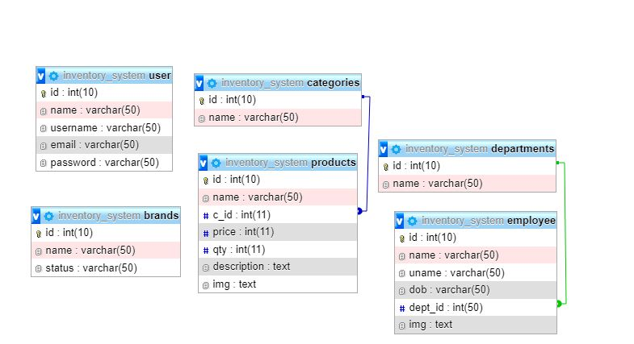

|  |  |  |  |  |  |
| --- | --- | --- | --- | --- | --- |
| **CO2 and CO4 Evaluation: Project Report Evaluation** | | | |  |  |
| **Completeness**  **(5)** | **Validation**  **(5)** | **Feature**  **Implementation**  **(5)** | **Concept**  **Understanding**  **(5)** | **Promptness**  **(5)** | **Total**  **(25)** |
|  |  |  |  |  |  |