
faculty of Artificial Intelligence Engineering
intelligent telecommunication engineering

Design of a Wireless Black Box for Cars
تصميم صندوق أسود لاسلكي للسيارات

Prepared by
Mohammad Lutfi Qassar

Supervised by
Prof. Dr. Eng. Hassan Ahmad
Eng. Mohammad Othman

Supervisor’s Declaration
I hereby certify that the preparation of this project, entitled “Design of a Wireless Black Box for Cars”, was carried out by the student Mohammad Lutfi Qassar under my supervision in the Department of Communications and Networks Engineering, Faculty of Computer and Informatics Engineering, and that it fulfils part of the requirements for the Bachelor’s degree in Communications and Networks Engineering.
Academic Rank: ………………………………
Name: ……………………………………
Signature: ………………………………
Date: …………………………………

Abstract
This project presents the design and implementation of a smart wireless black box system for vehicles based on the ESP32 microcontroller. The system is designed to monitor, record, and analyse important vehicle data during normal driving conditions and traffic accidents in order to improve road safety and support accident investigation processes with accurate and reliable information.
The ESP32 microcontroller acts as the main control and processing unit responsible for collecting, organizing, and storing data from multiple sensors and modules integrated into the system. Vehicle motion and orientation are monitored using the MPU6050 inertial measurement unit, which combines an accelerometer and gyroscope to detect acceleration, sudden movement, vibration, and abnormal driving behavior. A DS1302 Real-Time Clock (RTC) module is also integrated to provide accurate timestamps for all recorded events and measurements.
To provide visual evidence during vehicle operation, the system uses an ESP32-CAM module that continuously records video and stores it on an SD memory card in segmented AVI format. This feature helps document road conditions and surrounding events before and during accidents.
The system is further enhanced using a SIM808 module that combines GPS positioning and GSM/GPRS communication. This enables real-time vehicle tracking and allows emergency alerts containing the vehicle location to be transmitted automatically when critical events occur. Additional sensors include the MQ-3 alcohol sensor for detecting ethanol concentration, the SW-420 vibration sensor for impact detection, and LM35 temperature sensors for monitoring thermal conditions in different parts of the vehicle.
All collected data, including motion measurements, GPS coordinates, timestamps, temperature readings, vibration events, alcohol detection data, and video recordings, are securely stored on the SD card for later retrieval and analysis. The system operates automatically once powered on and provides a practical, low-cost, and efficient solution for vehicle monitoring, accident recording, and intelligent transportation safety applications.

الملخص
يقدم هذا المشروع تصميم وتنفيذ نظام صندوق أسود ذكي ولاسلكي للمركبات بالاعتماد على المتحكم الدقيق ESP32. يهدف النظام إلى مراقبة وتسجيل وتحليل البيانات المهمة الخاصة بالمركبة أثناء ظروف القيادة العادية وحوادث السير، وذلك بهدف تحسين السلامة المرورية ودعم عمليات التحقيق في الحوادث من خلال توفير معلومات دقيقة وموثوقة.
يعمل المتحكم ESP32 كوحدة التحكم والمعالجة الرئيسية المسؤولة عن جمع البيانات وتنظيمها وتخزينها من عدة حساسات ووحدات مدمجة ضمن النظام. تتم مراقبة حركة المركبة واتجاهها باستخدام وحدة القياس العطالية MPU6050، التي تجمع بين مقياس التسارع والجيروسكوب للكشف عن التسارع والحركات المفاجئة والاهتزازات وسلوك القيادة غير الطبيعي. كما تم دمج وحدة الساعة الحقيقية DS1302 لتوفير طابع زمني دقيق لجميع الأحداث والقياسات المسجلة.
ولتوفير توثيق مرئي أثناء تشغيل المركبة، يستخدم النظام وحدة ESP32-CAM التي تقوم بتسجيل فيديو بشكل مستمر وتخزينه على بطاقة ذاكرة SD بصيغة AVI مجزأة، مما يساعد في توثيق ظروف الطريق والأحداث المحيطة قبل الحوادث وأثناء وقوعها.
كما تم تعزيز النظام باستخدام وحدة SIM808 التي تجمع بين خدمات تحديد الموقع GPS وتقنيات الاتصال GSM/GPRS، مما يتيح تتبع موقع المركبة بشكل لحظي وإرسال تنبيهات طارئة تتضمن موقع المركبة تلقائيًا عند حدوث أحداث حرجة. بالإضافة إلى ذلك، يتضمن النظام حساس MQ-3 للكشف عن تركيز الكحول، وحساس الاهتزاز SW-420 لاكتشاف الصدمات، وحساسات LM35 لمراقبة درجات الحرارة في أجزاء مختلفة من المركبة.
يتم تخزين جميع البيانات المجمعة، بما في ذلك بيانات الحركة وإحداثيات الموقع والطوابع الزمنية ودرجات الحرارة وبيانات الاهتزاز والكشف عن الكحول وتسجيلات الفيديو، بشكل آمن على بطاقة الذاكرة لاسترجاعها وتحليلها لاحقًا. يعمل النظام تلقائيًا بمجرد تشغيله، ويقدم حلاً عمليًا منخفض التكلفة وفعالًا لمراقبة المركبات وتسجيل الحوادث وتطبيقات السلامة الذكية في أنظمة النقل الحديثة.

Chapter 1
General Theoretical Foundations

1.1 Introduction

Road safety is one of the most important challenges in modern transportation. Traffic accidents can result in serious injuries, financial losses, and damage to vehicles. In many cases, investigating an accident is difficult because accurate information about the vehicle's movement, surrounding environment, and the events leading to the incident may not be available. Furthermore, dangerous driving situations do not always result in an actual collision. Near-crash events, such as a vehicle suddenly entering the driver's path and forcing the driver to brake sharply, are also important indicators of potential road hazards and should be identified and documented.

This project presents the design of a Wireless Black Box for Cars that combines sensor-based monitoring, video recording, GPS positioning, and computer vision to provide a comprehensive record of vehicle operation and surrounding traffic events. The system is designed not only to record data related to vehicle movement and possible accidents, but also to identify potentially dangerous situations that occur before a collision takes place.

The ESP32 microcontroller serves as the main controller responsible for collecting and organizing data from the connected sensors. The MPU6050 measures vehicle acceleration and angular motion, while the vibration sensor detects sudden mechanical disturbances. The LM35 temperature sensors monitor temperature at selected locations, and the MQ-3 sensor measures the presence of alcohol vapour. A real-time clock (RTC) provides timestamps for recorded measurements, while the SIM808 module provides GPS positioning for associating recorded events with the vehicle's location. The ESP32-CAM captures video of the road and the surrounding environment and stores the recordings on a memory card.

In addition, the system uses a Raspberry Pi as a computer-vision processing unit for analysing road scenes and identifying potentially dangerous traffic situations. Using Python, OpenCV, and a lightweight object-detection model such as YOLO, the Raspberry Pi can detect and track nearby vehicles and pedestrians. By analysing their positions, movement, and changes in distance relative to the vehicle's path, the system can identify visual indicators of a potential near-crash event. These observations can be correlated with data from the vehicle's sensors, such as sudden deceleration or abrupt changes in motion, to improve the reliability of near-crash identification.

When a potentially dangerous event is identified, the system can associate the event with the corresponding video segment, timestamp, GPS coordinates, and sensor readings for subsequent review and analysis. By integrating embedded sensing, video recording, satellite positioning, and computer vision, the proposed system aims to provide a more complete understanding of both actual incidents and dangerous situations that may lead to collisions. This information can support accident investigation, the study of driving behaviour, and the development of safer intelligent transportation systems.

1.2 State of the Art
Vehicle safety monitoring and event recording systems have evolved from conventional event data recorders (EDRs), which mainly store vehicle information around a collision, to more advanced systems that combine sensor measurements, video recording, positioning technologies, and intelligent data analysis. Traditional EDRs provide valuable information for accident reconstruction; however, they generally focus on crash-related events and may not provide a complete record of dangerous situations that do not result in a collision
Recent research has explored intelligent black box systems that use video analysis and anomaly detection to identify important driving events. Feng et al. presented an intelligent event data recording approach that uses video anomalies and action detection to identify events of interest and prioritize the storage of relevant driving data .These approaches demonstrate the potential of combining continuous video recording with automated event analysis.
Computer vision and deep learning have also become important techniques in road safety applications. Object detection and tracking algorithms can identify vehicles and pedestrians, estimate their movement, and analysis changes in their positions over time. Such information can help identify potentially dangerous traffic situations before an actual collision occurs. For example, the Nexar Dashcam Collision Prediction Dataset and Challenge introduced annotated driving videos for evaluating algorithms that predict collisions and near-collision events in real-world traffic scenarios
Another important research direction is the use of lightweight processing systems to analyse traffic events directly within a vehicle. Ke et al. investigated an edge-intelligence approach for near-crash detection using object detection, tracking, and event-based data logging. Their work demonstrates the potential of processing video and combining information from different sources to identify and record near-crash events .
Based on these developments, the proposed Wireless Black Box for Cars integrates sensor-based vehicle monitoring, video recording, GPS positioning, and computer vision within a unified system. The ESP32 collects data from the connected sensors, while the ESP32-CAM records the surrounding road scene. A Raspberry Pi is intended to process the video using computer-vision techniques to detect and track nearby vehicles and pedestrians. By combining visual information with motion measurements, such as sudden deceleration or abrupt changes in vehicle movement, the system aims to identify potentially dangerous situations and associate them with the corresponding video, timestamp, GPS location, and sensor readings. This approach extends the role of the black box beyond recording collision-related information to include the identification and documentation of near-crash events.

1.3 Scientific Problem Statement
The scientific problem addressed by this project is the difficulty of obtaining a coordinated, time-aligned record of a vehicle’s surroundings and sensor measurements for later analysis. Video, motion readings, timestamps, and location information may be stored separately or may not all be available when an incident is reviewed. Furthermore, a dangerous near-crash may occur without physical contact, so an impact sensor alone may not identify it. The project therefore considers how video-based scene understanding from a Raspberry Pi can be combined with ESP32 sensor measurements to identify possible dangerous events while preserving the evidence needed for later review.
The main research question is: how can a low-cost embedded system collect and locally store vehicle sensor measurements together with synchronized video and location data? A second question is: how can computer vision running on a Raspberry Pi be combined with motion-sensor data from the ESP32 to flag possible near-crash situations, such as sudden path intrusion followed by hard braking, while limiting false alarms?

1.4 Project Aim and Objectives
The main aim is to design and implement a prototype wireless black box for cars that records selected sensor measurements, timestamps, GPS information, and video in a coordinated local record.
• Collect motion and sudden-movement measurements using the MPU6050 and vibration sensor.
• Record video while the system is operating using the ESP32-CAM and store the video on an SD card.
• Attach time information using the DS1302 real-time clock.
• Read GPS location information from the SIM808 module when a valid satellite fix is available.
• Record temperature measurements from the LM35 sensors and alcohol-sensor readings from the MQ-3.
• Organize and store the collected readings locally so that they can be reviewed alongside video files.
• Investigate a near-crash detection extension in which a Raspberry Pi analyses video and combines visual risk indicators with ESP32 motion data; evaluate the detection performance and false-alarm rate before describing it as a reliable function.

1.5 Proposed Solution and block diagram
The basic recording prototype uses two cooperating ESP32-based boards. The main ESP32 reads the sensors and modules, adds timestamps and available GPS data, and sends a formatted telemetry record over UART. The ESP32-CAM records video and writes the received telemetry to the SD card. For the proposed near-crash extension, a Raspberry Pi would receive video and relevant telemetry, or access synchronized recordings and logs, and run a Python/OpenCV processing pipeline. A lightweight YOLO model could detect vehicles and pedestrians, while ByteTrack could associate detections between consecutive frames. The Raspberry Pi would estimate risk from object approach, apparent size changes, and possible overlap with the vehicle path, then compare those visual indicators with sudden braking or motion changes measured by the ESP32. If the combined rules indicate a possible near-crash, the system could preserve the corresponding clip and its time, GPS, and sensor data.
Visual indicators (object approach / path overlap) + ESP32 motion indicators (hard braking / sudden movement) → temporal risk rules → possible near-crash flag → preserve event clip, timestamp, GPS, and sensor readings. This is a proposed extension requiring validation.
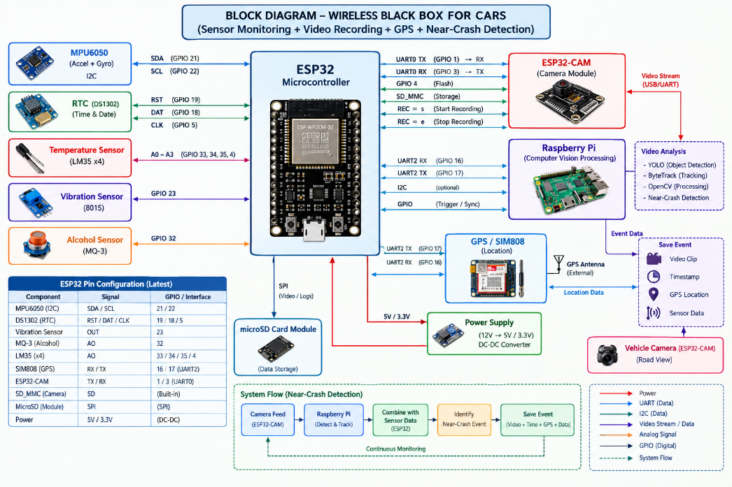
Figure 1.1.block diagram of wireless black box

1.6 Operating Flowchart
The basic recording workflow is summarized first. The additional near-crash workflow below describes the proposed Raspberry Pi extension and should not be interpreted as a completed or validated function.
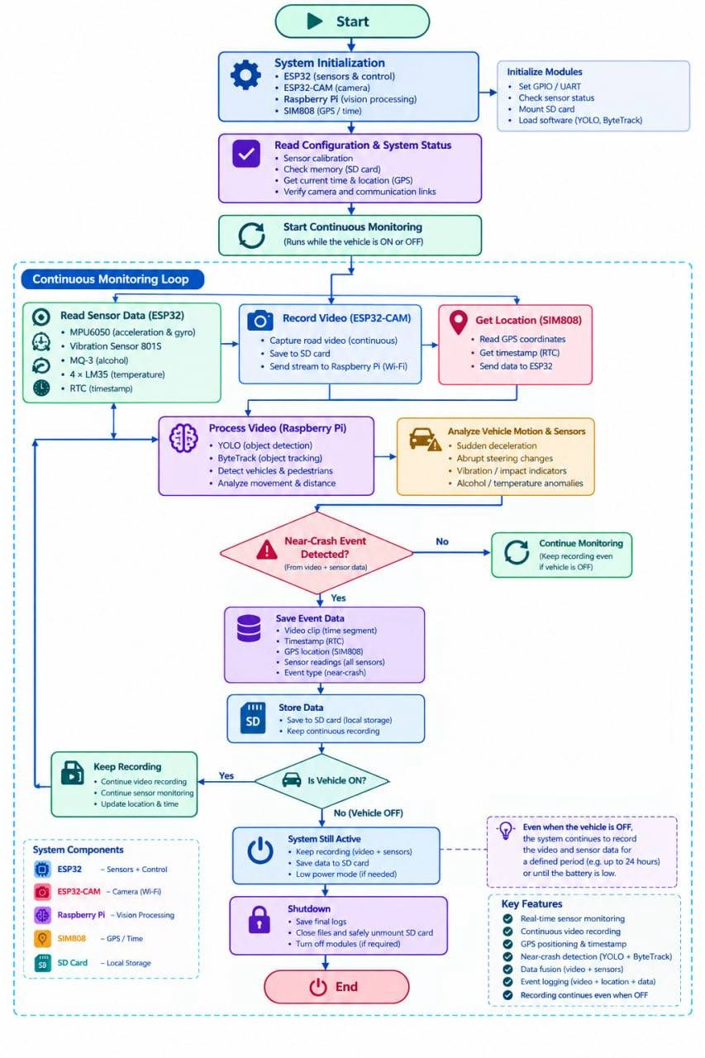

Figure 1.2. Basic data-recording flowchart.

1.7 Theoretical Foundations Required by the Project
The design relies on several theoretical concepts that are developed in detail in Chapter 2: (1) embedded microcontrollers and sensor acquisition; (2) inertial measurement using accelerometers and gyroscopes; (3) analog-to-digital conversion; (4) I²C and UART communication; (5) real-time clocks and timestamping; (6) GPS positioning; (7) digital video capture, file segmentation, and SD-card storage; and (8) computer vision for the proposed near-crash extension, including object detection, object tracking, estimation of approach and path overlap, temporal decision rules, and synchronization of video with motion measurements. The Raspberry Pi would run the video-analysis pipeline, while the ESP32 would provide the sensor measurements used to support or reject a visual risk indication.

1.8 Scope and Limitations
The current scope includes integrating the ESP32 main controller, ESP32-CAM, MPU6050, DS1302 RTC, SIM808 GPS, MQ-3, SW-420/801S vibration module, LM35 temperature sensors, and local SD-card storage. The system is intended to record data and support later review; it does not directly measure every vehicle parameter, and MPU6050 readings should not be described as a direct vehicle-speed measurement. GPS availability and accuracy depend on satellite reception and installation conditions.
Near-crash detection using a Raspberry Pi and computer vision is an additional proposed work item for this semester. The intended pipeline includes vehicle/pedestrian detection, object tracking, analysis of approach and possible path conflict, and comparison with ESP32 motion data such as hard braking or sudden movement. The system may then preserve the relevant video clip, timestamp, GPS position, and sensor log. Detection accuracy, processing requirements, synchronization, and false-alarm rate must be measured in controlled scenarios. Until those tests are completed, the report must not claim that near-crash detection is already implemented or reliably operating. Remote emergency messaging, cloud storage, and unverified automatic responses are outside the claims of this chapter.

1.9 Conclusion of Chapter One
This chapter has defined the scientific problem, reviewed existing vehicle-recording approaches, and stated the aim, objectives, architecture, and scope of the wireless black box. The basic prototype records sensor readings, time information, GPS data, and video for later review. The chapter also describes the proposed new near-crash detection idea: a Raspberry Pi analyses video using computer-vision methods, then combines visual risk indicators with ESP32 motion measurements to flag possible dangerous events and preserve the related evidence. This feature remains a research and implementation task that requires evaluation. Chapter 2 presents the theoretical principles of the hardware, communication methods, and computer-vision concepts needed for the project.

