Tema : Aplikasi Event Organizer

Nama : Gelora – Pagelaran Karya

Role : Penyelenggara dan Pengguna

Deskripsi

Aplikasi yang menyediakan management tiket event di daerah jawa timur yang dapat diakses oleh Masyarakat dan penyelenggara event.

**Entity**

|  |  |  |  |  |  |
| --- | --- | --- | --- | --- | --- |
| **No** | **Nama Entity** | **Atributte** | **Jenis** | **Tipe Data** | **Nullable** |
| 1 | user | id_user | Primary Key | Char(36) | Not Null |
| nama_lengkap | - | Varchar (30) | Not Null |
| email | UID | Varchar(30) | Not Null |
| password | - | Varchar(30) | Not Null |
| nomor_telepon | UID | Varchar(13) | Not Null |
| role_id | Foreign Key | Integer | Not Null |
| created_at | - | Timestamp | Not Null |
| updated_at | - | Timestamp | Not Null |
| 2 | roles | id_role | Primary Key | Integer | Not Null |
| nama_role | - | Varchar(13) | Not Null |
| created_at | - | Timestamp | Not Null |
| updated_at | - | Timestamp | Not Null |
| 3 | event | id_event | Primary Key | Char(36) | Not Null |
| judul_event | - | Varchar(50) | Not Null |
| deskripsi_event | Optionality Atributte | Text | Yes |
| tanggal_mulai_event | - | Timestamp | Not Null |
| tanggal_selesai_event | - | Timestamp | Not Null |
| lokasi | - | Text | Not Null |
| poster_event | - | Varchar(2048) | Not Null |
| id_penyelenggara | Foreign Key | Char(36) | Not Null |
| created_at | - | Timestamp | Not Null |
| updated_at | - | Timestamp | Not Null |
| 4 | tipe_tiket | id_tipe_tiket | Primary Key | Integer | Not Null |
| id_event | Foreign Key | Char(36) | Not Null |
| nama_tipe | - | Varchar(30) | Not Null |
| harga | - | Decimal(15,2) | Not Null |
| kuota | - | Integer | Not Null |
| created_at | - | Timestamp | Not Null |
| updated_at | - | Timestamp | Not Null |
| 5 | order | id_order | Primary Key | Char(36) | Not Null |
| id_user | Foreign Key | Char(36) | Not Null |
| tanggal_order | - | Timestamp | Not Null |
| id_voucher | Foreign Key | Integer | Yes |
| total_harga | - | Decimal(15,2) | Not Null |
| metode_pembayaran | - | Vrachar(12) | Not Null |
| status_pembayaran | - | Varchar(20) | Not Null |
| created_at | - | Timestamp | Not Null |
| updated_at | - | Timestamp | Not Null |
| 6 | order_item | id_order_item | Primary Key | Integer | Not Null |
| id_order | Foreign Key | Char(36) | Not Null |
| id_tipe_tiket | Foreign Key | Integer | Not Null |
| kuantitas | - | Integer | Not Null |
| harga_beli | - | Decimal(15,2) | Not Null |
| created_at | - | Timestamp | Not Null |
| updated_at | - | Timestamp | Not Null |
| 7 | vouchers | id_voucher | Primary Key | Integer | Not Null |
| kode_voucher | UID | Varchar(30) | Not Null |
| jenis_diskon | - | Varchar(10) | Not Null |
| nilai_diskon | - | Decimal(15,2) | Not Null |
| tanggal_mulai_berlaku | - | Date | Not Null |
| tanggal_kadaluarsa | UID | Date | Not Null |
| kuota | - | Integer | Not Null |
| created_at | - | Timestamp | Not Null |
| updated_at | - | Timestamp | Not Null |
| 8 | tiket | id_tiket | Primary Key | Integer | Not Null |
| id_order | Foreign Key | Char(36) | Not Null |
| id_tipe_tiket | Foreign Key | Integer | Not Null |
| kode_tiket | UID | Char(36) | Not Null |
| status_tiket | - | Varchar(30) | Not Null |
| created_at | - | Timestamp | Not Null |
| updated_at | - | Timestamp | Not Null |

**ERD Logical**

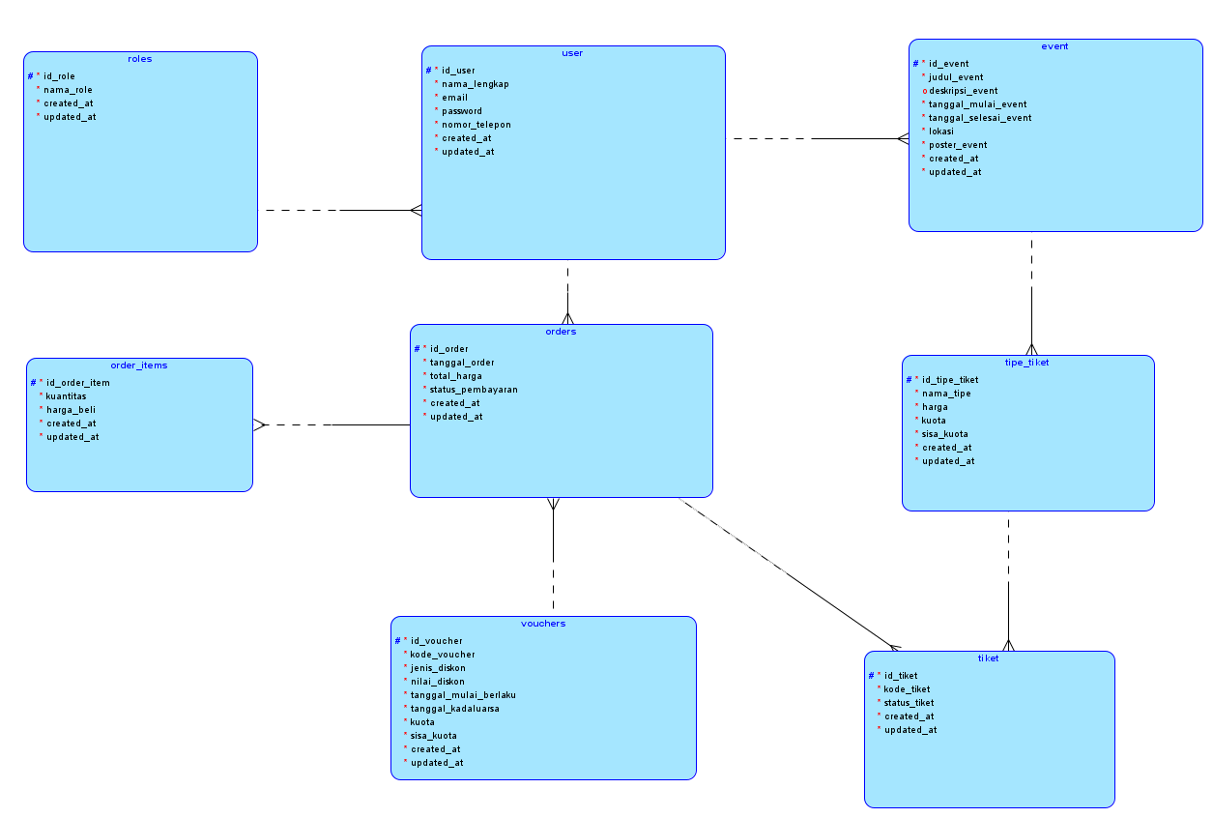

**ERD Relational**

